**NASA DEVELOP National Program**

****NASA Ames Research Center

**Fall 2015**

**Short Title: Puerto Rico Health & Air Quality**

**Subtitle:** A Geospatial Assessment of Environmental Variability in Puerto Rico and its relation to Confirmed Dengue Fever Cases

**VPS Title:** Dengue Bites: Predicting Dengue Risk in Puerto Rico

**Project Team & Partners**

**Project Team:**

Andrew Nguyen (Project Lead), Andrew.nguyen@nasa.gov

Alannah Johansen

Martha Sayre

**Advisors & Mentors:**

Dr. Juan Torres-Pérez (Bay Area Environmental Research Institute)

**Partner Organizations:**

Medical Sciences Campus of the University of Puerto Rico (End-User), POC: Dr. Pablo Méndez-Lázaro

U.S. Centers for Disease Control and Prevention (CDC) Dengue Branch (End-User), POC: Dr. Roberto Barrera

Puerto Rico Department of Health (End-user), POC: Jessica Cabrera

**Project Details**

**Applied Sciences National Applications Addressed:** Health & Air Quality

**Study Area:** Puerto Rico

**Study Period:** January 2009- December 2013

**Earth Observations & Parameters:**

Terra/ Aqua, MODIS - Sea surface temperature (SST), land surface temperature (LST)

TRMM, PR – Total Precipitation (TP) from the Climate Hazards Group InfraRed Precipitation and Satellite (CHIRPS) model

**Ancillary Datasets Utilized:**

* USGS National Land Cover Dataset (NLCD) - land cover
* USGS- Digital Elevation Model (DEM)
* NOAA National Climatic Data Center (NCDC) - weather station data
* Caribbean Coastal Ocean Observing System (CariCOOS) - Sea temperature buoy data
* Dengue Branch of the Centers for Disease Control and Prevention (CDC) and the Puerto Rico Department of Public Health (PRDH) Passive Dengue Surveillance System (PDSS) – Confirmed Dengue Fever Cases (CDFC)
* Geostationary Operational Environmental Satellite system Puerto Rico Water Energy Balance (GOES-PRWEB) - Downscaled soil moisture, ambient temperature, runoff, rainfall, relative humidity, soil saturation, and wind speed

**Models Utilized:**

* Clark Labs’ TerrSet - Habitat and Biodiversity Modeler

**Software Utilized:**

TerrSet – Modeling

ArcGIS - raster manipulation/analysis, model builder, image enhancement & map creation of Aqua/Terra MODIS

**Project Overview**

**80-100 Word Objectives Overview:**

To assess the effects of climate and environmental conditions and their contribution to the presence of the dengue virus in Puerto Rico. Additionally, to derive and statistically evaluate these variables to produce a Vulnerability Index Method (VIM) with the goal of complementing early warning systems for dengue and vector-based diseases in Puerto Rico. Lastly, to better understand the relationship between oceanic conditions and land conditions contributing to dengue.

**Abstract:**

The dengue virus is the fastest-growing vector-borne disease in the world and has been declared endemic in the Caribbean. This deleterious illness is transmitted by tropical mosquitoes and can lead to hemorrhagic fever, shock, and death in severe cases, posing a major threat to the health of Caribbean communities. A high occurrence of the primary vector of the dengue virus *(Aedes aegypti*) has been detected in the city of San Juan, contributing to several dengue outbreaks, including instances in 2010, 2012, and 2013. This study examined environmental conditions contributing to Confirmed Dengue Fever Cases (CDFC) from January 2009- December 2013 using monthly NASA Terra/ Aqua Moderate Resolution Imaging Spectroradiometer (MODIS) 0.5° land surface temperature (LST) products, 1km Geostationary Operational Environmental Satellite system Puerto Rico Water Energy Balance (GOES-PRWEB) humidity products, 0.5° Climate Hazards Group InfraRed Precipitation and Satellite (CHIRPS) total precipitation (TP) modeled data, elevation, and land cover. These data were incorporated into a maximum entropy species distribution model to spatially delineate potential dengue risk, and output the statistical contribution of variables based on reported cases in Puerto Rico in monthly timesteps. Additionally, the statistically significant variables were seasonally compared to CDFC from 2009-2013. Lastly, using Time Series Frequency Analysis, the correlation between MODIS 4km sea surface temperature (SST) products and environmental conditions were tested to better understand the relationship between oceanic and land conditions contributing to dengue. Results indicate a strong significance of urban density, elevation, and TP. SST and environmental conditions correlation coefficients indicate moderate to strong relationships.

**Community Concerns:**

* The dengue virus is the fastest-growing vector-borne pathogen in the world and has been declared endemic in the Caribbean and Puerto Rico.
* Several dengue outbreaks have recently been recorded in San Juan, Puerto Rico, including instances in 1994, 1998, 2007, and 2010.
* Due to elevating sea levels, the San Juan Bay estuary boundaries are shifting toward the coast of Puerto Rico; this suggests that there is a higher chance of the dengue virus affecting the island, as there is a strong correlation between mean sea level, dengue, and mosquito vector populations.
* There is a moderate correlation between sea surface temperature (SST) and an increase in the dengue transmission as salinity-tolerant mosquitoes become more abundant in the coastal zones of other tropical countries.

**Current Management Practices & Policies**:

Currently, the various entities involved in this project use quantitative research on vector-borne diseases and outbreaks, such as dengue, to inform public policy on vector control measures that can be taken to prevent the spread of such illnesses. The Puerto Rico Department of Health provides citizen services, public announcements, and conducts health assessments pertaining to dengue awareness on the island. The Dengue Branch of the CDC employs public health practices such as education on causes for the household spread of dengue, surveillance systems of dengue-infected hospitals, and diagnostic testing. They also conduct molecular research and field investigations regarding dengue contraction and control.

**Decision Support Tools & Benefits:**

|  |  |  |
| --- | --- | --- |
| **End-Product** | **Earth Observations Used** | **Benefit & Impact** |
| Vulnerability Index Method (VIM) | Terra, MODIS  TRMM, PR | Show dengue risk in Puerto Rico according to environmental factors for potential early detection of dengue. This will assist the Department of Public Health and CDC Dengue Branch in assessing which communities may require the most disease prevention resources and training. |
| Time Series of Past Outbreaks for 2009-2013 | Terra, MODIS  TRMM, PR | Geospatially delineate dengue risk in Puerto Rico through a maximum entropy species suitability model. This provides historical context to the dengue outbreak and will allow the Department of Public Health and CDC to analyze whether these regions should be of greater concern. |
| Vulnerability Index Method (VIM) Tutorial | Terra, MODIS  TRMM, PR | Allows end-users the ability to recreate results using NASA Earth observation products for future research opportunities. |

**Project Imagery**

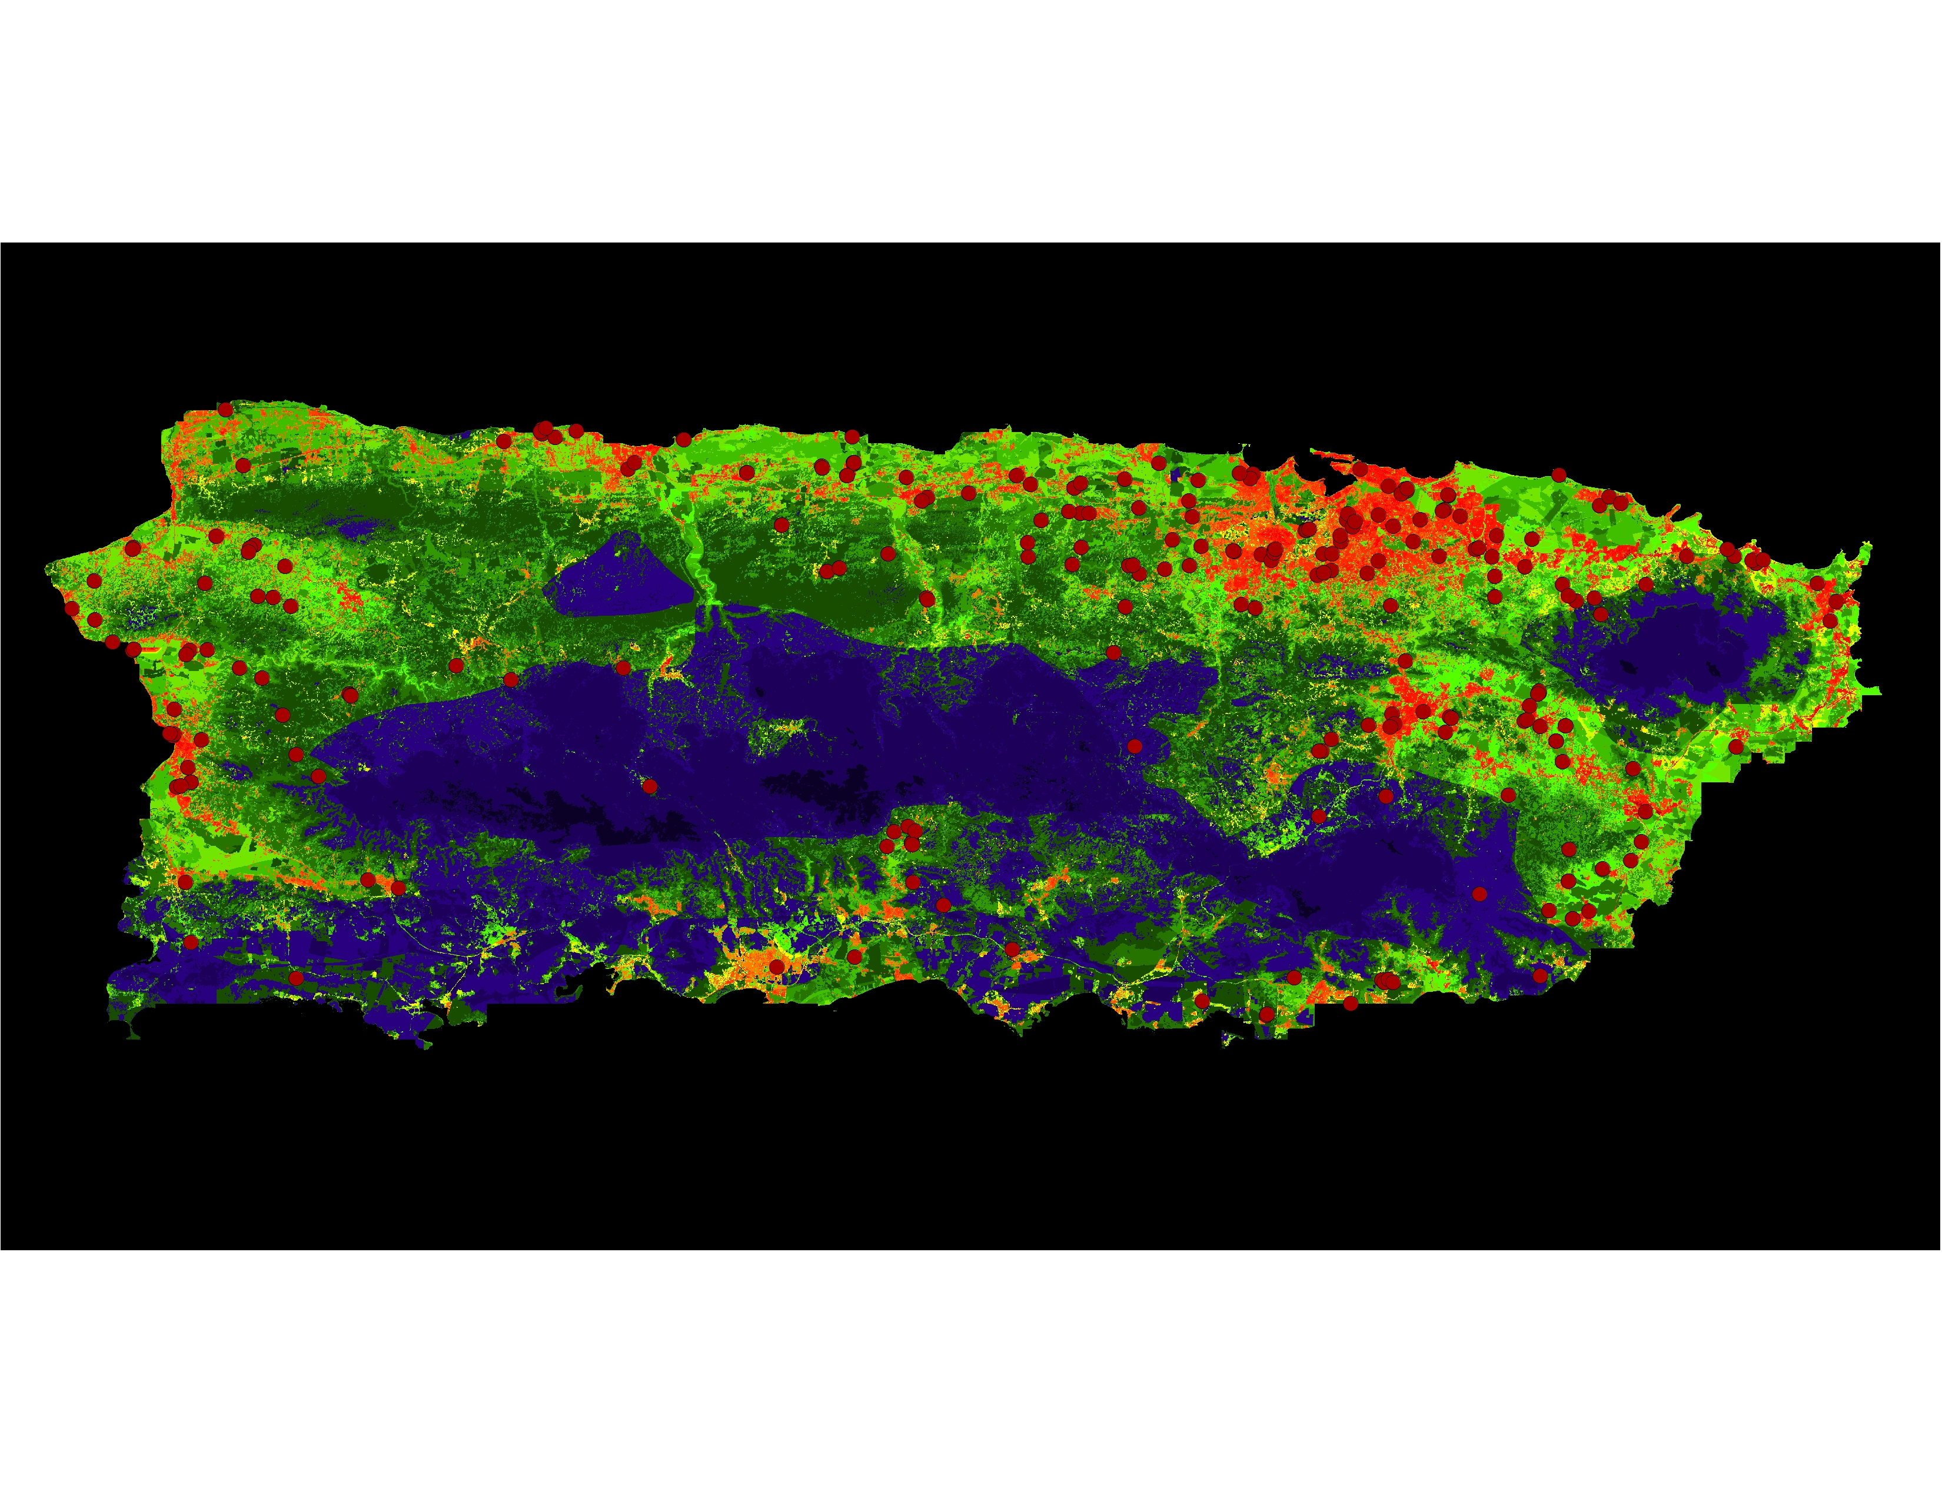

**Caption:** Predicted dengue risk for Puerto Rico in September 2009. Warmer colors indicate higher risk, and cooler colors indicate lower risk. Red dots indicate Confirmed Dengue Fever Cases.

Image Credit: NASA Ames Research Center Fall 2015 Puerto Rico Team.

**Image:** 2015Fall_ARC_PuertoRicoHealthAQ_VPS_Image

**Software Release Requirements**

Category I- Software Release action is not required.