Bhutan Water Resources II

Comparing Phenology, Precipitation, and Temperature Data in Bhutan to Assist the Himalayan Environmental Rhythm Observation and Evaluation System (HEROES) Project

 **Technical Paper**

Final – April 2nd, 2021

Deki Namgyal (Project Lead)

Sonam Dorji

Yeshey Seldon

Tenzin Wangmo

***Advisors:***

Joseph Spruce (Consultant to Science Systems & Applications, Inc.)

Timothy Mayer (NASA SERVIR Science Coordination Office)

Caily Schwartz (NASA SERVIR Science Coordination Office)

Kenton Ross (NASA Langley Research Center)

Sean McCartney (NASA Goddard Space Flight Center)

Robert Griffin (The University of Alabama Huntsville)

Jeffrey Luvall (NASA Marshall Space Flight Center)

***Previous Contributors:***

Kinley Rinzin Dorji

Tashi Kaneko

# 1. Abstract

Bhutan is vulnerable to climate fluctuations that can affect vegetation phenology patterns. Changes in the climate have raised concerns from local farmers about altered growing seasons. In response, the DEVELOP team assessed annual vegetation phenology trends across Bhutan from 1981-2014 by comparing vegetation phenology-derived data and meteorological data. The project assessed phenology change using Vegetation Index and Phenology (VIP) Normalized Difference Vegetation Index (NDVI) products from the Advanced Very High-Resolution Radiometer (AVHRR) and the Terra and Aqua Moderate Resolution Imaging Spectroradiometer (MODIS) sensors. We also used Climate Hazards Center Infrared Precipitation with Station (CHIRPS) precipitation data and Famine Early Warning System Network Land Data Assimilation System (FLDAS) temperature data to assess climate trends in the country. The team assessed VIP phenology data for 1981-2014 to assess trends for the start of season, day of peak, and length of season. For the main growing season, the results indicated that the start of season and day of peak were delayed, while the length of season increased by 22 days. Analysis of temperature and precipitation data for the early 1980s to present indicted that Bhutan’s temperature has become warmer and precipitation has increased. Satellite-based precipitation and temperature data were compared to *in situ* precipitation and temperature data, yielding high correlations for both precipitation (R=0.85) and temperature (R=0.9). The project results and methods were shared with the Ugyen Wangchuck Institute for Conservation and Environmental Research (UWICER) to help assess climate change impacts in Bhutan.

**Key Terms**

remote sensing, vegetation phenology, start of season, length of season, day of peak, VIP Phen, AVHRR, MODIS, FLDAS, CHIRPS

# 2. Introduction

***2.1 Background Information***

Bhutan is a small country situated between India, China, and the Tibet Autonomous Region of China (Figure 1). It is located in the fragile Eastern Himalayan region where climate change poses a threat to the environment, sustainable development, and the livelihoods of the people. In addition, growing settlements and rapid development in Bhutan put more acute pressure on the natural landscape (Mondal et al., 2020). Across the high mountain Himalayas, average air temperatures have risen by nearly two degrees Fahrenheit since the start of the 20th century (Wester et al., 2019). In response, glaciers are retreating, melting, and weather patterns are becoming more erratic. This disrupts previously reliable water sources for millions of people and can lead to more natural disasters (Borunda, 2019). The melting ice from these receding glaciers is increasing the volume of water in glacial lakes, and the melting of ice-cored dams is destabilizing them, pushing the hazard risk for glacial lake outburst floods (GLOFs) to critical levels (The United Nations Development Programme, 2011). Bhutan’s economic development revolves around the hydropower, agriculture, and forestry sectors and is therefore in a highly vulnerable position if impacted by projected changes in climate. Mountainous environments are also rated as being sensitive to changes in climate especially in lieu of the short growing season (Thinley et al., 2019). Climate change impacts were found to be responsible for 10–20% of crop damages (Chhogyel et al., 2020). Farmers in Bhutan have reported that due to the change in climate over the years, invasive plants increasingly colonized highland pasture, preventing the regeneration of fodder grasses (Thinley et al., 2019).

In the previous term of this multi-term project, trends in precipitation, temperature, and vegetation phenology were assessed for three districts of Bhutan: Gasa, Thimphu, and Chhukha. These three regions were chosen due to their variation in topography, and since Bhutan has a very diverse climate despite its small size. The Bhutan Water Resource Team in the 1st term determined that the climate for the three districts varied drastically. The previous team then analyzed phenological and meteorological patterns within Bhutan from 1996 to 2017 using NASA’s Moderate Resolution Imaging Spectroradiometer (MODIS) and ancillary datasets such as Climate Hazards Center InfraRed Precipitation with Stations (CHIRPS) and Famine Early Warning System Network Land Data Assimilation System (FLDAS). Results of the project also characterized the phenology of spring green up of vegetation in the three districts from 2001-2018. For the current term, the team leveraged work from the previous term to employ phenology-derived satellite products from the Advanced Very High-Resolution Radiometer (AVHRR), MODIS, as well as climatic data from CHIRPS, and FLDAS, to assess co-occurring trends in vegetation phenology and climatology for the entire country of Bhutan (Figure 1) over the past 40 years (1981-2020). Preprocessed AVHRR and MODIS data were used to assess trends in vegetation phenology. CHIRPS estimates and FLDAS modeled data were used to assess trends in precipitation and temperature, respectively.

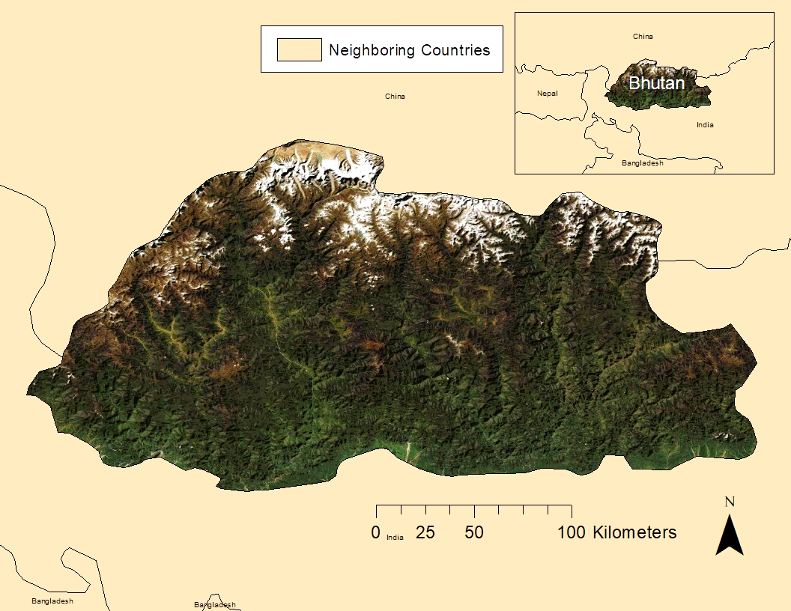

*Figure 1. Map highlighting the study area of Bhutan.*

***2.2 Project Partners & Objectives***

Partners for this project were the Ugyen Wangchuck Institute for Conservation and Environmental Research (UWICER), the Karuna Foundation, and the Bhutan Foundation. These organizations coordinate and fund the Himalayan Environmental Rhythm Observation and Evaluation System (HEROES) project, a school and community-based citizen science initiative to monitor climate change and its impact on the Himalayan mountain ecosystem. UWICER bases its project support decisions on the goals outlined in the 12th Five Year Plan (FYP) for Bhutan, via robust science-based research and dissemination of scientific outcomes to field practitioners, environmental leaders, and policymakers. It aims to encourage better conservation of Bhutan's natural heritage, land, water, air, and wildlife. The Karuna Foundation contributes to the pressing issues of climate mitigation and adaptation in the vulnerable Himalayan region including Bhutan. The Bhutan Foundation works and supports efforts to build Bhutanese capacity and serve the Bhutanese people in sharing the principles of Gross National Happiness.

This project was conducted to strengthen the efforts of UWICER in understanding climate change across Bhutan. The team analyzed the precipitation and temperature data from 1981-2020 for the whole country and also assessed trends in vegetation phenology for start and end of season for the same time period. This work was performed to assist the HEROES project in recognizing changes in the past 40 years regarding vegetation phenology and climatology. This project was conducted to explore and demonstrate how Earth observations provide objective, timely, explicit spatial information and can serve as another monitoring tool to promote a better understanding and appreciation of climate change and its impacts on the biodiversity in Bhutan.

# 3. Methodology

***3.1 Data Acquisition***

NASA Making Earth System Data Records for Use in Research Environments (MEaSUREs), Vegetation Index and Phenology (VIP) products were downloaded from NASA’s Earthdata Search, an online portal for data discovery, filtering, visualization, and access across all of NASA’s Earth science data holdings. VIP products are derived from the AVHRR and MODIS sensors and were used to characterize 33-year trends ranging from 1981-2014 in Bhutan for ten phenological variables. Among the 10 variables, Start of Season (SOS), Day of Peak (DOP), and Length of Season (LOS) were the main foci of the research. Other variables that were looked at were the End of Season, Average Vegetation Index (VI), Background VI, Rate of Greenery, Rate of Senescence, Cumulative VI, and Maximum VI. The AVHRR imagery was derived from the National Oceanic and Atmospheric Administration (NOAA)’s satellite series.

Produced in part with satellite data, FLDAS modeled products were accessed from Google Earth Engine (GEE) to estimate the annual temperature of Bhutan for 1982-2020 (38 years). The product the team focused on was the Tair_f_tavg which gave the near surface air temperature data. The team also accessed the CHIRPS Daily (version 2.0 final) data from GEE to analyze trends in precipitation in the country ranging from 1982-2020 (38 years).

The team accessed the ground data on weather station precipitation and temperature published by Dorji et al. (2016). The latter researchers summarized annual temperature and precipitation, plus geo-locations for 70 different weather stations in the country. From the 70, the team used data from 15 weather stations where the time periods for the ground data and the satellite data co-collected. The annual precipitation and temperature data from the Dorji et al. (2016) paper were from a valid source; therefore, the team used it as *in situ* reference data for comparing to satellite-based estimates of precipitation and temperature.

***3.2 Data Processing***

The VIP data downloaded from NASA Earthdata Search were clipped to Bhutan and converted from .hdf files to Geotiff files using QGIS. Then, the clipped vegetation phenology data were uploaded to the GEE platform as assets. The team’s focus was on the entire country of Bhutan and used the Height Above the Nearest Drainage (HAND) tool (based on SRTM elevation data) and land cover maps for processing the phenology, temperature, and precipitation data. HAND is a useful tool as it helps narrow down the regions of interest from the whole of Bhutan to the human settlement areas in the country. The team used the HAND tool and land cover maps to eliminate areas with minimal to no vegetation, including areas with extreme elevation and permanent snow and ice cover. This filtering to the region of interest was applied to all climatic and phenologic data, including the clipped VIP imagery. The HAND tool served as an appropriate filtering tool as it not only filtered out the high elevation areas with little to no vegetation and as a result, highlights areas with human settlement that are in closer proximity to drainages. All HAND filtered phenology and climatic data were grouped into five-year intervals and data for each interval were averaged for further analysis.

For the weather station data obtained from Dorji et al. (2016), the team converted the weather station data to a shapefile in ArcGIS Pro and uploaded it to GEE. The pixels and points from the ground data were used to find the precipitation and temperature data from CHIRPS Daily and FLDAS using GEE. Then, the team downloaded the temperature and precipitation data for the 70 weather stations as comma-separated values (CSV) files. The files were copied to Microsoft Excel to compare the FLDAS and CHIRPS data with the in-situ data.

***3.3 Data Analysis***

The team downloaded the data for the phenology variables as CSV files and used Microsoft Excel to create charts and trendlines. The trendlines created on each variable were used to analyze and discuss whether seasons were starting earlier or later. The team also downloaded the CHIRPS and FLDAS data as CSV files and copied them to Microsoft Excel to create charts for analysis. Trendlines were created on the charts to analyze the increase in temperature and precipitation over the years. These graphs assisted the team in analyzing and explaining the change in climate variables over time for the country. This helped the team in forming the results and drawing a relation between the climatic variations and changes in phenology.

Afterward, CHIRPS and FLDAS data were downloaded as a CSV file and copied to a Microsoft Excel sheet. Linear regression and descriptive analysis were done to evaluate the data from CHIRPS and FLDAS by creating trendlines on the scatter plot graphs. These graphs assisted the team in analyzing and explaining the change in climate variables over time for the country. This helped the team in forming the results and drawing a relation between the climatic variations and changes in phenology. The team compared the temperature and precipitation data from GEE with the *in situ* data. Each weather station had its unique start year and end year, so the team divided the weather stations by the same time frame. Some timeframes had only one or two weather stations which were not enough for optimal correlation analysis. Therefore, the team took the timeframe ranging from 1996-2010 as 15 weather stations (the largest possible number) were concurrently collected during that time frame (Figure 2). The team created a correlation graph for the in situ and satellite-based precipitation in Excel and calculated the R value to find the correlation between the in situ and satellite-based precipitation data. R squared values were also calculated to evaluate the correlation of the weather station data to the raster data obtained from GEE. This statistical comparison process was completed for both the precipitation and temperature data.

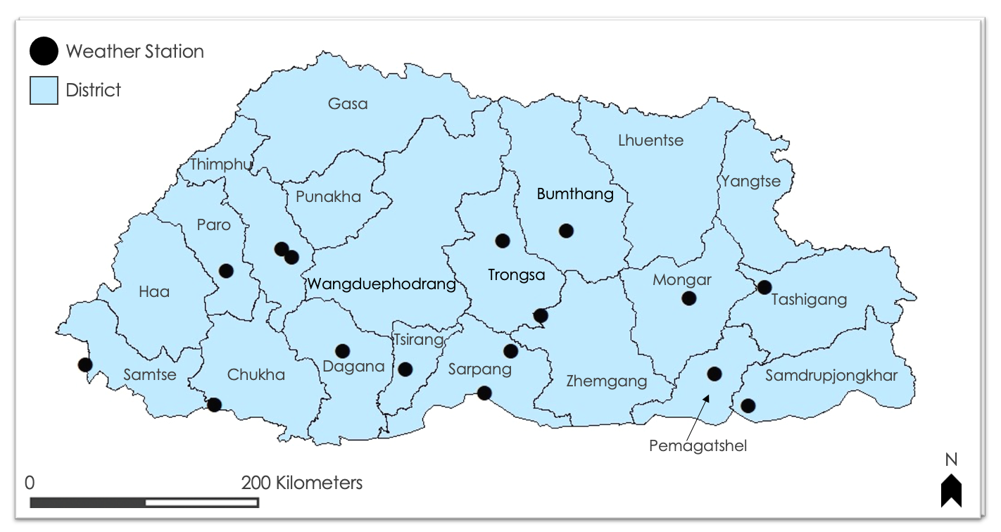

*Figure 2. Bhutan District Map showing point locations of 15 weather stations used in project analyses.*

# 4. Results & Discussion

***4.1 Phenology***

***4.1.1 Start of Season***

The team computed the non-overlapping rolling average of the start of season variable for 5-year intervals from 1981-2014 (Figure 3). The SOS values were all in Julian days which is the count of the number of days between January 1st and the end of the calendar day for a given year. The VIP data used were from two different sensors—AVHRR from 1981-1999 and MODIS from 2000-2014. The team calculated the mean value for start of season using AVHRR ('81-‘99) and got 79.52. The average for SOS using MODIS was 126.53. Trendlines for the AVHRR versus MODIS SOS observations were looked at separately.

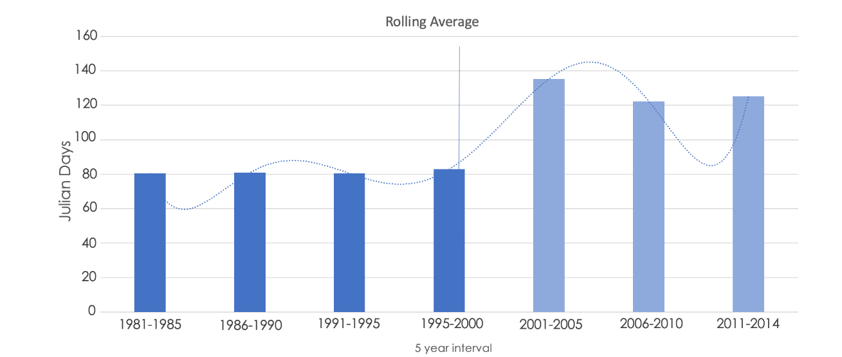

*Figure 3. Rolling average for start of season (5 years per sampling interval).*

From 1981-1999, the values remained quite consistent and there wasn’t much of a trend for analysis as the days were in between the 80th to 83rd Julian days which when converted to calendar date is about March 21st to 24th. From 2001-2014, there was a decreasing trendline for the rolling average of SOS. The change that should be noted was between 2001 to 2010 where there is a decrease in the SOS day from 135 to 122 Julian days which is a reduction in SOS of 13 days. This decrease in the days is what caused the overall decrease in trend for the years with the MODIS sensor. After 2010, there was an increase in the SOS date but only by a few days, which did not affect the trendline much. Many of the years in the MODIS era are amongst the hotter years in the recent decades but this did not seemingly translate to earlier SOS dates. Even though warming is occurring, this does not necessarily equate to earlier springs. Yu et al. (2010) also reported delayed springs occurring for the Tibetan Plateau region close to Bhutan. Other potential explanatory factors for delayed spring on the AVHRR versus MODIS data include: 1) the MODIS data is based on two collections per day, while the AVHRR is based on daily data; and 2) the definition of red and NIR spectral bands differ for AVHRR versus MODIS. Also, it should be noted that the AVHRR and MODIS data were subjected to a cross-sensor calibration and harmonization process that aimed to minimize differences in sensor design and image data collection specifications.

***4.1.2******Day of Peak***

The team calculated the rolling average DOP NDVI for 5-year interval time frames from 1981 to 2014 (Figure 4).

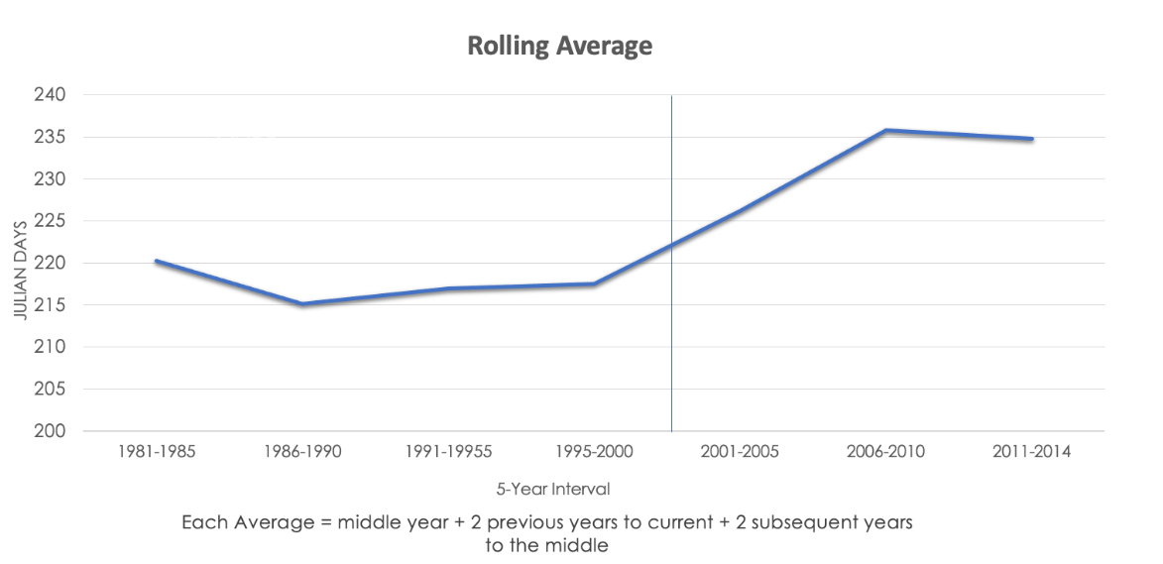

*Figure 4. Rolling average for Day of Peak NDVI (5 years per sampling interval)*

The graph above was also divided into AVHRR and MODIS timeframes. The team noticed that with both AVHRR and MODIS sensor timeframes an increase in the rolling averages. For the years 1981-1999 (AVHRR), the DOP decreased by about 5 days from 1981-1990; however, after that, it increased by a day or two. For the years 2001-2014 (MODIS), the DOP had increased from 226 to 235 from 2001-2010 which is about 9 days. From 2006 to 2016, it decreased by a day. The overall trend of the day of peak chart was increasing. This seems reasonable, especially given that delayed SOS.

***4.1.3******Length of season***

The team calculated the rolling average for (LOS) for 5-year interval time frames from 1981-2014. The graph, like the other two, was also divided into AVHRR and MODIS timeframes. Within the AVHRR timeframe from 1981-1999, we can see that the LOS increased from 1981 to 1995 and it slightly dropped from then till 2000. Within the MODIS timeframe, the LOS for 2001-2005 was lower than the previous period for AVHRR (1996-2000), but thereafter ~~i~~ncreased greatly for 2006 -2010 and then slightly dropped for 2011-2014 compared to the previous 5-year interval.

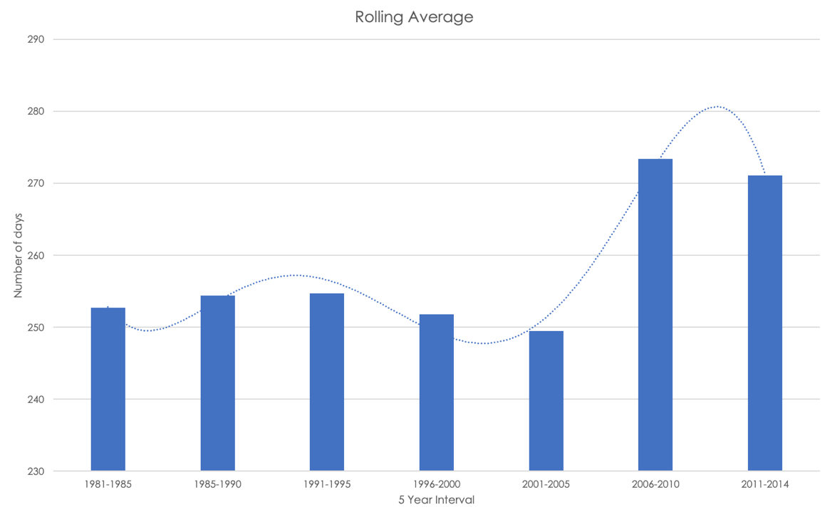

*Figure 5. Rolling average for length of season (5 years per sampling interval).*

The chart (Figure 5), like the previous two, was also divided into AVHRR and MODIS timeframes. Within the AVHRR timeframe from 1981-1999, we can see that the length of season increased from 1981 to 1995 and it slightly dropped from then till 2000. Within the MODIS timeframe, the length of season was seen to increase greatly from 2000-2010 and it slightly dropped from 2011. The LOS from 1981 to 2014 increased by approximately 18 days according to this chart.

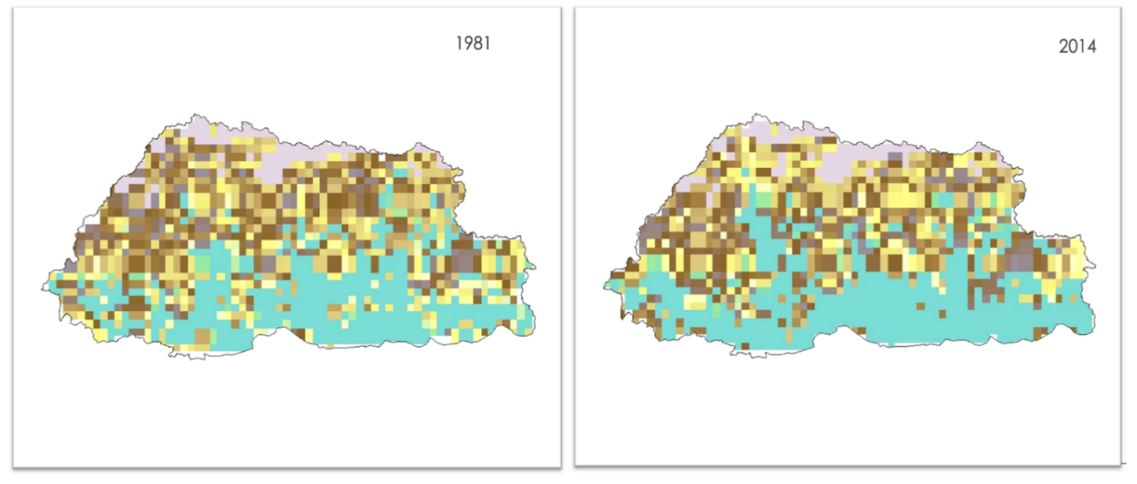



No data /

*Figure 6. Length Of Season maps for 1981 and 2014.*

The purpose of these two maps in Figure 6 was to compare the length of season pixels computed for the first and last year in the LOS data. The greenish-blue color represents longer seasons and as the color band changes from greenish blue to pink, it shows the shortening of seasons. The pink color or 0 days is a no-data zone. These are high elevation alpine environments that have no vegetation to measure phenological response. These LOS maps show the general difference between the two dates and we can tell that the aquamarine-colored pixels increased somewhat for the country at large, especially in the western and southern parts, perhaps due to the expansion of evergreen broadleaved forests.

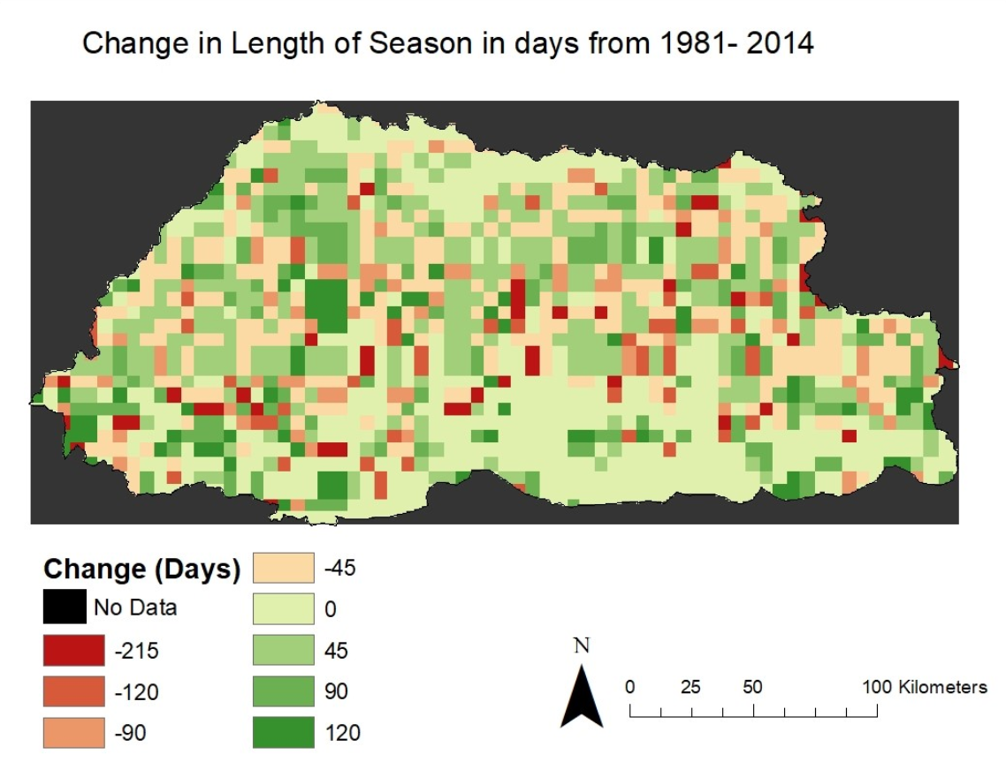

*Figure 7. Map illustrating change in Length Of Season for years 1981 versus 2014.*

The map in Figure 7 shows the LOS difference map for 2014 versus 1981. This indicates the location and magnitude of differences in LOS between the two years. The red tones on the map represent reductions in LOS for 2014 relative to 1981 and then mid to dark green tones represent increases in the LOS for 2014 versus 1981. The “no change” areas are shown in lime green, which predominantly pertain to evergreen broadleaved forests. Note that the map shows more moderate to dark green colored pixels relative to the red tones indicating that overall, there is increased LOS for 2014 versus 1981. Also note that the most extreme negative (darkest reds) and positive change values (darkest greens) may be noise due to factors such as atmospheric contamination (e.g., cloud cover) affecting which dates were used to compute LOS for each input year. The overall mean of the difference or change between the two annual LOS maps is 20.10 days meaning the length of season for the country has increased by about 20 days for the observed 33-year period. This is somewhat higher than what was reported in a study by Liu et al. (2006), who indicated that the Tibetan Plateau experienced an estimated increase of approximately 17 days in growing season length across a 43-year period. The latter study was 17 years earlier and the world has since become warmer which could explain the apparent additional increase in the length of season (of 20 as opposed to 17 days). The moderately high amount of no change areas in lime green contributed to the mean change level, lowering it from what it would be if the no change areas were disregarded. Given that the LOS change map for the overall study area contains about 375 pixels, the hope is that the mean change value is an approximate indicator of LOS change for 2014 versus 1981. The map also contained a high degree of variability so there is uncertainty (SD = approximately 97.84, n= 385) about this average LOS change value. Additional research is needed to further analyze this uncertainty.

***4.2 Climate Variables from 1981-2020.***

***4.2.1 Temperature***

The team calculated and plotted the mean annual temperature data from FLDAS for the time ranging from 1981-2020 (Figure 8). In doing so, the team graphed the mean annual temperature data and created a trendline along with the chart. Based on the FLDAS data, the mean annual temperature in 1981 was approximately 9°C and about 10°C in 2020. An overall upward trend was seen suggesting that it is getting warmer over the years. On average, the overall temperature has increased by 0.9 degrees Celsius. A comparable increase in temperature was also reported for a climate study in the Hindu Kush Himalaya (HKH) region by Sabin et al. (2020), who reported that the climate in HKH at large has been warming since 1951 at a clip of 0.2 degrees C per decade with high amounts observed (~0.5 degrees C) in the higher more extreme alpine elevations.

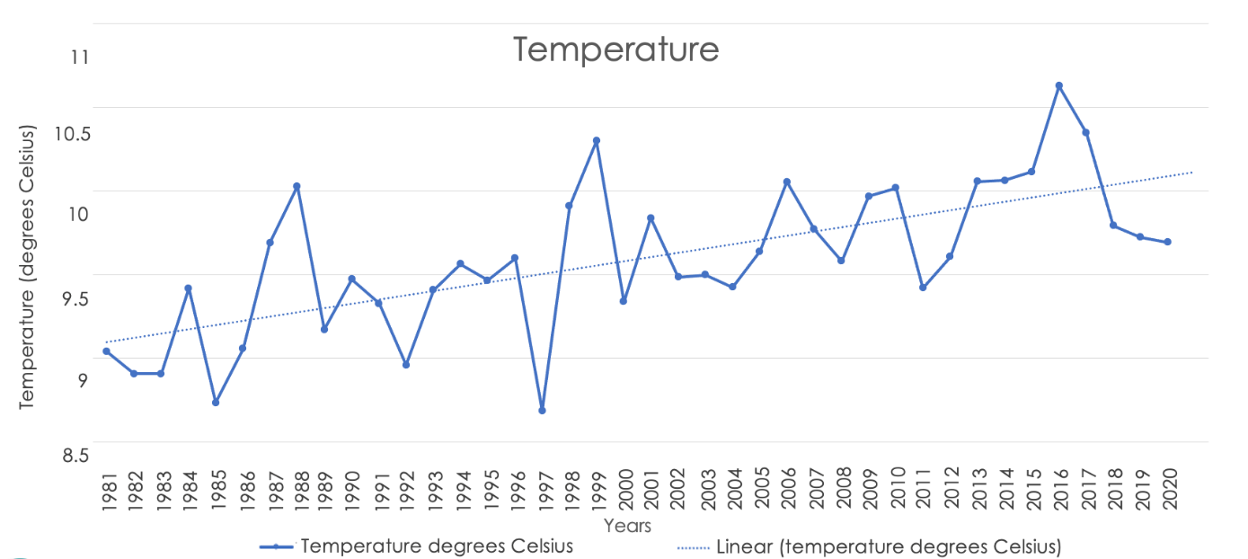*Figure 8. Mean annual Temperature chart from 1981-2020.*

The team then compared temperature maps for 1982 and 2020 (Figure 9). This was done to view per pixel changes in temperature for the beginning versus the end of the observation period. The white pixels represent areas that have been masked out due to high elevations and drainages using HAND data set. The darker shades of red represent warmer regions averaging about 25 degrees Centigrade (77 degrees Fahrenheit) and the lighter colors represent cooler regions with an average temperature of about 6 degrees Centigrade for the minimum value (0 degrees Fahrenheit). The temperature maps were visually similar for these two years.

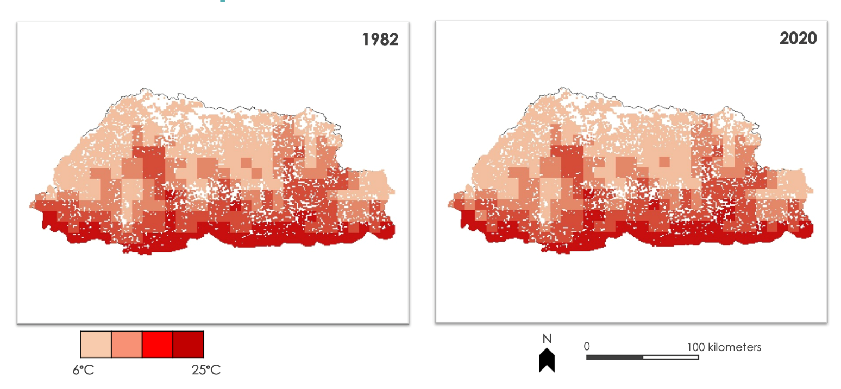 *Figure 9. Maps for mean annual temperature 1982 and 2020.*

***4.2.2 Precipitation***

Figure 10 shows the annual precipitation over the years, which has remained fairly consistent with a slight upward trend. The mean annual precipitation in 1981 was 853.5 mm and 827.8 mm in 2020, but on average precipitation has increased overall by 68.8mm in the past 40 years. The team also took the precipitation map of one of the earlier years in the timeline, which is 1983, and compared it to the temperature of 2020 (Figure 11). This was done to see the difference and change in precipitation over the years. The darker shades of blue represent regions experiencing higher rainfall (maxima set to 3200mm – or ~126 inches) and the lighter shades of blue representing lower rainfall (minima set to 0mm). Although there is not much difference between the two years, little changes can be seen in the southern foothills, with certain areas in 2020 receiving more rain. The dark blue color at the very southeast was replaced by light blue pixels, which suggests the rainfall had decreased in those locations. Some pixels with a very light blue color were replaced by a little darker blue in the southwest region, which suggests such locations received more rainfall for 2020 versus 1983.

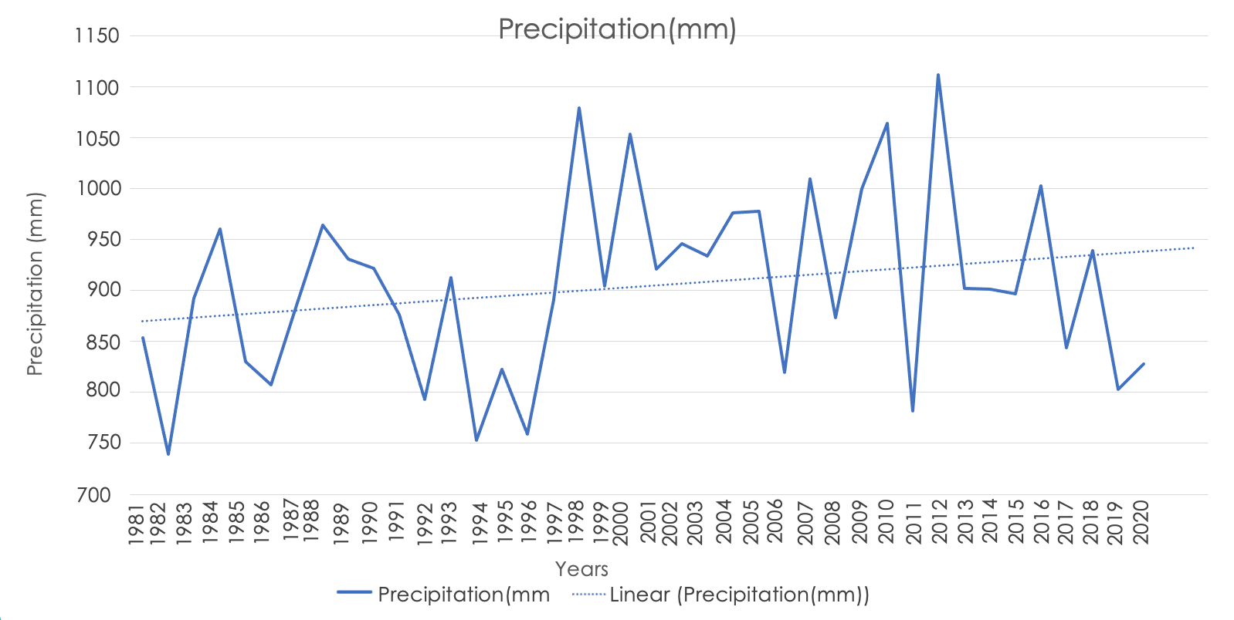

*Figure 10. Mean annual Precipitation graph for 1981-2020.*

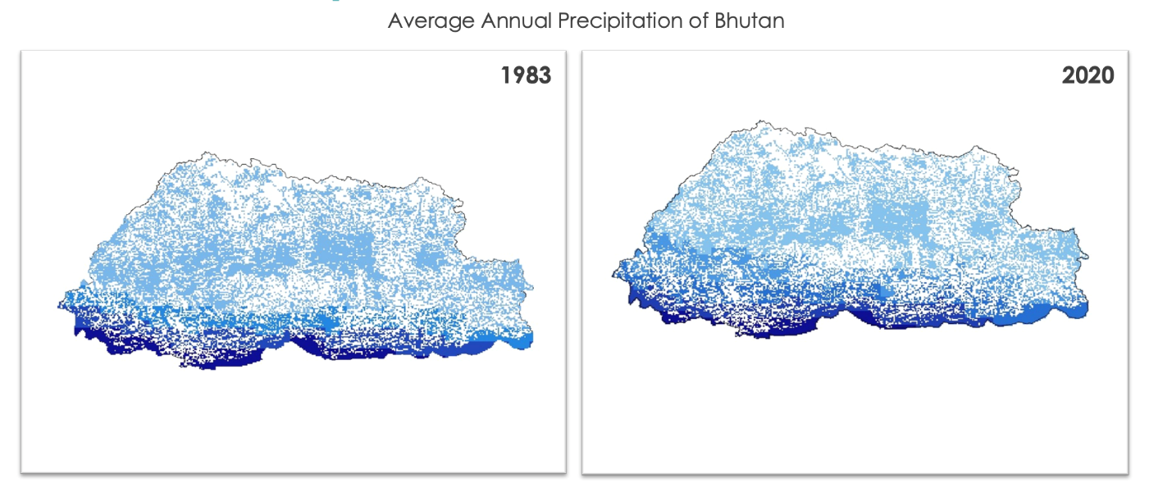



*Figure 11. Maps for mean annual precipitation 1983 and 2020.*

***4.3 Comparison of Ground and Satellite Data for Climate Variables***

***4.3.1 Temperature Correlation***

The team then compared the satellite and ground temperature data for 15 weather stations from 1996-2010 to estimate the correlation between the two data sets (Figure 12). The R squared was also calculated along with the correlation, R. The R for the temperature dataset was ~0.90 and the R squared value was ~0.82. The R and R squared value suggests that the two datasets are highly correlated to one another.

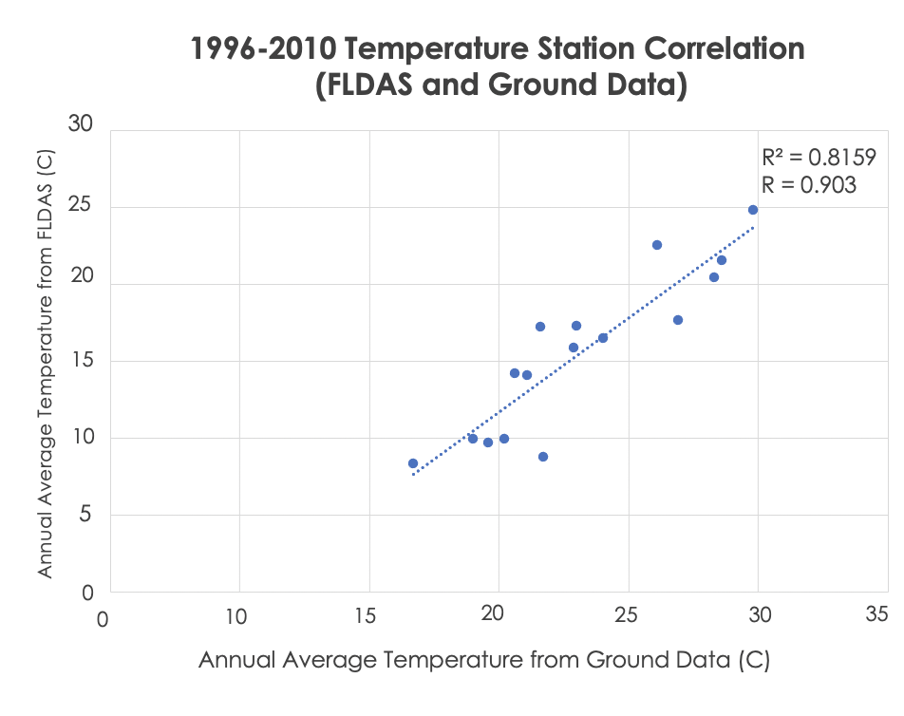

*Figure 12. Correlation graph (Mean Annual Temperature).*

***4.3.2 Precipitation Correlation***

The team also graphed the satellite and ground precipitation data for the same 15 weather stations for 1996-2010 to find the correlation coefficient, R, between the two data sets (Figure 13). The coefficient of determination, R squared, was also calculated along with the R, correlation. The R for the temperature dataset was ~0.85 and the R squared value was ~0.73. The R and R squared value provide evidence that the two compared datasets are highly correlated to one another. Both the R and the R squared values for the precipitation data were found to be lower than the temperature data. This could be in part to the increased variability in mean annual precipitation compared to mean annual temperature.

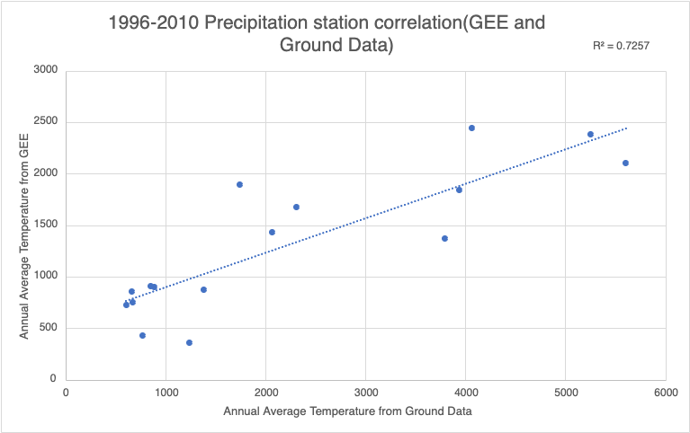

*Figure 13. Correlation graph (Mean Annual Precipitation).*

***4.4 Future Work***

This term focused on using the previous project’s methods to assess trends across the entire country in regards to satellite-based temperature, precipitation, and vegetation phenology data. Country-wide analyses of potential changes in vegetation phenology, precipitation, and temperature were conducted for a ~40 year period, considering multiple Earth observation data sources. This project is expected to continue in summer 2021, leveraging the work of the two previous terms to further assess relationships between climate and phenology focusing on agricultural/forestry impacts and possibly construct a GEE tool for end-users to explore trends on climatic and vegetation phenology time series data. This tool will help collaborators assess climate and vegetation changes within specific regions of Bhutan. More work on the change in vegetation phenology is needed to augment example change maps from the current term. For example, there were no NDVI magnitude change maps computed for any of the key phenology metrics such as peak growing season NDVI or mean annual NDVI. Additional research could be conducted to compare the VIP data to the high spatial resolution MODIS MCD12Q2 vegetation phenology datasets from 2001 to 2018. Also, more efforts are needed to assess phenology trends for specific land cover types of interest such as forest and agricultural types.

# 5. Conclusions

Based on our project results, seasonal and climatic variability commonly occurs in Bhutan, and co-occurring changes in phenology metrics were also observed. The project used satellite platforms and sensors like CHIRPS, FLDAS, AVHRR, and MODIS to assess trends in precipitation, temperature, and phenology in the country of Bhutan. The project considered the entire country as the region of interest with high elevation points and snowcaps masked out using the HAND SRTM data, as opposed to the more location-specific analyses that were conducted for the three jurisdictional districts in the previous term. If needed, our prototype can be used to focus on particular regions within the study area or for specific land cover types or elevation zones within the region. The team obsered a gradual increase in the temperature over the past 40 years by 0.9 degrees Celsius, and while comparing ground data to satellite data for temperature, there was a strong correlation between the two with an R-value of 0.9. There was also an overall increase in annual rainfall by 68.8 mm. The correlation for ground data and satellite data for precipitation was 0.85. Based on the observed high correlation between temperature and precipitation between the satellite and ground data, we can infer if there are missing records for the *in situ* data, satellite data may be an effective substitute, especially in terms of broad area estimates. We also conclude that the mean annual temperature across Bhutan has been gradually increasing since the early 1980s. The country as a whole is experiencing slightly more rainfall annually since the 1980s. Based on the results acquired from analyzing the VIP datasets, the team observed an overall upward trend for all the variables of day of peak, length of season, and start of season. These research results indicate the main growing season has been slightly pushed back, meaning the season is starting later and experiencing a longer duration by approximately 22 days.

# 6. Acknowledgments

The team would like to acknowledge the following individuals for their influence in our work:

* Joseph Spruce (Science Systems & Applications, Inc., Diamondhead, MS)
* Timothy Mayer (NASA SERVIR Science Coordination Office)
* Sean McCartney (Science Systems & Applications, Inc., NASA Goddard Space Flight Center)
* Dr. Kenton Ross (NASA Langley Research Center)
* Caily Schwartz (NASA SERVIR Science Coordination Office)
* A. Rochelle Williams (NASA DEVELOP)

# 7. Glossary

**AVHRR** – Advanced Very High-Resolution Radiometer

**CHIRPS** – Climate Hazards Group InfraRed Precipitation with Station data

**EO** – Earth Observations

**FLDAS** – Famine Early Warning Systems Network (FEWS NET) Land Data Assimilation System

**GEE** – Google Earth Engine

**GLOF** – Glacial Lake Outburst Floods

**HAND –** Height Above Nearest Drainage

**HEROES** – Himalayan Environmental Rhythm Observation and Evaluation System

**HKH** – Hindu Kush Himalaya

**LOS** – Length of Season

**MODIS** – Moderate Resolution Imaging Spectroradiometer

**NASA –** National Aeronautics and Space Administration

**NDVI –** Normalized Difference Vegetation Index

**NOAA** – National Oceanic and Atmospheric Administration

**SOS** – Start of Season

**SRTM** – Shuttle Radar Topography Mission

**UWICER** – Ugyen Wangchuck Institute for Conservation and Environmental Research

**VIP** – Vegetation Index and Phenology

# 8. References

Borunda, A. (2019, February 10). *Climate change is roasting the Himalaya region, threatening millions. National Geographic.* <https://www.nationalgeographic.com/environment/2019/02/himalaya-mountain-climate-change-report/#close>

Chhogyel, N., Kumar, L., Bajgai, Y., & Hasan, M. K. (2020). Perception of farmers on climate change and its impacts on agriculture across various altitudinal zones of Bhutan Himalayas. *International Journal of Environmental Science and Technology*, 1-14. https://doi.org/10.1007/s13762-020-02662-8

Climate Hazards Group InfraRed Precipitation with Station Data (CHIRPS): <https://www.chc.ucsb.edu/data/chirps>

Didan, K., Barreto, A. (2016). NASA MEaSUREs Vegetation Index and Phenology (VIP) Phenology NDVI Yearly Global 0.05Deg CMG [Data set]. NASA EOSDIS Land Processes DAAC. Accessed 2021-04-19 from https://doi.org/10.5067/MEaSUREs/VIP/VIPPHEN_NDVI.004

Dorji, U., Olesen, J. E., Bøcher, P. K., & Seidenkrantz, M. S. (2016). Spatial variation of temperature and precipitation in Bhutan and links to vegetation and land cover. *Mountain Research and Development, 36*(1), 66-79. <https://doi.org/10.1016/j.rsase.2020.100307>

Famine Early Warning Systems Network (FEWS NET) Land Data Assimilation System   
(FLDAS): <https://ldas.gsfc.nasa.gov/fldas>

Height Above Nearest Drainage (HAND): <https://gena.users.earthengine.app/view/global-hand>

Himalayan Environmental Rhythm Observation and Evaluation System (HEROES):

<http://www.heroes.gov.bt/web/index.php>

Liu, X., Yin, Z., Shao, X., & Qin, N. (2006). Temporal trends and variability of daily maximum and Minimum, extreme temperature events, and growing season length over the eastern and central Tibetan Plateau during 1961–2003. *Journal of Geophysical Research: Atmospheres, 111*(D19). https://doi.org/10.1029/2005JD006915

Mondal, P., McDermid, S. S., & Qadir, A. (2020). A reporting framework for Sustainable Development Goal 15: Multi-scale monitoring of forest degradation using MODIS, Landsat and Sentinel data. *Remote Sensing of Environment,* 237, 111592. <https://doi.org/10.1016/j.rse.2019.111592>.

Sabin, T.P., Krishnan, R., Vellore, R., Priya, P., Borgaonkar, H.P., Singh, B.B., & Sagar, A. (2020). Climate change over the Himalayas. In R. Krishnan, J. Sanjay, C. Gnanaseelan, M. Mujumdar, A. Kulkarni, & S. Chakraborty (Eds.), *Assessment of Climate Change over the Indian Region* (pp. 207-222). Springer, Singapore. <https://doi.org/10.1007/978-981-15-4327-2_11>

Thinley, U., Banterng, P., Gonkhamdee, S., & Katawatin, R. (2019). Distributions of Alien Invasive Weeds under Climate Change Scenarios in Mountainous Bhutan. *Agronomy, 9*(8), 442 MDPI AG. Retrieved from <http://dx.doi.org/10.3390/agronomy9080442>

United Nations Development Programme. (2011). *Bhutan*. Climate Change Adaptation: <https://www.adaptation-undp.org/explore/bhutan#:~:text=The%20most%20significant%20impact%20of,of%20glaciers%20with%20increasing%20temperatures.&text=The%20result%20is%20that%20glaciers,30%2D60%20meters%20per%20decade>

Wester, P., Mishra, A., Mukherji, A., & Shrestha, A.B. (Eds.). (2019).*The Hindu Kush Himalaya assessment: Mountains, climate change, sustainability and people*. Springer International Publishing. <https://doi.org/10.1007/978-3-319-92288-1>

Yu, H., Luedeling, E., & Xu, J. (2010). Winter and spring warming result in delayed spring phenology on the Tibetan Plateau. *Proceedings of the National Academy of Sciences, 107*, 22151-22156