**NASA DEVELOP National Program**



NASA Langley Research Center

*Summer 2017*

Pacific Southwest Cross-Cutting

Utilizing NASA Earth Observations to Develop a Land Use Change Detection Tool for Habitat Conservation Plan Areas

**Technical Report**

Final Draft – August 10, 2017

Sean Robison (Project Lead)

Liz Dyer

Katie Thomas

Dr. Kenton Ross, NASA Langley Research Center (Science Advisor)

# 1. Abstract

Habitat Conservation Plans (HCPs) were designed to protect and manage areas where desired economic development is in conflict with the needs of threatened and endangered species. Each plan is developed through collaboration between United States Fish and Wildlife Service (USFWS) and a landowner or other project proponent. Regulations restrict activities within HCP boundaries to minimize impacts to listed species while still allowing for land development. The USFWS does not have the capacity to closely monitor and assess the millions of acres of private- and publically-owned lands to ensure compliance with restrictions. In order to assist monitoring efforts by the USFWS, a methodology was constructed that uses remote sensing data and the Normalized Difference Vegetation Index (NDVI) to detect land use change. Past land use change from 1995 to 2017 in the Pacific Southwest HCPs was analyzed. This methodology used publically available satellite data from Landsat 5 and Landsat 8, and was implemented in the open source Google Earth Engine (GEE) API. The USFWS will be able to use this tool on the GEE platform to continue evaluating HPCs for disturbance, saving significant travel time and effort.

**Keywords**

Remote sensing, Normalized Difference Vegetation Index (NDVI), Relative Greenness (RG), Normalized Burn Ratio (NBR), land use change, Google Earth Engine, Landsat

# 2. Introduction

* 1. ***Background Information***

Created in 1982 with an amendment to the Endangered Species Act (ESA), Habitat Conservation Plans (HCPs) are an integral part of the policies designed to relieve conflict between desired economic development and the protection of threatened and endangered species (USFWS & NOAA, 2016). HCPs are created during the process of applying for an Incidental Take Permit, which allows development activities that would otherwise be prohibited due to the presence of these species.

The US Fish and Wildlife Service (USFWS) works with a proponent applying for an Incidental Take Permit to develop a plan detailing the impacts the proposed project would have on endangered species and the steps intended to minimize and mitigate those impacts. They determine the areas that could be impacted by the development and establish this as the HCP site. If the HCP is approved and an Incidental Take permit is granted, the project is implemented and the party in charge of the project is responsible for following the practices described in the plan. As time goes on, the USFWS receives updates on the HCP site from the project proponent, and they make an effort to monitor the areas and ensure that the regulations are being followed.

In order to better manage the ever growing lands under HCPs, USFWS wants to use remote sensing to increase efficiency among their limited staff. Remote sensing has a wide range of applications including land use, land cover, and vegetation change analysis (Green et al., 1994; Lyon et al., 1998; Poudyal et al., 2016), making it an increasingly common tool for the management of natural conservation areas and monitoring urban growth (Herold et al., 2003; Franklin et al., 2011). The ability to analyze large areas without physically visiting every site is an advantage of remote sensing and is one of the qualities that makes it useful to conservationists. The time and money necessary for collecting field data can be efficiently spent to visit only the areas showing unexpected results in the remote sensing analysis. A tool that has the flexibility to be applied to multiple areas and different environmental conditions could be useful to large organizations such as USFWS that are responsible for properties across the nation.

The Pacific Southwest Region of the USFWS includes California, Nevada, and the Kalamath basin of Oregon; however, this study focuses on areas under HCPs within California. The USFWS has established 126 HCPs in California to help protect some of the 309 threatened and endangered species found within the state (USFWSa, 2016). Within these HCPs are a wide range of habitats types including deserts, grasslands, savannahs, woodlands, marshes, and wetlands, and cover more than 79 million acres.

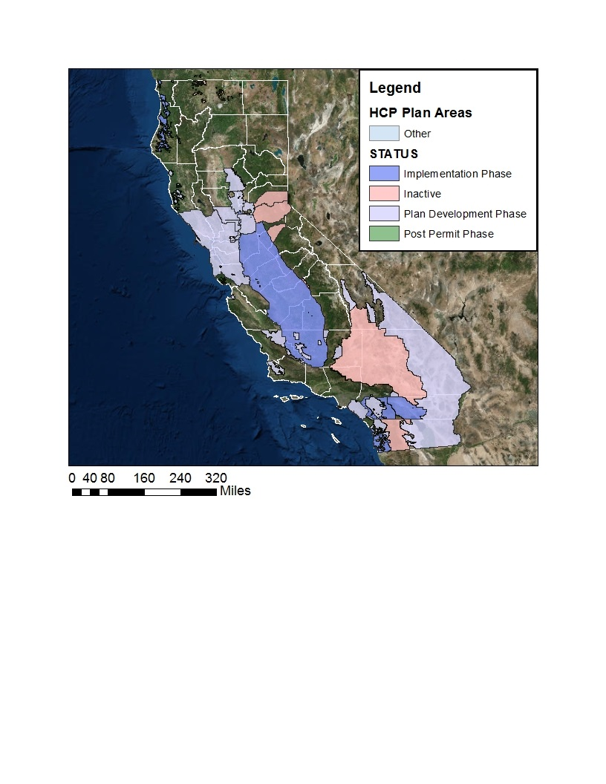

*Figure 1.* Study area map depicting the state of California and current areas under Habitat Conservation Plans. Legend Terms: Implementation Phase is the stage in the process where the permittee proceeds with implementing the HCP conservation strategy and their covered activities. Inactive areas show plans where activities are currently at a standstill for an unknown reason. Areas in the Plan Development Phase are still developing the HCP, a permit has not yet been granted. Areas in the Post Permit Phase have completed the HCP conservation strategy and planned activities. (USFWS & NOAA, 2016)

* 1. ***Project Partners & Objectives***

The USFWS is a federal agency within the Department of the Interior. Their mission is to “work with others to conserve, protect, and enhance fish, wildlife, and plants and their habitats for the continuing benefit of the American people” (USFWSb, 2016). The USFWS is responsible for monitoring HCP areas to ensure regulations are being followed, and current monitoring approaches require field visits to confirm that areas are being managed responsibly by the project proponent. Because individual HCP biologists are responsible for several HCP areas at a time, it is difficult for each individual to find the time to adequately check all areas for compliance. The USFWS would like a tool that utilizes remote sensing to help HCP biologists manage their respective areas more efficiently.

Ideally, the USFWS would have a tool that can remotely find unexpected land changes. This type of tool could be adapted to many areas across the country, involving HCPs focused on different species, different habitats, and different environmental conditions.

The original partnership only included the Pacific Southwest Region (California, Nevada, and Klamath Basin of Oregon) of the USFWS. However, early on in the process the Midwest Region (Illinois, Indiana, Iowa, Michigan, Minnesota, Missouri, Ohio, and Wisconsin) of the USFWS expressed additional interest in the tool. The Midwest Region was then included in the project discussion, but the study area remained contained to the Pacific Southwest Region.

This study integrates the Ecological Forecasting and Agriculture national application areas, earning the designation of a cross-cutting project. Both of these application areas using satellite imagery to provide natural resource managers with information about the current land use and condition of various natural resources, and our final product will assist decision makers within the USFWS in managing existing conservation areas.

# 3. Methodology

***3.1 Data Acquisition***

The public data archive for Google Earth Engine (GEE) API hosts more than thirty years of satellite imagery. Any of the available satellite imagery can be easily imported into a script within the GEE API. Our project uses Landsat 5 Thematic Mapper (TM) and Landsat 8 Operational Land Imager (OLI). The specific datasets imported are the USGS Landsat 5 Collection 1 Tier 1 TOA Reflectance (Orthorectified) and USGS Landsat 8 Collection 1 Tier 1 TOA Reflectance (Orthorectified). In this script, the user can specify the desired time periods for which years of imagery will be imported and then analyzed.

Two ancillary datasets are also imported through GEE in the same way. These are the National Agriculture Imagery Program (NAIP) imagery and the USDA National Agricultural Statistics Section (NASS) Cropland Data Layers. NAIP is collected by the USDA Farm Service Agency during agricultural growing seasons across the continental US. NAIP imagery is useful as an ancillary dataset because it has a higher resolution of 1-meter ground sample distance (GSD) compared to a resolution of 30-meter GSD for Landsat imagery. However, NAIP was collected on a five year cycle beginning in 2003, and began a three-year cycle in 2009, making imagery too infrequent for any analysis.

The USDA NASS Cropland Data layers are produced once a year and are available for California from 2007 to the present. The purpose of this data layer is to provide crop-specific output products to determine if changes in vegetation cover were due to changes in crop type.

HCP shapefiles were provided by the USFWS and are incorporated into the program by linking to a Google Fusion Table within the script. This allows the shapefiles to be used within the code in order to clip results to specific HCPs.

***3.2 Data Processing***

|  |  |  |  |
| --- | --- | --- | --- |
| Band | Satellite | Band Number | Wavelength (micrometers) |
| Red | Landsat 5 | 3 | 0.63-0.69 |
| Landsat 8 | 4 | 0.636-0.673 |
| Near Infrared  (NIR) | Landsat 5 | 4 | 0.76-0.90 |
| Landsat 8 | 5 | 0.851-0.879 |
| Short Wave Infrared  (SWIR) | Landsat 5 | 5 | 1.55-1.75 |
| Landsat 8 | 6 | 1.566-1.651 |

Table 1: Relevant Landsat bands

Normalized Difference Vegetation Index (NDVI) has been shown to be very useful for accurately measuring vegetation changes remotely (Townshend & Justice, 1986). For this reason, the first step is calculating NDVI (Eq. 1, Table 1) for all images within time periods specified by the user. The NDVI is then added as an additional band to the images, which allows computations on the NDVI going forward in GEE.

$$\text{NDVI=}\frac{\text{NIR-Red}}{\text{NIR+Red}}$$

*Equation 1*: Normalized Difference Vegetation Index (NDVI)

Before any further calculations takes place, the year is divided up into groups. This allows the comparison of results across years, even if the images were taken on slightly different days. Currently, the results of all vegetation indices are averaged within each group. The size of the group can be changed by the user, but the default is set to 16 days, which is Landsat’s return period.

For each group within the baseline years, the maximum and minimum NDVI value is found for each pixel. This allows us to find the Relative Greenness (RG) (Eq. 2, Table 1). This tool focuses on RG because it can identify small vegetation changes across a highly variable landscape more accurately than just NDVI (Newnham et al., 2011). Within California the land cover is highly variable, so using RG produces more meaningful results, as the results have been normalized to the history of each pixel. A small change in NDVI in a desert is likely to be more of concern to the user than the same amount of change in a heavily forested area, so using RG means this type of change can be identified. A higher RG indicates the presence of more vegetation and a lower RG value indicates less vegetation.

$${\text{RG}}_{\text{i,j}}\text{=}\frac{{\text{NDVI}}_{\text{i,j}}\text{-}{\text{NDVI}}_{\text{min,j}}}{{\text{NDVI}}_{\text{max,j}}\text{-}{\text{NDVI}}_{\text{min,j}}}$$

*Equation 2*: Relative Greenness (RG)-where *i*,*j* is the NDVI at recorded time(*i*) at a specific pixel(*j*) and

NDVI*max,j* and NDVI*min,j* are the historic range of pixel *j*.

In order to examine the RG results for significant change, ΔRG from the previous year and percent ΔRG (Eq. 3) were calculated. A larger (and more positive) ΔRG indicated that the amount of vegetation within the pixel increased; a more negative ΔRG indicated the loss of vegetation from the previous year.

$$\text{Percent Change RG=}\frac{{\text{RG}}_{\text{y2}}\text{-}{\text{RG}}_{\text{y1}}}{{\text{RG}}_{\text{y1}}}$$

*Equation 3*: Percent Change in Relative Greenness (RG)

Currently, Landsat 5 imagery is always used for the chosen baseline time period. When specifying the images that will be compared to the baseline, either Landsat 5 or Landsat 8 imagery is analyzed depending on the time period chosen by the user. The default settings uses Landsat 5 imagery from 2000-2010 for the baseline, and Landsat 8 imagery from 2014-2017 is compared to that baseline.

In order to examine the possibility that vegetation change was caused by a fire, Normalized Burn Ratio (NBR) is calculated (Eq. 4, Table 1). NBR was developed by the US Forest Service after observation that NIR generally decreases while SWIR generally increases from prefire to postfire in forested areas; this calculation appears to provide the best distinction between burned and unburned areas. This is because bare areas are highly reflective in SWIR and vegetated areas are not (Key and Benson, 2006; USFS, n.d.). Low NBR can be used to identify the likelihood a fire may have occurred recently in that area.

$$\text{NBR=}\frac{\text{NIR-SWIR}}{\text{NIR+SWIR}}$$

*Equation 4*: Normalized Burn Ratio

***3.3 Data Analysis***

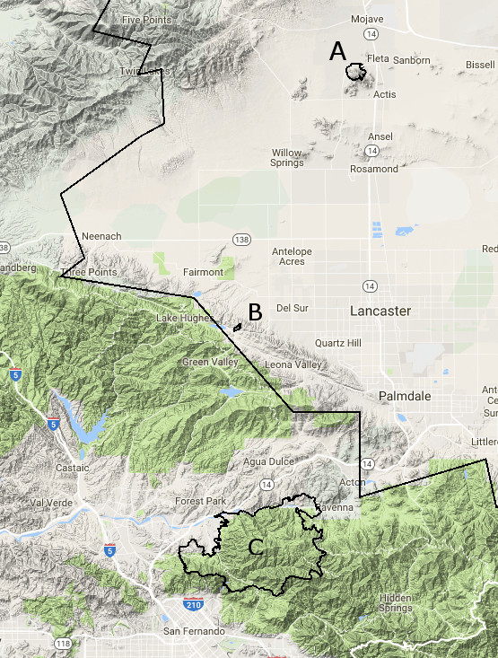For preliminary verification of results, we used aerial photography and wildfire records to examine areas of vegetation loss, and examples of these areas are discussed below.

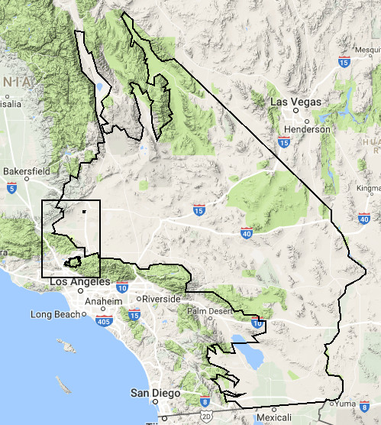

Figure 2- The left shows the Desert Renewable Energy Conservation Plan HCP, which is the largest polygon, and the location of three study areas in relation to this HCP. The right shows more detail of the three study location. (A: strip mine near Edwards Air Force base, B: 2016 Johnson Fire, C: 2016 Sand Fire).

The first study area is a strip mine in California operated by Golden Queen Mining Company (Fig. 3). This was chosen as one of the examples because it is located within the Desert Renewable Energy Conservation Plan HCP, and by examining past aerial photography you can see that it recently underwent new development on the north side.

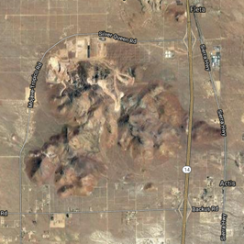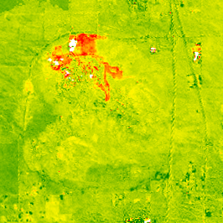

Relative Greenness

-1 (Vegetation Loss)

0 (No Change)

1 (Vegetation Change)

**b**

**a**

Normalized Burn Ratio

-0.35 (Fire Likely)

-0.15 (Fire Unlikely)

**d**

**c**

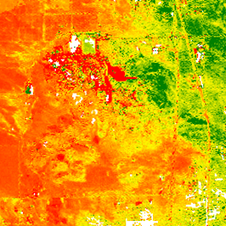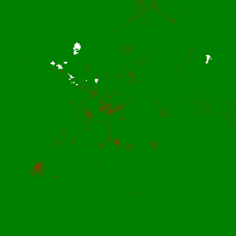

Percent Change Relative Greenness

-100% (Vegetation Loss)

0% (No Change)

100% (Vegetation Change)

*Figures 3a-d*: January, 2017 (a) Aerial photography from GEE (b) Relative Greenness (c) Percent Change in Relative Greenness (d) Normalized Burn Ratio.

Fires occur frequently in California, so for our second example study site we chose a wildfire that occurred within the Desert Renewable Energy Conservation Plan HCP. Los Angeles County Fire Department keeps records of fires that occurred within their county and they generate shapefiles for each of the fires. These shapefiles can be used to verify fire locations within the mapped area. Fig 4a-c shows the results from shortly after the Johnson fire in October, 2016 (Fig 2b).

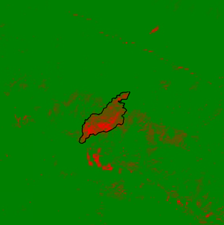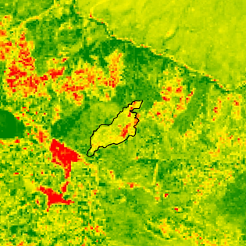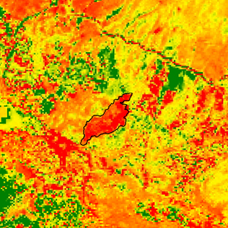

Percent Change Relative Greenness

-100% (Vegetation Loss)

0% (No Change)

100% (Vegetation Change)

Normalized Burn Ratio

-0.35 (Fire Likely)

-0.15 (Fire Unlikely)

Relative Greenness

-1 (Vegetation Loss)

0 (No Change)

1 (Vegetation Change)

**c**

**b**

**a**

*Figures 4a-c*: (November, 2016) (a) Relative Greenness (b) Percent Change in Relative Greenness (c) Normalized Burn Ratio

Other examples of study site results (including the Sand Fire from Fig. 2) can be found in the Appendix.

***3.3 Coding Methodology***

At the beginning of the code, there is a section separated out that only contains the variables that the user is allowed to change. These include the baseline year range, the range for the years of interest, the desired display year, month, and date, and the group size. There are two versions of the code, one that only uses the USFWS HCPs, and one that needs individual shapefiles taken from Assets or custom drawn within GEE. For the HCP version, the user must input the name of the HCP. For the custom version, they can input the name of their Geometry within GEE.

The program does all previously mentioned calculations for every group in every year from the given interest year range, but only can *display* one group and year combination on the Map display within GEE. The user inputs what year they wish to see, and chooses a month and day number. The code finds what group this day falls within, and displays the results from this group.

There are two versions of the USDA Croplands layer within the code. One is a raster that is displayed in the official USDA Land Cover Category colors. However, a raster only can store numbers as variables, so if the user did not know which landcover corresponded with the landcover class value, this would not help them in identifying cause of change. Therefore this layer was converted to a vector, which was not displayed on the map. When the user clicks on the landcover they are interested in, using the vector file the landcover name displays on the screen.

The options for the final display are RG, the ΔRG, the percent ΔRG, and the NBR for that group, along with the Cropland layer from that year and NAIP imagery that is the closest in date to the chosen display date. Checkboxes within the console allow the user to choose which of these they wish to display. The default only displays the chosen study area outline.

# 4. Results & Discussion

***4.1 Analysis of Results***

For the Golden Queen strip mine, you can see the recent development on the north in the aerial photography (Fig. 3a) and corresponding low RG in the same location in Fig 3b. The results from percent change in RG are less clear, but pick up overall vegetation loss due to the mine, and appear to register more significant changes in some areas of the recently developed north side.

For the 2016 Johnson fire, the program appears to clearly register the results from the fire. In percent change RG, high vegetation loss compared to the previous year is seen right within the fire polygon boundaries. However, it is notable that the RG is not particularly low in this area- perhaps the area is particularly susceptible to fires and that is incorporated within the baseline. This highlights the importance of looking at both RG and the change in RG from year to year. An area like this would not show up as significant when looking at just RG, but a sudden change that may be of interest to the user will show up when examining year to year change.

Along with examining a time series of RG and change in RG through the years, looking into the differences in the results between RG and the change in RG in the same year could help reveal both abrupt changes and long term changes, both of which could be a concern to the user.

When this information is paired with ancillary datasets, causes of the changes can be hypothesized. If a user was unaware of the presence of the mine, and checked the NBR results for the Golden Queen mine area (Fig. 3d), they would correctly see no indications that this change was caused by a fire. However, for the Johnson fire area, the NBR results are clearly different (Fig 4c). The low NBR values clearly demonstrate that this change was likely caused by a fire, and the results fall within the fire polygon boundaries. From our preliminary investigations, it appears that the NBR layer usually displays a fire in the same location as the fire polygons. Therefore, low NBR values in other areas outside of LA County could indicate a fire as well.

There were areas that showed a very low NBR in areas not recorded by the LA County Fire Department as experiencing a fire, including some small areas outside of the fire polygon in Fig. 4c. These observations are consistent with those of Cocke et al. (2005), who found that NBR occasionally makes an error distinguishing between burned and unburned areas. Since NBR is only calculated from NIR and SWIR, other causes of very low NIR may result in these probably false indications. Also, NBR is more accurate in forested areas, and as some areas of California are deserts, this may be influencing the results. Droughts, which California has a problem with, also can cause error in NBR results.

The other ancillary dataset incorporated thus far was the USDA cropland layers for California. Comparing USDA cropland layers across two years could show a change in crop cover, which may explain changes seen in vegetation cover, as different types of vegetation affect the NIR band return differently due to their different biomass.

***4.2 Error and Future Work***

There is unfortunately some error inherent both in the data and in this method of analyzing land cover change. For example, there can be instances where the sensor briefly malfunctions and produces an anomalous result. Landsat 8, which has a newer and more updated sensor than Landsat 5, has a different spectral resolution, and so the direct comparison between Landsat 8 and Landsat 5 results without correction will always contain a certain amount of error. Landsat imagery, which is freely available, is a more coarse resolution than might be desired. Future work is hoped to involve using imagery with at least a slightly better resolution (ex: Sentinel 2). This will allow more accurate mapping and analysis of land use change and enable the detection of change on a smaller scale. Analyzing the change in NBR will likely produce more accurate results, and there needs to be verification of the NBR threshold value we chose using visual examination of results compared to the fire polygons.

Future work will also involve the addition of more ancillary datasets. Additional ancillary datasets would enhance the ability of the user to determine the cause of the vegetation change, increasing the utility of the script for USFWS. This also increases the user’s capability to decide if the changes were expected or unexpected, along with giving the user information about the condition at the site. This information can affect their decision to investigate the changes in the HCP in person and help determine the priority of that visit.

Another main goal for the second term is to increase usability of the script for people with little GIS or coding experience. GEE does allow the creation of a limited user interface over the GEE code. For example, the years of interest, baseline years, HCP name, and other inputs could be entered into a prompt box instead of in specified places within the code itself. This could reduce the intimidation felt by users who are inexperienced with code, but also limits the uses of the code because users cannot make alterations for their own purposes.

Additionally, further research should be done on the seasonal rainfall patterns in California. The high variability of rainfall within the state impacts vegetation growth, which affects the results from the code. California has been experiencing severe droughts for a long time, so this will have impacted both the results in the baseline and in the interest years. Now that the base code has been completed, there needs to be further analysis and verification done on how accurately these indices are mapping vegetation change, and which, if any, further variables need to be factored in to target unexpected areas more effectively.

# 5. Conclusions

This study showed the feasibility of a remote sensing tool within Google Earth Engine that can detect recent appreciable land cover change and can be operated by a user with limited GIS experience. Using GEE the prototype tool was able to successfully calculate NDVI, RG, change in RG, and percent change in RG within a specified area. The tool is successfully able to calculate all of these indices for a given HCP, and so highlights areas that likely have experienced significant vegetation loss or gain.

With preliminary verification using aerial photography, the results supported that when vegetation loss or gain occurs, it is reflected in the RG and change in RG. Preliminary verification of the NBR results using recent fire records showed that if a fire had occurred, this was reflected clearly in the NBR. This was consistent over several examples in different locations and different years. Further investigation will be needed to establish the accuracy of these indices and to further refine the criteria for identifying vegetation change or the presence of fire.

The script also successfully incorporates the USDA NASS Cropland Data Layers for California from 2007 to the present. Along with the NBR results, these two ancillary datasets and analysis combine with the RG results to make the base of a potentially powerful tool with a user friendly interface that can assist land managers in remotely monitoring vast acreages of land for disturbance and determining possible causation. Incorporation of additional datasets will advance the user’s ability to derive possible causes of change. This is an important step to improving the monitoring process of HCPs. This tool could be used as a preliminary step to note possible areas of unexpected changes and USFWS can prioritize those locations for field visits. This should improve the management process of HCPs, allowing for quicker adjustments to management plans, and improving their overall effectiveness in protecting threatened and endangered species.

# 6. Acknowledgments

Dr. Kenton Ross, Develop National Science Advisor

Emily Gotschalk, DEVELOP Center Lead at NASA Langley Research Center

Pat Lineback, Regional GIS Coordinator; USFWS Pacific Southwest Region

Dan Cox, Regional Habitat Conservation Coordinator; USFWS Pacific Southwest Region

Brian Huberty, Regional NWI and Remote Sensing Coordinator; USFWS Midwest Region

Any opinions, findings, and conclusions or recommendations expressed in this material are those of the author(s) and do not necessarily reflect the views of the National Aeronautics and Space Administration.

This material is based upon work supported by NASA through contract NNL16AA05C and cooperative agreement NNX14AB60A.

# 7. Glossary

**Endangered Species Act** (ESA) – Signed into effect in 1973, the Endangered Species Act aims to protect and recover imperiled species and their ecosystems. It is administered by the US Fish and Wildlife Service and the Commerce Department’s National Marine Fisheries Service.

**Google Earth Engine** (GEE) API – cloud computing platform run by Google for processing satellite imagery and other Earth observation data

**Ground Sample Distance** (GSD) – the distance between pixel centers measured on the ground in a digital photo of the ground from air or space

**Habitat Conservation Plan** (HCP) – A required part of an application for an Incidental Take Permit, this document describes the expected impacts a project will have on a threatened or endangered species and the planned actions to minimize or mitigate those impacts. It also must describe how the HCP is being funded. It is developed by the entity requesting the Incidental Take Permit with help from the US Fish and Wildlife Service.

**Incidental Take Permit** – This permit allows private, non-federal entities to conduct a lawful activity on an area that contains threatened or endangered species. Without this permit, these activities would be in violation of the Endangered Species Act.

**NBR** (Normalized Burn Ratio) – another vegetation index similar to NDVI; used to detect the occurrence of a fire in an area

**NDVI** (Normalized Difference Vegetation Index) – an index that uses the visible and near-infrared bands of the electromagnetic spectrum to estimate the amount of vegetation found in the area

**NIR** (Near Infrared Radiation) – the shorter wavelengths of electromagnetic radiation in the infrared region of the spectrum, 0.76 to 0.90 micrometers (Band 4) in Landsat 5 and 0.851 to 0.879 micrometers (Band 5) in Landsat 8

**Operational Land Imager** (OLI) – sensor on Landsat 8 satellite that measures in the visible, near infrared, and short wave infrared portions of the spectrum

**Relative Greenness** (RG) – This is a method for portraying how green the vegetation in an area has been historically. Each pixel is normalized to its past ranges, preventing false gains or losses in vegetation. For example, it prevents a desert pixel from being compared to the historical values of a forested area, and vice versa.

**SWIR** (Short-Wave- InfraRed) – radiation with wavelengths from 1.55 to 1.75 micrometers (Band 5) in Landsat 5 and 1.566 to 1.651 micrometers (Band 6) in Landsat 8

**Thematic Mapper** (TM ) – sensor on Landsat 5 that measures mid-range infrared radiation

**Threatened and endangered species** – As defined by the ESA, an endangered species is any species that is in danger of extinction throughout all or a significant portion of its range. A threatened species is any species that is likely to become an endangered species within the foreseeable future throughout all or a significant portion of its range.

**United States Fish and Wildlife Service** (USFWS) – The Federal organization that is partially responsible for administering and enforcing the Endangered Species Act. This organization is mainly responsible for terrestrial and freshwater organisms.

# 8. References

Cocke, A. E., Fule, P. Z., Crouse, J. E. (2005). Comparison of burn severity assessments using Differenced Normalized Burn Ration and ground data. *International Journal of Wildland Fire. 14*(2), 189-198. doi: 10.1071/WF04010.

Franklin, J., Regan, H., Hierl, L., Deutschman, D., Johnson, B., & Winchell, C. (2011). Planning, implementing, and monitoring multiple-species habitat conservation plans. *American Journal of Botany,* *98*(3), 559-571. doi:10.3732/ajb.1000292.

Green, K., Kempka, D., & Lackey, L. (1994). Using remote sensing to detect and monitor land-cover and land-use change. *Photogrammetric Engineering & Remoting Sensing*, *60*(3), 331–337.

Herold, M., Coucleis, H., & Clarke, K. C. (2003). The role of spatial metrics in the analysis and modeling of urban land use change. *Computers, Environment and Urban Systems*, *29*(2005), 369–399. doi:10.1016/j.compenvurbsys.2003.12.001

Key CH, Benson NC (2006) Landscape assessment: ground measure of severity, the Composite Burn Index; and remote sensing of severity, the Normalized Burn Ratio. In ‘FIREMON: Fire Effects Monitoring and Inventory System’. (Eds DC Lutes, RE Keane, JF Caratti, CH Key, NC Benson, LJ Gangi) USDA Forest Service, Rocky Mountains Research Station General Technical Report, in press.

Los Angeles County GIS Data Portal. (2016). Los Angeles County Fire Department- Historic Fire Perimeters. Retrieved from https://egis3.lacounty.gov/dataportal/2014/04/28/fire-perimeters-1965-2013/.

Lyon, J. G., Yuan, D., Lunetta, R. S., & Elvidge, C. D. (1998). A change detection experiment using vegetation indices. *Photogrammetric Engineering and Remote Sensing*, *64*(2), 143–150.

Newnham, G. J., Verbesselt, J., Grant, I.F., Anderson, S. A. J. (2011). Relative Greenness Index for assessing curing of grassland fuel. *Remote Sensing of Environment, 115*(6), 1456-1463. doi:10.1016/j.rse.2011.02.005.

Poudyal, N. C., Elkins, D., Nibbelink, N., Cordell, H. K., & Gyawali, B. (2016). An exploratory spatial analysis of projected hotspots of population growth, natural land loss, and climate change in the conterminous United States. *Land Use Policy*, *51*, 325–334. doi:10.1016/j.landusepol.2015.11.021.

Townshend, J. R. G., Justice, C. O. (1986). Analysis of the dynamics of African vegetation using the normalized difference vegetation index. *International Journal of Remote Sensing, 7*(11), 1435-1445. doi: 10.1080/01431168608948946.

U.S. Department of Agriculture, National Agricultural Statistics Service. (2016). Cropland data layer. Retrieved from https://www.nass.usda.gov/Research_and_Science/Cropland/Release/index.php (2017).

US Fish & Wildlife Service. (2016a, April 7). About the Pacific Southwest Regional Office. Retrieved from https://www.fws.gov/cno/about_us.html

US Fish & Wildlife Service. (2016b, March 24). About the U.S. Fish and Wildlife Service. Retrieved from https://www.fws.gov/help/about_us.html

US Fish & Wildlife Service & National Oceanic & Atmospheric Administration. (2016, December 21). Habitat Conservation Planning and Incidental Take Permit Processing Handbook. Retrieved from <https://www.fws.gov/endangered/esa-library/pdf/HCP_Handbook.pdf>

US Forest Service. (n.d.). Burned Area Emergency Response FAQ. Retrieved from <https://www.fs.fed.us/eng/rsac/baer/barc.html>

U.S. Geological Survey Earth Resources Observation and Science Center. (2012). Provisional Landsat TM Surface Reflectanc*e*. US Geological Survey. https://doi.org/10.5066/F7KD1VZ9

U.S. Geological Survey Earth Resources Observation and Science Center. (2014). Provisional Landsat OLI Surface Reflectance. US Geological Survey. https://doi.org/10.5066/F7KD1VZ9

# 9. Appendices

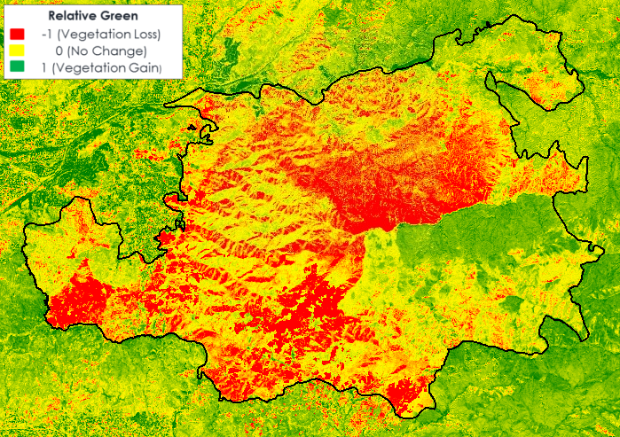

Figure A1a: Sand Fire Relative Green

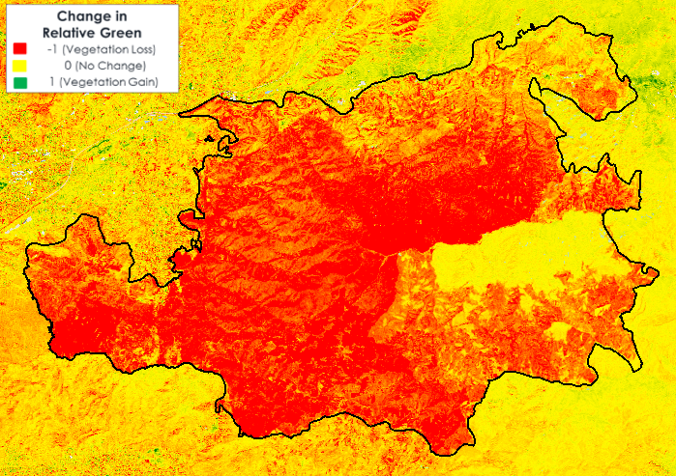

Figure A1b- Sand Fire change in Relative Green

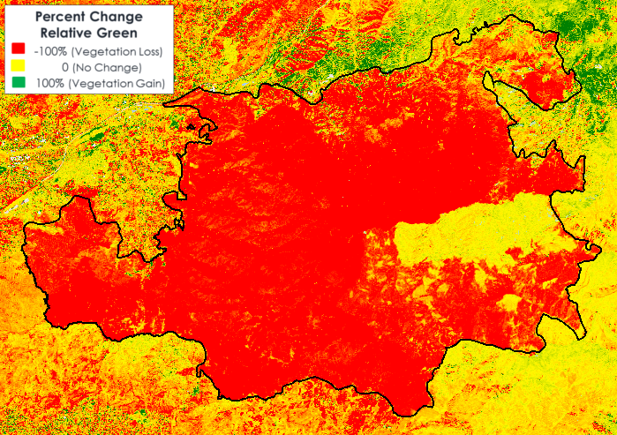

Figure A1c: Sand Fire Percent change in RG

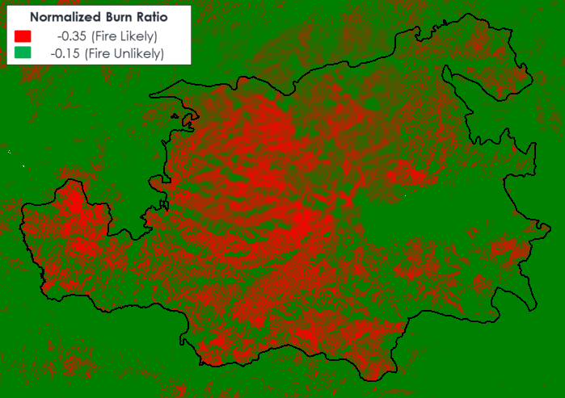

Figure A1d: Sand Fire NBR

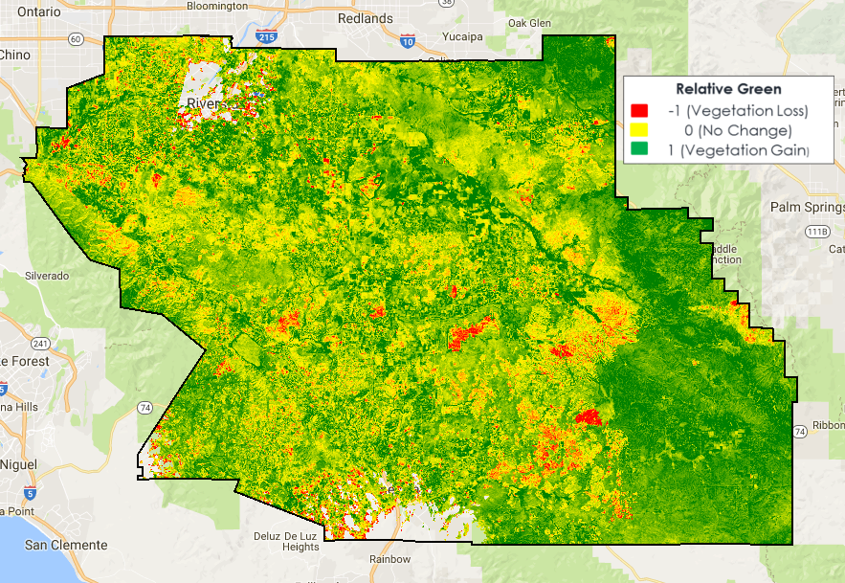

Figure A2a- Western Riverside County HCP Relative Green (June 2017)

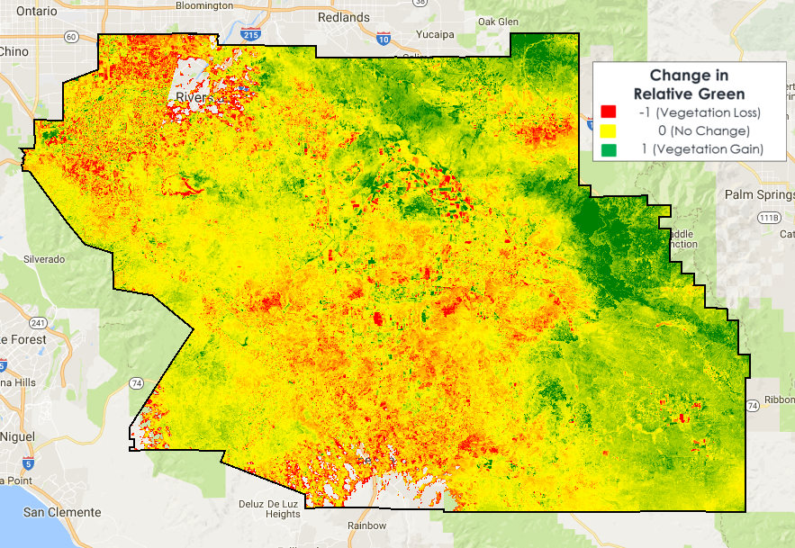

Figure A2b- Western Riverside County HCP Change in RG (June 2017)

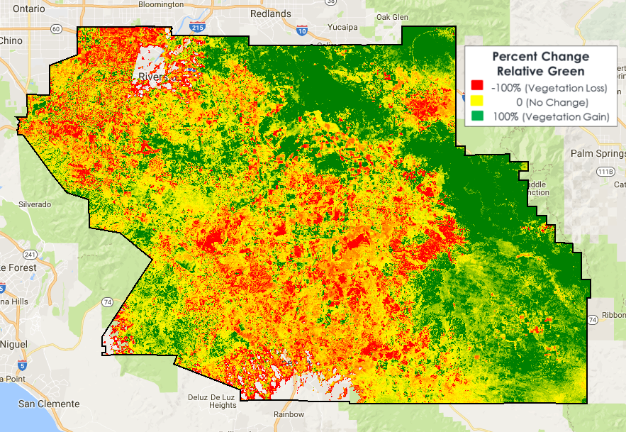

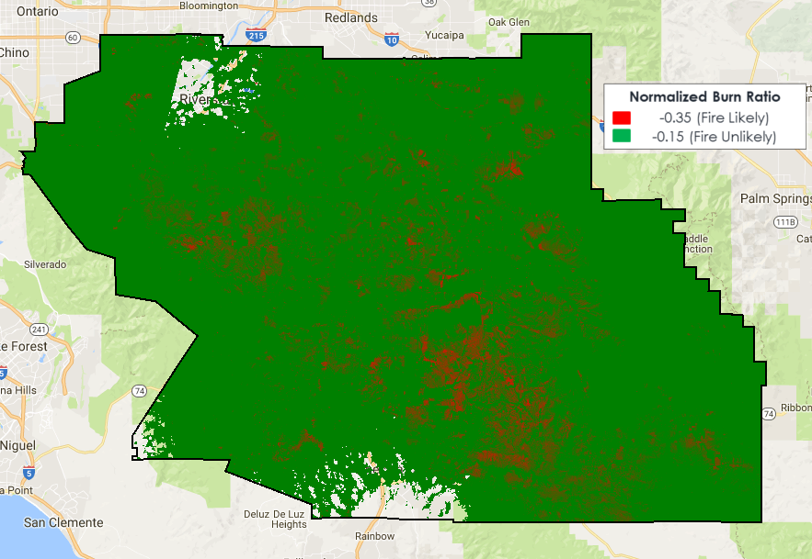Figure A2c: Western Riverside County HCP percent change in RG (June 2017)

Figure A2d: Western Riverside County NBR (June 2017)