**NASA DEVELOP National Program**

****Maricopa County Department of Public Health and Arizona State University

**Summer 2016**

**Short Title: Maricopa County Health & Air Quality**

**Subtitle:** Monitoring PM10 Concentrations for Enhanced Maricopa County Department of Public Health and Maricopa County Air Quality Department Decision Making and Epidemiology

**VPS Title:** The Dirt That Hurts: Monitoring Harmful Particulate Matter

**Project Team & Partners**

**Project Team:**

Jason Hodgson (Project Lead), jhodgson7739@gmail.com

Leslie Araujo

Tamara Dunbarr

**Advisors & Mentors:**

Lance Watkins (Center Lead)

David Hondula (Arizona State University)

**Partner Organizations:**

|  |  |  |  |
| --- | --- | --- | --- |
| **Organization** | **POC (Name, Position/Title)** | **Partner Type** | **Boundary Org?** |
| Maricopa County Department of Public Health (MCDPH) | Kate Goodin, Epidemiologist and Data Services Program Manager | End-User | No |
| Maricopa County Air Quality Department (MCAQD) | Ronald Pope, Atmospheric Scientist | Collaborator | No |

**Project Details**

**Applied Sciences National Application Addressed:** Health & Air Quality

**Study Area:** Maricopa County, AZ

**Study Period:** 1 Jan 2006 – 31 Dec 2015

**Earth Observations & Parameters:**

Terra, Moderate Resolution Imaging Spectroradiometer (MODIS) – aerosol optical depth

Aqua, Moderate Resolution Imaging Spectroradiometer (MODIS) – aerosol optical depth

Landsat 5, Thematic Mapper (TM) – USGS NLCD 2011 land cover data

**Ancillary Datasets Utilized:**

* NCEI Global Historical Climatology Network (GHCN) – Station location, elevation, temperature, wind speed, visibility, pressure, and precipitation
* 2011 USGS National Land Cover Dataset (NLCD) – land cover
* US Census Bureau TIGER dataset – Maricopa County, Arizona County Borders shapefile and Arizona Roads shapefile
* ESRI World Data 2012 – Streets shapefile
* US Environmental Protection Agency AIRNow – PM10 measurements

**Software Utilized:**

* ArcGIS – raster manipulation/analysis, image enhancement & map creation of Aqua and Terra MODIS aerosol optical depth
* Python – creation of scripts to process satellite images, automate a model of PM concentrations with additional variables.
* R – statistical data analysis, mixed model development, and model application to other data

**Project Overview**

**80-100 Word Objectives Overview:**

The primary focus of the project was to correlate measured PM10 concentrations from ground-based air quality instruments with MODIS satellite data to better predict PM10 concentrations in areas without ground-based monitoring. Additional location and environmental factors, such as transportation data, climate data, elevation, and land cover strengthened the model. The model employed satellite data and allows the Maricopa County Department of Public Health and Maricopa County Air Quality Department to make well-informed decisions that positively influence both pollution monitoring and public health analysis and programming within Maricopa County.

**Abstract:**

One of the most prevalent issues with air quality monitoring is the lack of distribution of sampling sites that gather data regarding particulate matter (PM) concentrations in the surrounding environment. By utilizing data from the Moderate Resolution Imaging Spectroradiometer (MODIS) on the Aqua and Terra satellites, we constructed a mixed model to provide a significantly high correlation between aerosol optical depth (AOD) and PM10 concentrations. Due to the mixed model’s use of additional periodic variables – such as meteorological and environmental factors – the model can be used in conjunction with satellite data in the absence of ground-based monitors to present a better picture of the air quality in Maricopa County, Arizona. By employing such a model, both the Maricopa County Department of Public Health and the Maricopa County Air Quality Department can apply the model data to future epidemiological research, policy-making, environmental justice analyses and other important processes and decisions regarding air quality and public health improvements. The products, of the Maricopa County Health & Air Quality project, are ultimately intended to benefit the Maricopa County community by contributing to the area of public health and potentially even influencing future changes and the overall development of the county.

**Keywords:**

Remote Sensing, MODIS, Pollution, Particulate Matter, Aerosol Optical Depth

**Community Concerns:**

* Various studies have linked elevated concentrations of PM10 to increased morbidity, mortality and other adverse health effects, especially in urban areas.
* On June 10 1996, the Environmental Protection Agency (EPA) designated Maricopa County as being in “serious non-attainment” of PM10 standards.
* According to the EPA regulations, the Maricopa County PM10 monitor network currently lacks spatial (majority of Maricopa County without monitors) and temporal coverage, and the monitors’ measurements do not necessarily have a consistent sampling rate.
* Dust storm events, common in the region and especially between June 15th through September 30th, are a primary factor in Maricopa County’s multiple PM10 exceedances (about 10-15 per year).
* There is an ongoing legal battle on the manner in which policy involving air quality monitoring should be handled/interpreted by the EPA, and it could potentially change Maricopa County’s PM10 attainment status of federal standards.

**Current Management Practices & Policies**:

Much of the monitoring of PM10 by the Maricopa County Department of Air Quality is guided by the Environmental Protection Agency’s (EPA) federal air quality compliance standards.

Although there is a minimum of three PM10 stations required (dictated by population numbers), Maricopa County utilizes sixteen monitors to characterize PM10 concentrations in the region. Many of these monitors are concentrated in and around the urban core of the county (Phoenix metropolitan area), thus leaving large gaps of land unmonitored in the county’s more rural places. Each monitor has a different representative area range (one monitor may represent a five-kilometer radius, whereas another may represent a fourteen-kilometer radius). The PM10 monitoring network data are used by the EPA to determine whether or not Maricopa County is in attainment of federal air quality standards, and recently, Maricopa County was designated as a “serious non-attainment zone.” Following this designation of unsatisfactory air quality, Maricopa County has been required (as mandated by the Clean Air Act) to implement a plan to fall in attainment of these standards. However, the dust storm events were considered a large part of the reason for why PM10 concentrations become elevated in Maricopa County, and the EPA has an “Exceptional Event” provision to counteract these natural, out-of-human-control events from affecting attainment statuses. This provision, though, has been demonstrated to be controversial and is currently the motivation behind a lawsuit against the EPA; Maricopa County will likely be impacted by the legal outcome due to its petitioned use of Exceptional Events. Having a continuous monthly surface of PM10 concentrations in Maricopa County by using a model including aerosol optical depth data will help bring more insight into the health impacts and policy standards of PM10 concentrations within the county.

**Decision Support Tools & Benefits:**

|  |  |  |  |
| --- | --- | --- | --- |
| **End-Product** | **Earth Observations Used** | **Benefit & Impact** | **Software**  **Release** |
| Model for PM10 prediction over an area without ground-based sensors | Terra MODIS Aerosol Optical Depth, Aqua MODIS Aerosol Optical Depth | Allows decision makers to understand spatial patterns of PM10 | 2 |
| Overlay map showing areas of PM10 concentration overlaid with Social Vulnerability Index | Terra MODIS Aerosol Optical Depth, Aqua MODIS Aerosol Optical Depth | Allows decision makers to view correlations between PM10 concentrations and health effects | N/A |

**Project VPS/Booklet Imagery**

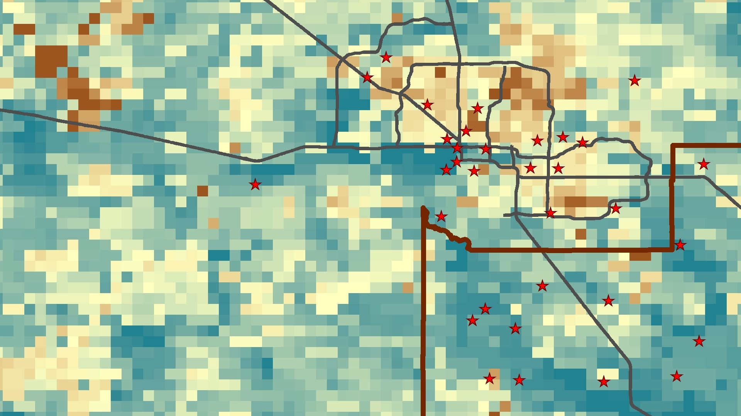

**Caption:** Maricopa and Pinal County AOD measurements with PM monitor locations overlaid. Image Credit: Maricopa County Health and Air Quality Team

**Image:** File Name: 2016Sum_AZ_MaricopaCountyHealthAndAirQuality_Imagery.jpg