**NASA DEVELOP National Program**



Stennis Space Center, MS

*Spring 2014*

U.S. Disasters and Ecological Forecasting

Assessing the Potential to Use VIIRS Data for Detecting Forest Disturbance from Insects and Fire

**Technical Report**

Feb 20, 2014

Jamie Thompson, University of Southern Mississippi (Project Lead)

Brittany Howell, University of Southern Mississippi (Team Member)

Alyssa Pourmonir, State University of NY Maritime (Team Member)

Timothy Sutherlin, University of Southern Mississippi (Team Member)

Heather Nicholson, University of Southern Mississippi (Team Member

Joseph Spruce, Computer Sciences Corporation (Science Advisor)

# I. Abstract

This report discusses results of a project that researched use of VIIRS data as a surrogate for MODIS data in the generation of near real time forest monitoring products currently found in the US Forest Service ForWarn forest threat early warning system. Numerous biotic (e.g., caterpillars, beetles, and diseases) and abiotic (e.g., droughts, fires, and tornadoes) factors threaten forested lands all over the world; although these threats can never be completely eliminated, detecting and evaluating them early is critical to an effective mitigation strategy. Thus, forest managers need accurate and timely forest monitoring and assessment tools. For years, Moderate Resolution Imaging Spectroradiometer (MODIS) data currently plays a pivotal role in meeting this need. ForWarn, an online decision support tool for displaying satellite-based forest change recognition and tracking, currently uses MODIS data products to calculate these disturbances by calculating the Normalized Difference Vegetation Index (NDVI). However, with both existing MODIS sensors now operating well beyond their six-year design life, it is essential that new methods (i.e. using alternative data streams) are rapidly developed for using Visible Infrared Imaging Radiometer Suite (VIIRS) data in a comparable fashion for the application at hand. This will help to ensure uninterrupted decision support to forest resource managers and enable ForWarn to further asses integrating the use of VIIRS into the ForWarn Forest Change Assessment Viewer.

**Keywords**

Remote sensing, Disasters, Forest Disturbance, Ecological Forecasting, VIIRS, MODIS, NDVI

# II. Introduction

In the United States, forests are constantly vulnerable to multiple biotic and abiotic threats that can cause disturbances. Insects, both native and non-native, as well as diseases, damage about 45 times more forest area and impact the economy five times more than wildfires. Forest damaging insects collectively cause billions of dollars in economic loss in U.S. forest products per year. The United States Healthy Forests Restoration Act (HFRA 2003) requires the development of a national Early Warning System (EWS) to detect, monitor, and mitigate forest disturbance threats (Spruce et al.,2011). The United States Department of Agriculture Forest Service (USDA Forest Service) and its collaborators have already established methods to detect forest disturbances, including Aerial Detection Surveys (ADS), ground surveys, and insect trapping programs (Spruce et al., 2011). It is essential that new methods be rapidly developed, such as integrating VIIRS data in a way that is comparable to current MODIS data collection methods.

# Background Information

The forest tent caterpillar, Malacosoma disstria, is found throughout the United States and Canada commonly where hardwoods grow (Batzer and Morris, 1981). This greyish colored caterpillar with yellow and blue stripes and rows of white spots can grow up to two inches long when fully developed (Resources), as shown in Figure 1. According to Batzer and Morris, the favored hosts are various broadleaved trees such as aspens, oaks, water tupelo, and cottonwood as well as many others, however the three types avoided by the caterpillar are those dominated by red maple, sycamore, and most conifers. They also feed on shrubs and the leaves of fruit and vegetable plants. The forest tent caterpillar often defoliates large areas and can cause the death of trees after successive defoliation seasons. Caterpillars in the young life stages usually leave holes in the leaves, while fully developed caterpillars have the capability of completely defoliating the tree. Outbreaks of the forest tent caterpillar generally last for three years. In the southern United States, the infestations are continuous, especially near bodies of water such as swamps and ponds (Batzer and Morris, 1981). Deciduous trees usually take more than one year of defoliation to die, while conifers can die within one season of defoliation (Norman, 2013). The United States Forest Service states that biotic and abiotic factors that impact the tree’s overall health making them more susceptible to insects include: heat, drought, flooding, lightning, animals, construction damage, and soil compaction. Although fires can more quickly damage a forest and may result in more localized damage, insects account for higher total tree mortality than fires. Insects account for 41% and diseases cause 26% of tree mortality (Forest Service).

The Rim Fire was the third largest fire recorded in California and the largest fire to impact the Yosemite National Park, destroying 257,314 acres of the central Sierra Nevada region from Aug 17th to October 24th (Norman, 2013). An unusually dry winter and spring, weather conditions, and access to fuels produced a fast spreading Rim Fire (Tracking, 2013). Fire forecasting parameters include: temperature, relative humidity, lightning activity level, wind strength and direction, precipitation, sky condition, and fuel moisture trends. These factors are used by meteorologists to forecast fire behavior, but they also give some insight on what factors result in such a historic fire, such as the Rim Fire (MetED). The Rim fire was historically significant because of its spreading rate, which caused an extensive amount of damage and was fueled brush, oak trees, pine trees, and conifer stands (System, 2014) This fire event resulted in ten injuries and 127 million dollars in costs (System, 2014). A problem associated with this fire included smoke transport; fire smoke became trapped in the central valley of California due to a weak temperature inversion. On September 8, 2013 this problem was a concern, but on September 9th the inversion broke and allowed for the smoke to mix within the atmosphere (System, 2014). Another fire related problem includes intense winds, up to 120 mph, that result from the rising of hot air, which yields a vacuum below that air must quickly fill in (National Park Service).

In summary, Fire disturbances are more severe based on their quick occurrence time, while caterpillar forest impacts are more extensive each year but requires successive years of defoliation to result in tree mortality.

**Project Objective**

Compute VIIRS forest disturbance detection products for at least one regional biotic forest disturbance (e.g., caterpillar-caused defoliation) and one broad-scale abiotic disturbance (e.g., fire or tornado). Evaluate these VIIRS-derived products against existing MODIS and Landsat data as a demonstration to Federal and State forest management agencies of VIIRS’ capability to detect regionally evident forest disturbance from insects and fire.

**Current Management Practices and Policies**

Caterpillar controls include: wasps, flies, beetles, ants, spiders, birds, small animals, microbial insecticides, or chemical insecticides. Trees can be protected by gathering and destroying the eggs masses, as shown in Figure 2 (Batzer, 1981). ForWarn currently utilizes MODIS products to detect and track regionally evident forest disturbances by calculating and comparing current and historic NDVIs.

**Study Area**

Our study area encompassed the Pearl River swamp in St. Tammany Parish, LA, the Pearl River County, MS, and Hancock County, MS (2012/2013 caterpillar defoliation).

In California we conducted our study in Yosemite National Park (2013 Rim Fire).

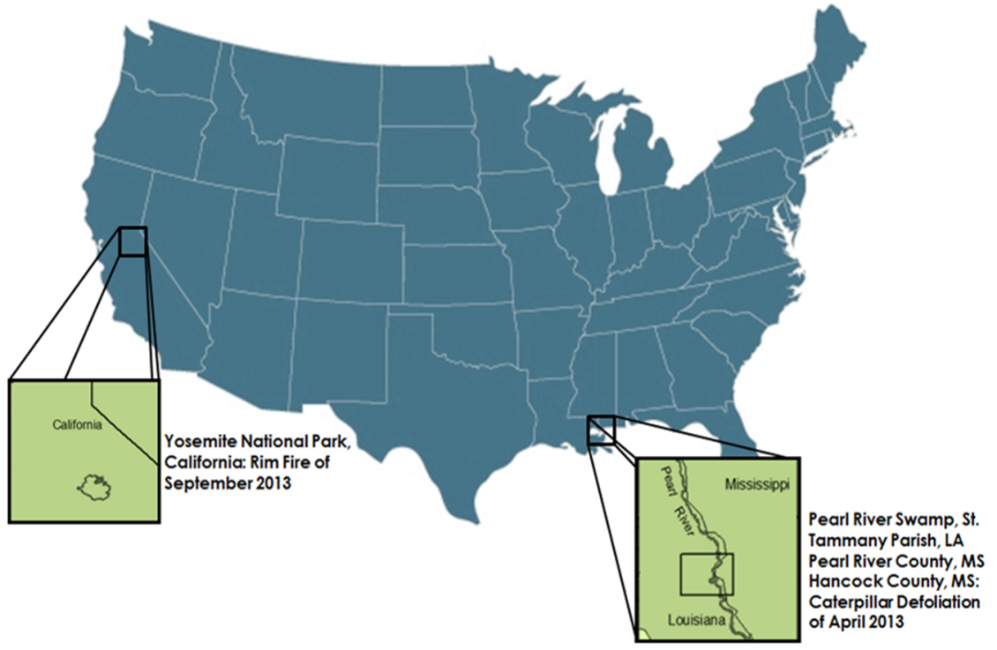

Figure 1: Study areas for the Rim Fire and Forest Tent Caterpillar Defoliation

**Study Period**

For the caterpillar defoliation event, a three year baseline previous to the defoliation will be assessed with a year occurring after the defoliation. The three year baseline will cover April 2010-2012 and will be compared against April 2013. The Rim fire event will compare September 2013 to the previous year, September 2012.

**National Applications Addressed**

This project applies to the application areas of disasters and ecological forecasting. It will help to detect and determine changes caused by natural disasters, such as fires and insect defoliation, on forests and assist with decision making for mitigation strategies.

**Project Partners**

William Hargrove (USDA Forest Service, principal investigator for the ForWarn forest threat early warning system) – expressed an eventual need to integrate VIIRS data products into ForWarn.

# III. Methodology

**Data Acquisition**

VIIRS 500m NDVI data were acquired from LAADS Web. VIIRS 375m gridded, time-composited NDVI data is currently unavailable through this venue. Supplement MODIS NDVI data was obtained from Joe Spruce, Senior Research Scientist, and James Smoot, Senior Scientist, both with Computer Sciences Corporation, NASA Applied Science and Technology Project Office, Stennis Space Center. Their office supplies MODIS NDVI change products for Forwarn. Joe Spruce also serves as the project’s science advisor, and James Smoot serves as our alternate science advisor.

**Data Processing**

MODIS 24-day baseline pre-event NDVI data and a VIIRS NDVI post-event data were uploaded into ArcMap. The reproject tool was used to reproject the VIIRS data to match the projection of the MODIS data. Then the resample tool was used in order to resample VIIRS 500m down to 250m in order to the same resolution of MODIS. The VIIRS rasters were then converted to a 32-bit floating point in order to have decimal values.

**Methodology**

Using MODIS and VIIRS NDVI data, change products were created by calculating a percent difference between baseline MODIS NDVI data collected prior to the event and VIIRS NDVI data collected during (forest tent caterpillar) or after (Rim Fire) the event. The raster calculator was used in order to calculate the percent change pre-event and post-event. The calculation used is (VIIRS NDVI Data Post Event – MODIS NDVI Data Pre Event)/MODIS NDVI Pre Event. The resulting raster was then uploaded to ERDAS and ran through a model that was used to scale the values and create a color ramp that was similar to the one used by ForWarn.

# IV. Results & Discussion

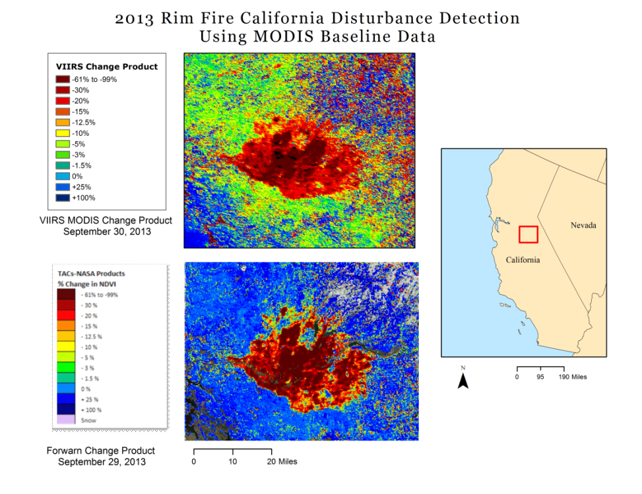

Figure 2: Shows the 2013 Rim Fire percent change in NDVI using MODIS baseline data and VIIRS post-event data (top) and ForWarn percent change in NDVI (bottom)

Z:\Spring2014\US_DISASTERS\Deliverable_Templates\Imagery\rimfiremapviirsbaselinecorrect.tif

Figure 3: Shows the 2013 Rim Fire percent change in NDVI using VIIRS baseline data and VIIRS post-event data (top) and ForWarn percent change in NDVI (bottom)

Z:\Spring2014\US_DISASTERS\Deliverable_Templates\Imagery\caterpillarmapcorrect.tif

Figure 4: Shows the Forest Tent Caterpillar Defoliation percent change in NDVI using MODIS baseline data and VIIRS post-event data (top) and the ForWarn percent change in NDVI (bottom)

**Analysis of Results**

Our analysis of our results consisted of a visually comparing our results of percent change in NDVI with those produced by the ForWarn website. For the 2013 California Rim Fire, our final image produced using MODIS baselines and VIIRS post event data closely matched that shown at the ForWarn website (Figure 2). The outline of the area affected by the fire and the magnitude of the decrease in NDVI is similar for both images. For the area outside that was affected by the fire, the percent change in NDVI is somewhat different between the two images. The image using VIIRS data shows a broader area of slight decrease in NDVI of 0% to -5% as indicated by green in our image. For the same event, the image produced using VIIRS NDVI data as a baseline and as well as VIIRS post event NDVI data (Figure 3) also showed comparable results to the ForWarn percent change product for the same time period. Both the extent and total area indicated as affected in the two images are similar. The magnitude of the decreases in NDVI for the affected area is comparable. The area surrounding the affected region, however, appears to show changes in NDVI that more closely match those of ForWarn than the results using MODIS baselines

Our results for the 2013 caterpillar defoliation event in the lower Pearl River Swamp were also comparable to those of the ForWarn percent change product (Figure 4). Areas of large decreases in NDVI indicated by orange and red pixels, closely approximates the same area and magnitude of decreases in NDVI produced by ForWarn. Our image, however, showed greater decreases in NDVI than ForWarn for areas surrounding the defoliation site.

For both of our final images using MODIS baselines, it is possible that the discrepancies in NDVI change for the areas surrounding the disturbed area is due to the different time of day that VIIRS and MODIS capture data. The MODIS NDVI data set we used is a composite of the MODIS sensors onboard both the Terra and Aqua satellites. The MODIS sensor aboard Terra captures data in the morning, which is more likely to produce a higher average of NDVI values than those gathered in the afternoon. The VIIRS sensor onboard the SUOMI NPP satellite captures data in the afternoon when NDVI values would typically be lower than those measured in the morning. So images produced using a mixture of VIIRS and MODIS (Terra) data are likely to show overall differences in NDVI due to the different time of day they are captured.

**Future Work**

Since VIIRS 375 m data were not available for the time period that was required, acquiring VIIRS 375 m NDVI data is a future goal. If the NDVI data is not available, 375 m reflectance data could be acquired and NDVI can be calculated in-house. The percent change in NDVI for additional disturbance events, such as tornadoes and droughts, should be calculated with VIIRS 375 m NDVI data to accurately assess its potential to detect various types of disturbances. In the future, new change products should be computed using VIIRS 375 m NDVI data and MODIS 250 m NDVI data instead of VIIRS 500 m NDVI data.

# V. Conclusions

With the research and analysis that was conducted during this project, it can be concluded that the VIIRS 500 meter NDVI data that was utilized for this project does show potential for detecting various forest disturbances. This data also shows potential for being integrated with MODIS data in order to calculate the percent NDVI changes similar to that of ForWarn. This is especially relevant given that, though the demise of MODIS sensors is not expected anytime in the near future, they have exceeded their predicted life expectancy. In this light, the project results suggest the VIIRS sensor may provide a viable source of vegetation data when the MODIS sensors no longer produce operational data. Although this data does show promising potential for detecting forest disturbances and being integrated with MODIS data, more work is needed to confirm or refute these initial findings. This would include assessments of other disturbance events, as well as other types of analysis in addition to the visual analysis that was conducted. Also, acquiring and assessing the use of VIIRS 375 meter NDVI data would be extremely beneficial. Initially, the goals for this project included the use of the VIIRS 375 meter NDVI data, but this data was not available for the time periods of the events of interest selected for this project. Our primary contact with the NASA Land Product Quality Assessment Group, Robert Wolfe, is looking into the feasibility of making 375 meter NDVI data available for a longer period on the LAADS Web site. After a few more years of VIIRS collecting data, selecting an event within the available time range could be another viable option in order to further analyze the process that was created. Obtaining this data and applying it to the methodology used during this project could potentially yield better results since it is a better resolution than the VIIRS 500 meter NDVI data that was used. Attempts to integrate the VIIRS 375 meter NDVI data with the MODIS 250 meter NDVI data to calculate the percent change of the NDVI, as we did with the VIIRS 500 meter NDVI data, would be another important aspect to analyze as well. Data from the VIIRS sensor shows results comparable to the products produced by ForWarn and shows potential as a suitable candidate to integrate into forest disturbance detection methods, but additional work is needed to support these initial findings.

# VI. Acknowledgments

We would like to thank the following for their assistance, advisement, and collaboration for this project:

Joe Spruce – CSC Stennis Space Center

James Smoot – CSC Stennis Space Center

Bill Hargrove –USDA Forest Service

Jason Jones – DEVELOP Program Support

Ross Reahard – SSC DEVELOP Center Lead

NASA DEVELOP National Program Office

# VII. References

Batzer, Harold and Robert Morris. "Forest Tent Caterpillar." *USDA Forest Service* (1981). Web.http://www.na.fs.fed.us/spfo/pubs/fidls/ftc/tentcat.htm

Meeker, James. "Forest Tent Caterpillar." *University of Florida* (2001). Web. http://entnemdept.ufl.edu/creatures/trees/forest\_tent\_caterpillar.htm

Meted. "Keeping Current With the Weather." n.d. Web. https://www.meted.ucar.edu/fire/s290/unit8/

National Park Service. "Fire and Weather." n.d.: 7. Web. http://www.nps.gov/maca/forteachers/upload/Fire\_and\_Weather.pdf

Norman, Steve. "Monitoring Gypsy Moth Defoliation in Near Real Time." *ForWarn* (2013). Web. http://forwarn.forestthreats.org/highlights/112

Norman, Steve. "Tracking the Historic Rim Fire." *ForWarn* (2013). Web. http://forwarn.forestthreats.org/highlights/117

Resources, University of California Agriculture and Natural. *How to Manage Pests: UC Pest Management Guldelines*. 9 3 2013. Web. 29 January 2014. http://www.ipm.ucdavis.edu/PMG/r3300711.html\

Service, Texas A&M Forest. Insects. n.d. Web. 2 February 2014.http://texasforestservice.tamu.edu/main/article.aspx?id=1209

Spruce, Joseph P., et al. "Assessment of MODIS NDVI time series data products for detecting forest defoliation by gypsy moth outbreaks." *Remote Sensing of Environment* (2010): 427-437. Database.

System, Incident Information. *Rim Fire*. n.d. Web. 2 February 2014. *http://System.nwcg.gov/incident/3660/*

IPM od Midwest Landscapes. "Forest Tent Caterpillar." n.d. *Entomology University of Minnesota.* Web. 23 2 2014 http://www.entomology.umn.edu/cues/Web/138ForestTentCaterpillar.pdf

# 

# VIII. Appendices

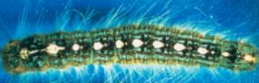

Figure 5: Forest Tent Caterpillar larva

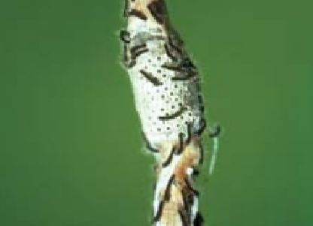

Figure 6: Forest Tent Caterpillar egg masses and larva

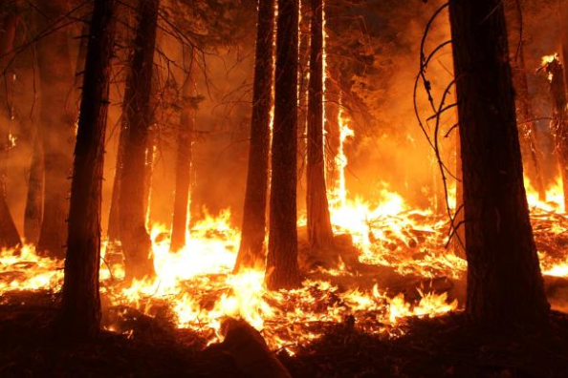

Figure 7: Rim fire night activity

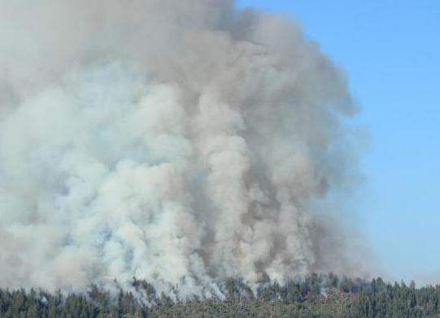

Figure 8: Rim fire smoke plumes on August 29, 2013

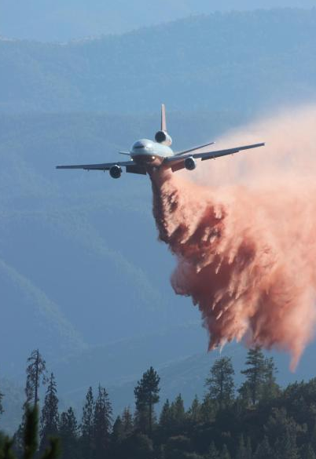

Figure 9: Rim fire airplane operations

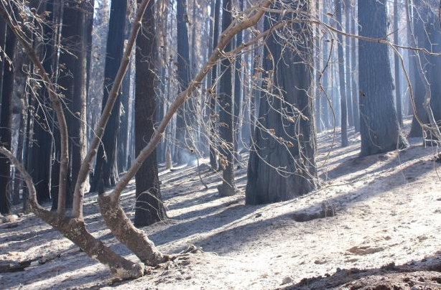

Figure 10: Rim fire burned forest covered with ash