**NASA DEVELOP National Program**

****NASA Ames Research Center

**Spring 2016**

**Short Title: Puerto Rico Health & Air Quality II**

**Subtitle:** A Geospatial Assessment of Environmental Variability in Puerto Rico and Its Relation to Confirmed Dengue Fever Cases

**VPS Title:** Dengue Bites II: Predicting Dengue Risk in Puerto Rico

**Project Team & Partners**

**Project Team:**

Andrew Nguyen (Project Lead), Andrew.Nguyen@nasa.gov

Martha Sayre

**Advisors & Mentors:**

Dr. Juan Torres-Pérez (Bay Area Environmental Research Institute)

**Past or Other Contributors:**

Alannah Johansen

**Partner Organizations:**

University of Puerto Rico, Medical Sciences Campus (End-User), POC: Dr. Pablo Méndez-Lázaro

US Centers for Disease Control and Prevention (CDC) Dengue Branch (End-User), POC: Dr. Roberto Barrera

Puerto Rico Department of Health (End-user), POC: Jessica Cabrera

**Project Details**

**Applied Sciences National Application Addressed:** Health & Air Quality

**Study Area:** Puerto Rico (PR)

**Study Period:** January 2009 – December 2013

**Earth Observations & Parameters:**

Terra/ Aqua, MODIS – Sea surface temperature (SST), land surface temperature (LST), Normalized Difference Water Index (NDWI)

TRMM, PR – Total Precipitation (TP) from the Climate Hazards Group InfraRed Precipitation and Satellite (CHIRPS) model

**Ancillary Datasets Utilized:**

* USGS National Land Cover Dataset (NLCD) – Land cover
* USGS DEM – Digital Elevation Model (DEM)
* USGS- Hydrological Unit Code (HUC)- Watersheds
* Dengue Branch of the Centers for Disease Control and Prevention (CDC) and the Puerto Rico Department of Public Health (PRDPH) Passive Dengue Surveillance System (PDSS) – Confirmed Dengue Fever Cases (CDFC)
* Geostationary Operational Environmental Satellite system Puerto Rico Water Energy Balance (GOES-PRWEB) – Downscaled soil moisture, runoff, relative humidity, soil saturation

**Models Utilized:**

* Clark Labs’ TerrSet – Habitat and Biodiversity Modeler (HBM)- Maximum Entropy Species Distribution Model
* Clark Labs’ TerrSet- Earth Trends Modeler (ETM)- Seasonal Trends Analysis, Inter-annual Trends Analysis

**Software Utilized:**

TerrSet – Modeling

ArcGIS – Raster manipulation/analysis, model builder, image enhancement & map creation of Aqua/Terra MODIS data

**Project Overview**

**80-100 Word Objectives Overview:**

To assess the effects of climate and environmental conditions and their contribution to the presence of *Aedes aegypti* using Confirmed Dengue Fever Cases in Puerto Rico. Additionally, to derive and statistically evaluate these conditions to produce results that could complement public health outreach efforts for dengue and other vector-based diseases in Puerto Rico.

**Abstract:**

Vector-borne diseases such as dengue fever, chikungunya, and Zika pose a major threat to the health of Caribbean communities. *Aedes aegypti (Ae. aegypti),* the primary vector of these viruses, is dependent on humans for reproduction, and has been detected in populated areas within Puerto Rico. The vector’s lifecycle and its transmission of dengue in Puerto Rico have been connected to specific environmental conditions. This study examined environmental conditions related to Confirmed Dengue Fever Cases (CDFC) for Puerto Rico from January 2009 - December 2013 by modeling the distribution of dengue-infected *Ae. aegypti* and its relationship to a suite of environmental variables. This project used monthly National Aeronautics and Space Administration (NASA) Terra/ Aqua Moderate Resolution Imaging Spectroradiometer (MODIS) Normalized Difference Water Index (NDWI), along with day and night land surface temperature (DLST / NLST) products, Geostationary Operational Environmental Satellite system Puerto Rico Water Energy Balance (GOES-PRWEB) humidity products, and Climate Hazards Group InfraRed Precipitation and Satellite (CHIRPS) total precipitation (TP) modeled data. A Maximum Entropy Species Distribution Model and Earth Trends Modeler within Clark Labs’ TerrSet were used to spatially delineate monthly *Ae. aegypti* habitat suitability, determine the permutation importance of the environmental conditions, and quantify island-wide environmental trends. TP and DLST had the highest mean relative importance of the dynamic environmental variables, agreeing with several studies that climatic environmental conditions play a significant role in disease transmission.

**Community Concerns:**

* The dengue virus is the fastest-growing vector-borne pathogen in the world and has been declared endemic in the Caribbean and Puerto Rico.
* Several dengue outbreaks have recently been recorded in San Juan, Puerto Rico, including instances in 2010, 2012, and 2013.
* *Aedes aegypti* is the primary vector of the dengue, chikungunya, and Zika viruses. Recently, the chikungunya and Zika viruses have been reported in Puerto Rico.
* Due to elevating sea levels, the San Juan Bay Estuary boundaries are shifting toward the coast of Puerto Rico. The strong correlation among mean sea level, dengue, and mosquito vector populations suggests that there is a higher risk of disease transmission on the island with rising sea levels.
* There is a moderate correlation between sea surface temperature (SST) and an increase in the dengue transmission as salinity-tolerant mosquitoes become more abundant in the coastal zones of other tropical countries.

**Current Management Practices & Policies**:

The various entities involved in this project employ little to no remote sensing or environmental modeling techniques to better understand vector-borne diseases and outbreaks, such as dengue, to inform public policy on vector control measures. The Puerto Rico Department of Health provides citizen services and public announcements, and conducts health assessments pertaining to dengue awareness on the island. The Dengue Branch of the CDC employs public health practices such as education on causes for the household spread of dengue, surveillance systems of dengue-infected hospitals, and diagnostic testing. They also conduct molecular research and field investigations regarding dengue contraction and control.

**Decision Support Tools & Benefits:**

|  |  |  |
| --- | --- | --- |
| **End-Product** | **Earth Observations Used** | **Benefit & Impact** |
| *Aedes Aegypti* Suitability Method (AASM) | Terra, MODIS  TRMM, PR | Delineate *Aedes aegypti* suitability and seasonality in Puerto Rico based on CDFC and environmental conditions for potential early detection of vector-borne disease. This will assist the Department of Public Health and CDC Dengue Branch in assessing which communities may require the most disease prevention resources and training. |
| Time Series of Past Outbreaks and Environmental Variability | Terra, MODIS  TRMM, PR | Geospatially delineate dengue fever and other vector-borne disease risk, along with environmental variability in Puerto Rico through a Maximum Entropy Species Distribution Model and Earth Trends Modeler. This provides historical context to the dengue outbreak and will allow the Department of Public Health and CDC to analyze whether these regions should be of greater concern. |
| *Aedes Aegypti* Suitability Method (AASM)Tutorial | Terra, MODIS  TRMM, PR | Allows end-users the ability to recreate results using NASA Earth observation products for future research opportunities. |

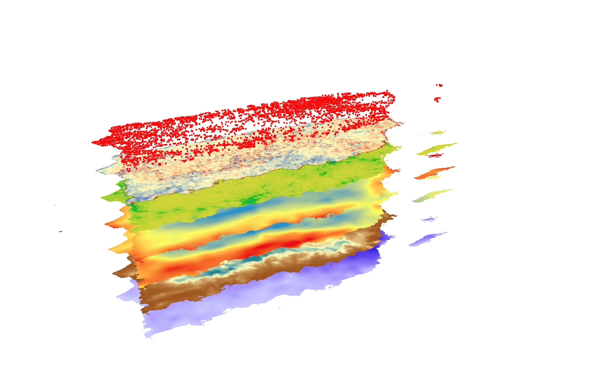

**Project Imagery**

**Caption:** Puerto Rico- Environmental variables associated with *Aedes aegypti* habitat suitability: precipitation, humidity, daytime temperatures, nighttime temperatures, population density, vegetation water content, Confirmed Dengue Fever Cases.

**Image Credit:** Puerto Rico Health Team

**Image:** Spring2016_ARC_PuertoRicoHealth_VPS_Image.png

**Software Release Requirements**

Category I- Software Release action is not required.