Milwaukee Urban Development

Assessing the Drivers of Urban Flooding Vulnerability in Milwaukee using NASA Earth Observations

 **Technical Report**

Final – August 11th, 2022

Madeleine Tango (Project Lead)

Jack Acomb

Annika Harrington

Lisa Sun

Remi Work (Assistant Fellow)

***Advisors:***

Lauren Childs-Gleason, NASA Langley Research Center (Science Advisor)

Dr. Kenton Ross, NASA Langley Research Center (Science Advisor)

# 1. Abstract

Milwaukee County has experienced an increase in flooding due to climate change and urbanization. The frequency and severity of flooding vary spatially due to differences in land cover, surface permeability, and infrastructure. Marginalized communities tend to experience disproportionately high flooding and damage due to infrastructural inequalities and limited access to resources. To quantify these differences, we used the Natural Capital Project’s Integrated Valuation of Ecosystem Services and Tradeoffs (InVEST) Urban Flood Risk Mitigation Model to calculate and create maps of runoff retention, nominal flood depth, and economic damage to buildings in Milwaukee. Our model inputs included land cover, surface permeability, and rainfall. To inform our precipitation inputs, we used NASA’s Integrated Multi-satellite Retrievals for Global Precipitation Measurement (GPM IMERG) and National Weather Service (NWS) data. We assessed the relationship between flood risk and social and environmental spatial data including redlining, racial demographics, greenspace, and community resilience. The data demonstrate that flood risk is higher in historically redlined neighborhoods, majority Hispanic and Black census block groups, areas that lack parks and trees, and areas of low community resilience as measured by the Census Bureau’s Community Resilience Estimates (CRE). These findings will support our partners, Groundwork Milwaukee and Groundwork USA, in their efforts to promote the equitable distribution of resources and support environmental health in urban spaces. The end products of this project provide our partners with tools to assess urban flooding vulnerability, guide future intervention projects, quantify the effects of environmental injustice, and improve stakeholder access to data.

**Key Terms:** environmental justice, flood risk, vulnerability, InVEST, runoff retention, redlining

# 2. Introduction

***2.1 Background Information***

Within the last two decades, Milwaukee, Wisconsin, located on the western bank of Lake Michigan (Figure 1), has experienced more intense and frequent flooding events. These floods have claimed several lives, destroyed homes, and cost millions of dollars in damage. Increasingly frequent flooding events can be attributed primarily to two phenomena: climate change and urbanization. Since 1950, Milwaukee has experienced a 15% increase in rainfall due to climate change, as warm air can hold more water (Schulte, 2021). Furthermore, as the city has expanded, the area of impervious surfaces (such as rooftops, roads, sidewalks, etc.) has also increased, replacing natural flood buffers such as wetlands and trees, decreasing city-wide water retention, and increasing runoff. Previous studies have found that the increase in impervious surfaces is the primary driver of worsening flooding, with one study finding that urbanization in southeast China was responsible for 59% of the increase in annual runoff whereas precipitation was responsible for 1% (Bian et al., 2017).

Non-white, low-income communities in Milwaukee suffer disproportionate damages from flood events, making urban flooding an overlooked environmental injustice (Capps & Cannon, 2021; White-Newsome & Slay, 2021). Environmental injustice refers to the unequal impacts of environmental hazards on marginalized communities. Environmental justice is the movement that seeks to abolish environmental harms and address their systemic causes (Energy Justice Network, n.d.). In the 1930s, the Home Owners’ Loan Corporation (HOLC) created “residential security maps” that assigned each neighborhood a letter grade and color to indicate mortgage security risk. These grades were based heavily on racial demographics, leading to extensive redlining and underinvestment in communities of color (Figure 2). Today, the racial makeup of Milwaukee neighborhoods remains similar to that of the 30s, and Black and Hispanic populations remain poorer due to historical underfunding (Foltman et al., 2019). Minorities suffer disproportionately from flooding, as they are overrepresented in flood zones, lack financial capabilities to prepare for and respond to floods, and are less likely to receive disaster information (White-Newsome & Slay, 2021). The uneven distribution of greenspaces and green infrastructure in Milwaukee also contributes to flooding impacts on vulnerable communities. Communities of color tend to experience a much smaller ratio of greenspace to gray space (such as buildings, pavement, and sewer systems), but research demonstrates that green infrastructure is more cost-effective and environmentally preferable than stormwater management, or gray infrastructure (Heynen et al., 2006; Keeley et al. 2013; Zimmerman et al., 2016).

The City of Milwaukee has taken several steps to manage flooding with varying levels of success. In 1960, the city channeled the Kinnickinnic River; however, instead of controlling flooding in the surrounding neighborhoods, channeling the river increased flow speed, worsened sewage overflow, degraded ecological services, and worsened downstream flooding (Schuelke, 2014). Now, the river is undergoing a $390 million restoration project that is removing the concrete walls and adding natural storage pools (Bergquist, 2019). The Deep Tunnel is the other major flood mitigation structure in the city. It is a 28-mile-long pipe with a 32-foot diameter that stores water in the case of a sewage overflow. When the Deep Tunnel went live in 1993, it reduced the number of annual sewage overflows from 50–60 to 2.4 (Brooke, 2019). Despite recent improvements, flooding will worsen with continued climate change and environmental degradation, necessitating greater investments in green infrastructure.

|  |  |
| --- | --- |
| Figure 1. Study area of Milwaukee County, Wisconsin | Figure 2. Milwaukee Redlining from "Mapping Inequality" series in American Panorama |

***2.2 Project Partners & Objectives***

Groundwork USA is a network of trusts that work with communities across the country to improve their environmental, social, and economic conditions. Groundwork Milwaukee focuses on transforming brownfields, educating youth and community members, and protecting urban waters. One of the organization’s main goals is to help communities increase flood resiliency, which they do through mapping flood risk and constructing green infrastructure. Previously, Groundwork Milwaukee used the New School Urban Systems Lab’s flood predictions generated by the CityCAT model, which utilizes soil characteristics, elevation, and hydrological flow (Urban Systems Lab, n.d.). Now, they want to complement those outputs by leveraging the Natural Capital Project’s Integrated Valuation of Ecosystem Services and Tradeoffs (InVEST) Urban Flood Risk Mitigation Model, which additionally considers soil and land cover characteristics (Natural Capital Project, 2022). Groundwork Milwaukee is one of several Groundwork USA trusts participating in Climate Safe Neighborhoods, a project that studies the relationship between historic redlining and modern-day urban climate impacts. Groundwork USA uses GIS analyses to show how historically redlined neighborhoods tend to suffer disproportionately from environmental hazards, such as flooding, heat islands, and brownfields.

The main objective for this project was to use InVEST to quantify the spatial distribution of pluvial flood risk and vulnerability based on runoff retention, nominal flood depth, and estimated economic damage. This project was done through a lens of environmental justice; using InVEST’s results, we analyzed the relationship between flood risk and historical redlining, census tract racial demographics, parks and tree cover, and community resilience estimates.

# 3. Methodology

***3.1 Environmental Justice***

Our project methodology was driven by the 17 Principles of Environmental Justice as outlined by the Delegates to the First National People of Color Environmental Leadership Summit held on October 24–27, 1991, in Washington DC. Specifically, we drew from Principles 2 and 12: “Environmental Justice demands that public policy be based on mutual respect and justice for all peoples, free from any form of discrimination or bias” and “Environmental Justice affirms the need for urban and rural ecological policies to clean up and rebuild our cities and rural areas in balance with nature, honoring the cultural integrity of all our communities, and provided fair access for all to the full range of resources.” (The First People of Color Environmental Leadership Summit, 1991)

Our analysis focused on not only the spatial locations of flood depth, runoff, and economic damages, but also the people that live in Milwaukee. We specifically highlighted the ties between redlining—a government-sanctioned policy—and current flood impacts in order to demonstrate that public policy has not been based on respect, but rather has been built upon discriminatory ideology that dictates how marginalized groups interact with their environment today. Redlining is thus not entirely a historical policy, but also a modern one, as its impact on Milwaukee remains visible.

The current failure of Milwaukee to meet Principle 2 moves us forward to the need to fulfill Principle 12: rebuild cities in balance with nature in an equitable way. Our analysis highlighted several of the ecological aspects of cities that are distributed unevenly, namely parks, trees, and impervious surfaces, as well as the locations where they are lacking. Showing the relationships between permeability, flooding, and race demonstrates how ecological policies can be used to make nature more accessible and pervasive around the city, especially in historically underfunded areas.

***3.2 Data Acquisition***

The InVEST Urban Flood Risk Mitigation Model requires input datasets to generate flood risk estimates, including several study area polygons: census tracts (Figure A1), census block groups (Figure A2), and sewersheds (Figure A3). Other inputs included a precipitation event estimate in millimeters, a land cover raster (Figure A4), a hydrologic soil groups raster (Figure A5), and a biophysical table containing runoff curve numbers of Milwaukee’s hydrological soil groups and land cover classes. There are also two optional inputs that can be used to estimate economic damages and savings incurred in the simulated flood event: a built infrastructure vector and a damage loss table containing infrastructure categories and their associated economic value (Table A1). To validate and contextualize InVEST results, we referred to datasets summarized in Table A2. Finally, we collected several additional datasets in order to analyze correlations between environmental justice and the InVEST outputs. These datasets included: historic redlining, demographic data, greenspace, and community resilience estimates (Table A3).

*3.3.1 Primary InVEST Inputs*

To satisfy the requirements of the InVEST model, we first conducted several pre-processing steps on the various input data. Using ArcGIS Pro 2.9, we clipped the National Land Cover Database (NLCD) data and the gridded National Soil Survey Geographic Database (gNATSGO) data to the Milwaukee County boundary. We chose Milwaukee County, rather than the City of Milwaukee, in order to capture differences that may occur between the densely populated and racially diverse city and the more affluent, white suburbs. We modelled rainfall scenarios in 2011, 2016, and 2019 using NLCD data from those years.

Next, we created a raster dataset categorizing the study area’s soil groups by pulling hydrological soil group data from the gNATSGO database, which categorizes each 10x10m pixel as soil type A, B, C, or D (Table A4). We used soil data from the USDA’s gNATSGO database, despite it being generally less accurate than the USDA’s Soil Survey Geographic Database (SSURGO) data, due to the current lack of SSURGO data for a large portion of Milwaukee County. We reclassified pixels from the gNATSGO database to values of 1, 2, 3, or 4 to align with InVEST’s formatting requirements. Some pixels in gNATSGO have dual classifications, labeled as A/D, B/D, or C/D, which represent soils that have low infiltration due to high water tables but would have higher infiltration if the water table were drained. In these cases, we made the conservative assumption that these soils’ water tables are not drained, so we reclassified all dual classifications to soil type D. Finally, since all NULL values had to be removed from the soil layer before modeling, we chose to also classify NULL pixels as type D soil.

We also used historical surveys to better reflect variation in Milwaukee’s soil. gNATSGO pulls soil data primarily from the high-resolution SSURGO database but also pulls from the lower-resolution State Soil Geographic Database (STATSGO2) in cases where SSURGO data is unavailable, as is the case in portions of Milwaukee County. This causes areas containing STATSGO2 data to appear unusually homogenous compared to neighboring regions containing SSURGO data. By contrast, historical soil surveys for the area report significant soil variation in these regions. To partially account for this disparity, we georeferenced and manually digitized soil series from a 1918 soil survey in STATSGO2 regions of the county. The largest soil series for the area (Miami clay loam, Miami silty clay loam, and Superior clay loam) were not digitized, as we assumed that the STATSGO2 data already reflected these soils’ characteristics. For each digitized soil series, we estimated hydrological soil groups by referencing Appendix A of the USDA’s Urban Hydrology for Small Watersheds (TR-55) report (United States Department of Agriculture, 1986) and soil series descriptions from the Natural Resources Conservation Service (Natural Resources Conservation Service, n.d.**)**. We then rasterized the digitized layer according to hydrological soil groups and combined it with the original gNATSGO layer. We cannot assume that this process produced a completely accurate hydrological soil group layer for STATSGO2 areas, but it serves as a valuable supplement to gNATSGO in lieu of more comprehensive soil data.

We then created a biophysical table to quantify infiltration capacity and runoff potential based on soil type and land cover. To do this, we assigned runoff curve numbers determined by the Natural Resources Conservation Service (NRCS) to each combination of NLCD land cover type and hydrological soil groups (A, B, C, and D). The Soil Conservation Service (SCS) curve number method is used to approximate runoff from a rainfall event based on location-specific hydrological soil group and land use (LaJoie et al., 2021).

InVEST requires an input for depth of rainfall in millimeters, which we derived by referencing two complimentary sources of precipitation data: NASA’s GPM IMERG and the National Weather Service’s (NWS) Milwaukee/Sullivan Weather Forecast Office. We collected GPM IMERG Final Precipitation data from 2010 to 2020 using NASA’s Giovanni and HDFView 3.1.4. We decided to take the highest daily precipitation values for this 10-year period as a suitable representation of that decade’s extreme weather. For the NWS data, we compiled a spreadsheet of daily precipitation measurements from the same decade. Comparing these two sources, we decided 50mm, 75mm, 100mm and 150mm were a representative range of rainfall events for the purposes of the InVEST model. For simplicity, we used outputs from the 100mm rainfall simulation for most of our analyses.

*3.3.2 Optional InVEST Inputs*

Additional pre-processing was also necessary in order to run the economic damages portion of the InVEST model. We performed a one-to-one spatial join between the building footprint polygons and tax parcel polygons to associate property information with each footprint. Once the building footprint received the zoning description attribute from the tax parcel features, we created a new attribute to numerically code the building type. Based on the zoning description, a building would fall into one of 6 types: 0: OTHER, 1: RESIDENTIAL, 2: COMMERCE, 3: INDUSTRY, 4: INFRASTRUCTURE, and 5: AGRICULTURE. Finally, we created a damage loss table. We referenced the North American values in the Global Flood Depth Damage Functions spreadsheet for each building type and converted the euro currency to U.S. dollars (Huizinga et al., 2017). Due to this, our damage loss table was based upon FEMA Hazus’s nationwide damage estimates, rather than damage estimates specific to Milwaukee, which means estimates of economic damage may not accurately reflect regional or local damage patterns (Huizinga et al., 2017). Since the damage value varies based on flood depth, we generated a unique damage table for each rainfall event run by linearly interpolating the damage functions based upon each precipitation value.

# 4. Results & Discussion

***4.1 Analysis of Results***

*4.1.1 Invest Outputs*

InVEST produces two raster datasets that quantify and spatialize flood risk within the study area: runoff retention and flood depth. Runoff retention represents the volume of rainfall that is locally absorbed by soil (Figure 3). Conversely, flood depth represents the expected depth of water that is not absorbed by soil and instead runs off, potentially resulting in floods (Figure 4). Throughout this study, we refer to InVEST’s flood depth estimates as “nominal flood depth” to denote that they are not representative of the true expected flood depths in a real rainfall scenario; this metric ignores changes in elevation and stormwater drainage systems, which are major factors in determining if or where flooding occurs. Instead, it serves simply as a measure of how much rainfall is left uncaptured by the soil. This metric is useful to compare the efficacy of natural flood mitigation across space but should not be interpreted as a comprehensive flooding prediction.

In Milwaukee County, we found that there was significant spatial variation in runoff retention and nominal flood depth. Central areas of the county, particularly the City of Milwaukee’s downtown, retain less runoff and are thus potentially more prone to flooding than regions on the periphery of the county. The highly developed urban land uses and impervious surfaces in the downtown area are the key drivers of this disparity. By contrast, outlying areas of the county, which typically have less-densely developed land and more trees and greenspace, have greater runoff retention. In both cases, the underlying soil conditions contribute to some minor variability, but it is difficult to draw meaningful spatial conclusions regarding the impact of hydrologic soil groups in Milwaukee without access to complete and reliable data. We created a focused report on the results within Groundwork Milwaukee’s Lindsay Heights Climate Safe Neighborhood. See the Lindsay Heights Case Study within Appendix B for our findings.

The InVEST optional economic outputs give an indication of where building damage is most costly and the economic value of natural capital, in this case soil and land cover (Figure 5). Damage is estimated by finding the expected damage for each building, and then aggregating those damages to the block group level. To account for larger block groups containing more buildings on average, we normalized the damage estimates by polygon area. At this stage of precision, the outputs should strictly be taken as indicators and not actual dollar estimates due to limitations of the model. This lack of confidence is why there is very little analysis of the economic damage estimations in this report. The economic outputs do not consider land cover or soil hydrologic group; it simply multiplies the square footage of building footprints within a polygon with a damage cost per square meter. We were able to account for flood depth by approximating the damage cost per square meter on the damage curve; however, by nature of the model, the cost is uniform across all polygons for each building type. This meant that the flood depth used to estimate the damage curves was rarely equivalent to the flood depth estimated by InVEST. Additionally, the recommended damage cost functions from FEMA Hazus were obtained from riverine and coastal flood events which may not be comparable to a pluvial flood in Milwaukee (Federal Emergency Management Agency, 2020).

|  |  |  |
| --- | --- | --- |
| /Users/annikaharrington/Downloads/Runoff_Layout.png  Figure 3. Runoff Retention output for 100mm storm | /Users/annikaharrington/Downloads/OneDrive_1_8-4-2022/FloodRaster_Layout.png  Figure 4. Nominal flood depth output for 100mm storm | /Users/annikaharrington/Downloads/Damages_Layout (1).png  Figure 5. Economic Damages output for 100mm storm |

The economic damage cost output is essentially a summary of building footprint density with some differences for building type; for example, residential buildings have higher damage costs than commercial buildings per square meter. It assumes all buildings will be subject to the same flood depth regardless of elevation. It also assumes all buildings will be repaired after damage, though Milwaukee has many vacant and unmaintained buildings that would most likely be demolished or left in disrepair in the event of a flood (Shelbourne, 2021). Given these shortcomings, even strictly comparative analyses of the economic outputs are potentially misleading and should be interpreted cautiously.

*4.1.2 Environmental Justice Results*

*4.1.2.1 Historic Redlining*

To measure the relationship between redlined areas and modern flood risk, we calculated the average nominal flood depth for each HOLC region (Figure 6) and then aggregated regions of the same HOLC designation together. Figure 7 shows that the median nominal flood depth for areas that received HOLC grade D (“redlined” areas) was worse than the other areas. The average pixel in historically redlined areas had 14% deeper nominal flood depths than the average pixel in historically green-lined areas (83.12 mm vs. 72.73 mm). This difference was found to be statistically significant under a one-way ANOVA test (*P* < .001). This pattern also emerged in preliminary analysis of the economic damage outputs generated by InVEST. We found that census block groups in historically redlined areas were expected to incur an average of 12% more dollars of damage than their green-lined counterparts in a scenario of equal flooding. This likely reflects a greater density of buildings in historically redlined areas, which leads to greater maximum damage estimates. Additionally, greater density in the built environment typically allows for fewer permeable surfaces, which could further exacerbate this disparity in a real flooding scenario.

|  |  |
| --- | --- |
| /Users/annikaharrington/Downloads/OneDrive_1_8-4-2022/Redlining_Layout.png  Figure 6. HOLC Residential Security Map 1938 | /Users/annikaharrington/Desktop/Screen Shot 2022-08-04 at 4.01.53 PM.png  Figure 7. Average Nominal Flood Depth by HOLC Grade (100mm storm) |

*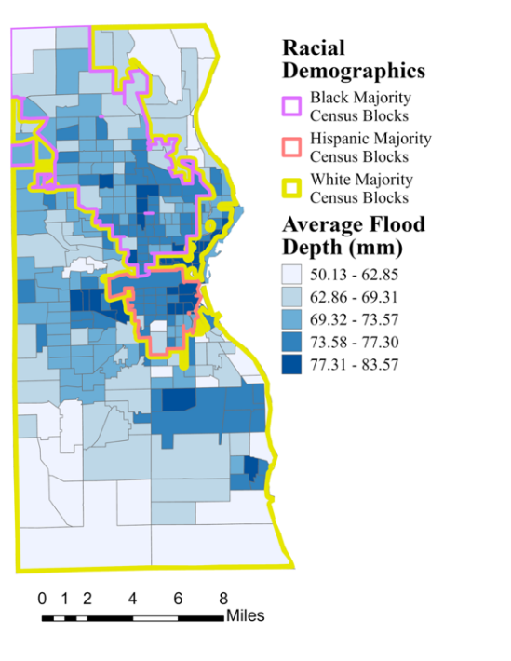4.1.2.2 Racial Demographics*

To analyze the relationship between modern day racial demographics and flood risk, we first used Milwaukee County census data to map the majority racial group per census tract. We then used the Zonal Statistics as Table and Spatial Join tools in ArcGIS Pro to calculate and map the average nominal flood depth per census tract (Figure 8). Next, we aggregated census tracts with the same majority population to calculate the average flood depth experienced by each racial demographic. Our demographics calculations revealed that the average nominal flood depth in predominantly Black census tracts (70.69 mm) is 6.61% higher than in predominantly white census tracts (66.31 mm), while the average nominal flood depth in predominantly Hispanic census tracts (74.37 mm) is 12.16% higher than in white census tracts. The disparity in racial groups’ flood risks demonstrates how current and past policies and structures do not serve all people equally, as well as how flood risk is a source of environmental injustice. The ties between modern day neighborhood racial demographics and historic redlining further exemplify the discrimination present in government policies surrounding environmental issues.

Figure 8. Average Nominal Flood Depth by Majority Racial Demographic (100mm storm)

*4.1.2.3. Greenspace: Parks and Tree Cover*

To calculate greenspace, we used ArcGIS Pro to merge and dissolve parks and tree canopy layers. We then intersected the greenspace layer with block groups to divide polygons that spanned multiple census block groups and used the Summarize Within tool to calculate the total geodesic greenspace area. We then divided the summed areas by each census block group area to acquire the percent greenspace. We used Zonal Statistics as Table to summarize the raster percent runoff retention by each census block group, to be graphed against the percent greenspace per block group (Figure 9). We found a 0.4 R-squared value when assessing the correlation between greenspace and runoff retention (Figure 10).

We calculated the difference between flood depth in pixels with greenspace versus without. We subtracted the greenspace layer from the county polygons using the Erase tool. We used Zonal Statistics as Table to calculate the average runoff retention for the greenspace non-greenspace layers. Average runoff retention was 67% higher in areas with parks or tree cover (30.44 m3) compared to areas without (18.26 m3). We had been expecting this outcome, as the model directly accounts for parks and tree cover through the land cover layer. Nonetheless, this relationship highlights the importance of land cover in the InVEST model, as well as the importance of greenspace in water retention and flood mitigation.

Spatial distribution of greenspaces is an important source of environmental injustice. Previous research shows that communities of color tend to have less access to parks, trees, and other greenspaces than white communities (Heynen et al., 2006). Lack of greenspace in communities of color is another result of systemic racism and redlining; not only did banks and cities refuse to invest in housing, but they also refused to invest in other neighborhood structures, such as parks. Greenspaces have numerous health benefits for nearby communities, including flood prevention, and their absence in marginalized communities is a significant environmental injustice.

|  |  |
| --- | --- |
| /Users/annikaharrington/Downloads/OneDrive_1_8-4-2022/Greenspace_Layout.png  Figure 9. Percent Greenspace per Census Block Group (100mm storm) | Figure 10. Runoff Retention per Census Block Group by Percentage Park of Tree Cover (100mm storm) |

*4.1.2.4. Community Resilience Estimates*

Social risk is measured by the Community Resilience Estimates (CRE), a group of 10 social risk indicators, including poverty, caregiver presence, crowding, employment, disability, health insurance coverage, age, communication barriers, access to vehicles, and broadband internet (U.S. Census Bureau, 2021). It is derived from American Community Survey and the Census Bureau's Population Estimates Program, and it uses more current data than the Social Vulnerability Index ([SVI]; Sawyer, 2021). Figure 11 shows the percentage of people with 3 or more risks within each census tract. There is a slight correlation of 0.09 between areas of low runoff retention and high social risk (Figure 12). In areas where low rainfall retention and low resiliency overlap, the consequences of a flood event are compounded. On the other hand, areas with low rainfall retention and high resiliency, such as downtown Milwaukee, may have the resources to dampen the effects of a flood event. CRE is a useful complement to income and racial demographics because resiliency to flood events is determined by other variables as well. It is also important to note that communities typically considered to be marginalized often have strong social networks that translate into higher resiliency.

|  |  |
| --- | --- |
| Figure 11. Percentage of Population with 3+ CRE Risk Factors per Census Tract (100mm storm) | Figure 12. Runoff Retention by Census Tract Per Percentage of Population with 3+ CRE Risk Factors (100mm storm) |

*4.1.3 Contextual Analysis Results*

The InVEST outputs give a limited understanding of flood risk areas in Milwaukee. Taken into consideration along with satellite-derived water imagery, flood models, and other geospatial data, InVEST can be part of a more comprehensive flood risk package. We used Landsat 7 derived Normalized Difference Water Index (NDWI) raster images and Sentinel-1A derived water masks to compare areas of moisture and water to InVEST areas of high nominal flood depth. We also compared citizen reports of basement backups to InVEST outputs.

*4.1.3.1 NDWI*

NDWI is used to highlight bodies of water in a satellite image. It is calculated using the visible green (Band 2) and near-infrared (Band 4) combination, which allows it to detect subtle changes in water bodies rather than water in leaves of plants (Equation 1). After using Equation 1, we used the values in Table A5 to classify the values to symbolize standing water (Earth Observing System, n.d.). However, the index is sensitive to built structures and sometimes counts wet, impervious surfaces as standing bodies of water, so it can overestimate water bodies especially in urban areas (Earth Observing System, n.d.). While some images we created using the NDWI calculation corresponded to the flood estimates output by the InVEST model after large storms, NDWI calculated from images taken during dry periods occasionally show patterns consistent with flooding as well (Figure A6, Figure A7, Figure A8). Therefore, even though the NDWI visualizations are calculated from real images that reflect the impact of sewer systems, elevation, flow, and other factors left out of models, NDWI is not a perfect representation of flooding, as it tends to overestimate water bodies on impervious surfaces, much like the InVEST model. While it can be used to corroborate the model, it did not work as an effective verification tool.

$$\frac{Float\left(GREEN-NIR\right)}{Float\left(GREEN+NIR\right)}$$ Equation 1.

*4.1.3.2. SAR Imagery*

We used Sentinel-1a imagery to detect areas of inundation during a rain event. Sentinel performs C-band synthetic aperture radar (SAR) imaging, allowing it to capture the Earth’s surface regardless of weather conditions (Alaska Satellite Facility, 2019). We separated water from non-water in the Sentinel image by applying a threshold mask. The threshold corresponds to the curve minimum between two modes of backscatter distribution in the image histogram. Low values of backscatter correspond to smoother surfaces which standing water would fall under. By applying this process to an image taken August 29, 2018, during a 1.26-inch rainfall, we were able to identify areas of inundation. Using SAR imaging we identified areas of inundation depicted in Figure A9. Like NDWI, Sentinel-1 SAR imagery is also subject to false positives and false negatives. Linear and artificially shaped regions with large flat surfaces can present as standing water. For example, in Milwaukee, the airport often shows up as standing water. With these caveats in mind, we can use the resulting water mask to approximate areas of flooding and provide more detailed information on where flooding is occurring.

*4.1.3.3 Self-reported basement flooding*

To validate the InVEST model, we used basement backup surveys within the City of Milwaukee from the Milwaukee Metropolitan Sewerage District and performed a frequency ratio analysis, which assessed whether there was a correlation between basement backups and the estimated flood risk as determined by the InVEST model (Figure A11). We used Natural Breaks (Jenks) to divide the nominal flood depth raster into 5 categories, reclassified between 1 and 5 with 1 referring to the lowest flood risk and 5 referring to the highest (Table A6). We used Extract Values to Points to count how many points were in each classification. For each class, we calculated a Basement Backup Ratio*,* a Pixel Ratio, and the final Frequency Ratio (Equations 2, 3, 4; Table A7). Ratios greater than 1 signal that the susceptibility factor is strongly related to the classification in which the frequency was counted (Aldama et al., 2019).

|  |  |
| --- | --- |
| $$Basement Backup Ratio = \frac{number of basement backups in class i}{total number of basement backups}$$ | Equation 2. |
| $$Pixel Ratio = \frac{number of pixels in class i}{total number of pixels}$$ | Equation 3. |
| $$Frequency Ratio = \frac{Basement Backup Ratio}{Pixel Ratio}$$ | Equation 4. |

Class 4 was the only class with a frequency ratio above 1, signifying a relationship between reported basement backup surveys and estimated flood risk according to the InVEST model. We suspect that class 5 would have shown to be more significant if we had only included residential areas in our analysis, as there are many areas of high flood risk with no reports (Figure A10),which could be because homes are not present in those areas. Additionally, a source of uncertainty with our survey data is that reporting is not necessarily equally representative across regions of the city.

*4.1.3.4 Alternative flood risk models*

We compared the InVEST model to several other flood risk models, both for validation and to create a more comprehensive understanding of our flooding results. We compared the high flood risk areas from CityCAT to InVEST. CityCAT is a hydrodynamic model that takes into account soil characteristics and simulates water flow, volume, and velocity (Urban Flood Resilience Research Group, n.d.). We did not find a significant correlation between CityCAT’s block groups by percent flooded and InVEST’s block groups by nominal flood depth (Figure A12). This discrepancy can partially be explained by CityCAT’s lack of nuance in land cover and InVEST’s absence of topographic data.

The Blue Spot model was originally developed by Project SWAMP, initiated by ERA-NET Road, a cross-border European road research program (ERA-NET Road, 2010). It has been applied in GIS applications by the Danish and Swedish governments (Climate-ADAPT, 2020). We followed the Danish workflow in ArcGIS Pro to derive blue spots, areas that water will accumulate after rain events (Balstrøm, 2022). We computed Milwaukee County blue spots for a 100mm rainstorm using USGS 10x10m DEM with burned on streams and buildings (Figure A13). The identified blue spots largely overlapped with the County’s closed depressions GIS layer (Figure A14). Groundwork Milwaukee was interested in the relationship between known depression points and flood locations to assess the spatial distribution of development on areas higher flood risk.

We also delineated streams within the Milwaukee County watersheds using USGS 10x10m DEM (Figure A15). Using ArcGIS Pro Raster Analysis Tools, including Flow Direction and Flow Accumulation, we were able to identify directional lines of water flow during rain events. Rainfall will follow the flow lines down the topography and eventually pool in a low elevation area with no surface outlet, otherwise known as a blue spot or depression. Both delineated streams and the blue spot analysis indicate where water will go in realistic situations. This adds important contextual information to the InVEST model (Table A8).

***4.2 Limitations & Future Work***

This study faced limitations both surrounding the InVEST model and regarding our access to data and community input, leaving room for further study and analysis in the future. In terms of data access, we encourage use of updated hydrologic soil type data from SSURGO once it becomes available for Milwaukee in 2023. We were also limited by access to sewer infrastructure data, which would have helped us better understand discrepancies in access to and quality of flood mitigation infrastructure.

The InVEST model had many limitations, so we cannot consider it an accurate representation of flood vulnerability in practice. For example, the InVEST model measures only rainfall-caused flooding, as opposed to riverine flash flooding. It does not consider runoff flow or elevation; it only considers flooding pixel by pixel. It also does not account for sewer infrastructure, which is a significant flood mitigation structure, especially in Milwaukee. The InVEST model also did not consider social factors that can lead to flood vulnerability.

InVEST’s economic outputs in this study were limited due to damage estimates that were not specific to Milwaukee and did not account for social vulnerability. Future studies can obtain more accurate damage costs from studies of past flood events in Milwaukee and create a damage curve function from varying levels of rain or flood depth. We also know that certain buildings will most likely never flood due to elevation or adjacent topographic features. By filtering out footprints situated on ridges, future studies can narrow the damage to structures that are more likely to be impacted. Additionally, future work interested in improving InVEST’s economic damage estimates could further our approach by generating damages values for each watershed individually, based upon the estimated flood depth in each, rather than a global value. This would allow damage estimates to reflect the spatial variation in estimated flood depth. Social vulnerability could also be incorporated into the economic damage estimates to reflect disparities in the ability to pay for damages.

Future terms could use the InVEST model to assess and quantify the impacts of changes to land cover and neighborhood investment. For example, future studies could use InVEST to model flooding before and after building green infrastructure in high flood risk areas in Milwaukee. Groundwork is interested in transforming brownfields into greenspaces, and InVEST could quantify the flood risk mitigation advantages of such a project.

With more time, we would center Climate Safe Neighborhoods and local Milwaukee communities in our analysis. The second DEVELOP term could seek out community input regarding what variables are most important for them to analyze based on community members’ experiences. Some of these variables may include communities’ proximity to toxic waste sites, to stormwater drains, and to interstate construction. Future studies could also seek to corroborate narratives provided by community members with modelling results and analyses.

# 5. Conclusions

We found that the InVEST Urban Flood Risk Mitigation model was a useful, albeit incomplete tool to understand localized flood risk in urban areas. By incorporating land use and soil characteristics in a relatively straightforward way, the tool is more accessible than other flood risk models. However, both the tool and its outputs may be difficult to interpret and implement for groups lacking technical expertise. The model is further limited as a stand-alone product because it does not allow users to include elevation, flow, or drainage system data. Moreover, InVEST lacks any integrated approach to incorporating environmental justice considerations, but as demonstrated in this project, its outputs can contribute to aspects of environmental justice research.

InVEST generated one of Milwaukee’s only estimates of spatialized flood risk and corroborated the known phenomenon that flood risk disproportionally impacts marginalized groups due to decades of infrastructure disinvestment, and is thus not free from discrimination or bias. Although limited in the variables, it accounted for InVEST’s emphasis on highlighting that impervious surfaces are still useful in assessing flood risk, particularly in its utility to identify areas that lack greenspace. Previous studies have found that urbanization is the most influential source of worsening flooding; therefore, even though InVEST focuses primarily on impervious surfaces, this attention is important for environmental justice work, as it affirms the need for urban ecological policies to rebuild cities (Bian et al., 2017; The First People of Color Environmental Leadership Summit, 1991). Other studies have found that green infrastructure is more effective at mitigating flood risk than gray infrastructure, so InVEST’s focus on permeability can allow policymakers to focus their attention and efforts on how to best utilize natural solutions (Zimmerman et al., 2016).

Greenspace distribution is tied to government disinvestment in particular neighborhoods, which is supported by our analysis correlating higher flood risk with redlined areas. Our analysis also found that predominantly Black and Hispanic neighborhoods experience greater flood risk than predominantly white neighborhoods, which is unsurprising considering the links between historic redlining and modern-day segregation as well as the lingering uneven distribution of greenspace. We similarly found that many areas of high flood risk also face increased social and economic vulnerability according to Community Resilience Estimates, reported race, and decreased generational wealth due to redlining. These factors affect a community’s resilience to flood-related damage. The relationship between physical and social vulnerability is important for decision-makers to understand as they attempt to promote equity, and accept and address the reality of environmental injustice as a result of public policy.

Our partners at Groundwork Milwaukee and Groundwork USA will be able to leverage these findings in discussions with policymakers and in their outreach to local communities, particularly through their Climate Safe Neighborhoods program. Future collaboration between NASA DEVELOP teams and Groundwork will allow for a fuller incorporation of economic damages data, which will further enhance the utility of InVEST as an advocacy tool. Studies should integrate social and economic vulnerability into the damage estimates, as the ability to address flood damage in homes is central to understanding economic damages.

Recognizing the shortcomings of InVEST’s methodologies and estimates, it remains important to balance the use of InVEST with data gathered from local communities. City-wide or county-wide modelling plays an important role in informing local urban policy related to flood mitigation, but the needs of local communities cannot be fully understood with these processes alone. Centering the needs and perspectives of communities and residents remains key in pursuing flood risk mitigation strategies that align with the values of environmental justice.

# 6. Acknowledgments

We would like to thank our project partners at Groundwork USA and Groundwork Milwaukee for their support and collaboration: Lawrence Hoffman, John Valinch, Young Kim, Keviea Guiden, and Jess Haven. The team additionally thanks our Science Advisors, Dr. Kenton Ross and Lauren Childs-Gleason for their guidance throughout this term. We also thank our NASA DEVELOP Fellow Marco Vallejos and Assistant Fellow Remi Work for their guidance and support throughout this term.

Finally, we thank our collaborators within NASA DEVELOP. Thanks to Paxton LaJoie and the Summer 2021 Cincinnati and Covington Urban Development Team for their previous work on the InVEST model. Credits to Eric Sjöstedt and the Summer 2022 Kansas City Disasters Team for working with us on the InVEST model and Bluespot Model and assisting with stream delineation.

We acknowledge that Milwaukee is built on traditional Potawatomi, Ho-Chunk and Menominee homeland along the southwest shores of Michigami, North America’s largest system of freshwater lakes, where the Milwaukee, Menominee and Kinnickinnic rivers meet and the people of Wisconsin’s sovereign Anishinaabe, Ho-Chunk, Menominee, Oneida and Mohican nations remain present.

Maps throughout this work were created using ArcGIS® software by Esri. ArcGIS® and ArcMap™ are the intellectual property of Esri and are used herein under license. All rights reserved.

Any opinions, findings, and conclusions or recommendations expressed in this material are those of the author(s) and do not necessarily reflect the views of the National Aeronautics and Space Administration.

This material is based upon work supported by NASA through contract NNL16AA05C.

# 7. Glossary

**Blue spot** – An area that is likely to fill or overflow in a rainfall event, as defined by the Danish Road Directorate as another term for depressions (Balstrøm, 2022).

**Brownfield** –a tract of land that has been developed for industrial purposes, polluted, and then abandoned (Merriam-Webster)

**Climate Safe Neighborhood** – A project carried out by 13 Groundwork trusts across the US that aims to “explore the relationship between historical race-based housing segregation and the current and predicted impacts of climate change” (Groundwork USA, 2022).

**Closed depression** – An area of low elevation with no surface outlet.

**Combined sewer system** – A system in which rainwater runoff, domestic sewage, and industrial wastewater flow in the same pipes. During times of high rainfall, the system overflows, releasing human waste and toxins into waterbodies and other areas where water will naturally pool.

**DEM** – A Digital Elevation Model, or a dataset that contains elevation information relative to sea level for a given area, typically in raster format.

**Environmental justice (EJ)** – The concept which links social and environmental exploitation and advances movement towards just practices, removal of oppressive structures, and the meaningful involvement of marginalized communities in laws, wellness, and policies linked to the environment and/or public health (Liu et al., 2022). EJ practices often address environment-related systemic practices that have disproportionately harmed the health or wellbeing of marginalized and low-income communities, particularly having to do with resource extraction, hazardous waste, and disasters.

**Gray infrastructure** – Manmade drainage, sewer, and water treatment systems such as pipes, tanks, or underground storage facilities (Keeley et al., 2013).

**Gray space** – Impervious surfaces such as roads, sidewalks, buildings, roofs, etc.

**Green infrastructure** – Structures that use naturally occurring plant and soil systems to harvest, reuse, store, and infiltrate natural elements such as stormwater and air while simultaneously providing numerous other human and ecosystem benefits (Keeley et al., 2013).

**InVEST** – Integrated Valuation of Ecosystem Services and Tradeoffs. The name of a suite of models, including the Urban Flood Risk Mitigation Model (to which we are referring when we say “the InVEST model”), created by the Natural Capital Project.

**Normalized Difference Water Index (NDWI)** – An index used to highlight open water features in a satellite image. It is calculated using the GREEN-NIR (visible green and near-infrared) combination, allowing it to detect subtle changes in open bodies of water rather than changes to water in leaves of plants. =

**Sewershed** – A geographical area that encompasses flows of a watershed and also drainage into sewer pipes.

**SEWRPC** – Southeastern Wisconsin Regional Planning Commission

**Social vulnerability** –A measure of how susceptible certain communities are to climate events, disasters, and hardships. These indices commonly include socioeconomic data, social determinants of health, and social resources.

**Redlining** – The practice of delineating neighborhoods based on race to prevent particular communities from receiving investment through loans and solidify racial segregation. In Milwaukee, these areas include many of the neighborhoods encircling the industrial downtown core such as Lindsay Heights.

**Runoff curve number** – A standard, no-unit measure of runoff potential where lower numbers indicate lower runoff potential and vice versa.

**Watershed** – A geographical area that encompasses where water drains into an outflow point to a particular waterbody.

# 8. References

Alaska Satellite Facility. (2019). *Generate Inundation Map using Sentinel-1 GRD with S1TBX*. [Online tutorial]. <https://asf.alaska.edu/wp-content/uploads/2019/02/s1tbx_inundation_v1.1-1.pdf>

Aldama, S., Dandridge, C., Kim, K., & Pavur, G. (2019). *Mapping landslide susceptibility and exposure in the Dominican Republic using NASA Earth observations.* [Unpublished manuscript]. NASA DEVELOP National Program, Langley.

Balstrøm, T. (2022, April 21). *Model bluespots to map flood risk.* [Online tutorial]. <https://learn.arcgis.com/en/projects/model-bluespots-to-map-flood-risk/>

Bergquist, L. (2019, May 30). *Massive $390 million transformation of Milwaukee’s “Forgotten River” underway*.

Milwaukee Journal Sentinel. <https://www.jsonline.com/story/news/2019/05/30/milwaukees-forgotten-river-poised-390-million-face-lift/1151553001/>

Bian, G.D., Du, J.K., Song, M.M., Xu, Y.P., Xie, S.P., Zheng, W.L., Xu, C.-Y. (2017). A procedure for

quantifying runoff response to spatial and temporal changes of impervious surface in Qinhuai River basin of southeastern China, *CATENA*, 157, 268-278, <https://doi.org/10.1016/j.catena.2017.05.023>.

Brooke, Z. (2019, December 5). *The city known for ‘sewer socialists’ actually has great sewers*. Bloomberg. <https://www.bloomberg.com/graphics/2021-flood-risk-redlining/>

Capps, K., Cannon, C. (2021, March 15). *Redlined, now flooding.* Bloomberg.

<https://www.bloomberg.com/graphics/2021-flood-risk-redlining/>

Climate-ADAPT (2020, March 4). *The Blue Spot model: A key tool in assessing flood risks for the climate adaptation of national roads and highway systems.* <https://climate-adapt.eea.europa.eu/metadata/tools/the-blue-spot-model-a-key-tool-in-assessing-flood-risks-for-the-climate-adaptation-of-national-roads-and-highway-systems>

Dewitz, J., & U.S. Geological Survey. (2021). *National Land Cover Database (NLCD) 2019 Land Cover Conterminous United States* (ver. 2.0, June 2021) [Data Set]. U.S Geological Study. <https://doi.org/10.5066/P9KZCM54>

Earth Observing System. (n.d.). *Normalized Difference Water Index*. EOS.

<https://eos.com/make-an-analysis/ndwi/>

Energy Justice Network. *Environmental justice/environmental racism*. <http://www.ejnet.org/ej/>

ERA-NET Road. (2010). *SWAMP Storm Water prevention -Methods to Predict damage from the water stream in and near road pavements in lowland areas*. [Project Description]. <https://trimis.ec.europa.eu/sites/default/files/project/documents/Project%20Description_0.pdf>

Federal Emergency Management Agency. (2020) *Multi-hazard loss estimation methodology: Hazus-MH user manual.* FEMA.gov.

<https://www.fema.gov/sites/default/files/2020-09/fema_hazus_flood-model_user-manual_2.1.pdf>

Firebaugh, G. (2001) Ecological Fallacy, Statistics of. *International Encyclopedia of the Social & Behavioral Sciences*, *2001*, 4023-4026 https://www.sciencedirect.com/science/article/pii/B0080430767007658

Foltman, L., Jones, M., Bourbeau, C. (2019, Feb 28). *How redlining continues to shape racial segregation in*

*Milwaukee: 1930s lending map reveals the policy roots of housing discrimination.* WisCONTEXT. <https://www.wiscontext.org/how-redlining-continues-shape-racial-segregation-milwaukee>

Groundwork USA. (2022). *About Climate Safe Neighborhoods/Acerca de los Vecindarios Climaticament Seguros*.

Groundwork USA. <https://groundworkusa.org/focus-areas/climate-safe-neighborhoods/about/>

Heynen, N., Perkins, H.A., Roy, P. (2006) The political ecology of uneven green space: The impact of

political economy on race and ethnicity in producing environmental inequality in Milwaukee. *Urban Affairs Review, 42*(1), 3-25. [https://doi.org/10.1177/1078087406290729](https://doi.org/10.1177%2F1078087406290729)

Huffman, G.J., Stocker, E.F., Bolvin, D.T., Nelkin, E.J., & Tan, J. (2019). *GPM IMERG Final Precipitation L3 1 month 0.1 degree x 0.1 degree* V06 [Data Set] Greenbelt, MD, Goddard Earth Sciences Data and Information Services Center (GES DISC), (Accessed 2022-07-05). <https://doi.org/10.5067/GPM/IMERG/3B-MONTH/06>

Huizinga, J., de Moel, H., Szewczyk, W. (2017) *Global flood depth damage functions: methodology and the database with guidelines.* Joint Research Center Technical Reports. <https://publications.jrc.ec.europa.eu/repository/bitstream/JRC105688/global_flood_depth-damage_functions__10042017.pdf>

Keeley, M., Koburger, A., Dolowitz, D.P. Medearis, D., Nickel, D., Shuster, W. (2013). Perspectives on the

use of green infrastructure for stormwater management in Cleveland and Milwaukee. *Environmental Management,* *51,*1093–1108. <https://doi.org/10.1007/s00267-013-0032-x>

LaJoie, P., Cronin, E., Perotti, J., Shives, E., Webster, S. (2021) *Cincinnati & Covington Urban Development II: Assessing Flooding and Landslide Susceptibility Along the Ohio-Kentucky Border.* [Published manuscript]. NASA DEVELOP National Program, Virtual – Environmental Justice. https://ntrs.nasa.gov/citations/20210021222

Liu, J., Cooper, E., Johnson-Griffin, N., & Kessler, K. (2022). *Environmental justice needs assessment for disasters: Assessing the landscape and capacity of organizations & communities working towards environmental justice with potential to use NASA earth observations to support equitable disaster management and risk reduction.* [Published manuscript]. NASA DEVELOP National Program, Virtual – Environmental Justice. https://ntrs.nasa.gov/citations/20220006798

Milwaukee County. (2020). *2020 2D Buildings.* [Data Set]. Milwaukee County GIS and Land Information Office. <https://county.milwaukee.gov/EN/Administrative-Services/Land-Information-Office/GIS-Data/Data-Download-Form>

National Weather Service (2010, July 22). *2010, July 22, Flash Flooding & Tornado Outbreak*. Weather.gov.

<https://www.weather.gov/mkx/072210_flashflooding-tornadoes>

National Cooperative Soil Survey. (n.d). *Soils2026 Initial Soil Survey Projects* [webmap]. https://nrcs.maps.arcgis.com/apps/webappviewer/index.html?id=94cb4d57853c4f57bfce03a9aab8a930

Natural Capital Project. (2022). *Urban Flood Risk Mitigation model.* InVEST documentation.

<https://invest-userguide.readthedocs.io/en/latest/urban_flood_mitigation.html>

Natural Resources Conservation Service, United States Department of Agriculture. (n.d) *Official Soil Series*

*Descriptions (OSDs*). NRCS.USDA.gov https://www.nrcs.usda.gov/wps/portal/nrcs/detail/soils/survey/class/data/?cid=nrcs142p2\_053587

Nelson, R.K., Winling, L., Marciano, R., Connolly, N., et al. (2020) Historical/redlining\_1938 [mapping

inequality]. *American Panorama*, ed. Robert K. Nelson and Edward L. Ayers <https://lio.milwaukeecountywi.gov/arcgis/rest/services/Historical/Redlining_1938/ImageServer>

Sawyer, R. C. (2021, May 7). *U.S. Census Bureau: Community Resilience Estimates.* [Presentation Slides] U.S. Census Bureau. <https://www2.census.gov/about/partners/cac/nac/meetings/2021-05/presentation-community-resilience-estimates.pdf>

Schuelke, N. J. (2014). Urban River Restoration and Environmental Justice: Addressing Flood Risk Along

Milwaukee's Kinnickinnic River. *Theses and Dissertations.* 513. <https://dc.uwm.edu/etd/513>

# Schulte, L. (2021, May 6). *Climate change is bringing heavier rains. Here are steps Wisconsin communities are taking to*

# *combat flooding*. Milwaukee Journal Sentinel. <https://www.jsonline.com/story/news/local/wisconsin/2021/05/06/wisconsin-communities-combat-flooding-warming-brings-heavier-rains/7285113002/>

Shelbourne, T. (2021, July 15). *In Milwaukee, thousands of vacant homes and lots threaten neighborhood safety and property values.* Miliwaukee Journal Sentinel. <https://www.jsonline.com/story/news/local/milwaukee/2021/07/15/milwaukees-vacant-homes-threaten-neighborhood-safety-property-values/5026155001/>

Southeast Wisconsin Regional Planning Commission (SEWRPC). (2022*). Southeast Wisconsin Subbasins (2009)*. [Data Set] n.p.

The First People of Color Environmental Leadership Summit. (1991, October 27). *The Principles of*

*Environmental Justice (EJ).* EJnet. https://www.ejnet.org/ej/principles.pdf

United States Census Bureau (U.S. Census Bureau). (2021, August 10). *2019 Community Resilience Estimates Quick Guide*. Small Area Estimates Program Social, Economic, and Housing Statistics Division U.S. Census Bureau, Department of Commerce. <https://www2.census.gov/programs-surveys/demo/technical-documentation/community-resilience/2019/cre_quickguide_2019.pdf>

United States Department of Agriculture (USDA) (1986). Appendix A: Hydrologic soil groups in *Urban*

*Hydrology for Small Watersheds.* <https://www.geol.wwu.edu/rjmitch/hydro_soil_groups.pdf>

United States Department of Agriculture (USDA) Soil Survey Staff. (2022). *Gridded National Soil Survey Geographic (gNATSGO) Database for Wisconsin FY2021* [Data Set]. Natural Resources Conservation Service. <https://nrcs.app.box.com/v/soils>

Urban Flood Resilience Research Project. (n.d.) *CityCAT Urban Flood Model* [Factsheet].

<http://www.urbanfloodresilience.ac.uk/documents/factsheet-citycat.pdf>

Urban Systems Lab. (n.d.). *Environmental justice of urban flood risk and green infrastructure solutions: Methodological*

*considerations and modeling assumptions*. <https://static1.squarespace.com/static/552ec5f5e4b07754ed72c4d2/t/60db1f326d3d82420f558b66/1624973106683/USL+Urban+Flood+Risk-+Methods+and+Assumptions.pdf>

White-Newsome, J.L., & Slay, J.A. (2021). Learning to lead with equity: advancing climate resilience

planning to address urban flooding across multiple sectors and scales. In: Petersen, B., Ducros, H.B. (eds) *Justice in Climate Action Planning. Strategies for Sustainability*. Springer, Cham. 97-115. <https://doi.org/10.1007/978-3-030-73939-3_6>

Whitson, A., Geib, & W., Dunnewald, T., (1919) *Soil Survey of Milwaukee County Wisconsin.* Wisconsin Geological and Natural History Survey. https://wgnhs.wisc.edu/catalog/publication/000066

Wisconsin Department of Natural Resources. (2016). WISCLAND 2. [Data Set]. <https://www.arcgis.com/home/item.html?id=d7f5d33b182044c187c776e47d72ce84>

Zimmerman, E., Bracalenti, L., Piacentini, R., Inostroza, L. (2016). Urban flood risk reduction by

increasing green areas for adaptation to climate change, *Procedia Engineering, 161*, 2241-2246, <https://doi.org/10.1016/j.proeng.2016.08.822>.

# 8. Appendix A

|  |  |
| --- | --- |
| Engineering drawing  Description automatically generated with low confidence  Figure A1. Milwaukee County Census Tract Boundaries. Racial demographic and CRE data are summarized on the tract level. | Engineering drawing  Description automatically generated with low confidence  Figure A2. Milwaukee County Census Block Group Boundaries. CityCAT, InVEST, and greenspace data are summarized on the block group level. |

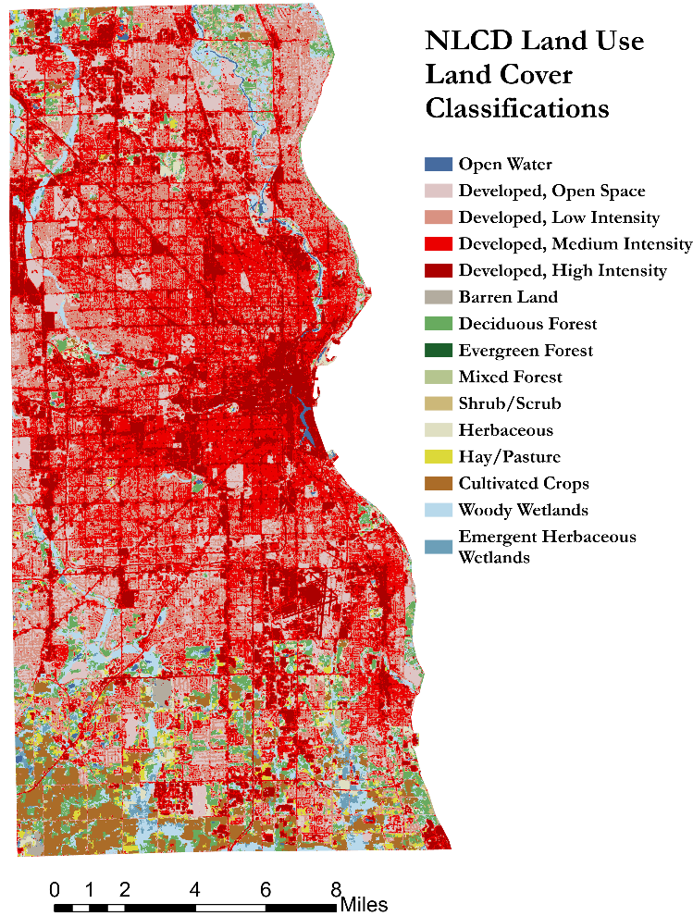

Figure A3. Sewershed boundaries indicated Figure A4. Map of land cover/land use classification

by purple outlines. Diagonal hatch indicates from National Land Cover Database 2019.

combined sewer area.

Figure A5. Soil Hydrologic Groups. Large section in the middle is based on 1918 Soil Survey approximations.

Table A1. Description of Data Inputs to the InVEST Urban Flood Mitigation Model

|  |  |  |  |
| --- | --- | --- | --- |
| **Data Name** | **Data Type** | **Date(s)** | **Institutional Data Source** |
| National Land Cover Database (NLCD) | Land use / land cover categorizations (30x30m spatial resolution) | 2011, 2016, 2019 | Multi-Resolution Land Characteristics (MRLC) Consortium |
| Gridded National Soil Survey Geographic (gNATSGO) Database | Hydrologic soil group categorizations (10x10m spatial resolution) | 2021 | United States Department of Agriculture (USDA) |
| Soil Survey of Milwaukee County, Wisconsin | Historical soil survey of study area | 1919 | Wisconsin Geological and Natural History Survey (Whitson et al., 1919) |
| GPM IMERG Final Precipitation | Daily accumulated precipitation estimates (L3 1 day 0.1 degree x 0.1 degree V06) | Jan 1, 2010 – September 30, 2021 | NASA |
| Monthly Climate Observations, Milwaukee/Sullivan, WI | Daily precipitation and temperature records | January 1, 2010 – December 31, 2020 | National Weather Service (NWS) and National Oceanic and Atmospheric Administration (NOAA) |
| MMSD Sewershed Boundaries | Sewershed vectors including areas of combined sewers | 2022 | Milwaukee Metropolitan Sewerage District (MMSD) |
| Census Block Groups | US Census Block Group vectors | 2018 | US Census Bureau |
| Milwaukee County LiDAR 2D Buildings | Building infrastructure footprint vector | 2020 | Milwaukee County Land Information Office (MCLIO) |
| Milwaukee County Parcel Information | Tax Parcel vector and attribute table | 2022 | Milwaukee County Land Information Office (MCLIO) |
| Global Flood Depth Damage Functions | Spreadsheet of monetary damages per square meter based on building type | 2017 | European Commission Joint Research Center (JRC) |

Table A2. Contextual Datasets

|  |  |  |  |
| --- | --- | --- | --- |
| **Data Name** | **Data Type** | **Date(s)** | **Institutional Data Source** |
| CityCAT Milwaukee Flood Risk Maps | Maps of 10-year and 100-year flood risk by census group | 2021 | Urban Systems Lab at The New School |
| Normalized Water Difference Index (NDWI) | Raster image of water content on Earth’s surface | 2021, 2015, 2016 | Landsat 7 |
| Milwaukee County Sewer Backups and Wet Basements | Point data of reported basement flooding | 2008-2021 | Milwaukee Metropolitan Sewerage District (MMSD) |
| Milwaukee County Closed Depressions | LiDAR derived closed depression vectors | 2020 | Milwaukee County Land Information Office (MCLIO) |
| Digital Elevation Model (DEM) | Raster image of Milwaukee County bare earth surface elevations (10x10m spatial resolution) | 2022 | United States Geological Survey (USGS) |

Table A3. Social and Environmental Datasets

|  |  |  |  |
| --- | --- | --- | --- |
| **Data Name** | **Data Type** | **Date(s)** | **Institutional Data Source** |
| Milwaukee County Tree Canopy | LiDAR derived tree canopy vectors | 2020 | Milwaukee County Land Information Office (MCLIO) |
| Milwaukee County Parks | Park vectors | 2022 | Milwaukee County Land Information Office (MCLIO) |
| Community Resilience Index | Census tract statistics vectors on community resilience to disasters | 2019 | US Census Bureau |
| Milwaukee Residential Security Map | Digitized HOLC neighborhood grade (redlining) vectors | 1938 | Milwaukee County Land Information Office (MCLIO) |
| Milwaukee County Black, Hispanic, and white Population | Census tract statistics vectors on Black, Hispanic, and white population | 2022 | Milwaukee County Land Information Office (MCLIO) |

Table A4. Hydrological Soil Groups

|  |  |  |
| --- | --- | --- |
| **Hydrological Soil Group** | **InVEST Pixel Value** | **Physical Description**  *Source:* (United States Department of Agriculture, 1986) |
| A | 1 | “Group A soils have low runoff potential and high infiltration rates even when thoroughly wetted. They consist chiefly of deep, well to excessively drained sand or gravel and have a high rate of water transmission (greater than 0.30 inches/hour)” |
| B | 2 | “Group B soils have moderate infiltration rates when thoroughly wetted and consist chiefly of moderately deep to deep, moderately well to well drained soils with moderately fine to moderately coarse textures. These soils have a moderate rate of water transmission (0.15-0.30 inches/hour)”. |
| C | 3 | “Group C soils have low infiltration rates when thoroughly wetted and consist chiefly of soils with a layer that impedes downward movement of water and soils with moderately fine to fine texture. These soils have a low rate of water transmission (0.05-0.15 inches/hour)”. |
| D | 4 | “Group D soils have high runoff potential. They have very low infiltration rates when thoroughly wetted and consist chiefly of clay soils with a high swelling potential, soils with a permanent high water table, soils with a claypan or clay layer at or near the surface, and shallow soils over nearly impervious material. These soils have a very low rate of water transmission (0-0.05 inches/hour).” |

Table A5. NDWI Classifications

|  |  |
| --- | --- |
| **NDWI Value** | **Interpretation** |
| -1.0 – -0.3 | Drought, non-aqueous surface |
| -0.3 – 0 | Moderate drought, non-aqueous surface |
| 0 – 0.2 | Flooding, humidity |
| 0.2 – 1 | Water surface |

|  |  |  |
| --- | --- | --- |
| /Users/annikaharrington/Downloads/NDWI_Layouts/2012_NDWI_Layout.png  Figure A6. Image taken July 7, 2012. No rainfall for the previous four days, only 0.08 inches of rainfall within the previous 20 days. | /Users/annikaharrington/Downloads/NDWI_Layouts/2015_NDWI_Layout.png  Figure A7. Image taken April 13, 2015, after 3.18 inches of rain fell on April 9. | /Users/annikaharrington/Downloads/NDWI_Layouts/2016_NDWI_Layout.png  Figure A8. Image taken November 7, 2016. No rainfall for the previous five days. |

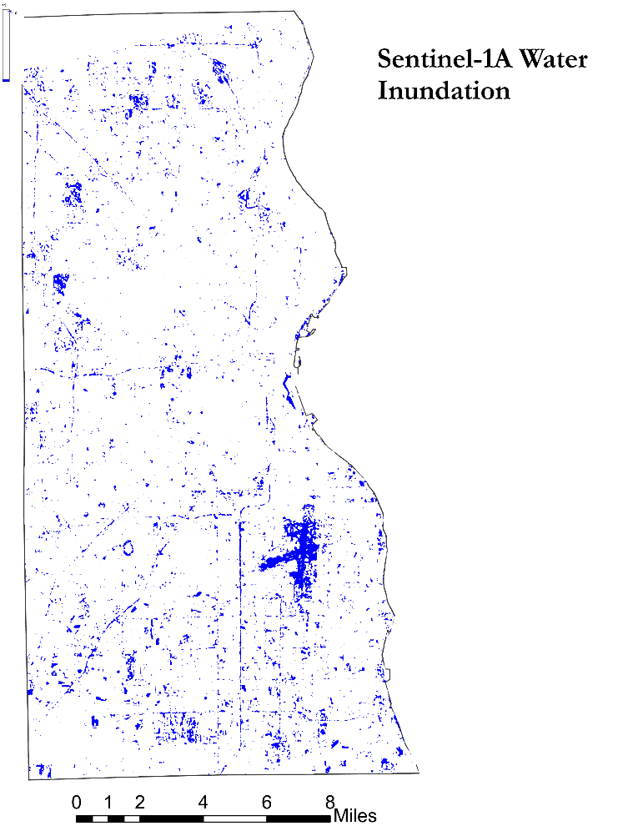

Figure A9. Image taken August 29, 2018, after 0.67 inches

of rainfall earlier in the day and another 4 rainfall events in the previous week.

Table A6. Number of basement backup reports and total number of pixels per flood risk class as calculated using Natural Breaks (Jenks).

|  |  |  |  |  |  |
| --- | --- | --- | --- | --- | --- |
| **Class** | **1** | **2** | **3** | **4** | **5** |
| # Basement backup reports | 2 | 1 | 155 | 4715 | 9311 |
| # Pixels | 1754 | 4373 | 24268 | 54436 | 193128 |

Table A7. Basement backup ratio, pixel ratio, and frequency ratio calculations per flood risk class as calculated using Natural Breaks (Jenks).

|  |  |  |  |  |  |
| --- | --- | --- | --- | --- | --- |
| **Class** | **1** | **2** | **3** | **4** | **5** |
| Basement backup ratio | 0.000141 | 0.000071 | 0.010928 | 0.332417 | 0.656444 |
| Pixel ratio | 0.006310 | 0.015733 | 0.087308 | 0.195842 | 0.694808 |
| **Frequency ratio** | **0.022345** | **0.004481** | **0.125164** | **1.697374** | **0.944785** |

Figure A10. Bar graph of frequency ratios per class, calculated from basement backup occurrence data and InVEST flood depth metrics. Class 4 was the only class that showed a significant relationship between flood risk and basement backup occurrences.

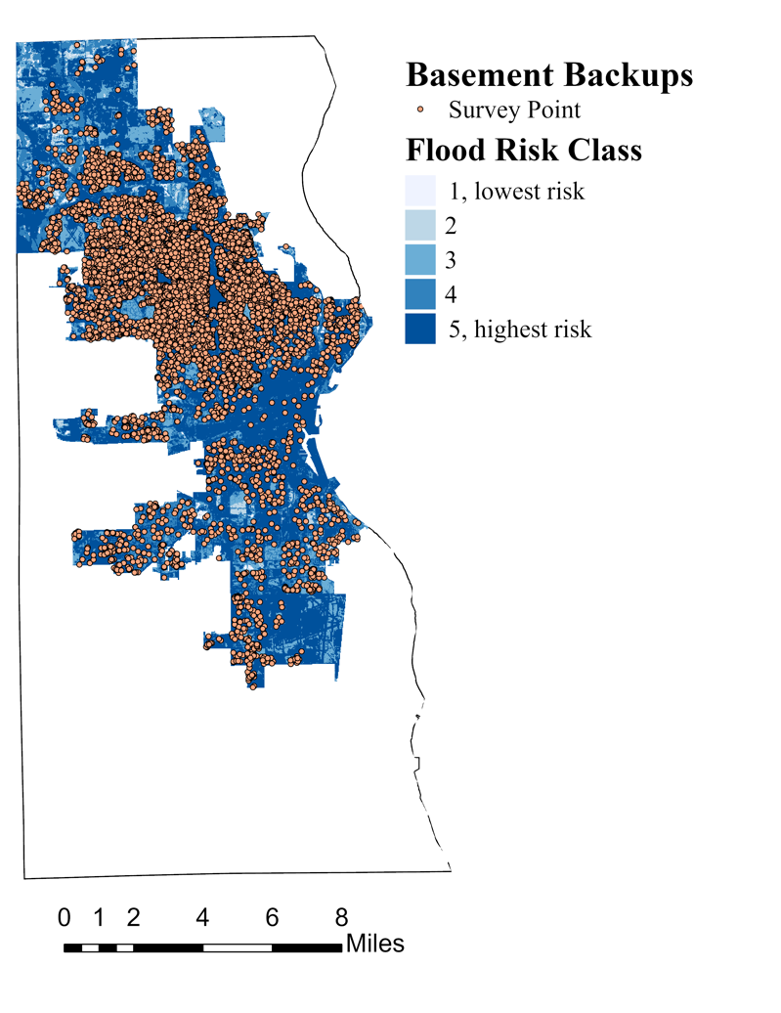

Figure A11. Basement backup points from 2008-2021 over InVEST’s flood depth layer classified into 1-5 (lowest to highest risk).

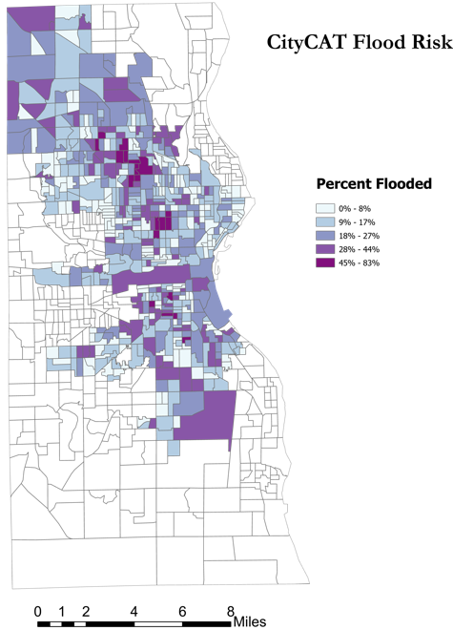 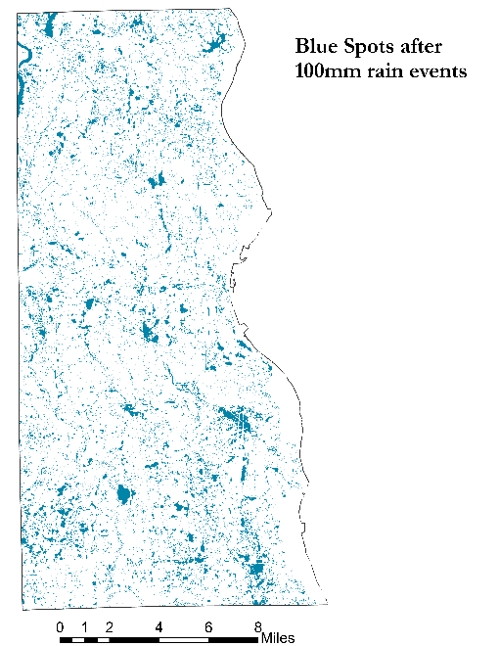

Figure A12. CityCAT Flood Risk Map by Figure A13. Blue Spots after Simulated 100mm Storm

Census Block Group

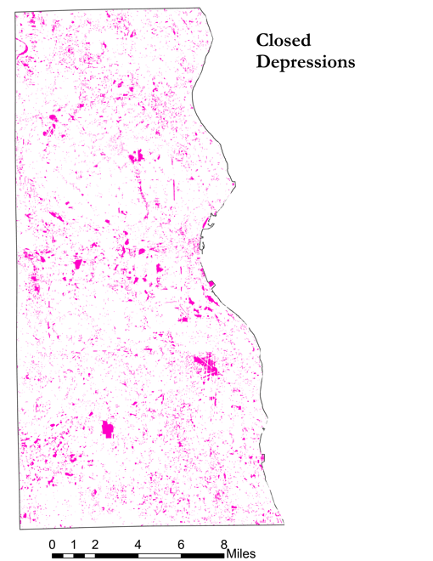 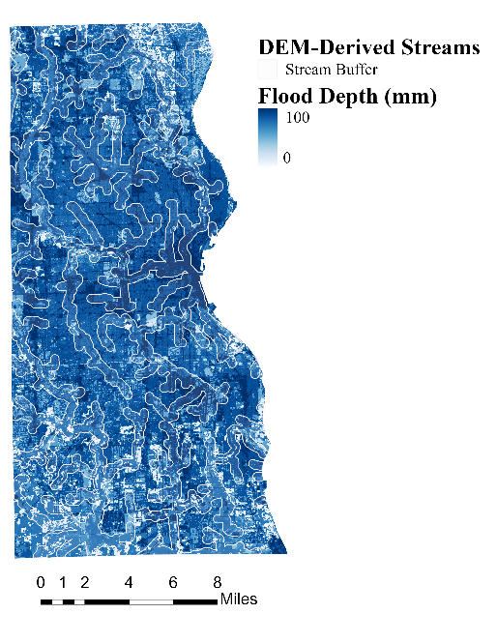

Figure A14. Milwaukee County Closed Figure A15. DEM-Derived Streams with Buffer Depressions Derived from LiDAR

Table A8. Comparison of Flood Models

|  |  |  |  |  |
| --- | --- | --- | --- | --- |
| Model | Flow Simulation | Land Cover | Soil Permeability | Stormwater Infrastructure |
| InVEST | No | Yes | Yes | No |
| CityCAT | Yes | Only pervious and impervious | Yes | Optional |
| Blue Spot | Yes | No | No | No |
| Delineated Streams | Yes | No | No | No |

# 9. Appendix B

**Lindsay Heights Case Study**

Although we have illustrated some broad trends related to flood risk across the whole of Milwaukee County, not all local areas follow these trends uniformly, and they only serve to paint a partial picture of true flood risk and vulnerability in these communities. To evaluate how these patterns intersect at a local level, we analyzed the case of Lindsay Heights, a neighborhood of Milwaukee to the northwest of downtown.

Lindsay Heights falls within an area of moderate flood risk according to InVEST’s estimates. It exists on land that was historically redlined, and today has a predominately Black population. Lindsay Heights scores high on CRE metrics for social risk compared to the rest of the county, but also contains some corridors of significant greenspace according to our data. High social risk and historical redlining are consistent with county-wide correlates of flood risk, but the presence of significant greenspace in an area of moderate flood risk demonstrates that these metrics may not be capturing the full picture of local flood risk.

Although these data points may be useful in providing high-level insight into flood risk or potential flood vulnerability in neighborhoods like Lindsay Heights, local patterns and the lived experiences of community members are not necessarily captured in this snapshot. In practice, flood vulnerability may be accentuated or mitigated by factors like greenspace or social vulnerability in ways that are not immediately intuitive, and analyses that conflate these county-level and local patterns may misrepresent the needs of communities (Firebaugh, 2001). A more accurate understanding of how flooding is experienced requires engagement with local communities.