**NASA DEVELOP National Program**



Wise County Clerk of Court’s Office

*Spring 2016*

Wise County Disasters

Using NASA Earth Observations to Identify the Historic and Future Flooding Extent throughout Wise County, Virginia.

 **Technical Report**

Final Draft – March 31, 2016

Kimberly Berry (Project Lead)

Abhijeet Singh Baghel

Grant Bloomer

Zachary Tate

Dr. Kenton Ross, NASA DEVELOP National Program (Science Advisor)

Dr. DeWayne Cecil, Global Science & Technology National Centers for Environmental Information (Science Advisor)

Bob VanGundy, University of Virginia’s College at Wise (Science Advisor)

# I. Abstract

Wise County is located in the Appalachian Mountains of southwest Virginia. Mountainous terrain increases the amount of runoff into local drainage basins during strong storms, which can increase the frequency of flash floods. This project determined areas that are more susceptible to flooding using Esri ArcGIS and The Coupled Routing and Excess Storage (CREST) model to analyze data collected from the Shuttle Radar Topography Mission (SRTM). These sensors collected data on rainfall, elevation, and land use change from 2000-2015. The modeled flooding data was compared to estimated historical floods to increase the confidence of the CREST modeled flood predictions. Maps created from the flood models have been handed off to the Wise County Emergency Operations Center for use in planning for future flood events.

**Keywords**

Snowmelt, Surface Runoff, CREST, GPM, SRTM, SSURGO

# II. Introduction

Wise County is located in southwest Virginia and is home to more than 40,000 people, thousands of which live near streams and rivers (US Census Bureau). Factors that may contribute to destructive flooding in this area include increased runoff due to hardened soil, low capacity thresholds of the many stream networks, and high rainfall rates associated with numerous strong storm systems. In recent years, Wise County has sustained several million dollars in flood damage (Igo, 2015). Knowing which areas are prone to severe flooding will improve how county officials and first responders prepare for these events (Knocke and Kolivras, 2007).

This project’s study area surrounds Wise County, Virginia and encompasses the neighboring counties of Dickenson, Russell, Scott and Lee Counties in Virginia, and Harlan County in Kentucky. This project aims to help the Wise County Board of Supervisors and officials from surrounding counties better understand the watersheds in Wise County, and how they affect the residents of the county. Currently, the County’s only way of monitoring flood threats is contact with the National Weather Service and monitoring the IFLOWS stream gauge network to monitor stream height and determine where flood conditions may be observed based on a forecasted river height.

The flood hazard was calculated usingthe Coupled Routing and Excess Storage (CREST) model from The University of Oklahoma. The model requires *in situ* and remotely-sensed data. The outputs from the CREST model, which include flood maps, will be delivered to the project partners—the Wise County Office of Emergency Management. Remotely-sensed data from 2000-2014 were collected from Aqua/ Terra Moderate Resolution Image Spectroradiometer (MODIS) for use in calculating Potential Evapotranspiration (PET); Tropical Rainfall Measuring Mission (TRMM) and Global Precipitation Model (GPM) used for precipitation; and Shuttle Radar Topography Mission (SRTM) for Digital Elevation Models. Flood hazard maps generated by CREST will be compared to historical flood data as well as Federal Emergency Management Agency (FEMA) flood maps to assess how accurate the CREST model’s predictions are.

# III. Methodology

**Data Acquisition**

SRTM data were obtained from the United States Geological Survey’s (USGS) EarthExplorer website, which provided the team with a 30-meter digital elevation model (DEM) of the study area. Ancillary data utilized in this project included a boundary shapefile provided by Wise County.

GPM and TRMM data were collected for precipitation totals using the Giovanni data acquisition tool. Giovanni allowed a polygon to be drawn over the study area on an interactive web map. Once the desired area was found, data were requested by running the “Merged satellite-gauge precipitation estimate - Final Run (recommended for general use)” for precipitation in units of mm/month. After plotting the data and confirming the study area was fully covered, the data were downloaded in NetCDF format. Using conversion tools present in ArcMap, the data were converted from NetCDF to raster format.

Soil data needed for the CREST model, including, soil type, and hydraulic conductivity, were gathered using the Web Soil Survey Map from United States Department of Agriculture (USDA) Natural Resource Conservation Service (NRCS). The soil data for the counties were downloaded as shapefiles and then merged and clipped to the study area. Soil characteristics needed for the CREST model were exported as raster files.

The CREST model was processed in Flood Event (FE) Mode instead of Regular Mode. The FE Model was chosen because it only models outputs within the period of the flood events specified in the control file. The FE Model can be used in both simulation and calibration style to save computational time since it skips the non-flood event periods ([Shen](http://hydro.ou.edu/research/crest/), 2014). All CREST files are saved in a single folder called the Project Folder. Five files were needed to run the CREST models; the Control File, Basic Folder, Parameters (Params) Folder, Rains Folder, and the Potential Evapotranspiration (PET) Folder.

The Control File was stored in the root of the project folder. It contained the model options and path variables for all other data files needed by CREST. The variable paths were assigned to the computer's operating system to bind the input parameters to the model. The Basic Folder contained the DEM, FDR (Flow Direction) file, and FAC (Flow Accumulation) file. There were also optional files in the Basic Folder such as the Mask file, GridArea file, Area Fact file, Stream file, Slope file, and LakeMask file. The optional files for slope and streams data were included in this project. The Parameters file contained information on the physical characteristics, such as soil moisture, hydraulic conductivity, overland runoff velocity, overland flow speed, and river cell threshold. The Rains Folder contained precipitation raster data over the entire study area. The PET Folder contained the potential evaporation data ([Shen](http://hydro.ou.edu/research/crest/), 2014).

The CREST model required a calibration file to control the extreme values of the results. The calibrations were entered as a text file that constraints the data points in the model to improve accuracy. Figure 1 from the CREST User Manual (Shen, 2014) shows the required inputs for the calibration file.

Table 1. Table of the Calibration.txt File inputs and descriptions from (Shen, 2014)

|  |  |  |  |
| --- | --- | --- | --- |
| Module | Symbol(v2.1) | Symbol(v1.6c) | Description |
| Initial Condition | W0  SS0  SI0 | iWU  iSO  iSI | Initial Value of Soil Moisture  Initial Value of Overland Reservoir  Initial value of Interflow Reservoir |
| Physical Parameters | Ksat  RainFact  WM  B  IM  KE  coeM | pFc  Rain  pWm  B  pIM/100  pKE  coeM | The Soil saturate hydraulic conductivity  The multiplier on the precipitation field  The Mean Water Capacity  The exponent of the variable infiltration  Impervious area ratio  factor to convert the PET to local actual  Overland runoff velocity coefficient |
| Conceptual Parameters | expM  coeR  coeS  KS  KI | expM  River  Under  LeakO  LeakI | Overland flow speed exponent  Multiplier used to convert overland flow speed to channel flow speed  Multiplier used to convert overland flow speed to interflow flow speed  Overland reservoir Discharge Parameter  Interflow Reservoir Discharge Parameter |
| Adjustment Paramenters | (Omitted)/TH  (Omitted)/GM  AreaFact | TH  GM  AreaC | Threshold to determine which cells are river cells  Downstream cell is higher than the upstream downstream cell is a nodata/outside region cell  Multiplier that modifies area of grid cells |

Once the model has successfully executed, the outputs are located in the Results Folder. This contained hydrographs, output variables, and calibration results in various formats.

To test the accuracy of the CREST models prediction capability, three previous flooding events were chosen from the stream gauge data. The precipitation, evapotranspiration, and steam discharge were collected and then fed into the CREST model. The CREST model automatically compared the observed stream flow to the calculated and output the statistical variation between the values.

If the statistical variance was not acceptable then the parameters would need to be recalibrated and the model run anew. When the statistical variance was acceptable the CREST model could then be used to forecast stream and river flooding in Wise County, Virginia.

# IV. Results & Discussion

Final results from the Crest Model are still pending. The CREST model accurately showed the areas that experienced flooded in the historical simulations. However, the calculated stream discharges were greatly under exaggerated.

Figures 1 and 2 show the locations of simulated floods along the Pound River in Wise County, Virginia. These rivers flow northeast toward the Ohio River. Figure 1 is from the first major confluence of headwater tributary streams. Figure 2 shows a larger area downstream of Figure 1. There CREST simulation correctly displayed that how the flooding propagated downstream.

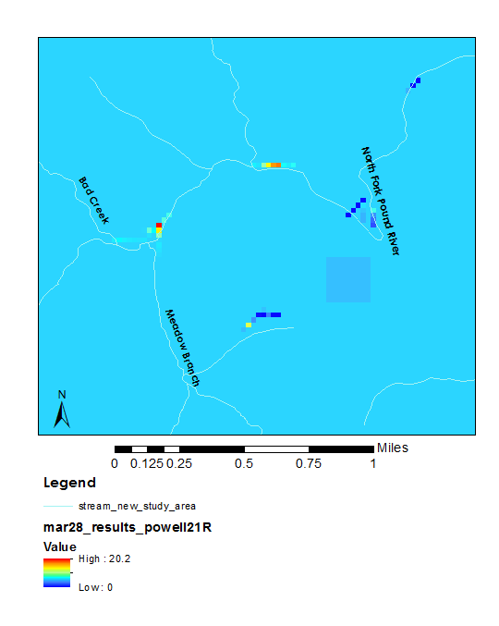  


Figure 1. Representation of CREST simulated result in ArcMap, the red pixels are at areas that have a higher chance of flooding as the calculated discharge is greater.

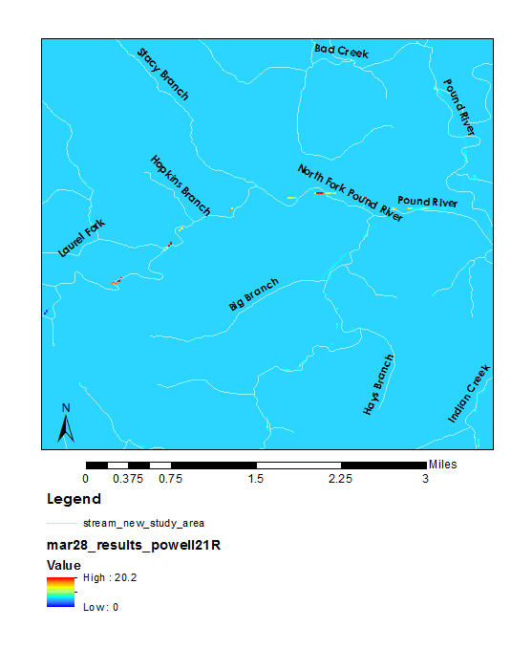

Figure 2. Representation of CREST simulated result in ArcMap, the red pixels are at areas that have a higher chance of flooding as the calculated discharge is greater.

Errors in the CREST model are speculated to be from the physical and conceptual parameters, DEM resolution, sparse stream gauge coverage, and satellite measured precipitation uncertainties in mountainous terrain. Furthermore, due to the coupled routing nature the CREST model may overestimate the infiltration and underground water flow because of the regions complex geography and geology.

The team plans to continue working with the CREST model over the interim period to address errors and explore uncertainties.

# V. Conclusions

The CREST Model correctly located areas that have recorded flooding in historical simulations. Unfortunately, the magnitude of the calculated steam discharge was very low, indicating that the model was not run correctly. Before parameters, errors, and uncertainties can be explored, the CREST model must output calculated stream discharge comparable to the observed stream flow.

# VI. Acknowledgments

The Wise County Disasters team would like to thank the mentors and partners who provided their time and support to make this project possible:

Mentors/ Science Advisors

* Dr. Kenton Ross
* Dr. DeWayne Cecil
* Bob VanGundy

Partners

* Wise County Board of Supervisors (End-user, Boundary Organization)
* POC: Bob Adkins (Director of Emergency Management)

Any opinions, findings, and conclusions or recommendations expressed in this material are those of the author(s) and do not necessarily reflect the views of the National Aeronautics and Space Administration.

This material is based upon work supported by NASA through contract NNL11AA00B and cooperative agreement NNX14AB60A.

# VII. References

Igo, Stephen. (2015, February 25). Flooding could become next big concern for SW Virginia. Times News, 1p. Retrieved from: http://www.timesnews.net/News/2015/02/26/Flooding-could-become-next-big-concern-for-SW-Virginia.

Knocke, Ethan T. and Kolivras, Korine N. (2007). Flash Flood Awareness in Southwest Virginia. Risk Analysis, Vol. 27, No. 1. Pp 155-169.

US Census Bureau. (July 1, 2015, (V2015)) Population estimates. (n.d.). Retrieved April 01, 2016, from: <http://www.census.gov/quickfacts/table/PST045215/51195>

[Shen, X. S., Hong, Y. (2014). CREST: Coupled Routing and Excess Storage User Manual. Unpublished manuscript. University of Oklahoma, Norman, OK.](http://hydro.ou.edu/research/crest/)

Willson, W. (2015). The [Coupled Routing and Excess Storage (CREST) Hydrologic Model. Unpublished manuscript. NASA DEVELOP National Program.](http://hydro.ou.edu/research/crest/)

# VIII. Content Innovation

VPS

File name: Spring2016_WC_WiseDisasters_VPS_FD.mp4

Inline Supplementary Material (figures, tables, computer code)

File name: A_Guide_Through_CREST.pdf

AudioSlides

File name: Spring2016_WC_WiseDisasters_Audioslides.mp4