**NASA DEVELOP National Program**

****NOAA National Centers for Environmental Information

**Summer 2015**

**Short Title: Southwest United States Disasters**

**Subtitle:** Incorporating CDRs and MODIS to Create a Predictive Model of Post-Burnout Vegetation Regrowth in Relation to Flood Risk

**VPS Title:** Remote Sensing to Enhance Modeling of Post-Burnout Runoff Risk

**Project Team & Partners**

**Project Team:**

Jason Zylberman (Project Lead), jason.zylberman@noaa.gov

Jennifer Holder

Lance Watkins

**Advisors & Mentors:**

DeWayne Cecil (Global Science & Technology [GST] National Centers for Environmental Information [NCEI])

Gregg Garfin (Climate Assessment for the Southwest [CLIMAS])

Tim Brown (Western Regional Climate Center [WRCC])

Dennis Staley (USGS Landslide Hazards Program)

Jason Kean (USGS Landslide Hazards Program)

**Partner Organizations**

Climate Assessment for the Southwest (CLIMAS), Collaborator, POC: Gregg Garfin

Western Regional Climate Center (WRCC), Collaborator, POC: Tim Brown

**Project Details**

**Applied Sciences National Applications Addressed:**

Disasters

**Study Area:** AZ: Lower Colorado River Basin

**Study Period:** June 2002 - August 2014, Summer Monsoon Season (July, August, September)

**Earth Observations & Parameters**

PERSIANN-CDR, GridSat-B1 – Precipitation Rate

CMORPH-CDR, Passive microwave and infrared from several geostationary satellites – Precipitation Rate

Terra, ASTER – Digital Elevation Model (DEM)

Terra, MODIS – Normalized Difference Vegetation Index (NDVI)

AVVHR NDVI – Lets take a look at see what this product might look like.

**Ancillary Datasets Utilized**

* Burned Area Emergency Response (BAER) – Burned Area Reflectance Classification (BARC) Imagery – Soil Burn Severity
* US Department of Agriculture (USDA) Arizona General Soil Map – Soil Classification
* USGS National Land Cover Dataset (NLCD) – Land Cover
* USGS Gaging Stations – Rainfall-Runoff Thresholds

**Models Utilized**

* USGS Landslide Hazards Program Post-Fire Debris Flow Hazards tool

**Software Utilized**

ERDAS IMAGINE – deriving NDVI from Landsat imagery, Image Enhancement

ArcGIS – Raster Manipulation/Analysis, Image Enhancement & Map Creation of Landsat OLI and TM multispectral imagery

Python – Data Processing and Data Conversion of MODIS, PERSIANN, and CMORPH datasets

R Statistical Programming – Statistical analysis

**Project Overview**

**80-100 Word Objectives Overview**

This project established a spatio-temporal relationship between vegetation regrowth as a function of NDVI and post-fire flood hazard over a 10-year period for Arizona in the Lower Colorado River Basin. Historical flood events were identified in the NOAA PERSIANN precipitation Climate Data Records to establish return intervals associated with increased post-wildfire flooding risk in relation to vegetation regrowth. This study demonstrates the usefulness of satellite products by utilizing NOAA Climate Data Records (CDRs), NASA Earth Observations, and in-situ data as alternative sources for input parameters to access watershed recovery via changes in vegetation regrowth for emergency and flood managers.

**Abstract**

This study investigates the relationship between vegetation response and flooding following wildfire events in Arizona within the Lower Colorado River Basin. Extensive studies have been conducted on post-burnout rainfall-run-off relationships or post-burnout vegetation regeneration, but few establish a relationship between both processes. In this study, MODIS-NDVI Earth Observations were first used to create a surface indicating vegetation regrowth rate on a per-pixel basis following historical wildfire events. Next, historical flood events were identified in the NOAA PERSIANN precipitation Climate Data Records to establish return intervals associated with increased post-wildfire flooding risk. The relationships between recurrence intervals, time since the fire, burn severity, and vegetation regrowth were then used to enhance the post-fire warning systems of local management. By utilizing remotely sensed vegetation and precipitation data in a study area with limited *in situ* data, this analysis provides an additional long-term predictive tool for managing future post-fire hazards.

**Community Concerns**

* “Post wildfire flash flood and debris flow hazards pose a significant threat to lives and property throughout the Southwest states including Arizona” according to Michael Schaffner of the National Weather Service, Project Partner
* Wildfires exacerbate flood incidences as burned areas alter the terrain and remain at increased flood risks until vegetation is restored – up to five years after burn occurrences

**Current Management Practices & Policies**

Currently, the Burn Area Emergency Response (BAER) Imagery Support program, in coordination with the USGS Center for Earth Resources Observation and Science and USDA Forest Service Remote Sensing Applications Center provide satellite imagery on burn severity. USGS programs then incorporate the burn severity data into the current USGS Debris-Flow tool to assess potential debris-flow volumes after wildfire events. With limited *in situ* data in the Southwest US, post-burnout flood modeling is limited.

**Decision Support Tools & Benefits**

|  |  |  |
| --- | --- | --- |
| **End-Product** | **Earth Observations Used** | **Benefit & Impact** |
| NDVI-Based Vegetation Regrowth Rate | Terra MODIS NDVI | This will be a set of maps depicting average vegetation regrowth rate on a per-pixel bases for a series of fires in the study area. The accompanying python script allows for the replication and future development of the product to further advance post-fire flooding tools. |
| PERSIANN-CDR-Based Post-Burnout Flood Recurrence Intervals | PERSIANN-CDR GridSat-B1 | This tool establishes flood recurrence intervals each year post-burnout. |
| NDVI Extended Post-Burnout Flood Risk | PERSIANN-CDR GridSat-B1, CMORPH-CDR, Terra ASTER, MODIS NDVI | This tool allows the end-user to estimate vegetation regrowth post-burnout over an extended period of time. This can be used to improve post-fire risk of the previous and existing tools. |

**Project Imagery**

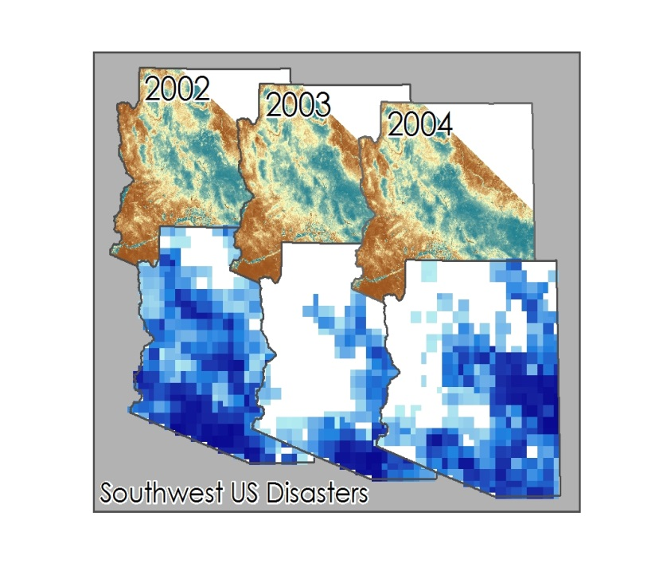

**Caption:** [Yearly Average MODIS NDVI compared to Yearly Average NOAA PERSIANN-CDR Precipitation] Image Credit: Southwest United States Disasters Team.

**Image:** 2015Sum_NCEI_SouthwestUSDisasters_ProjectImage.jpg