**NASA DEVELOP National Program**



NASA Langley Research Center

*Fall 2015*

North Carolina Ecological Forecasting

Reassessment of NOAA C-CAP Wetland Delineation and Further Disaggregation of Land Use Classes using Remote Sensing

**Technical Report**

Rough Draft – October 8, 2015

Ben Roberts-Pierel (Project Lead)

Brett Buzzanga

Michelle Pasco

Jake Patrick

Benjamin Charlem

Taylor Sage (USAF)

Emily Adams, Center Lead

Rebekke Muench, Assistant Center Lead

Dr. Kenton Ross, DEVELOP Science Director

Previous Contributors:

Zand Bakhtiari (Team Lead)

Stephen Zimmerman

Kayla Patel

Brad Gregory (USAF)

# I. Abstract

**Keywords**

Remote Sensing, Wetland, Albemarle-Pamlico, North Carolina, Land Use, Landsat 8, Satellite

# II. Introduction

**Background Information:** The Albemarle-Pamlico region is the second largest estuary system in North America (NEPCC Report, 2007). It consists of seven river basins (fig 1) as well as the Albemarle and Pamlico Sounds. The water bodies generally, and the wetlands specifically, provide enormous value to the southeastern United States through numerous ecosystem services. Wetlands absorb storm winds and surges; they minimize eutrophication by retaining and filtering agricultural and urban runoff; they provide protection for developing fish and amphibian species thereby continuing the proliferation of terrestrial and oceanic biodiversity.

However, the complex and dynamic nature of the Albemarle-Pamlico estuary system necessarily makes it a delicate system. Climate change induced sea level rise and population growth generated land use change are two of the largest threats to the Albermarle - Pamlico region. Sea level is currently rising at a rate faster than that which wetland vegetation can keep pace with, leading to inundation and erosion (-3.3 feet/year) (Carpenter, 2012). In the twenty years between 1990 and 2010, North Carolina’s population grew from 6.2 million to 9.5 million (APNEP, 2012). This population increase necessitates land change in the form of urban development and agricultural clearing. Even when wetlands aren’t specifically drained and converted to these purposes, mismanagement of natural resource consumption, waste production, and nutrient runoff have reduced the water quality and human health in the Albemarle-Pamlico watershed (Carpenter, 2012).

In order to protect this region the dynamics and characterizations of the estuary system must be better understood. A previous investigation, utilizing remote sensing data and indices that measured the extent and health of wetlands, concluded that wetland health has been deteriorating over time; however, to fully understand the implications of this deterioration we must have a clear understanding of the types of wetlands that currently exist, which types are deteriorating, and how this will affect the region as a whole.

**Project Objectives:** The Albemarle-Pamlico National Estuary Partnership (APNEP) currently relies on land use and land cover (LULC) data from NOAA’s Coastal Change Analysis Program (C-CAP) to understand land use designations and wetland types. This information better informs their management decisions by enabling them to decide where to allocate resources. However, C-CAP is only updated every five years and is designed for regional coastline classifications; the team aims to provide an updated classification that is tailored to the Albemarle-Pamlico estuary by providing additional land classification types. Building on the previous study (Bakhtiari, 2015), the team will look for a correlation between wetland deterioration and type. The objective is not only to provide APNEP with a set of images based on most recent available Landsat 8 imagery, but also to create a method of replicability so it would be possible for APNEP to update these classifications on a more regular basis than what C-CAP offers.

**Study Area**: The Albemarle-Pamlico region is located on the coast of northeastern North Carolina and southeastern Virginia. The extent consists of two major sounds, Albermarle and Pamlico, and seven river basins (fig 1)- six of which APNEP monitors. Three major land cover classifications - forests (40.1%), wetlands (15.8%) , and croplands (25.3%) - make up the region’s 31,000 square miles of land and water (Carpenter, 2012; APNEP, 2012).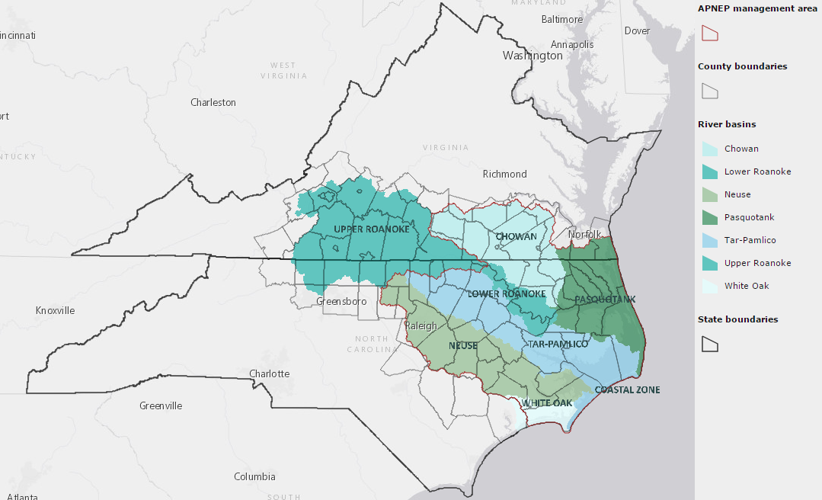

Figure 1: Map of the Albemarle-Pamlico study area: river basins and major sounds (<http://portal.ncdenr.org/web/apnep/maps>)

**Study Period:** The time period for this study began in May 2000 and has continued on to November 2015.

**National Application:** Delineating the current extent of the wetlands using remote sensing data, and software such as ArcGIS and ERDAS IMAGINE, has contributed to NASA Ecological Forecasting. LULC processes are common and important for many applications, both for increasing scientific knowledge and as tool for enhanced decision-making. The process and methodologies developed here will provide an aid and guidelines for classifying LULC on higher resolution scale than C-CAP. This will allow organizations throughout the nation to better protect and manage their wetlands and watersheds.

**Project Partner:** Partnership with APNEP started in the Spring of 2015. The primary goal of APNEP is to protect the resources of the Albemarle-Pamlico estuary system. They seek a better understanding of how the individual parts of the ecosystem function together as a whole to maintain a healthy environment. They are focused on analyzing both short and long term trends and utilizing citizen’s groups, researchers, local governments, and state/federal agencies to determine problem areas within the region to monitor and restore (APNEP, n.d.).

# III. Methodology

This study conducted a supervised land classification by using elevation, hydrography, and soil data to select calibration points for the Random Forest Land Classification Model (Norning). The model converts spectral radiance values as recorded in Landsat images to user - specified land cover types.

The NC Ecological Forecasting Team utilized Landsat 8 Operational Land Imager (OLI) scenes (Path 14, Row 35; Path 14, Row 36), 1/3 arc-second digital elevation models (DEMs), the national hydrography dataset (NHD), and the soil survey geographic database (SSURGO). All the data is publicly available through the United States Geological Survey (USGS), except for SSURGO, which is publicly available through the United States Department of Agriculture (USDA). Landsat 8 OLI scenes were preprocessed by the USGS to correct for top of atmosphere reflectance (TOA) in the Provisional Landsat 8 Surface Reflectance data product, part of the Landsat 8 Climate Data Record (CDR) data set (Product Guide, 2015). Two dates from each scene were obtained (June 15, 2015; July 22, 2015) for a total of four Landsat scenes. The scenes were chosen due to the relatively high quality of the images: little cloud cover and most recent peak vegetation.

These different datasets were aggregated in ESRI’s ArcGIS software. Eight 1/3 arc-second DEMs were mosaicked to create one representative raster of the area covered by the Landsat scenes. The ‘swamp/marsh’ type of the NHD Waterbody feature class was clipped to the study area. The “Ecological Site” and “Hydric Rating” SSURGO attributes were similarly merged for analysis within ArcGIS. The former attribute describes an area’s characteristic soils, hydrology, and vegetation; the latter demarcates the percentage of an area’s soil that qualifies as hydric (“soil that is formed under conditions of saturation, flooding or ponding long enough during the growing season to develop anaerobic conditions in the upper part”) (USDA,<http://www.nrcs.usda.gov/wps/portal/nrcs/detail/soils/use/hydric/?cid=nrcs142p2_053961>).

These datasets were compared with one another in order to select locations - training sites - that would best serve as calibration points for the Random Forest Model. Using ArcGIS and ESRI Imagine, training sites were chosen that clearly delineated a specific landcover type. The C-CAP classifications (Appendix I) guided the choices in landcover types, but some regionally inappropriate classes were ignored (such as tundra), while others of local concern were added (Appendix II).

The training sites were 90 meters2 to allow for a two pixel margin of error in the Landsat images (30m2 resolution). The Near-Infrared Band (NIR), which identifies vegetation and shorelines, coupled with the with the Ecological Site identifier found in the SSURGO database, was particularly effective in separating wetlands by vegetation type.

A dozen training sites were selected for each land cover classification type (Appendix I). The sites and chosen classification types were then input to the Random Forest Model which extrapolated the classification of the training sites to the entire spectral area, generating an image of land classification for the whole study area.

The classifications produced by the model were compared against the specific case studies areas utilized in the previous North Carolina Ecological Forecasting project (Bakhtiari, 2015) to determine if there was a correlation between wetland type and health.

To increase the robustness of this land classification, a model was written in the open source programming language R that alters spectral value based on geographic location. The program takes as input a vector location and a percent land classification type. It then exports the pixel values as originally established by the Random Forest Model, and reruns the model. This enables the classification system to be easily updated to reflect changing (or previously incorrect) land cover type.

# VI. Acknowledgments

Dr. Kenton Ross – National Science Advisor, NASA DEVELOP National Program

Emily Adams – Center Lead LaRC, NASA DEVELOP National Program

Rebekke Muench – Assistant Center Lead LaRC, NASA DEVELOP NATIONAL Program

Bill Crowell – Ablemarle-Pamlico National Estuary Partnership

Any opinions, findings, and conclusions or recommendations expressed in this material are those of the author(s) and do not necessarily reflect the views of the National Aeronautics and Space Administration.

This material is based upon work supported by NASA through contract NNL11AA00B and cooperative agreement NNX14AB60A.

# VII. References

Carpenter, D., Dubbs, Dr. Lindsay. (2012) *Albemarle-Pamlico Ecosystem Assessment 2012.* Print.

*National Estuary Program Coast Condition Report.* (2007, June). Retrieved from Environmental Protection Agency: <http://www.epa.gov/owow/oceans/nepccr/index.html>.

“NC Department of Environment and National Resources Albemarle-Pamlico National Estuary Partnership - Albemarle-Pamlico National Estuary Partnership.” NCDEQ. Web. 29 Sept. 2015

NOAA Office for Coastal Management. “C-CAP Regional Land Cover Classification Scheme” Published by the National Oceanic and Atmospheric Administration. November 20, 2014. (C-CAP)

Saltonstall, Kristin. "Cryptic Invasion by a Non-native Genotype of the Common Reed, Phragmites Australis, into North America." *Proceedings of the National Academy of Sciences* 99.4 (2002): 2445-449. Web. 29 Sept. 2015.

Intergovernmental Panel on Climate Change. *Climate Change 2007: Impacts, Adaption and Vulnerability.* Cambridge: Intergovernmental Panel on Climate Change, 2007. Print.

Ablemarle-Pamlico National Estuary Partnership. “Comprehensive Conservation and Management Plan.” 2012. 15. Print.