Cherokee Water Resources

Mapping Hemlock Tree Composition and Health in the Southern Appalachians Using NASA Earth Observations to Enhance Drought and Watershed Health-Related Forest Management for the Eastern Band of the Cherokee Indians

 **Technical Report**

August 6th, 2020

Richard Murray

Travis Newton

Chloe Schneider

Wilson Goode

***Advisors***

Dr. Bjorn Brooks, North Carolina Institute for Climate Studies, NOAA National Centers for Environmental Information (Science Advisor)

Dr. Steve Norman, USDA Forest Service, Eastern Forest Environmental Threat Assessment Center (Science Advisor)

# 1. Abstract

The Eastern Band of Cherokee Indians (EBCI) owns and manages more than 55,000 acres of land in in the Southern Appalachian Mountains of western North Carolina. Most of these lands reside within the Oconaluftee River watershed. In this region and watershed, hemlock trees are a culturally significant foundation species that contribute to habitat biodiversity, regulate temperature and evapotranspiration of riparian environments, and provide economic value for tourism and recreation. The hemlock woolly adelgid (HWA), an invasive insect, has caused widespread hemlock mortality in recent decades, raising concerns about hemlock decline. Hemlock mortality leads to standing dead trees and increased evapotranspiration which can abet the spread of wildfires, especially during periods of drought. The DEVELOP team used satellite imagery from Landsat 5 Thematic Mapper (TM) to quantify and map possible hemlock decline by comparing changes in the normalized difference vegetation index (NDVI) values of winter season between 2003 and 2010. The project utilized the Shuttle Radar Topography Mission (SRTM) along with imagery from Landsat 8 Operational Land Imager (OLI) to create a weighted suitability analysis that maps topographic and environmental conditions favorable for hemlock habitat. This study found that 67% of evergreen and mixed forest cover in the Oconaluftee River valley exhibited a decrease in winter NDVI from 2003 to 2010. Additionally, the two example weighted suitability analyses showed 4.5-9.5% of hemlock suitable land in 2018 in the Oconaluftee. The partners of this project can use the outputs to identify extent of potential hemlock decline in the Oconaluftee and establish benchmark metrics for assessing changes in hemlock suitable areas over time.

**Key Terms**

EBCI, Forest Health and Resources, Hemlock, Remote Sensing, Vegetation Mapping, Evergreen

# 2. Introduction

***2.1 Background Information***

The Eastern Band of Cherokee Indians (EBCI) owns and manages over 55,000 acres of land in Jackson, Swain, Cherokee, Graham, and Haywood Counties in the southern Appalachian Mountains of western North Carolina. This land has been subject to a complicated land-use history that has led to the forest management concerns currently facing the EBCI. The tribal lands are fragmented, with many smaller tracts separated from a larger area known as the Qualla Boundary. The majority of these lands are allocated to possessory holders, with the remaining lands part of the Tribal Reserve controlled by the EBCI Government (Forest Stewards, 2016). The area has experienced a history of high-grading, or the selective cutting of large and high-value trees, which has left behind a mixed forest with a high concentration of less valuable tree forms (Forest Stewards, 2016). Tribal land has also been sold to timber speculators, rail lines, and to Nantahala Power and Light Company in the 1920s for the construction of multiple hydroelectric dams along rivers running through the area (Forest Stewards, 2016). These past management decisions have impacted the current forest and water quality of the area.

More recently, the hemlock woolly adelgid (HWA), an invasive insect species, has spread throughout the Appalachians and is present in nearly every stand of eastern and Carolina hemlock. HWA infestations lead to hemlock decline over several years, often combined with other environmental stressors, including drought and other pests. Hemlocks contribute essential ecosystem services by shading mountain streams and providing year-round habitat among their branches (Vose et al., 2013). In EBCI lands, hemlocks may also provide habitat to the endangered Carolina northern flying squirrel (*Glaucomys sabrinus coloratus*) (Forest Stewards, 2016). Several efforts set out to quantify the spread and effect of HWA on hemlock stands in the United States and, primarily, the Appalachians (Bonneau et al., 1999a, 1999b; Evans & Gregoire, 2007; Koch et al., 2005; Vose et al., 2013). Because of the Trust Lands’ proximity to the Great Smoky Mountains National Park, methods developed for the park should apply to or, at minimum, provide a comparison for EBCI forests (Madden et al., 2004). The HWA infestation in the southern Appalachians is estimated to have begun in the early 2000s, with evidence of infestation across EBCI-linked counties by 2004 (Evans & Gregoire, 2007). To monitor the decline, the team selected a study period of 2000 through early 2020 to capture decline due to HWA and other contextual factors, like drought and fire history.

Data for monitoring hemlock stands on the ground tends to be sparse, and the data available are not comprehensive, leaving gaps in defining hemlock health and abundance. With the application of remote sensing, it is possible to fill those gaps and provide essential monitoring to classify areas that require monitoring and treatment (Bonneau et al., 1999b). Data sets acquired from satellite sensors can be processed to produce and detect a change in vegetation using the normalized difference vegetation index (NDVI), which is a measure of the radiation absorbed and reflected by chlorophyll. To estimate vegetation health, previous studies have created NDVI maps from satellite-derived data sets (Bonneau et al., 1999a). To further improve the accuracy, studies have included weighted suitability models to provide additional information for regions of interest (AL-Taani et al., 2020). For this study, the Summer 2020 NASA DEVELOP Cherokee Water Resources team investigated hemlock health and trends in the Southern Appalachians using NASA Earth observations (*Figure 1*).

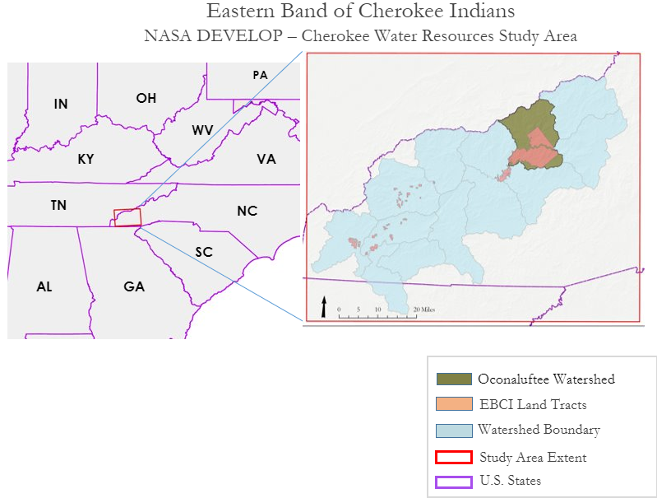*Figure 1.* Map of the Eastern Band of Cherokee Indians Study Area. The red box depicts the collection area for Earth observation data, the light blue outline are the multiple watersheds that encompass the EBCI lands (shown in orange) and the Oconaluftee River watershed (green).

***2.2 Project Partners & Objectives***

The Cherokee Water Resources team of the NASA DEVELOP program partnered with the EBCI Natural Resources program, a program responsible for the conservation and management of the Cherokee lands. With the overarching goal “to perpetually maintain healthy and diverse forest resources through an informed and adaptive management approach,” the EBCI National Resources program works to regulate the environment through their Air Quality, Fish and Wildlife, Forestry, Horticulture, and Water Quality and Watershed Management programs (Forest Stewards, 2016). To address the decline of hemlock populations that is affecting the region's delicate ecological cycles, the EBCI program expressed interest in using remote sensing to identify hemlock presence in the region and apply geospatial data for future management (Forest Stewards, 2016). To meet the EBCI program needs, the team’s primary objectives were to create an NDVI winter change analysis between 2003 and 2010, a weighted suitability analysis for 2018, and create a tutorial for use within the EBCI Natural Resources program. The tutorial and the development of these products will strengthen the geospatial capabilities of EBCI Natural Resources for future management strategies.

# 3. Methodology

***3.1 Data Acquisition***

The team acquired tier-1 level-2 Landsat 5 Thematic Mapper (TM) and Landsat 8 Operational Land Imager (OLI) surface reflectance scenes at 30-meter resolution using Google Earth Engine (GEE) (Earth Resources Observation And Science (EROS) Center, 2014, 2017a). The application of cloud masks creates cloud-free seasonal images, and the team collected cloud-free composites of surface reflectance scenes for the summer (01 June – 01 August) and winter (01 December – 01 March) seasons of each year in the study period. Using GEE allowed the team to mosaic seasonal images and use the GEE cloud masking functions to created cloud-free composites. For topographic data, the team downloaded Digital Elevation Models (DEM) derived out of the Shuttle Radar Topography Mission (SRTM) from USGS (Earth Resources Observation And Science (EROS) Center, 2017c). The SRTM data, initially collected in 2000, were reprocessed as ‘2013 SRTM Plus’ at 1/3 arc second, which is a 30m resolution. Table 1 contains the Digital Object Identifiers and time period of collection for these NASA Earth observation products.

Table 1

*NASA Earth observation products used in the project.*

|  |  |  |
| --- | --- | --- |
| **Earth Observation Data** | **Digital Object Identifier (DOI)** | **Time Period** |
| Landsat 5 TM tier-1 level-2 surface reflectance | https://doi.org/10.5066/F7N015TQ | 2000-2011 |
| Landsat 8 OLI tier-1 level-2 surface reflectance | https://doi.org/10.5066/F78S4MZJ | 2013-2018 |
| Shuttle Radar Topography Mission (SRTM) Digital Elevation Model (DEM) | https://doi.org/10.5066/F7PR7TFT | 2000/2013 |

National Land Cover Database (NLCD) maps, created by multiple federal agencies using Landsat, were retrieved from the Multi-Resolution Land Characteristics Consortium (MRLC) for the dates between 2001-2016, which gave the team references for known tree categories for detailed analysis of the landscape (Homer et al., 2012). The team also access high resolution (2 meter) aerial imagery from the National Agriculture Imagery Program (NAIP) server hosted by the United States Department of Agriculture (USDA) (Earth Resources Observation And Science (EROS) Center, 2017b). Information on infrastructure and political boundaries from the U.S. Census Bureau supplied vector data files of roads, counties, states, and tribal lands (United States Census Bureau, 2019). Additionally, the team accessed watershed boundaries from the National Watershed Boundary Dataset to identify the region of the study area within the Oconaluftee River watershed (Federal Standards and Procedures for the National Watershed Boundary Dataset (WBD), 2013).

Lastly, the team contacted managers from the Hemlock Restoration Initiative (HRI) and the Great Smoky Mountains National Park (GSMNP) for vector data files of Hemlock Conservation Areas (HCA). These areas are plots within the national park and other surrounding forest that contain hemlock trees treated for HWA starting between 2012 and 2018. and the Hemlock Restoration Initiative (HRI) supplied locations with known hemlocks (Great Smoky Mountains National Park GIS, n.d.). *Figure 2* displays the boundary of the Great Smoky Mountains National Park, as well as locations of the HCA polygons, in relation to the EBCI land tracts and the Oconaluftee watershed. Appendix A displays the sources of these ancillary datasets.

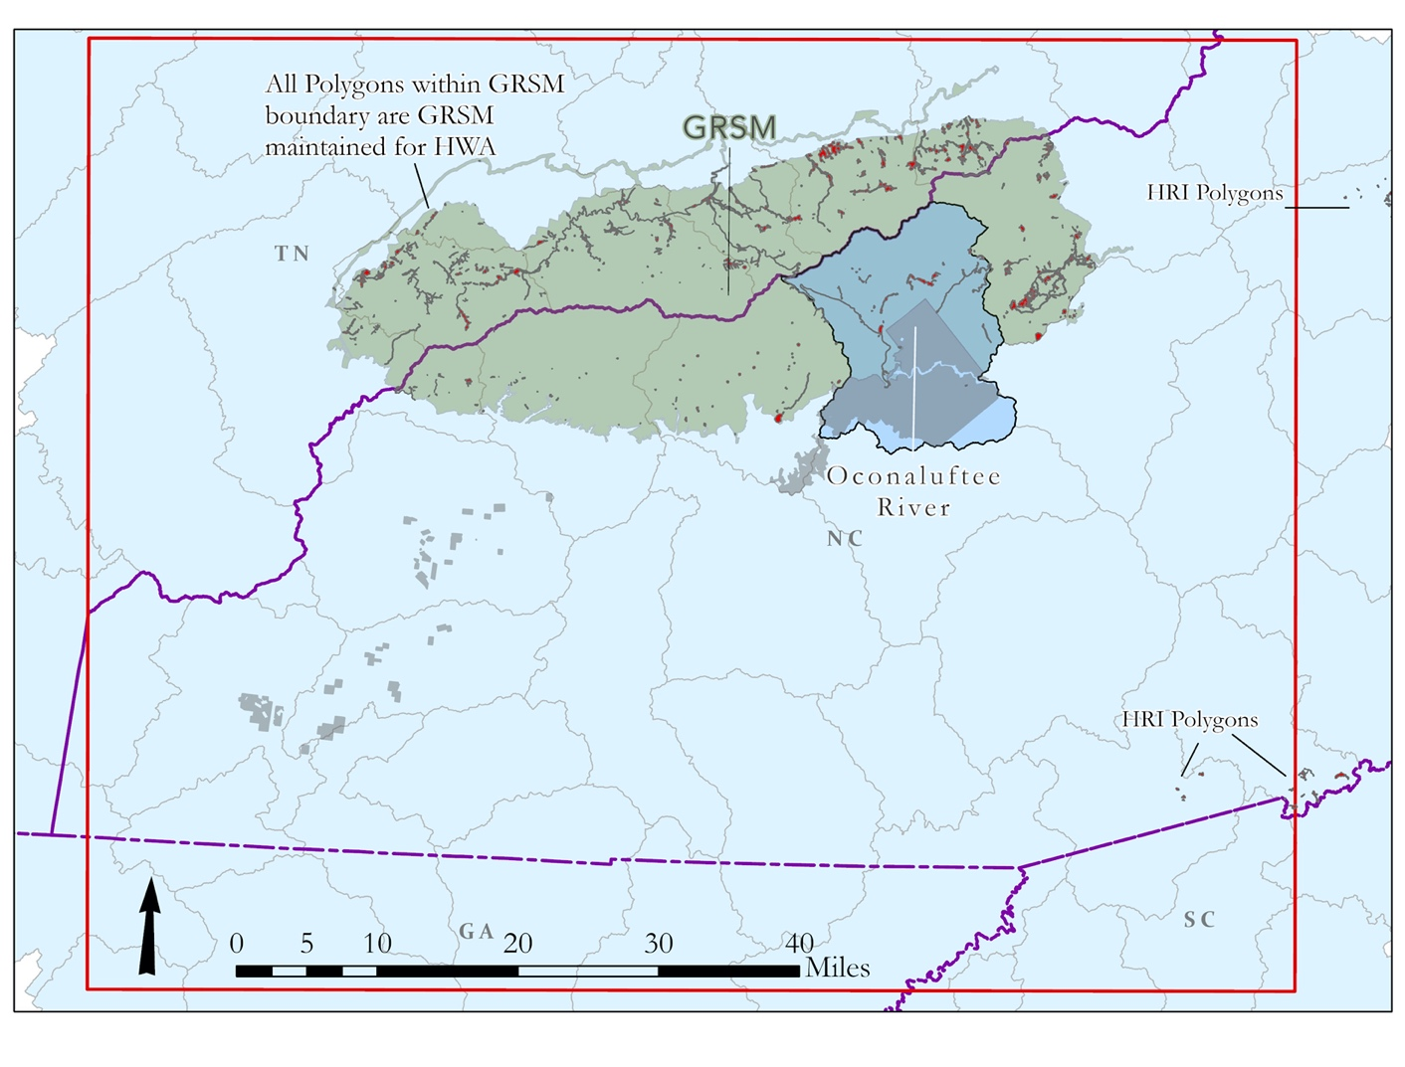

HCA polygons within GSMNP

GSMNP

HCA polygons

HCA polygons

Oconaluftee Watershed

*Figure 2.* Extent of the Great Smoky Mountains National Park (GSMNP) and locations of the HCA polygons in relation to the Qualla Boundary (gray) and the Oconaluftee watershed.

***3.2 Data Processing***

For data processing, the team primarily used ArcGIS Pro 2.5 (ArcPro) and RStudio 4.0.2 to manipulate the geoTIFF’s and other geospatial datasets. The Normalized Difference Vegetation Index (NDVI) was used for the Landsat imagery to detect vegetated areas and vegetation health. ArcGIS Pro has built-in tools to calculate spectral indices with the image analyst extension, which calculate NDVI using the near-infrared (NIR) and red-light (R) bands for all of the Landsat 5 and Landsat 8 surface reflectance summer and winter composites (Equation 1). The output is a raster with pixels valued between –1 and 1, where values close to 1 are green, vegetated areas, and 0 to –1 are impervious surfaces or bodies of water. From the resulting NDVI images, the team used winter NDVI images between 2003 and 2010 to meet the first objective of the project, which was mapping winter NDVI decline. The team then used the 2018 summer and winter average NDVI images for the second objective of the project, which was mapping suitability criteria for hemlock in the region.

$NDVI=\frac{NIR-R}{NIR+R}$ (1)

From the DEM, the team extracted topographic variables for the study area including aspect, slope, and hill shade rasters. The NLCD dataset contained land cover features including forest type, urban areas, and bodies of water. These data were used to create masks of evergreen and mixed forest types to demonstrate NDVI change only within these forest types which are most likely to contain hemlock stands. The team also used the NLCD dataset to mask out bodies of water and urban areas for the weighted suitability analysis.

***3.3 Data Analysis***

The team approached this study via two analytic approaches that sought to meet the project objects. The first analysis determined winter NDVI change between 2003 and 2010 in the greater study region. This analysis also produced a focused analysis of NDVI change in the Oconaluftee watershed. The second approach produced an example weighted suitability analysis that assembled various topographic and environmental criteria related to the suitability of landscapes for hemlock habitat.

*3.3.1 Winter NDVI Change Analysis*

With the study area masked to include only evergreen and mixed forest areas, the team chose to analyze the difference in Landsat 5 2003/2004 and 2009/2010 winter images to calculate decline, noting HWA began noticeable hemlock degradation in 2004. Conversations with the partner groups indicated that much of the HWA infestation and resultant hemlock decline was observed by 2011. Focusing on change between 2003 and 2010 allowed the team to examine NDVI decline in this region that can most likely be attributed to HWA and, therefore, can mostly likely represent hemlock decline. As hemlocks are evergreens, the focus on winter NDVI change further contributes to linking NDVI change with change in evergreen coverage and health. To create a smooth image that eliminates erroneous image noise (cloud, snow, missing pixel, etc.), NDVI values of the two consecutive winter years were averaged for each pixel to create the 2003/2004 image and the 2009/2010 image. The resulting 2009/2010 average winter NDVI image was subtracted from the 2003/2004 average winter NDVI image to demonstrate change from the start year. The resultant raster image was then masked to only include NDVI change in areas classified as either evergreen or mixed forest by the 2003 NLCD land cover classifications. The change map was categorized to demonstrate pixels that experience moderate to low NDVI increase, little to no change, and low to extreme decrease over the 2003/2004 to 2009/2010 period.

*3.3.2 Weighted Suitability Analysis*

The weighted suitability analysis is a type of suitability model that assigns locations weights relative to one another based on criteria specified in order to find favorable locations for particular species of interest, such as hemlock habitat in this project. The weighted suitability analysis uses the weighted overlay tool that the team used in ArcPro. The tool assembles user-identified suitability criteria based on topographic, climate, environmental, and other variables. For this project, the team provided an example weighted suitability analysis that examined the topographic and environmental criteria related to hemlock habitats. Appendix B lists the example selected criteria and the corresponding weighting schemes. The team selected the topographical and environmental variables for analysis from several sources, including literature review and interviews with partners to incorporate their local knowledge. Additionally, the team investigate the topographic and environmental variables for the HCA polygon within the Oconaluftee watershed. Based on 95 randomly selected observation points from within these polygons, the team averaged the topographic and environmental variables to assess average conditions and used those conditions to inform the suitability criteria thresholds.

The team used two methods for the weighting schemes of the selection criteria: single categorical and multi-categorical. For the single categorical method, hemlock suitable areas were identified by agreeing with a binary variable test. The variables are tested against the pixel values, and outputs a value of 0= false and 1=true, creating a weighted overlay that displays all areas as either ‘suitable’ or ‘not suitable’ (Table B2). For example, if an area was above 2,500ft, it was deemed hemlock suitable based on elevation criteria, and the pixel would be given the value of 1. As an example of an unexpected attribute within a variable, the average for aspect (direction) was 195 degrees (southwest) for HCA polygon in the Oconaluftee. The literature indicated that hemlocks are quite shade resistant and grow mostly on north slopes (0 degrees). Discussions with the partner representatives indicated that hemlocks are observed on both north and south facing slopes. The selection criteria for aspect reflects this knowledge. For the single categorical method, the team masked the weighted overlay outputs to only evergreen and mixed forest types.

For the multi-categorical method, the same variables were analyzed, except a range of three categories was used instead of the binary criteria used in the single categorical method. These three categories included high, moderate, and low suitable conditions for hemlock (Table B3). This means that a variable can have levels of preference and be ranked on a scale rather than the binary of suitable or not suitable. For example, with aspect variables, we reclassified in the manner of –1 to 90 degrees as moderate suitability, 90 to 190 degrees as low suitability, and 190 to 360 as high suitability. For the multi-categorical method, the team masked the weighted overlay to forest cover types (evergreen, mixed, and deciduous) in the Oconaluftee watershed.

# 4. Results & Discussion

***4.1 Winter NDVI Change Results***

The team chose to focus the final analysis of NDVI decline within the Oconaluftee watershed, of which EBCI land occupies a large portion. *Figure 3*shows the Oconaluftee watershed with streams and a masked raster of NDVI change from 2003 to 2010 as well as categorized NDVI change. One assumption in the team’s process was that hemlock would not be found in purely deciduous forest, so the NLCD land cover types of evergreen and mixed forests were used to mask NDVI change results. We found areas of high NDVI decline clustered together, rather than evenly distributed across the study area. When exploring these areas with high resolution NAIP imagery, we were able to find several dead trees (snags) that are characteristic of dead hemlocks. Though further analysis would be necessary to address the limitations of our approach, this demonstrated the value of a simple NDVI change analysis for finding areas of hemlock decline.

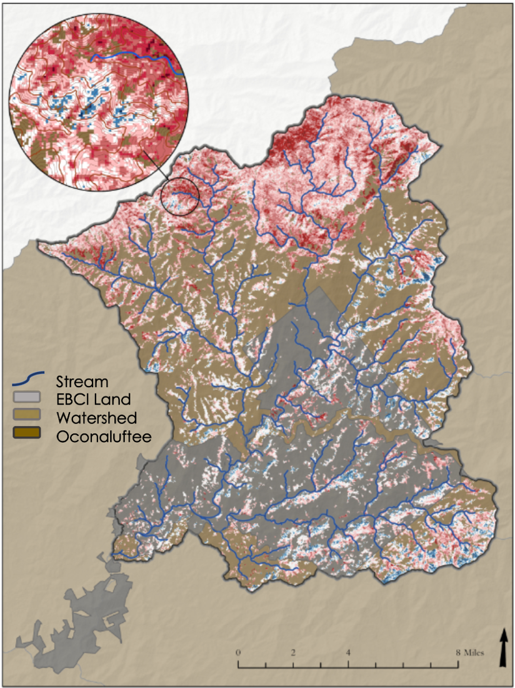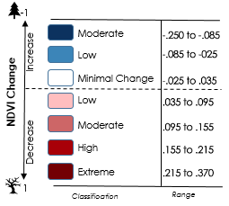

*Figure 3.* Categorized Winter NDVI Change 2003-2010 in evergreen and mixed forests (NLCD Land Cover) in the Oconaluftee watershed. The values of NDVI change (right column of legend) were categorized into moderate to low NDVI increase, little to no change, and low to extreme decrease values.

Of evergreen and mixed forests in the Oconaluftee watershed, 67.16% exhibited a decrease in NDVI, 27.65% showed a minimal change, and 5.16% exhibited an increase in NDVI from 2003 to 2010 (Figure 4). With higher resolution, the team expects that the percentage of these areas experiencing decline would change, due to greater specificity in identifying individual trees. Using recent NAIP imagery—which was flown with red, green, blue, and near-infrared bands—it would be possible to find each individual tree. However, these 4 band NAIP products do not exist for the 2000s, meaning the data could only be used for more recent analyses.

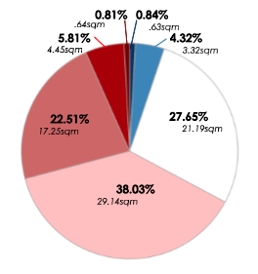

*Figure 4*. NDVI Change Categorization by area within Evergreen and Mixed Forests (NLCD Land Cover) in the Oconaluftee watershed for decrease (red), minimal change (white), and increase (blue).

Because this analysis used several tiles from Landsat 5 to create each winter NDVI image, it is possible that portions of the image were sampled at different times from year to year. For example, the range of dates we allowed for our “winter” image was December 1 to March 1. If the same region within our study area was sampled in December in 2003 or 2004 and March in 2009 or 2010, the NDVI characteristics may not be represented consistently. Because we relied on GEE to produce cloud-free images, we cannot say definitively that this effect did not occur. The increased NDVI observed in some parts of the map above (Figure 5) could be the result of compensatory evergreen growth, such as rhododendron or other evergreen understory species filling available space.

***4.2 Weighted Suitability Analysis Results***

The single category method highlights areas that meet the selected suitability criteria within evergreen and mixed forest types in the Oconaluftee watershed. Based on this method, 8.54 square miles of land in the watershed were identified as ‘hemlock suitable’, making up 4.54% of the total watershed area. The multi-category method included all forest types (evergreen, mixed, and deciduous). This method output 17.91 square miles of land categorized as highest suitability, which equates to 9.53% of the total watershed area (*Figure 5*).

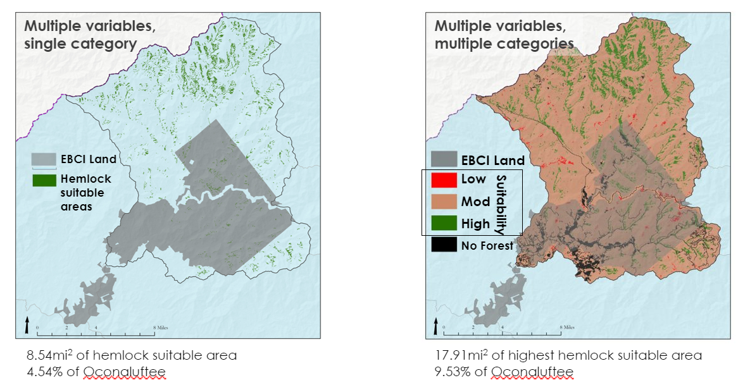

*Figure 5*. Hemlock suitability within the Oconaluftee watershed. Left: single-category, Right: multi-category.

The team was able to categorize the areas of highest hemlock suitability from the multi-categorical method based on forest cover type. The pie chart in Figure 6 shows percent of highest suitability areas that appear in each forest cover type. For example, 34% of the highest suitable pixels were found in the evergreen forest classification. Additionally, the team produced a bar graph (Figure 6) that show percent of forest cover type in the Oconaluftee that contains highest suitable areas. For example, 28% of the evergreen forest classification in the Oconaluftee contains areas classified as high suitability.

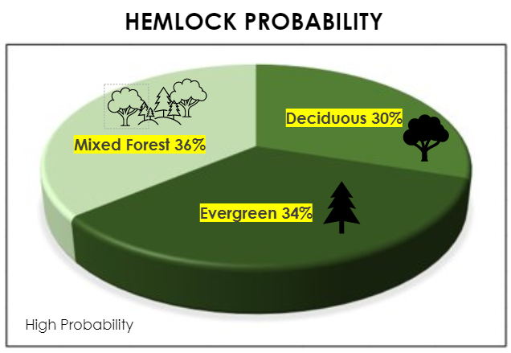 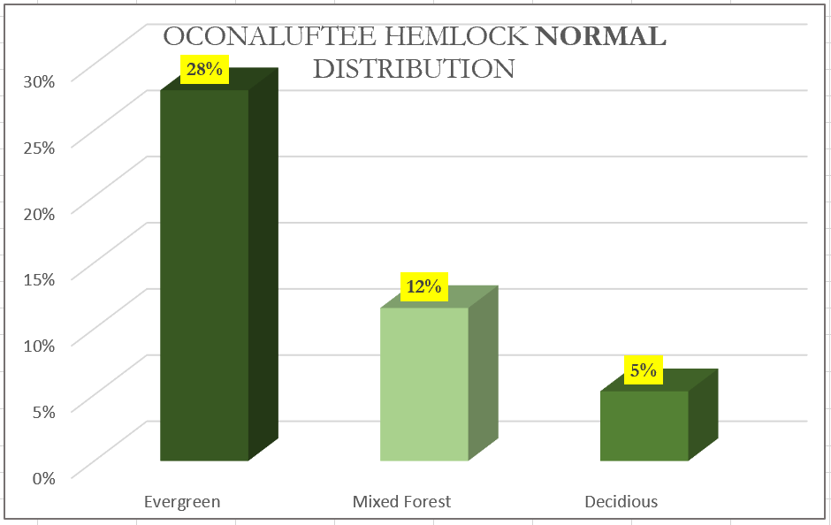

% of Highly Suitable pixels in each forest type

*Figure 6*. Left: The percent of high suitable areas found within each forest cover type. Right: The percent of area in each forest cover type in the Oconaluftee watershed that contains highly suitable areas.

***4.3 Future Work***

Future work on the investigation of hemlock decline in the EBCI region should include climate and ecological data to understand changes that result from hemlock loss. Areas of historical hemlock loss identified in this project could be further investigated in relationship to variables such as temperature, vegetation composition and height, soil moisture, and other environmental conditions to provide insight as to how areas with hemlock mortality transition. Hemlocks play important ecological roles in their environment and understanding how these areas transition after hemlock loss would be beneficial to predict future environmental change. Another future project worth investigating is the relationship between fires and hemlock mortality in the area, as dead hemlocks have potential to abet wildfires. NASA fire data could be used in conjunction with land classifications to further investigate possible correlations between hemlock mortality and local wildfires. Another possible future project could map hemlocks treated with chemicals to reduce mortality from HWA with surrounding untreated hemlocks to compare success of hemlock treatments. With the indices function available in ArcGIS Pro, the study can shift data collection to retrieve other multi-spectral indices derived from other satellite missions.

# 5. Conclusions

This project was able to use 30-meter, multi-spectral imagery from the Landsat missions to map areas of likely hemlock decline in the Oconaluftee watershed. These results will help the EBCI Natural Resources program identify stands experiencing decline for the application of management practices. This knowledge of hemlock presence and decline in the region can aid our partners in management efforts and increase community awareness of local hemlock health. The weighted suitability analysis provides a replicable framework for the partners to understand opportunities for restoration efforts in the region. The results of the suitability analysis can be used as a benchmark to map changes in suitability over time as a way to help prioritize field work and other restoration or management efforts. The project also connected the partners to resources that will allow them to recreate these methods, such as a package of ArcPro model builders that outline the calculation of NDVI and the weighted suitability analysis process.

# 6. Acknowledgments

* Dr. Steve Norman (Science Advisor)
* Dr. Bjorn Brooks (Science Advisor)
* Maria Dunlavey (EBCI)
* Dr. Caleb Hickman (EBCI)
* Tommy Cabe (EBCI)
* Margot Wallston (Hemlock Restoration Initiative)
* Jesse Webster (Great Smoky Mountains National Park)
* Andrew Shannon (NASA DEVELOP Fellow/North Carolina Lead)

Any opinions, findings, and conclusions or recommendations expressed in this material are those of the author(s) and do not necessarily reflect the views of the National Aeronautics and Space Administration.

This material is based upon work supported by NASA through contract NNL16AA05C.

# 

# 7. Glossary

**Earth observations** – Satellites and sensors that collect information about the Earth’s physical, chemical, and biological systems over space and time

**DEM** – Digital Elevation Module

**EBCI** – The Eastern Band of Cherokee Indians

**EROS** - Earth Resources Observation And Science

**GEE** – Google Earth Engine

**GSMNP** – Great Smoky Mountains National Park

**HRI** – Hemlock Restoration Initiative

**HWA** – Hemlock Woolly Adelgid

**MRLC** – Multi-Resolution Land Classification Consortium

**MODIS** – MODerate resolution Imaging Spectroradiometer

**NAIP** – National Agriculture Imagery Program

**NCEI** – National Centers for Environmental Information

**NDVI** – Normalized difference vegetation index

**NLCD** – National Land Cover Dataset

**RGB** – Red, Green, Blue (color scheme)

**ROI** – Region of Interest

**SRTM** – Shuttle Radar Topography Mission

# 8. References

AL-Taani, A., Al-husban, Y., & Farhan, I. (2020). Land suitability evaluation for agricultural use using GIS and remote sensing techniques: The case study of Ma’an Governorate, Jordan. *The Egyptian Journal of Remote Sensing and Space Science*. <https://doi.org/10.1016/j.ejrs.2020.01.001>

Bonneau, L. R., Shields, K. S., & Civco, D. L. (1999a). A Technique to Identify Changes in Hemlock Forest Health over Space and Time Using Satellite Image Data. *Biological Invasions*, *1*(2), 269–279. <https://doi.org/10.1023/A:1010081832761>

Bonneau, L. R., Shields, K. S., & Civco, D. L. (1999b). Using Satellite Images to Classify and Analyze the Health of Hemlock Forests Infested by the Hemlock Woolly Adelgid. *Biological Invasions*, *1*(2), 255–267. <https://doi.org/10.1023/A:1010021629127>

Earth Resources Observation And Science (EROS) Center. (2014). *Collection-1 Landsat 8 OLI Level-2 Surface Reflectance (SR) Science Product* [Data set]. U.S. Geological Survey. <https://doi.org/10.5066/F78S4MZJ>

Earth Resources Observation And Science (EROS) Center. (2017a). *Collection-1 Landsat 4-5 Thematic Mapper (TM) Level-1 Data Products* [Tiff]. U.S. Geological Survey. <https://doi.org/10.5066/F7N015TQ>

Earth Resources Observation And Science (EROS) Center. (2017b). *National Agriculture Imagery Program (NAIP)* [Tiff]. U.S. Geological Survey. <https://doi.org/10.5066/F7QN651G>

Earth Resources Observation And Science (EROS) Center. (2017c). *Shuttle Radar Topography Mission (SRTM) 1 Arc-Second Global* [Tiff]. U.S. Geological Survey. <https://doi.org/10.5066/F7PR7TFT>

Evans, A. M., & Gregoire, T. G. (2007). A geographically variable model of hemlock woolly adelgid spread. *Biological Invasions*, *9*(4), 369–382. <https://doi.org/10.1007/s10530-006-9039-z>

Federal standards and procedures for the National Watershed Boundary Dataset (WBD) (Report No. 11-A3; 4th ed., Techniques and Methods, p. 77). (2013). USGS Publications Warehouse. <https://doi.org/10.3133/tm11A34>

Forest Stewards. (2016). *Forest Management Plan: Eastern Band of the Cherokee Indians Trust Lands*. Eastern Band of the Cherokee Indians.

Great Smoky Mountains National Park GIS. (n.d.). *GRSM HWA Treatment Areas* [Map]. Retrieved August 5, 2020, from <https://public-nps.opendata.arcgis.com/datasets/grsm-hwa-treatment-areas>

Homer, C. G., Fry, J. A., & Barnes, C. A. (2012). *The National Land Cover Database* (Report No. 2012–3020; Fact Sheet). USGS Publications Warehouse. https://doi.org/10.3133/fs20123020

Koch, F. H., Cheshire, H. M., & Devine, H. A. (2005). Mapping hemlocks via tree-based classification of satellite imagery and environmental data. *Third Symposium on Hemlock Woolly Adelgid in the Eastern United States*.

Madden, M., Welch, R., Jordan, T., Jackson, P., Seavey, R., & Seavey, J. (2004). *Digital Vegetation Maps for the Great Smoky Mountains National Park*. 121.

United States Census Bureau. (2019). TIGER Census Tracts [Data file]. Retrieved on June 18, 2020, from https://www.census.gov/cgi-bin/geo/shapefiles/index.php?year=2019&layergroup=Census+Tracts

Vose, J. M., Wear, D. N., Mayfield, A. E., & Dana Nelson, C. (2013). Hemlock woolly adelgid in the southern Appalachians: Control strategies, ecological impacts, and potential management responses. *Forest Ecology and Management*, *291*, 209–219. https://doi.org/10.1016/j.foreco.2012.11.002

# 9. Appendices

**Appendix A.**Sources of ancillary datasets and information on wavelengths of Landsat imagery

Table A1

*Ancillary datasets used in the project.*

|  |  |  |
| --- | --- | --- |
| **Ancillary Datasets (non EO)** | **Source** | **Years of Collection** |
| Multi-Resolution Land Characteristics | [https://www.mrlc.gov](https://www.mrlc.gov/) | 2001, 04, 06, 08, 11, 13, 16 |
| TIGER – U.S. Primary, Secondary Roads (NC, GA, SC, TN) | <https://www.census.gov/> | 2019 |
| TIGER – U.S. County | <https://www.census.gov/> | 2019 |
| TIGER – U.S. States | <https://www.census.gov/> | 2019 |
| TIGER – Current American Indian Tribal Subdivisions | <https://www.census.gov/> | 2019 |
| Hemlock Conservation Area polygons (GSMNP) | <https://public-nps.opendata.arcgis.com/datasets/grsm-hwa-treatment-areas> | 2012 - 2018 |
| Hemlock Conservation Area polygons (HRI) | Direct contact via e-mail | 2014 - 2018 |
| National Hydrology Dataset: Watersheds | <https://nrcs.app.box.com/v/huc/folder/39640323180> | 2019 |

Table A2

*Wavelengths of selected Landsat bands used for calculating NDVI.*

|  |  |  |  |
| --- | --- | --- | --- |
| **Landsat 5** | | | |
| **Band Number** | **Band Color** | **Wavelength (um)** | **Resolution (m)** |
| 3 | Red | 0.630 – 0.690 | 30 |
| 4 | Near Infrared | 0.760 – 0.900 | 30 |
| **Landsat 8** |  |  |  |
| 4 | Red | 0.640 – 0.670 | 30 |
| 5 | Near Infrared | 0.850 – 0.880 | 30 |

**Appendix B.**Weighted Suitability Analysis Variables & Methods

Table B1

*Averages from 95 observation points in the Oconaluftee HCA polygons. HCA treatments took place between 2012 – 2018.*

|  |  |  |  |
| --- | --- | --- | --- |
| **Oconaluftee Averages** | | | |
| **Source** | **Year** | **Variable** | **Attribute** |
| SRTM | 2013 | Stream Euclidean Distance | 777.31 |
| Landsat8 | 2018 | NDVI Winter | 0.18 |
| MRLC | 2016 | Forest Classification | 2 or 3 forest masks |
| SRTM | 2013 | Aspect | 194.03 |
| SRTM | 2013 | Elevation | 3510.81 |
| SRTM | 2013 | Slope | 4.98 |
| MRLC | 2016 | Urban Euclidian Distance | 8390.01 |
| TIGER | 2019 | U.S. Primary Roads (highways, interstates) Euclidian Distance | 16919.35 |
| Landsat8 | 2018 | NDVI Summer | 0.60 |

Table B2

*Variable inputs and weighted scheme of example single categorical method*

|  |  |  |  |
| --- | --- | --- | --- |
| **Weighted Suitability Single Category Raster** | | | |
| **Variable** | **Attribute Range** | **Rank** | **Weight %** |
| Stream | < 2000ft | 1 | 25 |
| NDVI Winter | >.0 & <.03 value | 2 | 20 |
| Forest Cover | Mixed forest & Evergreen forest | 3 | 18 |
| Aspect | >180 & <45 degree | 4 | 15 |
| Elevation | >2500ft | 5 | 12 |
| Slope | >4 & <6 degree | 6 | 4 |
| Urban | >500ft | 7 | 3 |
| Road | >1000ft | 8 | 2 |
| NDVI Summer | >.4 & <.7 value | 9 | 1 |

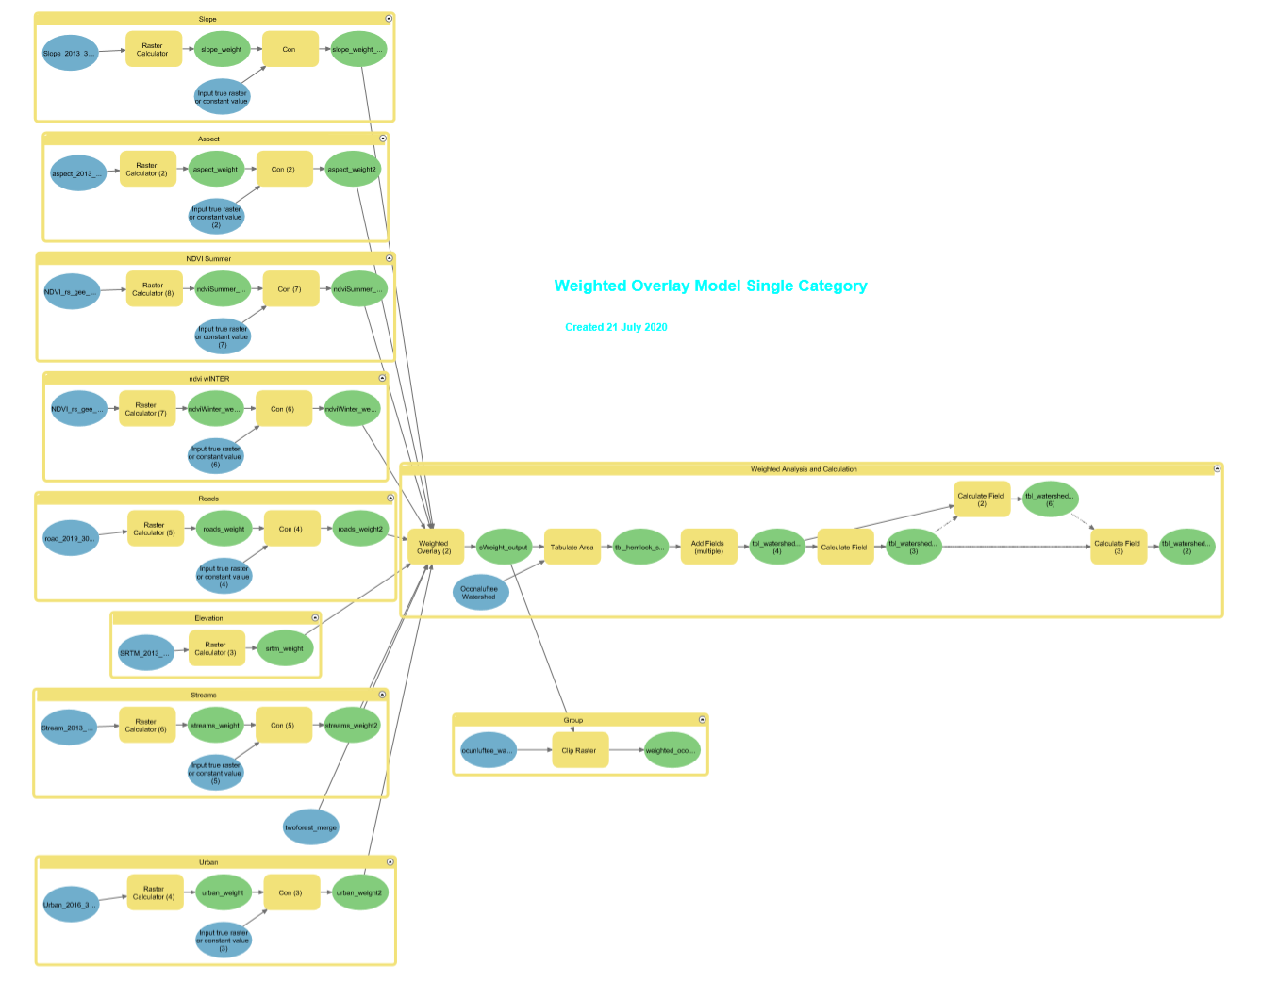

*Figure B1*. Single Category Weighted Suitability Analysis model builder

Table B3

*Variable inputs and weighted scheme of example multi-categorical method.*

|  |  |  |  |  |  |  |
| --- | --- | --- | --- | --- | --- | --- |
| **Weighted Suitability Multi Category Raster** | | | | | | |
| **Variable** | **Reclass 1** | **Reclass 2** | **Reclass 3** | **Rank** | **Weight %** | **Remap Value** |
| Stream | ***0 – 1000*** | 1000 – 3000 | 3000 - 10000 | 1 | 25 | 3, 2, 1 |
| NDVI Winter | -0.83 – 0.1 | ***0.1 – 0.3*** | 0.3 – 0.72 | 2 | 20 | 1, 3, 2 |
| Forest Cover | 41 (deciduous) | ***42 (evergreen)*** | 43 (mixed) | 3 | 18 | 1, 3, 2 |
| Aspect | -1 – 90 | 90 -190 | ***190-360*** | 4 | 15 | 2, 1, 3 |
| Elevation (shown in meters) | 209 – 761 | ***761 – 1371*** | 1371 - 2029 | 5 | 12 | 1, 3, 2 |
| Slope | 0 -3 | ***3 – 8*** | 8 – 90 | 6 | 4 | 2, 3, 1 |
| Urban | 0 – 5000 | 5000 – 25000 | ***25000 – 38000*** | 7 | 3 | 1, 2, 3 |
| Road | 0 – 15000 | ***15000 – 34000*** | 34000 – 52000 | 8 | 2 | 1, 3, 2 |
| NDVI Summer | -0.66 - -0.2 | -0.2 – 0.4 | ***0.4 – 0.76*** | 9 | 1 | 1, 2, 3 |

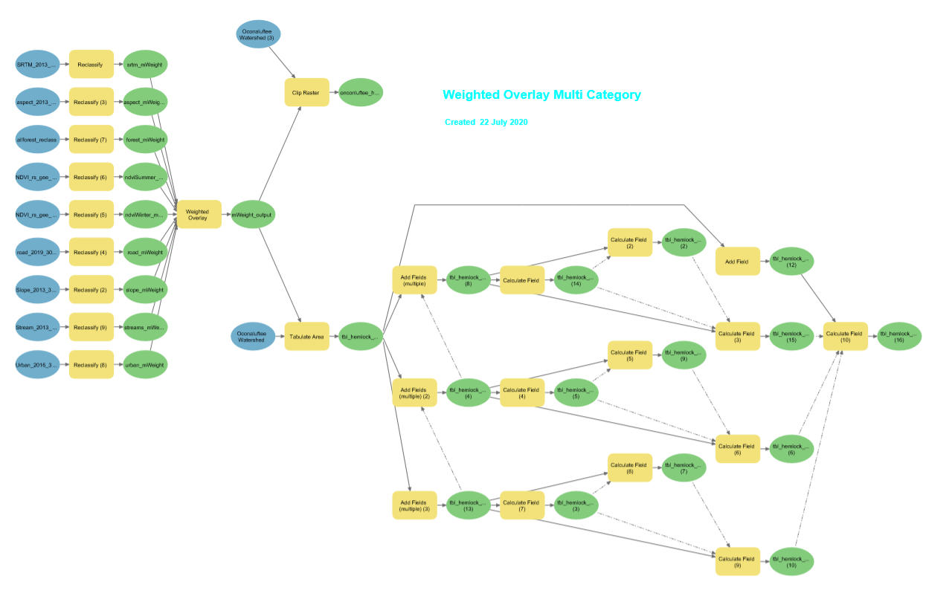

*Figure B2.* Multi-Category Weighted Suitability Analysis model builder