**NASA DEVELOP National Program**

****University of Georgia

**Spring 2016**

**Short Title: Perú Climate II**

**Subtitle:** Monitoring and Forecasting Shifting Climate and Land Change Impacts in Perú’s Parque de la Papa for Enhanced Agricultural Management

**VPS Title:** Hot Potato: Preserving Traditional Farming in the Peruvian Andes

**Project Team & Partners**

**Project Team:**

Caren Remillard (Project Lead), carenremillard@gmail.com

Brandon Hays

Benjamin Page

Adam Salway

Sam Weber

Xuan Zhang

**Advisors & Mentors:**

Dr. Kenton Ross (NASA DEVELOP National Program Science Advisor)

Dr. Marguerite Madden (University of Georgia, Center for Geospatial Research, UGA DEVELOP Lead Science Advisor)

**Past or Other Contributors:**

Rebekke Muench

Kayla McDonald

Ryan Murphy

Michael Sclater

Richard Rose

Dajon Begin

Noel Baker

Genesis Abreu

**Partner Organizations:**

International Potato Center (CIP) (End-User), POCs: Dr. Noelle Barker, Dr. David Ellis, and Rene Gomez; Boundary Organization

Asociación para la Naturaleza y el Desarrollo Sostenible (ANDES) (End-User), POC: Alejandro Argumedo

**Project Details**

**Applied Sciences National Applications Addressed:** Climate, Agriculture, Ecological Forecasting

**Study Area:** Parque de la Papa, Perú

**Study Period:** January 1990 - February 2016

**Earth Observations & Parameters:**

Landsat 4, TM - land cover/planting patterns

Landsat 5, TM - land cover/planting patterns

Landsat 8, OLI/TIRS - land cover/planting patterns, land surface temperature

Terra, ASTER- elevation

**Ancillary Datasets Utilized:**

* NOAA NCDC Climate Data - temperature and precipitation
* CIP HOBO Transportable Weather Stations - temperature, relative humidity, dew point
* CIP GPS Coordinates - locations of potato plots
* Global Historical Climate Network (GHCN) - historical meteorological data
* Servicio Nacional de Meterologia e Hidrologia del Perú (Senamhi) - historical meteorological data
* QuickBird Imagery - land cover

**Software Utilized:**

ArcGIS - raster manipulation/analysis, image enhancement & map creation

ENVI - raster manipulation/analysis, image enhancement & map creation, atmospheric correction

MATLAB - raster manipulation/analysis, image enhancement & map creation

**Project Overview**

**80-100 Word Objectives Overview:**

In recent years, changing climatic conditions have forced traditional farmers in the Peruvian Andes to plant potatoes at increasingly higher elevations. The goal of this project was to use Landsat series satellites, the Terra ASTER sensor, and local climate data to document recent changes in cropland distribution and elevation, temperature, and precipitation within the Parque de la Papa, Perú. These results were then used to inform a crop suitability model designed to identify areas with the most potential for future agricultural use.

**Abstract:**

Agricultural systems in tropical montane regions are particularly vulnerable in the face of global climate change. Anecdotal evidence from Parque de la Papa, located in the Peruvian Andes, indicates that farmers following traditional practices have moved potato crops to higher elevations seeking suitable growing conditions for the potato varieties they have cultivated for centuries. The primary threat to native potatoes has increased mortality rates stemming from pests and diseases. In particular, rising temperatures have led to increases in the population and habitat range of the Andean potato weevil, *Premnotrypes spp*. To assess support for the anecdotal evidence, we quantified changes in potato field elevation over the past three decades using Landsat imagery. This cultivation time-series analysis, slope and elevation data from ASTER, and historical changes in precipitation and temperature was incorporated into a crop suitability model. This model was then used to predict optimal areas for potato cultivation and later given to the International Center for Potatoes (CIP) for use in a management plan to inform the farming efforts of the indigenous communities within Parque de la Papa.

**Community Concerns:**

* Local farmers have been compelled to move their potato crops to higher elevations in response to changing temperatures and increased pest survival
* Less land is available for harvesting and increased topographic variability at higher elevations presents additional challenges
* Indigenous farmers work to maintain traditional farming practices and conserve multiple native potato varieties, making genetic preservation a challenge

**Current Management Practices & Policies**:

CIP works with local communities within Parque de la Papa to ensure farmers are able to maintain potato biodiversity and continue to follow traditional practices. CIP currently maintains and evaluates multiple research plots at different elevations within the park. These experimental plots contain different varieties of potatoes as well as HOBO data loggers which record meteorological data. CIP purchased QuickBird satellite images in 2007 but have not integrated climatic data to assess potato suitability.

**Decision Support Tools & Benefits:**

|  |  |  |
| --- | --- | --- |
| **End-Product** | **Earth Observations Used** | **Benefit & Impact** |
| Cultivation Time-series Analysis | Landsat 4 TM, 5 TM, and 8 OLI/TIRS | Quantify changes in spatial distribution and abundance of land under cultivation |
| Climate Variability Visualizations | None | Model and assess temperature and precipitation regimes affecting the park |
| Crop Suitability Map | Landsat 4 TM, 5 TM, and 8 OLI/TIRS, Terra ASTER | Identify areas with the most potential for future agricultural use under changing climate conditions |

**Project Imagery**

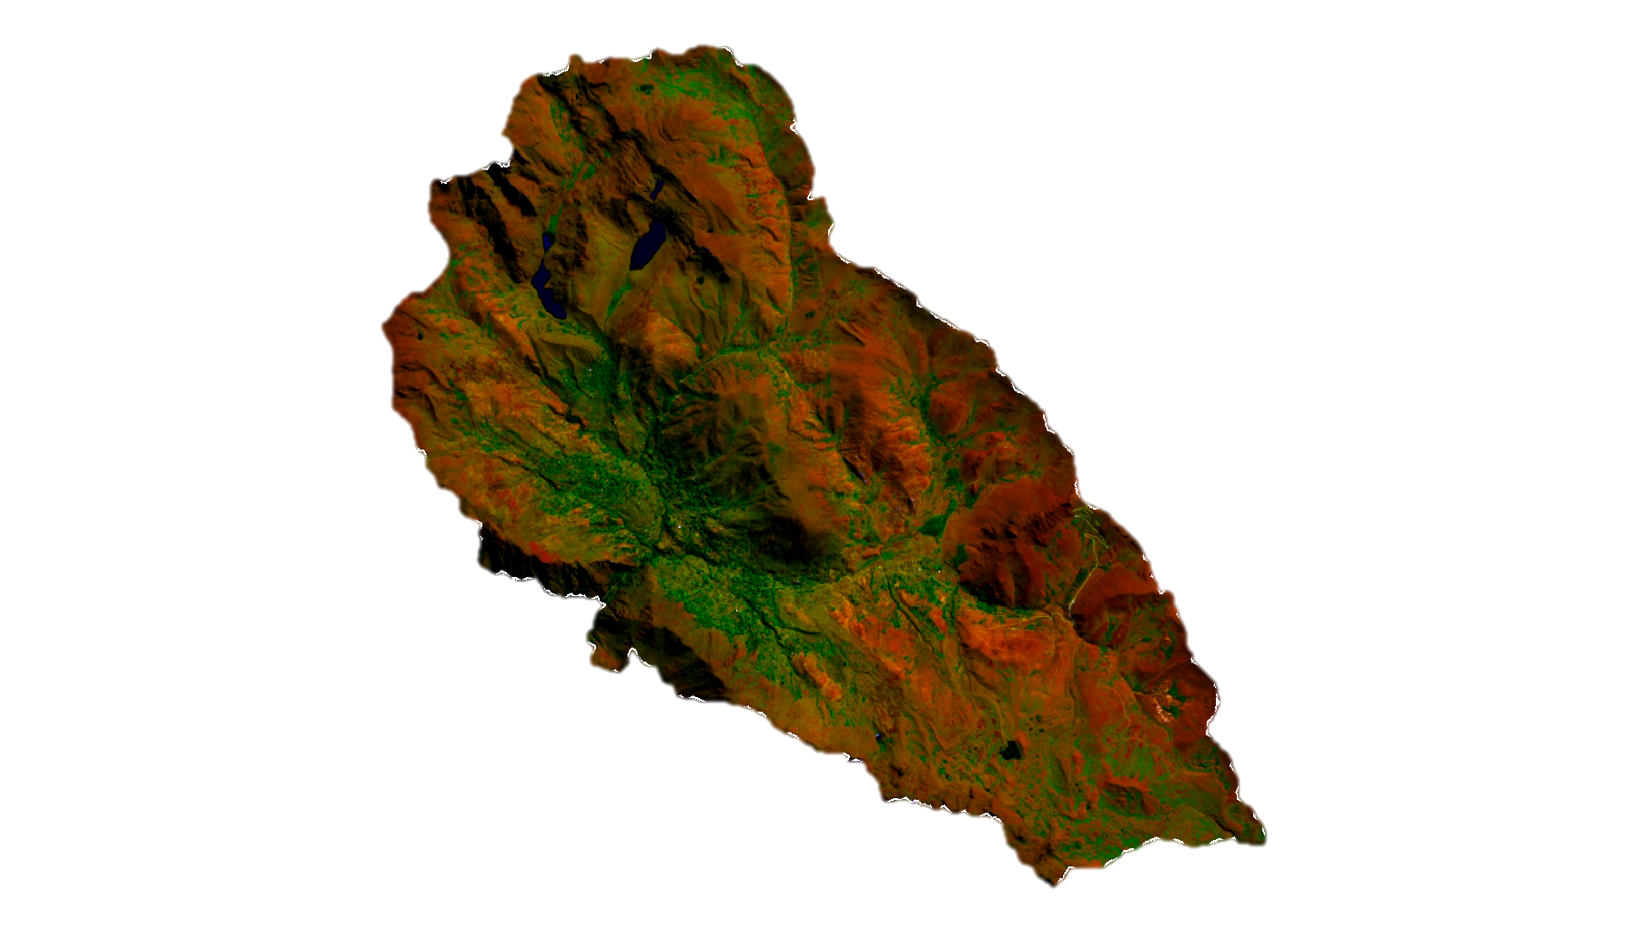

**Caption:** Landsat 8 OLI 6-5-2 band composite image highlighting agriculture in bright green. Image Credit: Perú Climate II Team.

**Image:** 2016Spring_UGA_PeruClimateII_VPSImage

**Software Release Requirements**

What category do the tools your project is creating fall within? Category I