**DEVELOP Virtual Machine Guidebook**

Your virtual machine is a SMCE EC2 instance. Here’s a quick guide on getting it started and using some of its helpful features. Navigate to any of the sections directly by clicking on its name in the Table of Contents.

Table of Contents

I. Launch the EC2 0

II. Remote into Your VM 4

III. SMCE AWS Passwords 7

Check Password Expiration 7

Change Password 8

IV. Connecting to the Shared Drive 9

V. Sharing Files Outside of Your EC2 12

VI. Shutting Down Your EC2 14

**Troubleshooting Note:** If you are experiencing any difficulties with your VM, reach out to James (Jim) Davis via Microsoft Teams or email ([james.davis@ssaihq.com](mailto:james.davis@ssaihq.com)).

# I. Launch the EC2

1. Navigate to the Jenkins server login page: [**https://jenkins.developprogram.org:8443/**](https://jenkins.developprogram.org:8443/)

*Note: If you are logged into a NASA VPN, the page will not load. Disconnect and reload the Jenkins server login page. Most participants will not have VPN access, so this mainly applies to Fellows.*

1. Sign in with the password provided to you by James (Jim) Davis. The username should look something like **firstname.lastname**, and the password will be pretty long!

*Note: Passwords are set to expire every 60 days. Refer to Section III on how to check and change your password*

1. Select **AWSDevelop**. This is where you will be able to view the job build history and start a new job.

1. In the left-hand panel, select **Build with Parameters**. This is where you can start, stop, reboot, or check the status of your EC2.

1. To start your EC2 Instance, you first need to select the type from the **InstanceType** dropdown menu. Because we are starting the instance, select **Start** under the **Operation** dropdown menu, then click the blue **Build** button.

*Participants should start with T3 and Fellows should start with T3G. Upgrades to other instance types must be approved by DEVELOP Leadership. If you find programs are running slowly, ask your Fellow to submit a VM upgrade request and forward to Jim Davis.*

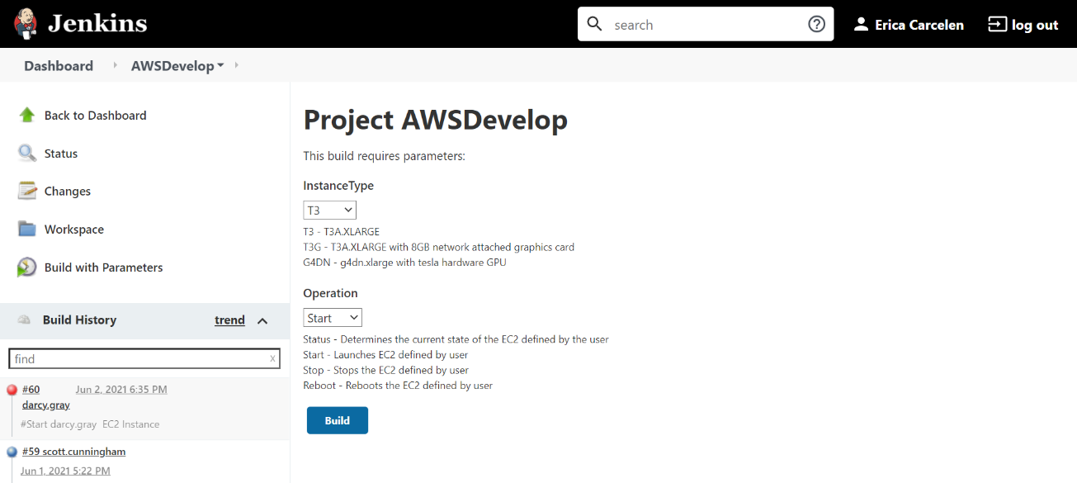

1. You can view the progress of your build under the **Build History** panel on the left-hand side.

1. Wait until the progress bar shows the build is complete (it should have a green checkmark or blue circle next to it in the **Build History** panel). It will always be the first one in the list.
2. Once the build is complete, select once again **Build with Parameters** and run a Status check by selecting the correct InstanceType, and the Operation option to “Status”, and hitting “Build”.

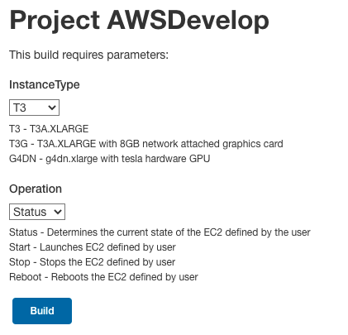

1. Once again, wait for build to complete, then click on the Status build under “Build History”. Then, select **Console Output** on the left-hand side.

1. Scroll to the bottom of your console output and find your IP address. It will be towards the bottom half of the screen, nested in an entry that will look like this: Develop-SGARA-jadavis5_T3 running ami-07ed7a6c8391a9c82 0.101 i-0a72ae989c58a83be May 27 2020 01:13 PM t3.xlarge Summer2020 **54.165.146.9**

1. Highlight and copy the IP address and continue to Section II.

# II. Remote into Your VM

1. You will need a Microsoft Remote Desktop client. This client is provided as part of the Windows operating systems.
   1. Mac OS X users will need to download/install from the AppStore.
   2. On Windows, if you search for “remote,” the Remote Desktop client is usually the first applications offered.
2. Launch Microsoft Remote Desktop. Enter the IP address you located in Section I, Step 11 in the field labeled Computer (Windows) or PC name (Mac).

v

1. Click **Connect** (Windows) or **Add** (Mac) and double click the PC you just added in the Remote Desktop main page.
2. Enter your login information. Your username is develop\**firstname.lastname**, and the password is the same you used to get into the Jenkins server in Section I, Step 2.

1. You may get a pop-up about validity of certificate similar to the example below. Click **Continue**, this is normal for Remote Desktop connections to EC2 instances.

1. After clicking **Continue**, you should be greeted with your EC2 instances’ desktop!

# III. SMCE AWS Passwords

For security reasons, your SMCE AWS account passwords expire every 60 days. Please keep track of when your password will expire and remember to change it beforehand!

## Check Password Expiration

1. When logged into your EC2, a window should pop up within 10 days of expiration with a warning that your password will expire soon. However, you can check the expiration date at any time.
2. Open the **Command Prompt** application in your EC2. In the Command Prompt application, type **net user <your login> /domain** replacing <your login> with your AWS username (typically firstname.lastname) and hit Enter

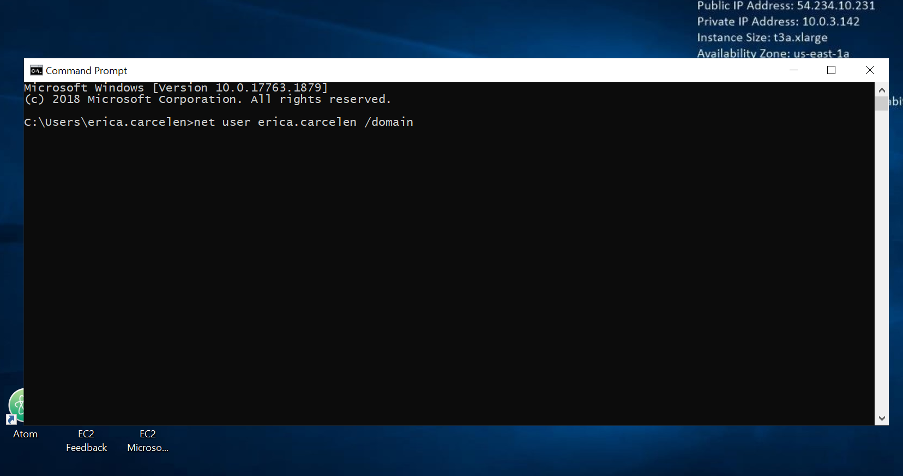

1. A report will then show up with information about your account. Refer to the passwords section for the exact day your current password is set to expire.

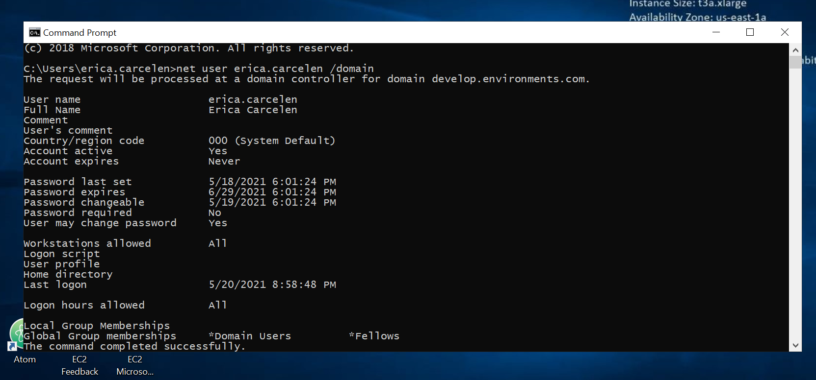

## Change Password

1. In the Command Prompt on your EC2, type **osk** and hit Enter.
2. A keyboard will pop up. On your machine’s keyboard **hold Ctrl-Alt** (these should turn blue on the screen keyboard) and **click Del** on the screen keyboard. *Make sure you* ***click Del on the screen keyboard*** *and do not hit Del on your machine’s keyboard.* If you hit instead of click, you may be changing the password on your local machine, not the EC2!

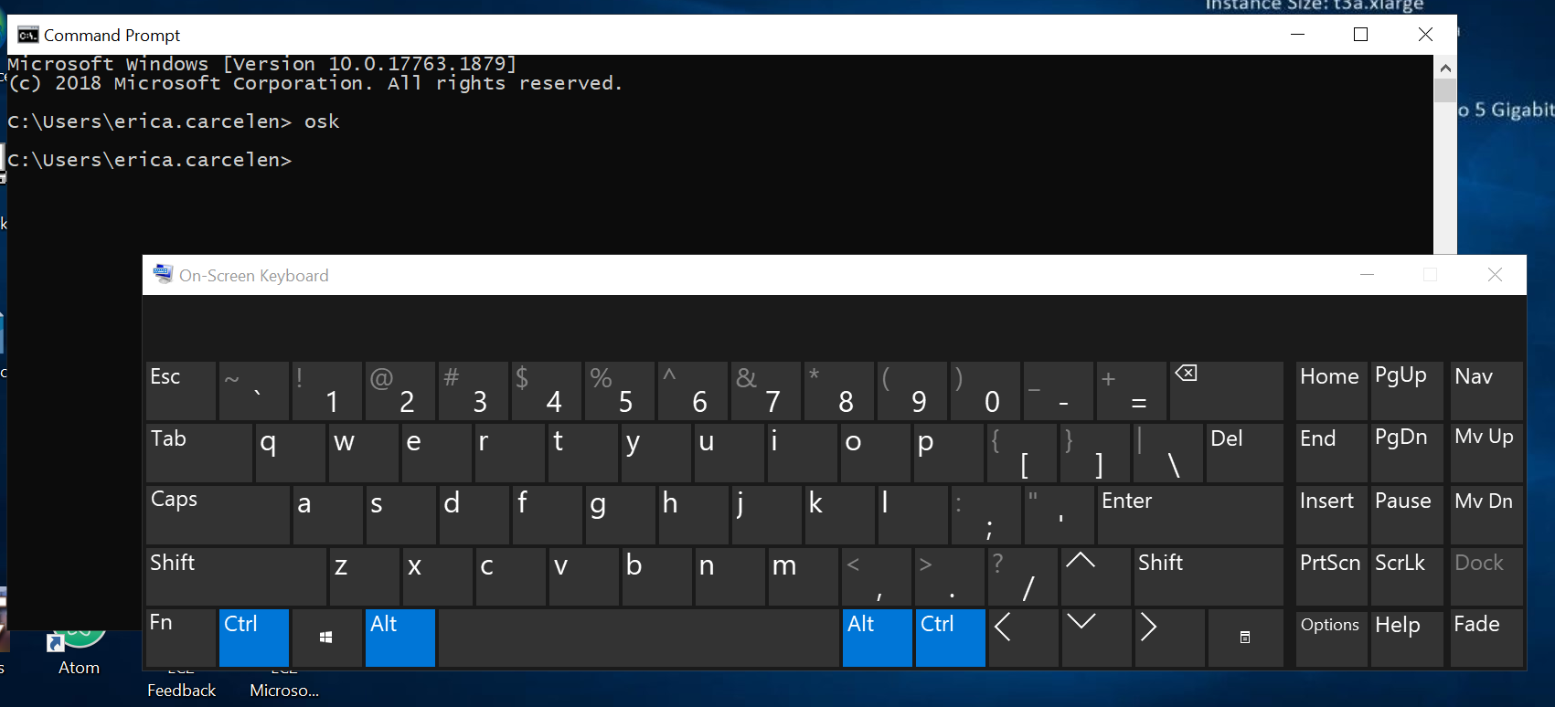

1. Select **Change a password** and fill out the sections accordingly. Now your password is set for the next 60 days!

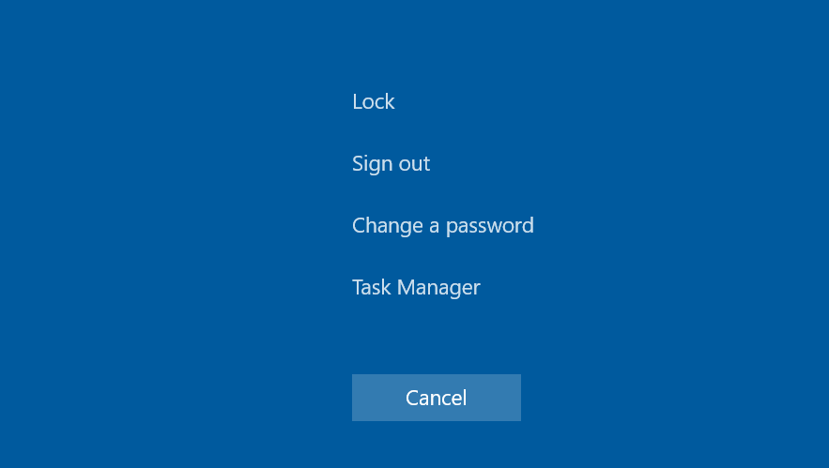 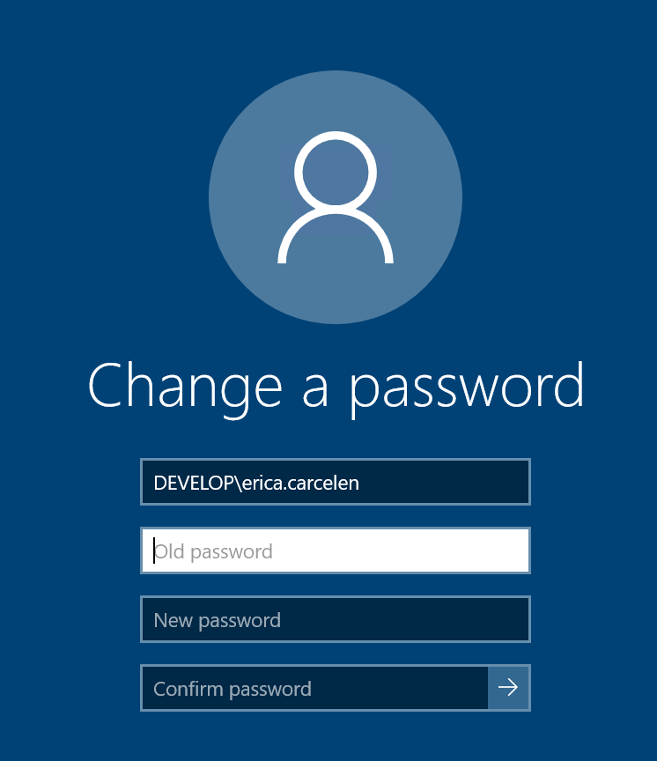

# IV. Connecting to the Shared Drive

Map your network drive to the D: drive to share files and data between your team’s VMs. The shared drive may already be mapped to the D: drive. If you do not see \\developfs1.developprogram.org\ under Network locations, follow the steps below.

1. Open **File Explorer** by double clicking the folder icon in the bottom left task bar of your desktop.

1. Right click on the **Network** icon on the left-hand panel and select **Map network drive…** from the pop-up selection screen.

1. Select drive letter **D:** for the mapping.
2. Enter **\\developfs1.developprogram.org\share** in the **Folder:** path field.

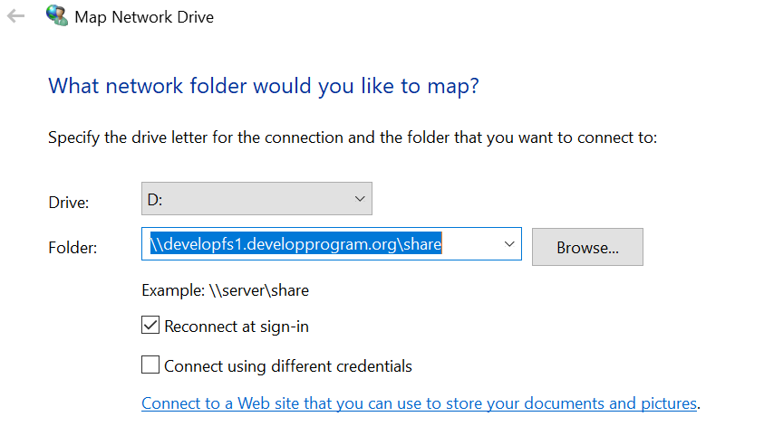

1. Ensure the box is checked for **Reconnect at sign-in**. Click **OK**.
2. Verify you see a **C:** and a **D:** drive mapping in File Explorer when you select **This PC** in the left side panel.

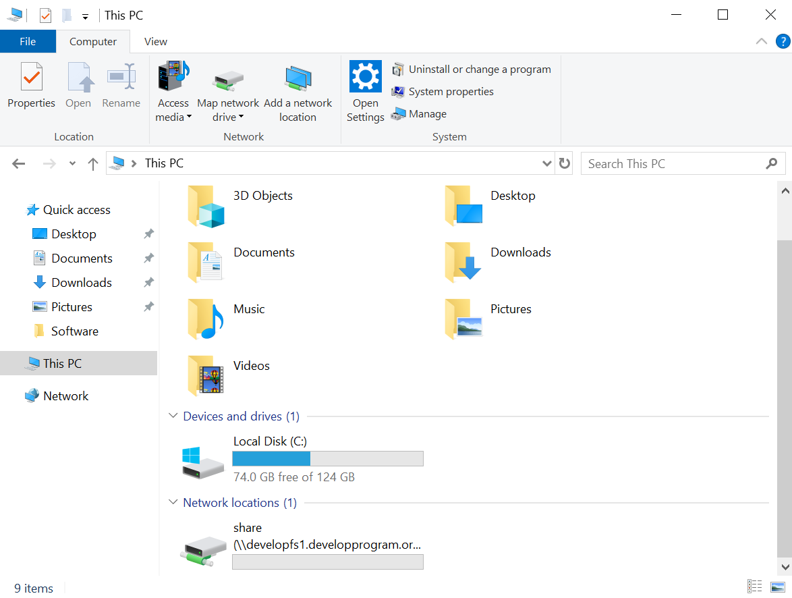

**Things to Note:**

* This shared **D:** drive is your DEVELOP project space. With everyone mapping this drive to their EC2 instances, you can easily share files between systems and have applications access that shared data for processing.
* AWS will perform periodic snapshots (backups) of this space.
* If your EC2 instance was terminated, any data on this shared drive will remain.

# V. Sharing Files Outside of Your EC2

Install the AWS Amazon WorkDrive software to your EC2 instance to make files available between your EC2 and local machine (i.e., your laptop).

1. You can download the WorkDocs drive software for pc by navigating to the following website on your **EC2’s desktop**: [**https://amazonworkdocs.com/apps.html**](https://amazonworkdocs.com/apps.html)
2. Select **Download for PC** under the Drive App section save the file when the pop-up appears.
3. Launch the file to install WorkDocs. Select **Yes**.

1. Click **No**, you will restart after completing the installation configuration.

1. Enter **developprogram** as the WorkDocs site URL and click **Next**.

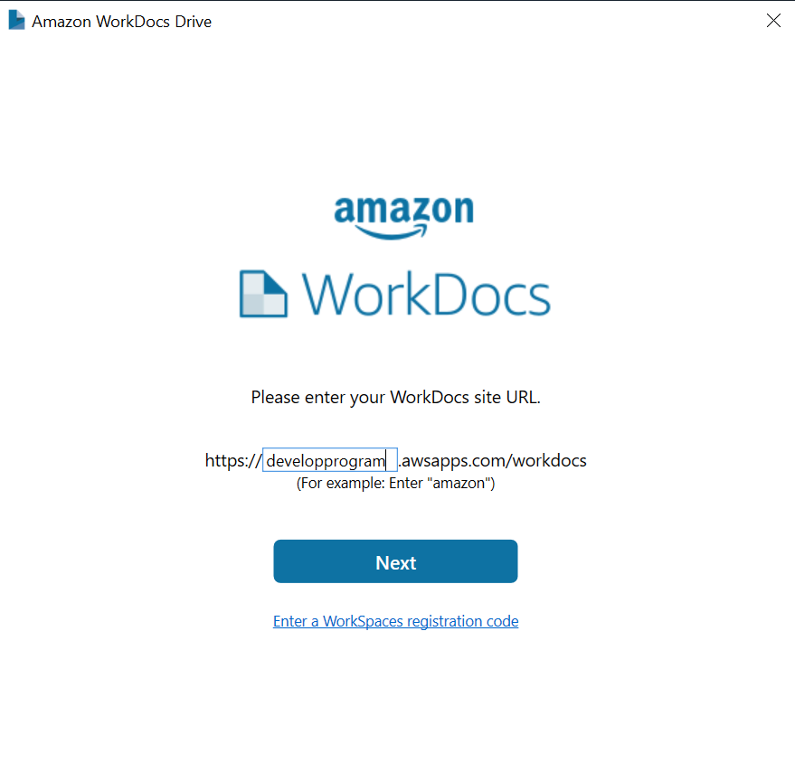

1. Enter the same username and password you used to login to the Jenkins server to sign in.

1. Restart your EC2 instance to finish the installation of the WorkDocs Drive.
2. After your EC2 restarts and you are able to login, open up File Explorer and click on the This PC icon in the left panel. You should see a **C:** , **D:** and **WorkDocs** drives listed like the picture below.

1. You’ve connected your AWS WorkDocs folder to your EC2, now you can put files in this folder for access outside of your EC2. To get to this AWS folder outside of your EC2, login to AWS WorkDocs on your browser at [**https://developprogram.awsapps.com/workdocs**](https://developprogram.awsapps.com/workdocs) or repeat Steps 1-8 on your local machine.

# VI. Shutting Down Your EC2

You ***MUST*** shut down your EC2 every single time you are done using it! We don’t want to waste energy or money on an unused virtual machine.

* 1. If you are not currently logged in to Jenkins, you will need to log back into the Jenkins server: [**https://jenkins.developprogram.org:8443/**](https://jenkins.developprogram.org:8443/)

* 1. Click on **DevelopAWS** to navigate back to the DEVELOP AWS project page.
  2. Select **Build with Parameters** on the left-hand side panel.

* 1. In the **Operation** dropdown menu, select the option **Stop** and make sure the **InstanceType** is set to the same one you started (T3, T3G, etc.).

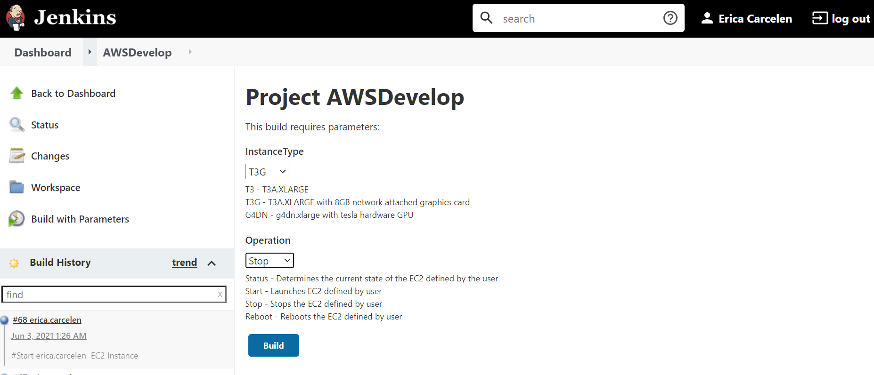

* 1. Click the blue **Build** button.
  2. You can view the progress of your Stop job in the bottom left-hand panel under **Build History**. Your job will always be the first one listed.
  3. Once you see a green checkmark next to it, you know that your EC2 has shut down and you are good to log off for the night.

c