Marin County Wildfires II

Improving Fire Suppression Modeling to Inform Fire Prevention and Suppression Decisions in Marin County, CA

 **Technical Report**

August 11th, 2023

Harrison Raine (Project Lead)

Anai Tene

Katherine Scott

Tiffany Mar

Nikitha Shivakumar

***Advisors:***

Dr. Juan Torres-Pérez, NASA Ames Research Center (Science Advisor)

Dr. John (Jake) Dialesandro, Santa Clara University (Science Advisor)

Britnay Beaudry, NASA Ames Research Center (Science Advisor)

***Previous Contributors:***

Suhani Dalal

Katera Lee

Chandler Ross

Gabriel Rosenstein

***Fellow:***  
Lisa Tanh (ARC)

# 1. Abstract

A future of increased wildfires requires greater integration of spatial analysis and local knowledge of emergency responders. We examine the application of a Potential Operational Delineations (PODs) framework for strategic pre-fire planning in Marin County. PODs are spatial units for wildfire management that combine predictive modeling and local firefighter expertise to identify potential control locations as unit boundaries and assess the difficulty of suppression within units. Additionally, this project explores the integration of road networks and social vulnerability to assess environmental justice in evacuation safety. This project constitutes a novel application of the PODs framework as it integrates expertise from Marin County senior firefighters with a Fireline Location Model (FLM) to achieve POD definition and uses a Suppression Difficulty Score (SDS) to rank each POD. The FLM uses network analysis and hydrologic modeling to identify key roads and ridgelines as boundaries and combines them with expert knowledge, in the form of

workshops, to construct PODs. Once identified, PODs are classified using SDS, which includes processed inputs such as LiDAR-derived aboveground biomass, ECOSTRESS Evaporative Stress Index, land use cover type from Sentinel-2 Imagery, and a digital elevation model. Environmental justice for evacuation safety incorporated three key road metrics such as connectivity, travel area, and exit capacity, the Social Vulnerability Index from the Center for Disease Control, and cell coverage to determine a final Evacuation Difficulty Score. Results indicate a strong link between road networks as primary POD boundaries, with ridgelines and waterways as secondary and tertiary locations. Specifically, we find 78.5% of expertise-identified POD boundaries align with FLM-determined boundaries. More validation is needed to support this process; however, initial results signal a feasible framework to integrate expertise and spatial analysis in local level strategic fire planning.

**Key Terms:**

Wildfire modeling, Potential Operational Delineations (PODs), Suppression Difficulty, Random Forest, ECOSTRESS, Network Analysis, Evacuation, Environmental Justice

# 2. Introduction

***2.1 Background Information***

*2.1.1 Background Information*

Wildfires are increasing in intensity and frequency in California, and this is attributed to climate warming, severe drought, and fuel accumulation due to decades of active fire suppression (Chen & Jin, 2022). Weather is the most variable component that affects the speed and intensity of wildfires, as temperature and humidity fluctuate daily and determine the probability of ignition for vegetation (Millison et al., 2018). Topography is another driver of fire behavior, as slope and landform influence the intensity and speed of wildfire spread (Millison et al., 2018). Fuel, in the form of vegetation, is the ultimate factor in determining how wildfire travels through a given landscape and is most imperative when predicting wildfire risk (Millison et al., 2018).

The rapid expansion of infrastructure and human settlements into previously undeveloped areas in California is increasing the wildland-urban interface (WUI; Radeloff et al., 2005; Chen & Jin, 2022). WUI areas are characterized as high-risk due to an interspersion of flammable wildland vegetation with human structures, and California’s most catastrophic wildfires often occur within the WUI (Moritz et al., 2014).

Due to the increasing volatility of wildfires, fire managers and researchers are in need of new solutions to address growing risk, especially within the WUI. Tools such as remote sensing and fire modeling are of rising importance to support disaster planning, response, and recovery. Remote sensing can be utilized for mapping fuel types on a global scale (Mitsopoulos et al, 2017). High spatial resolution imagery allows for the creation of fine-scale measurements in the fuel models, consequently allowing for mapping of the fuel model’s spatial extent and fire suppression difficulty maps (Mitsopoulos et al, 2017).

Additionally, Potential Operational Delineations (PODs) are now being developed by state, local, and federal agencies as a means of fire management and assessment (Thompson et al., 2020). POD maps compartmentalize a continuous landscape into discrete units, demarcated by rivers, roads, and ridgelines. These compartmentalized areas are bounded by potential fire control locations that support strategic fire planning and emergency response (Greiner et al., 2021). POD Networks are identified through workshops that combine the expertise of local fire managers with geospatial data for fire control likelihood (Caggiano et al., 2021). These quantitative inputs are then combined with qualitative data via wildfire planning workshops to determine POD networks.

*2.1.2 Study Area and Period*

Marin County is in the northwestern part of the San Francisco Bay Area in California (CalFire FRAP GIS Data, 2023; Figure 1). Marin County experiences strong seasonal fire weather conditions in the late summer & fall, rugged terrain, and a growing wildland-urban interface. All these factors combine to make wildfire suppression in Marin County a difficult and dynamic task.

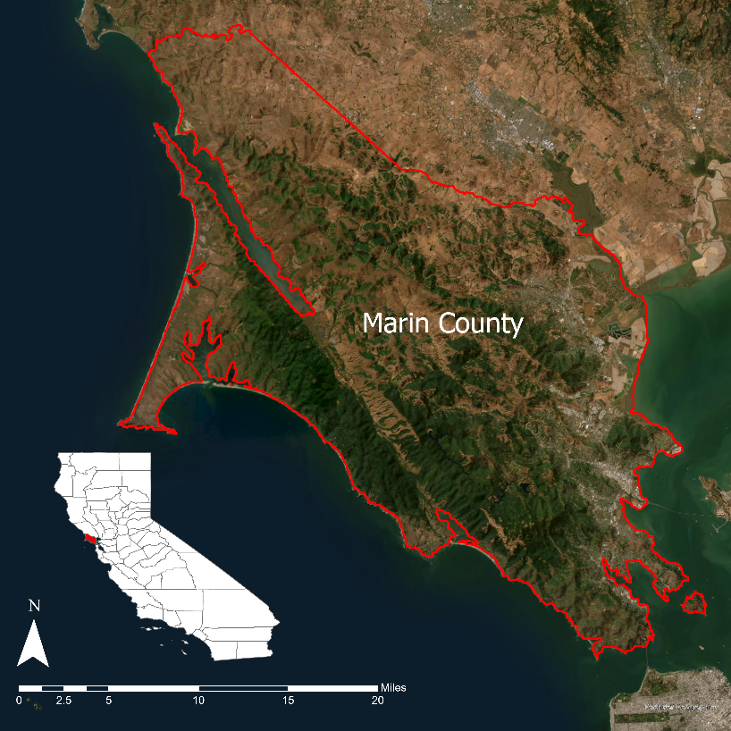

*Figure 1.* 10-meter spatial resolution imagery of Marin County.

The first term of the Marin County Wildland Fire project collaborated with the Marin County Fire Department (MCFD) and FIRE Foundry (Fire, Innovation, Recruitment, and Education) to create models that assist with fire management and suppression. The NASA DEVELOP team’s models used various input data to evaluate where to best target wildfire suppression (Dalal et al., 2023). This term’s project enhanced these suppression models with additional inputs and supplemented the suppression model findings with a PODs network. Additionally, this term expanded beyond biophysical risk and sought to incorporate an environmental justice framework.

Critical to our team and project is recognition of the disproportionate impacts from wildfire across disadvantaged communities in Marin County. Masri et al (2020) identified that wildfires disproportionately impact elderly and low-income communities in California, thereby making safety from wildfires a focus for Environmental Justice (EJ). EJ encompasses the right to a clean, healthy, and (importantly in this context) safe environment and access to resources, such as emergency services, that influence the wellbeing of communities. Our methodology forefronts EJ values by using cell reception data, evacuation route data, indicators of social vulnerability from the United States Census to identify areas vulnerable to wildfire evacuation challenges.

***2.2 Project Partners & Objectives***

The objective of this project was to integrate spatial analysis for wildfire risk with local knowledge and expertise. We used multiple biophysical inputs related to vegetation, terrain, and weather to assess fire risk and identify areas of high likelihood for successful fire suppression. These areas were then vectorized into spatial units, allowing them to be compared against one another through the application of key metrics such as aboveground biomass and evaporative stress. Data on social vulnerability was integrated in this analysis to yield a lens focused on human dimensions within spatial units. Our team used local knowledge to validate the potential areas for fire suppression and their associated risk profiles.

Our project was conducted in partnership with FIRE Foundry and MCFD to explore opportunities to integrate spatial analysis into wildfire management in Marin County. FIRE Foundry is an educational and workforce development program that prepares historically underrepresented populations in Marin County to pursue full-time fire service and fire prevention careers. The program is supported by Conservation Corps North Bay, College of Marin, U.C. Berkeley, Marin Fire, the County of Marin, and more. Through this project, FIRE Foundry recruits benefited from learning remote sensing applications as they learn to make informed decisions regarding vegetation management projects.

MCFD is the primary agency responsible for wildfire management and life safety within Marin County. MCFD can benefit from the results of this NASA DEVELOP project by utilizing the applicable tools and deliverables we provided to expand on their firefighting response and suppression strategy.

# 3. Methodology

***3.1 Data Acquisition***

*3.1.1 USFS Risk Management Assistance Products*

In 2020, the US Department of Agriculture collaborated with Pyrologix to analyze and create open-source Risk Management Assistance (RMA) products for critical fire-prone areas in the Western U.S. Our team downloaded RMA products at 30m spatial resolution, including raster sets for Wildfire Hazard Potential (WHP) and Potential Control Locations (PCLs). These indices are currently identified as the foremost form of analysis for integrating wildfire hazard, exposure, and probability into single metrics.

WHP quantifies the relative potential for wildfire to be difficult to control. This metric relies heavily on high resolution fire modeling outputs to analyze burn and fire length probabilities on a pixel-by-pixel basis. PCLs are scaled from 0-100% and are intended to communicate the probability of successfully containing a wildfire. PCLs are determined by comparing historic fires and their controls with specific landscape characteristics such as fuel transition zones, roads, and topographic features such as ridgelines.

*3.1.2 Moisture & Vegetation Health*

ECOsystem Spaceborne Thermal Radiometer Experiment on Space Station (ECOSTRESS) is a NASA thermal instrument currently onboard the International Space Station that measures vegetation and soil temperature to analyze plant stress with a 70m spatial resolution. We downloaded various ECOSTRESS data layers from NASA’s Application for Extracting and Exploring Analysis Ready Samples (AppEEARS; Appendix A1). The data layer downloaded from AppEEARS was the Level-4 Evaporative Stress Index (ESI; Hook & Fisher, 2019), and this was used to evaluate the stress level of vegetation as well as the drought-susceptibility of Marin County. We also downloaded Level-2 Cloud Masks (Hook & Hulley, 2022) which removed clouds from the data. We then collected ESI and Cloud Mask data for the fire season, which is from May to October, and compiled all images in that season for 2018 to 2023.

*3.1.3 One Tam Products & Aboveground Biomass*

Our team downloaded various LiDAR datasets from the California Forest Observatory that contained canopy height models for Marin County (Appendix A1). Each metric was derived from airborne LiDAR data that was processed through deep learning pattern recognition models. The data was then stored in UTM 10 North coordinate reference system (ESPG: 32610). These data provide canopy cover and canopy bulk density at 3ft resolution. Our team processed high-resolution canopy height rasters in an open-source Random Forest Machine Learning Algorithm to yield Aboveground Biomass data. MarinVegMap also provided rasters for canopy cover and canopy bulk density at 0.91m resolution. These data layers stem from an effort to assess vegetation across Marin County, titled One Tam, from Marin County Parks and supporting agencies to conduct high resolution mapping in December 2018 and March 2019. In addition to canopy height, we accessed county-wide One Tam LiDAR topography products such as a digital elevation model (DEM) slope & aspect. Collection of these 10m spatial resolution products occurred between December 2018 and March 2019. Lastly, One Tam provided high resolution orthoimagery at 0.5ft resolution.

*3.1.4 Environmental Justice*

Our team accessed United States Census Bureau data to obtain Marin County demographic information (Explore Census Data, n.d.). We utilized the Center for Disease Control’s (CDC) Social Vulnerability Index to identify environmental and social factors that are most relevant to Marin County’s communities (ATSDR, 2023). We also used Fire Safe Marin’s evacuation maps to obtain information about evacuation routes and areas classified as Wildland Urban Interface (WUI; Zonehaven, 2020). Lastly, we downloaded available cellular data from T-Mobile and Verizon 4G LTE coverage from the Financial Communication Commission Mobile LTE Coverage Map (2021).

*3.1.5 Ancillary Datasets & First Term Imagery*

Our team acquired datasets related to critical infrastructure such as roads, evacuation routes, trails, transmission lines, and building footprints. These vector datasets are located in two key sources: Marin County GIS Portal for all local level structures and infrastructure and the California Energy Commission for transmission lines. These data were incorporated into the suppression model. Additionally, we utilized the same Sentinel-2 imagery from the first term team’s models as a model input for land classification, and as such it did not require further acquisition or processing steps.

***3.2 Data Processing***

*3.2.1 Potential Operational Delineations*

Our team processed statewide risk management assessment (RMA) data from Pyrologix with additional localized vector datasets from Marin County. Initially in ArcGIS Pro 3.1.1, we defined projection coordinate systems for multiple RMA raster sets to NAD 1983 2011 State Plane III and clipped them to the area of interest. Due to their status as publicly available products for fire suppression, minimal preprocessing was necessary for the RMA datasets. However, to best localize the data to Marin County, we added additional vector datasets acquired from the Marin County GIS portal. Our partners identified the importance of roads, ridgelines, and rivers as important features for fire suppression and these inputs required data processing prior to analysis with RMA products. Our team processed the roads layer through the creation of a network dataset that can be input into Network Analyst tools. This required the calculation of drive times for each road type, as specified by cross-referencing the dataset’s attribute table with Census Feature Class Codes (CFCCs) to derive approximate speeds. Additionally, we buffered the roads centerlines to their appropriate widths based upon CFCC specifications for each road type. Next, we processed county hydrologic data to delineate watersheds utilizing a suite of tools in the ArcHydro toolbox to yield ridgeline vector files. This included a series of models and iterators in ModelBuilder to conduct a workflow that included flow direction, flow accumulation, stream segmentation (watersheds), and the creation of catchment delineation polygons. The boundaries of these polygons serve as ridgelines, as they are the edges of watershed basins. No preprocessing was necessary for river vector data. Finally, our team ran each vector file through a zonal statistics tool to calculate the Suppression Difficulty Score (SDS) and Potential Control Line (PCL) disaster products to yield their average value for each vector file.

*3.2.2 Aboveground Biomass & Canopy Height*

Our team used a canopy height model derived from airborne LiDAR and processed it through a machine learning image recognition algorithm. To translate this model to output aboveground biomass data, we ran the data through a watershed delineation method and the Random Forest algorithm. To start, we used a gaussian smooth convolution method across the canopy height dataset to remove outliers associated with sensor error that could possibly skew the data. Next, using the smoothed canopy height model, we ran an algorithm to determine local maximums and identify the highest tree points in the image. After doing this, we created a mask to represent all the local maximums in the array and removed all the NaN values that could also skew the data. We ran this mask and the smoothened array into the watershed segmentation algorithm, which outputs an array of labels representing the separated tree canopies to be used in the biomass calculations. Finally, we split the array into predictor variables for the biomass and the tree IDs.

Next, we trained and fitted the Random Forest model using training data that was acquired from an SJER biomass dataset. This model was fit to output predictions with an accuracy of 85%. Using the fitted model, we uploaded the predictor variables that were output from the watershed segmentation algorithm. The model then produced an estimate of the total biomass in Marin County as well as a raster that represented the predicted biomass of each individual tree in Marin County.

*3.2.3 Moisture & Vegetation Health*

Once ECOSTRESS ESI and WUE data were downloaded from AppEEARS, it was processed by our team using a Python script that was developed by Dr. Gregory Halverson for the “Applications of Remote Sensing-Based Evapotranspiration Data Products for Agricultural and Water Resource Management” Applied Remote Sensing Training (ARSET, 2022) program. The Python script masked out “no data” values and applied a cloud mask. We then computed composite images for both WUE and ESI for the 2022 fire season. Finally, values that were negative or outside of the expected range for the dataset were removed.

*3.2.4 Environmental Justice*

We chose to create an evacuation route analysis to characterize Marin County’s road networks. We first made fixed buffer areas of 2km centered around each of the 32 towns in Marin County and then analyzed the surrounding towns using three road metrics. The first metric we used was an Exit Capacity metric, which we obtained by buffering at a fixed distance of 2 km and intersecting the buffer edge with roads or evacuation routes. This demonstrated the number of roads available from a town’s center point (Dye et. Al, 2021).

The second metric we used was a Travel Area metric that measured the maximum number of places that can be reached within a specified distance of 2 km from the starting point in the center of the town. This metric measured travel area exclusively along the path of the road network and allowed us to account for the curviness of the roads (Dye et al., 2021). On ArcGIS Pro we used the "Service Area Network Analyst", "Add Locations", and "Solve" tools to calculate travel along the road network. Then, we created polygons for each buffer area to bound and summarize the travel area. The resulting metric was the total area square kilometers of the polygons. Buffer areas with larger travel areas were less vulnerable, as it implies that there is more potential road space to be able to drive away in the event of an evacuation.

Lastly, we created a connectivity metric which summarizes the total number of connected roads at each intersection. The metric is based upon the idea that well-connected streets are more efficient in directing people to their destinations (Handy et al, 2003). We used the "Line and Junction Connectivity" tool in ArcGIS Pro to find the road intersections as vector points and an attribute showing the total of connecting roads at each point. Then, we clipped the areas to be within the buffer areas for each town. Any points that overlapped were added together. Higher values are indicative of greater flexibility and emergency access during wildfire evacuation. The final metric was the sum of the number connecting roads in each buffer area (Dye et al., 2021).

*3.2.5 Additional Data*

We processed road, trail, and power line data in ArcGIS Pro. First, an 8-meter buffer was applied to road data, and a 1-meter buffer was applied to trail and power line data. Then, the polygon buffer file was run through the Polygon to Raster tool so that it could be added to the suppression difficulty model. Digital Elevation Model (DEM) raster images were mosaicked with the “Mosaic to New Raster” tool. Then, the DEM was resampled from 1.5 ft to 10 m, so it matched the resolution of the other inputs to the suppression model. To derive slope and aspect from the DEM, the “Slope” and “Aspect” tools were used respectively.

Additionally, we used network analysis tools in ArcGIS Pro to produce an emergency response layer that calculated areas within 15 minutes of Marin County and partnering fire department stations. This layer utilized the road network dataset that our team created and used traffic conditions based upon ESRI default traffic levels for Saturday, July 8th, 2023. This output polygons resembling accessible service areas for fire stations and imply higher rates of suppression success due to rapid response.

***3.3 Data Analysis***

*3.3.1 Workshop on Potential Operational Delineations*

Without input and buy-in from local experts, Potential Operational Delineations are unlikely to become integrated and operationalized by fire managers. Additionally, local expertise serves as a critical form of qualitative data that can support validation for GIS-derived POD boundaries. Therefore, we facilitated an in-person workshop with senior fire managers at Marin County Fire Department. During the workshop, our team provided experts with overlays of the processed ridgelines and roadways with their probabilities of control demarcated and asked experts to draw and or otherwise indicate where they would attempt to control a wildfire under different scenarios. We also determined from experts which major roadways are to be used in the event of a wildfire. After documenting the control lines that the MCFD would use or construct in the event of a wildfire, our team acquired a sum equivalent of 14.1 miles of expert-defined POD boundaries to be used as a validation set. We then digitized this validation dataset to provide a dataset for GIS-defined POD boundaries and expert-defined POD boundaries. Next, we buffered the GIS-defined POD boundaries by 30ft and used them to clip the expert-defined boundaries. This buffer size was selected to account for 30m spatial resolution in the raster dataset. The clipping removed all overlapping areas of GIS- and expertise-defined boundaries, leaving only the areas of difference between the two datasets.

*3.3.2 Fire Suppression Difficulty Score*

To calculate the SDS, all the inputs were reclassified on a scale of -1 to 5, with -1 values actively detracting from fire suppression difficulty, like roads and trails, and values of 1 to 5 adding to suppression difficulty to various degrees, with values of 5 being the most difficult to suppress. For slope, canopy base height, canopy bulk density, aboveground biomass, ladder fuels, and the evaporative stress index (ESI), the default reclassification values for 5 classes in ArcGIS was used, so values were equally distributed on the 1-5 scale based on how much they would affect fire suppression difficulty. For the land, we took the first team’s Sentinel-2 classification and classified trees as 5, shrub & scrub as 4, grass as 3, crops and bare land as 2, and snow & ice, built, and flooded vegetation as 1. Layers that detracted from fire suppression difficulty, namely roads, trails, and areas within a 15-minute response time from the closest fire department, were all given values of -1 and added to a raster of the whole county that had a value of 0.

Then, all input layers were weighted and added together using the Weighted Sum tool in ArcGIS Pro. The weights must add up to 1, and higher weights had more of an effect on the final SDS. Land cover, slope, and ESI were all weighted the most at 0.16. The 15-minute response time variable was weighted second highest at 0.12. Aspect was weighted as 0.08. Aboveground biomass, canopy cover, and canopy bulk density were weighted as 0.06. Roads, ladder fuels, canopy base height, and trails were weighted the lowest at 0.055.

*3.3.3 Weighting Evacuation Challenges and Social Vulnerability*

To create the Evacuation Difficulty Score for each buffer area, we weighted each category in the following ranges: road metrics (0-3), cellular coverage (0-4), and CDC’s Social Vulnerability Index (SVI) from (0-4). The cell coverage and social vulnerability inputs of the Evacuation Difficulty Score were reclassified to a scale of 0-4, where 0 values were lowest vulnerability, and 4 values were highest vulnerability. For cell coverage, 0 values were where there was no cell coverage, 2 values had one cellular provider, and 4 values had both T-Mobile and Verizon coverage. Each of the three-road metrics (Exit Capacity, Travel Area, Connectivity) were reclassified to a scale of 0-1, then summed together for a total score of 0-3. For all road metrics 1 represents the maximum amount of either exits, roads, or intersections and 0 the minimum.

**4. Results & Discussion**

***4.1 Analysis of Results***

*4.1.1 Potential Operational Delineations*

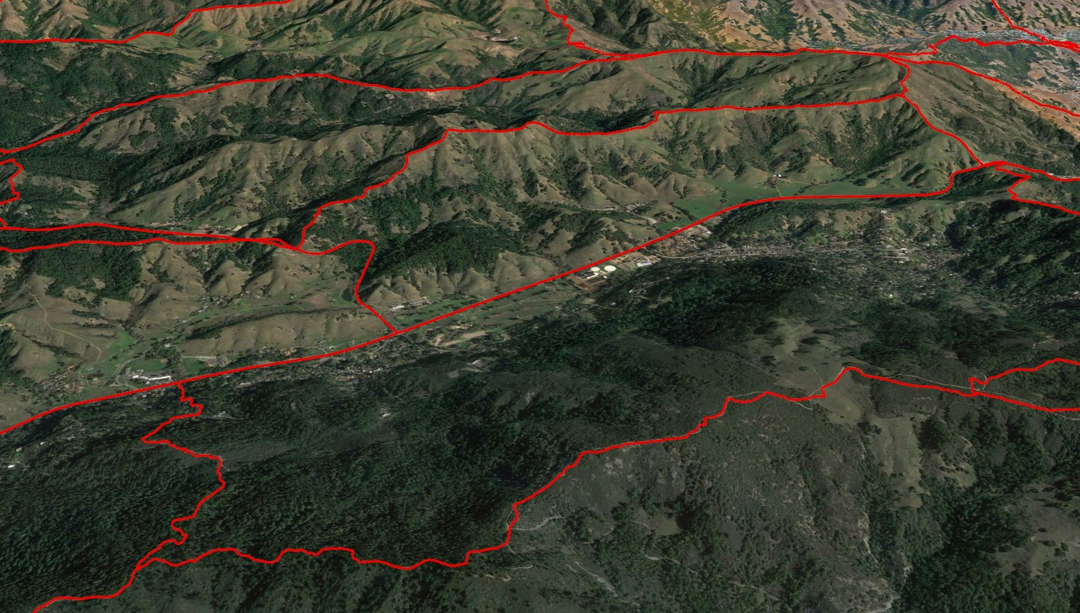Results from the PODs workshop with MCFD senior firefighters identified that 78.5% of expert-defined POD boundaries align with GIS-derived POD boundaries. These results, while preliminary, suggest that the GIS workflow utilized for PODs identification produce results similar to control locations likely to be utilized by Marin County fire managers. This validation supported the use of GIS workflow for POD boundaries for the broader Marin County landscape. For the extent of the study area, PODs followed a similar framework to align POD boundaries with watershed boundaries and major roadways. However, this validation test occurred on a subsection of Marin County and greater validation is necessary to support the implementation and accuracy of a GIS-derived POD network.

*Figure 2.* This is an image of POD boundaries as red vectors as they appear in Google Earth. The boundaries indicate potential control locations for fire that occurs within each unit. These boundaries follow along ridgelines, major roads, and waterbodies.

*Figure 3.* This is an image of the Suppression Difficulty Score (SDS) on the left, added to the PODs map in the middle, with the PODs ranked by their cumulative SDSs on the right.In both the left and right maps, reddish orange represents higher SDSs, and blue represents the lowest SDSs.

*4.1.2 Fire Suppression Difficulty Score*

As can be seen in Figure 2 above, the Suppression Difficulty Score estimates where fire suppression will be more difficult in Marin County, CA on a scale of 0 to 4, with 4 representing areas where fire is estimated to be hardest to suppress. In the map, which is on the left of the figure, dark orange areas are the areas where fire would be hardest to suppress, and blue areas are where fire is estimated to be easiest to suppress. This concentration of higher scoring PODs correlates with the Mt. Tamalpais Open Space, an area of steep canyons with dense vegetation that experiences moderate to high evaporative stress. Full evacuation difficulty scores can be found in Appendix A2.

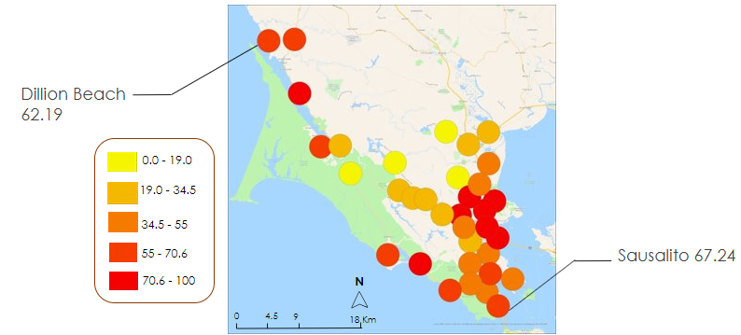

*Figure 4.* Census-designated areas in Marin County with Evacuation Difficulty Scores based on road networks, social vulnerability scores, and availability of cell coverage.

*4.1.3 Evacuation Difficulty Score*

As shown in Figure 4, the Evacuation Difficulty Score was applied to all the buffer areas, summing together the scores for cell coverage, the three-road metrics, and social vulnerability. The score is on a scale of 0-100, 100 representing the most vulnerable areas. In the areas where evacuation is most difficult, the buffer areas are red and areas where evacuation is least difficult are shown in yellow. From a physical location standpoint, the east side of Marin County has more exits available, more places that can be reached and more roads connecting at intersections, than the west side. The top three towns with the most roads connected at each intersection were Northeast San Quentin, San Anselmo, and Mill Valley. However, from an overall approach accounting for road metrics, cell coverage and social vulnerabilities, we found the top three towns with the highest difficulty scores were: San Rafael with a score of 100, San Quentin with a score of 91.4, and Santa Venicia with a score of 83.8. We identified that many of the communities with higher scores correlate with areas of higher CDC Social Vulnerability Scores, such as San Rafael. This demonstrates that evaluating evacuation difficulty from just a physical location standpoint is not sufficient. Once social factors and communication networks are included it provides a holistic approach for evaluating difficulty throughout the towns of Marin County.

*4.1.4 Error Analysis*

Our final suppression model predicted the fire severity of each POD that was identified based on Potential Control Locations for wildfire containment. However, due to time constraints and data limitations, there are some pieces of uncertainty that exist in our model. Regarding Suppression Difficulty Score, the input parameters may not be as up to date or real time as possible, due to the temporal availability of the EO data. Also, the factors that influence fire behavior are difficult to identify due to the unpredictable nature of the weather. Furthermore, in Marin County, due to the cloud cover, numerous EO images during our study period were unusable, resulting in only inputs for the summer seasons that have less cloud coverage. This may misrepresent Marin County as an overwhelmingly cloudless county to partners trying to replicate our Suppression Difficulty Score.

Additionally, the aboveground biomass (AGB) estimation was produced using the Random Forest machine learning model. However, the machine learning model was trained using data from the NEON SJER site, which imposes limitations on the AGB accuracy. Because some trees in Marin County were not represented by this set of training data, there could be some variances in the biomass estimation for individual trees. Our team faced data limitations in this way, as it was not feasible to collect the required data to train the model on Marin County vegetation information.

The Evacuation Difficulty Score was created using the Social Vulnerability Index (SVI) made by the CDC using Census Bureau data. However, there were some uncertainties when using the SVI because the data was collected on a national scale and our study area was localized to a single county. There were also data limitations with the cell coverage network information – our team was only able to acquire for two major cell coverage providers (Verizon and T-Mobile). Therefore, this is not a fully comprehensive description of cell coverage in Marin County because it does not account for populations that use different cellular providers.

***4.2 Feasibility Assessment***

Through this project, our team assessed the feasibility of implementing Earth Observations to inform wildfire suppression and evacuation vulnerability. We incorporated multispectral NASA satellite data for evapotranspiration measurements, as well as aerial LiDAR survey observations for aboveground biomass and tree data. We concluded that it is feasible to create a Suppression Difficulty Score and risk characterized POD map using the remote sensing methods mentioned previously. Further, we were also able to successfully create an Evacuation Difficulty Score to supplement our analysis on wildfire behavior.

Using the outputs provided from our project, the Marin County Fire Department (MCFD) will be able to successfully understand fire suppression for specific spatial regions in Marin County. Because the MCFD has previously relied on local expertise and past fire behavior to understand fire suppression, our Suppression Difficulty Score will provide a standardized way to strategically plan wildfire management and supplement experience-based knowledge. The POD map will allow our partners to understand which regions of the county require further allocation of resources and vegetation management, as well as identify strategic boundaries for suppressing fire. Furthermore, the accompanying Evacuation Difficulty Score will also provide a lens on the environmental justice aspect of wildfires, allowing vulnerable communities to better assess their evacuation options.

***4.3 Future Work***

Future work should incorporate local knowledge and expertise to validate our Suppression Difficulty Score and ensure that each POD delineation is drawn to maximize wildfire suppression efficiency. Additionally, the Suppression Difficulty Score can incorporate additional parameters such as weather data and other NASA earth observations to produce a more well-rounded index. The MCFD would also like to see 4-5 separate POD maps characterized by monthly Suppression Difficulty Scores for each month of the fire season in Marin as well as divided by fire department within the county. Through this adjustment, the MCFD could gain a more comprehensive and detailed approach about fire suppression in response to changing fire behavior. For the Evacuation Difficulty Score, future work can include community refuges as an additional parameter when identifying communities most vulnerable to evacuation barriers. In addition, the Census-designated zones used for the buffer areas can be expanded and localized to town boundaries for a more in-depth analysis.

**5. Conclusions**

In this feasibility study, we found that Earth observations can effectively be used to estimate fire suppression difficulty in Marin County’s unique environment of microclimates. Potential Operation Delineations (PODs) were found to be a useful framework for the Marin County Fire Department to identify strategic boundaries where fire could be contained and fought effectively. Further, we also found that physical and social factors of evacuation difficulty can be effectively analyzed through an Environmental Justice-based analysis.

The Suppression Difficulty Score output revealed that most of the county is susceptible to moderate fire suppression difficulty. After combining our score with the POD map that was created using processed Ridgeline data, our team was able to produce an output that classified spatial regions of Marin based on fire suppression difficulty. The Evacuation Difficulty Score also demonstrated that assessing evacuation difficulty only based on physical factors is insufficient. Incorporating social and communication networks provides a comprehensive method for assessing evacuation challenges across Marin County.

Our team hopes that the Marin County Fire Department can integrate our characterized POD map to better understand fire suppression for Marin County. Firefighters will be able to use our maps to identify potential control locations, support strategic planning, as well as evaluate which PODs could benefit from vegetation management. Additionally, our hope is that the metrics presented within the Evacuation Difficulty Score may help communities understand and prioritize how their evacuation options may be limited by physical and social vulnerabilities.

**6. Acknowledgements**

Our team would like to thank everyone involved in this project for their support and guidance, especially our science advisors Dr. John (Jake) Dialesandro at Santa Clara University and Dr. Juan Torres-Pérez and Britnay Beaudry at NASA Ames Research Center. We thank our project partners, Josh Dimon (FIRE Foundry) and Graham Groneman (Marin County Fire Department) for their support and guidance. Lastly, we want to thank our NASA DEVELOP ARC Fellow, Lisa Tanh, for her great help and our project coordination Fellow Laramie Plott.

This material contains modified Copernicus Sentinel data (2020, 2021) processed by ESA.

Any opinions, findings, and conclusions or recommendations expressed in this material are those of the author(s) and do not necessarily reflect the views of the National Aeronautics and Space Administration.

This material is based upon work supported by NASA through contract NNL16AA05C.

**7. Glossary**

**Canopy Base Height (CBH)** – The distance between the bottom of the canopy and the forest floor. If base height is smaller, a fire is more likely to spread into the canopy where it will do maximum damage while a large base height suggests a crown fire is less likely.

**Canopy Bulk Density (CBD)** –A measure of the weight of the canopy per unit of ground, which tracks how much fine fuel would likely burn in a canopy fire.

**Canopy Cover (CC)** – The percent of horizontal land covered by tree canopy. Complete canopy could lead to more rapid spread of a damaging tree crown fire.

**Canopy Height (CH)** – The distance from the forest floor to the top of the canopy. Used to understand the total aboveground biomass that may be converted into wildfire fuel.

**Earth observations** – Satellites and sensors that collect information about the Earth’s physical, chemical, and biological systems over space and time.

**Fire break** – A gap in vegetation that impedes the spread of wildfire.

**Ladder fuels** – Ladder fuels provide a connection for fire to travel from a mild surface fire into the tree canopy, creating a much more severe and uncontrollable fire. Ladder fuel density measures how much of this dangerous fuel is present per unit of ground. Satellite products alone cannot measure ladder fuel as it is typically obscured by the tree canopy, but LiDAR can measure these fuels.

**LiDAR** – Short for Light Detection and Ranging, LiDAR is an active remote sensing technique that uses a pulsed laser to measure the distance to the Earth and other objects on its surface.

**WUI** – Wildland Urban Interface, a term for urban and residential development that extends into natural areas, putting the infrastructure at fire risk and complicating efforts to fight fire that otherwise could burn naturally without threatening human life or property.

# 8. References

ArcGIS Web Application. (n.d.). Marincounty.maps.arcgis.com. Retrieved June 29, 2023, from <https://marincounty.maps.arcgis.com/apps/webappviewer/index.html?id=688f506cfb144067826bb35a062b0f0a>

ARSET - Applications of Remote Sensing-Based Evapotranspiration Data Products for Agricultural and Water Resource Management. NASA Applied Remote Sensing Training Program (ARSET). (2022). <https://appliedsciences.nasa.gov/join-mission/training/english/arset-applications-remote-sensing-based-evapotranspiration-data>

Brown, C.F., Brumby, S.P., Guzder-Williams, B. et al. (2022). Dynamic World, Near real-time global 10 m land use land cover mapping. Sci Data 9, 251. [doi:10.1038/s41597-022-01307-4](https://doi.org/10.1038/s41597-022-01307-4)

Caggiano, M. D, Thompson, M. P., & Gannon, B. M. (2021). Forest Roads and operational wildfire response planning. *Forests*, *12*(2), 110. <https://doi.org/10.3390/f12020110>

CalFire FRAP GIS Data. (2023). <https://frap.fire.ca.gov/mapping/gis-data/>

Cell Towers, Small Cells, Fiber | Crown Castle. (n.d.). [Www.crowncastle.com](http://Www.crowncastle.com). Retrieved June 29, 2023, from <https://www.crowncastle.com/infrastructure-solutions/?level=9>¢er=-122.40494

Centers for Disease Control and Prevention/ Agency for Toxic Substances and Disease Registry/ Geospatial Research, Analysis, and Services Program. CDC/ATSDR Social Vulnerability Index 2020 Database US. <https://www.atsdr.cdc.gov/placeandhealth/svi/data_documentation_download.html>. Accessed on June 29, 2023.

Chen, B., & Jin, Y. (2022). Spatial patterns and drivers for wildfire ignitions in California. *Environmental*  *Research Letters*, *17*(5), 055004. <https://doi.org/10.1088/1748-9326/ac60da>

Dalal, S., Lee, K., Rosenstein, G., Ross, C. (2023). *Marin County Wildland Fires: Examining Fuel Load and Land Cover Change to Inform Fire Prevention and Suppression Decisions in Marin County, CA*. NASA DEVELOP National Program, NASA Ames Research Center.

Dye, A.W., Kim, J.B., McEvoy, A. et al*.* Evaluating rural Pacific Northwest towns for wildfire evacuation vulnerability. *Nat Hazards* **107**, 911–935 (2021). <https://doi.org/10.1007/s11069-021-04615-x>

EJI Data Download | Place and Health | ATSDR. (2023, May 25). [Www.atsdr.cdc.gov](http://Www.atsdr.cdc.gov). <https://www.atsdr.cdc.gov/placeandhealth/eji/eji-data-download.html>

Explore Census Data. (n.d.). Data.census.gov. Retrieved June 29, 2023, from <https://data.census.gov/table?q=S2503:+FINANCIAL+CHARACTERISTICS&g=050XX00US06041>

Explore Census Data. (2021a). Data.census.gov. <https://data.census.gov/table?t=Housing&g=050XX00US06041>

Explore Census Data. (2021b). Data.census.gov. <https://data.census.gov/table?q=S1601:+LANGUAGE+SPOKEN+AT+HOME&tid=ACSST1Y2021.S1601>

Explore Census Data. (2021c). Data.census.gov. <https://data.census.gov/table?t=Educational+Attainment&g=050XX00US06041>

Explore Census Data. (2021d). Data.census.gov. <https://data.census.gov/table?q=S1701:+POVERTY+STATUS+IN+THE+PAST+12+MONTHS&tid=ACSST1Y2021.S1701>

Greiner, S. M., Schultz, C. A., & Kooistra, C. (2021). Pre-season fire management planning: The use of potential operational delineations to prepare for wildland fire events. *International Journal of Wildland Fire*, *30*(3), 170. <https://doi.org/10.1071/wf20124>

Handy, S, Paterson, RG, & Butler, K (2003). Planning for street connectivity. Getting from here to there. American Planning Association, Planning Advisory Service (Planning Advisory Service report, no. 515), Chicago.

Hook, S. & Fisher, J. (2019). *ECOSTRESS Evaporative Stress Index PT-JPL Daily L4 Global 70 m V001* [Data set]. NASA EOSDIS Land Processes DAAC. Accessed 2023-06-28 from <https://doi.org/10.5067/ECOSTRESS/ECO4ESIPTJPL.001>

Hook, S. & Fisher, J. (2019). *ECOSTRESS Water Use Efficiency Daily L4 Global 70 m V001* [Data set]. NASA EOSDIS Land Processes DAAC. Accessed 2023-06-28 from <https://doi.org/10.5067/ECOSTRESS/ECO4WUE.001>

Hook, S., Hulley, G. (2022). *ECOSTRESS Swath Cloud Mask Instantaneous L2 Global 70 m v002* [Data set]. NASA EOSDIS Land Processes DAAC. Accessed 2023-06-28 from <https://doi.org/10.5067/ECOSTRESS/ECO_L2_CLOUD.002>

Mitsopoulos, I., Mallinis, G., Zibtsev, S., Yavuz, M., Saglam, B., Kucuk, O., Bogomolov, V., Borsuk, A., & Zaimes, G. (2017). An integrated approach for mapping fire suppression difficulty in three different ecosystems of Eastern Europe. *Journal of Spatial Science, 62*(1)*,* 139–155. <http://dx.doi.org/10.1080/14498596.2016.1169952>

Mobile LTE Coverage Map. (2021, August 6). Federal Communications Commission. https://www.fcc.gov/BroadbandData/MobileMaps/mobile-map

Radeloff, V. C., Hammer, R. B., Stewart, S. I., Fried, J. S., Holcomb, S. S., and McKeefry J. F. (2005) The wildland–urban interface in the United States. *Ecological Applications,* 15, 799–805.

Thompson, M. P., Gannon, B. M., Caggiano, M. D., O’Connor, C. D., Brough, A., Gilbertson-Day, J. W., &

Scott, J. H. (2020). Prototyping a geospatial Atlas for Wildfire Planning and Management. *Forests*,

*11*(9), 909. <https://doi.org/10.3390/f11090909>

Yavuz, M., & Saglam, B., (2012). Use of remote sensing and GIS techniques for forest fires. *KSU Journal of*  *Engineering Sciences Vol 11. Issue 1.* 235-242.

# 9. Appendices

Appendix A

Appendix A1.

*List of data products used in the project*

|  |  |  |  |
| --- | --- | --- | --- |
| **Data Name** | **Use** | **Data** | **Resolution** |
| **Risk Assessment Data** | | | |
| Suppression Difficulty Index | [Pyrologix](https://data-usfs.hub.arcgis.com/datasets/usfs::wildfire-suppression-difficulty-index-97th-percentile-2022-image-service/explore?location=38.070082%2C-122.551496%2C12.61) | 2022 | 30m |
| Wildfire Hazard Potential | [Pyrologix](https://data-usfs.hub.arcgis.com/datasets/usfs::wildfire-suppression-difficulty-index-97th-percentile-2022-image-service/explore?location=38.070082%2C-122.551496%2C12.61) | 2020 | 30m |
| Potential Control Locations | [Pyrologix](https://data-usfs.hub.arcgis.com/datasets/usfs::wildfire-suppression-difficulty-index-97th-percentile-2022-image-service/explore?location=38.070082%2C-122.551496%2C12.61) | 2023 | 30m |
| **Earth Observation Data** | | | |
| Land Cover Classification | Dynamic World | 2018, 2019, 2020, 2021, 2022 | 10m |
| Imagery | Landsat 8 | 2018, 2019, 2020, 2021 | 10m |
| Imagery | Sentinel 2 | 2020, 2021 | 10m |
| ESI | ECOSTRESS | 2018, 2019, 2020, 2021 | 60m |
| Vegetation Metrics (Canopy Height, Cover, Ladder fuels, Bulk Density) | [One Tam](https://vegmap.marincounty.org/pages/vegetation-and-land-cover-map-products) and [Cal Forest Observatory](https://forestobservatory.com/) | 2019 | 1m |
| Digital Elevation Model | [One Tam](https://vegmap.marincounty.org/pages/vegetation-and-land-cover-map-products) | 2019 | 10m |
| **Vector Data** | | | |
| Roads | [Marin County GIS](https://gisopendata.marincounty.gov/) | 2017 | - |
| Trails | [Marin County GIS](https://gisopendata.marincounty.gov/) | 2014 | - |
| Evacuation Routes | Zonehaven | 2020 | - |
| Social Vulnerability | [Center for Disease Control](https://www.atsdr.cdc.gov/placeandhealth/svi/data_documentation_download.html) | 2022 | - |
| Cell Coverage | [Federal Communication Commission](https://www.crowncastle.com/infrastructure-solutions/?level=9&center=-122.61643,37.92585) | 2021 | - |

Appendix A2.

*Results Evacuation Difficulty Scores*

|  |  |  |  |  |
| --- | --- | --- | --- | --- |
| **Rank** | **Town Name** | | | **Score** |
| 1 | | San Rafael | 100 | |
| 2 | | San Quentin | 91.4 | |
| 3 | | Santa Venicia | 88.3 | |
| 4 | | Marhsall | 86.8 | |
| 5 | | Northeast San Quentin | 83.8 | |
| 6 | | Las Gallinas | 80.7 | |
| 7 | | San Anselmo | 80.4 | |
| 8 | | Stinson Beach | 77.7 | |
| 9 | | Bolinas | 70.4 | |
| 10 | | Muir Beach | 69.4 | |
| 11 | | Sausalito | 67.2 | |
| 12 | | Tomales | 66.6 | |
| 13 | | Dillion Beach | 62.7 | |
| 14 | | Strawberry | 59.9 | |
| 15 | | Inverness | 58.4 | |
| 16 | | Corte Madera | 54.7 | |
| 17 | | Marin City | 51.8 | |
| 18 | | Tiburon | 49.6 | |
| 19 | | Ross | 47.6 | |
| 20 | | Mill Valley | 46.7 | |
| 21 | | West Marinwood | 46.6 | |
| 22 | | Tamalpais | 43.1 | |
| 23 | | Southwest Ignacio | 40.4 | |
| 24 | | Fairfax | 34.4 | |
| 25 | | Point Reyes | 33.2 | |
| 26 | | San Geronimo | 32.9 | |
| 27 | | Novato | 31.7 | |
| 28 | | Woodacre | 28.5 | |
| 29 | | Black Point/ Green Point | 27.4 | |
| 30 | | Lagunitas | 23.4 | |
| 31 | | Kentfield | 23.1 | |
| 32 | | West Novato | 18.8 | |
| 33 | | Lucas Valley - Marinwood | 18.4 | |