**NASA DEVELOP National Program**



NASA Langley Research Center

**Spring 2015**

**Virtual Poster Session Wave 1 Submission**

**DEVELOP Short Title:** Coastal Mid-Atlantic Water Resources III

**Team Location:** NASA Langley Research Center - Hampton, Virginia

**Project Lead & Email:** Kent Sparrow, kent.h.sparrow@nasa.gov

**VPS Title:** Drought Monitoring in the Coastal Mid-Atlantic Region

**Images:**

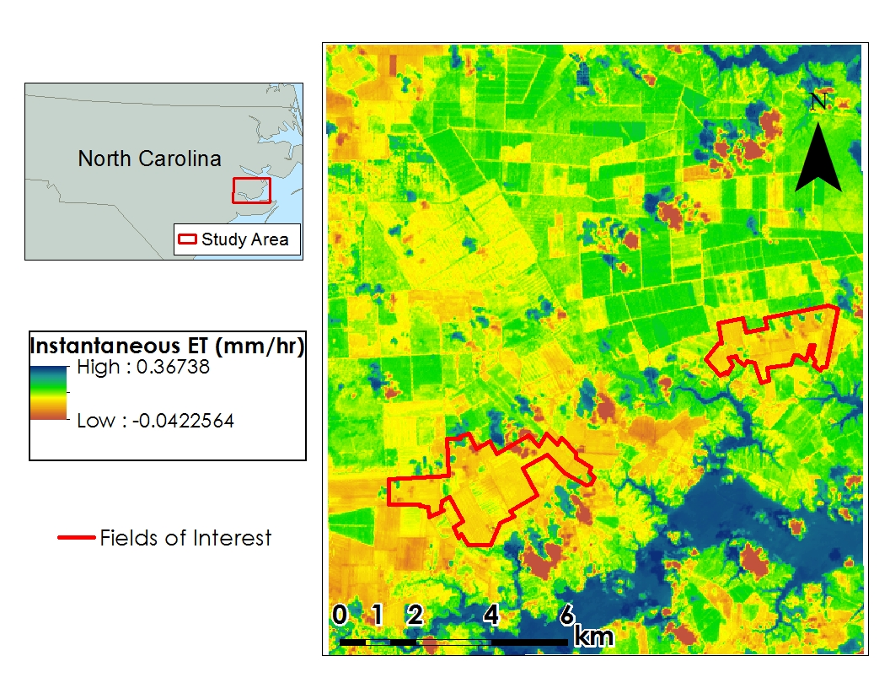

Image 1: Map of ETinst calculated by the METRIC model for the Mid-Atlantic Coastal Plain. The red squares depict our study areas and fields of interest.

**Squib:** (max 50 words)

An increasing demand for food has pressured the agricultural industry to optimize production and increase irrigation efficiency. Could NASA Earth observations be used to mitigate water waste? Come explore how the DEVELOP team used Landsat 8 imagery in the METRIC model to help farmers estimate crop-water use for irrigation planning.

**Video Style:**

This tutorial-styled video will explain the layout of the Coastal Mid-Atlantic METRIC model, how to submit a test run, and how to import and view the output data within ArcMap. We will provide step by step guidance on inputting files and file path naming conventions, note any important constants that are hard-coded into the model, and where to locate the output files. This video is focused on the utilization of the Coastal Mid-Atlantic METRIC model, and the clips will be recorded at NASA Langley Research Center.

**VPS Outline**

**Introduction:**

-DEVELOP Intro clip-

-Intro (images of drought)-

-Background (Scenes of agricultural fields)-

-Team Introductions-

**I**. **Community Concerns**:

1. Environmental Issues:

Wasteful and costly irrigation practices place an unnecessary economic burden on farmers and may negatively affect productivity. ET estimates derived from remotely sensed data may be useful for farmers interested in irrigating crops based on their actual water requirements instead of the traditional static crop coefficients currently used for irrigation planning. It is likely that future drought monitoring and irrigation management can be improved by the use of the METRIC model.

1. Research Purpose:

Using the METRIC model to estimate ET and monitor drought conditions is not something that can currently be done in a user-friendly manner. Applications of this model require trained experts with a background in energy balance, radiation physics, and knowledge of vegetation characteristics, as well as access to high-quality hourly weather data. The METRIC model was originally designed for use in the western US, but could eventually be adapted to benefit farmers and state officials in other regions, such as the Coastal Mid-Atlantic.

**II**. **Collaborators and End-Users**

1. The partners for this project include members of the Virginia and North Carolina state governments and a private company working with the State of Virginia, Digital Harvest. Virginia Secretary of Natural Resources, Molly Ward, Virginia Secretary of Technology, Karen Jackson, and Virginia Secretary of Agriculture and Forestry, Todd Haymore, along the with Virginia Department of Environmental Quality Director of Surface and Ground Water Supply Planning, Scott Kudlas, were the project partners in the Virginia state government. At Digital Harvest, the team worked with General Manager, Young Kim and Agronomist, Ed Hassell. The company is interested in using the METRIC model to provide evapotranspiration maps for their customers as a potential crop-monitoring tool.

**III**. **Data Usage**

1. NASA observations:

Landsat 8 level 1 T data bands 2-7 and 10-11 were used.

1. Data Acquisition:

The crop data layer (CDL) used in this study was acquired from the U.S. Department of Agriculture (USDA) to identify and select various land cover types in the southern Idaho and Coastal Mid-Atlantic sample areas. Landsat 8 level 1 T data were acquired from the USGS Global Visualization viewer. Data from bands 2-7 and 10-11 were used as input to make the METRIC model compatible with Landsat 8 data. Weather data, recorded from automated surface observing system (ASOS) stations, were taken from the National Climate Data Center (NCDC) for local weather inputs. *In situ* measurements of hourly evapotranspiration rates, used for verification of model output, are based on lysimeter estimates available on the AgriMet website (<http://www.usbr.gov/pn/agrimet/wxdata.html>). A DEM with a 30m resolution was acquired from the USGS Center for Earth Resources Observation and Science (EROS) website.

1. Data Processing

Data of METRIC model follows a set of equations established by Allen et al. (2007). Landsat imagery, a DEM, and in situ weather data are used as inputs for the series of equations in a Python script. ET is first calculated for a 10 km X 10 km sample region in southern Idaho, where the model was tested and validated. The in situ weather data was recorded at a nearby AWOS weather station. The testing phase of this study was necessary for establishing model accuracy since the model was designed for specifically calculating ET in the Western US. The model was then adapted to the Coastal Mid-Atlantic Region, where it was used to predict ET rates for a region along the Coastal plains of Maryland, Virginia, and North Carolina. Model output was displayed using ArcGIS to provide ET maps in specific study areas for end users, such as the DEQ, farmers, and various policy makers. Since ET rates are influenced by radiation, air temperature, humidity, and wind speed, numerous calculations were required to adapt the METRIC model to a specific study area.

1. **Benefits**
2. End User Benefits

This project developed a more accurate method of using the METRIC model to determine evapotranspiration in the coastal plain of Virginia, North Carolina, and Maryland. The findings from this research will contribute necessary information for efficient irrigation in the region. The results from this study can be used to cut irrigation costs for farmers and provide a means of drought monitoring for state officials.

ii. Societal Benefits

Efficient irrigation practices and better drought monitoring will result in lower produce costs and mitigate food shortages that are a result of drought conditions.

1. **Video Closing**
2. DEVELOP closing clip (available on the Exchange at: Start > Earthzine – Virtual Poster Sessions > Video Opening & Closing Clips)