**NASA DEVELOP National Program**



University of Georgia

*Fall 2015*

Antarctica Climate

Applying NASA Earth Observations to Assess the Seasonal and Inter-annual Variability of Sea Ice Dynamics in McMurdo Sound, Ross Sea, Antarctica

**Technical Report** 

Final Draft – November 19, 2015

Elizabeth Benyshek (Project Lead)

Christopher Cameron

Caren Remillard

Eduardo Rendon

Dr. Sally Walker, Department of Geology, University of Georgia (Science Advisor)

Dr. Adam Milewski, Department of Geology, University of Georgia (Science Advisor)

# I. Abstract

This project employed ICESat and MODIS datasets to derive sea ice and temperature measurements in McMurdo Sound, Antarctica from 2003 to 2008. Time series maps were produced to illustrate both seasonal and inter-annual variability in sea ice characteristics within three partner-identified ecologically significant regions: Explorers Cove, Bay of Sails, and Ferrar Glacier. The team used parameters including sea ice thickness, ice surface temperature, and sea ice extent along with sea surface temperature to improve understanding of local sea ice dynamics. Additionally, the team evaluated potential spatio-temporal correlations between these parameters. Remote sensing datasets enhanced project partner’s ability to assess sea ice characteristics on a larger spatial and temporal scale, broadening their limited study area and field season to the wider McMurdo Sound and the western Ross Sea throughout the entire year.

**Keywords**

ICESat, MODIS, McMurdo Sound, Sea Ice Dynamics, Remote Sensing

# II. Introduction

**Background**

Waters surrounding Antarctica are rich in economically-important species, yet little is known about ecosystem interactions in relation to climate change. In particular, sea ice is integral to the health of Antarctic ecosystems. Decreased sea ice can lead to a decrease in nutrient supply, directly affecting productivity and population densities. The Ross Sea is unique in that this area has experienced a positive trend in sea ice extent and negative trend in sea surface temperature compared to other regions in Antarctica (Comiso et al., 2010; Drucker et al. 2011; Price et al., 2012; Price et al., 2013). However, other studies show significant warming trends over the West Antarctic ice sheet suggesting overall influences of the increasing atmospheric greenhouse gases on a long‐term basis (Comiso et al., 2011). Scientists working in the McMurdo Sound region have observed a gradual decrease in sea ice coverage (Price et al., 2013). Additional work related to changing ice conditions within the Ross Sea is needed to understand recent ice variability.

Due to the difficulty and high cost of conducting survey work in Antarctica, alternative methods are both necessary and of great value. NASA Earth Observing System (EOS) satellites Ice, Cloud and land Elevation Satellite (ICESat) and Terra satellite were utilized to obtain sea ice data to characterize ice conditions. The Moderate Resolution Imaging Spectroradiometer (MODIS) onboard Terra collected sea ice extent and surface temperature measurements that have been used to monitor changes in Antarctica (Zwally et al., 2008; Price et al., 2012; Price et al., 2013; Kern and Spreen, 2015). Previous research has shown these datasets are useful for characterizing local sea ice dynamics in conjunction with field data.

The Geoscience Laser Altimeter System (GLAS) onboard ICESat acquired a large volume of data between 2003 and 2008 using three laser sensors. These data have been applied to detect changes in Greenland and Antarctic ice sheets, sea ice freeboard heights, and the distribution of cloud and aerosols (Wang et al., 2011). ICESat is particularly valuable for polar studies, because its orbit inclination ensures a high concentration of observations at high latitudes (Gunter et al., 2009). Sea ice volume is an important parameter to identify the impact of climate change at these higher latitudes, as has been shown for the Arctic (Schweiger et al., 2011).

MODIS is one of five instruments aboard NASA’s Terra EOS platform launched in December 1999 (Platnick et al., 2003). MODIS data studies global dynamics of Earth’s atmosphere, land, ice and oceans. MODIS provided datasets of sea ice extent, ice surface temperature, and sea surface temperature. Products are based on the normalized difference between a visible and a shortwave-infrared band (EOS Data Products Handbook). Together, these satellites provide a robust system for addressing how climate change affects sea ice dynamics.

**Project Objectives**

The objective of this project was to characterize multi-annual and seasonal sea ice variability to enhance understanding of how ecological health and productivity are affected by changing sea ice conditions in western McMurdo Sound, Antarctica. This objective was achieved by examining historical and current ICESat and Terra datasets pertaining to sea ice dynamics. More is known about Arctic than Antarctic sea ice volume and fundamental gaps in knowledge regarding environmental conditions remain. This project is focused on examining historical and current ICESat and MODIS data products to characterize seasonal and inter-annual variability in sea ice parameters including sea ice thickness, sea surface temperature, ice surface temperature, and sea ice extent in western McMurdo Sound, Antarctica.

**Study Area and Study Period**

The western coast of McMurdo Sound, Antarctica is rich in economically-important species. Our partners are specifically interested in sea ice dynamics in their field site regions of Explorers Cove, Ferrar Glacier, and Bay of Sails (Figure 1). We studied sea ice parameters for spring and summer seasons from October 2003 to December 2008 in this region of interest.

**National Application Area**

NASA climate variability data is centered around providing global scale observational data sets on oceans, ice and their interactions within broader Earth systems. This study addresses the Climate Application area by using these data to evaluate changes on a seasonal to decadal timescale to improve understanding of the role of sea ice in McMurdo Sound. Previous investigations have linked changes in the multiyear sea ice area of McMurdo Sound, Antarctica (from 1213 km2 in 2003 to 4923 km2 in 2005) to the passage of large tabular icebergs preventing the annual sea ice breakout (Price et al., 2013). This maximum coverage then gradually diminished, by 2009 covering 1453 km2 (Price et al., 2013).

**Project Partners**

Project partners at The Wadsworth Center and The University of Georgia believe the results of this project will be critical in helping them achieve their goal of expanding knowledge of sea ice dynamics in the McMurdo Sound region. Currently, field collection is the only method project partners have for surveying ecological populations in association with sea ice dynamics. Remote sensing data provided to the National Science Foundation (NSF) Polar Programs and scientists, including project partners Dr. Sally Walker and Dr. Sam Bowser, will supply baseline data to model ecosystems and aid in assessing ecological risk in response to climate change.

To date, NASA products have not been tied to ecological impacts by directly measuring sea ice dynamics. However, these data can be used for long-term monitoring of Antarctic ecosystems and resource management decisions essential for supporting Antarctica’s environmental conservation. For the first time, partners will have seasonal and inter-annual understanding of local sea ice conditions and will be able to visualize differences in sea surface conditions through the years. The spatial and temporal relationships of sea ice variables will help them understand conditions in western McMurdo Sound during spring and summer seasons.

# III. Methodology

**Data Acquisition**

ICESat provided measurements of polar ice sheet elevations using a 1064 nm laser channel for surface altimetry that measures the time delay between the transmission of the laser pulse and the detection of the echo waveform from the surface (Zwally et al., 2008). The precision of ICESat measurements of mean surface elevations of flat surfaces is 2 cm over 70 m laser footprints spaced at 172 m, providing a powerful tool for studying sea ice freeboard and thickness (Zwally et al., 2008). The ICESat orbit extends to polar latitudes of 86° and provides coverage of all sea ice in the Southern Ocean surrounding Antarctica and most of the sea ice in the Arctic Ocean (Zwally et al., 2008).

The interpolated, gridded ICESat data for each of the thirteen campaigns were downloaded from the Cryosphere Science Research Portal hosted by the NASA Goddard Space Flight Center. Point data for sea ice freeboard and thickness within McMurdo Sound was extracted in ArcGIS 10.1. This process was repeated for each ICESat campaign dataset to represent sea ice trends between the years 2003 to 2008. These ICESat datasets are the result of an interpolation of mean sea ice values and represented by stereographic data with a 25 km resolution.

Daytime sea ice extent and ice surface temperature were downloaded from the National Snow and Ice Data Center (NSIDC) data platform. These MODIS datasets contain tiles of daily 1 km resolution sea ice extent and ice surface temperature. MODIS thermal infrared bands are used to derive temperature estimates of the top millimeter of the 1 km pixel (EOS Data Products Handbook). Monthly sea surface temperature data were downloaded from NASA GIOVANNI’s Ocean Color Radiometry Online Visualization and Analysis data browser.

**Data Processing**

The ICESat campaign data were downloaded as ASCII text files. This information was extracted and opened in text editor software then converted to spreadsheet format. This allowed us to display the coordinate points that contain the freeboard and ice thickness data in our study area. The ICESat data was organized in tables where a new column was created to eliminate the -999 values corresponding to data estimated on land. Using different ArcGIS tools, the ICESat point grids were clipped appropriately and symbolized according to temporal datasets. Our study area is covered by approximately 100 points and they were used to create interpolation maps using an inverse distance weighted (IDW) technique in ArcGIS.

Sea surface temperature was downloaded as hdf files. Using ENVI 5.0, sea surface temperature data was rotated 270o and transposed to the correct orientation. Data was georeferenced to datum PS-WGS-84 from -180E to 90N. The pixel and cell sizes were adjusted for ease of analysis between datasets. Data was imported into ArcMap and clipped to our study area. Raster calculator was run to set a null value (65535) for every dataset. For our study area, sea surface temperature was only available for the austral summer months (approximately December-March) during melt-out seasons.

The MOD29 level 3 product containing ice surface temperature and sea ice extent data was downloaded from NSIDC as hdf files from the FTP server using Firezilla. The 5th, 15th, and 25th day of each desired month were downloaded. Data were imported to ArcGIS to extract each sub dataset separately. Ice surface temperature was scaled using scaling equation:

*IST (Kelvin) = 0.01 (calibrated data – offset)*

Data was then converted from Kelvin to Celsius. Two null values were set for open water (5000) and land (2500) in the ice surface temperature raster.

The sea ice extent data values were similarly extracted from the hdf files. The ice extent is not estimated at night and its algorithm identifies pixels by reflectance characteristics such as sea ice, ocean, land, inland water, cloud or “other” (Riggs et al., 2015). The maximum and minimum values for ice extent go from 0 to 254; however, values equal to 0 represent missing data and 1 no decision. Sea ice area was calculated by extracting the count values for each ice surface temperature raster and multiplying by the associated pixel resolution (1 km).

Time series maps of sea ice thickness, sea surface temperature and ice surface temperature were created in ArcMap. Sea ice thickness interpolated data was mapped, clipped, and projected using the Filled Contours Tool. Processed sea and ice surface temperature data was classified based on temperature value range. Maps were then clipped to our study area frame and exported.

**Data Analysis**

Historical and current ICESat and MODIS datasets were analyzed to characterize seasonal and inter-annual variability in sea ice parameters including sea ice thickness, sea surface temperature, snow depth on sea ice, and sea ice extent. We created time series maps for each sea ice parameter, with the exception of sea ice extent. We analyzed sea ice thickness and sea ice extent for spring and summer seasons over our study period. For sea and ice surface temperatures, we chose one month to compare for each year as well as each spring and summer month from 2006.

# IV. Results & Discussion

Sea ice thickness, surface temperature, extent, and sea surface temperature Parameters were analyzed to characterize sea ice dynamics in McMurdo Sound. Sea ice thickness was observed for spring and summer from 2003 to 2008. Spring data showed a decrease in sea ice thickness of ~0.33 m from 2003 to 2007 (Figure 2). Summer ice thickness decreased by ~0.5 m in some areas between 2004 and 2008 (Figure 3).

Ice surface temperature was analyzed annually and multi-annually. October data was used because it represents spring in the Southern Hemisphere. During this season, ice is still reasonably abundant. Ice surface temperature decreased from 2003 to 2008, but was highly variable (Figure 4). Ice surface temperature was then compared throughout the year of 2006 (Figure 5). In the summer, ice surface temperature decreased from January to March. In the spring, it increased from November to December. Summer ice surface temperature was highest at 5.75 °C and lowest at -49.25 °C from 2003 to 2008 while the highest temperature in spring was 14.45 °C.

Sea surface temperature was analyzed similarly to ice surface temperature, except the month chosen for yearly comparison was December due to the abundance of data. Sea surface temperature ranged between -2 °C and 2 °C, a much smaller change than between ice surface temperatures. Sea surface temperatures rose from 2003 to 2008 with exceptionally high temperatures in 2004. Additionally, sea surface temperature changes in the year of 2006 were compared, showing only a 4 °C change between spring and summer seasons.

Spring sea ice variability shows an inverse relationship between sea surface temperature and sea ice thickness (Figure 8). As surface temperatures of the ocean surrounding sea ice in McMurdo Sound increase during spring seasons, ice thickness decreases. Ice surface temperature decreases from 2003 to 2005 then increases from 2005 to 2007.

Summer sea ice variability shows a slightly different trend (Figure 9). From 2004 to 2006 sea surface temperature increases, decreasing sea ice thickness. As sea surface temperatures begin to decrease from 2007 to 2008, ice thickness continues to decrease. Ice surface temperature increases from 2004 to 2006, then decreases from 2006 to 2008, in contrast to the spring trend.

For sea ice extent, the overall trend of the spring season was positive from 2004 to 2008 (Figure 10). Summer sea ice extent decreased from 2004-2005, but increased from 2005 to 2007. For spring, average sea ice area for our region of interest exhibited a 65 km2 change from maximum to minimum extent between 2003 and 2008 (Table 1). Sea ice area showed the highest increase from 2006 to 2007. For summer, average sea ice area exhibited a 58 km2 change from maximum to minimum extent. Though this change may not seem drastic out of more than 22,000 km2 ice area, it has a great impact on the ecological communities.

Primary limitations of these results include varying dataset resolution (Table 2), season selection, and time span. Sea ice thickness was bimonthly data derived from a 25 km point grid. ICESat campaigns were characterized in seasons as spring being October and November and summer being February and March, except in 2007 when the campaign was March and April. ICESat thickness data only measures actual sea ice, but in reality there is a layer of snow above and platelet ice below from the expulsion of saline water. MODIS sea surface temperature was monthly data derived from a 4 km grid system. Sea ice extent and ice surface temperature were daily data derived from a 1 km grid but, due to time constraints, only data from the 5th, 15th, and 25th were obtained. More accurate results can be obtained from analyzing every day of every month. There was also a scaling factor applied to the values of the dataset creating a degree of uncertainty. Lastly, the five year time span our team analyzed is not sufficient to make climatic conclusions about McMurdo Sound, Antarctica.

# V. Conclusions

Based on available data, western McMurdo Sound (between 2003 and 2008) showed a positive trend in sea surface temperature and an overall decrease in sea ice thickness. Spring ice surface temperature decreased from 2003 to 2005, but increased from 2005 to 2007. Summer sea ice surface temperature increased from 2004 to 2006 and decreased from 2006 to 2008.

Future work concerning sea ice in Antarctica should expand temporal and spatial coverage utilizing IceBridge and the upcoming ICESat 2 satellite. Additionally, the Antarctic Oscillation Index could provide further understanding of ocean interaction with sea ice dynamics in McMurdo Sound.

# VI. Acknowledgments

The authors would like to acknowledge Drs. Sally Walker and Adam Milewski for project development and advisement, and Dr. Samuel Bowser for his partnership. Thank you to Linli Zhu, Brandon Adams, and Rachel Rotz for their support.

Any opinions, findings, and conclusions or recommendations expressed in this material are those of the author(s) and do not necessarily reflect the views of the National Aeronautics and Space Administration.

This material is based upon work supported by NASA through contract NNL11AA00B and cooperative agreement NNX14AB60A.

# VII. References

Comiso, J., Kwok, R., Martin, S., & Gordon A. (2011). Variability and trends in sea ice

extent and ice production in the Ross Sea. *Journal of Geophysical Research*, 116, 1-19.

Drucker, R., Martin,S., and Kwok, R. (2011). Sea ice production and export from coastal

polynyas in the Weddell and Ross Seas. *Geophysical Research Letters,* 38, 1-4.

*EOS Data Products Handbook: Volume 1.* Retrieved from

http://eospso.nasa.gov/sites/default/files/publications/data_products_1.pdf

Gunter, B., Urban, T., Riva, R., Helsen, M., Harpold, R., Poole, S., Nagel, P., Schultz, B., &

Tapley, B. (2009). A comparison of coincident GRACE and ICESat data over Antarctica. *Journal of Geodesy*, 83 (11), 1051-1060.

Platnick, S., King, M.D., Ackerman, S. A., Menzel, W. P. , Baum, B. A. , Riedi, J. C., Frey, R.

(2003). The MODIS cloud products: algorithms and examples from Terra. *IEEE Geoscience and Remote Sensing,* 41 (2), 459-473.

Price, D., Rack, W., Haas, C., Langhorne, P. J., & Marsh, O. (2012). Assessment of sea ice

freeboard and thickness in McMurdo Sound, Antartica, derived by ground validated satellite altimeter data. *International Archives of the Photogrammetry, Remote Sensing and Spatial Information Sciences,* 39, 585-590.

Price, D., Rack, W., Haas, C., Langhorne, P. J., & Marsh, O. (2013). Sea ice freeboard in

McMurdo Sound, Antarctica, derived by surface-validated ICESat laser altimeter data. *Journal of Geophysical Research*, 118, 3634–3651.

Riggs, G., Hall, D. (2015). MODIS Sea Ice Products User Guide to Collection 6. 8-9

Schweiger, A., Lindsay, R., Zhang, J., Steele, M., Stern, H., & Kwok, R. (2011). Uncertainty

in modeled Arctic sea ice volume. *Journal of Geophysical Research*, 116, 1-21.

Wang, X., Cheng, X, Gong, P., Huang, H., Li, Z., and Li, X. (2011). Earth science

applications of ICESat/GLAS: a review. *International Journal of Remote Sensing*, 32 (23), 8837–8864.

Zwally, H. J., Yi, D., Kwok, R., Zhao, Y. (2008). ICESat measurements of sea ice freeboard

and estimates of sea ice thickness in Weddell Sea. *Journal of Geophysical Research,* 113, 1-17.

# VIII. Content Innovation

In preparation for DEVELOP’s coming microjournal, please select three content innovation features to support your paper. For each item, please list the name of the feature, and include the tool itself if possible (eg. glossary terms and definitions). If the tool does not work in Microsoft Word (eg. Interactive MATLAB Figure Viewer), please list the file name and upload the related file to the DEVELOP Exchange. If you choose to use Inline Supplementary Material, please also include where the material should appear in the text.

**AudioSlides:**

2015Fall_UGA_AntarcticaClimate_AudioSlides.pptx

**Data Profile:**

2015Fall_UGA_AntarcticaClimate_DataProfile.xml

**Glossary Viewer:**

2015Fall_UGA_AntarcticaClimate_GlossaryViewer.docx

# IV. Appendices

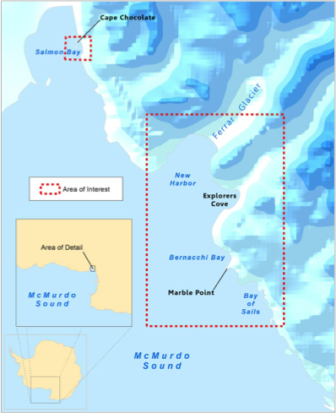

*Figure 1: Study Area Map including locations of interest*

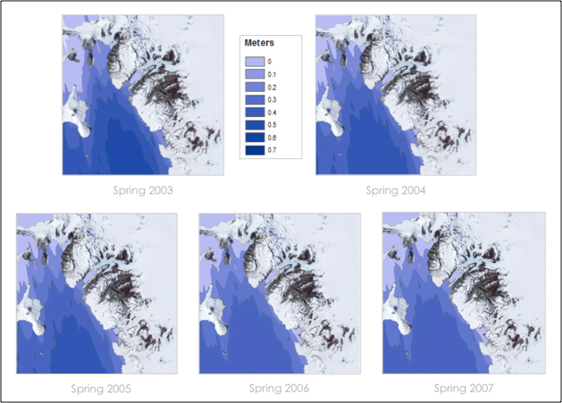

*Figure 2: Spring Sea Ice Thickness 2003-2007*

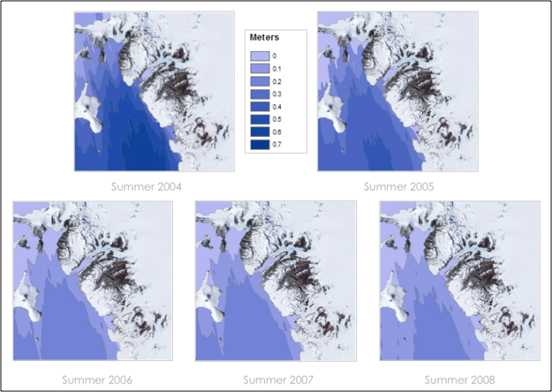

*Figure 3: Summer Sea Ice Thickness 2004-2008*

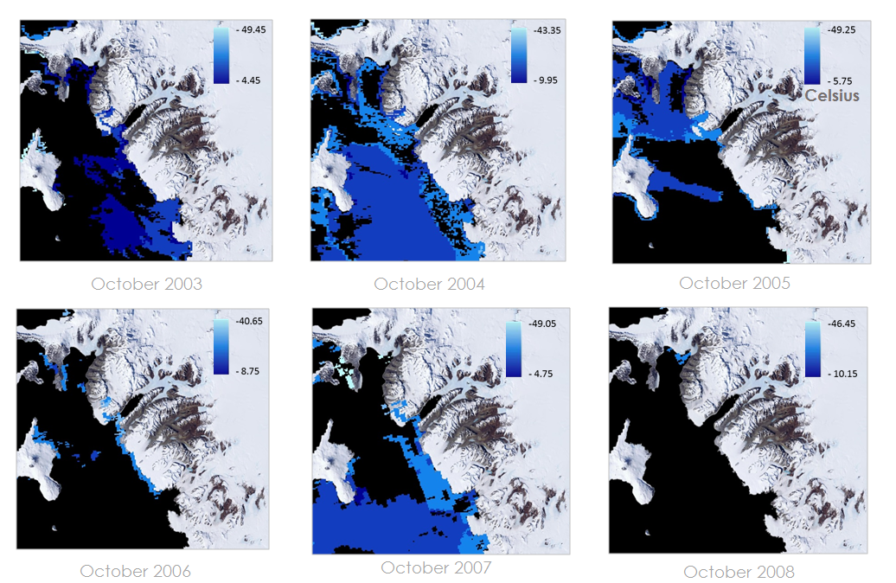

*Figure 4: Yearly Ice Surface Temperature for the month of October from 2003-2008*

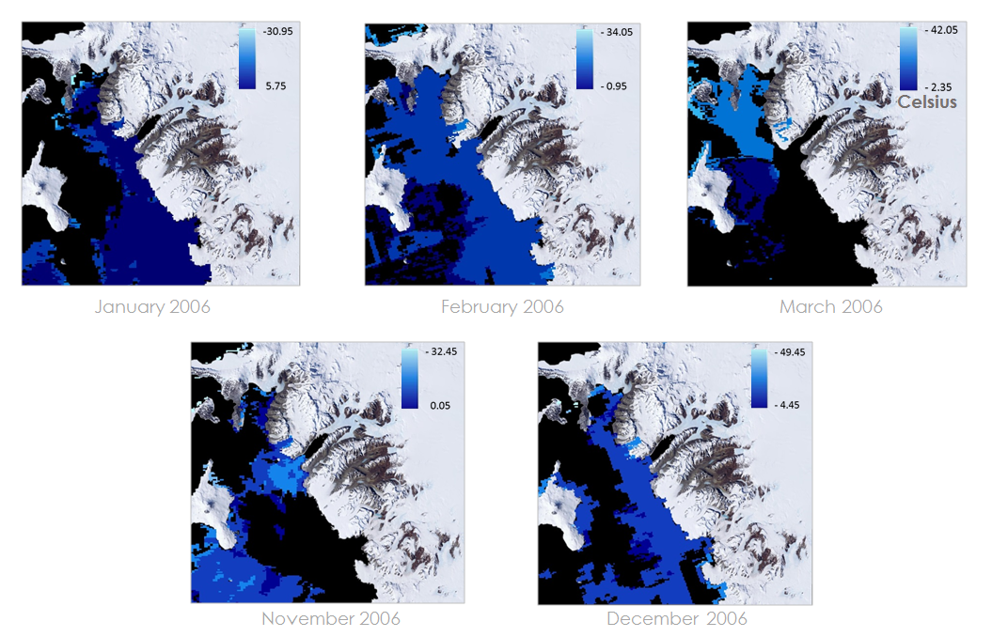

*Figure 5: Ice Surface Temperature for Spring and Summer 2006*

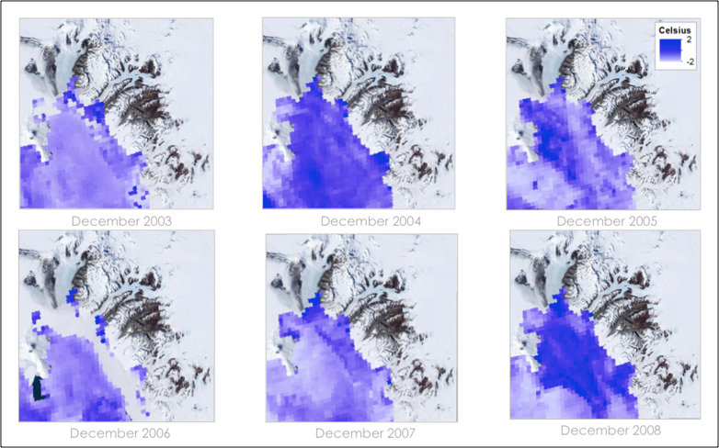

*Figure 6: Sea Surface Temperature for the month of December from 2003-2008*

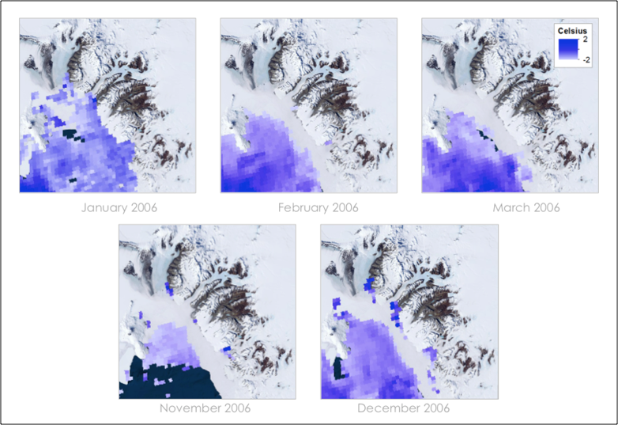

*Figure 7: Sea Surface Temperature for Spring and Summer 2006*

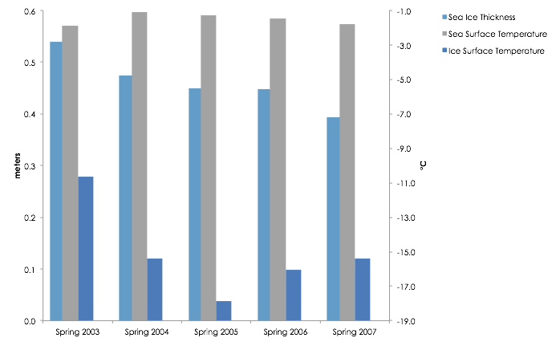

*Figure 8: Spring Sea Ice Variability*

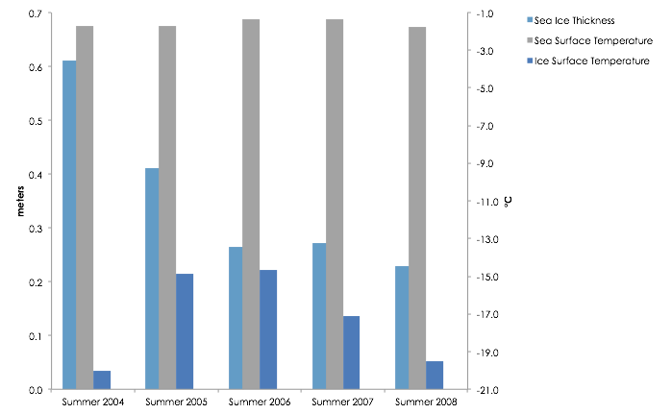

*Figure 9: Summer Sea Ice Variability*

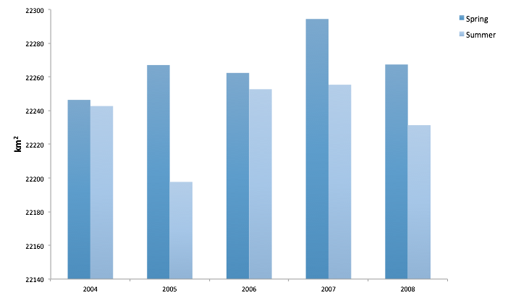

*Figure 10: Spring and Summer Sea Ice Extent 2004-2008*

|  |  |  |  |  |  |
| --- | --- | --- | --- | --- | --- |
| *Change in Sea Ice Area (km2)* | | | | | |
|  | *2003 - 2004* | *2004 - 2005* | *2005 - 2006* | *2006 - 2007* | *2007 - 2008* |
| *Spring* | *21.33* | *20.67* | *-4.67* | *32.00* | *-27.00* |
| *Summer* | *N/A* | *-45.00* | *55.00* | *2.67* | *-24.00* |

*Table 1: Spring and Summer changes in Sea Ice Area in McMurdo Sound*

|  |  |  |
| --- | --- | --- |
| *Data Set* | *Temporal Resolution* | *Spatial Resolution* |
| *Sea Surface Temp* | *Monthly* | *4 km* |
| *Sea Ice Thickness* | *Bi-monthly* | *25 km* |
| *Ice Surface Temp* | *Daily* | *1 km* |
| *Sea Ice Extent* | *Daily* | *1 km* |

*Table 2: Data Resolution*

|  |  |  |  |  |  |  |  |  |  |  |  |  |
| --- | --- | --- | --- | --- | --- | --- | --- | --- | --- | --- | --- | --- |
| **Sea Surface Data Coverage** | | | | | | | | | | | | |
|  | Jan | Feb | Mar | April | May | June | July | Aug | Sept | Oct | Nov | Dec |
| 2003 |  |  |  |  |  |  |  |  |  | X | X | X |
| 2004 | X | X | X | X |  |  |  |  |  |  | X | X |
| 2005 | X | X | X | X |  |  |  |  |  |  | X | X |
| 2006 | X | X | X |  |  |  |  |  | X |  | X | X |
| 2007 | X | X | X |  | X |  |  |  |  | X | X | X |
| 2008 | X | X | X | X |  |  |  |  |  |  | X | X |
| **Sea Ice Surface Data Coverage** | | | | | | | | | | | | |
|  | Jan | Feb | Mar | April | May | June | July | Aug | Sept | Oct | Nov | Dec |
| 2003 |  |  |  |  |  |  |  |  |  | X | X | X |
| 2004 | X | X | X | X |  |  |  |  | X | X | X | X |
| 2005 | X | X | X | X |  |  |  |  | X | X | X | X |
| 2006 | X | X | X | X |  |  |  |  | X | X | X | X |
| 2007 | X | X | X | X |  |  |  |  | X | X | X | X |
| 2008 | X | X | X | X |  |  |  |  | X | X | X | X |
| **Sea Ice Extent Data Coverage** | | | | | | | | | | | | |
|  | Jan | Feb | Mar | April | May | June | July | Aug | Sept | Oct | Nov | Dec |
| 2003 | X | X | X | X |  |  |  |  | X | X | X | X |
| 2004 | X | X | X | X |  |  |  |  | X | X | X | X |
| 2005 | X | X | X | X |  |  |  |  | X | X | X | X |
| 2006 | X | X | X | X |  |  |  |  | X | X | X | X |
| 2007 | X | X | X | X |  |  |  |  | X | X | X | X |
| 2008 | X | X | X | X |  |  |  |  | X | X | X | X |
| **Sea Ice Thickness Data Coverage** | | | | | | | | | | | | |
|  | Jan | Feb | Mar | April | May | June | July | Aug | Sept | Oct | Nov | Dec |
| 2003 |  |  |  |  |  |  |  |  |  | X | X |  |
| 2004 |  | X | X |  | X | X |  |  |  | X | X |  |
| 2005 |  | X | X |  | X | X |  |  |  | X | X |  |
| 2006 |  | X | X |  | X | X |  |  |  | X | X |  |
| 2007 |  |  | X | X |  |  |  |  |  | X | X |  |
| 2008 |  | X | X |  |  |  |  |  |  |  |  |  |

*Tables 3 through 6: EOS dataset temporal coverage. X’s indicate months where data was available.*