|  |  |  |  |  |
| --- | --- | --- | --- | --- |
| **Stage 1** | **Stage 2** | **Stage 3** | **Stage 4** | **Stage 5** |
| End-user was not engaged during the project. | End-user was engaged in a limited capacity. | End-user was engaged throughout the project. End-user capacity slightly built. | End-user was very engaged throughout the project. End-user capacity built. | End-user was very engaged throughout the project. End-user capacity greatly built. |
| Nothing new was introduced to end-user, and no substantial end-products. | End-products only met some of the partner’s needs. | End-products met end-user needs with few issues. | End-products met end-user needs. | End-products were more than static maps, met end-user needs. Interactive hand-off at least. |
| No innovation in EO used. Very simple methodology. | Very little innovation in EO. Methodology built on the work of others. | Some innovation in EO. Methodology built on the work of others. | Some innovation in EO. Attempted something new. | Many innovations in EO. Attempted something new. |
| Limited to no science advising. | Some science advising or some error assessment. | Science advising and error assessment. | Science advising with expert and error assessment. | Science advising with expert, error assessment, and some publication. |

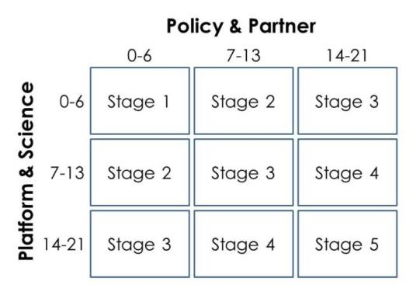

End-user was not engaged.

Nothing new was introduced, no substantial end-product.

No innovation in EO used.

Very simple methodology.

Limited to no science advising.

End-user was engaged in a limited capacity.

End-products only met some of the partner’s needs.

No innovation in EO used.

Very simple methodology.

Limited to no science advising.

End-user was engaged throughout the project.

End-user capacity built.

End-products met end-user needs.

No innovation in EO used.

Very simple methodology.

Limited to no science advising.

End-user was not engaged.

Nothing new was introduced, no substantial end-product.

Very little innovation in EO.

Methodology built on other work.

Some science advising or some error assessment.

End-user was engaged throughout the project.

End-user capacity built.

End-products met end-user needs.

Some innovation in EO.

Attempted something new.

Science advising and error assessment.

End-user was engaged throughout the project.

End-user capacity slightly built.

End-products meet end-user needs with few issues.

Very little innovation in EO.

Methodology built on other work.

Science advising and error assessment.

End-user was engaged in a limited capacity.

End-products only met some of the partner’s needs.

Many innovations in EO.

Attempted something new.

Expert science advising and error assessment.

End-user was engaged.

End-user capacity built.

End-products meet end-user needs.

Many innovations in EO.

Attempted something new.

Expert science advising and error assessment.

End-user was very engaged, capacity greatly built.

End-products more than static maps, met end-user needs.

Interactive hand-off.

Many innovations in EO.

Attempted something new.

Expert science advising, error assessment, some publication.

14-21

14-21

7-13

7-13

0-6

0-6

**Platform & Science**

**Policy & Partner**