St. Joseph Peninsula Disasters

Using NASA Earth Observations to Investigate Land Cover, Shoreline Change, and Sediment Transport in St. Joseph Peninsula after Hurricane Michael

 **Technical Report**

Final – November 18th, 2021

Erica Kriner (Project Lead)

Paige Aldenberg

James Byrne

Brianne Kendall

Nicholas Roberge

***Advisors:***

Dr. Robert Griffin, The University of Alabama Huntsville (Science Advisor)

Dr. Jeffrey Luvall, NASA Marshall Space Flight Center (Science Advisor)

# 1. Abstract

T.H. Stone Memorial St. Joseph Peninsula State Park experienced significant damages from Hurricane Michael in 2018, the first Category 5 hurricane to hit the contiguous United States since 1992. These damages included a 300-meter-wide and 10-meter-deep breach in the peninsula, habitat disruption, and a forced closure of over half of the total park area. These damages, coupled with restricted visitor access, resulted in a significant loss of revenue for the park. NASA DEVELOP partnered with the Florida Department of Environmental Protection (DEP) to determine the overall impact of Hurricane Michael on land cover and shoreline change by using NASA Earth observations including Landsat 7 Enhanced Thematic Mapper Plus (ETM+), Landsat 8 Operational Land Imager (OLI), Aqua Moderate Resolution Imaging Spectroradiometer (MODIS), and the European Space Agency’s Sentinel-2 Multispectral Instrument (MSI) to analyze sediment transport and climatology to further understand the lasting impacts of hurricanes on the ecosystems of the park. The DEVELOP team’s analyses showed that chlorophyll-a concentrations, sea surface temperature, and precipitation are increasing over time. The sediment transport analysis showed dynamic movement across the peninsula, with the greatest erosion occurring within the bay and along the length of the peninsula. These results are supported by evidence of declining seagrass abundances and seasonal turbidity patterns within those areas. Providing these analyses for the partner allows for a greater understanding of how best to proceed with restoration efforts, which may include rebuilding camping services, expanding fishing recreation, and conserving habitats for endangered species.

**Key Terms**

coastline restoration, remote sensing, NDVI, climatology, timeseries, Landsat 7 ETM+, Landsat 8 OLI, disaster mitigation

# 2. Introduction

***2.1 Background Information***

Designated parks and natural areas are an integral component of community development and ecosystem conservation. Along the Gulf of Mexico, numerous state and federal parks span across five states and host 130 species of federally protected wildlife (U.S. Fish & Wildlife Service, 2013). This region is impacted by an average of 3.7 named storms per year, with most hurricanes happening from June to November (Miller & Trepanier, 2021). These hurricanes cost the local communities $2.9 billion per year, and these damages are expected to increase with greater storm frequency and severity (Zia, 2012).

T.H. Stone Memorial St. Joseph Peninsula State Park, shown in Figure 1, is located in Cape San Blas, Florida. The park spans 7.1 kilometers of recreational areas, wildlife preserves, and the largest sand dunes in the Florida panhandle. Annually, the park hosts about 300,000 visitors. In 2018, Hurricane Michael became the first Category 5 storm to make landfall on the Florida panhandle, resulting in $18.4 billion in damages (Beven et al., 2018) and forcing the closure of over half the park. Hurricane damage resulted in a breach in the middle of the peninsula that spanned around 305 meters and split the park in two. The storm eroded the park’s famed sand dunes, damaging vulnerable wildlife habitat and permanently altering the state’s unique geology (United States Geological Survey [USGS], 2018).

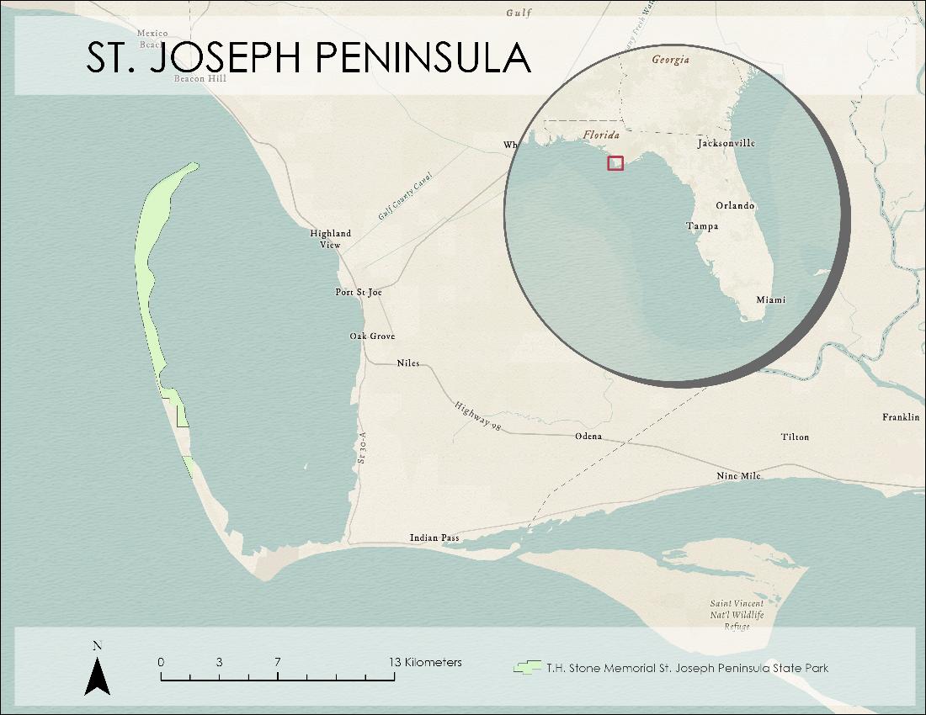

*Figure 1.* This map displays the boundary of T.H. Stone Memorial St. Joseph Peninsula State Park in reference to the broader Florida region.

St. Joseph Peninsula is particularly susceptible to hurricane damage because it acts as a barrier island. The barrier island effect refers to small landmasses between bodies of water that serve as storm protection for the mainland. They reduce wave energy and protect fragile ecosystems that form behind the barrier. Over time, these barrier islands erode and become more sensitive to damage (Smith, 2018). With the increased severity of tropical cyclones, warming ocean temperatures, and decreased winter storms, the temperate St. Joseph Peninsula ecosystem is at risk of tropicalization (Dauphin Island Sea Lab, 2019). This process introduces species from tropical climates south of the Gulf of Mexico. This can severely imbalance an ecosystem with the introduction of invasive species that will compete for resources and threaten keystone species. Keystone species found in the St. Joseph Peninsula are seagrass, which live at the bottom of sea floors and hold down sediments. Tropical species that feed on seagrass can deplete its abundance, thus promoting erosion and sediment change. Natural disaster and anthropogenic impacts on St. Joseph Peninsula put the park at continued risk for land breaches, habitat destruction, and limitations on community recreation.

It has become a vital component of disaster planning to understand the changing landscape of the peninsula. Ongoing recovery and restoration efforts are costly, and mapping land cover change can help partners better understand what areas to prioritize for preventative measures. This will reduce overall costs and mitigate socio-economic impacts of future storm events. To analyze land cover change, this project used Earth observations from 1990–2021 to gauge change in shoreline, sediment transport, and climatology variables like sea surface temperature and precipitation. These indicators show how the peninsula changed over time as well as help predict future impacts.

Past research relating to barrier islands and hurricanes utilized historic land cover datasets to determine where seagrass was most abundant. Digital shoreline transect data were used to determine shoreline change rates, barrier island widths, and width change rates. Senne (2020) implemented datasets from 1959–2019 in ArcGIS Pro software to determine seagrass meadow locations in St. Joseph Bay. When used to analyze change in seagrass meadows and sediment transport through time, these remote sensing methodologies can provide feedback about the severity of storm damage, critical zones for erosion, and endangered species habitats most at risk. Satellite data will prepare the park for restoration and mitigation plans that will protect the wildlife, recreation, and community from future severe storms.

***2.2 Project Partners & Objectives***

In partnership with the Florida Department of Environmental Protection (DEP), this project aimed to assess the impact of Hurricane Michael on St. Joseph Peninsula by investigating the land cover and shoreline. The Florida DEP is concerned with protection and enhancement of local ecosystems, as well as maintenance and restoration of the park. Restoration projects related to the study area include rebuilding the eroded sand dunes and damaged shorelines. Our project aimed to support restoration efforts through sediment transport and climatology timeseries to help our partners visualize changes to the landscape. These analyses will aid the partners in better understanding which factors have the most impact on shoreline change and which areas are most vulnerable to severe storm events. Furthermore, this project will build the capacity of our partners to use Earth observations in their continued conservation efforts. At the time of this report, the partners use little GIS and remote sensing technology in their analyses; this project aims to highlight the specific use cases by which they could accomplish their goals.

# 3. Methodology

***3.1 Data Acquisition***

The team acquired Earth observation data via USGS Earth Explorer, USGS GloVis, and the Google Earth Engine (GEE) data catalog. The team performed analyses with data from Landsat 7 Enhanced Thematic Mapper Plus (ETM+), Landsat 8 Operational Land Imager (OLI), Sentinel-2 MultiSpectral Instrument (MSI), and Aqua Moderate Resolution Imaging Spectroradiometer (MODIS). Sea surface temperature analysis drew from the respective Aqua MODIS product. The team analyzed precipitation and sea surface temperature trends over a 30-year span using data published by the National Oceanic and Atmospheric Administration (NOAA) and the UCSB Climate Hazards Center.

Table 1.

*Remote sensing data used in GEE.*

|  |  |  |  |
| --- | --- | --- | --- |
| **Sensor** | **Processing Level** | **Data Provider** | **GEE ImageCollection ID** |
| Landsat 5 TM | Level 2 Surface Reflectance Collection 2 Tier 1 | USGS Earth Explorer | LANDSAT/LT05/C02/T1_L2 |
| Landsat 7 ETM+ | Surface Reflectance Tier 1 | USGS Earth Explorer | LANDSAT/LE07/C01/T1_SR |
| Landsat 8 OLI | Level 2 Surface Reflectance Tier 1 | USGS Earth Explorer | LANDSAT/LC08/C01/T1_SR |
| Sentinel-2 MSI | Level 1C TOA Reflectance | European Space Agency (ESA) Open Access Hub | COPERNICUS/S2 |
| Aqua MODIS | Level 3 Standard Mapped Image | NASA Ocean Biology Processing Group (OBPG) | NASA/OCEANDATA/MODIS-Aqua/L3SMI |
| NOAA-19 AVHRR | N/A | NOAA | NOAA/CDR/OISST/V2_1 |
| CHIRPS | N/A | UCSB Climate Hazards Center | UCSB-CHG/CHIRPS/DAILY |

***3.2 Data Processing***

The team processed data and graphs in GEE and then created imagery in ArcGIS Pro. The true color images and turbidity calculations drew from both Landsat and Sentinel data along with the Normalized Difference Turbidity Index (NDTI), the Normalized Difference Vegetation Index (NDVI), and colored dissolved organic matter (CDOM). The team only used Landsat data to calculate diffuse light attenuation (Kd490), the Normalized Difference Water Index (NDWI), and the Modified Normalized Difference Water Index (MNDWI). Data from Landsat 8 allowed the team to calculate chlorophyll-a and the Normalized Difference Aquatic Vegetation Index (NDAVI). For analysis, the team used these Earth observations alongside previously created DEVELOP GEE tools, namely ORCAA, Tool CREOL, and SHARQ.

*3.2.1 Land Cover*

Of primary interest was the relative loss of biomass right after Hurricane Michael. In lieu of a more traditional land cover land use map, the team elected to create two maps showing calculated NDVI before and after Hurricane Michael using Landsat 8 OLI imagery collected from USGS Earth Explorer. Two images were collected, one from September 2018 and the latter from right after the hurricane hit in October 2018. Both images contained less than 20% cloud cover. These images were then assigned their appropriate bands within ArcGIS Pro and tested by creating a true-color composite image. Of these bands, the team selected those necessary for a Normalized Difference Vegetation Index (NDVI), outlined in Equation 1 below (Rouse et al., 1974). The selected bands correspond to the Red and Near-Infrared (NIR) bands from Landsat 8. These bands were then composited into a multispectral image for further analysis.

$$\begin{aligned}\text{NDVI = }\frac{\text{NIR} \text{- }\text{RED}}{\text{NIR + RED}}\#\left(1\right)\end{aligned}$$

*3.2.2 Shoreline Change*

The bulk of the shoreline change data was gathered from Landsat 7 ETM+ and Landsat 8 OLI. The team uploaded surface reflectance images from January 1999 to October 2021 from these Landsat satellites into GEE. The composites were filtered by study area and cloud cover. The images shown only included ones of St. Joseph Peninsula with less than 20% of cloud cover, which the team found by using the cloud-masking algorithm provided in GEE. The cloud-mask assigns “no data” to pixels that indicated cloud cover, and those pixels are then ignored by other GEE functions that might have previously misidentified the pixels as water. After filtering the Landsat images, the team selected and renamed the spectral bands needed to calculate the Normalized Difference Water Index (NDWI) and the Modified Normalized Difference Water Index (MNDWI). Both of these indices differentiate between water and land features on satellite images. NDWI utilizes the Green and NIR spectral bands (Equation 2; Gao, 1996). MNDWI uses Short Wave Infrared (SWIR) bands instead of NIR bands because research showed that using the SWIR bands removes more built-up land noise (Equation 3; Xu, 2006). The team decided to calculate both NDWI and MNDWI to acquire more accurate data. After the team selected the bands and renamed them “Green,” “NIR,” and “SWIR,” the team merged all of the satellite images from Landsat 7 ETM+ and Landsat 8 OLI into a single image collection.

$$\begin{aligned}\text{NDWI} \text{= }\frac{\text{GREEN - NIR}}{\text{GREEN + NIR}}\#\left(2\right)\end{aligned}$$

$$\begin{aligned}\text{MNDWI} \text{= }\frac{\text{GREEN} \text{-} \text{SWIR}}{\text{GREEN} \text{+} \text{SWIR}}\#\left(3\right)\end{aligned}$$

To make analysis easier, the team changed the range of the indices’ outputs to binary values of 0 or 1. The pixels assigned 0 and classified as “land” had negative and zero values. Pixels assigned 1 and classified as “water” had positive values. The team merged the NDWI and MNDWI indices into a single collection that differentiated between land and water features of St. Joseph Peninsula from 1999 to 2021. To detect yearly changes in the indices, the team parsed the image collection into 22 individual years. The team also applied a threshold to the images to identify and re-assign visual artifacts. Visual artifacts are disturbances either on the Earth’s surface or within the satellite sensor that disturb the overall satellite image, and they can present themselves as solid lines or scratches along an image (Roman-Gonzalez, 2013). For the threshold, the team assigned 0 to pixel values less than 0.12 and 1 to pixel values greater than 0.88. Once the image collection was prepared, the team exported the annual image rasters as GeoTIFFs and uploaded them to ArcGIS Pro for further analyses.

*3.2.3 Sediment Transport*

The Optical Reef and Coastal Area Assessment (ORCAA) tool was created by NASA DEVELOP teams in 2019 to process coastal remote sensing data in GEE (Devine et al., 2019; Pippin et al., 2019). Due to limited temporal availability of Sentinel-2 and Landsat 8 data, the team modified ORCAA to include Landsat 7 ETM+ based upon a script from the Seaport & Harbor Area Resource Quality (SHARQ) tool. Another NASA DEVELOP team created SHARQ as a modified version of ORCAA to incorporate different satellites and sensors (Rocha et al., 2021). ORCAA masked pixels with cloud cover and returned only unobscured surface reflectance values for use in turbidity and ocean color calculations.

The team clipped each layer to the area of interest, which was St. Joseph Bay and the waters extending 4 miles into the Gulf of Mexico to account for barrier island analysis. Water quality calculations can be influenced by bottom reflectance in shallow water. Therefore, the team masked out water shallower than 1.8 meters utilizing bathymetry data from the Florida Fish and Wildlife Conservation Commission (2021). ORCAA was then utilized to calculate turbidity using the Normalized Difference Turbidity Index (NDTI). NDTI is a band ratio technique to estimate turbidity using the red and green bands of satellite imagery (Lacaux et al., 2007). Greater turbidity equates to more suspended particles in the water and higher reflectance in the red wavelength (Islam & Sado, 2006). The index, a relative measure, accounted for the lack of calibration data (Equation 4).

$$\begin{aligned}\text{NDTI} \text{= }\frac{\text{RED} \text{-} \text{GREEN}}{\text{RED} \text{+} \text{GREEN}}\#\left(4\right)\end{aligned}$$

The Tool for Coastal Remote Ecological Observations in Louisiana (Tool CREOL) was created in GEE by a summer 2021 NASA DEVELOP team to process remote sensing data in the Gulf of Mexico. Due to this tool focusing on Louisiana barrier islands and waterbodies, the team modified Tool CREOL to be oriented to St. Joseph Peninsula and St. Joseph Bay. The team adjusted the values of seagrass detection according to the bay’s depth and the unique minimum and maximums of seagrass abundance. Using the same mask from the adjusted ORCAA tool, the features in the tool were made more accurate to the study area. Tool CREOL calculated the abundance of seagrass in St. Joseph Bay by finding the normalized difference between near infrared and blue bands (Equation 5; Moeen et al., 2021; Villa et al., 2014). Using the Normalized Difference Aquatic Vegetation Index (NDAVI) instead of the Normalized Difference Vegetation Index (NDVI) allows for the GEE analysis to focus on vegetation in the water rather than terrestrial vegetation.

$$\begin{aligned}\text{NDAVI = }\frac{\text{NIR - BLUE}}{\text{NIR + BLUE}}\#\left(5\right)\end{aligned}$$

*3.2.4 Climatology*

Tool CREOL also produced chlorophyll-a imagery and examined the abundance over time. The Normalized Difference Chlorophyll-a Index (NDCI) used near infrared and red bands to derive relative values of chlorophyll-a concentration (Equation 6). Then, NDCI values served as an input to Equation 7, where the calibrated model coefficients of a0=14.039, a1=86.115, and a2=194.325 enabled approximation of chlorophyll-a concentration in mg/m3 (Mishra & Mishra, 2012). The team utilized the sea surface temperature (SST) band from the Ocean Color Standard Mapped Image (SMI) Aqua MODIS dataset and the NOAA Climate Data Record (CDR) Optimum Interpolation Sea Surface Temperature (OISST) v02r01 dataset. The team planned to use NOAA CDR WHOI: Sea Surface Temperature, Version 2 to verify SST values, but the dataset did not cover the study area. The precipitation band was utilized from the Climate Hazards Group InfraRed Precipitation with Station Data (CHIRPS) version 2.0 final dataset out of the UCSB Climate Hazards Center.

$$\begin{aligned}\text{NDCI = }\frac{\text{NIR-RED}}{\text{NIR+RED}}\#\left(6\right)\end{aligned}$$

$$\begin{aligned}\text{chlorophyll-a }\left({\text{mg}}/{{\text{m}}^{\text{3}}}\right) \text{=} {\text{a}}_{\text{0}}\text{+}\left({\text{a}}_{\text{1}}\text{×NDCI}\right)\text{+}({\text{a}}_{\text{2}}\text{×}{\text{NDCI}}^{\text{2}})\#\left(7\right)\end{aligned}$$

***3.3 Data Analysis***

*3.3.1 Land Cover and NDVI Change*

After computing NDVI for both before and after the hurricane, the team used the ArcGIS Pro raster function “Compute Change” to show how NDVI values had changed from the image prior to Hurricane Michael to the image after. The team found that the change image seemed most reliable when computed from the processed NDVI imagery. This is opposed to using unprocessed multispectral imagery or a true-color composite.

*3.3.2 Shoreline Change*

After classifying pixels as land or water in GEE, the team used the Raster Calculator (spatial analysis) tool in ArcGIS Pro to quantify shoreline change along St. Joseph Peninsula from 1999 to 2021. The Raster Calculator tool applies mathematical functions to individual rasters and then produces a new raster collection. To visualize shoreline change for each year, we subtracted the “initial” year raster from the “final” year raster. The resulting raster quantified the change in land and water over that specific year. For example, the team subtracted 2020 from 2021 to quantify shoreline change over the past year. Then, the team assigned each change raster to a custom color gradient where green indicated an increase in land over that year and blue indicated an increase in water. Any area that showed no significant change was transparent. Because it was difficult to pinpoint shoreline change from year to year, the team combined the 22 individual year analyses into a single raster using the Merge to New Raster tool. This created a single overlay map of shoreline change from 1999 to 2021. The team used the same tool to also create six-year analysis maps from 1999 to 2005; 2005 to 2011; and 2011 to 2017; as well as a pre- and post-Hurricane Michael map from 2017 to 2021. To compare these analyses to other storm trends, the team also used Landsat 5 TM to replicate the above process for Hurricane Opal in 1995. Hurricane Opal was the next most recent major storm to hit the peninsula.

*3.3.3 Sediment Transport*

The team utilized ORCAA’s built-in time series chart function to generate graphs of ocean color and turbidity data. The time series chart function allows the user to plot daily or monthly averages of ocean color or turbidity over the selected area on a line graph (Pippin et al., 2019). The team analyzed ocean color and turbidity from 1999 to 2021. Each year was divided into ‘summer’ (April – September) and ‘winter’ (October – March) to account for seasonal changes in wave energy, beach slope, and beach volume (Aubrey, 1979; Shepard, 1950). To support the sediment transport and shoreline change analyses, the team also analyzed seagrass abundance over time. The team looked at the median composite of seagrass abundance in the summers before and after Hurricane Michael, from 2018 to 2019, using Tool CREOL. The median composite summer months spanned from June to August. To offer some validation of the changes in abundance, the team also looked at the median composite of summer months before and after Hurricane Opal, from 1995 to 1996.

*3.3.4 Climatology*

For the climatology timeseries, the team analyzed SST, precipitation, and chlorophyll-a data. The team utilized Tool CREOL’s time series function to generate graphs from 1984 to 2021, and generated imagery of the chlorophyll-a concentrations before and after Hurricane Michael in summer 2018 and summer 2019 using a median composite. The team gathered and utilized median composites of imagery from 2002 to 2020 in GEE to unveil trends in SST and precipitation for the St. Joseph Peninsula area. Time series charts were produced in Microsoft Excel for SST, precipitation, and chlorophyll-a. These methods highlight changes in parameter value and variability over time.

# 4. Results & Discussion

***4.1 Analysis of Results***

By performing imagery and timeseries analyses with Tool CREOL and ORCAA in GEE, the team assessed hurricane damages on St. Joseph Peninsula. The analyses focused on sediment transport, shoreline change, and climatology. Sediment transport and shoreline change analyses supported evidence of the peninsula experiencing damage from severe tropical cyclones and of which areas of the peninsula were most impacted. In conjunction with the shoreline change analyses, the climatology timeseries further predicted how future storms might impact the peninsula and critical ecosystems in the park.

*4.1.1 Land Cover and NDVI Change*

The resulting image shows calculated change in NDVI from September 2018 to October 2018 (Figure 2). Cloud cover accounts for the most drastic changes seen here, although the results are consistent with what is known to be true otherwise, including the drastic reduction of biomass at the site of the breach. This is indicated in the image below with a bright red patch at the peninsula’s midpoint. Overall, the peninsula suffered an incredible loss of vegetation after the hurricane, with no notable gain in vegetation. The blue spots seen below were likely areas in which cloud cover obscured only the pre-hurricane image and not the post-hurricane image, which would read to the program as a net gain in vegetation.

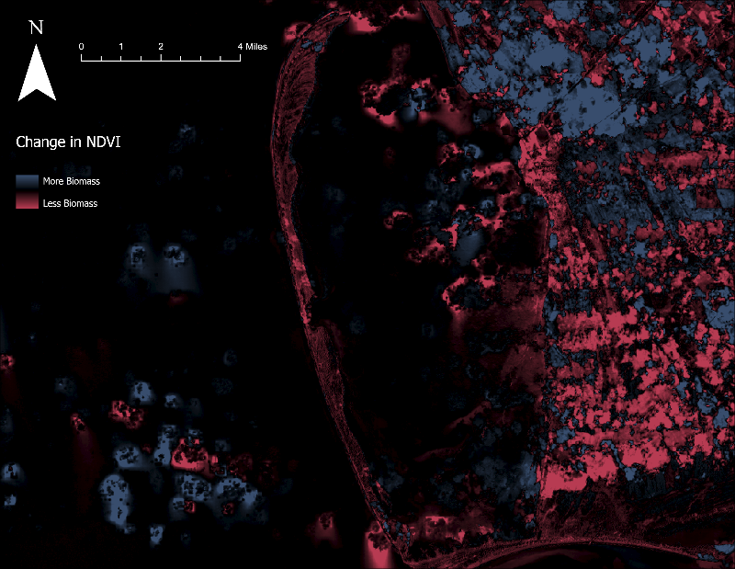

*Figure 2.* Visualized difference in NDVI from September 2018 to October 2018.

*4.1.2 Shoreline Change*

As expected, St. Joseph Peninsula experienced both land gain and land loss from 1999 to 2021 (Figure 3). This is simply because the peninsula is a coastal area, and sediment is constantly eroded and deposited along various points of the shore by wind, waves, and storm surges. There were, however, a few areas that showed more definitive trends. The Northern and Southern tips of the peninsula displayed the greatest areas of land accretion, while the length of the peninsula and the inland bay area experienced the most erosion over the years. The team found aerial images of St. Joseph Peninsula and compared those to the results. According to a beach renourishment report from Gulf County, Florida, beach filling projects occurred along the peninsula from 2009 to 2014. Once those projects were left unattended, however, the beaches experienced substantial erosion in the subsequent years. This offers one explanation for why the peninsula experienced a heavy mix of land gain and land loss over the past 22 years. It was difficult to detect significant changes in our individual year analyses, but the most interesting to note is that years with severe droughts, like 2000 and 2007, showed significantly more land accretion than erosion, likely due to the lack of rainfall and weather events that normally induce coastal erosion. To better identify shoreline trends, the team compiled the annual maps into six-year analysis maps. These six-year analyses, shown in Figure A1, clearly indicate the restorative nature of barrier islands like St. Joseph Peninsula. From 1999 to 2005, the length of the peninsula eroded, and the bay acquired land. Then from 2005 to 2011, the built-up areas within the bay eroded and that sediment was transported to the ocean facing side of the peninsula. From 2011 to 2017, the peninsula experienced more erosion than land accretion; however, the reverse occurred from 2017 to 2021. It appears that the currents surrounding the peninsula easily transport sediment from one end of the preserve to the other.

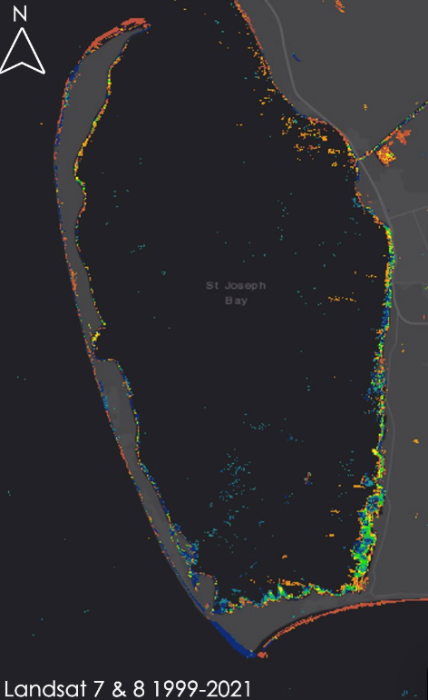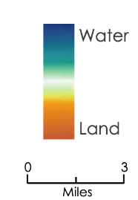

*Figure 3.* Twenty-two-year shoreline change of St. Joseph Peninsula and St. Joseph Bay captured by Landsat 7 ETM+ and Landsat 8 OLI from 1999 to 2021.

The team also took a closer look at the effects of Hurricane Michael on the St. Joseph shoreline. Figure 4 shows the annual changes from 2017 to 2020, from before to nearly two years after Hurricane Michael hit the peninsula. The location of the breach site was used to test the accuracy of these shoreline maps. The team used the 2017 to 2018 map as the control map because most of the data were collected before Hurricane Michael made landfall. On this map, there is no significant land accretion or erosion near the breach site. However, the area is almost entirely eroded from 2018 to 2019 when the breach was present and allowing water to flow freely across the peninsula. On the 2019–2020 map, the breach site has filled back in with sediment and consequently shows a lot of land accretion. The most interesting thing to note is how Figure 3 quantifies that peninsula’s ability to rebound from disaster. From 2018 to 2019, not even a year after Hurricane Michael hit, the northern and southern tips of the peninsula experienced the greatest erosion, while the greatest land accretion occurred within the bay. The 2019–2020 map, which indicates recovery almost two years post-Hurricane Michael, is almost a reverse image of the map before. The northern and southern tips have filled back in with sediment, and the excess land accretion within the bay has receded back to the ocean. The partners were unable to perform extensive restoration work during this time, so it is impressive to see how well the barrier island recovered on its own.

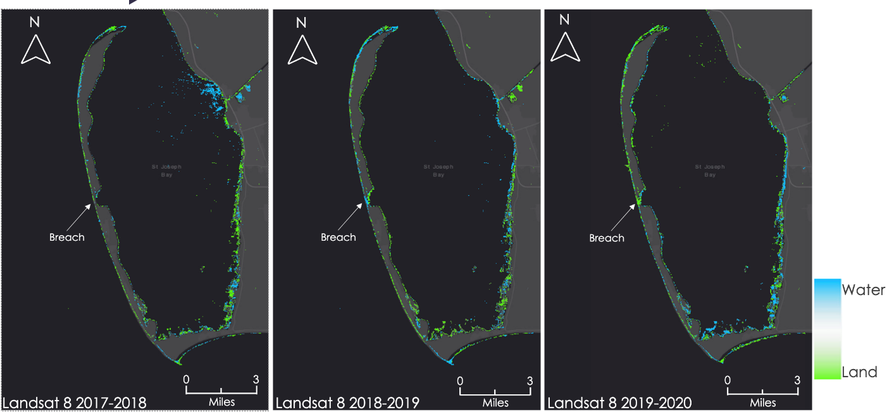*Figure 4.* Shoreline change pre-and post-Hurricane Michael captured by Landsat 7 ETM+ and Landsat 8 OLI from 2017–2020.

*4.1.3 Sediment Transport*

Turbidity varied by season throughout the timeframe (1999–2021). The southern shore and northern tip of Cape San Blas had higher turbidity which coincided with shoreline changes at those locations. After periods of heavy rainfall, the mouth of the Gulf County Canal produced high turbidity in St. Joseph Bay. Overall, higher turbidity was seen in the ‘summer’ study period than in ‘winter’ (Figure 5). Maps of seasonal turbidity can be found in Figure B1, and a chart in Figure B2. The team also looked at NDTI ten days before and after Hurricane Michael using Sentinel-2 imagery. Sentinel imagery was used instead of Landsat due to the limited availability of Landsat imagery during the study timeframe. Higher levels of turbidity were most notably observed on the gulf side of the peninsula, particularly at the northern tip, as well as at the mouth of the Gulf County Canal, likely due to the increase rainfall (Figure 6).

*Figure 5.* Average monthly NDTI captured from Landsat 7 and 8 from January 1999 to October 2021.

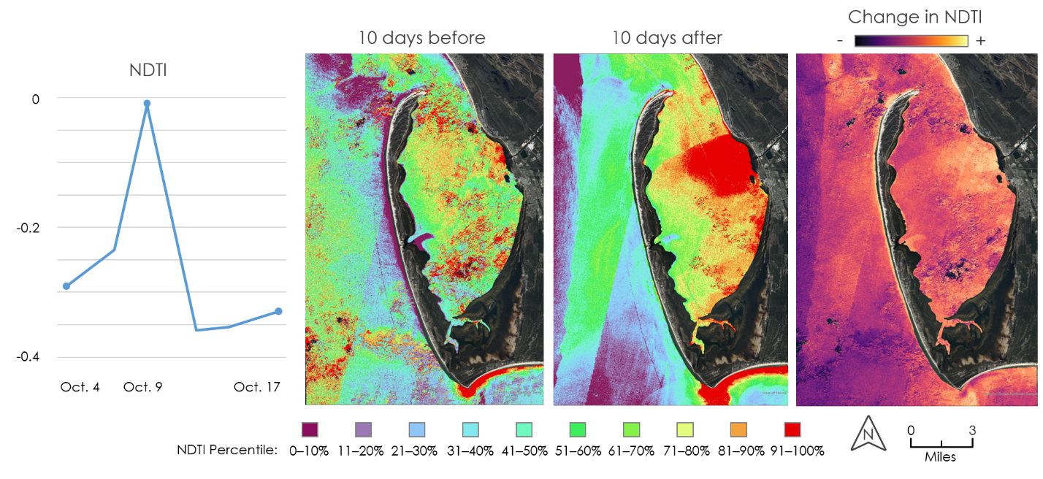

*Figure 6.* NDTI measured with Sentinel-2 ten days before and after the turbidity spike on October 9th, the day before Hurricane Michael landed.

*4.1.4 Climatology*

The SST and precipitation analyses supported the trends of tropicalization. The data showed that SST and precipitation are increasing over time (Figure 7) as well as increasing in variability (Figure 8). Precipitation and stormwater runoff have a positive correlation with chlorophyll-a concentrations, as stormwater runoff increases the nutrients in the water. Chlorophyll-a thrives in locations with excess nutrients and warm temperatures, and as these factors have increased over time, so has chlorophyll-a in the form of algae blooms. Imagery-detected chlorophyll-a aligned with locations where seagrass concentrations were not detected. Algae blooms prevent sunlight penetration to the bay floor, so the seagrass that needs sunlight to grow declines in abundance in these areas. A lack of freezing temperatures in winter years encourages tropical species to thrive and not die off. These tropical species are usually brought in by hurricanes and land in non-tropical ecosystems. Without the freezing winter temperatures, these tropical species stay and may become invasive species that further deplete seagrass abundance. Because seagrass holds sediment down, a decrease in abundance may result in increased erosion and sediment movement. Analyses related to seagrass can be found in Appendix D.

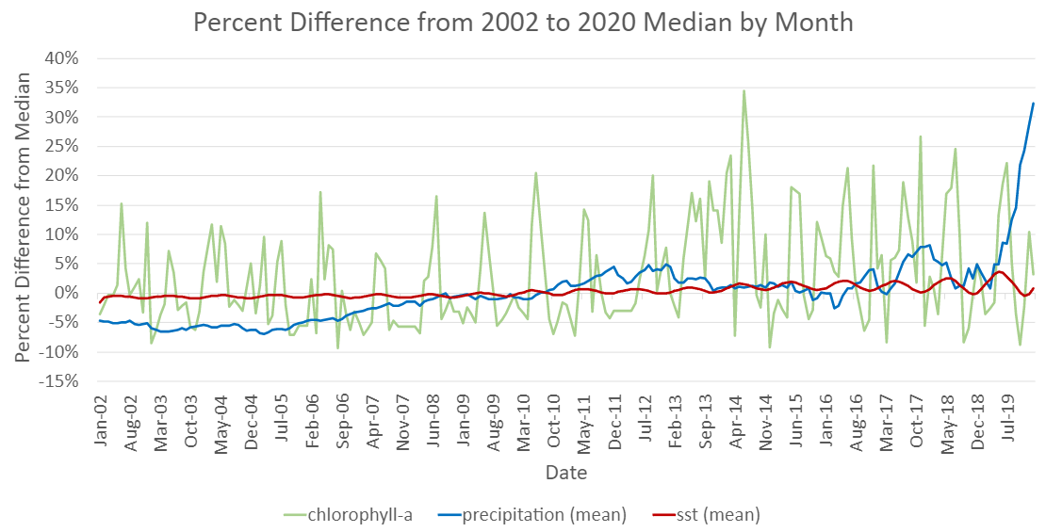

*Figure 7*. The difference in median SST, precipitation, and chlorophyll-a from January 2002 to January 2020 captured from NOAA-19 and Landsat 7 and 8.

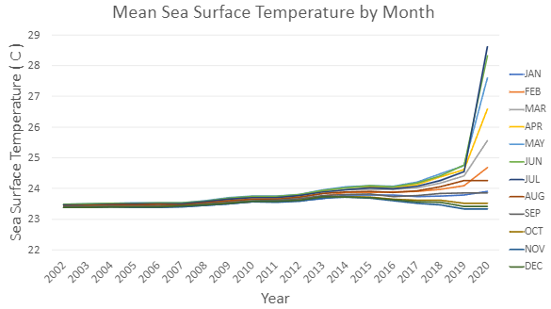

*Figure 8.* Average SST by month from 2002 to 2020 from NOAA CDR OISST dataset showing an increase of SST variability over time.

***4.2 Errors and Uncertainties***

The results of each analysis represented the hurricane damages that occur on barrier islands. To enhance the results of future work, there are uncertainties in the analyses to address. Differences in satellite technologies from Landsat 5 and Landsat 8 impacted seagrass monitoring and showed a trend of increasing abundance from 1984 to 2021. In comparison, aerial imagery and past research in the study area show that seagrass abundance has decreased over time. There was an overlap in the methodology used to detect and map seagrass and turbidity in GEE, with high seagrass abundance correlating with high turbidity. Additionally, cloud masking left gaps in coverage of the data and had the potential to produce false readings. Aerial imagery mitigated these errors, but more *in situ* data would validate this project’s results further.

***4.3 Future Work***

Future analyses would assist in developing hurricane mitigation strategies to further protect the ecosystems and recreation areas throughout St. Joseph Peninsula. In the greater Florida Panhandle region, wildfires have drastic impacts on surrounding communities. Damages from wildfires destroy vegetation, and a continued analysis on vegetative species in St. Joseph Peninsula would provide more insight on sediment transport trends. Expanding the study’s time frame would also provide a better understanding of shoreline change over time, as would comparing the analysis of Hurricane Michael’s impacts to more in-depth analyses of other hurricanes, such as Hurricane Opal. This project’s data and methodologies can be applied to other critical shorelines across the Florida Panhandle that are prone to hurricane damage.

# 5. Conclusions

This project utilized remote sensing techniques to assist the team at T.H. Stone Memorial St. Joseph Peninsula Park with recreational and ecological restoration and with future mitigation plans in response to the damages incurred after Hurricane Michael in 2018. By analyzing data in ArcGIS Pro and using the ORCAA, CREOL, and SHARQ tools, the team created maps that illustrate the park’s land cover before and after the hurricane. The extent of the park’s sediment change impacted other ecological factors that exacerbated effects such as tropicalization and seagrass depletion. The climatology timeseries can improve predictions on future land cover changes in the case of other major storm events. The team found that the northern-most portion of the park is most at risk for future habitat and recreation damages. This is a concern for the local communities that use the park for fishing, camping, and other recreational activities. As this area is still closed and in recovery from the 2018 storm, further damages will create more concerns for endangered species’ habitat conservation and community outreach. Mitigation initiatives will have the most impact on preventing future disaster damages if focused on these at-risk zones. Climatology timeseries and landcover maps will provide the partners with the necessary tools to identify for which areas they want to implement these restoration and mitigation plans.

# 6. Acknowledgments

The St. Joseph Peninsula Disasters team would like to thank our partners from the Florida Department of Environmental Protection for their collaboration and guidance on this project. Thank you to our science advisors Dr. Robert Griffin and Dr. Jeffrey Luvall, and to our fellow Paxton LaJoie for their input and guidance throughout the project’s duration. The team would also like to thank the greater DEVELOP network and previous terms’ teams for the impact they had in the direction of our analyses.

This material contains modified Copernicus Sentinel data (2017–2021), processed by ESA.

Any opinions, findings, and conclusions or recommendations expressed in this material are those of the author(s) and do not necessarily reflect the views of the National Aeronautics and Space Administration.

This material is based upon work supported by NASA through contract NNL16AA05C.

# 

# 7. Glossary

**CDOM** – Colored Dissolved Organic Matter

**Chlorophyll-a** – Photosynthetic pigment found in chloroplasts of plants, algae, and plankton

**Earth observations** – Satellites and sensors that collect information about the Earth’s physical, chemical, and biological systems over space and time

**GEE** – Google Earth Engine

**Kd (490)** – Diffuse Attenuation Coefficient at 490nm

**MODIS** – Moderate resolution Imaging Spectroradiometer

**MSI** – Multispectral Instrument

**NDAVI** – Normalized Difference Aquatic Vegetation Index

**NDTI** – Normalized Difference Turbidity Index

**ORCAA** –Optical Reef and Coastal Area Assessment tool

**SHARQ** – Seaport & Harbor Area Resource Quality tool

**SST** – Sea Surface Temperature

**Tool CREOL** –Tool for Coastal Remote Ecological Observations in Louisiana

**Tropicalization** – The process of a non-tropical ecosystem or biome acquiring species and changes in climate that align with a tropical biome

**Turbidity** – A measure of water clarity in which high turbidity corresponds to a large presence of suspended matter

# 8. References

Aubrey, D. (1979). Seasonal patterns of onshore/offshore sediment movement. *Journal of Geophysical*  *Research: Oceans*, *84*(C10), 6347–6354. https://doi.org/10.1029/JC084iC10p06347

Beven, J. L., Berg, R., & Hagen, A. (2018). National Hurricane Center tropical cyclone report Hurricane Michael.

Dauphin Island Sea Lab. (2019, May 2). *Defining Hurricane Michael's impact on St. Joe Bay, Florida*. Phys.org. https://phys.org/pdf475983520.pdf

Devine, C., Lin, A., Higgins, A., & Skoglund, S. (2019). *Belize Water Resources:* *A Google Earth Engine dashboard for assessing coastal water quality in Belize’s coral reefs to identify Sustainable Development Goals for achieving sustainable use of natural resources* [Unpublished manuscript]. NASA DEVELOP National Program, California – JPL & California – Ames.

Florida Fish and Wildlife Conservation Commission. (2021). Bathymetry Contours Southeast United States. https://geodata.myfwc.com/datasets/0f0270271a7f4ab0b2c43c8e8bd984c3/explore

Gao, B. (1996). NDWI—A normalized difference water index for remote sensing of vegetation liquid water from space. *Remote Sensing of Environment*, *58*(3), 257–266. https://doi.org/10.1016/S0034-4257(96)00067-3

Islam, M. M., & Sado, K. (2006). Analyses of ASTER and spectroradiometer data with in situ measurements for turbidity and transparency study of Lake Abashiri. *International Journal of Geoinformatics*, *2*(1), 31–45.

Lacaux, J. P., Tourre, Y. M., Vignolles, C., Ndione, J. A., & Lafaye, M. (2007). Classification of ponds from high-spatial resolution remote sensing: Application to Rift Valley Fever epidemics in Senegal. *Remote Sensing of Environment*, *106*(1), 66–74. https://doi.org/10.1016/j.rse.2006.07.012

Miller, P. W., & Trepanier, J. C. (2021). Predicting the Gulf of Mexico hurricane season with 500‐hPa temperature. *Geophysical Research Letters*, *48*(17), Article e2021GL094741. https://doi.org/10.1029/2021GL094741

Mishra, S., & Mishra, D. R. (2012). Normalized difference chlorophyll index: A novel model for remote estimation of chlorophyll-a concentration in turbid productive waters. *Remote Sensing of Environment*, *117*, 394–406. https://doi.org/10.1016/j.rse.2011.10.016

Moeen, M., Babin, D., Young, K., Waite, T., & Tentoglou, T. (2021). *Louisiana Water Resources: Using NASA Earth observations to monitor historical changes in the extension of seagrass meadows in the Breton National Wildlife Refuge in Louisiana* [Unpublished manuscript]. NASA DEVELOP National Program, California – Ames.

Pippin, H., Olarte, A., Pilot, R., & Valenti, V. (2019). *Belize & Honduras Water Resources II: Developing a Google Earth Engine dashboard for assessing coastal water quality in the Belize and Honduras barrier reefs to identify adequate waste control and inform coastal resource monitoring and management* [Unpublished manuscript]. NASA DEVELOP National Program, California – JPL.

Rocha, B., Smith, A., Ortiz, E., Leung, M., & Enz, M. (2021). *Florida Transportation & Infrastructure: Monitoring water quality along southern Florida seaports to assess impact on coral reef tracts from harbor deepening projects* [Unpublished manuscript]. NASA DEVELOP National Program, California – Ames.

Roman-Gonzalez, A. (2013). Compression based analysis of image artifacts: Application to satellite images. *Telecom ParisTech*. https://tel.archives-ouvertes.fr/tel-00935029/file/Compression_Based_Analysis_

of_Image_Artifacts_Application_to_Satellite_Images.pdf

Rouse, J. W., Haas, R. H., Scheel, J. A., & Deering, D. W. (1974). Monitoring vegetation systems in the Great Plains with ERTS. *Third Earth Resources Technology Satellite-1 (ERTS-1) Symposium*, *1*, Paper A 20, 309–317. https://ntrs.nasa.gov/citations/19740022614

Senne, A. (2020). Mapping the effects of Hurricane Michael and biological drivers of change on seagrass in St. Joseph Bay, Florida. *USF St. Petersburg campus Honors Program Theses*  *(Undergraduate).* https://digitalcommons.usf.edu/honorstheses/265

Shepard, F. P. (1950). Beach cycles in southern California. *U.S. Army Beach Erosion Board Technical Memorandum*, *20*, 1–26. http://hdl.handle.net/11681/3369

Smith, C. G., Long, J. W., Henderson, R. E., & Nelson, P. R. (2018). Assessing the impact of open-ocean and back-barrier shoreline change on Dauphin Island, Alabama, at multiple time scales over the last 75 years. *U.S. Geological Survey Open-File Report*, *2018–1170*, 1–20. https://doi.org/10.3133/ofr20181170

U.S. Fish & Wildlife Service. (2013). *Vision for a healthy Gulf of Mexico watershed*. https://www.fws.gov/southeast/pdf/gulf-vision-document-overview.pdf

United States Geological Survey [USGS]. (2018, October 18). *Before and after: Coastal change caused by Hurricane Michael*. USGS. https://www.usgs.gov/news/featured-story/and-after-coastal-change-caused-hurricane-michael

Villa, P., Mousivand, A., & Bresciani, M. (2014). Aquatic vegetation indices assessment through radiative transfer modeling and linear mixture simulation. *International Journal of Applied Earth Observation and Geoinformation*, *30*, 113–127. https://doi.org/10.1016/j.jag.2014.01.017

Xu, H. (2006). Modification of normalized difference water index (NDWI) to enhance open water features in remotely sensed imagery. *International Journal of Remote Sensing*, *27*(14), 3025–3033. https://doi.org/10.1080/01431160600589179

Zia, A. (2012). Land use adaptation to climate change: Economic damages from land-falling hurricanes in the Atlantic and Gulf states of the USA, 1900–2005. *Sustainability*, *4*(5), 917–932.

https://doi.org/10.3390/su4050917

# 9. Appendices

Appendix A: Shoreline Change

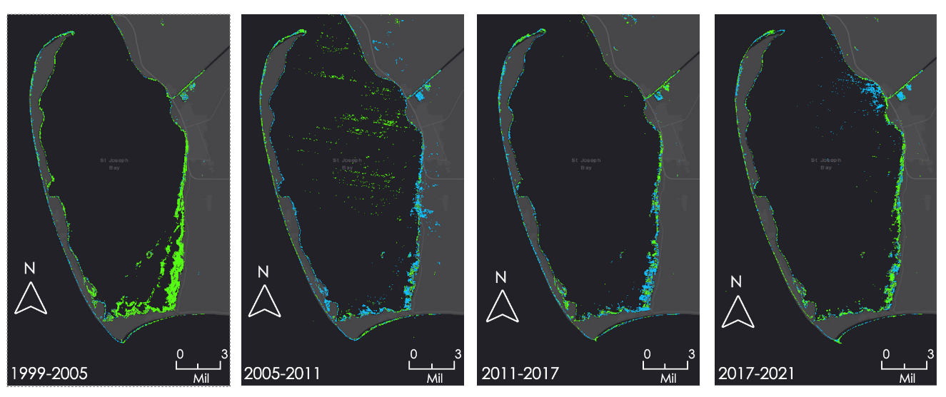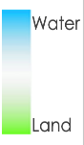*Figure A1.* Six-year annual shoreline change derived from Landsat 7 ETM+ and Landsat 8 OLI. These trends are discussed in section 4.1.2.

Appendix B: Sediment Transport

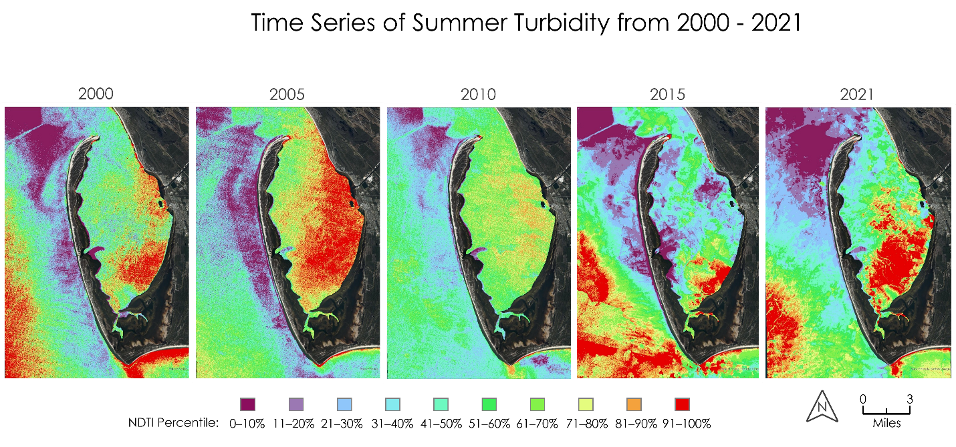

*Figure B1*. Time series map of turbidity measured in percentile of NDTI for the summer months between 2000 and 2021 in five-year increments derived from Landsat 7 ETM+ and Landsat 8 OLI. These trends are discussed in Section 4.1.3.

*Figure B2.* Chart of summer and winter NDTI between January 1999 and October 2021 utilizing Landsat 7 ETM+ and Landsat 8 OLI. These trends are discussed in Section 4.1.3.

Appendix C: Climatology

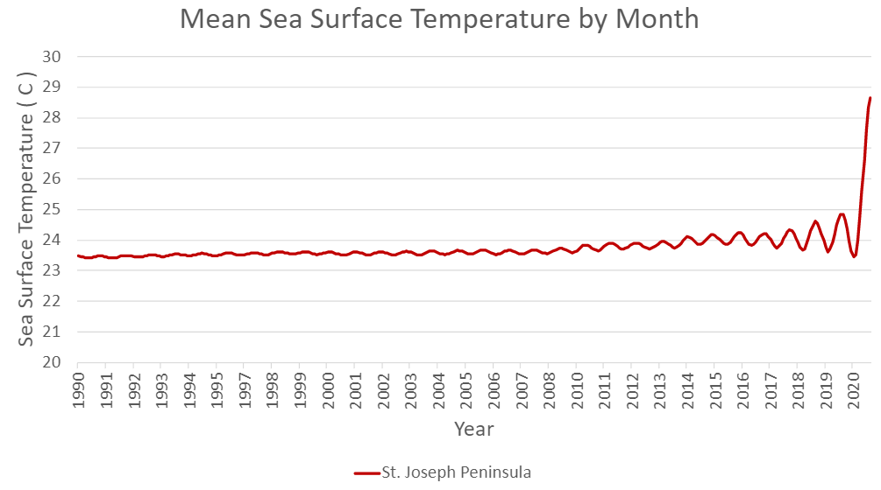

*Figure C1.* Time series chart of the mean sea surface temperature (SST) per month around the St. Joseph Peninsula from 1990 to 2020. Data from the NOAA CDR OISST dataset.

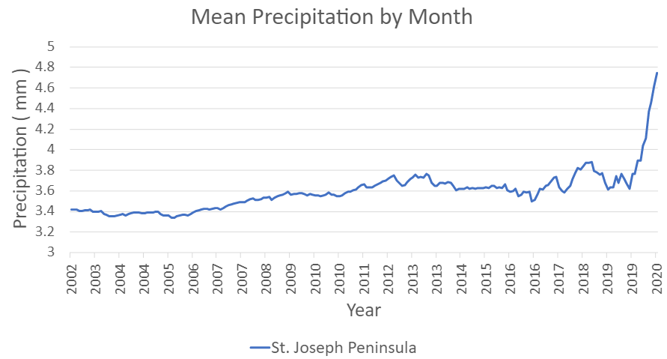

*Figure C2.* Time series chart of the mean precipitation per month on and around the St. Joseph Peninsula from 2002 to 2020. Data from the CHIPRS dataset.

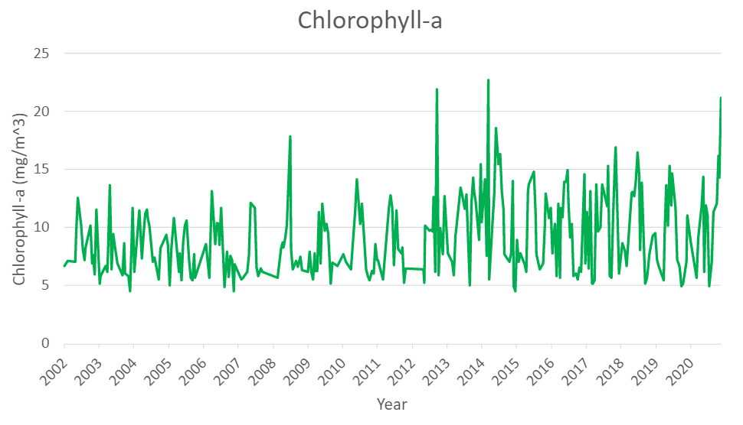

*Figure C3.* Time series chart of the chlorophyll-a concentration around the St. Joseph Peninsula from 2002 to 2020.

Appendix D: Seagrass

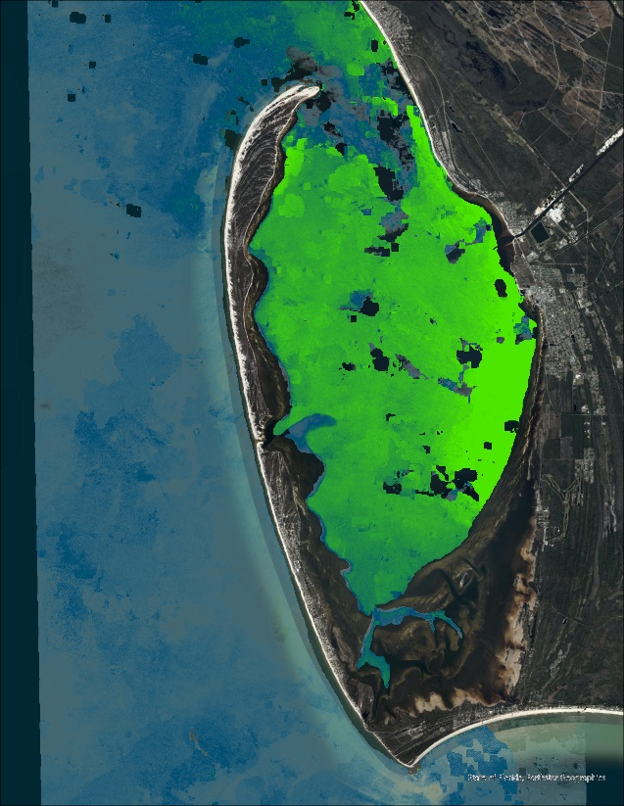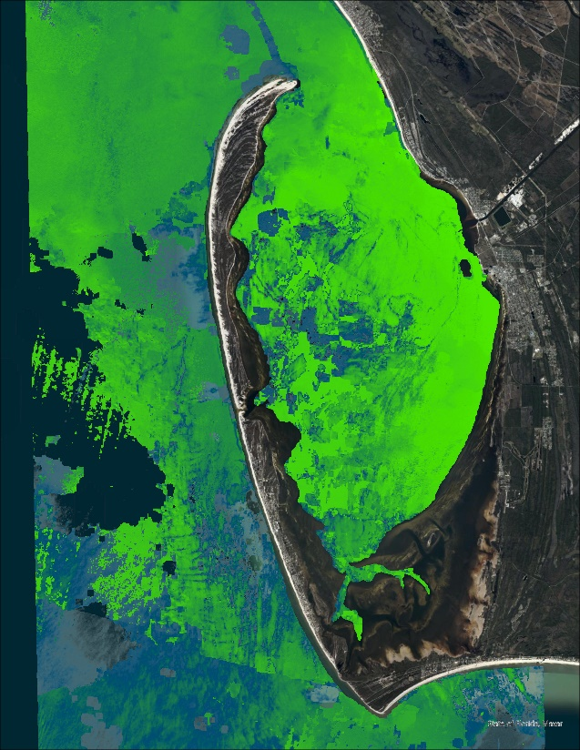

*Figure D1:* Seagrass abundance before and after Hurricane Michael in summer 2018 and summer 2019. Data from Landsat 8. These results are discussed in section 4.1.4.