**NASA DEVELOP National Program**



Wise County Clerk of Court’s Office

**Summer 2015**

**Short Title: Peru Disasters II**

**Subtitle:** Utilizing NASA Earth Observations to Develop the Tools for Flood Risk Mitigation for the Ochape Sub-Basin in the La Libertad Region of Peru

**VPS Title:** Holding back the river crest with CREST!

**Project Team & Partners**

**Project Team:**

William Wilson (Project Lead), [will.h.wilson@gmail.com](mailto:will.h.wilson@gmail.com)

Grant Bloomer

Allison Daniel

Anthony Donzella

Josh Hammes

**Advisors & Mentors:**

Dr. Kenton Ross (NASA DEVELOP National Program)

Dr. DeWayne Cecil (Global Science and Technology Inc.)

**Past or Other Contributors:**

Scott Arnette Sarah Medley

Jordan Bates Steve Padgett-Vasquez

Kieran Blakemore Azeb Shewago

Manzi Roger Dusabimana Catherine Steentofte

Abigail Holbrook Rohini Swaminathan

**Partner Organizations**

Water For People, End-User, POC: Mark Duey & Francisco Soto

Instituto Nacional de Defensa Civil del Peru (INDECI)

**Project Details**

**Applied Sciences National Applications Addressed:** Disasters

**Study Area:** Ochape sub-basin, Cascas District, Gran Chimu Province, La Libertad Region, Peru

**Study Period:** 2007 – 2014 (3 major floods identified during 2008, 2013 and 2014)

**Earth Observations & Parameters**

Landsat 8, OLI/TIRS - evapotranspiration, land cover

SRTM – elevation

TRMM, PR - precipitation

Terra, MODIS - MOD16– climatology-based, globally averaged Potential Evapo-Transpiration (PET)

**Ancillary Datasets Utilized**

* DIVA- GIS – assorted boundary shape-files

**Models Utilized**

* NASA University of Oklahoma’s Coupled Routing and Excess Storage (CREST) Flood Model

**Software Utilized**

* ArcGIS - Raster manipulation/analysis, flood inundation map creation
* Python - Processing of bulk data
* CREST v2.1 – Hydrological modeling and simulation of spatial and temporal surface variations
* MATLAB – Numerical computation and data analysis

**Project Overview**

**80-100 Word Objectives Overview**

This project utilized NASA Earth observations to improve upon the resources necessary to provide a preliminary flood risk analysis. Peru’s landscape leaves large segments of the population exposed to natural disasters. Reliable flood risk management plans are inadequate in this area, as are flood models that could be of great use to local decision makers. Our goal is to assist Water for People and help them incorporate flood modeling into their work by figuring and running the CREST v2.1 model and then transmitting to them how to use it via a guide.

**Abstract**

In recent years, natural disasters have afflicted the rural regions of Peru. Large flooding events in 2008, 2013, and 2014 disrupted central highlands districts, including the Cascas district of the Gran Chimu province about 110 km inland from the coastal city of Trujillo. The primary study area was the Ochape river sub-basin near the city of Cascas, the capital of the Gran Chimu province. In partnership with Water For People and the Instituto Nacional de Defensa Civil Del Peru (INDECI), this project created resources and tools necessary for flood risk assessment projects in the Cascas district of Peru. NASA Earth observations were used as inputs in the Coupled Routing and Excess Storage (CREST) Distributed Hydrological Model, which was developed by the University of Oklahoma in collaboration with NASA SERVIR. These inputs include Digital Elevation Models (DEM) and related data from the HydroSHEDS portfolio of NASA’s Shuttle Radar Topography Mission (SRTM), rainfall data collected by Tropical Rainfall Measuring Mission (TRMM), and Landsat 8 imagery. All final maps, models, datasets, and tutorials developed in this project will enable Water For People and the local government to be more equipped in analyzing seasonal flood patterns.

**Community Concerns**

* Flooding greatly affects the agricultural sector, the largest source of income for Peru, contributing 13% of the Gross Domestic Product (GDP) and employing 10,000,000 Peruvians.
* Statistics compiled by the National Emergency Operations Center (COEN) show that between October 2014 and February 2015, natural disaster episodes claimed 6,344 lives and displaced another 77,534 individuals.

**Current Management Practices & Policies**

The National System for Management of Disasters (SINAGERD) tasks itself with crafting risk management policies that will help prevent and control future natural disasters. It operates in coordination with the National Centre for Strategic Planning (CEPLAN), Instituto Nacional de Defensa Civil del Peru (INDECI), and entities in the private sector. National regulations are disseminated to local Civil Defense committees, who adopt and tailor these guidelines to their respective administrative realms. Currently, Water For People is partnering with these local governments to develop water resources management plans while also assisting the Peruvian government in flood risk mitigation. However, because of the lack of in situ data, Water for People wishes to incorporate remotely-sensed data from NASA Earth observations to help augment currently available in situ data. In addition to underdeveloped water resource management plans, current flood disaster management plans are incomplete and there are not enough proactive plans to prevent widespread disaster. This project would assist local policy makers in developing stronger, research-backed efforts to manage floods.

**Decision Support Tools & Benefits**

|  |  |  |
| --- | --- | --- |
| **End-Product** | **Earth Observations Used** | **Benefit & Impact** |
| CREST V2.1 outputs and related map products | TRMM  SRTM | Show the practical use of flood modeling software to end user. Determine whether CREST Model simulates regional patterns w/o in situ data. If so, could be a model replicated in other basins. |
| CREST V2.1 Fortran Tutorials / Material |  | Accompanying literature to our project partners will assist them in reproducing and running the model as new data becomes available and enable them to employ model on other basins. |

**Project Imagery**

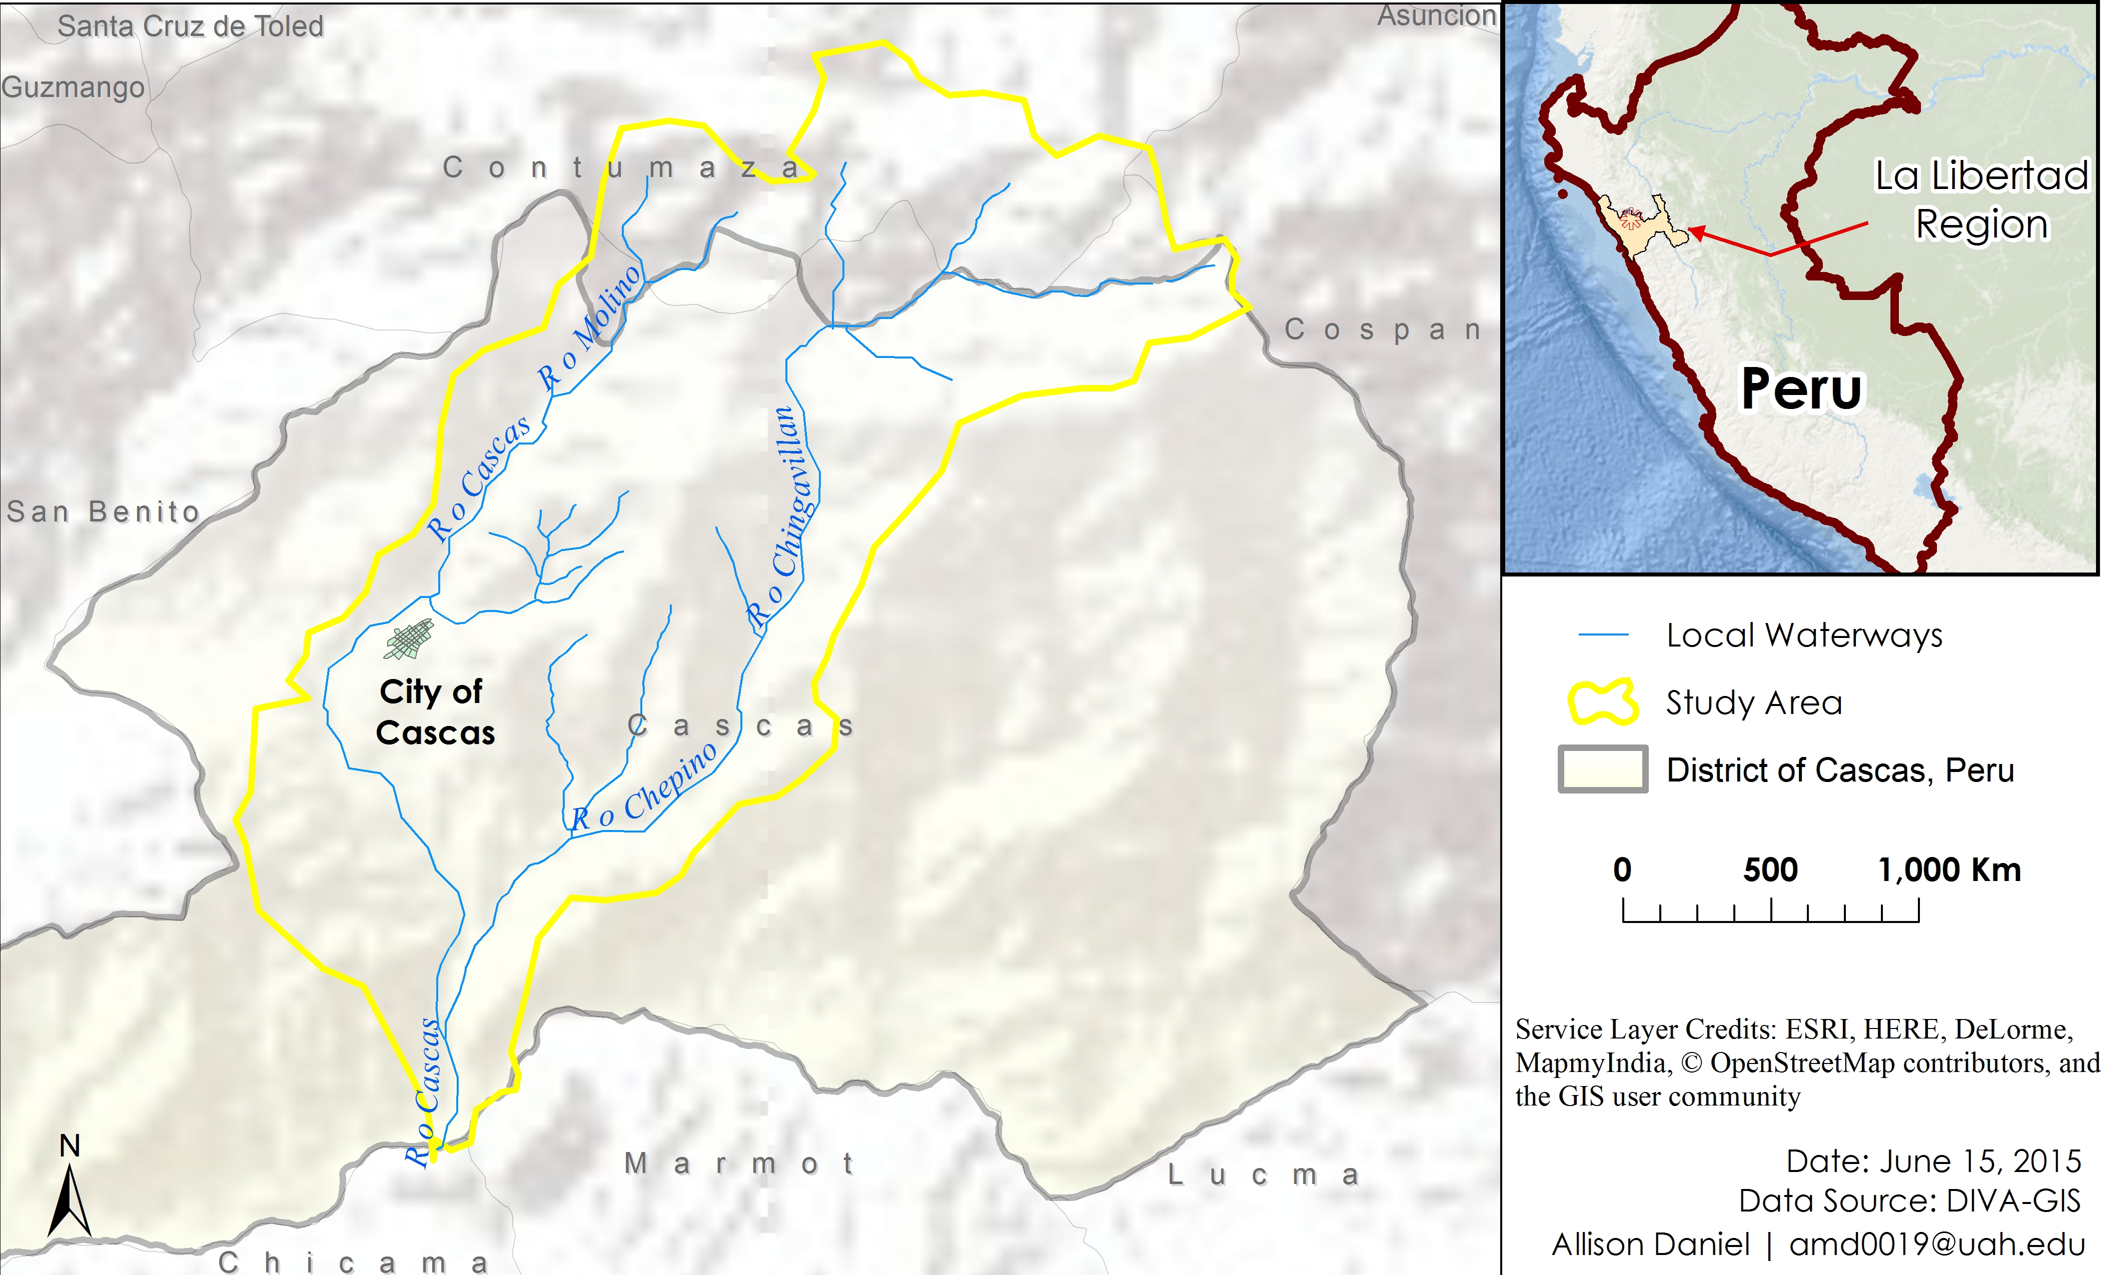

**Caption:** Bounds and Location of Study Area, Ochape Sub-basin, District of Cascas - Image Credit: Peru Disasters II Team.

**Image:** map2_studyarea.jpeg