**NASA DEVELOP National Program**

****University of Georgia

**Fall 2015**

**Short Title: Antarctica Climate**

**Subtitle:** Applying NASA Earth Observations to Assess the Seasonal and Inter-annual Variability of Sea Ice Dynamics in McMurdo Sound, Ross Sea, Antarctica

**VPS Title:** Antarctic Sea Ice: Archives of Climate

**Project Team & Partners**

**Project Team:**

Elizabeth Benyshek (Project Lead), ebenyshek@gmail.com

Christopher Cameron

Caren Remillard

Eduardo Rendon

**Advisors & Mentors:**

Dr. Sally Walker (Department of Geology, University of Georgia)

Dr. Adam Milewski (Department of Geology, University of Georgia)

**Past or Other Contributors:**

Linli Zhu (Geoinformatics Fellow, NASA DEVELOP)

**Partner Organizations:**

The Wadsworth Center: New York's State Public Health Laboratory (End-User), POC: Samuel Bowser, Ph.D.

University of Georgia (Collaborator), POC: Sally Walker, Ph.D.

**Project Details**

**Applied Sciences National Application Addressed:** Climate

**Study Area:** McMurdo Sound, Ross Sea, Antarctica

**Study Period:** October 2003 – December 2008

**Earth Observations & Parameters:**

ICESat, GLAS - Ice-sheet topography and extent

Terra, MODIS - Sea surface temperature, sea ice surface temperature, and sea ice extent

**Ancillary Datasets Utilized:**

* Dr. Samuel Bowser- study area coordinates

**Models Utilized:**

* NASA GIOVANNI

**Software Utilized:**

ArcGIS – data processing/analysis, image enhancement & map creation

ENVI Classic – georeferencing and data file conversion

**Project Overview**

**80-100 Word Objectives Overview:**

The objective of this project is to examine historical and current ICESat and MODIS data to characterize seasonal and inter-annual variability in sea ice parameters including sea ice thickness, ice surface temperature, and sea ice extent along with sea surface temperature. Additionally, the project will evaluate potential spatio-temporal correlations between these parameters along the coast of western McMurdo Sound, Antarctica. Particular attention will be paid to project partner field sites in Explorers Cove, Bay of Sails, and Ferrar Glacier.

**Abstract:**

This project employed the Ice, Cloud, and land Elevation Satellite (ICESat) and the Moderate Resolution Imaging Spectrometer (MODIS) to derive sea ice and temperature measurements in McMurdo Sound, Antarctica from 2003 to 2008. Time series maps were produced to illustrate both seasonal and inter-annual variability in sea ice characteristics within three partner-identified ecologically significant regions: Explorers Cove, Bay of Sails, and Ferrar Glacier. The team used parameters including sea ice thickness, ice surface temperature, and sea ice extent along with sea surface temperature to improve understanding of local sea ice dynamics. Additionally, the team evaluated potential spatio-temporal correlations between these parameters. Remote sensing datasets enhanced project partner’s ability to assess sea ice characteristics on a larger spatial and temporal scale, broadening their limited study area and field season to the wider McMurdo Sound and the western Ross Sea throughout the entire year.

**Community Concerns:**

* The Antarctic coast of McMurdo Sound experiences important changes in ice dynamics throughout a calendar year as both glaciers and sea ice undergo melt-freezing cycles.
* Long-term variability in sea ice conditions has focused on continental-scale trends.
* Compounded changes in local ice regimes can affect vulnerable ecological communities in the Explorers Cove region.

**Current Management Practices & Policies**:

Since 1990, project partner Dr. Samuel Bowser has made biannual trips to McMurdo Sound, Antarctica to conduct field-based research. Currently, field measurements are the only method project partners possess for surveying ecological populations in association with sea ice conditions. Although labor-intensive, scuba diving is the main field method for obtaining data concerning sea ice in McMurdo Sound.

**Decision Support Tools & Benefits:**

|  |  |  |
| --- | --- | --- |
| **End-Product** | **Earth Observations Used** | **Benefit & Impact** |
| Sea-Ice Topography Time Series Maps | ICESat, GLAS | For the first time, partners will have seasonal and inter-annual understanding of local sea ice conditions |
| Sea Surface Temperature Series Maps | Terra, MODIS | Project partners will be able to visualize differences in sea surface conditions through the years |
| Composite Time Series Maps and Correlations | ICESat, GLAS; Terra, MODIS | Spatial and temporal relationships of sea ice variables will help partners understand conditions in McMurdo Sound outside of the field season |

**Project Imagery**

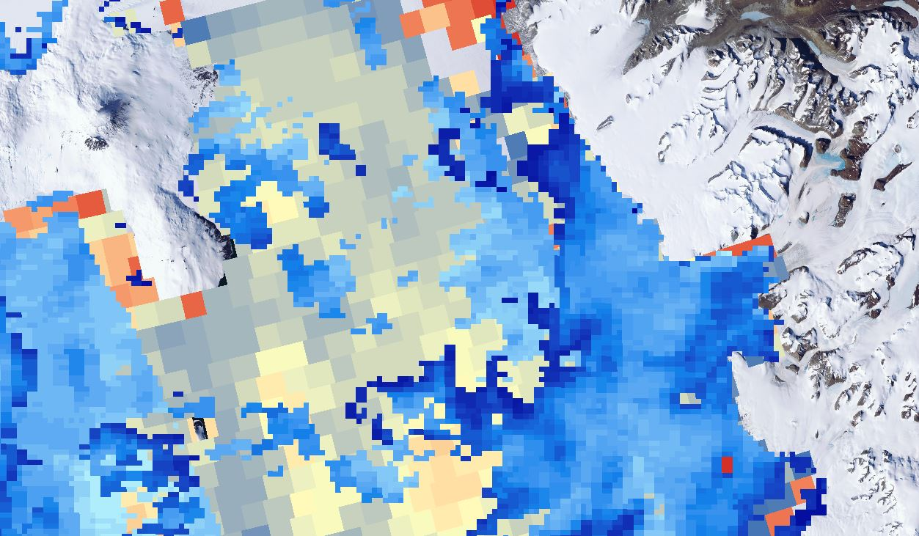

**Caption:** MODIS-derived sea and sea ice surface temperature within western McMurdo Sound, Antarctica. Darker colors represent colder temperatures and lighter colors represent warmer temperatures.

Image Credit: Antarctica Climate Team.

**Image:** 2015Fall_UGA_AntarcticaClimate_VPS_Image.jpeg

**Software Release Requirements**

What category do the tools your project is creating fall within? Category I