NASA DEVELOP National Program
NASA Marshall Space Flight Center
Fall 2016

Mississippi River Basin Disasters
Utilizing NASA Earth Observations to Enhance Flood Monitoring Throughout the Mississippi River Basin

 Technical Report
Final Draft – October 17, 2016

Chris Ploetz (Project Lead)
Dashiell Cruz (Project Lead)
Mercedes Bartkovich
Olivia Callaway
Nicholas McVey

Dr. Jeffrey Luvall, NASA at NSSTC (Science Advisor)
Dr. Robert Griffin, University of Alabama in Huntsville (Science Advisor)
Dr. Andrew Molthan, NASA SPoRT (Science Advisor)
Leigh Sinclair, University of Alabama in Huntsville/Information Technology and Systems Center (Mentor)

1. Abstract
The Mississippi River Basin is an area prone to multi-level flood events of various intensities, as well as a home to millions of Americans. Stretching from Louisiana to Minnesota and draining 41 percent of the contiguous US, the basin covers 13 states and 1.245 million miles making it the third largest drainage basin in the world. This large area is susceptible to water level rises following changes in precipitation, snow melt, and water table levels, which can cause both small and large scale flooding. Disaster relief agencies, such as the Federal Emergency Management Agency (FEMA) and the United States Geologic Survey (USGS) are interested in the creation of a more precise and comprehensive method to use in their decision making process for locating and prioritizing areas that require aid. The flood map algorithm created in this project will help identify the probability of flooding within a given area for use in flood monitoring and the decision making process of relief efforts. The map incorporates the Landsat 8 Operational Land Imager and Digital Elevation Model derived from Shuttle Radar Topology Mission v2 to determine the probability of flooding in an area. Additionally Landscan and Security Infrastructure Preparedness Data were also used to create an exposure map.

Keywords
Landsat 8 OLI, SRTM-v2, NDVI, NDWI, flood extent map, flood probability

Introduction
The Mississippi River Basin encompasses portions of 13 states, from Louisiana to Minnesota, and is home to millions of people. This area has been susceptible to a number of flood events that vary in intensity, with possible contributing factors including excessive precipitation, topography, vegetation cover, water table depth, and increased runoff due to impermeable surfaces and hardened soils. In the past 6 years, areas within the Mississippi River Basin have sustained over $34 billion in flood damage. The most recent flooding events in December 2015 and January 2016 added an estimated $3 billion in damages and cost the lives of at least 20 people (Grencer, 2015). To prevent New Orleans from flooding in 2011, a spillway was opened to flood around 130,000 acres of farmland (Guarino, 2011). This spillway threatened the operations of 10 oil refineries that account for around 14 percent of U.S. operating capacity (Shenk, 2011). Identifying the areas with a higher probability of flooding, as well as having both a flood extent map and a flood probability algorithm, will allow disaster response and management organizations to prepare for floods in a timely manner.

The study area of this project (Figure 1), focused on areas affected by the flood events of December 2015 to January 2016, which recorded historic highs in water levels of the Mississippi River in some areas. The geographic study area is defined as a subset of the greater Mississippi River Basin encompassing Arkansas, Kentucky, Illinois, Louisiana, Mississippi, Missouri, and Tennessee. In an effort to complement disaster relief organizations’ efforts for a more timely response to extreme flood events, the Mississippi River Basin Disasters team aimed to create an applicable algorithm, using NASA Earth observations, to identify the probability of flooding within a given area. Currently, disaster relief organizations, such as the Federal Emergency Management Agency (FEMA) and other disaster response agencies rely on flood detection models to plan relief efforts. These models have no predictive ability, are not near-real time, and can only be used to find areas that have already flooded and are in need of aid.
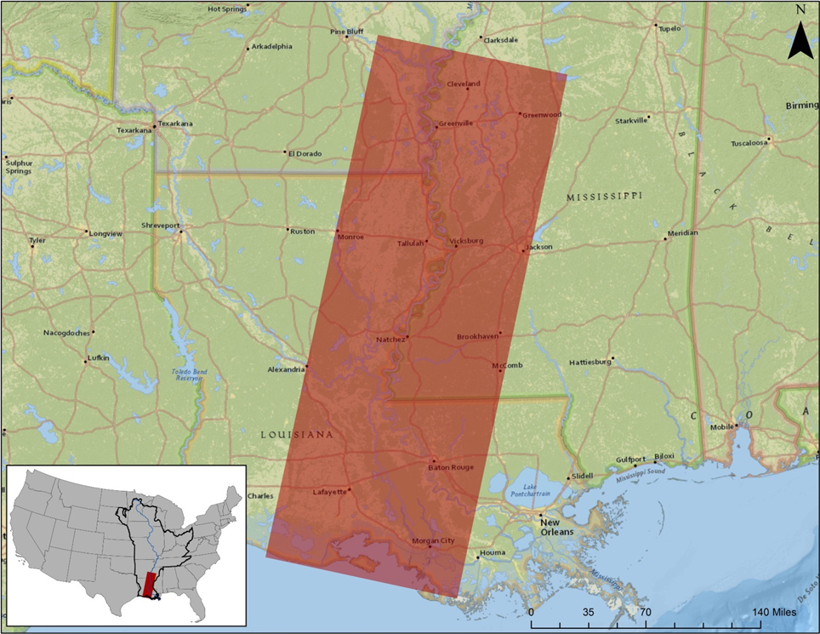
Figure 1. Project study area. Subset of the Mississippi River Basin
Disaster response and relief organizations need to gather data and maps, with near-real time capabilities, to use in their decision making process to prioritize areas requiring aid. Additionally, FEMA and USGS need to map the total affected area for the purposes of estimating damage and recovery costs, particularly when remotely sensed inundation areas can be integrated with other geospatial data sets, such as population, building footprints, and other measures of affected infrastructure. With a formulated and replicable methodology, the decision maker or supporting partner can create near-real time flood mapping products to improve upon and support their interests in mapping the extent and duration of flood water.

3. Methodology

3.1 Data Acquisition
Earth Observations / Ancillary Data
Satellite | Resolution/Date or Year/ Paths/Rows | Data Source
SRTM v2 | 30m | USGS
Landsat 8 OLI | 30m / c. 2015 - 2016/ Path 23/ Rows 37,38,39 | USGS
MODIS MFW | 250m | NASA NRT
NLCD 2011 | 30m | MRLC
HSIP Public | c. 2016 | NGA
LandScan | c. 2014 | Oakridge National Laboratory
Table 1. List of Earth observations and data used

Shuttle Radar Topography Mission (SRTM) Void filled version 2 data were acquired from the United States Geological Survey’s (USGS) Earth Explorer website. Version 2 SRTM data were selected because it has been significantly edited by the National Geospatial Intelligence Agency (NGA) to show defined bodies of water, coastlines and an absence of spikes and wells (Shuttle Radar Topography Mission, 2015). This dataset provided the team with a 30m Digital Elevation Model (DEM) of the study area.

Landsat 8 Operational Land Imaging (OLI) sensor data were acquired using the USGS Global Visualization viewer (GLOVIS). Three tiles were obtained: one from October 2015 (pre-flood), another from December 2015 (initial flood), and the final from January 2016 (during flood); along path 23 and rows 37, 38, and 39. The Landsat 8 OLI imagery provided the team with 30m resolution multispectral imagery for the flooding events.

Moderate Resolution Imaging Spectroradiometer Flood Water (MODIS MFW) data were obtained from the NASA Near Real Time (NRT) Global Flood Mapping website. The MODIS data provided the current flood mapping capabilities at 250m spatial resolution.

National Land Cover Database 2011 (NLCD) data were obtained from the Multi-Resolution Land Characteristics consortium (MRLC) website. The 2011 NLCD dataset is the most recent land cover product available, providing 16 classes of land cover as a 30m spatial resolution.

Homeland Security Infrastructure Preparedness (HSIP) data was acquired from the National Geo-spatial Intelligence Agency (NGA). The HSIP data were used to map flood impact on infrastructure.

3.2 Data Processing
The SRTM-v2 DEMs were re-projected to North American Datum 1983 (NAD 83 UTM Zone 15), mosaicked, and then clipped to the pre-defined study area. Because DEMs contain sinks and peaks due to errors in resolution or rounding of the elevation, the fill tool in ArcMap 10.3 was used to “smooth” out the data creating a depression-less DEM for the hydrologic model (Tarboton et al., 1991). This ‘Fill’ raster was used to create ‘Flow Direction’ and ‘Flow Accumulation’ for use in determining the if classified flood areas were realistic given elevation and slope.

Landsat 8 OLI imagery was also projected to NAD 83 UTM Zone 15. Before a mosaic of the three tiles could be performed, Digital Number (DN) values, which have not yet been calibrated into physically meaningful units, were converted into top of atmosphere (TOA) reflectance, as surface reflectance values require extensive time to process, using the following equation:

ρλ' = M_{ρ}Q_{cal} + A_{ρ} (1)

where ρλ' is TOA planetary reflectance, M_{ρ} is band-specific multiplicative rescaling factor from the metadata, Q_{cal} is quantized and calibrated DN values, and A_{ρ} is band-specific additive rescaling factor from the metadata (Landsat 8 Data Users Handbook 2016). Until this is done the imagery cannot yield any quantitative information about the features on the surface (Solutions HG 2016). Afterwards, atmospherically corrected imagery was mosaicked together for ease of use.
3.3 Data Analysis
Indices such as Normalized Difference Vegetation Index (NDVI) and Normalized Difference Water Index (NDWI), as well as the created band combinations of Near Infrared (NIR)/Short Wave Infrared (SWIR)/Red were examined by team members to determine the spectral signatures that best separated water from other land features. Using ArcMap’s Image classification toolbar, 100 polygon training samples were created for water features, and an additional 100 polygons for land features. These training polygons were used to conduct a maximum likelihood supervised classification on flooded imagery.

NDVI = | Band(Red) - Band(NearIR)
 | Band(Red) + Band(NearIR)
NDWI = | Band(Green) - Band(NearIR)
 | Band(Green) + Band(NearIR)
NIR/SWIR = | Band(Red) - Band(SWIR)
 | Band(Red) + Band(SWIR)
NIR/Red = | Band(NearIR) x Band(Red)
 | Band(NearIR) + Band(Red)

To assess the accuracy of the classification technique, a visual accuracy assessment was conducted followed by a more technical confusion matrix to score the accuracy of each of the spectral signatures’ ability to correctly identify water versus land. One hundred and fifty random points were generated using the “Create Random Points” tool in ArcMap, and were analyzed using the true color image to determine whether the points were located on water or land. Following that, the points were re-assessed on each spectral signature’s classification and evaluated on whether the point was located on water or land based on the way the signature classified the feature (Table 3). The points were then cross reference with the true color assessment, and if the classification attempt agreed with the true color assessment, then it was scored with a 1, and if it did not agree then it was scored with a 0. An accuracy percentage was then taken by dividing the summation of the spectral signature classification with the total possible points scored.

This process was replicated 4 times using newly generated random points each time. Once all replicates were complete, the signature that was the most consistent with having the highest accuracy was used for further application. The chosen signature was applied to a recent flood event that occurred in the same area in January 2016, and was used to create a flood extent map and a flood exposure map that incorporated from Landscan and USGS land cover data.

4. Results & Discussion
The NDWI, NDVI, NIR/SWIR, and NIR/Red indices all produced levels of accuracy greater than the current MODIS MFW product, as shown in table 4 and Appendix A. NDWI and NDVI were the two highest scoring indices; however, since NDVI can be affected by plant cover, soil moisture, plant moisture, plant stress, and photosynthetic activity, it is more sensitive to changes in season than NDWI (Bo-cai., 1999); therefore, NDWI was selected as the index from which to derive the flood map algorithms spectral signature.

 | NIR/SWIR | NDVI | NDWI | NIR/Red | MODIS MFW (Product)
Total Correct | 94 | 95 | 96 | 92 | 75
Total Scored | 98 | 98 | 98 | 95 | 85
Accuracy | 95.9% | 96.9% | 98.0% | 96.8% | 88.2%
Table 2. Spectral signature accuracy percentage of single assessment

The NDWI derived spectral signature was applied to the December 2015 - January 2016 flood event that occurred throughout the study area to create a Flood Extent Map, shown in Figure 2. The global water mask from the University of Maryland was used to remove non-flood waters from the map, resulting in only flood induced water. The Flood Extent Map provided a more precise estimation of flooding within the study area. Once created, the Flood Extent Map was then overlain with LandScan, HSIP, and NLCD 2011 data to create a Flood Exposure Map, shown in Figure 3. This exposure map can provide information as to not only where flooding occurred, but what impact the flood had on populations, infrastructure, and economics.

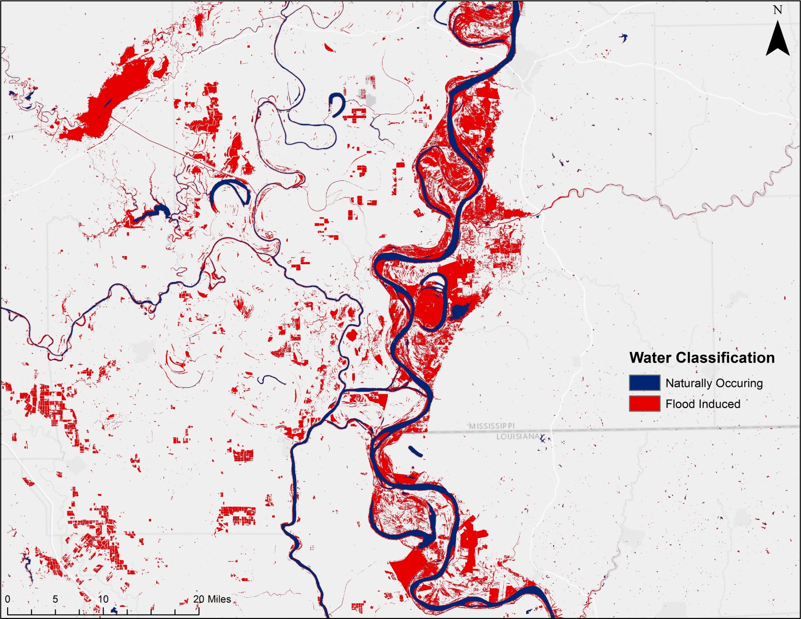
Figure 2. Flood Extent Map

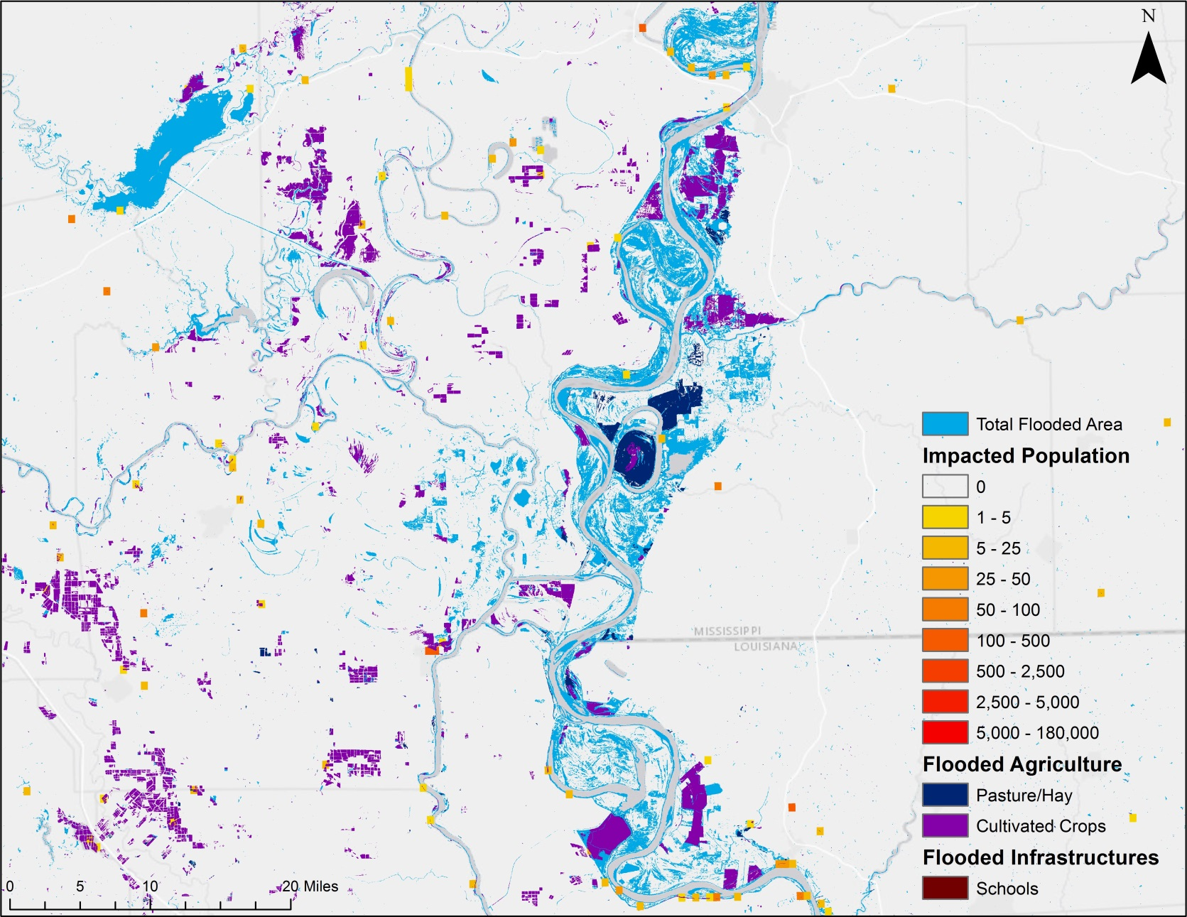
Figure 3. Flood Exposure Map

4.1 Limitations and Uncertainties
There are limitations and uncertainties present within this project that should be addressed. Cloud cover is an inherent problem with flood mapping, as flooding often produces heavy rain and cloud cover. Landsat 8 imagery comes with a cloud mask which can be applied to simply ignore the clouds; however, the same cannot be said for cloud shadows, as they are much more difficult to mask out and can frequently be incorrectly classified as water. The time of year can also have an impact on certain indices. While likely to a lesser extent than NDVI, NDWI is also affected by seasonality. Time of day can also impact solar angles, which can affect the length of cloud shadows that, as previously mentioned, can be classified as water. Probably the greatest limitation of this algorithm is its reliance on Landsat 8 imagery. Given the 16 day temporal resolution of Landsat 8 OLI, the map product derived from this project will most likely be used in second and third phase disaster responses. MODIS, while having a lower accuracy and a coarser spatial resolution, has a much higher temporal resolution at once a day global coverage. Used in conjunction the two products, it can be utilized to greater effect.

4.2 Future Work
In a second term, the focus will be to automate the Flood Probability Algorithm created during this term (Figure 4) using python scripting. This will allow for the project partners to be able to map probable flooded areas as they occur in a near-real time aspect. The algorithm will be further applied to other imagery sources such as Sentinel, MODIS, EO-1, IKONOS, and Synthetic Aperture Radar (SAR) assets in an effort to further refine and improve the methodology. Additionally, incorporation of more detailed socioeconomic data into the Flood Probability Algorithm including women, children, single women with children, elderly and physically challenged individuals is a long term goal for the project.

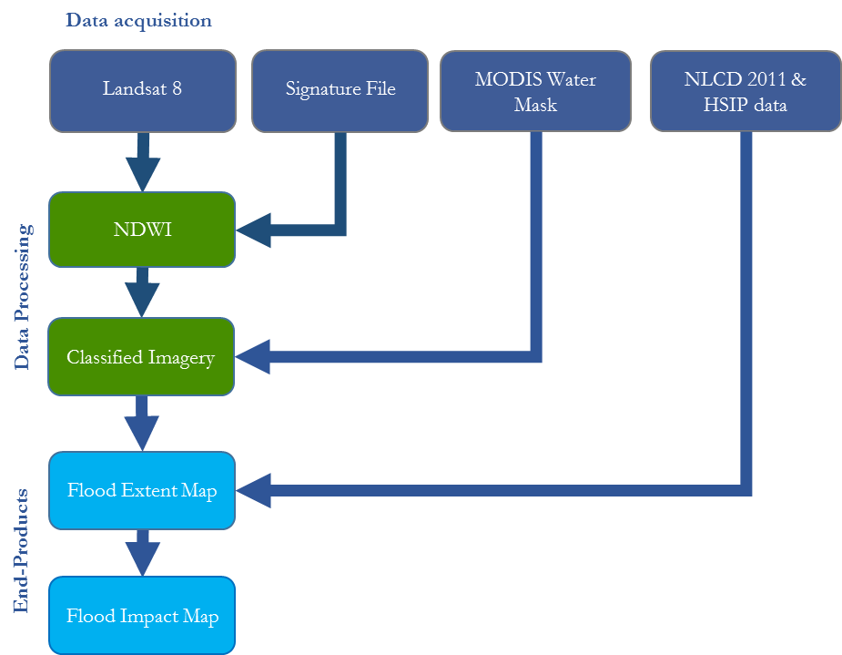
Figure 4. Flood Map Algorithm

5. Conclusions
An algorithm was designed to classify water from land using the spectral signature derived from the Landsat 8 NDWI. The global water mask was used to remove expected water from the Landsat 8 scene. This resulted in an output map of only the probable flood waters creating a Flood Extent Map. Infrastructure, population, and land cover data was overlaid onto the Flood Extent Map resulting in a Flood Exposure Map product. This Flood Exposure Map product will help disaster response organizations and policy makers identify areas of probable flooding within a given area for the use in flood monitoring, decision making, relief efforts, and damage assessments.

6. Acknowledgments
The Mississippi River Disaster team would like to thank the mentors and partners who dedicated their time and assistance to this project. Without any of them, this project would not have been possible.

Mentors/Science Advisors:
- Dr. Jeffrey Luvall (NASA at NSSTC)
- Dr. Robert Griffin (University of Alabama in Huntsville)
- Dr. Andrew Molthan (NASA SPoRT)
- Leigh Sinclair (University of Alabama in Huntsville/Information Technology and Systems Center)
Partners:
- Dr. Andrew Molthan - NASA SPoRT
- Brenda Jones - USGS Hazard Data Distribution System (HDDS)
- Christopher Vaughan - FEMA
Others:
- Maggi Klug – NASA DEVELOP MSFC Center Lead
- Daryl Ann Winstead – NASA DEVELOP

Any opinions, findings, and conclusions or recommendations expressed in this material are those of the author(s) and do not necessarily reflect the views of the National Aeronautics and Space Administration.

This material is based upon work supported by NASA through contract NNL11AA00B and cooperative agreement NNX14AB60A.

7. References
Bo-cai Gao, Bo-cai. "NDWI-A Normalized Difference Water Index for Remote Sensing of Vegetation Liquid Water from Space." NDWI-A Normalized Difference Water Index for Remote Sensing of Vegetation Liquid Water from Space. Remote Sensing of Environment, 22 Feb. 1999. Web. 14 Nov. 2016.
Gerencer, T. (2015). U.S. Floods Cost $34 Billion. Retrieved October 04, 2016, from http://moneynation.com/u-s-floods-cost-34-billion/
Guarino, M. (2011, May 15). Morganza spillway: Flooding farmland to save New Orleans. Retrieved October 04, 2016, from http://www.csmonitor.com/USA/2011/0515/Morganza-spillway-Flooding-farmland-to-save-New-Orleans
Landsat 8 Data Users Handbook (2016, March 29). Retrieved November 14, 2016, from http://landsat.usgs.gov/documents/Landsat8DataUsersHandbook.pdf
Nobre, A. D., Cuartas, L. A., Hodnett, M., & Saleska, S. (2011, March 24). Height Above the Nearest Drainage - a hydrologically relevant new terrain model. Journal of Hydrology, 404, 13-29. Retrieved October 4, 2016, from https://www.researchgate.net/publication/232042361_Height_Above_the_Nearest_Drainage_-_a_hydrologically_relevant_new_terrain_model.
Rice, D. (2016). Wintertime floods among costliest ever. Retrieved October 04, 2016, from http://www.usatoday.com/story/weather/2016/01/08/mississippi-river-flood-cost/78366942/
Shenk, M. (2011, May 16). Oil Falls on Ebbing Concern the Mississippi to Flood Refineries. Retrieved October 04, 2016, from http://www.bloomberg.com/news/articles/2011-05-16/oil-falls-on-ebbing-concern-the-mississippi-to-flood-louisiana-refineries
Shuttle Radar Topography Mission (SRTM). (2015, January). Retrieved October 04, 2016, from https://lta.cr.usgs.gov/SRTM
Solutions HG. Digital Number, Radiance, and Reflectance. Harris Geospatial Solutions. http://www.harrisgeospatial.com/home/newsupdates/tabid/170/artmid/735/articleid/13592/digital-number-radiance-and-reflectance.aspx. Accessed October 6, 2016.
Tarboton, D. G., R. L. Bras, and I. Rodriguez–Iturbe. 1991. "On the Extraction of Channel Networks from Digital Elevation Data." Hydrological Processes 5: 81–100.

8. Content Innovation

Content Innovation #1
VPS
Emailed to Tiffani.N.Miller@nasa.gov with filename: 2016fall_MSFC_MississippiRiverBasinDisasters_VPSOO

Content Innovation #2
Interactive map viewer
Emailed to Tiffani.N.Miller@nasa.gov with filename: 2016Fall_MSFC_MississippiRiverBasinDisasters_InteractiveMapViewer

Content Innovation #3
Audio Slides
Emailed to Tiffani.N.Miller@nasa.gov with filename: 2016Fall_MSFC_MississippiRiverBasinDisasters_AudioSlides

9. Appendices

Appendix A.
Water classification maps of NDWI, NDVI, NIR/SWIR, NIR/Red spectral signatures and the current MODIS MFW product.

NDWI Water Classification Map

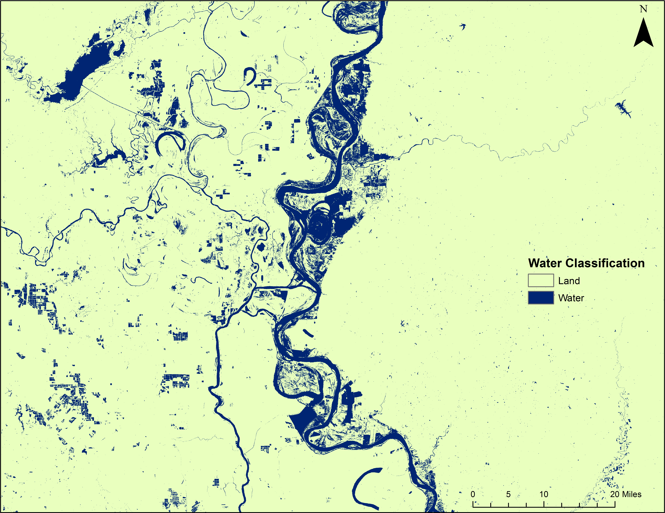
Figure 5. NDVI Water Classification Map

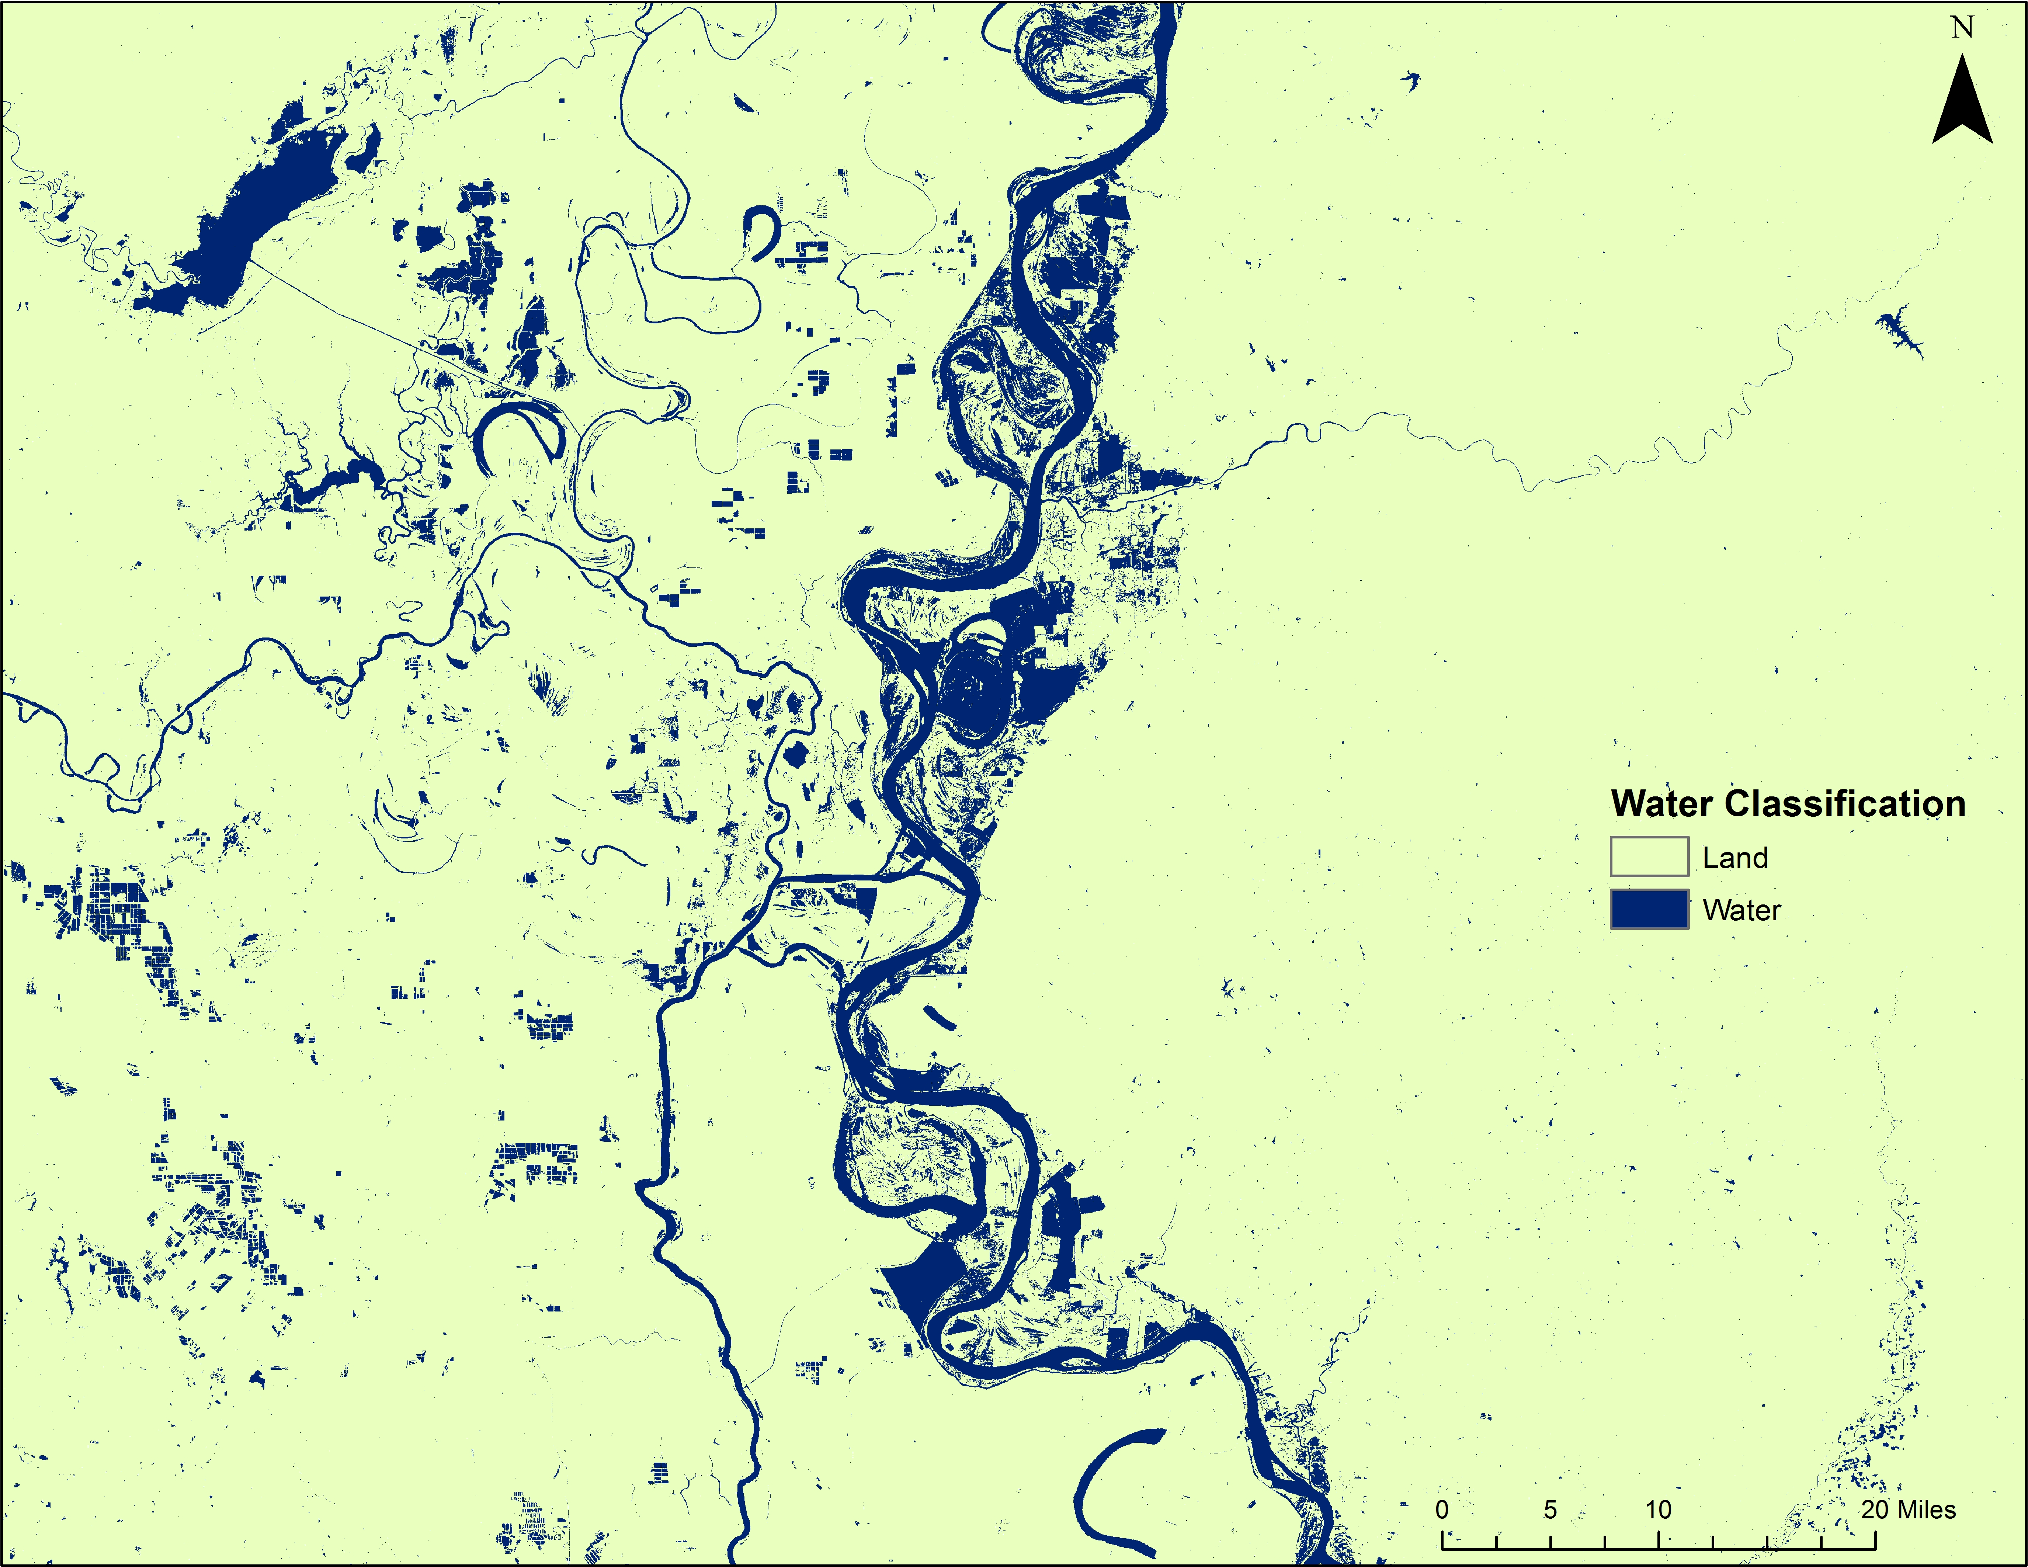
Figure 6. NIR/SWIR Water Classification Map

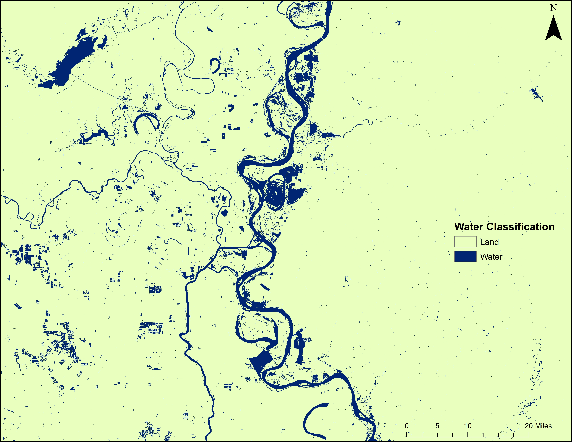
Figure 7. NIR/Red Water Classification Map

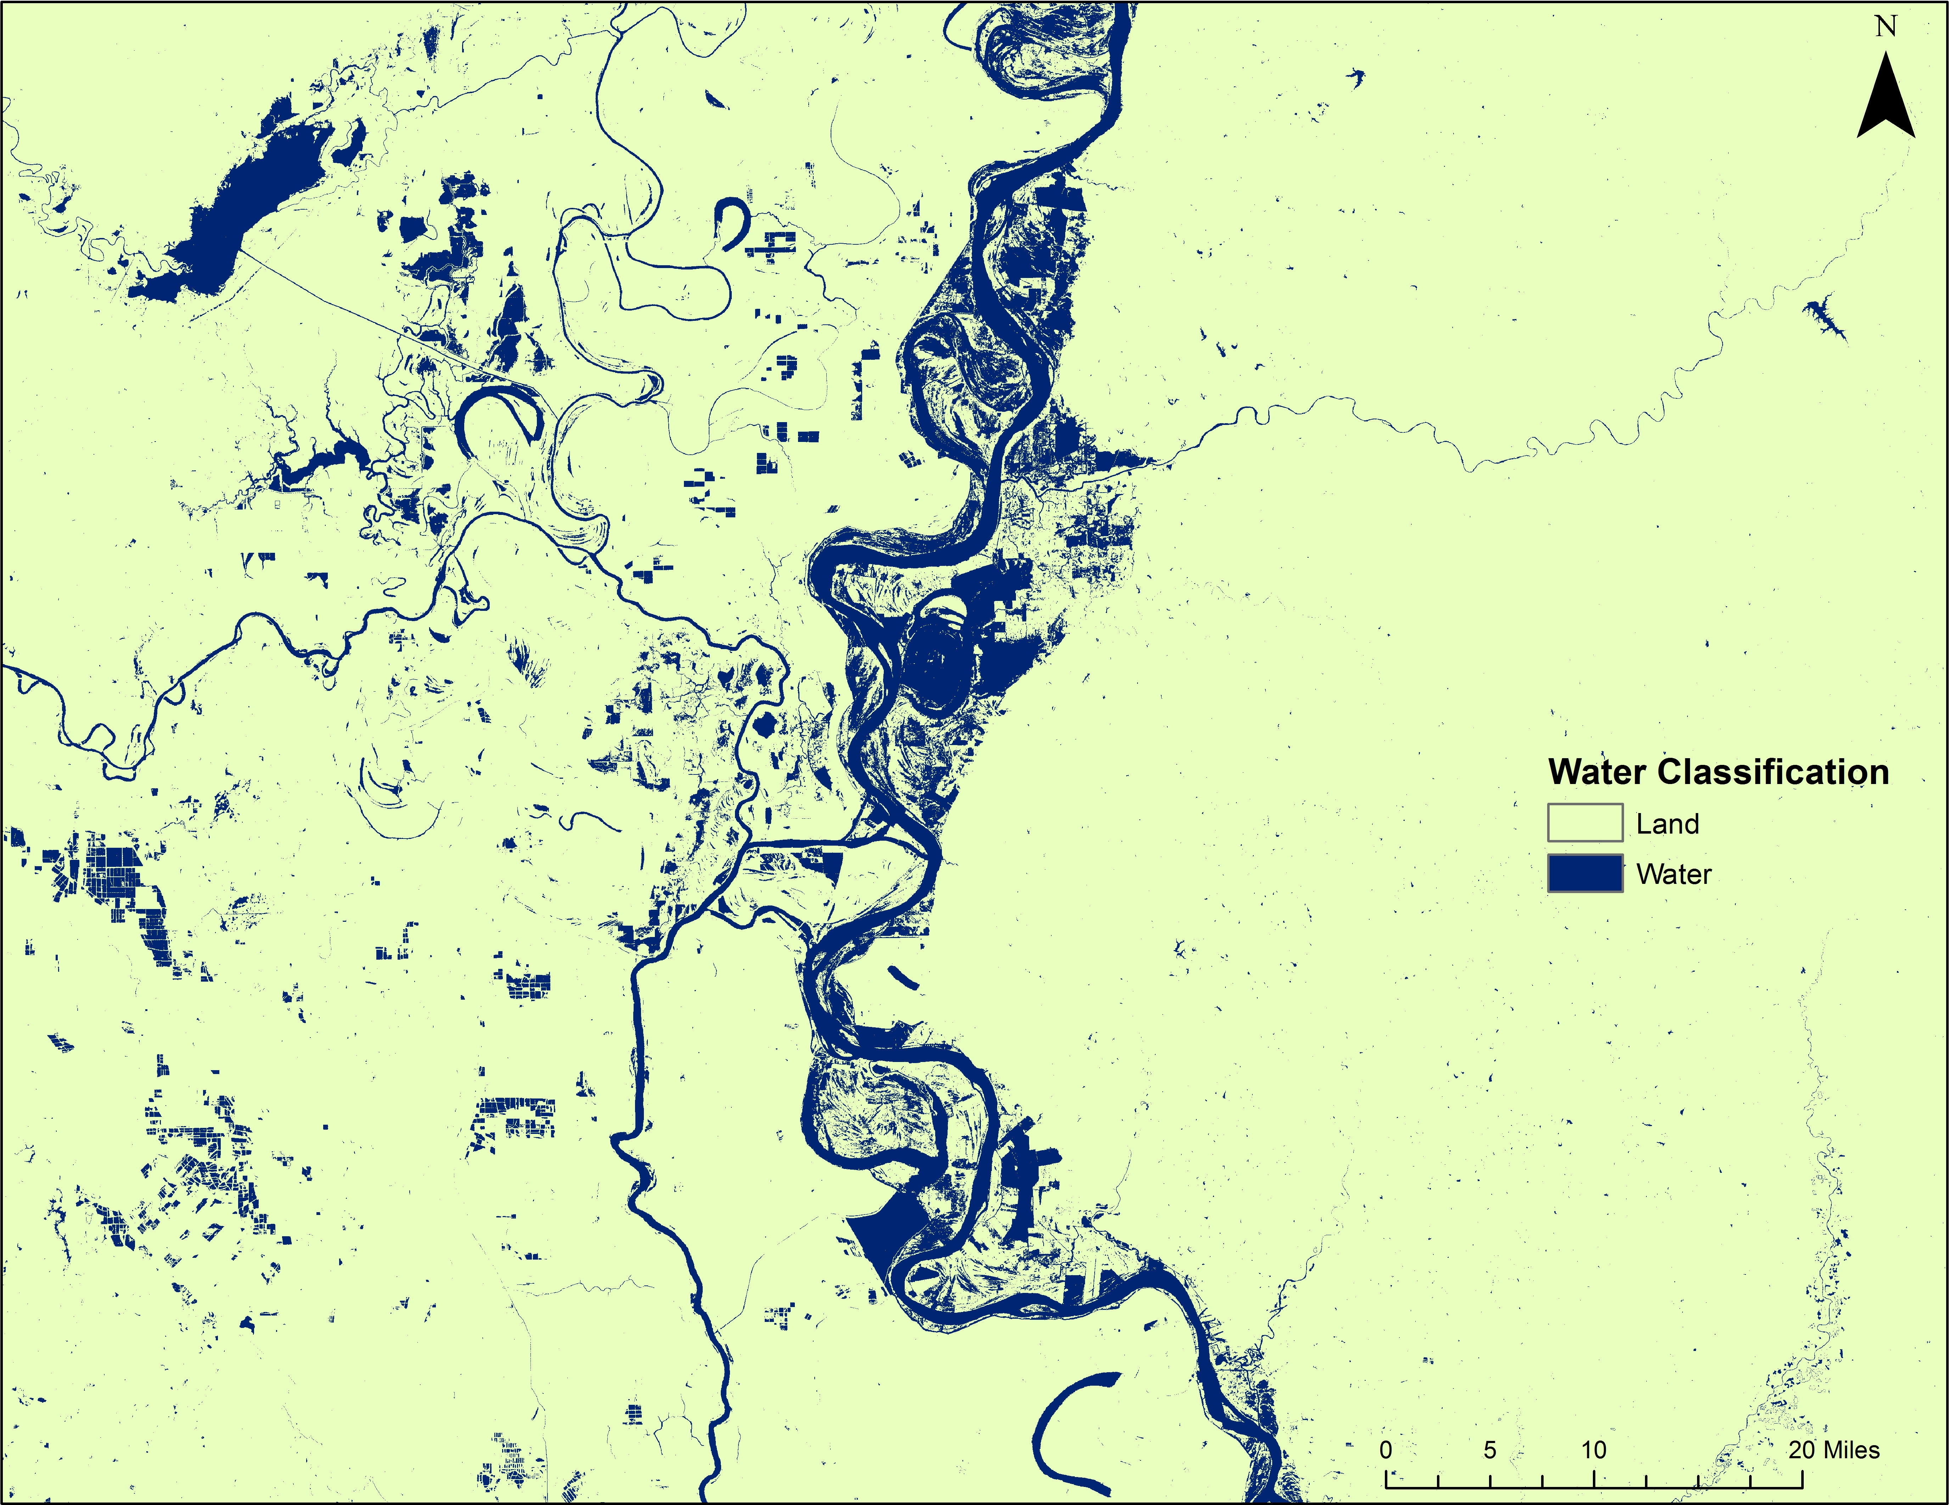
Figure 8. MODIS MFW Product Water Classification Map

 | True Color |  | NIE/SWIR | NDVI | NDWI | NIR/Red | MODIS MFW (Product)
Point 1 | NA |  | NA | NA | NA | NA | NA
Point 2 | NA |  | NA | NA | NA | NA | NA
Point 3 | 0 |  | 0 | 0 | 0 | 0 | NA
Point 4 | 0 |  | 0 | 0 | 0 | 0 | 0
Point 5 | NA |  | NA | NA | NA | NA | NA
Point 6 | 0 |  | 0 | 0 | 0 | 0 | 0
Point 7 | 0 |  | 0 | 0 | 0 | 0 | 0
Point 8 | 0 |  | 0 | 0 | 0 | 0 | 0
Point 9 | 0 |  | 0 | 0 | 0 | 0 | 0
Point 10 | NA |  | NA | NA | NA | NA | NA
Point 11 | NA |  | NA | NA | NA | NA | NA
Point 12 | 0 |  | 0 | 0 | 0 | 0 | 0
Point 13 | 0 |  | 0 | 0 | 0 | 0 | NA
Point 14 | 0 |  | 0 | 0 | 0 | 0 | 0
Point 15 | 0 |  | 0 | 0 | 0 | 0 | 0
Point 16 | 0 |  | 0 | 0 | 0 | 0 | 0
Point 17 | NA |  | NA | NA | NA | NA | NA
Point 18 | 0 |  | 0 | 0 | 0 | 0 | 0
Point 19 | NA |  | NA | NA | NA | NA | NA
Point 20 | NA |  | NA | NA | NA | NA | NA
Point 21 | 0 |  | 0 | 0 | 0 | 0 | NA
Point 22 | NA |  | NA | NA | NA | NA | NA
Point 23 | NA |  | NA | NA | NA | NA | NA
Point 24 | NA |  | NA | NA | NA | NA | NA
Point 25 | 0 |  | 0 | 0 | 0 | 0 | 0
Table 3. Assessment of 25 out of 150 random points examining each spectral signature’s classification of land versus water

 | NIR/SWIR | NDVI | NDWI | NIR/Red | MODIS MWF (Product)
Point 1 | NA | NA | NA | NA | NA
Point 2 | NA | NA | NA | NA | NA
Point 3 | 1 | 1 | 1 | 1 | NA
Point 4 | 1 | 1 | 1 | 1 | 1
Point 5 | NA | NA | NA | NA | NA
Point 6 | 1 | 1 | 1 | 1 | 1
Point 7 | 1 | 1 | 1 | 1 | 1
Point 8 | 1 | 1 | 1 | 1 | 1
Point 9 | 1 | 1 | 1 | 1 | 1
Point 10 | NA | NA | NA | NA | NA
Point 11 | NA | NA | NA | NA | NA
Point 12 | 1 | 1 | 1 | 1 | 1
Point 13 | 1 | 1 | 1 | 1 | NA
Point 14 | 1 | 1 | 1 | 1 | 1
Point 15 | 1 | 1 | 1 | 1 | 1
Point 16 | 1 | 1 | 1 | 1 | 1
Point 17 | 1 | 1 | 1 | 1 | 1
Point 18 | 1 | 1 | 1 | 1 | 1
Point 19 | NA | NA | NA | NA | NA
Point 20 | NA | NA | NA | NA | NA
Point 21 | 1 | 1 | 1 | 1 | NA
Point 22 | NA | NA | NA | NA | NA
Point 23 | NA | NA | NA | NA | NA
Point 24 | NA | NA | NA | NA | NA
Point 25 | 1 | 1 | 1 | 1 | 1
Table 4. Accuracy assessment scoring of 25 out of 150 random points comparing spectral signature classification to the true color classification where if the classification attempt agreed with the true color assessment, then it was scored with a 1, and if it did not agree then it was scored with a 0

