**NASA DEVELOP National Program**



Goddard Space Flight Center

*Fall 2015*

Himalayan Disasters III

Utilizing a Landslide Identification Product and a Real-time Rainfall Detection Tool for Enhanced Landslide Detection in Nepal

 **Technical Report**

Rough Draft – October 8, 2015

Amanda Rumsey (Project Lead)

Jordan Scheffler

Jessica Fayne

Dr. Dalia B. Kirschbaum, NASA Goddard Space Flight Center (Science Advisor)

Dr. John D. Bolten, NASA Goddard Space Flight Center (Science Advisor)

Thomas A. Stanley, NASA Goddard Space Flight Center (Science Advisor)

Previous Contributors:

Justin Roberts-Pierel

Aakash Ahamed

Jamie Shiplet

# I. Abstract

[Placeholder - do not put anything here until the final draft submission. The abstract in the project summary is where the working draft of the abstract should “live”]

**Keywords**

Landslides, Precipitation, Remote Sensing, Landsat, GPM, SLIP, DRIP

# II. Introduction

A landslide is a type of mass wasting event that occurs when down-slope forces exceed the strength of the slope materials (Cruden, 1991). Changes in slope stability can occur due to natural forcings like intense rainfall, rapid snowmelt, fluctuating water levels, and seismicity (Caine, 1980; Wieczoreck, 1996), as well as anthropogenic factors like deforestation and land use change (Swanson and Dyrness, 1975). Nepal is highly susceptible to landslides due to mountainous topography, active seismicity, complex terrain, and monsoon rains. Additionally, Nepal’s underdeveloped infrastructure coupled with its vulnerable location results in hundreds of fatalities and millions of dollars in losses caused by landslides in the region annually (Dahal and Hasegawa, 2008).

On April 25, 2015, the magnitude 7.8 Gorkha earthquake struck Nepal, causing more than 9,000 fatalities, 21,000 injuries, and $1-2 billion in damages. Given the approaching monsoon season, rainfall-triggered landslides are likely to emerge as a significant induced hazard in the region. While the Gorkha earthquake is thought to have caused over 900 landslides (British Geological Survey and ICIMOD), historic data shows that more than 80% of landslides in the region occur between June and August due to increased levels of precipitation associated with the summer monsoon season (Dahal and Hasegawa, 2008). As such, more attention must be given to mitigating loss of life and economic damages during the monsoon period.

The devastating Gorkha earthquake has garnered the attention of international organizations who have increased landslide mapping efforts and high-resolution imagery acquisition. These collaborative developments present an exciting research opportunity to prevent loss of life and economic damages caused by rainfall-induced landslides in the region by developing near real-time automatic detection products, hazard assessments, and decision support tools for end-users. With current underestimation of landslide impacts and the increasing trend in frequency and intensity of landslide events due to anthropogenic factors (Petley et al., 2007), this work is critical even outside the scope of the earthquake.

Previous work in this study aimed to collate and mine available landslide inventories including NASA’s Global Landslide Catalog (GLC) and The International Centre for Integrated Mountain Development’s (ICIMOD) landslide datasets to create a 23-year landslide database detailing landslide event information from 1992 to 2015 for the Nepal and Himalaya region. Along with event data collection, a landslide susceptibility map was created using an empirical frequency ratio model to analyze the impact of anthropogenic and natural variables on slope stability. This study also leveraged spectral red band properties to develop an automated Sudden Landslide Identification Product (SLIP) to identify landslides that were not recorded in the GLC and the ICIMOD landslide datasets, and used Global Precipitation Measurement Mission (GPM) and Tropical Rainfall Measuring Mission (TRMM) data to develop a real-time rainfall measurement tool known as Detecting Real-time Increased Precipitation (DRIP). Together SLIP and DRIP form a real-time landslide hazard assessment model for Nepal and the Himalaya region.

The current phase of the study seeks to validate the SLIP and DRIP products by evaluating their landslide identification capabilities on a regional and global scale. SLIP will be validated by comparing the model results to known landslide events information throughout Nepal, Brazil, and the United States. This product will serve end-users, including The International Centre for Integrated Mountain Development, with the intention to prevent landslide-induced casualties and damages.

Our partner and boundary organization, ICIMOD, is an intergovernmental organization that serves eight regional entities located within the Hindu Kush Himalayan region, including Afghanistan, Bangladesh, Bhutan, China, India, Myanmar, Nepal, and Pakistan. Through partnerships with regional institutions, ICIMOD is able to serve as a regional knowledge hub that provides its end-users with insight on how climate change and globalization impact the fragile mountainous ecosystems as well as local communities. ICIMOD oversees a variety of programs that were constructed to generate innovative forecasting products. ICIMOD’s Koshi Basin Program was assembled to enhance the management of the Koshi River Basin within Nepal and to improve the wellbeing of local communities through evaluation of water-related pathways. As of now, few efforts have been made to use remotely sensed information to document landslide locations and estimate potential landslide conditions in near-real time within the region. The hazard model and nowcasting product provided as an outcome of this study will be used by ICIMOD to protect and manage the river basin ecosystem and to reduce casualties, injuries, damage to infrastructure, and poverty through integrated natural resources management and basin-wide cooperation.

# III. Methodology

**Sudden Landslide Identification Product (SLIP)**

*Algorithm*

The initial development of the Sudden Landslide Identification Product (SLIP) detection algorithm involved downloading a single Landsat 8 scene from January 2015 to quantify the spectral characteristics of a specific landslide event, the Jure Landslide, which occurred on August 2nd 2014. The original algorithm focused on the combination of the visible red, green, and blue wavelengths to find areas that matched the color of a landslide. Testing and validation indicated that increases in red wavelengths better captured the spectral characteristics of landslides. Therefore, percent red wavelength was calculated for each pixel, and a comparison was made between consecutive Landsat scenes to flag areas of interest. Large percentage increases in the red wavelengths (Band 4) are indicative of bare soil areas that are more likely to be landslides. Red wavelengths are calculated using a simple percent change technique: ((Red Date 2-Red Date 1)/Red Date 1)*100. In addition, the near infrared and short-wave infrared bands are used to calculate a moisture index (Modified from Qu), and (IR-SWIR)/(IR+SWIR). This product is calculated over each scene individually and then between dates to identify change. Values falling within the range of expected values for a landslide event are translated into binary matrices, and then summed.

Cloud cover is a well-documented issue in remote sensing and image analysis (e.g. Asner, 1999). Clouds alter the overall spectral signature of Landsat images and obscure relevant information on the landscape. This study sought to expand on previous work by applying a cloud mask to each Landsat image, and then backfilling that image with previous scenes. This process involved applying a cloud masking algorithm to the previous Landsat scene, replacing masked pixels on the current image with cloud-free pixels on the previous scene, and then repeating the process for the past 10 scenes.

*Automation*

In order to apply SLIP to near-real time satellite imagery, a Python program was written to automatically download Landsat 8 scenes in the Nepal and Himalaya region (Paths 139-144; Rows 39-41) as they become available. Each path has a return time of 16 days. The SLIP algorithm is applied to each new scene, and new scenes are compared against previous scenes in order to identify areas where spectral changes have occurred at the pixel level. Once a binary detection raster has been created, the Python program searches through an archive of GPM IMERG 30-minute data created by DRIP to find the maximum 72-hour window of accumulated precipitation over each detected landslide. The center of this window is then used as an estimated date for this landslide. The date itself is retrieved from the IMERG 30-minute file name, then it is converted to an integer (i.e., 08/15 is represented by 815), and a raster with the same dimensions as the current Landsat 8 scene is created with these integers as pixel values. These pixels overlap exactly with the SLIP landslide detection scene, so that each detected pixel has an associated estimated date, calculated from DRIP.

*Integration with Ancillary Datasets*

Other datasets and analytical techniques were considered in order to assess the likelihood that pixels characterized as “changed” from one Landsat scene to the next accurately reflected landslides. A 30-meter Digital Elevation Model (DEM) was mosaicked from Advanced Spaceborne Thermal Emission and Reflection Radiometer (ASTER) imagery. Levels of confidence (1-3) are applied to each pixel based on which of the following criteria they meet: 1) Red wavelength change > 40%, 2) Soil Moisture Index Change 3) Slopes above 15%. Pixels meeting all three criteria are characterized as full confidence landslides.

***Detecting Real-time Increased Precipitation (DRIP)***

DRIP is run from a python program created in this study. GPM IMERG 30-minute data is downloaded as it is made available on the NASA GPM FTP server ([ftp://arthurhou.pps.eosdis.nasa.gov/)](ftp://arthurhou.pps.eosdis.nasa.gov/)_). Products typically have a latency of around 3 hours. The data is then summed into moving 24, 48, and 72-hour windows and saved as GeoTIFFs for further analysis by the user. The moving 24-hour window was compared to historical TRMM as well as triggering thresholds from literature. Email alerts are generated and sent along with the most recent GeoTIFF of Nepal if thresholds are exceeded.

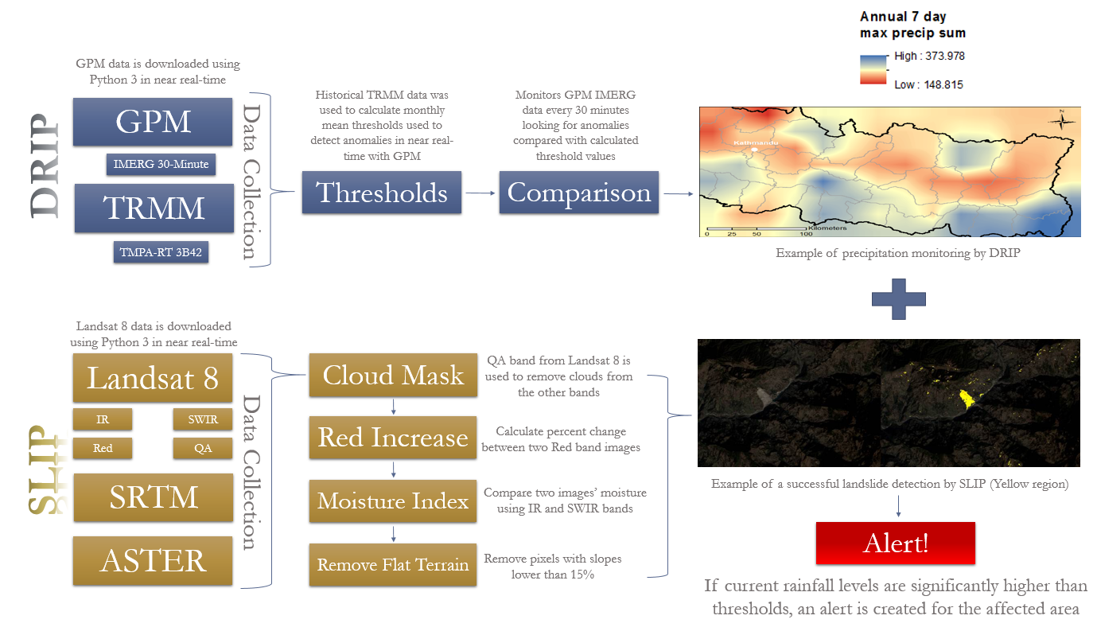

Figure X: Schematic of Methodology

***Validation***

During this study, an accuracy assessment was performed on the SLIP classification outputs in order to determine the degree of accuracy that the model correctly detects landslide events. Pixel areas of observed landslides were identified and then compared to the pixels classified as landslides in the SLIP outputs. Statistics were then calculated to determine the ommission error, commission error, and overall accuracy and inter-rater agreement of the model.

The accuracy assessment was performed on multiple locations in order to validate that the model is robust enough to be reusable and able to classify pixels accurately in more than one location. The first location for validation was through out Nepal where the model was originally trained. The second location in which the model was validated is Teresopolis, a particularly mountainous and landslide-prone city outside of Rio de Janierio, Brazil. Landslide inventories and inventory maps were used in order to determine specific landslide locations and events for the validation process.­

# IV. Results & Discussion

Insert images, graphs, maps, charts, etc. here. Choose the most important results to highlight here. No word cap, but two to six pages is a good range.

Things to discuss:

* Analysis of Results: What can you tell from your graphs, images, etc? What does this mean for your project?
* Errors & Uncertainty: What factors could you not account for, what things didn’t work out like you expected they would, etc.
* Future Work: If this project was to be selected for another term, what would be the focus? What other areas would be of interest?

# V. Conclusions

Final conclusions. Word count: 200-600 (~a page).

# VI. Acknowledgments

Insert here. Keep to a concise paragraph or bullets of names. End with the following sentence.

Any opinions, findings, and conclusions or recommendations expressed in this material are those of the author(s) and do not necessarily reflect the views of the National Aeronautics and Space Administration.

This material is based upon work supported by NASA through contract NNL11AA00B and cooperative agreement NNX14AB60A.

# VII. References

Asner, G. P. (2001). Cloud cover in Landsat observations of the Brazilian Amazon. International Journal of Remote Sensing, 22(18), 3855-3862.

Broxton, Patrick D., Xubin Zeng, Damien Sulla-Menashe, and Peter A. Troch. (2014) "A Global Land Cover Climatology Using MODIS Data." *Journal of Applied Meteorology and Climatology,* 53, 1593-605.

Caine, N. (1980). The rainfall intensity: duration control of shallow landslides and debris flows. *Geografiska Annaler. Series A. Physical Geography*, 23-27.

Cruden, D. M. (1991). A simple definition of a landslide. *Bulletin of Engineering Geology and the Environment*, *43*(1), 27-29.

Dahal, R. K., & Hasegawa, S. (2008). Representative rainfall thresholds for landslides in the Nepal Himalaya. *Geomorphology*, *100*(3), 429-443.

Glade, T., Crozier, M., Smith, P.(2000), *Applying Probability Determination to Refine Landslide-triggering Rainfall Thresholds Using an Empirical “Antecedent Daily Rainfall Model”.*

Elsebaie, I. H. (2012). Developing rainfall intensity–duration–frequency relationship for two regions in Saudi Arabia. *Journal of King Saud University-Engineering Sciences*, *24*(2), 131-140.

Petley, D. N., Hearn, G. J., Hart, A., Rosser, N. J., Dunning, S. A., Oven, K., & Mitchell, W. A. (2007). Trends in landslide occurrence in Nepal. *Natural Hazards*, *43*(1), 23-44.

Podger, G., and Bobinskas, C. “Transboundary Water Management in the Koshi River Basin.” 2013, November 28.

Shanker, D., Harihar Paudyal, and H. N. Singh. "Discourse on Seismotectonics of Nepal Himalaya and Vicinity:Appraisal to Earthquake Hazard." *Journal of Geo-sciences* 1, no. 1 (2011): 1-15.

Swanson, F. J., and Dyrness, C. T. (1975). Impact of clear-cutting and road construction on soil erosion by landslides in the western Cascade Range, Oregon. *Geology*, *3*(7), 393-396.

Wang, Lingli, and John J. Qu. 2007. "NMDI: A normalized multi-band drought index for monitoring soil and vegetation moisture with satellite remote sensing." *Geophysical Research Letters* 1-5.

Wieczoreck, G.F., 1996. Landslide triggering mechanisms, In: A.K. Turner and R.L. Schuster (Editors), Landslides: Investigation and Mitigation. Transportation Research Board, National Academy of Sciences, Washington, D.C., Special Report 247, pp. 76-90.

# VIII. Content Innovation

In preparation for DEVELOP’s coming microjournal, please select three content innovation features to support your paper. For each item, please list the name of the feature, and include the tool itself if possible (eg. glossary terms and definitions). If the tool does not work in Microsoft Word (eg. Interactive MATLAB Figure Viewer), please list the file name and upload the related file to the DEVELOP Exchange. If you choose to use Inline Supplementary Material, please also include where the material should appear in the text.

**Some options include:**

AudioSlides

Database Linking Tool

Data Profile

Executable Papers

Featured Author Videos

Featured Multimedia for this Article (video and podcast options)

Glossary Viewer

Inline Supplementary Material (figures, tables, computer code)

Interactive Map Viewer

Interactive MATLAB Figure Viewer

Interactive Plot Viewer

Nomenclature Viewer

# IV. Appendices

Insert here