Grand Canyon Ecological Forecasting

Using NASA Earth Observations to Monitor and Model Juniper Woodland Mortality in Grand Canyon National Park

 **Technical Report**

Final– March 31st, 2022

Scarlet Jackson (Project Lead)

Michael Hitchner

Miriam Ritchie

Joe Miotke

***Advisors:***

Dr. Paul Evangelista (Colorado State University, Natural Resource Ecology Laboratory)

Dr. Catherine Jarnevich (USGS, Fort Collins Science Center)

Dr. Anthony Vorster (Colorado State University, Natural Resource Ecology Laboratory)

Peder Engelstad (Colorado State University, Natural Resource Ecology Laboratory)

Nicholas Young (Colorado State University, Natural Resource Ecology Laboratory)

Brian Woodward (Colorado State University, Natural Resource Ecology Laboratory)

# 1. Abstract

Significant die-off of the drought tolerant species Utah juniper (*Juniperus osteosperma*) and one-seeded juniper (*Juniperus monosperma*) have been observed in Grand Canyon National Park (GCNP) and throughout central and northern Arizona. As climate models project rising temperatures and continuous drought, land managers are concerned for the future of juniper in and around Grand Canyon National Park. This project incorporated data from Landsat 8 Operational Land Imager (OLI), the Shuttle Radar Topography Mission (SRTM), and ocular samples of the National Agriculture Imagery Program (NAIP) in a random forest model in an effort to identify patterns between characteristics of the landscape and locations of juniper woodland mortality and to model areas subject to vulnerability. This study found no significant correlation between ocularly sampled juniper tree mortality and remotely sensed environmental variables used and thus, accurately modeling mortality vulnerability in the future was not feasible. The ocular sampling, however, allows our partners at the National Park Service to better understand areas of juniper tree woodland mortality and the relative amount of mortality in the park. Additionally, the areas of juniper tree mortality found in this project provide our partners with guidance for future field sampling.

**Key Terms**

Remote Sensing, Random Forest, Juniper Woodland Mortality, Ocular Sampling, NAIP

# 2. Introduction

***2.1 Background Information***

The American Southwest is experiencing a 'megadrought' that has been ongoing since 2000. Of the last 40 years, 2018 had the lowest amount of precipitation and was believed to have caused widespread canopy die-back within juniper woodlands (Kannenberg et al. 2021). Significant die-off of Utah juniper (*Juniperus osteosperma*) and one-seeded juniper (*Juniperus monosperma*) have been observed in Grand Canyon National Park (GCNP) and throughout central and northern Arizona. As climate models project rising temperatures and continuous drought, land managers are concerned for the future of juniper woodlands in and around Grand Canyon National Park. Juniper woodlands play important economic, cultural, and ecological roles. They act as an important food and shelter source to wildlife in the area, increase water resources, help prevent soil erosion, and play an important cultural role with their medicinal properties and wood quality (Rahmonov, 2017). Some of the concerns for juniper woodland die-back include mass amounts of flammable fuel, fire regime shifts, decreases in water availability, forest composition shifts, species shifts, and carbon feedback to atmospheric and climatic systems (Byer and Jin 2017, Huang et al. 2010).

Though drought is thought to be the cause for juniper mortality, in a recent study, precipitation was not found to be correlated with die-back, but rather leaf water potential, hydraulic conductivity, percent loss of conductivity, and interactions with temperature and elevation (Kannenberg et al., 2021). It is also generally accepted that juniper is thought to be a drought-tolerant species, as it can grow at lower elevations in hot temperatures amongst desert flora (Linton, 1998). At a study site in northern New Mexico where over 95% of pinyon experienced mortality during the drought between 2000 and 2007, only 0.4% of juniper experienced die-off (McDowell, 2008). There is a need to analyze environmental factors associated with juniper woodland mortality, identify patterns between those environmental factors and mortality in juniper woodland stands, and model landscape most susceptible to future juniper woodland mortality.

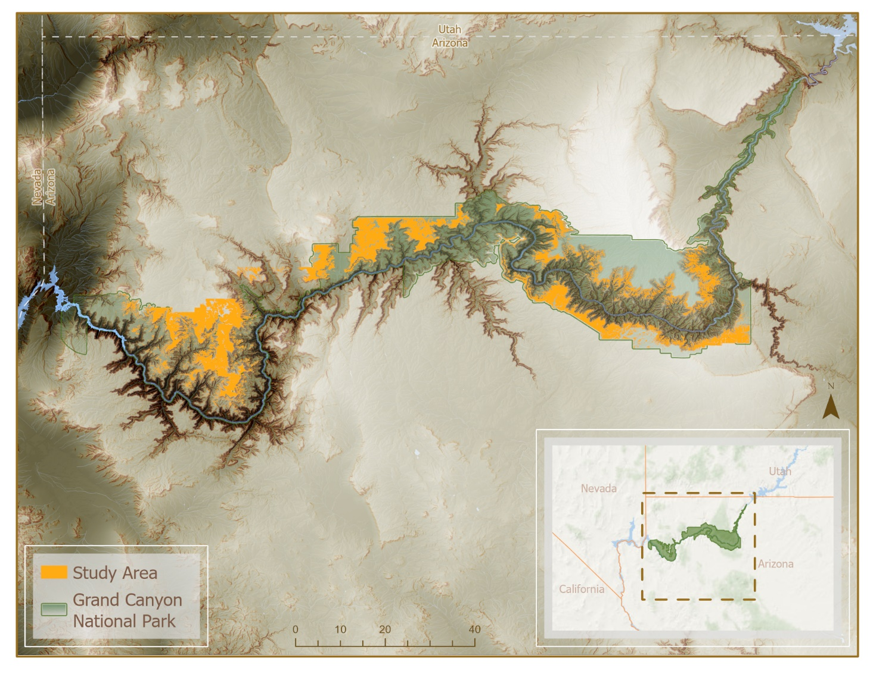

*Figure 1.* Project study area in Northwest Arizona, including Grand Canyon National Park. The study area was determined through identifying vegetation classes that had substantial juniper presence.

***2.1.1 Study Area and Period***

The study area lies mainly within Grand Canyon National Park and some surrounding areas with vulnerable stands of concern. Our partners at GCNP provided vegetation polygons from the Vegetation Classification and Mapping Project which mapped vegetation classes within GCNP using a combination of satellite imagery and field surveys (Kearsley et al. 2015). We simplified our study area to only include vegetation classes where juniper is a major component. There can be a wide range of weather and climate within GCNP because of the substantial changes in elevation and topography due to the Canyon itself. Juniper woodlands mainly occur on the rims of the canyon from elevations between ~ 3,000 to 8,000 feet (Jacobi, 2016). The soil types can range from deep, fine-textured soil to shallow and rocky soils. Terrain also varies from gentle valleys and plains to rugged and steep rocky terrain (NPS, 2015). The time period of our analysis spanned from 2016 and 2021 to capture recent mortality events that may have been impacted by extreme drought years such as 2018.

***2.2 Project Partners & Objectives***

Our partners at GCNP’s Science and Resource Management Division monitor tree health in and around the park by hand. There are programs in place to treat and remove dying trees, but efforts are limited by the size and accessibility of affected areas. Partners have identified climate change adaptive planning as a priority in the coming years and are implementing climate change scenarios into their decision-making. Our analysis of patterns between ocularly sampled points and environmental variables will provide the field managers at GCNP with an enhanced understanding of relationships between characteristics of the landscape and locations of juniper woodland mortality. This will enable the NPS to make more targeted protection and restoration efforts in GCNP. Additionally, a risk map of areas likely to experience mortality in the future map will potentially aid juniper woodland mortality preparedness within the park.

A major focus of this project was to determine the feasibility of detecting juniper woodland mortality with ocular sampling of high-resolution imagery. The primary objectives of this project were to utilize ocular sampling to identify mortality across a set of sample points randomly distributed throughout our study area and then (1) analyze environmental and topographic variables associated with juniper woodland mortality, (2) identify patterns between variables and mortality in juniper woodland stands, and (3) model landscape most susceptible to future juniper woodland mortality.

# 3. Methodology

***3.1 Data Acquisition***

Our partners at GCNP provided vegetation polygons from the Vegetation Classification and Mapping Project where juniper is a major component of the vegetation class (Kearsley et al. 2015). Within these vegetation classes juniper woodlands occurrence points were ocularly sampled (see section 3.2.1) using the National Agriculture Imagery Program’s (NAIP) 2021 1 m2 resolution true and false color imagery. In addition, the team chose environmental layers to use in analysis and modeling habitat that were likely to correlate with areas vulnerable to mortality. The team acquired environmental layers from satellite imagery from Shuttle Radar Topography Mission (SRTM), Landsat 8 Operational Land Imager (OLI), and the National Elevation Dataset Digital Elevation Model (NED DEM). From these datasets, the team acquired and derived tasseled cap indices, topographic variables, and vegetation indices to explore the relationships between vegetation health, topography, and environmental factors (Table 1 & Appendix A). Fire layers were also retrieved from Monitoring Trends in Burn Severity (MTBS), such as burn frequency, burn severity, and number of times burned.

Table 1

*Sources, resolution, and dates of environmental layers*

|  |  |  |  |  |
| --- | --- | --- | --- | --- |
| Environmental Layer Used | Source | Native Resolution | Image Date | Access/Processing |
| Tasseled Cap Indices | Landsat 8 OLI | 30 m | 2021 | Google Earth Engine |
| Northness, Eastness, Slope, Elevation | SRTM | 30 m | 2021 | Google Earth Engine |
| Topographic Diversity  CHILI  TPI | NED DEM | 10 m | 2006 -2011 | Google Earth Engine |
| NDVI, NBR, NDMI | Landsat 8 OLI | 30 m | 2015 - 2021 | Google Earth Engine |

***3.2 Data Processing***

Of the given Vegetation Classification Dataset, we extracted the vegetation classes within the data set that corresponded with juniper woodland and used these combined vegetation classes as our specified study area (Table 2). We selected vegetation classes where juniper or juniper woodland species are a major component of the vegetation to ensure accuracy while ocular sampling. These vegetation classes were combined as a single polygon to create a single boundary for ocular sampling. Because these classes so closely hug the edges and cliffs of the canyon, we created a receding buffer of 30m to exclude any sampling points that may fall on a canyon ledge. The team downloaded the necessary NAIP 2021 image tiles to cover the entirety of the study area. The two true color tiles were imported into ArcGIS Pro where they were clipped to exclude any unnecessary data and mosaiced to create one image for the study area. The same process was done for the false color imagery.

Table 2

*Vegetation classes included in ocular sampling boundary*

|  |  |
| --- | --- |
| Vegetation Class Scientific Name | Vegetation Class Common Name |
| *Juniperus osteosperma* Woodlands/Savannahs | Utah Juniper Woodlands/Savannahs |
| *Pinus edulis - Juniperus osteosperma* / *Artemisia* Woodland Alliance | Two-needle Pinyon – Utah Juniper / Sagebrush Woodland Alliance |
| *Pinus edulis - Juniperus osteosperma* / *Cercocarpus - Quercus* Woodland Alliance | Two-needle Pinyon - Utah Juniper / Mountain-mahogany - Oak Woodland Alliance |
| *Pinus edulis - Juniperus osteosperma / Coleogyne ramosissima* Woodland | Two-needle Pinyon – Utah Juniper / Blackbrush Woodland |
| *Pinus edulis - Juniperus osteosperma* / Grass - Forb Understory Woodland Alliance | Two-needle Pinyon – Utah Juniper / Grass – Forb Understory Woodland Alliance |
| *Pinus edulis - Juniperus osteosperma / Quercus turbinella* Woodland | Two-needle Pinyon – Utah Juniper / Turbinella Live Oak Woodland |
| *Pinus edulis - Juniperus osteosperma* / Sparse Understory Woodland | Two-needle Pinyon – Utah Juniper / Sparce Understory Woodland |
| *Pinus edulis - Juniperus osteosperma* / Talus or Canyon Slope Scrub Alliance | Two-needle Pinyon – Utah Juniper / Talus or Canyon Slope Scrub Alliance |
| *Pinus monophylla - Juniperus osteosperma* / Grass - Forb Understory Woodland Alliance | Singleleaf Pinyon – Utah Juniper / Grass – Forb Understory Woodland Alliance |
| *Pinus monophylla - Juniperus osteosperma /* Shrub Understory Woodland Alliance | Singleleaf Pinyon – Utah Juniper / Shrub Understory Woodland Alliance |

***3.2.1 Ocular Sampling***

Ocular sampling is a method in which visual estimates are made of characteristics in remote sensing imagery. The ocular sampling methodology presented in this paper utilizes high resolution true and false color imagery of the juniper woodlands in GCNP to develop percentage estimates of areas that have experienced mortality as well as areas of healthy vegetation. The sample points were randomly distributed across the known juniper woodland habitat. These methods have been used for similar research on tree mortality in response to spruce beetle outbreaks (Woodward et al. 2018). We used a stratified random sampling to generate 300 random points in our study area in Esri ArcGIS Pro.

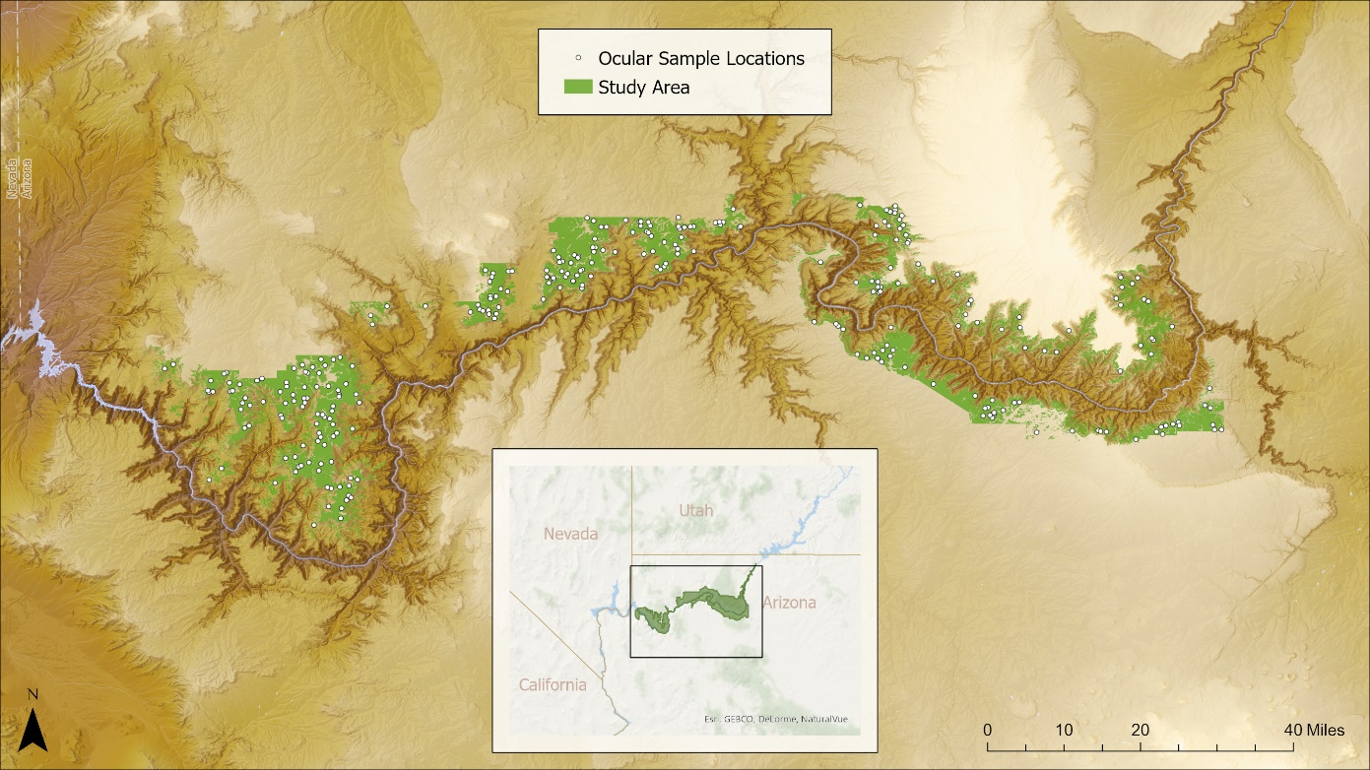

*Figure 2.* Ocular sample points within the project study area.

We created a 20 x 20m overlay grid across our study area and used the corresponding square to sample each point. At each point we estimated the percent cover of healthy juniper woodland canopy, percent cover of juniper woodland mortality canopy, percent of shadow, and percent of a “other” category which accounted for bare ground etc. We leveraged both true and false color imagery to analyze healthy and stressed canopy percentage. We calibrated our method using field points corresponding with known juniper woodland mortality and across team members to ensure accuracy and consistency during sampling.

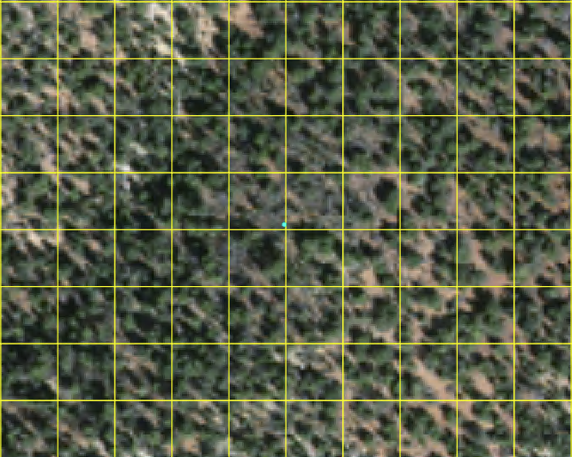

*Figure 3.* Example of sample point (blue) on NAIP imagery within the 20x20 fishnet sample grid.

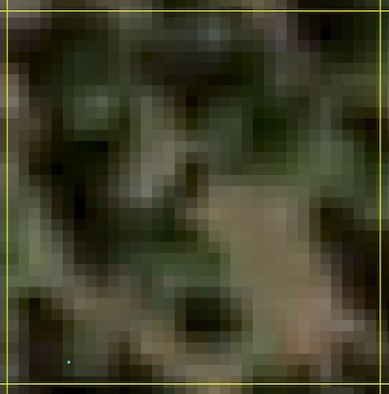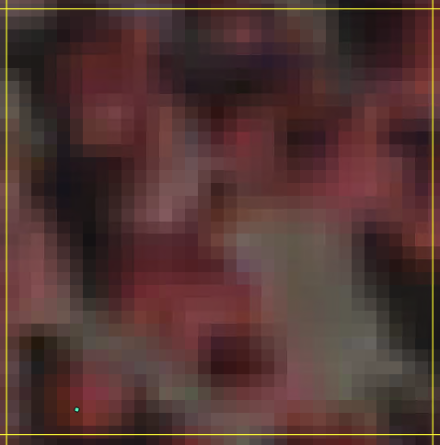

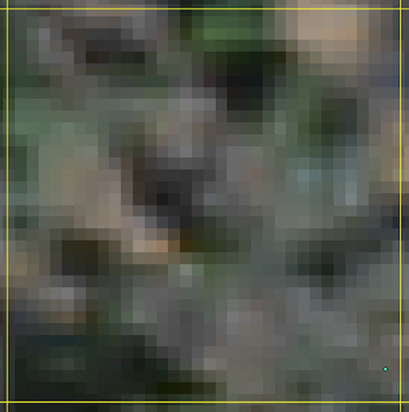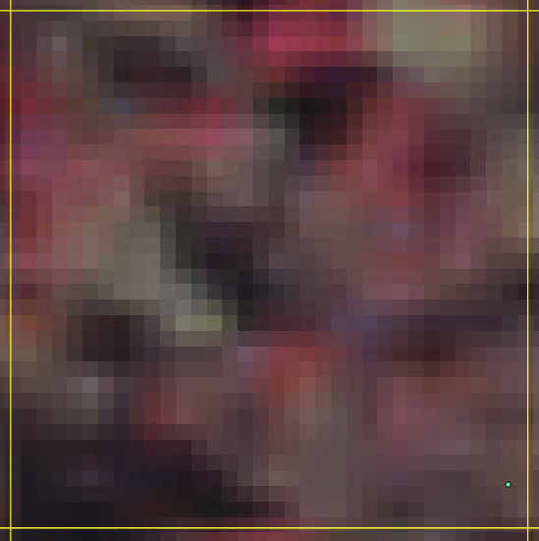

*Figure 4.* Examples of sample points within the grid on true color NAIP imagery (left) and false color NAIP Imagery (right). The top pair of sample point images contain no observed mortality, while the following two images do contain observed mortality.

***3.4 Data Analysis***

We attempted to detect areas of vulnerable juniper woodland on a park-wide scale using the following methodology: data for all environmental variables were extracted at each ocular sampling point. The resulting environmental variable data along with ocular sampling results were analyzed to determine any correlation between ocular sampling results and individual environmental predictors. Percent mortality, percent green, total cover, and percent stress per percent cover were compared to each environmental variable.

Next, we created a random forest (RRF) regression model and a classified random forest (CRF) model using the “randomForest” package in R 4.1.2. Random forest (RF) is a machine learning algorithm that models either a continuous or classified variable in the instance of numerous explanatory variables, utilizing decision trees to produce estimates of response variables. The conclusions of each tree are averaged, meaning a larger number of trees can produce more stable or consistent predictions. In this instance, we ran the model with 5000 trees for both the RRF and the CRF.

We trained both RF models utilizing the environmental variables extracted from each ocular sampling point. Percent mortality was used as the model response in the RRF, and binary classification of presence-absence of mortality was used in the CRF. We tested different input combinations of environmental variables in RStudio. Each combination produced a graph of variable importance, allowing the removal of environmental variables that exhibited high correlation with each other to better understand the drivers of the model itself. We ran the RRF first using various combinations of environmental variables, including running the model with all environmental variables, and then ran the CRF using the same methodology. The regression models produced an R2 value that represents the percentage of variance in the dependent variable (percent juniper tree mortality) explained the independent variables (environmental variables). A higher R squared value indicates more of the variance is explained by the data. An R squared of zero indicates that none of the variance is explained by the data.

# 4. Results & Discussion

***4.1 Analysis of Results***

Of the environmental variables included in our analysis, none were strongly correlated with our observed juniper mortality. Elevation had the highest R2 value of 0.0025 (Figure 5). We were able to summarize our ocular sampling points. Of the total percentages of each type of cover we sampled 39.5 percent was green, 14.7 percent shadow, 6.6 percent mortality, and 39.2 percent other (Figure 6). Juniper trees are generally spread out across the landscape, and so the high percentages of *other* and *shadow* could have been another contributing factor to our difficulty capturing juniper mortality through Landsat imagery. In topographically diverse locations such as Grand Canyon National Park, the high presence of *shadow* and *other* classifications in ocular sampling creates difficulties in identifying mortality in the landscape. This is particularly true as the environmental variables we examined are captured at a 30m resolution where differences in individual tree mortality can be lost in the total pixel extent. When using data of this resolution, field validation may be required to develop a more complete understanding of the observed mortality. Alternatively, higher resolution data sources may be required in order to complete a more comprehensive analysis of the study area.

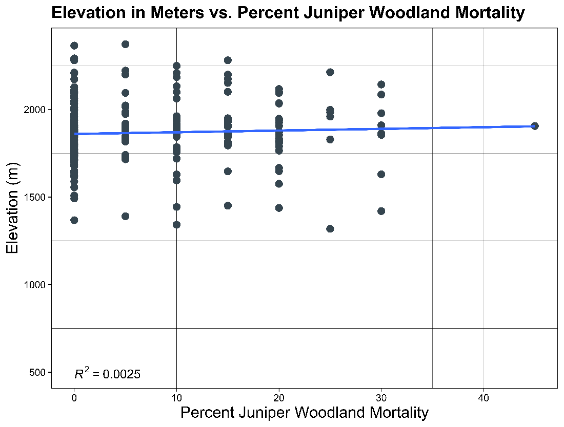

*Figure 5.* Elevation mapped against juniper woodland mortality showing a correlation with an R2 value of 0.014.

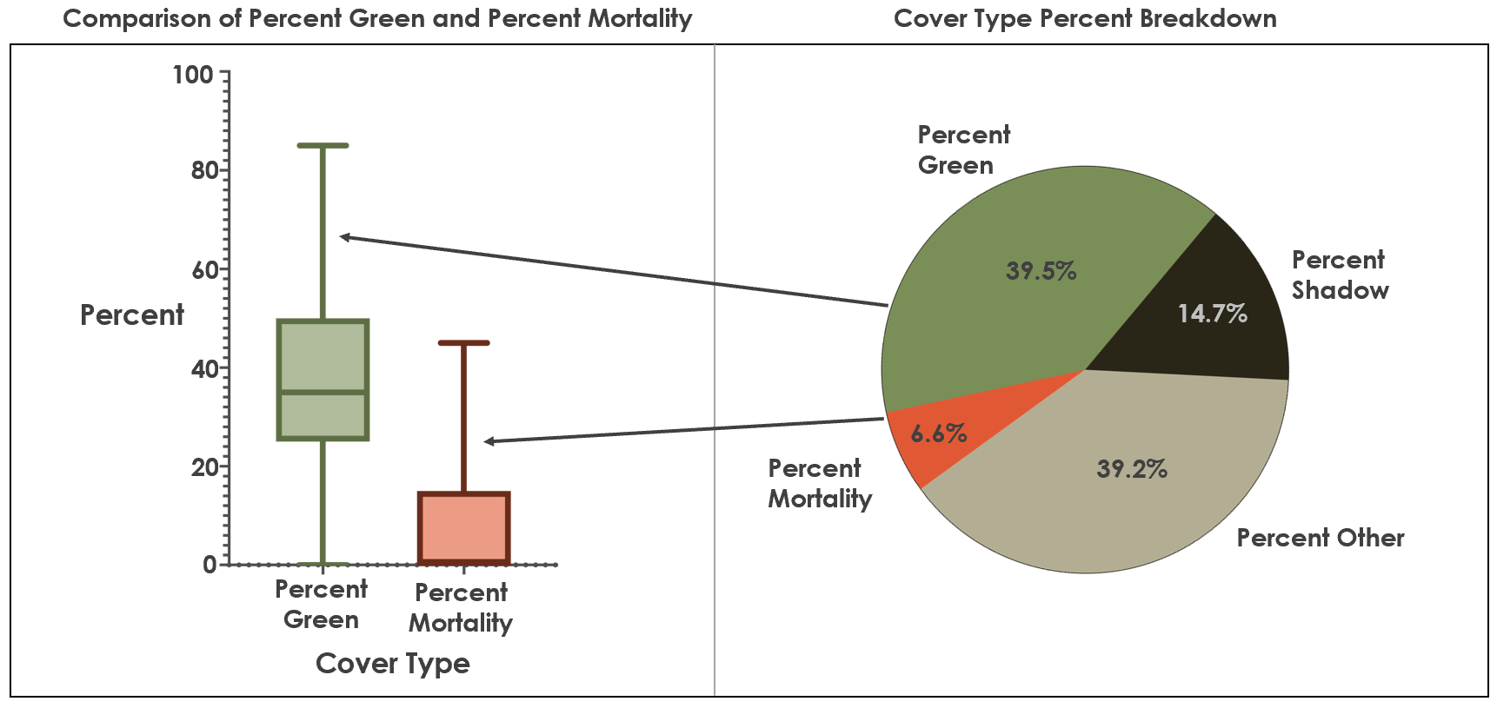*Figure 6.* Two graphs to give a summary of the ocular sampling results. The pie chart on the right shows the total percentages of each type of cover we sampled. 39.5 percent green, 14.7 percent shadow, 6.6 percent mortality, and 39.2 percent other. The plot on the left is an additional visualization comparing the percent green and percent mortality.

Because none of the environmental variables showed correlation with observed juniper mortality, we were unable to accurately model areas subject to future vulnerability. There was, however, value in mapping the observed mortality points and creating heat maps that highlighted areas of high density and low-density mortality (Figures 7 & 8). The area of no mortality is shown in blue as “cold spots” (Figure 8) There is also a hot spot with a higher density of mortality just to the east.

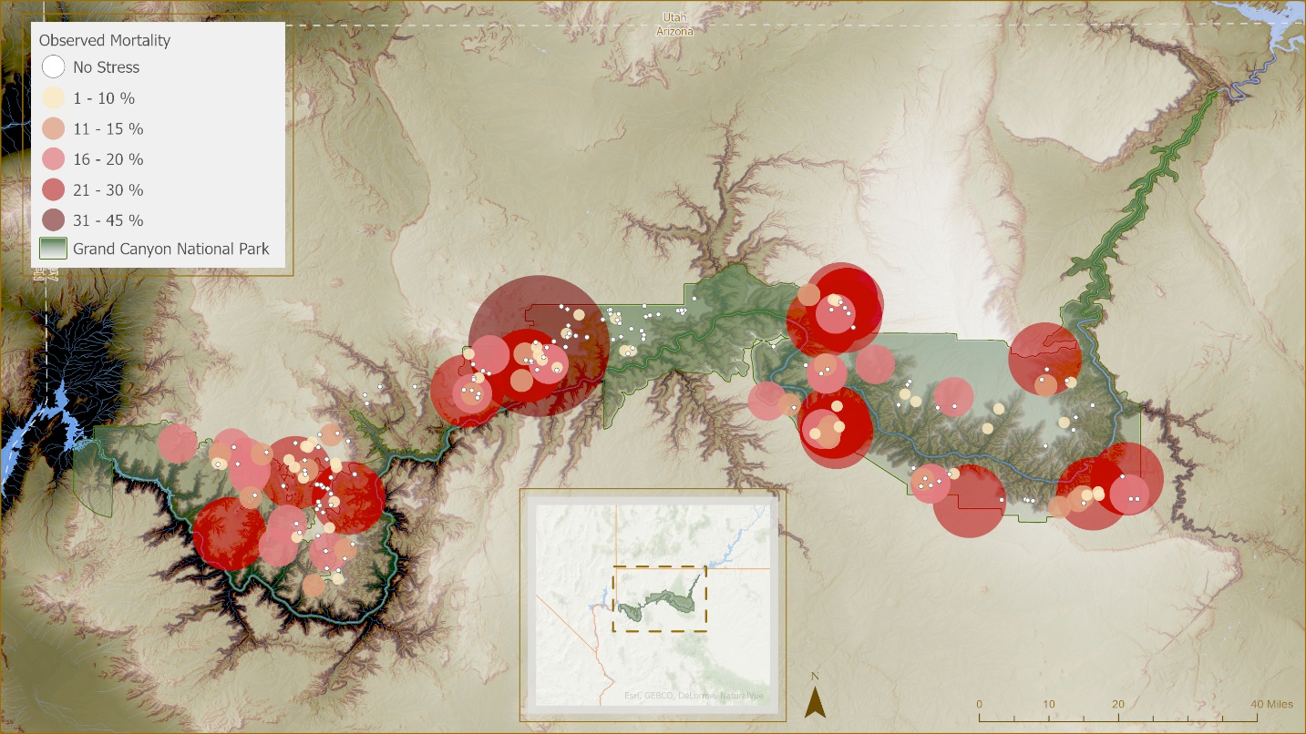*Figure 7.* Mortality was distributed throughout much of our study area, with only a small area in the central portion of the park having no observed mortality at our sample points. This map shows sample point observed mortality with larger, darker red circles having the highest rates, and smaller lighter circles having the lowest rates.

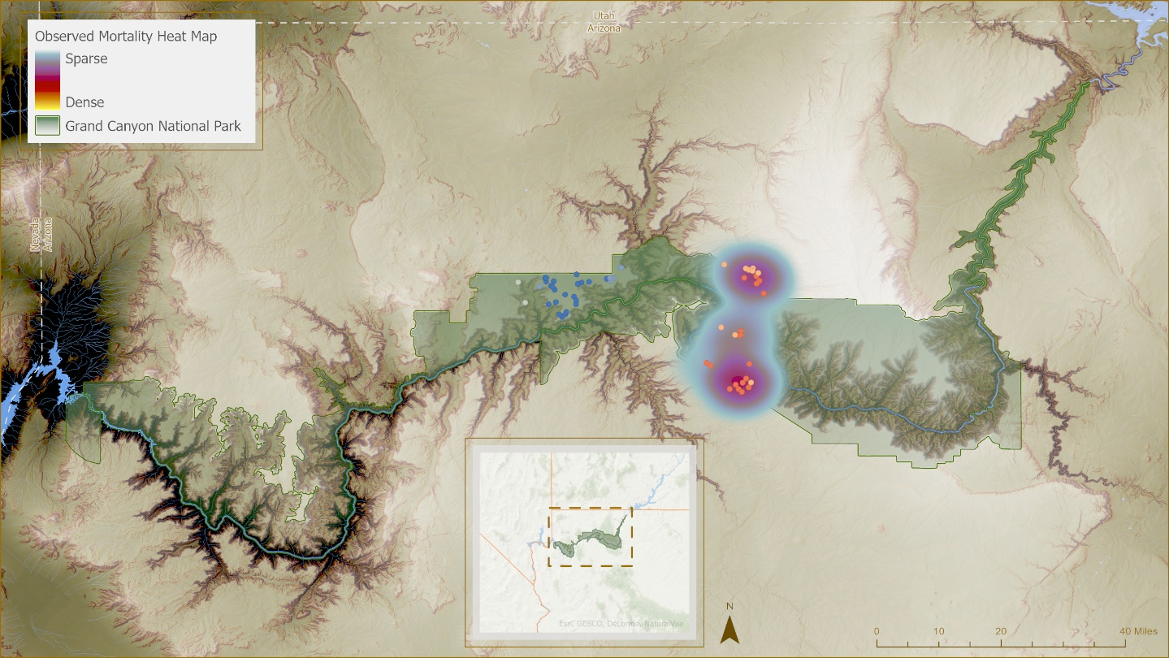*Figure 8.* Hot spot analysis of the sample data which finds areas of high density and low-density mortality. The area of no mortality identifiedappears here in blue “cold spots.” However, there is also a hot spot with a higher density of mortality just to the east.

***4.2 Limitations and Uncertainties***

The methodology and data we utilized for this project had several limitations and uncertainties. The ocular sampling method we used has the potential for observational error during the sampling process. Additionally, juniper can be a particularly challenging genus of tree to analyze via remote sensing. Although a tree may be experiencing mortality, it can still appear green and only have its mortality identifiable through field validation.

Another limitation we encountered was the resolution of the data from which we derived our environmental indices. Landsat 8 OLI imagery is available at a resolution of 30m, which is larger than the typical individual juniper tree in these environments. Because of the coarse resolution of our available data, correlating environmental or topographic variables with observed mortality can be challenging. Future work may find that higher resolution environmental indices could provide different correlation outcomes between observed mortality and the environmental variables explored in this project. There are myriad other factors that this study was unable to explore. Soil type and quality, ground water level and accessibility, high resolution precipitation and temperature data, and other factors could all play a role in the mortality that has been seen in this region.

***4.3 Future Work***

The goal of this project was to model environments in GCNP that were most vulnerable to juniper mortality in the near future. However, the environmental variables used in analysis did not show a strong correlation with the observed juniper mortality, explaining our low model accuracy. There are many opportunities to build on this study and further exploration of juniper woodland mortality in GCNP and surrounding areas. For example, inclusion of historic data could allow for drought effects to be studied over a larger temporal scale than this study had the opportunity to observe. Historic data could include historic climate models, historic imagery which predates satellite imagery, and imagery of historic fire. Because the American Southwest has been experiencing a mega drought for the last 40 years, incorporating these historic datasets could allow for further understanding of prolonged drought effects on juniper woodlands.

There are also studies that have found significant correlation between juniper die-off and tree characteristics, such as basal area (Kannenberg et al., 2021). Including these measurements in future analysis could help better understand which growth class of junipers are experiencing die-off and which to protect to mitigate future die-off. Collecting measurements to assess tree health in future field surveys could be added to analysis and potentially lead to die-off mitigation strategies. LiDAR could also be incorporated into the study to capture these tree measurements.

The most effective next step in this study, however, would be to conduct field surveys. Our partner at GCNP plans to hire field biologists to survey and verify our observed points of mortality within the park. The team has provided the observed mortality maps and point locations with their distance from roads to evaluate field survey feasibility and targeted survey plans. While conducting these surveys, tree characteristics can be measured, tree health assessed, and soil type can be documented. This field data will provide greater confidence in modeling juniper mortality accurately.

# 5. Conclusions

Significant die-off of the Utah juniper and the one-seeded juniper have been observed in Grand Canyon National Park (GCNP). We created a vulnerability map of the park to better understand where future die-off would occur using ocular sampling and random forest models for use by GCNP in conservation efforts. Ocular sampling was performed using high resolution National Agriculture Imagery Program (NAIP) imagery and allowed us to gather data on juniper woodlands across the entire GCNP. Environmental variables were chosen based on previous literature regarding juniper woodlands.

We were unable to find correlations between the environmental variables and the ocular sampling data. Our inability to find correlation between mortality and our chosen variables reveals that ocular sampling is likely not the best method for detecting juniper tress mortality, however the ocular sampled data can still provide insights. These insights include an estimate of the magnitude of mortality within the park and maps of where mortality occurred. Our partners at GCNP will be able to use these findings as a starting point for future work on juniper woodland mortality, including targeted field work in the areas of high mortality.

# 6. Acknowledgments

This work was made possible by our mentors: Dr. Catherine Jarnevich, Dr. Paul Evangelista, Peder Engelstad, and Nicholas Young from Colorado State University Natural Resource Ecology Laboratory;and Scott Cunningham from NASA DEVELOP. The team would also like to thank our project partner from Grand Canyon National Park’s Vegetation Program, Lonnie Pilkington, for sharing his extensive knowledge of juniper woodlands and environmental conditions within the park.

Any opinions, findings, and conclusions or recommendations expressed in this material are those of the author(s) and do not necessarily reflect the views of the National Aeronautics and Space Administration.

This material is based upon work supported by NASA through contract NNL16AA05C.

# 

# 7. Glossary

**Earth observations** – Satellites and sensors that collect information about the Earth’s physical, chemical, and biological systems over space and time

**Ocular Sampling -** A method in which visual estimates are made of characteristics in remote sensing imagery.

**Random Forest -** Amachine learning algorithm that models either a continuous or classified variable in the instance of numerous explanatory variables, utilizing decision trees to produce estimates of response variables.

**Remote Sensing -** Acquiring information about an object or landscape without physical contact. E.g. Through the use of satellites.

**Digital Elevation Model (DEM)** – A model representative of elevation data in order to represent landscape  
**NAIP** – National Agriculture Imagery Program. This program is part of the USDA’s Farm Service Agency (FSA) and acquires high resolution aerial imagery, typically during growing seasons, throughout the contiguous United States.

# 8. References

Byer, S., & Jin, Y. (2017). Detecting Drought-Induced Tree Mortality in Sierra Nevada Forests with Time Series of Satellite Data. *Remote Sensing*, *9*(9), 929. MDPI AG. Retrieved from http://dx.doi.org/10.3390/rs9090929

Huang, C.-ying, Asner, G. P., Barger, N. N., Neff, J. C., &amp; Floyd, M. L. (2010). Regional aboveground live carbon losses due to drought-induced tree dieback in piñon–juniper ecosystems. Remote Sensing of Environment, 114(7), 1471–1479. https://doi.org/10.1016/j.rse.2010.02.003

Jacobi, George H. “Juniper Years.” National Parks Service, U.S. Department of the Interior, 28 July 2016,https://www.nps.gov/grca/blogs/juniperyears.htm#:~:text=Along%20with%20the%20Pinyo  n%20Pine,and%208000%20feet%20of%20elevation.

Kannenberg, A. Steven, Driscoll, Avery W., Malesky, D., Anderegg, William R.L. (2021). Rapid and surprising dieback of Utah juniper in the southwestern USA due to acute drought stress, Forest Ecology and Management, Volume 480, 2021, 118639, ISSN 0378-1127, https://doi.org/10.1016/j.foreco.2020.118639.

Kearsley, MJ, et al. (2015). Grand Canyon National Park-Grand Canyon / Parashant National Monument vegetation classification and mapping project. Natural Resource Report. NPS/GRCA/NRR— 2015/913. National Park Service. Fort Collins, Colorado

Linton, M. J., Sperry, J. S., & Williams, D. G. (1998). Limits to water transport in Juniperus osteosperma and Pinus edulis: implications for drought tolerance and regulation of transpiration. Functional Ecology, 12(6), 906-911. <https://doi.org/10.1046/j.1365-2435.1998.00275.x>

McDowell, Nate, et al. "Mechanisms of plant survival and mortality during drought: why do some plants survive while others succumb to drought?." New phytologist 178.4 (2008): 719-739. <https://doi.org/10.1111/j.1469-8137.2008.02436.x>

Rahmonov, Oimahmad & Rahmonov, Małgorzata & Opała-Owczarek, Magdalena & Owczarek, Piotr & Niedzwiedz, Tadeusz & Myga-Piątek, Urszula. (2017). Ecological and cultural importance of juniper ecosystem in the area of Zeravshan valley (Tajikistan) on the background of environmental condition and anthropogenic hazards. Geographia Polonica. 90. 441-461. 10.7163/GPol.0110.

U.S. Department of the Interior. (2015, February 3). *Pinyon-Juniper Woodlands*. National Parks Service. Retrieved February 24, 2022, from <https://www.nps.gov/articles/pinyon-juniper-woodlands-species-composition-classification.htm#:~:text=Wide%20variety%20of%20topography%2D%20plains,sites%20and%20steep%2C%20rocky%20terrain.&text=Open%20savanna%2Dlike%20stand%20structure,of%20woodland%20expansion%20and%20contraction>.

Woodward, B., Evangelista, P., & Vorster, A. (2018). Mapping progression and severity of a southern Colorado spruce beetle outbreak using calibrated image composites. *Forests*, 9(6), 336. <https://doi.org/10.3390/f9060336>

# 9. Appendices

Appendix A

*Preprocessing and functionality of environmental layers*

|  |  |  |
| --- | --- | --- |
| Environmental Layer | Equation (if provided) | Functionality |
| Continuous Heat Isolation Load Index (CHILI) |  | CHILI assumes temperature based on topographic position. A value of 0 indicates a northeast slope and a value of 1 indicates a southwest slope. A northeast slope will have some of the coolest temperatures, while the southwest slopes will have some of the warmest (McCune, 2002) (Theobald, 2015). |
| Multi-Scale Topographic Position Index (mTPI) | TPI = *E0*- *En* | mTPI measures topography while including hillslope position to be quantified. A positive value indicates a high peak, a negative value indicates a valley or sink, and a value of 0 indicates a flat area or no slope.  *E0* is the elevation in meters at a given location, and *En* is the mean elevation within a desired area specified by radius *r* (Theobald, 2015). |
| Topographic Diversity (D) | D = 1 - ( 1 - *T'* ) * ( 1 - *C'* ) | Topographic diversity measures the combinations of temperatures and moisture conditions that are occurring.  Where *C’* is the standard deviation of the CHILI, and *T’* is mTPI (Theobald, 2015). |
| Normalized Difference in Moisture Index (NDMI) | (NIR - SWIR) / (NIR + SWIR) | A Normalized Difference in Moisture Index is used to indicate the water content in vegetation. |
| Normalized Burn Ratio (NBR) | (NIR - SWIR) / (NIR + SWIR) | Normalized Burn Ratio (NBR) is used to identify burned areas and provide a measure of burn severity. |
| Normalized Difference in Vegetation Index (NDVI) | NDVI = (NIR — VIS)/ (NIR + VIS) | Landsat Normalized Difference Vegetation Index (NDVI) is used to quantify vegetation greenness and is useful in understanding vegetation density and assessing changes in plant health. |
| Tasseled Cap Indices | Wetness:  (Blue*0.1511)+(Green*0.1973)+(Red*0.3283)+(NIR*0.3404)+(SWIR1*-0.7117)+(SWIR2*-0.4559)  Greenness:  (Blue*-0.2941)+(Green*-0.243)+(Red*-0.5424)+(NIR*0.7276)+(SWIR1*0.0713)+(SWIR2*-0.1608)  Brightness:  (Blue*0.3029)+(Green*0.2786)+(Red*0.4733)+(NIR*0.5599)+(SWIR1*0.508)+(SWIR2*0.1872) | These indices measure moisture content of soils and vegetation, vegetation health, and brightness or albedo or a surface. |