Colorado Front Range Disasters

Understanding the Impact of Forest Management on the Cameron Peak and CalWood Fire

 **Technical Paper**

Final – April 2nd, 2021

Neal Swayze (Project Lead)

Christopher Tsz Hin Choi

Garrett Knowlton

Jorune Klisauskaite

***Advisors & Mentors:***

Dr. Anthony Vorster (Colorado State University, Natural Resource Ecology Laboratory)

Brian Woodward (Colorado State University, Natural Resource Ecology Laboratory)

Nicholas Young (Colorado State University, Natural Resource Ecology Laboratory)

Peder Engelstad (Colorado State University, Natural Resource Ecology Laboratory)

Dr. Paul Evangelista (Colorado State University, Natural Resource Ecology Laboratory)

Dr. Catherine Jarnevich (United States Geological Survey, Fort Collins Science Center)

# 1. Abstract

Along the Colorado Front Range, forest management has gained significant attention due to uncharacteristically large fires that burned late in 2020. The Cameron Peak Fire (largest in Colorado recorded history) and the CalWood Fire collectively burned an estimated 219,019 acres from August through December of 2020. Project partners at the Coalition for the Poudre River Watershed, Colorado State Forest Service, Ben Delatour Scout Ranch, The Nature Conservancy, Colorado Forest Restoration Institute, and Colorado State University were interested in understanding the effectiveness of previous forest treatments in reducing burn severity within the Cameron Peak Fire and the CalWood Fire. We first collated a forest treatment dataset from pre-existing datasets by reclassifying over 29,000 treatments, which occurred across the Northern Colorado Front Range between 1970-2020. Secondly, we mapped three burn severity indices using Landsat 8 OLI and Sentinel-2 MSI Earth observations and compared them to soil burn severity field data. Thirdly, a total of 35 topographic, disturbance, forest structure, and treatment predictor variables were generated across the fires. Finally, we assessed relationships between these predictor variables and burn severity using the random forest algorithm. Model results indicate that the primary drivers of burn severity were elevation and distance to treatment edge for the Cameron Peak Fire and fire area and forest canopy cover for the CalWood Fire. Further analysis of these variables paired with field data is necessary to understand the relationship between burn severity and treatments to guide future restoration efforts, improve forest resiliency, and mitigate fire risks.

**Key Terms**

Remote sensing, Landsat, Sentinel, SRTM, fire, burn severity, forest treatment, fuel reduction, random forest algorithm

# 2. Introduction

***2.1 Background Information***

In late 2020, fires larger than historically seen (Kaufmann et al., 2006) burned across the northern Colorado Front Range (hereafter, the “Front Range”). The Cameron Peak Fire, CalWood Fire, and East Troublesome Fire collectively burned over 400,000 acres in total, with the Cameron Peak Fire and East Troublesome Fire becoming the two largest fires in Colorado’s recorded history (USDA Forest Service, 2020). The uncharacteristically large size and timing of these fires were the results of drought and high wind conditions, large bark-beetle infested stands, and fire suppression throughout the 20th century (Muir, 1941). Prior to the 2020 fire season, land managers and communities along the Front Range had taken proactive measures to reduce forest density and simulate historical natural fire regimes across different elevation zones using fuel reduction treatments, such as prescribed burning and mechanical thinning (Addington et al., 2018; Tinkham et al., 2017). However, forest fuel treatment efforts are expensive, time-intensive, and have complex social implications due to the variety of stakeholders that recreate in and value forests in northern Colorado. Improving the public perception of fuel reduction treatments is critical to implement effective forest management methods aimed at decreasing fire severity and minimizing wildfire risks to the community (Reinhardt et al., 2008; Champ et al., 2012; Moritz et al., 2014). These fires present a unique opportunity to assess relationships between burn severity and forest management efforts along the Front Range and to improve land manager and community understanding of fire behavior and improve fire risk mitigation.

***2.1.1 Study Area***

The Front Range spans from central Colorado to southeast Wyoming and is situated between the easternmost edge of the Rocky Mountains and the western limit of the High Plains (Addington et al. 2018). The mountainous region ranges from roughly 1,500 to 4,300 m above sea level and exhibits a range of vegetation zones that are controlled by topographic and climatic factors. Dry winds rapidly spread fire and are known to travel at speeds greater than 162 km/hr along the eastern slopes of the Front Range (Veblen and Lorenz, 1991). Between 1,500 and 2,400 m above sea level the lower montane dry forest region is dominated by ponderosa pine (*Pinus ponderosa*)and Douglas fir (*Psuedotsuga menziesii*)*,* especially on moister, north-facing slopes (Rocca et al., 2014). Productive understories of grasses, juniper, and pine paired with fire suppression have led to large understory fuel buildup in past decades (Ziegler et al., 2017). Fire return intervals in the lower montane region are thought to have been ca. 30 years in the pre-European settlement period, which limited fuel buildup and prevented the spread of large fires (Kaufmann et al., 2006). Thus, prescribed burnings and surface and ladder fuel removal have been the most employed forest treatment techniques in this region (Rocca et al., 2014).



*Figure 1*. Fire progression of the Cameron Peak and CalWood Fires in relation to nearby cities of Longmont, Loveland, and Fort Collins. Red represents the start of the fires with lighter colors representing fire progression since the start of the fire.

The upper montane forest from about 2,500 to 2,830 m elevation consists of ponderosa pine and mixed conifer. Historically only burning once every 35-100 years, treatment methods in the upper montane have involved small stand removal to emulate lightning strikes, but treatment methods are still being explored in this area (Agee & Skinner, 2005). Forest managers typically utilize clearcutting as a fuel reduction strategy in these areas. With increasing temperatures, earlier snowmelt, and lengthening dry seasons due to climate change, understanding how treatment methods affect high elevation and historically rarely burned areas is pertinent to upper montane forest management. Previous studies have tested fuel treatment effectiveness through field plot analysis of fuel characteristics, model development, and remote sensing to derive burn severity indices (Vaillant et al., 2013; Hudak et al., 2011). Studies have found that assessing treatment effectiveness remotely has many benefits but is often challenged by the impact of confounding variables that impact burn severity (Wimberly et al., 2009).

***2.2 Project Partners & Objectives***

The partners for this project included land managers and researchers at the Coalition for the Poudre River Watershed, Ben Delatour Scout Ranch, Colorado State University, Colorado Forest Restoration Institute, and the Nature Conservancy. The objectives of this study were to (1) collate a comprehensive northern Front Range forest treatment database, (2) map burn severity for the Cameron Peak Fire and the CalWood Fire using Landsat 8 Operational Land Imager (OLI) and Sentinel-2 MutiSpectral Instrument (MSI) satellite imagery, (3) assess relationships between burn severity and environmental and topographic variables and forest treatment attributes at the Cameron Peak and Calwood Fires, and (4) communicate these findings to foster future research and inform management and restoration efforts. The final burn severity maps, treatment evaluations, and StoryMap that communicate these findings to stakeholders and the public will be provided to the project partners to refine future treatment strategies.

# 3. Methodology

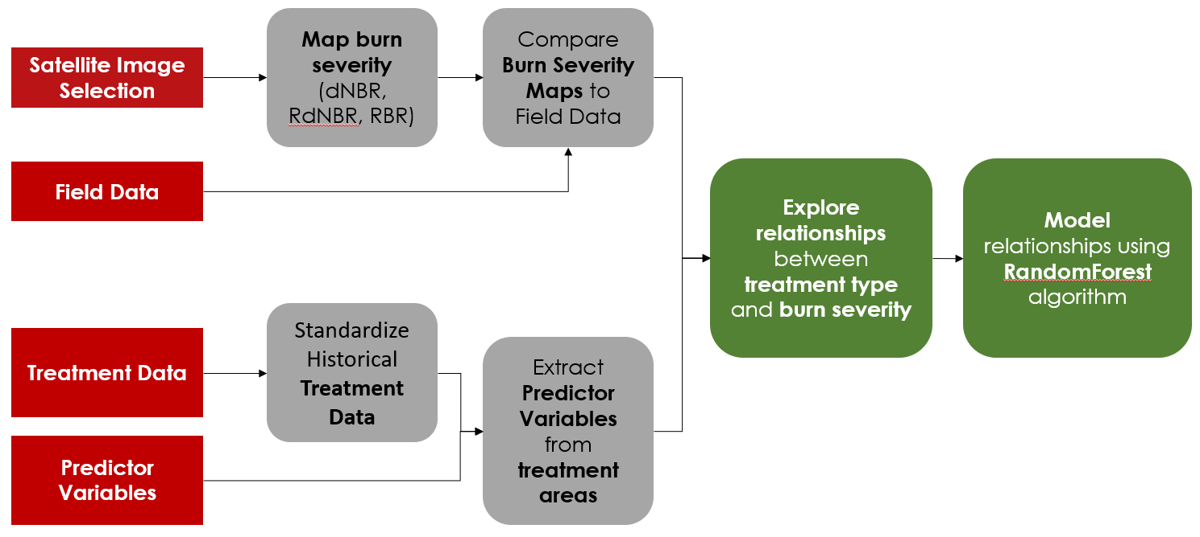

*Figure 2.* Flow chart depicting the general workflow and methods used to generate burn severity maps and treatment, environmental, and topographic predictor variables for the non-parametric model correlating burn severity and treatment type.

***3.1 Data Processing***

*3.1.1 Forest Treatment Processing*

Historic fuel treatment data from 1970-2020 were provided by the project partners and included treatment extent, treatment type, year of treatment, and other qualitative treatment information from state, county, and federal records. This included a compilation of treatments of interest to the forest management community provided by Colorado Forest Restoration Institute (Colorado Forest Restoration Institute Treatment Library and CPF Treatment Interactions v2, 2017), fire history perimeters (National Wildfire Coordinating Group, 2017), U.S. Forest Service treatments (Forest Activity Tracking System [FACTS], 2021), Colorado State Forest Service treatments (Stewardship Mapping and Reporting Tool [SMART], 2020), Hazardous Fuels Treatment Reduction (HAZFUELS), and historical treatment data provided by the Colorado State Forest Service (historic treatment data surrounding the CalWood Fire, 2020). These treatment datasets were standardized to include the year that the treatment occurred, the treatment size, and treatment type. To address the variability of how treatment type information was recorded, original treatment type names were classified into nine classes created by the Natural Resource Ecology Laboratory and Ben Delatour Boy Scout Ranch (Table B1). This created a treatment database that binned similar treatments and accounted for treatment history across the landscape.

For both the HAZFUELS database and the SMART datasets there were multiple treatments associated with place-specific polygons. For the SMART treatment dataset, we used stand level polygons that are related to management plans; however, management plan level polygons were excluded due to the uncertainty of area treated within them. For the USFS dataset, we used the full dataset in treatment processing. Finally, the LANDFIRE Remap Public Events Geodatabase was used for the forest treatment dataset (LANDFIRE, 2016). Treatment polygons were then collated to address re-entry within datasets and intersected areas across treatment datasets. Spatially overlapping and intersected treatments were concatenated by treatment type. In total, across the Cameron Peak Fire and the CalWood fire, there were a total of 254 unique treatment combinations. The shapefile datasets were then rasterized with a 30 x 30 m spatial resolution to use as predictor variables in the random forest model.

*3.1.2 Burn Severity Mapping*

Pre-and-post-fire Level 1C – Top of Atmosphere imagery from Sentinel-2 MSI was acquired using Google Earth Engine (GEE) for our two study areas: the Cameron Peak Fire and the CalWood Fire (Table A1). Since the fires occurred during different time frames, image date ranges were selected separately for each fire dependent on the length of the fire, image availability, and snow, smoke, and cloud cover. A table of specific images that were used for mapping burn severity can be found in Table A2. We investigated two burn severity mapping strategies. The first was a manual image selection approach and the second utilized a modified GEE script by Parks et al. (2018), which uses a pre-defined date range of imagery to generate pre-and-post fire composite images for both fires. For the manual image selection approach, we selected potential image date ranges for each fire by referencing the start and end dates of the fires. Following, we filtered Sentinel-2 MSI images for the selected dates with less than 15% cloud cover across the entire scene, and subsequent images were visually inspected and the images with the lowest snow/cloud cover were selected and mosaicked together as pre- and post-fire images.

For the automated pixel compositing approach, the date range for the pre-fire imagery was between September 1 - November 15, 2020 and the post-fire imagery range was September 1 - December 31, 2020. Clouds and snow were masked out of each pre-and-post-fire image collection and individual pixels were composited. Where pixels were unavailable within the pre-fire period, imagery from the same period over the previous years (up to 2 years) was used to form a composite image. After the normalized burn ratio (NBR) for each image was calculated (Equation 1), the lowest value pixel was chosen for each image collection to be composited once again. The two resulting pre-fire and post-fire NBR composites were then used to derive three burn severity indices across the study areas: the relativized burn ratio (RBR), the differenced normalized burn ratio (dNBR) (Equation 3), and the relativized differenced normalized burn ratio (RdNBR) (Equation 4). Burn severity values from the Parks et al. (2019) approach were then visually compared to the manually selected image approach.

$\text{ NBR = }\frac{\text{NIR-SWIR}}{\text{NIR-SWIR}}$ (1)

$\text{ RBR = }\frac{\text{dNBR}}{{\text{NBR}}_{\text{prefire }}\text{+1.001}}$ (2)

$\text{ dNBR =} {\text{((NBR}}_{\text{prefire}}\text{-}{\text{NBR}}_{\text{postfire}}\text{)× 1000)- }{\text{dNBR}}_{\text{offset}}$ (3)

$\text{ RdNBR = }\frac{\text{dNBR}}{\text{(}{{\text{NBR}}_{\text{prefire}}\text{)}}^{\text{0.5}}}$ (4)

For Cameron Peak, we utilized a slightly different approach because of the large spatial extent and extensive snow cover within the time frame of the fire. The Cameron Peak fire was separated into two regions, with individual pre- and post-fire dates, shown in figure 3. We treated the two sections of the fire individually to calculate burn severity indices merged by mosaicking to create final burn severity maps of the fire. The method outlined in Parks et al. (2019) offers a great way to automate burn severity mapping by selecting the minimum NBR values of each pixel across a series of images, masking by snow and cloud, and referencing multiple years of imagery. However, the method relies on Sentinel-2 Level 1C cloud masking, which has been shown to underestimate by an omission error of 37.4% (and >50% omission error in opaque clouds; Coluzzi et al., 2012).

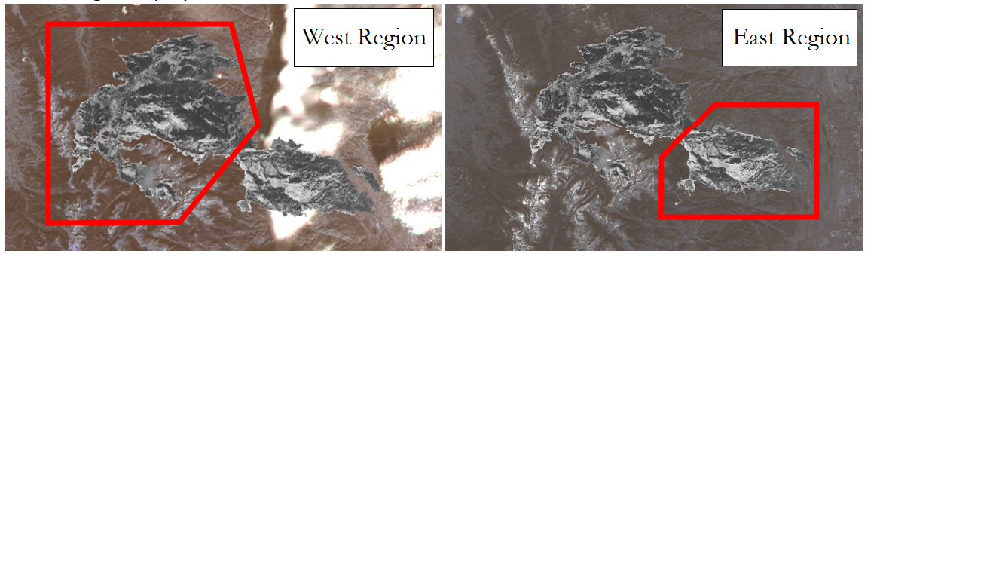*Figure 3.* Image selection approach for the Cameron Peak Fire, with the West and East sections of the fire depicted in the left and right panels, respectively.

*3.1.3 Predictor Variable Processing*

Using the 30 m Shuttle Radar Topography Mission (SRTM) dataset, we calculated a suite of topographic predictor variables for use in random forest modeling for the extent of each fire (Table C1). These variables included Slope, Slope North, Slope East, Northness, Eastness, Aspect, Elevation, Landform and the Solar-radiation Aspect Index (TRASP). Other pre-processed topographic variables included for the extent of the fires included SRTM topographic diversity, Multiscale Topographic Position Index (mTPI), Continuous Heat-Insolation Load Index (CHILI), U.S. National Elevation Dataset (NED), and the Physiographic diversity index. In addition, LandTrendr disturbance variables were derived from Landsat 8 OLI imagery (Kennedy et al., 2018). These variables included magnitude of greatest disturbance, year of disturbance, rate of disturbance, duration of disturbance, disturbance signal to noise ratio, and the pre-disturbance value. We also acquired raster data from the Landscape Fire and Resource Management Planning Tools Program (LANDFIRE, 2008), that captured ecological and environmental variables, including forest canopy height, fuel vegetation cover, canopy bulk density, fuel characteristic class, national vegetation classification, fuel vegetation type, existing fuel type, existing vegetation type, canopy base height, and fuel vegetation height. These were collected to serve as environmental predictor variables in assessing fire behavior within different forest strata.

We rasterized the final treatment polygon layer to generate a suite of treatment predictor variables, including treatment distance to edge, treatment type, and year since last treatment in ArcGIS Pro. Distance to treatment edge rasters were generated by calculating the distance of each pixel across the fires to the closest treatment feature within the collated treatment database. Distances of pixels outside of treatment were denoted as positive (+) values. Distances of pixels within treatments were denoted as negative (-) values. The year since last treatment raster was generated by differencing the largest treatment year of each treatment area from the year of the fire (2020). Finally, to generate fire progression rasters we identified unique dates in the fire progression polygon layer from the 2020 InciWeb Fire Progression Map (USDA Forest Service, 2020). The raw dataset recording acres of growth by date was standardized to a YYYY-MM-DD format. After merging polygons of the same date, we generated a day since the start of the fire field to convert to a raster. Finally, acres of growth and area in m2 raster layers were created from the existing fields in the dataset. All predictor variable rasters were standardized at a 30 m spatial resolution in the World Geodetic System 84 – Universal Transverse Mercator 13 coordinate system.

*3.1.4 Point Sampling and Feature Extraction*

We imported predictor and response rasters for each fire into RStudio and clipped them down to the desired areas of interest. We randomly stratified an equal number of points within and outside of treatment areas. 12,000 and 8,000 total points were generated for the Cameron Peak Fire and the CalWood Fire, respectively.

Next, we extracted values from the full list of predictor and response variables for these points. After extracting the raster values for the randomly stratified points, we selected the top 7 treatment types for both fires and removed NA values from the remaining points. Following these steps, we then plotted average burn severity values for the different treatment classes to visually assess the variability of burn severity within treatment classes.

*3.1.5 Burn Severity Comparison*

The Burned Area Emergency Response Team (BAER) with the Colorado State Forest Service (CSFS) collected 23 soil burn severity plots for the CalWood fire and 33 soil burn severity plots for the Cameron Peak Fire which were used to compare our remotely sensed burn severity maps. We also acquired from BAER daily fire progression maps to understand daily fire behavior and trends. First, we imported the burn severity rasters and the soil burn severity plot locations into RStudio. Next, we extracted the dNBR, RBR, and RdNBR burn severity index values at the field sampling locations for the BAER soil burn severity plots for both fires. Finally, we plotted relationships between ground-truth soil burn severity and remotely sensed burn severity to assess trends between mapped burn severity accuracy and field burn severity observations.

*3.1.6 Random Forest Modeling*

We assessed relationships between our remotely sensed burn severity response variables and our topographic, forest structure, disturbance, and treatment predictor variables using the random forest machine learning algorithm (RF) in RStudio. RF functions as a semi-automated, non-parametric modeling method. It can be used to evaluate independent samples of data by using a series of iterative decision trees to estimate variable importance and model relationships between variables (Breiman, 2001). Random forest has been used in a wide variety of ecological applications, including fire severity modeling and land cover classification, among others (Biau & Scornet, 2016). We first imported our randomly stratified points into RStudio treating dNBR for each fire as the response variable. Next, important predictor variables were selected using the Random Forest Model Selection tool (Murphy et al., 2010). Following, we dropped predictor variables that were co-correlated above +/- 0.7 with the lowest importance values. Following, the subset list of non-correlated predictor variables was used to run a RF regression for each fire to identify the primary drivers of remotely sensed burn severity (dNBR). Two primary RF models were investigated for each fire: 1) models including stratified points for both forest treatment areas and untreated areas (Full Model) and 2) models only analyzing stratified points within forest treatment areas (Treatment-only Model). The coefficient of determination (R2) and Root Mean Square Error (RMSE) from each of the predicted versus observed models were noted to determine each model’s effectiveness in explaining dNBR across the two fires. We also summarized important predictors, predicted versus observed burn severity regression results, and partial dependence plots of the top two predictors for each RF regression iteration.

# 4. Results & Discussion

***4.1 Analysis of Results***

*4.1.1 Burn Severity Validation*

For both the manual image selection and Parks et al. (2019) minimum compositing mapping approaches, there were clear trends between the different soil burn severity classes and the remotely sensed burn severity values. Remotely sensed burn severity increased linearly with ground truth soil burn severity. For the Cameron Peak Fire, the primary differences between the two approaches were found in the RdNBR datasets where the manually selected burn severity values had greater variability between soil burn severity classes (Figure 4). For the CalWood Fire, we saw similar linear trends between the two burn severity mapping approaches across the three burn severity indices (Figure 5). For both fires, dNBR had the most linear trend between the two approaches, with RBR tapering off for the Moderate/High and High burn severity classes. For RdNBR, there was less of a distinct trend between soil burn severity and remotely sensed burn severity. Overall, we found that dNBR values generated using the manual image selection method for both fires had a stronger linear trend with field soil burn severity plots.

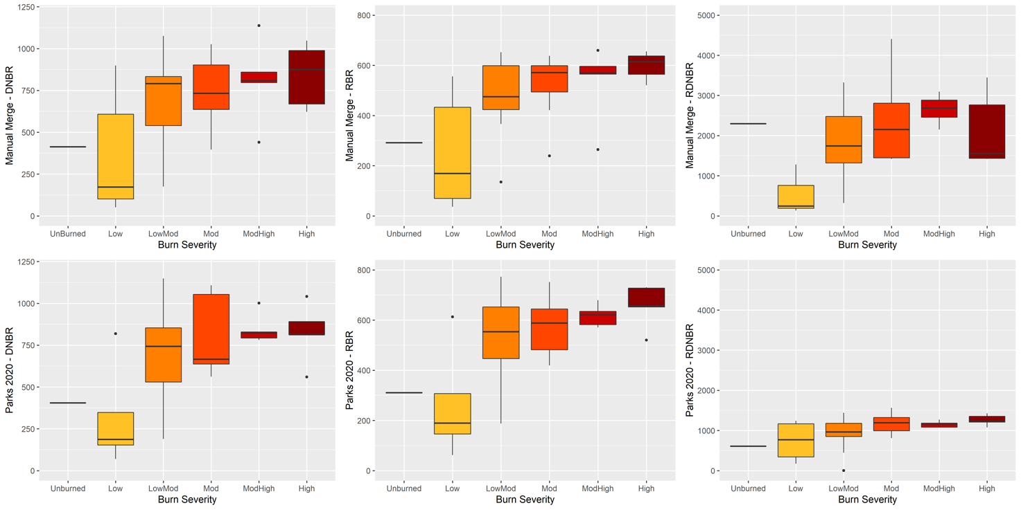

*Figure 4.* Box plots displaying relationships between ground truth soil burn severity (x-axis) and mapped burn severity (y-axis) for two different burn severity mapping methods (manual date selection on the top row and Parks et al. (2019) minimum compositing on the bottom row) for the Cameron Peak Fire. Ground truth soil burn severity points were collected and provided by the U.S. Forest Service.

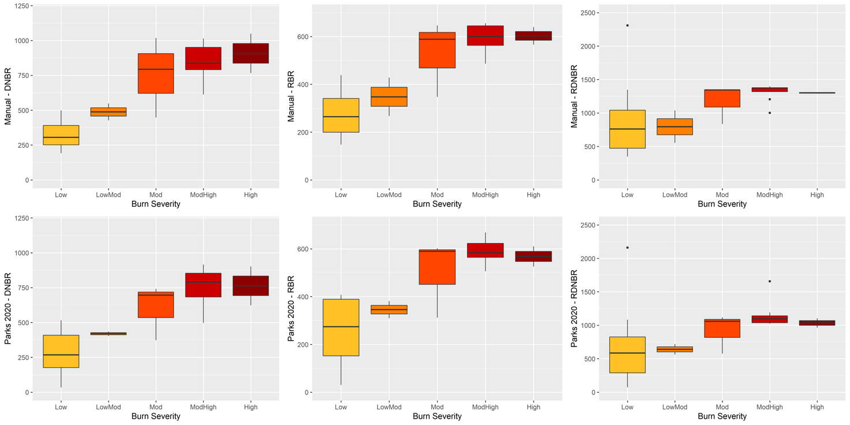

*Figure 5.* Box plots displaying correlations between ground truth soil burn severity (x-axis) and mapped burn severity (y-axis) for two different burn severity mapping methods (manual date selection on the top row and Parks et al. (2019) minimum compositing on the bottom row) for the CalWood Fire. Ground truth soil burn severity points were collected and provided by the U.S. Forest Service.

*4.1.2 Burn Severity vs Treatment Class Comparison*

The most common treatments for the Cameron Peak Fire area were wildfire, multiple surface fuels treatments, prescribed fire, prescribed fire plus multiple surface fuels treatments, and others (Figure B1, Table B2). The most common treatment combinations for the CalWood Fire area were prescribed fire, wildfire, and thinning treatments (Figure B2, Table B3). For the Cameron Peak Fire, we observed less variation in RBR values compared to dNBR values for the most common treatment classes (Figure 6). The order of average burn severity for the different treatment classes was identical between dNBR and RBR for the Cameron Peak fire. The lowest average burn severity treatment classes were (1) pile burning + multiple surface fuels and (2) pile burning + multiple surface fuels + thinning. The highest average burn severity treatment classes were (1) multiple surface fuels and (2) prescribed fire.

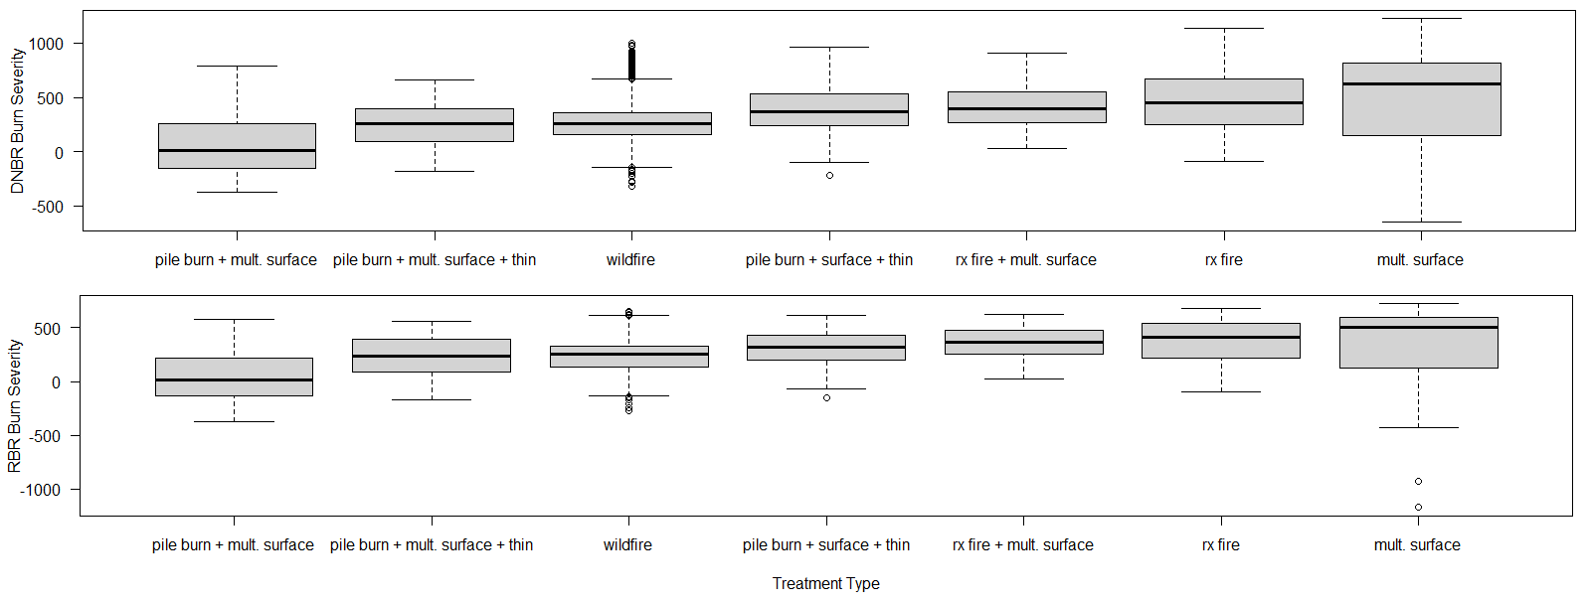

*Figure 6.* Box plots displaying correlations between forest treatment class (x-axis) and remotely sensed dNBR and RBR burn severity (top and bottom, respectively) for the Cameron Peak Fire.

For the CalWood Fire, we saw slight differences for the order of average burn severity for the different treatment classes between dNBR and RBR (Figure 7). These differences were with the three highest burn severity treatment classes. The treatments with the highest average dNBR values were (1) thinning, (2) multiple thinning, and (3) prescribed fire + multiple thinning + thinning. The three highest average RBR values were (1) prescribed fire + multiple thinning + wildfire, (2) thinning, and (3) multiple thinning. Overall, the highest average values for the top three classes were more similar for RBR than for dNBR (Table B3). Thinning, multiple thinnings, and wildfire treatments had a wider range of variability for dNBR and RBR compared to other treatment combinations. The lowest average burn severity treatment classes for both dNBR and RBR were (1) wildfire and (2) prescribed fire + wildfire (Figure 7).

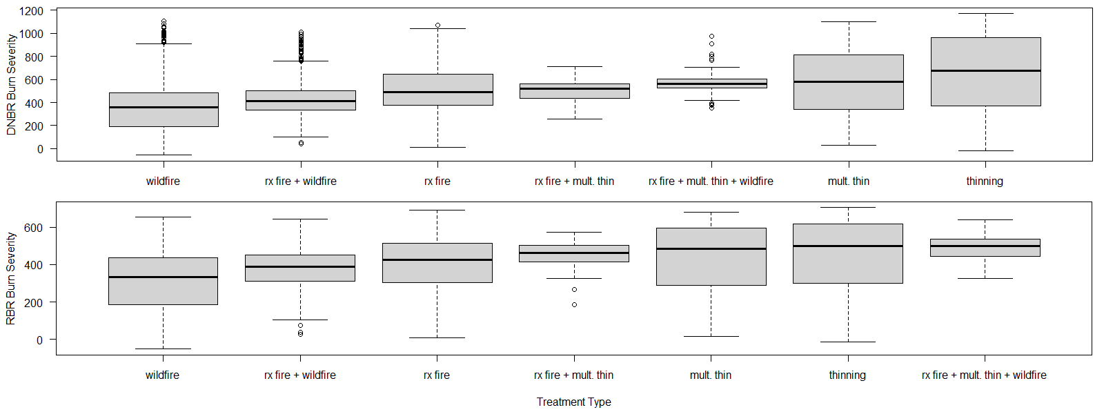

*Figure 7.* Box plots displaying correlations between forest treatment class (x-axis) and remotely sensed dNBR (top) and RBR (bottom) burn severity for the CalWood fire.

*4.1.3 Random Forest Modeling Assessment*

For the Cameron Peak Fire Full Model: elevation, distance to treatment edge, and physiographic diversity were the most important variables for predicting dNBR burn severity, with an R-squared value of 0.5937 and RMSE of 206.1 (Table 1). Partial dependency plots showed burn severity increasing between 2000 – 2750 m in elevation and dNBR burn severity increasing as distance to treatment edge areas decreased, with lower burn severities within treatment areas. In the Treatment-only Model of dNBR burn severity: elevation, physiographic diversity, and topographic diversity were the most important predictor variables, with an R-squared value of 0.6059 and an RMSE of 187.2. Partial dependency plots show that dNBR burn severity values were lowest for the 2000 – 2500 m gradient and highest for the 2500 – 3000 m elevation gradient. They also show a mildly bimodal relationship with physiographic diversity, with decreasing values of burn severity for increasing values of physiographic diversity.

*Table 1.* Random forest regression results for the Cameron Peak Fire and the CalWood Fire.

|  |  |  |  |  |
| --- | --- | --- | --- | --- |
| **Model Iteration** | **Number of important predictors** | **Predicted vs Observed R^2** | **Predicted vs Observed RMSE** | **Top Three Predictors** |
| Cameron Peak Fire Full Model | 8 | 0.5937 | 206.1 | 1. Elevation 2. Treatment Distance 3. Physiographic Diversity |
| Cameron Peak Fire Treatment-only Model | 9 | 0.6059 | 187.2 | 1. Elevation 2. Physiographic Diversity |
| CalWood Fire Full Model | 11 | 0.824 | 127.6 | 1. Fire Area 2. Forest Canopy Cover 3. CHILI |
| CalWood Fire Treatment-only Model | 11 | 0.8073 | 113.8 | 1. Fire Area 2. Forest Canopy Cover 3. Elevation |

For the CalWood Fire Full Model, fire area, forest canopy cover, and CHILI were the most important predictor variables for predicting dNBR burn severity with an R-squared value of 0.82 and an RMSE of 127.6. Partial dependency plots showed increasing burn severity as fire area and canopy cover increased. In the Treatment-only Model, fire area, forest canopy cover, and elevation were the most important predictor variables with an R-squared value of 0.81 and an RMSE of 113.8. Partial dependency plots showed a strong trend between dNBR burn severity, fire area, and forest canopy cover, with very similar results to the Full Model.

***4.2 Discussion of Results***

*4.2.1 Burn Severity Validation Discussion*

Based on the visual trends between remotely-sensed and field verified soil burn severity, we determined that the manual image selection was better suited for mapping late season fires compared to the automated pixel compositing method. While the automated approach might be better suited for typical fire season analysis, we were unable to validate selected pixels as snow and cloud-free. The manual image selection provided us with complete control over image selection as well as cloud and snow masking. RBR values had a smaller range of variability due to the relativizing step in the index equation, which helps standardize pre-NBR values so that areas with different starting pre-NBR values are represented fairly. This ensures that the final index results are more representative of the relativized shift in reflectance when comparing between pre- and post-fire.

*4.2.2 Burn Severity vs Treatment Class Comparison*

Preliminary trends between treatment classes and burn severity showed that areas that underwent (1) pile burning + multiple surface fuels, (2) pile burning + multiple surface fuels + thinning, and (3) wildfire treatments had the lowest average burn severity for the Cameron Peak Fire. For areas at the CalWood Fire that have undergone (1) wildfire and (2) prescribed fire + wildfire treatments showed the lowest burn severity. These trends align well with management objectives, as wildfire, prescribed fire, and pile and burn treatments can help remove surface fuels which reduce the potential flame length and increase the likelihood that the stand will survive a wildfire (Agee and Skinner, 2005). These preliminary trends suggest that fire-based treatments reduced burn severity, but further investigation of differences between treatment classes through variance analysis is necessary. In addition, remotely sensed burn severity maps require field validation to calibrate burn severity estimates (Cocke et al., 2005; Miller et al., 2009), which will be necessary to verify the accuracy of these findings. Further analysis of topographic and ecological landscape characteristics, such as studying burn severity within forested only areas, is necessary to determine if these trends are applicable towards managed areas.

*4.2.3 Random Forest Results Discussion*

For the Cameron Peak Fire, we saw that elevation, treatment distance, physiographic diversity, and topographic diversity were all important predictors in determining burn severity. Partial dependency plots for the Full Model and Treatment-only Model show that dNBR burn severity values were lowest for the 2000 – 2500 m gradient and highest for the 2500 – 3200 m elevation gradient. This trend is expected due to the different characteristics of forest types across these elevation gradients, as the 2000 – 2500 m gradient is primarily occupied by ponderosa pine stands (Addington et al., 2018). The 2500 – 3200m elevation gradient contains a mixture of ponderosa pine and Douglas fir at the lower elevations and lodgepole pine and Engelmann spruce in the higher elevations. The highest burn severity values were found at elevations above 3000 m, suggesting that intense canopy fires occurred in the lodgepole pine and Engelmann spruce forests in this area, but require field sampling to confirm remotely sensed trends. For the full model, it was interesting to see that points within all treated areas had lower burn severity values compared to points outside of treated areas. As a general trend, this suggests that treatments across the landscape had reduced burn severity compared to untreated areas, but further investigation of these trends through field sampling and further RF model exploration of RBR burn severity are necessary.

For the CalWood Fire, fire area and forest canopy cover were the top predictors in describing burn severity. The fire area was likely important due to large daily increases in fire size highly correlated with high burn severity on days two and three, where the fire moved through dense ponderosa pine stands. Burn severity decreased in the following days as the fire continued east into more open forested areas where forest treatments and fire mitigation efforts had been completed. The relationship of forest canopy cover is also expected, as areas with greater canopy cover are associated with higher above ground biomass and stand density, which can increase the likelihood of intense canopy fire (Agee and Skinner, 2005; Addington et al., 2018).

***4.3 Future Work***

This work was a critical first step in assessing relationships between fuel treatments and burn severity for the Cameron Peak Fire and the CalWood Fire in the Front Range. The collated treatment database created by combining and standardizing datasets from a range of project partners, government agencies, and federal agencies will assist future research efforts for characterizing relationships between fire treatments and burn severity. With these maps and the newly collated fuel treatment dataset, we were able to take an early look at how fuel treatments may have interacted with burn severity for the Cameron Peak and CalWood Fires.

However, this analysis was completed as an initial estimate of burn severity, and more time is necessary to allow post-fire mortality to fully manifest on the landscape. Therefore, we suggest that future research efforts investigate the relationships between treatment type and burn severity maps generated 1-year post-fire. Waiting for snow cover to decrease in the higher montane/subalpine regions will also allow for the East Troublesome Fire to be mapped, as we were unable to analyze this fire due to a lack of snow/cloud-free imagery. In addition to re-mapping the fires once more satellite imagery becomes available, additional work needs to be done to verify and calibrate these remotely sensed burn severity maps through field sampling within the two fire areas. Field sampling will allow for an improved understanding of on the ground attributes, like forest density, tree height, erosion, and canopy/soil burn severity. Extensive field validation efforts are critically important before drawing major conclusions about fuel treatment effectiveness. Future efforts could also utilize weather and fire directionality data to help describe fire behavior and interactions between different treated areas. Further modeling approaches could address more specific questions regarding topographic and ecological variables (e.g., north facing slopes vs south facing slopes, trends between elevational gradients, and within different forest types) to confirm preliminary trends seen in our initial RF model exploration. This work is expected to continue after the spring 2021 DEVELOP term led by our advisors at the Natural Resource Ecology Laboratory at Colorado State University.

# 5. Conclusions

We created initial burn severity maps of the Cameron Peak Fire and CalWood Fire that will be accessible to project partners and community stakeholders through an Esri StoryMap. We also collated a comprehensive forest treatment database that can be used to guide future management efforts and investigations of burn severity. Overall, our results indicate that elevation, treatment distance, and topographic indices were the top predictors for explaining burn severity for the Cameron Peak Fire. We also found that day of fire, forest canopy cover, and elevation were the top predictors for explaining burn severity for the CalWood fire. These results indicate that these two fires had independent drivers behind burn severity, likely due to the spatial extent and forest systems that they occurred in. Preliminary results indicate that areas with wildfires, prescribed burns, and pile and burn combination treatments had the lowest dNBR burn severity values. However, these results require more investigation and field validation to determine if these findings are significant.

Millions of dollars and thousands of hours have been spent implementing forest treatments along the Front Range to reduce wildfire impact. Our results and data will help guide future research investigating the relationship between treatments and burn severity. Project partners require more information regarding forest treatment effectiveness in order to implement more economically and impactful treatments for fostering more fire resilient forests. By providing managers with data about the effect of fuel reduction and treatment on fire severity, they can better communicate with stakeholders.

# 6. Acknowledgments

Project Partners:

* Daniel Bowker (Coalition for the Poudre River Watershed)
* Rob Addington (The Nature Conservancy – Colorado Chapter)
* Robert Sturtevant (Ben Delatour Boy Scout Ranch)
* Daniel Beveridge (Colorado State Forest Service)
* Michael Caggiano (Colorado Forest Restoration Institute)
* Wade Tinkham (Colorado State University)

Special Thanks:

* Scott Cunningham (NASA DEVELOP)
* Dr. Paul Evangelista (Colorado State University, NREL)
* Dr. Tony Vorster (Colorado State University, NREL)
* Brian Woodward (Colorado State University, NREL)
* Pedar Engelstad (Colorado State University, NREL)
* Nick Young (Colorado State University, NREL)
* Dr. Catherine Jarnevich (United States Geologic Survey)
* Jillian LaRoe (United States Geologic Survey)
* Mengfei Zhang (Colorado State University)
* Camille Stevens-Rumann (Colorado Forest Restoration Institute)
* Stephanie Mueller (Colorado Forest Restoration Institute)
* Kelsey Newton (Colorado Forest Restoration Institute)
* Sarah Osborne (Colorado State Forest Service)
* Amanda West (Colorado State Forest Service)

This material contains modified Copernicus Sentinel data (2019 – 2020), processed by ESA. Any opinions, findings, and conclusions or recommendations expressed in this material are those of the author(s) and do not necessarily reflect the views of the National Aeronautics and Space Administration.

This material is based upon work supported by NASA through contract NNL16AA05C.

# 

# 7. Glossary

**Aspect** – The direction that a slope faces

**Canopy base height** –Average height from canopy bottom to the ground

**Canopy bulk density** –Density of available canopy fuel in a stand

**Continuous Heat-insolation load index (CHILI)** – An index for effects of insolation and topographic shading on evapotranspiration

**Earth observations** –Satellites and sensors that collect information about the Earth’s physical, chemical, and biological systems over space and time

**Eastness** – The sine of aspect

**Existing Vegetation Type** –Plant communities type according to the NatureServe’s terrestrial Ecological Systems classification

**Forest Canopy Height** –Average height of the top of the vegetated canopy

**Forest Fuel –** Combustible natural materials that are found in forests, this may include grass, wood, shrubs, and needles

**Fuel characteristic class** –Describes the physical characteristics of uniform fuel classes

**Fuel vegetation cover** –A modified version of Existing Vegetation Cover that represents pre-disturbance vegetation

**Fuel vegetation height** –Mean height of dominant vegetation

**Fuel vegetation type** – A modified version of Existing Vegetation Type that represents pre-disturbance vegetation

**Front Range** –The easternmost portion of the Southern Rocky Mountains extending from southern Wyoming to central Colorado

**Fuel Reduction Treatments –** Actions taken to remove natural materials that provide fires material to burn. This may include burning, cutting of wood, canopy thinning, etc.

**Landform** – combines the Continuous Heat-insolation load index (CHILI) and Multiscale topographic position index (mTPI) to classify landform types.

**Lower Montane** –Areas below 8,200 feet on southern Front Range and 7,800 feet on northern Front Range

**Mechanical Thinning –** Removing whole trees from forested areas to increase non-forested space

**MODIS** –Moderate resolution Imaging Spectroradiometer

**Moraine** –A mass of rocks and sediment carried down and deposited by a glacier, typically as ridges at its edges or extremity

**Multiscale topographic position index (mTPI)** – Uses SRTM data to distinguish valleys and ridges. With negative values being valleys and positive values being ridges.

**National Vegetation Classification** –Dominant and codominant plant species and diagnostic growth forms

**Northness** – The cosine of aspect

**Physiographic diversity** – Uses landform and parent material to determine levels of diversity

**Prescribed Burning** –Managed fires that are started intentionally to remove forest fuels, remove invasive species, and create other ecologically important materials.

**Solar-radiation Aspect Index (TRASP)** – Uses aspect to calculate the cooler, wetter slopes with low values and hotter, drier slopes with higher values. Scaled from 0 to 1.

**Slope** – The rise or fall of a land surface

**Slope East** – Slope percentage multiplied by eastness

**Slope North** – Slope percentage multiplied by northness

**StoryMap** –A mapping tool developed by ESRI that allows users to create interactive web maps to visualize data and writing together

**Topographic Diversity** – Uses topographic data to determine levels of diversity

**Upper montane** –Areas of approximately 8,200 – 9,300 feet on southern Front Range and 7,800 – 9,100 feet on the northern Front Range

# 8. References

Addington, R. N., Aplet, G. H., Battaglia, M. A., Briggs, J. S., Brown, P. M., Cheng, A. S., Dickinson, Y., Feinstein, J. A., Pelz, K. A., Regan, C. M., Thinnes, J., Truex, R., Fornwalt, P. J., Gannon, B., Julian, C. W., Underhill, J. L., & Wolk, B. (2018). Principles and practices for the restoration of ponderosa pine and dry mixed-conifer forests of the Colorado Front Range. *RMRS-GTR-373. Fort Collins, CO: U.S. Department of Agriculture, Forest Service, Rocky Mountain Research* *Station. 121 p.*, *373*. <https://doi.org/10.2737/RMRS-GTR-373>

Agee, J. K., & Skinner, C. N. (2005). Basic principles of forest fuel reduction treatments. *Forest Ecology and Management*, *211*(1–2), 83–96. <https://doi.org/10.1016/j.foreco.2005.01.034>

Biau, G., & Scornet, E. (2016). A random forest guided tour. *TEST*, *25*(2), 197-227. <https://doi.org/10.1007/s11749-016-0481-7>

Breiman, L. 2001. Random forests. *Machine Learning, 45*, 5-32. <https://doi.org/10.1023/A:1010933404324>

Champ, J. G., Brooks, J. J., & Williams, D. R. (2012). Stakeholder understandings of wildfire mitigation: A case of shared and contested meanings. *Environmental Management*, *50*(4), 581-597. <https://doi.org/10.1007/s00267-012-9914-6>

Cocke, A. E., Fulé, P. Z., & Crouse, J. E. (2005). Comparison of burn severity assessments using Differenced Normalized Burn Ratio and ground data. *International Journal of Wildland Fire*, *14*(2), 189-198. <https://doi.org/10.1071/WF04010>

Colorado State Forest Service. (2020). The Stewardship Mapping and Reporting Tool (SMART). [Data set].

Colorado State Forest Service (2020). Historic treatment data surrounding the Calwood Fire digitized by Sarah Osborne. [Data set]. USDA National Institute of Food and Agriculture (grant number 2019-67019-29469).

Colorado Forest Restoration Institute (2017). CFRI Treatment Library. [Data set].

Colorado Forest Restoration Institute (2017). CPF Treatment Interactions v2. [Data set].

Coluzzi, R., Imbrenda, V., Lanfredi, M., & Simoniello, T. (2018). A first assessment of the Sentinel-2 Level 1-C cloud mask product to support informed surface analyses. *Remote Sensing of Environment, 217*, 426-443. <https://doi.org/10.1016/j.rse.2018.08.009>.

Hudak, A. T., Jain, T. B., Morgan, P., & Clark, J. T. (2011). Remote sensing of WUI fuel treatment effectiveness following the 2007 wildfires in central Idaho. *In* Wade, D.D., & Robinson, M.L. (Eds.) *Proceedings of the 3rd Fire Behavior and Fuels Conference*. International Association of Wildland Fire.

Kaufmann, Merrill R., Thomas T. Veblen, and William H. Romme. (2006). Historical fire regimes in ponderosa pine forests of the Colorado Front Range, and recommendations for ecological restoration and fuels management. Front Range Fuels Treatment Partnership Roundtable, findings of the Ecology Workgroup. <https://www.fs.usda.gov/treesearch/pubs/61131>

Kennedy, R.E., Yang, Z., Gorelick, N., Braaten, J., Cavalcante, L., Cohen, W.B., Healey, S. (2018). Implementation of the LandTrendr Algorithm on Google Earth Engine. *Remote Sensing, 10*, 691. <https://doi.org/10.3390/rs10050691>

LANDFIRE, 2008, Existing Vegetation Type Layer, LANDFIRE 1.1.0, U.S. Department of the Interior, Geological Survey. Accessed 25 January 2021 at <http://landfire.cr.usgs.gov/viewer/>.

LANDFIRE (2016). LANDFIRE Remap Public Events Geodatabase. [Data set]

Miller, J. D., Knapp, E. E., Key, C. H., Skinner, C. N., Isbell, C. J., Creasy, R. M., & Sherlock, J. W. (2009). Calibration and validation of the relative differenced Normalized Burn Ratio (RdNBR) to three measures of fire severity in the Sierra Nevada and Klamath Mountains, California, USA. *Remote Sensing of Environment*, *113*(3), 645-656. <https://doi.org/10.1016/j.rse.2008.11.009>

Moritz, M. A., Batllori, E., Bradstock, R. A., Gill, A. M., Handmer, J., Hessburg, P. F., ... & Syphard, A. D. (2014). Learning to coexist with wildfire. *Nature*, *515*(7525), 58-66. <https://doi.org/10.1038/nature13946>

Muir, W.D., 1941. Forest Fire Control in the United States of America. Forest Commission of New South Wales, p.13.

Murphy, M.A., Evans, J.S., & Storfer, A. (2010). Quantifying *Bufo boreas* connectivity in Yellowstone National Park with landscape genetics. *Ecology, 91*, 252.261. https://doi.org/10.1890/08-0879.1

NASA JPL (2014). *NASA Shuttle Radar Topography Mission Combined Image Data Set* [Data set]. NASA EOSDIS Land Processes DAAC. Accessed 2021-03-30 from <https://doi.org/10.5067/MEaSUREs/SRTM/SRTMIMGM.003>

National Wildfire Coordinating Group. (2017). Fire history perimeters. [Data set].

https://www.nwcg.gov/publications/pms936/nifs/public-distribution

Parks, S. A., Holsinger, L. M., Koontz, M. J., Collins, L., Whitman, E., Parisien, M.-A., Loehman, R. A., Barnes, J. L., Bourdon, J.-F., Boucher, J., Boucher, Y., Caprio, A. C., Collingwood, A., Hall, R. J., Park, J., Saperstein, L. B., Smetanka, C., Smith, R. J., & Soverel, N. (2019). Giving ecological meaning to satellite-derived fire severity metrics across North American forests. *Remote Sensing*, *11*(14), 1735. <https://doi.org/>10.3390/rs11141735

Parks, S.A., Holsinger, L.M., Voss, M.A., Loehman, R.A., & Robinson, N.P. (2018). Mean composite fires severity metrics computed with Google Earth Engine offer improved accuracy and expanded mapping potential. *Remote Sensing, 10*(6), 879. https://doi.org/10.3390/rs10060879

Reinhardt, E. D., Keane, R. E., Calkin, D. E., & Cohen, J. D. (2008). Objectives and considerations for wildland fuel treatment in forested ecosystems of the interior western United States. *Forest Ecology and Management*, *256*(12), 1997-2006. <https://doi.org/10.1016/j.foreco.2008.09.016>

Rocca, M.E., Brown, P.M., MacDonald, L.H., & Carrico, C.M. (2014). Climate change impacts on fire regimes and key ecosystem services in Rocky Mountain forests. *Forest Ecology Management, 327*, 290-305. <http://dx.doi.org/10.1016/j.foreco.2014.04.005>

Tinkham, W.T., Dickinson, Y., Hoffman, C.M., Battaglia, M.A., Ex, S., & Underhill, J. (2017). Visualization of heterogeneous forest structures following treatment in the southern Rocky Mountains. Gen. Tech. Rep. RMRS-GTR-365. Fort Collins, CO: U.S. Department of Agriculture, Forest Service, Rocky Mountain Research Station, 72 p.Vaillant, N., Noonan-Wright, E., Dailey, S., Ewell, C., & Reiner, A. (2013). *Effectiveness and longevity of fuel treatments in coniferous forests across California*. <https://doi.org/10.2737/RMRS-GTR-365>

USDA Forest Service. (2020). *Inciweb: Incident Information System*. https://inciweb.nwcg.gov/incident/6964/.

United States Forest Service Natural Resource Manager (NRM) Forest Activity Tracking System (FACTS). (2021). [Data set].<http://data.fs.usda.gov/geodata/edw/datasets.php>

Vaillant, N.M., Reiner, A.L., & Noonan-Wright, E.K. (2013). Prescribed fire effects on field-derived and simulated forest carbon stocks over time. *Forest Ecology and Management*, *310*, 711-719. https://doi.org/10.1016/j.foreco.2013.09.016

Veblen, T., & Lorenz, D. (1991). The Colorado Front Range - A Century of Ecological Change. 1st ed. Salt Lake City, Utah: University of Utah Press.

Wimberly, M. C., Cochrane, M. A., Baer, A. D., & Pabst, K. (2009). Assessing fuel treatment effectiveness using satellite imagery and spatial statistics. *Ecological Applications*, *19*(6), 1377–1384. <https://doi.org/10.1890/08-1685.1>

Ziegler, J., Hoffman, C., Fornwalt, P., Sieg, C., Battaglia, M., Chambers, M., & Iniguez, J. (2017a). Tree regeneration spatial patterns in ponderosa pine forests following stand-replacing fire: Influence of topography and neighbors. *Forests, 8*(10), 391. <https://doi.org/10.3390/f8100391>

# 9. Appendices

**Appendix A: Satellite Imagery**

*Table A1.* The table below indicates the satellite data that were used in this project. All data were accessed and processed in GEE.

|  |  |  |  |
| --- | --- | --- | --- |
| **Platform & Sensor** | **Data Product** | **Use** | **Dates** |
| **Landsat 8 OLI** | Top of Atmosphere Tier 1 | Landsat 8 OLI was used to generate LandTrendr disturbance variables including: Magnitude of Greatest Disturbance, Year of Disturbance, and Recovery Magnitude | LandTrendr Time Period:   * 1986-2019   LandTrendr Dates:   * 07/01 – 09/01 |
| **Sentinel-2 MSI** | Level 1C – Top of Atmosphere | Sentinel-2 MSI was used to map burn severity using multiple methods to be compared to field observations. | CalWood Fire Manual Dates:   * 11/18/2019 * 11/18/2020   Cameron Peak Manual Dates:   * Pre NBR 1 Image: 10/09/2019 * Post NBR 1 Image: 10/13/2020 * Pre NBR 2 Image:   11/18/2019   * Post NBR 2 Image:   12/22/2020  Parks et al. (2019) Minimum Compositing Dates:   * 9/1/2020 - 11/15/2020 & 11/1/2020 - 12/31/2020 |
| **Shuttle Radar Topography Mission (SRTM)** | Slope, Aspect, Elevation, Topographic Position Index (TPI), Topographic Wetness Index (TWI), and Landform | SRTM topographic indices were utilized for analyses of burn severity and in comparisons of treated and untreated areas. | 02/11/2020 – 02/22/2000 |

*Table A2.*The table below indicates the specific Sentinel-2 MSI satellite images that were used in this project. All data were accessed and processed in GEE.

|  |  |  |
| --- | --- | --- |
| **Purpose** | **Image Date** | **Unique Image Identifier** |
| Cameron Peak Fire (West) Pre-Image | 10/09/2019 | 20191009T175241_20191009T180207_T13TDE |
| Cameron Peak Fire (West) Post Image | 11/18/2019 | 20191118T175631_20191118T175629_T13TDE |
| Cameron Peak Fire (East) Pre-Image | 10/13/2020 | 20201013T175311_20201013T180206_T13TDE |
| Cameron Peak Fire (East) Post Image | 12/22/2020 | 20201222T175741_20201222T175743_T13TDE |
| CalWood Fire Pre-Image | 11/18/2019 | 20191118T175631_20191118T175629_T13TDE |
| Cal Wood Fire Post Image | 11/02/2020 | 20201102T175521_20201102T175922_T13TDE |

**Appendix B: Treatment Classifications**

*Table B1.*Database renaming structures.

|  |  |  |
| --- | --- | --- |
| **Database Label** | **CFRI Class** | **Fuels Reduction Class** |
| Chipping | Mechanical | Chipping |
| Chipping of Fuels | Mechanical | Chipping |
| Clear Cut | Clearcut | Clearcut |
| Patch Clearcut (EA/RH/FH) | Clearcut | Clearcut |
| Patch Clearcut (w/ leave trees) (EA/RH/FH) | Clearcut | Clearcut |
| Patch clearcutting (EA/RN/FH) | Clearcut | Clearcut |
| Patch Cut | Clearcut | Clearcut |
| Permanent Land Clearing | Clearcut | Clearcut |
| Stand Clearcut | Clearcut | Clearcut |
| Stand Clearcut (EA/RH/FH) | Clearcut | Clearcut |
| Stand Clearcut (w/ leave trees) (EA/RH/FH) | Clearcut | Clearcut |
| Stand Clearcutting(EA/RH/FH) | Clearcut | Clearcut |
| Two-aged Patch Clearcut (w/res) (2A/RH/FH) | Clearcut | Clearcut |
| Patch Clearcut | Clearcut | Clearcut |
| GSL 100 | Clearcut | Clearcut |
| GSL 110 | Clearcut | Clearcut |
| GSL 110, 2ac. Aspen patch cut | Clearcut | Clearcut |
| GSL 80, Clearcut 1/3 stand | Clearcut | Clearcut |
| Chemical | Invasives | Invasives |
| Chemical/Other | Invasives | Invasives |
| Chemical/PESTICIDE | Invasives | Invasives |
| Invasives - Mechanical / Physical | Invasives | Invasives |
| Invasives - Mechanical /Physical | Invasives | Invasives |
| Invasives - Pesticide Application | Invasives | Invasives |
| Enrollment in Tax Relief Program | N/A | N/A |
| Individual tree release and weeding | N/A | N/A |
| N/A | N/A | N/A |
| Pesticide Application | N/A | N/A |
| Scarify and Seed Landings | N/A | N/A |
| Stewardship Plan- Updated/Revised/Amended | N/A | N/A |
| Tree Release and Weed | N/A | N/A |
| Fuels and Fire Activities | N/A | N/A |
| Marking/Designation | N/A | N/A |
| NA | N/A | N/A |
| Invasive Species Inventories | N/A | N/A |
| Insect Control | N/A | N/A |
| Burning of Piled Material | Rx Fire | Pile burning |
| Fire/Hand Pile Burn | Rx Fire | Pile burning |
| Hand Pile Burn/Fire | Rx Fire | Pile burning |
| Machine Pile Burn | Rx Fire | Pile burning |
| Broadcast Burn | Rx Fire | Rx Fire |
| Broadcast Burn/Fire | Rx Fire | Rx Fire |
| Broadcast Burning - Covers a majority of the unit | Rx Fire | Rx Fire |
| Jackpot Burning - Scattered concentrations | Rx Fire | Rx Fire |
| Prescribed Fire | Rx Fire | Rx Fire |
| Prescribed Fire/NONE | Rx Fire | Rx Fire |
| Rx | Rx Fire | Rx Fire |
| Rx Fire | Rx Fire | Rx Fire |
| Site Preparation for Natural Regeneration - Burning | Rx Fire | Rx Fire |
| Under burn - Low Intensity (Majority of Unit) | Rx Fire | Rx Fire |
| Compacting/Crushing of Fuels | Mechanical | Surface fuels treatment |
| Crushing | Mechanical | Surface fuels treatment |
| Machine Pile | Mechanical | Surface fuels treatment |
| Machine Pile/Mechanical | Mechanical | Surface fuels treatment |
| Mechanical/Biomass Removal | Mechanical | Surface fuels treatment |
| Mechanical/Hand Pile | Mechanical | Surface fuels treatment |
| Piling of Fuels, Hand or Machine | Mechanical | Surface fuels treatment |
| Rearrangement of Fuels | Mechanical | Surface fuels treatment |
| Yarding - Removal of Fuels by Carrying or Dragging | Mechanical | Surface fuels treatment |
| Piling of Fuels | Mechanical | Surface fuels treatment |
| GSL 80, Salvage DF | Mechanical | Thinning |
| Commercial Thin | Mechanical | Thinning |
| Commercial Thinning | Mechanical | Thinning |
| Forest Restoration | Mechanical | Thinning |
| Fuel Break | Mechanical | Thinning |
| Fuels Reduction | Mechanical | Thinning |
| Fuels Reduction for Defensible Space | Mechanical | Thinning |
| Group Selection Cut (UA/RH/FH) | Mechanical | Thinning |
| Hand Thinning/Piling/Chipping | Mechanical | Thinning |
| Improvement Cut | Mechanical | Thinning |
| Mechanical | Mechanical | Thinning |
| mechanical | Mechanical | Thinning |
| Mechanical/Thinning | Mechanical | Thinning |
| Mechanical/Thinning | Mechanical | Thinning |
| Overstory Removal Cut (from advanced regeneration) (EA/RH/FH) | Mechanical | Thinning |
| Overstory removal cut (from advanced regeneration) (EA/RN/FH) | Mechanical | Thinning |
| Post-Sale | Mechanical | Thinning |
| Precommercial Thin | Mechanical | Thinning |
| Precommercial thinning - individual or selected trees | Mechanical | Thinning |
| Remove MPB, Leave seed tress | Mechanical | Thinning |
| Salvage Cut (intermediate treatment, not regeneration) | Mechanical | Thinning |
| Salvage DF, Group selection | Mechanical | Thinning |
| Salvage DF, GSL 80, Group selection | Mechanical | Thinning |
| Salvage DF, Thin | Mechanical | Thinning |
| Salvage DF, Thin, Group selection | Mechanical | Thinning |
| Salvage DF, Group selection | Mechanical | Thinning |
| Sanitation (salvage) | Mechanical | Thinning |
| Seed-tree cut (w/res) (EA/RN/NFH) | Mechanical | Thinning |
| Seed-tree Removal Cut (w/ leave trees) (EA/NRH/FH) | Mechanical | Thinning |
| Shelterwood Establishment Cut (with or without leave trees) (EA/RH/NFH) | Mechanical | Thinning |
| Shelterwood final removal cut (EA/NRN/FH) | Mechanical | Thinning |
| Shelterwood Preparatory Cut (EA/NRH/NFH) | Mechanical | Thinning |
| Shelterwood Removal Cut (EA/NRH/FH) | Mechanical | Thinning |
| Shelterwood Removal Cut (w/ leave trees) (EA/NRH/FH) | Mechanical | Thinning |
| Single-Tree Selection Cut | Mechanical | Thinning |
| Single-tree Selection Cut (UA/RH/FH) | Mechanical | Thinning |
| Single-tree selection cut (UA/RN/NFH) | Mechanical | Thinning |
| Slashing - Pre-Site Preparation | Mechanical | Thinning |
| Thin | Mechanical | Thinning |
| Thin (Firewood) | Mechanical | Thinning |
| Thin BA 40 | Mechanical | Thinning |
| Thin BA 65 | Mechanical | Thinning |
| Thin BA 68 | Mechanical | Thinning |
| Thin GSL 60 | Mechanical | Thinning |
| Thinning | Mechanical | Thinning |
| Thinning for Hazardous Fuels Reduction | Mechanical | Thinning |
| Thinning/Mechanical | Mechanical | Thinning |
| Timber Harvest | Mechanical | Thinning |
| Timber Salvage | Mechanical | Thinning |
| Two-aged Preparatory Cut (w/res) (2A/NRH/NFH) | Mechanical | Thinning |
| Two-aged Preparatory Cut (UA/RH/FH) | Mechanical | Thinning |
| Two-aged Shelterwood Final Removal Cut (w/res) (2A/NRH/FH) | Mechanical | Thinning |
| ACP thinning, Salvage | Mechanical | Thinning |
| Group Selection Cut | Mechanical | Thinning |
| Construction of Fuel Breaks in Activity Fuels | Mechanical | Thinning |
| DM control/ thin | Mechanical | Thinning |
| Improve 1979 thinning and remove SBW kill | Mechanical | Thinning |
| Log, Salvage | Mechanical | Thinning |
| Salvage DF | Mechanical | Thinning |
| Sanitation thinning | Mechanical | Thinning |
| SBW Salvage | Mechanical | Thinning |
| Seed-tree Final Cut | Mechanical | Thinning |
| Seed-tree Preparatory Cut | Mechanical | Thinning |
| Thin BA 70 | Mechanical | Thinning |
| Thin BA 80 | Mechanical | Thinning |
| Thin BA 90 | Mechanical | Thinning |
| Thin BA 90+ | Mechanical | Thinning |
| Thin BA 94 | Mechanical | Thinning |
| Thin GSL _ | Mechanical | Thinning |
| Thin GSL 100 | Mechanical | Thinning |
| Thin GSL 120 | Mechanical | Thinning |
| Thin GSL 40-60 | Mechanical | Thinning |
| Thin GSL 80 | Mechanical | Thinning |
| Thin GSL 80-100, BA 100 | Mechanical | Thinning |
| Thin GSL 80 in pond, Remove SBW kill on N slope | Mechanical | Thinning |
| Thin GSL 80, MPB removed | Mechanical | Thinning |
| Thin GSL 80, Sanitation | Mechanical | Thinning |
| Thin GSL 90 | Mechanical | Thinning |
| TSI, Douglas fir removed | Mechanical | Thinning |
| TSI, MPB removed, Salvage | Mechanical | Thinning |
| TSI, Salvage DF | Mechanical | Thinning |
| TSI, SBW & MPB kill removed | Mechanical | Thinning |
| TSI, SBW kill removed | Mechanical | Thinning |
| TSI, SBW kill removed, Thin PP-GSL 80 | Mechanical | Thinning |
| TSI, SBW+MPB kill removed, Thin healthy PP-GSL 80 | Mechanical | Thinning |
| TSI, Thin GSL 90 | Mechanical | Thinning |
| Pole Sale | Mechanical | Thinning |
| Mechanical and Rx Fire | Mechanical and Rx Fire | Thinning and Rx Fire |
| Fill-in or Replant Trees | N/A | Tree Planting |
| Plant Trees | N/A | Tree Planting |
| Planting | N/A | Tree Planting |
| PP Planting | N/A | Tree Planting |
| Reforestation - Other (Acres) | N/A | Tree Planting |
| Logged (bugs) | Unknown | Unknown |
| Timber Sale | Unknown | Unknown |
| Forest Health | Unknown | Unknown |
| Landowner Assistance | Unknown | Unknown |
| Non-Fire Treatment | Unknown | Unknown |
| Null | Unknown | Unknown |
| Physical/ | Unknown | Unknown |
| Physical/ALTER | Unknown | Unknown |
| PHYSICAL/REMOVE | Unknown | Unknown |
| Physical/REMOVE | Unknown | Unknown |
| Silviculture | Unknown | Unknown |
| Site preparation for natural regeneration | Unknown | Unknown |
| Site Preparation for Natural Regeneration - Mechanical | Unknown | Unknown |
| Site Preparation for Natural Regeneration - Other | Unknown | Unknown |
| Unknown | Unknown | Unknown |
| Logged | Unknown | Unknown |
| Site Preparation for Natural Regeneration | Unknown | Unknown |
| Fire | Wildfire | Wildfire |
| Wildfire | Wildfire | Wildfire |
| Wildfire - Natural Ignition | Wildfire | Wildfire |
| Wildland Fire | Wildfire | Wildfire |

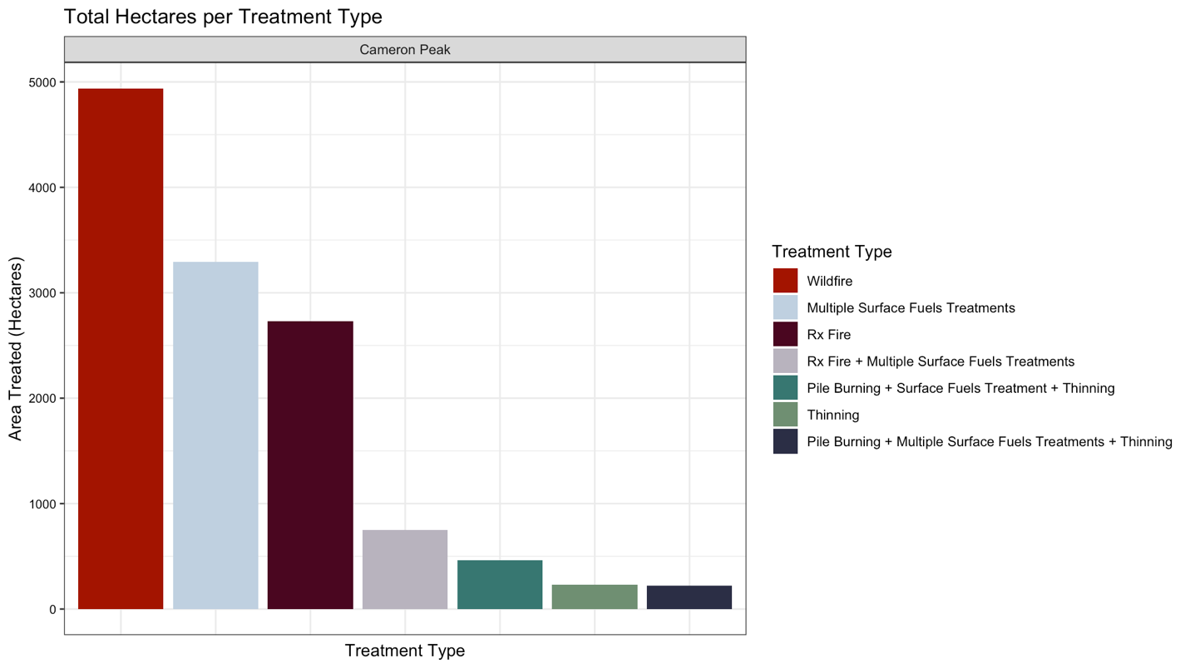

*Figure B1.* Most common treatment combinations for the Cameron Peak Fire

*Table B2.* Average burn severity values for the different forest treatment classes at the Cameron Peak Fire

|  |  |  |  |
| --- | --- | --- | --- |
| **Treatment Class** | **dNBR value** | **RBR value** | **RdNBR value** |
| Pile Burning + Multiple Surface Fuels | 71.898 | 65.923 | 441.945 |
| Pile Burning + Multiple Surface Fuels + Thinning | 255.6603 | 241.810 | 1492.174 |
| Wildfire | 272.282 | 239.264 | 1098.218 |
| Pile Burning + Surface Fuels + Thinning | 395.533 | 315.677 | 1134.091 |
| Rx Fire + Multiple Surface Fuels | 416.967 | 362.384 | 1478.025 |
| Rx Fire | 458.368 | 370.705 | 1338.394 |
| Multiple Surface Fuels | 521.970 | 378.012 | 933.865 |

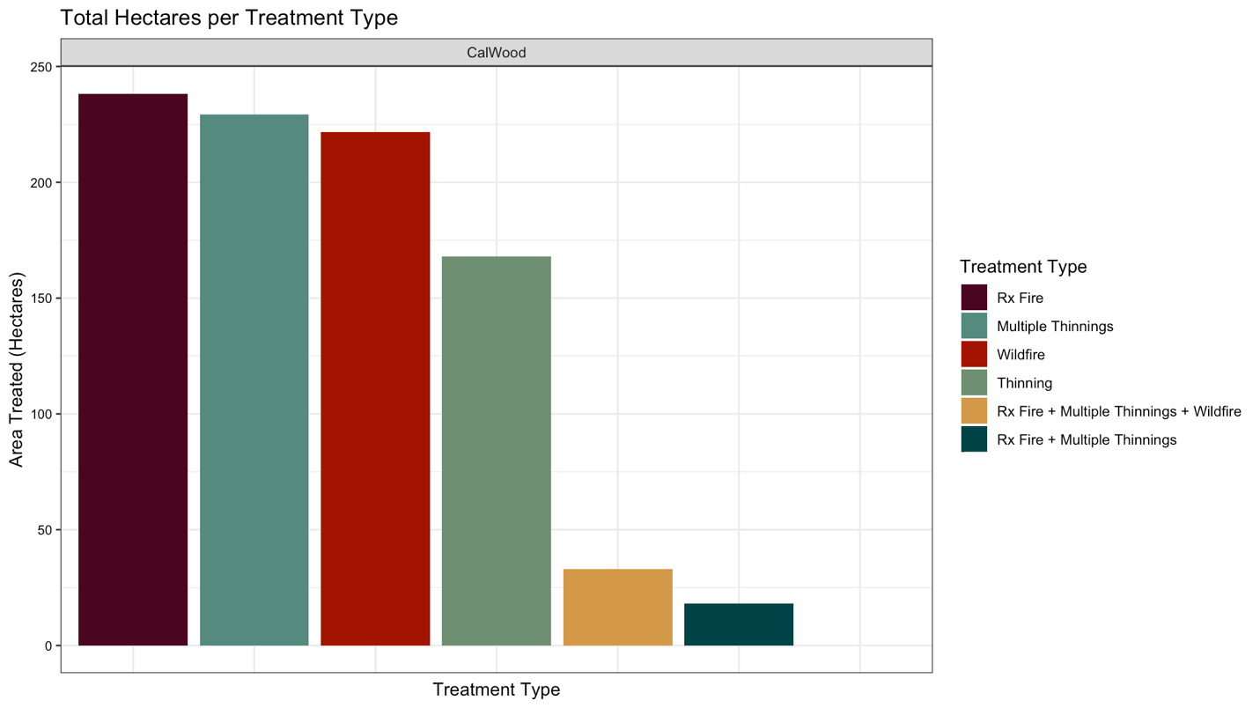

*Figure B2.* Most common treatment types by hectares treated in the CalWood Fire.

|  |  |  |  |
| --- | --- | --- | --- |
| **Treatment Class** | **dNBR value** | **RBR value** | **RdNBR value** |
| Wildfire | 361.18 | 312.025 | 1398.213 |
| Rx Fire + Wildfire | 434.793 | 379.730 | 1823.326 |
| Rx Fire + Multiple Thinning | 505.831 | 451.280 | 2071.322 |
| Rx Fire | 520.524 | 408.591 | 1241.990 |
| Rx Fire + Multiple Thinning + Wildfire | 574.432 | 488.616 | 1547.638 |
| Multiple Thinning | 578.500 | 438.178 | 1163.021 |
| Thinning | 657.270 | 448.591 | 1104.515 |

*Table B3*. Average burn severity values for the different forest treatment classes at the CalWood Fire.

**Appendix C: Variables used for Random Forest Modeling**

*Table C1.*List of variables utilized prepared for modeling burn severity across the Cameron Peak Fire and CalWood Fire.

|  |  |  |  |  |  |
| --- | --- | --- | --- | --- | --- |
| **Variable** | **Type** | **Source** | **Unit** | **Native Resolution** | **Access** |
| dNBR | Response | Sentinel-2 | N/A | 10m | Google Earth Engine |
| Treatment Size | Predictor | Collated Treatment Database | m2 | N/A | Collated Treatment Database |
| Treatment Age | Predictor | Collated Treatment Database | Year | N/A | Collated Treatment Database |
| Treatment Class | Predictor | Collated Treatment Database | N/A | N/A | Collated Treatment Database |
| Distance to Treatment Edge | Predictor | Collated Treatment Database | m | N/A | Collated Treatment Database |
| Fire Growth Area | Predictor | CFRI Fire Progression Maps | m2 | m2 | CFRI Fire Progression Maps |
| Day of Fire | Predictor | CFRI Fire Progression Maps | Day | N/A | CFRI Fire Progression Maps |
| Magnitude of Disturbance | Predictor | LandTrendr | N/A | 30m | Google Earth Engine |
| Year of Disturbance | Predictor | LandTrendr | Year | 30m | Google Earth Engine |
| Rate of Disturbance | Predictor | LandTrendr | N/A | 30m | Google Earth Engine |
| Duration of Disturbance | Predictor | LandTrendr | N/A | 30m | Google Earth Engine |
| Disturbance SNR | Predictor | LandTrendr | N/A | 30m | Google Earth Engine |
| Pre-value Disturbance | Predictor | LandTrendr | N/A | 30m | Google Earth Engine |
| Canopy Height | Predictor | LANDFIRE | m | 30m | LANDFIRE |
| Canopy Bulk Density | Predictor | LANDFIRE | kg/m3 | 30m | LANDFIRE |
| Canopy Base Height | Predictor | LANDFIRE | m | 30m | LANDFIRE |
| Canopy Cover | Predictor | LANDFIRE | Percent | 30m | LANDFIRE |
| Fuel Vegetation Cover | Predictor | LANDFIRE | Percent | 30m | LANDFIRE |
| Fuel Vegetation Type | Predictor | LANDFIRE | Percent | 30m | LANDFIRE |
| Existing Fuel Types | Predictor | LANDFIRE |  | 30m | LANDFIRE |
| National Vegetation Class | Predictor | LANDFIRE | N/A | 30m | LANDFIRE |
| Slope | Predictor | SRTM | Degrees | 30m | Google Earth Engine |
| Slope North | Predictor | SRTM | Degrees | 30m | Google Earth Engine |
| Slope East | Predictor | SRTM | Degrees | 30m | Google Earth Engine |
| Northness | Predictor | SRTM | N/A | 30m | Google Earth Engine |
| Eastness | Predictor | SRTM | N/A | 30m | Google Earth Engine |
| Aspect | Predictor | SRTM | Degrees | 30m | Google Earth Engine |
| Elevation | Predictor | SRTM | m | 30m | Google Earth Engine |
| Landform | Predictor | SRTM | N/A | 90m | Google Earth Engine |
| Physiographic Diversity | Predictor | National Elevation Dataset (NED) | N/A | 10m | Google Earth Engine |
| Topographic Diversity | Predictor | SRTM | N/A | 270m | Google Earth Engine |
| Continuous Heat Insolation Index (CHILI) | Predictor | SRTM | N/A | 90m | Google Earth Engine |
| Multi-Scale Topographic Position Index (mTPI) | Predictor | SRTM | N/A | 270m | Google Earth Engine |
| Solar-radiation Aspect Index (TRASP) | Predictor | SRTM | N/A | 30m | Google Earth Engine |