Short Title (Location + Main App Area)

Longer subtitle (Example: Synthetic Aperture Radar Data Decision Support for Atlantic Blue Fin Tuna Population Assessment and Management in the Gulf of Mexico)

 **Technical Report**

Rough Draft – July 8th, 2021

Author 1 (Project Lead)

Author 2

Author 3

Author 4

***Advisors:***

Advisor 1, Affiliation (Science Advisor)

Advisor 2, Affiliation (Science Advisor)

***Previous Contributors:***

Contributor 1

Contributor 2

# 1. Abstract

[Placeholder – do not put anything here until the final draft submission. The abstract in the Project Summary is where the working draft of the abstract should “live”.]

**Key Terms**

Insert 2 to 8 keywords here that relate to your project. Example: remote sensing, MODIS, Floating Algal Index, biodiversity hotspot, MaxEnt

# 2. Introduction

Be concise; this section should be between 500 and 800 words as one to two pages should suffice.

***2.1 Background Information***

Things to include (in whatever order you think flows best): **Background Information** – Relevant information to inform the reader of the current status, environmental issues, decision making, etc. **Scientific Basis** –previous studies, the scientific basis of your methods and how they have been used in previous research, etc. **Study Area** – Describe the geographic location of the study. **Study Period** – Explain the time period of data you are looking at (years and dates of data). **For II & III term projects** – Include a paragraph discussing what was done and/or found in the previous term.

***2.2 Project Partners & Objectives***

Things to include: **Project Partners** – Explain who the project partners are, why they are interested in this project, how they will use it, what decision making they have to do and is being addressed with this research and methodologies, etc. How will they benefit from this project and methodology? **Project Objectives** – These should be short decisive action items in paragraph form, not a bulleted list.

# 3. Methodology

This should be the focus of the paper – concise, yet explanatory. Highlight the NASA Earth observations utilized and their capabilities. Include a paragraph or more for each of the following items. There is no word cap, but be thoughtful and keep it in the 2- to 6-page range. **Use past tense, active voice whenever possible!**

***3.1 Data Acquisition***

What data did you get, what level products are they, for what dates did you get images, where did you get the images from, etc.? Consider adding a table to display this information if you are using multiple platforms/sensors. You do not need a separate paragraph for each data source under the Data Acquisition section.

***3.2 Data Processing***

What did you do to the data? Were there conversions needed to be able to analyze it? Did you have to mosaic images? Did you have to normalize anything to fit other datasets? Did you run an NDVI calculation, change detection, etc.?

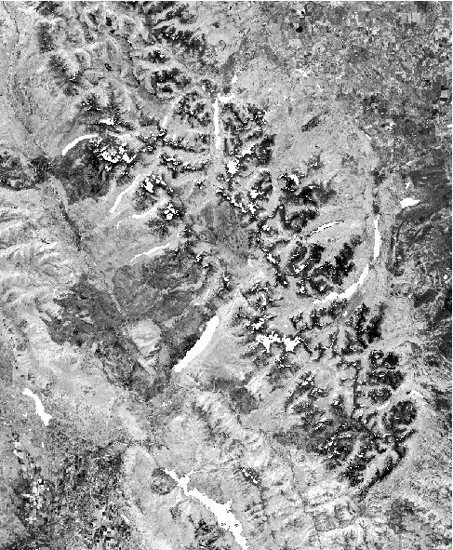

Figure 1. This is a composited and cloud-masked NDMI image clipped to the 4 km study boundary of Glacier National Park (from Landsat 5 TM, 2005).

$\text{N}\text{DMI = }\frac{\text{NIR - SWIR}}{\text{NIR + SWIR}}$ (1)

***3.3 Data Analysis***

How did you analyze the data – statistical analysis, validation, etc.? What methods did you use?

# 4. Results & Discussion

Insert images, graphs, maps, charts, etc. in this section. Choose the most important results to highlight here. No word cap, but 2 to 6 pages is a good range.

***4.1 Analysis of Results***

What can you tell from your graphs, images, etc.? What does this mean for your project?

What factors could you not account for? Include an error analysis. What things didn’t work out like you expected they would, etc.?

Table 3

*Interannual periods used to create persistence maps*

|  |  |
| --- | --- |
| **Persistence Year Range** | **Interannual Periods Aggregated for Persistence** |
| 2000-2005 | 2000-2001, 2001-2002, 2002-2003, 2003-2004, 2004-2005 |
| 2005-2011* | 2005-2006, 2006-2007, 2007-2009, 2009-2010, 2010-2011 |
| 2010-2016* | 2010-2011, 2011-2013, 2013-2014, 2014-2015, 2015-2016 |

The “*” indicates ranges with gaps due to missing interannual periods from Landsat for 2008 and 2012.

***4.2 Future Work***

If your team had more time to work on this project, what additional analyses would you pursue? If this project were to be selected for another term, what would be the focus? What additional research questions and topics would your partners wish to investigate themselves or have DEVELOP pursue in the future?

# 

# 5. Conclusions

Word count: 200 to 600, about a page.

**Synthesize your results here** – how do they relate to your community concerns, how will your partners benefit from the project results, etc.?

# 

# 6. Acknowledgments

Keep to a concise paragraph or bullets of names. End with the following sentences:

This material contains modified Copernicus Sentinel data (insert year), processed by ESA.

Any opinions, findings, and conclusions or recommendations expressed in this material are those of the author(s) and do not necessarily reflect the views of the National Aeronautics and Space Administration.

This material is based upon work supported by NASA through contract NNL16AA05C.

# 

# 7. Glossary

Define field-specific terms and acronyms. The goal of this section is to help the reader better understand the work presented in the paper. Include vocabulary that the reader may not be familiar with, in addition to defining the acronyms in your paper.

**Earth observations** – Satellites and sensors that collect information about the Earth’s physical, chemical, and biological systems over space and time

**MODIS** – Moderate resolution Imaging Spectroradiometer

**Moraine** – A mass of rocks and sediment carried down and deposited by a glacier, typically as ridges at its edges or extremity

# 8. References

Insert references here. Only include articles & data cited within the body of the text. It’s great if you read many other articles, but they should not all be listed here unless they are being cited in this report.

**References should be in APA formatting:**

[Purdue Online Writing Lab APA Citation Guide](https://owl.english.purdue.edu/owl/resource/560/01/)

***Example:***

Reynolds, L. V., & Cooper, D. J. (2010). Environmental tolerance of an invasive riparian tree and its potential for continued spread in the southwestern US. *Journal of Vegetation Science, 21*(4), 773-743.   
https://doi.org/10.1111/j.1654-1103.2010.01179.x

Citation in text: Please ensure that every reference cited in the text is also present in the reference list (and vice versa). Unpublished results and personal communications are not recommended in the reference list but may be mentioned in the text.

Web references: As a minimum, the full URL and the date when the reference was last accessed should be given. Any further information, if known (DOI, author names, dates, reference to a source publication, etc.), should also be given. Web references can be listed separately (e.g., after the reference list) under a different heading, if desired, or can be included in the reference list.

Citing NASA data: NASA’s Distributed Active Archive Centers (DAACs) have created and registered Digital Object Identifiers (DOIs) for many NASA data products. A DOI is a unique alphanumeric string to identify a digital object and provide a permanent link online – you might have seen these in citations for published journal articles. These DOIs allow others to easily identify and access the data used in your project.

The basic format is as follows: Dataset authors/producers. (Data release date). Dataset title, version. Data archive/distributor, access date in standard AMS format. Data locator/identifier (DOI or URL).

***Example:***

CERES Science Team. (2015). CERES Level 3 SYN1DEGDAYTerra+Aqua netCDF file, Edition 3A.

NASA Atmospheric Science Data Center, accessed 11 February 2016. doi://10.5067/Terra+Aqua/CERES/SYN1degDAY_L3.003A

# 9. Appendices

Begin each appendix on a **new page** with the word appendix in the top center. Use an identifying capital letter (e.g., Appendix A, Appendix B, etc.) if you have more than one appendix.

Label tables and figures in the appendix as you would in the text of your manuscript, using the letter A before the number to clarify that the table or figure is found in the appendix (e.g., Figure A1, Table B2, etc.)

**Don’t forget to refer to appendix figures in the body text of the paper.** If an appendix consists entirely of a single table or figure, the title of the table or figure should serve as the title of the appendix.