Kenya Agriculture & Food Security

Utilizing NASA Earth Observations in the RHEAS Model to Enhance Drought Monitoring and Mitigation in Kenya

 **Technical Report**

Final Draft – August 8th, 2019

Ryan Good (Project Lead)

Ryan Marshman

Amanda Tomlinson

Chiara Phillips

Dr. Jeffrey Luvall, NASA Marshall Space Flight Center (Science Advisor)

Dr. Robert Griffin, University of Alabama in Huntsville (Science Advisor)

# 1. Abstract

Many regions of Kenya historically and regularly experience severe drought, necessitating a robust and well-informed response to drought events to protect agricultural production and minimize drought impact on food security. The National Drought Management Authority currently publishes monthly Early Warning Bulletins that depend on Moderate Resolution Imaging Spectroradiometer (MODIS) indices and are not sufficient in assessing current drought status nor predicting its trajectory. This project utilized Soil Moisture Active Passive (SMAP) L-band Radiometer, Aqua and Terra MODIS, and Global Precipitation Measurement Core Observatory (GPM) Dual-Frequency Precipitation Radar (DPR) data as inputs into the Regional Hydrologic Extremes Assessment System (RHEAS). This model supports an unlimited number of variables, as it relies on a land surface model that can be easily customized, allowing data from multiple resolutions to be used without the need for preprocessing. Using inputs from the Regional Centre for Mapping of Resources for Development, the team created multiple drought time series to better assist stakeholders in implementing drought mitigation and adaptation measures. Initial results showed that drought indices that cover a longer time period provided a clearer trend of drought conditions by county. The team also provided partners an initial analysis of the indices produced and a story map derived from the time series. Follow on work will validate these products and create training documents for end users.

**Keywords**

RHEAS, remote sensing, SERVIR, Aqua, Terra, SMAP, GPM

# 2. Introduction

* 1. ***Background Information***

This project investigated drought in Kenya (*Figure 1*) from January 2016 to April 2019. Drought is a chronic issue that plagues countries in East Africa, causing food insecurity and leaving 10 million people hungry. Kenya is particularly prone to the impacts of drought, as over 80 percent of the country is comprised of arid or semi-arid lands (ASALs) (Central Intelligence Agency, 2019; Uhe et al., 2018). Kenya’s agricultural resources are susceptible to changes in rainfall, and because drought frequency and intensity have been increasing since 1960, crop yields are of major concern (Opiyo, Wasonga, Nyangito, Schilling, & Munang, 2015). In 2019, Kenya experienced significantly below-average rainfall for the second consecutive year, resulting in reduced crop production (Famine Early Warning Systems Network, 2019). This shortage left 3.4 million people in Kenya food insecure, with 2.6 million in the Crisis classification or above for food insecurity (*Appendix A*) (Kenya Food Security Steering Group, 2017). Poor agricultural performance is devastating for Kenya’s economy, as 25.9 percent of the Gross Domestic Product and 70 percent of the workforce are linked to agriculture (Ochieng, Kirimi, & Mathenge, 2016; Vrieling et al., 2016).

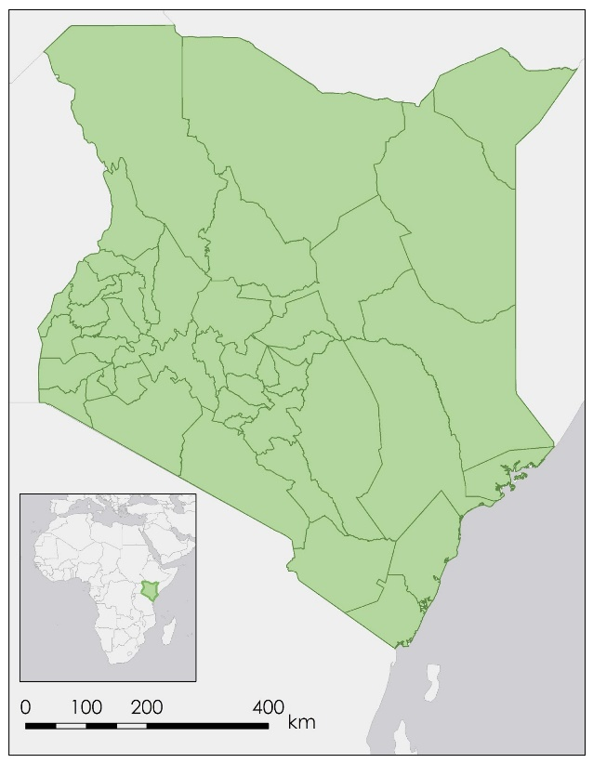

*Figure 1*. The study area comprises the 47 counties of Kenya.

According to the May 2019 National Drought Management Authority (NDMA) drought status update, ten counties were experiencing drought classified as Alarm, and eleven counties were close behind in the Alert classification (*Appendix B).* These classifications are calculated by evaluating several environmental and production indicators (*Tables C1 and C2)*. As drought continues and surface waters dry up, locals must navigate longer distances in order to access fresh water. Additionally, because surface water is the main irrigation source, agriculture begins to fail (Langat, Kumar, & Koech, 2018). All areas of the country experienced a decline in vegetative condition, with eight counties in significant vegetative deficit (National Drought Management Authority, 2019).

Drought management requires agencies to have accurate and timely data. Because field validation data can be difficult to obtain in this region, Earth observations present an opportunity to monitor large areas of land efficiently (Holzworth et al., 2015). The Regional Hydrologic Extremes Assessment System (RHEAS) is a software framework ideal for hydrologic modeling and data assimilation due to its easy implementation and customization. One study utilizing RHEAS examined maize yield in Kenya using the Decision Support System for Agrotechnology Transfer (DSSAT) model, which was populated by Moderate Resolution Imaging Spectroradiometer (MODIS), Climate Hazards Group InfraRed Precipitation with Station (CHIRPS), and National Center for Environmental Prediction (NCEP) sources on soil moisture, solar radiation, leaf area index, rainfall, and air temperature (Andreadis et al., 2017).

* 1. ***Project Partners & Objectives***

As part of its work managing drought impacts, NDMA publishes monthly Early Warning Bulletins that quantify and explain the current state of drought for each county in Kenya; these bulletins are primarily based on the MODIS Normalized Difference Vegetation Index (NDVI) 16-day product, limiting their efficacy. NDMA hopes to improve the bulletins with more complex and complete data beyond vegetation greenness but currently lacks the capacity to do so. Additionally, NDMA hopes to improve its ability to forecast drought in specific localities. The implementation of RHEAS for this end-user will markedly increase both the amount and range of data informing the conclusions and recommendations in the Early Warning Bulletins. This project built the capacity for the NDMA to present a more complete picture of current county-level drought in Kenya in order to more effectively distribute resources to mitigate impacts using NASA Earth observations.

The team collaborated with NASA SERVIR and the Regional Centre for Mapping of Resources for Development (RCMRD), the host organization for SERVIR’s Eastern-Southern Africa hub. The hub is focused on improving hydrologic estimation in the region, and much of its previous work has focused on flooding. The team used RCMRD’s knowledge of local hydrologic history to inform initial work with RHEAS. The Eastern-Southern Africa hub benefited from this collaboration as RHEAS will build local capacity to forecast drought, expanding the hub’s applied work on hydrologic issues beyond flooding. Additional end products developed during the second term of the project will also build RCMRD’s capacity to train local partners in the use of RHEAS.

Because semi-arid lands are primarily agro-pastoral, livelihoods are not wholly dependent on rainfall. NDMA’s only geospatial information currently used to analyze and categorize these areas are related to vegetation condition, necessitating additional indicators to inform classification of these areas. Therefore, the team generated and analyzed initial outputs of RHEAS, presented and discussed initial results to partners for input and adjustments to the model, and created an assimilation framework matching the outputs of these runs to partner needs. Specific and detailed records of this work will allow a second term to complete validation after handoff.

# 3. Methodology

***3.1 Data Acquisition***

In order to run RHEAS, the team installed VirtualBox, a software virtualization package, to work in a Linux environment on Windows computers. The team used the RHEAS ingest function to compile Earth observation-derived data on 1) precipitation, 2) soil moisture, 3) land surface temperature (LST), and 4) surface wetness from Soil Moisture Active Passive (SMAP) L-band Radiometer, Aqua MODIS, Terra MODIS, and Global Precipitation Measurement (GPM) Dual-frequency Precipitation Radar (DPR) (Table 1). The team also ingested ancillary precipitation and temperature data (Table 2) using both NCEP (Kalnay et al., 1996) and CHIRPS (Funk et al., 2015) sources. Lastly, the team acquired Vegetation Condition Index (VCI) data and the Early Warning Bulletin Drought Classifications from the NDMA (2019).  In order to ingest data into RHEAS, the team created configuration files defining temporal and geographic parameters and target variables. The team ran two VirtualBox images of RHEAS simultaneously, using complementary data sets and time periods. *Table 3* lists the ingested data and time periods for each of these images.

Table 1

*NASA satellite data sources ingested into RHEAS*

|  |  |  |  |  |
| --- | --- | --- | --- | --- |
| **Sensor and Platform** | **Date Range** | **Parameter** | **Temporal Resolution** | **Spatial Resolution** |
| GPM DPR | 2014-02-27 to 2019-05-01 | Precipitation | Daily | 5 km |
| SMAP L-band Radiometer | 2015-03-01 to 2019-05-01 | Soil Moisture | Daily | 36 km |
| Aqua MODIS | 2014-01-01 to 2019-05-01 | LST | Daily | 1000 m |
| Terra MODIS | 2014-01-01 to 2019-05-01 | LST | Daily | 1000 m |

Table 2

*Ancillary dataset sources ingested into RHEAS*

|  |  |  |  |  |
| --- | --- | --- | --- | --- |
| **Dataset** | **Date Range** | **Parameter** | **Temporal Resolution** | **Spatial Resolution** |
| CHIRPS | 2000-01-01 to 2019-06-23 | Precipitation | Daily | 5 km |
| NCEP | 2000-01-01 to 2019-06-23 | LST | Daily | 208 km |
| VCI (as calculated by NDMA) | 2014-01 to 2019-04 | Vegetation Condition | Monthly | County-level |

Table 3

*Data ingested for virtual box images of RHEAS*

|  |  |  |
| --- | --- | --- |
| **Data Ingested** | **Date Range for First Image** | **Date Range for Second Image** |
| CHIRPS | 2000-01-01 to 2019-06-23 | 2012-01-01 to 2019-06-23 |
| NCEP | 2000-01-01 to 2019-06-23 | 2012-01-01 to 2019-06-23 |
| GPM DPR | not ingested | 2014-02-27 to 2019-06-23 |
| SMAP | 2015-03-31 to 2019-06-23 | 2015-01-31 to 2019-06-23 |
| Leaf Area Index (LAI) | 2015-01-01 to 2019-06-23 | 2012-01-01 to 2019-06-23 |
| NDVI | 2014-01-01 to 2019-06-23 | 2012-01-01 to 2019-06-23 |

***3.2 Data Processing***

The team processed precipitation, soil moisture, land surface temperature, and surface wetness data using the Variable Infiltration Capacity (VIC) model within RHEAS (Andreadis et al., 2017). VIC is a large-scale hydrologic model that utilizes land surface models in conjunction with the meteorological drivers to produce outputs. Data were not pre-processed as RHEAS standardizes outputs at user-defined resolutions; this project generated outputs at a 25-kilometer resolution. RHEAS calculated drought indices based on the data ingested, including the Combined Drought Indicator (CDI), the Soil Moisture Deficit Index (SMDI), the Standardized Precipitation Index at 1-, 3-, 6-, and 12-month accumulation periods (SPI1, SPI3, SPI6, and SPI12, respectively) and the Standardized Runoff Index at 1-, 3-, 6-, and 12-month accumulation periods (SRI1, SRI3, SRI6, and SRI12, respectively).

RHEAS generates daily outputs based on the previous day values, and on initialization, RHEAS randomizes values since there are no previous-day calculated values. In order to account for these random values, the team had to train the model for a time period of two years to stabilize the data. The team also standardized the VCI data using Excel’s Standardize function (Equation 1) to allow a better comparison with the new drought index outputs.

$\text{Z}\text{= }\frac{\text{x}\text{- }\text{μ}}{\text{σ}}$ (1)

RHEAS populates outputs into a PostGIS database; the team used Python to extract raster images of each index and create time series graphs by county and index. The team performed this process from each VirtualBox image, creating time series derived from both CHIRPS and GPM DPR precipitation data in order to compare the efficacy of the two datasets.

***3.3 Data Analysis***

The team conducted a statistical and time series analysis on the output rasters from RHEAS, creating a time series for each drought index for all 47 counties in Kenya. The team created the time series by running a Python code in the VirtualBox image. To focus analysis, the team identified five case study counties based on the frequency of drought and geographic location (*Figure 2)*. Selected counties included two experiencing drought often (Wajir and Isiolo Counties), two rarely experiencing drought (Kwale and Narok counties), and one occasionally experiencing drought (Mandera county).

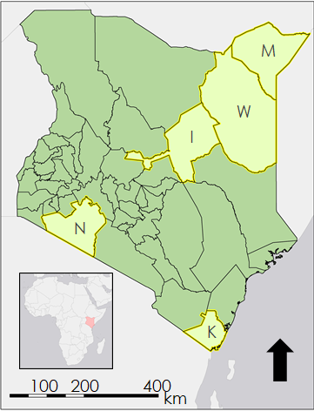

I = Isiolo

K = Kwale

M = Mandera

N = Narok

W = Wajir

*Figure 2*. Data analysis focused on five case study counties.

After creating a time series, the team used Pandas’ Dataframe.corr() function in Python to find Pearson Correlation values between the NDMA’s current VCI data and nine RHEAS-generated indices. CDI was excluded from this analysis because it is a categorical index. Lastly, the team conducted a first-order principal component analysis (PCA) of all ten drought indices by standardizing the data for each of the indices, creating a covariance matrix of all of the indices, and finding the eigenvectors for each index. These eigenvectors enumerated the variability contribution of each index to the data (Bayissa et al., 2019).

# 4. Results & Discussion

***4.1 Analysis of Results***

At the beginning of the project, the team hypothesized that CDI would be an effective all-purpose index for incorporation into the NDMA’s Early Warning Bulletins, as it accounts for vegetation stress, precipitation deficit, and soil moisture deficit. However, based on the raster images and time series data, CDI often returned values of 0 (indicating no drought) across the entire country of Kenya for both images of RHEAS, using both CHIRPS and GPM DPR precipitation data. Because many counties in Kenya are known to have experienced notable drought during the study period, such as Wajir and Isiolo Counties, these results were questionable. This suggests that the thresholds currently being used to delineate each drought category within CDI need adjustment in order for it to be a beneficial tool for NDMA.

SRI and SPI are highly correlated across each accumulation period (r = 1, r = 1, r = 1, r = 0.98) for the case study counties (*Figure 3)*; utilizing only one of these two indices would give nearly the same explanation. Based on the PCA, SPI1 (and therefore SRI1) tended to have the largest data variability among all of the indices, most likely because it has the shortest accumulation period (Table 4). Having a one-month accumulation period means that individual rain or drought events have more influence on SPI1 than on longer accumulation periods of this same index (or of SRI), giving a complete illustration of precipitation conditions over the preceding month. SPI1 also had a low negative correlation with VCI. When compared within the time series, dry and wet periods in VCI lagged behind those of SPI1. This suggests that SPI1 might be effective in a short-term drought forecasting system.

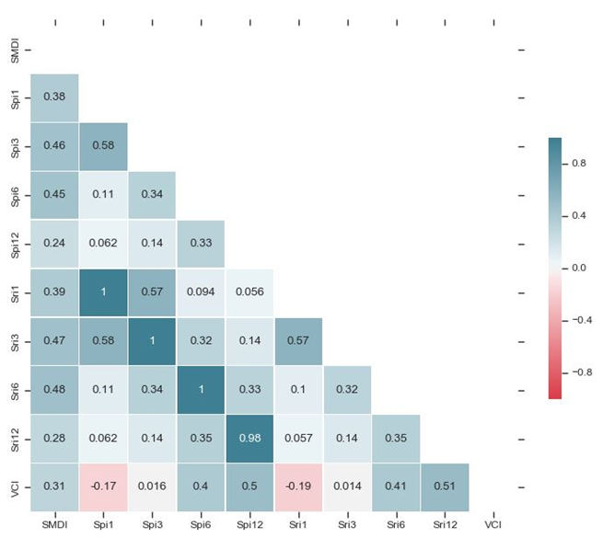

*Figure 3*. This heatmap displays the correlation of the nine RHEAS-generated continuous indices against each other and NDMA’s VCI data for Isiolo County.

Table 4

*Principal Component Analysis Eigenvectors for Isiolo County*

|  |  |  |  |  |  |  |
| --- | --- | --- | --- | --- | --- | --- |
| **CDI** | **SMDI** | **SPI1** | **SPI3** | **SPI6** | **SPI12** | **VCI** |
| 0.0598589 | 0.0024235 | 0.5495342 | 0.3717959 | 0.0028610 | 0.0000849 | 0.0134412 |

Behind SPI1, SPI3 tended to have the second most variability within its data. Since SPI3 takes the second fewest amount of days into account when calculating values, it is second-most influenced by individual rain or drought events. SPI3 has the potential for examining a particular growing season distinct from annual trends in drought.

Similarly, SRI6 could be used to examine growing seasons, depending on which crop the end user is interested. In contrast with SPI1 and SPI3, SPI6 and SPI12 generally had the least variability within their data relative to all of the indices (Table 4). Additionally, SPI12 had the highest correlation with VCI at 0.51 (*Figure 3*). Trends for the four SPI indices closely resemble the patterns of SRI1, 3, 6, and 12.

In comparison to SPI and SRI, SMDI gave a broader picture of soil moisture conditions in the region. While SPI and SRI can illustrate how much precipitation and runoff are occurring, SMDI can give a specific measure of how much of that precipitation is actually staying within the soil. SMDI was most closely correlated to SRI3 and SRI6, having r values of 0.48 and 0.47 respectively (*Figure 3*). The PCA revealed that SMDI accounts for very little of the variation in the data (Table 4). This may be in part due to RHEAS only calculating SMDI for the root zone of the soil, based on a comparison to an average across all recorded climatic history, making values less variable. In order to provide a more accurate picture of soil moisture, historic seasonal or monthly averages should be used for comparison.

*Figures 4 through 6* illustrate index variation over time for Isiolo County (see *Appendix E* for time series of other case study counties). VCI, the measure currently used by NDMA, takes longer to respond to seasonal drought indicators like precipitation in the time series compared to the other indices. VCI measures vegetation condition while the other indices (with the exception of CDI) only take precipitation or soil moisture into account; vegetation is slower to respond to both wet and dry conditions. This means that VCI is a reliable and important indicator in arid areas, but in semi-arid and wetter areas understanding of hydrological changes would provide additional context for drought classification.

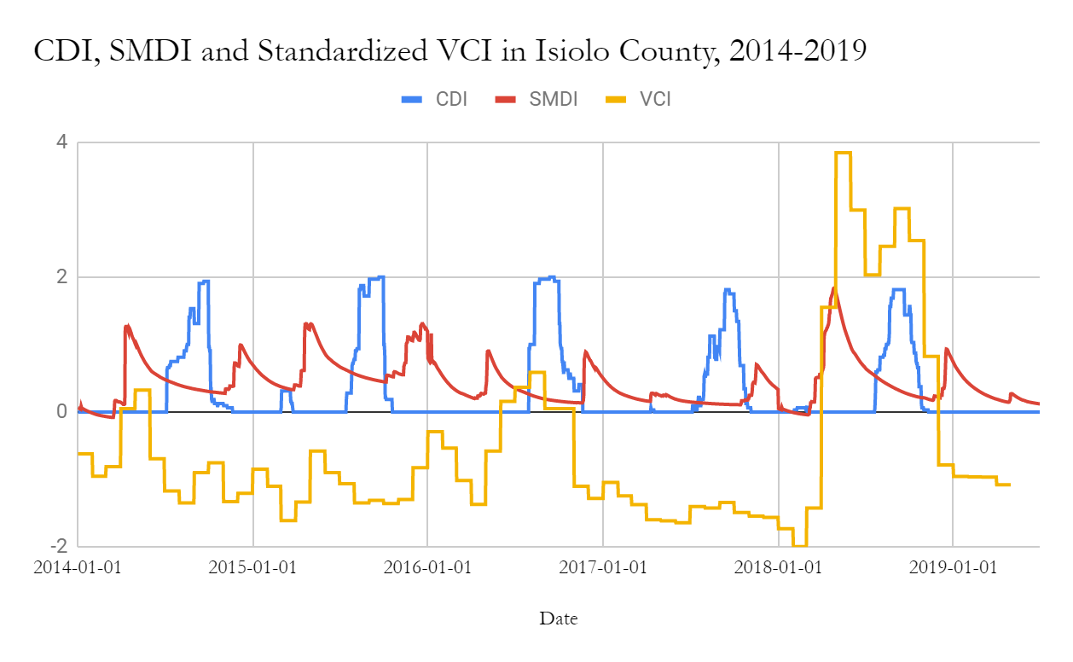

*Figure 4*. Time series graph for CDI, SMDI, and standardized VCI for Isiolo County from 2014 to 2019.

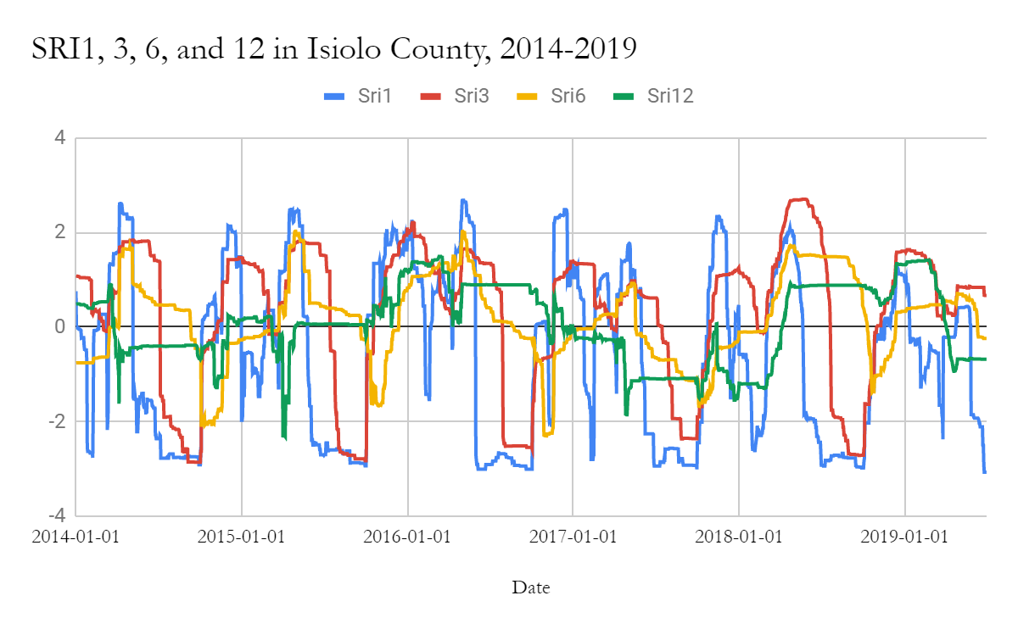

*Figure 5*. Time series graph for SRI at 1, 3, 6, and 12-month accumulation periods for Isiolo County from 2014 to 2019.

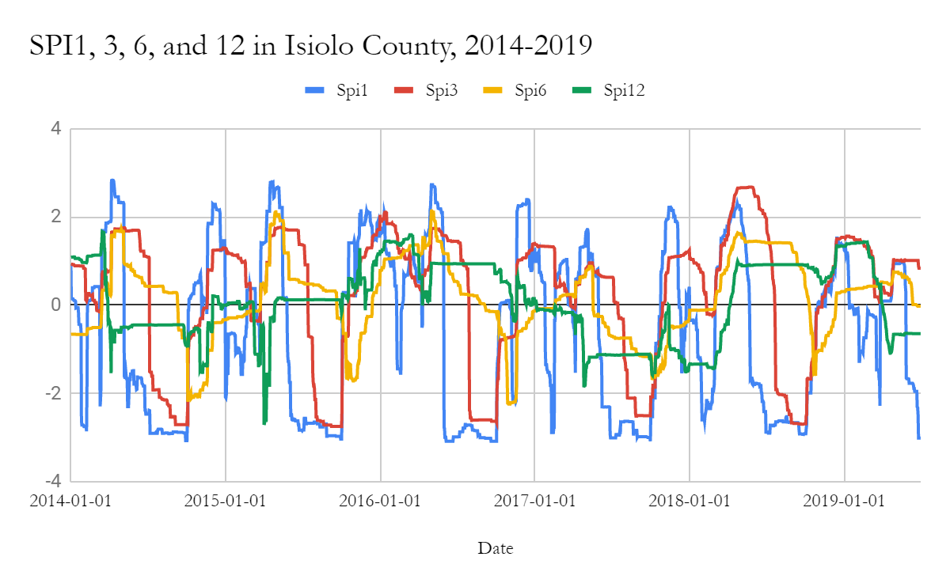

*Figure 6*. This is a time series graph for SRI at 1, 3, 6, and 12 month accumulation periods for Isiolo County from 2014 to 2019.

Unlike the other RHEAS-generated indices, CDI takes a combination of vegetation stress, precipitation, and soil moisture into account, but still appeared to perform ahead of VCI across semi-arid regions. This suggests that any of the RHEAS-generated indices would be a useful complement to VCI, especially in drought forecasting since vegetation condition responds to precipitation and soil moisture deficits. The two images of the model using precipitation data from CHIRPS and GPM delivered results that were highly correlated across all indices (*Appendix D*).

A limitation the team encountered was the inability to run the assimilation function of the RHEAS model. Assimilation serves as a fact check for the model, allowing for the merging of model predictions and ground observations by statistically taking into account the errors in both (Andreadis et al., 2017). This function could not be executed due to errors in the code and computational limits of the VirtualBox package. Therefore, the model does not account for uncertainty. In addition, the VCI data obtained from NDMA were monthly, limiting comparison with the daily outputs from RHEAS.

***4.2 Future Work***

The next steps for this project will begin with validating the model outputs, utilizing the nowcast function within RHEAS. The outcomes of this validation process will then inform forecasting. Forecasting will be explicitly run using the RHEAS forecasting function. The outputs created from the forecasting function will be potentially beneficial in predicting drought. Additionally, since this project ran the RHEAS model at a 25-kilometer resolution, future work should run the model at the finer spatial resolution of 5 kilometers to understand drought on a more localized level. The information derived from this project will be used to make adjustments to the model in order to run at 5-km resolution. Another goal for future work is the successful implementation of the assimilation function in RHEAS. This function uses soil moisture observations from either SMAP or Soil Moisture Ocean Salinity (SMOS) on a weekly level to gauge how effectively the model is performing in comparison to observed data. Use of this function could help validate results and calculate the error within RHEAS. Another avenue for future research could focus on specific crops which are widely grown within the area for local consumption, quantifying how crop success has changed over the study period and how the model predicts it will change in the future, executed by using the DSSAT model in place of the VIC model within RHEAS.

# 5. Conclusions

The goal of this research was to analyze 10 drought indices that may be useful for NDMA to implement in conjunction with VCI to inform their monthly Early Warning bulletins. Because VCI did not pick up seasonal drought triggers as quickly in the time series, SPI1 or SRI1 would have potential use value in an early-warning drought forecasting system when combined with VCI, allowing NDMA to consider both hydrological and vegetation health in their evaluations of drought. However, because CDI often showed that most of the country of Kenya was experiencing no drought, the thresholds that determine each drought category of CDI must be altered in order to have a more accurate view of drought in Kenya.

SMDI presents a broad look at soil moisture conditions in the region but has limited explanatory power given the limitations of how it is calculated in RHEAS. In addition, since SPI and SRI are nearly perfectly correlated, using only one of these indices is sufficient. As both SPI1 and SRI1 account for a relatively short period of time, they are more reflective of individual rain events and therefore give a better picture of surface-level soil moisture conditions, while SPI12 and SRI12 reveal longer-term drought trends and are more reflective of Kenya’s water table health. SPI3, SRI3, SPI6, and SRI6 each have potential use as tools in looking at past or future growing season trends since they fall in between the short- and long-term conditions. Moving forward, using diverse and accurate data to inform decision making in Kenya will help stakeholders to allocate resources to localities most in need of support during drought events.

# 6. Acknowledgments

The team is appreciative of the support and guidance provided by the following individuals:

* Science Advisors: Dr. Jeffrey Luvall and Dr. Robert Griffin
* NASA SERVIR Collaborators: Dr. Lee Ellenburg, Emily Adams, Dr. Vikalp Mishra, Sara Miller, and Helen Baldwin
* RCMRD Collaborator: Lilian Ndungu
* NDMA End User: Nelson Mutanda
* DEVELOP Center Lead: Madison Murphy
* The University of Alabama in Huntsville Mentor: Maggi Klug

Any opinions, findings, and conclusions or recommendations expressed in this material are those of the author(s) and do not necessarily reflect the views of the National Aeronautics and Space Administration.

This material is based upon work supported by NASA through contract NNL16AA05C.

# 

# 7. Glossary

**ASAL** – Arid and Semi-Arid Lands - Areas receiving less than 25 cm (arid) or between 25 and 50 cm (semi-arid) of rainfall annually

**CDI** – Combined Drought Indicator - A categorical drought index that takes precipitation, soil moisture, and vegetation stress into account

**CHIRPS** – Climate Hazards Group InfraRed Precipitation with Station data - Incorporates 0.05° satellite resolution with in-situ data to create rainfall time series

**DPR** – Dual-frequency Precipitation Radar - A spaceborne radar, providing three-dimensional maps of storm structure across its swath including the intensity of rainfall and snowfall at the surface

**DSSAT** – Decision Support System for Agrotechnology Transfer - Large-scale semi-distributed model that simulates growth, development, and yield of a crop under different management practices and soil properties

**Earth observations** – Satellites and sensors that collect information about the Earth’s physical, chemical, and biological systems over space and time

**GPM** –Global Precipitation Measurement -NASA-JAXA joint-operated imaging platform measuring Earth’s precipitation every 2 to 3 hours

**JAXA** –Japanese Aerospace Exploration Agency - An agency that develops and utilizes aerospace in Japan

**L-Band Radiometer** – A component of SMAP that measures naturally occurring radio frequency energy given off by the Earth’s surface, the L-band produces very high soil moisture accuracy by measuring the difference between wet and dry soils

**LST** – Land Surface Temperature

**MODIS** – MODerate resolution Imaging Spectroradiometer -NASA imaging sensor gathering 36 spectral bands of entire Earth every 1 to 2 days

**NCEP** –National Center for Environmental Prediction - Provides climatic, hydrologic, meteorological, space weather, and oceanographic information

**NDMA** –National Drought Management Authority (Kenya) - an agency of the Kenyan government mandated to ensure that drought does not end in an emergency

**NDVI** – Normalized Difference Vegetation Index -An index of land cover measuring vegetation greenness

**PCA** –Principal Component Analysis - A statistical tool used to emphasize variation and patterns in a dataset

**RCMRD** –Regional Centre for Mapping of Resources for Development - Organization established under the United Nations Economic Commission for Africa (UNECA) and the African Union (AU) to strengthen capacity for sustainable development in the Member States

**RHEAS –** Regional Hydrologic Extremes Assessment System - A software framework for hydrologic modeling and data assimilation

**SERVIR** – A joint venture between NASA and US Agency for International Development (USAID) that provides geospatial information and science applications to improve decision-making

**SMAP** – Soil Moisture Active Passive -NASA platform providing measurements of land surface soil moisture

**SMDI** – Soil Moisture Deficit Indicator - A continuous drought index that evaluates soil moisture

**SMOS** –Soil Moisture Ocean Salinity - European Space Agency mission dedicated to making global observations of soil moisture over land and salinity over oceans

**SPI** – Standardized Precipitation Index - A continuous drought index that evaluates precipitation

**SRI** – Standardized Runoff Index - A continuous drought index that evaluates surface water runoff

**VCI** – Vegetation Condition Index - Index comparing current NDVI to the range of values observed in the same period in previous years

# VIC – Variable Infiltration Capacity - Large-scale semi-distributed model that simulates hydrology in land surface processes

# 8. References

Andreadis, K. M., Das, N., Stampoulis, D., Ines, A., Fisher, J. B., Granger, S., … Behrangi, A. (2017). The Regional Hydrologic Extremes Assessment System: A software framework for hydrologic modeling and data assimilation. *PLoS ONE*, *12*(5), e0176506. https://doi.org/10.1371/journal.pone.0176506

Bayissa, Y. A. , Tadesse, T., Svoboda, M., Wardlow, B., Poulsen, C., Swigart, J. & Jan Van Andel, S. (2019). Developing a satellite-based combined drought indicator to monitor agricultural drought: A case study for Ethiopia. *GIScience & Remote Sensing*, *56*(5), 718-748. https://doi.org/10.1080/15481603.2018.1552508

Central Intelligence Agency. (2019). Africa:: Kenya. In *The world factbook 2016-17*. Washington, DC: Central Intelligence Agency. Retrieved on June 27, 2019, from https://www.cia.gov/library/publications/the-world-factbook/geos/ke.html

Famine Early Warning Systems Network. (August 2019). 3.1 million expected to face crisis (IPC Phase 3) or worse outcomes by October*. Kenya Food Security Outlook Update*. Retrieved on July 23, 2019, from http://fews.net/east-africa/kenya

Funk, C., Peterson, P., Landsfeld, M., Pedreros, D., Verdin, J., Shukla, S., … Michaelsen, J. (2015). The climate hazards infrared precipitation with stations—a new environmental record for monitoring extremes. *Scientific Data*, *2*(150066). https://doi.org/10.1038/sdata.2015.66

Holzworth, D. P., Snow, V., Janssen, S., Athanasiadis, I. N., Donatelli, M., Hoogenboom, G., ... & Thorburn, P. (2015). Agricultural production systems modelling and software: Current status and future prospects. *Environmental Modelling & Software*, *72*, 276-286. <https://doi.org/10.1016/j.envsoft.2014.12.013>

Kalnay, E., Kanamitsu, M., Kistler, R., Collins, W., Deaven, D., Gandin, L., … Joseph, D. (1996). The NCEP/NCAR 40-year reanalysis project. *Bulletin of the American Meteorological Society*, *77*(3), 437-472. https://doi.org/10.1175/1520-0477(1996)077<0437:TNYRP>2.0.CO;2

Kenya Food Security Steering Group. (2017). *The 2017 long rains season assessment report*. Rome, Italy: World Food Programme. Retrieved from https://reliefweb.int/sites/reliefweb.int/files/resources/2017%20LRA%20National%20Report.pdf

Langat, P. K., Kumar, L., & Koech, R. (2018). Understanding water and land use within Tana and Athi River Basins in Kenya: Opportunities for improvement. *Sustainable Water Resources Management*, *5*(3), 977-987. https://doi.org/10.1007/s40899-018-0274-0

Myneni, R., Knyazikhin, Y., Park, T. (2015). MCD15A3H MODIS/Terra+Aqua Leaf Area Index/FPAR 4-day L4 Global 500m SIN Grid V006 [Data file]. NASA EOSDIS Land Processes DAAC. https://doi.org/10.5067/MODIS/MCD15A3H.006

National Drought Management Authority. (2019). *National Drought Early Warning Bulletin*. Nairobi, Kenya. Retrieved from <https://reliefweb.int/sites/reliefweb.int/files/resources/National%20drought%20status%20EWS%20bulletin%20for%20May%202019.docx.pdf>

Ochieng, J., Kirimi, L., & Mathenge, M. (2016). Effects of climate variability and change on agricultural production: The case of small scale farmers in Kenya. *NJAS-Wageningen Journal of Life Sciences*, *77*, 71-78. https://doi.org/10.1016/j.njas.2016.03.005

ONeill, P.E., Chan, S., Njoku, E.G., Jackson, T., & Bindlish, R. (2019). SMAP L2 Radiometer Half-Orbit 36 km EASE-Grid Soil Moisture, Version 6 [Data file]. NASA National Snow and Ice Data Center DAAC. https://doi.org/10.5067/R50VUC07OM4W

Opiyo, F., Wasonga, O., Nyangito, M., Schilling, J., & Munang, R. (2015). Drought adaptation and coping strategies among the Turkana pastoralists of northern Kenya. *International Journal of Disaster Risk Science*, *6*(3), 295-309. https://doi.org/10.1007/s13753-015-0063-4

Precipitation Processing System. (2016). GPM merged radiometer global .1 x .1 degree half-hourly precipitation retrieval [Data file]. NASA Precipitation Processing System. https://doi.org/10.5067/GPM/IMERG/3B-HH/04

Uhe, P., Philip, S., Kew, S., Shah, K., Kimutai, J., Mwangi, E., … Otto, F. (2018). Attributing drivers of the 2016 Kenyan drought. *International Journal of Climatology*, *38*(S1), e554-e568. https://doi.org/10.1002/joc.5389

USGS Earth Resources Observation and Science (EROS) Center. (2019). Climate Hazards Group InfraRed Precipitation with Station data (CHIRPS) [Data file]*.* Climate Hazards Center at the University of California, Santa Barbara. http://doi.org/10.15780/G2RP4Q

Vrieling, A., Meroni, M., Mude, A. G., Chantarat, S., Ummenhofer, C. C., & de Bie, K. (2016). Early assessment of seasonal forage availability for mitigating the impact of drought on East African pastoralists. *Remote Sensing of Environment*, *174*, 44-55. https://doi.org/10.1016/j.rse.2015.12.003

# 9. Appendices

**Appendix A. FEWS NET Food Security Classification Categories**

|  |  |
| --- | --- |
| **Classification** | **Defining Features** |
| Minimal | Households are able to meet essential food and non-food needs without engaging in atypical and unsustainable strategies to access food and income. |
| Stressed | Households have minimally adequate food consumption but are unable to afford some essential non-food expenditures without engaging in stress-coping strategies. |
| Crisis | Households either:  - Have food consumption gaps that are reflected by high or above-usual acute malnutrition;  OR  - Are marginally able to meet minimum food needs but only by depleting essential livelihood assets or through crisis-coping strategies |
| Emergency | Households either:  - Have large food consumption gaps which are reflected in very high acute malnutrition and excess mortality;  OR  - Are able to mitigate large food consumption gaps but only by employing emergency livelihood strategies and asset liquidation. |
| Famine | Households have an extreme lack of food and/or other basic needs even after full employment of coping strategies. Starvation, death, destitution, and extremely critical acute malnutrition levels are evident. (For Famine Classification, area needs to have extreme critical levels of acute malnutrition and mortality.) |

**Appendix B. NDMA county-level drought classified for April 2019 (National Drought Management Authority, 2019)**

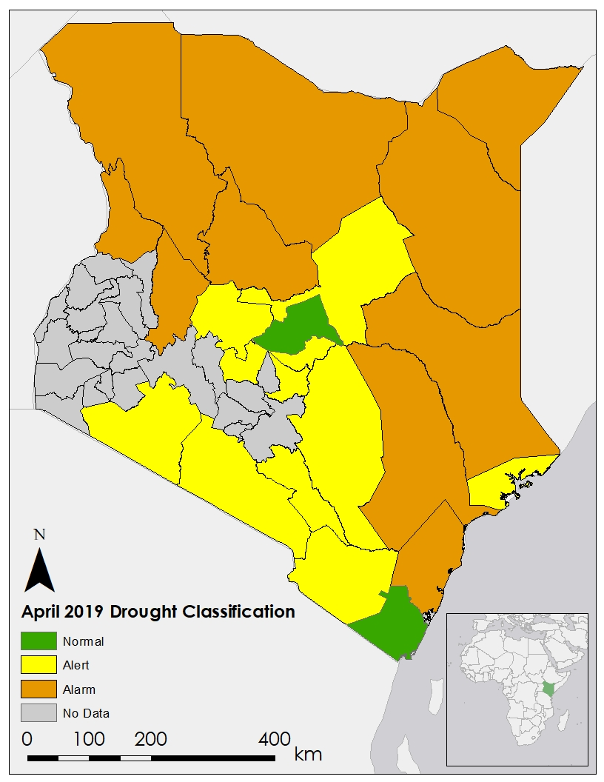

**Appendix C. Drought Classification Categories and Indicators**

Table C1

*NDMA drought level classifications*

|  |  |
| --- | --- |
| **Classification** | **Defining Features** |
| Normal | Environmental indicators show no unusual fluctuations |
| Alert | Environmental indicators fluctuate outside expected seasonal ranges |
| Alarm | Environmental and production indicators fluctuate outside seasonal ranges |
| Emergency | All indicators are outside normal ranges |
| Recovery | Environmental indicators return to seasonal norms |

Table C2

*NDMA drought indicators*

|  |  |
| --- | --- |
| **Indicator** | **Conditions** |
| Rainfall | Dry conditions and high temperatures have led to a shortage in both water and pasture; the shortage of pasture has led to negative impacts on the livestock body condition and triggered earlier than normal migration of livestock |
| Vegetation condition | Fast deterioration of vegetation greenness has led to moderate and severe vegetation deficit categories |
| Livestock production | Overall, the current body condition of most livestock is below normal compared to similar periods during a normal year; in some areas, there are signs of conditions worsening; there is also a concern of milk shortage from water scarcity and inadequate forage |
| Crop production | The projected short rainfall season will have negative impacts on agricultural activities |
| Access to water | Increased average distances to water for both households and livestock |
| Terms of trade | A worsening trend in terms of trade largely due to a decrease in the goat prices as a result of a downward swing in the body condition and a general increase in maize prices |
| Health and nutrition | Regular monitoring of sampled children below 5 years showed that the malnutrition status of children have worsened most likely due to unavailability of milk as well as inadequate dietary intake |

**Appendix D. Correlations between Indices Using CHIRPS and GPM Precipitation Data**

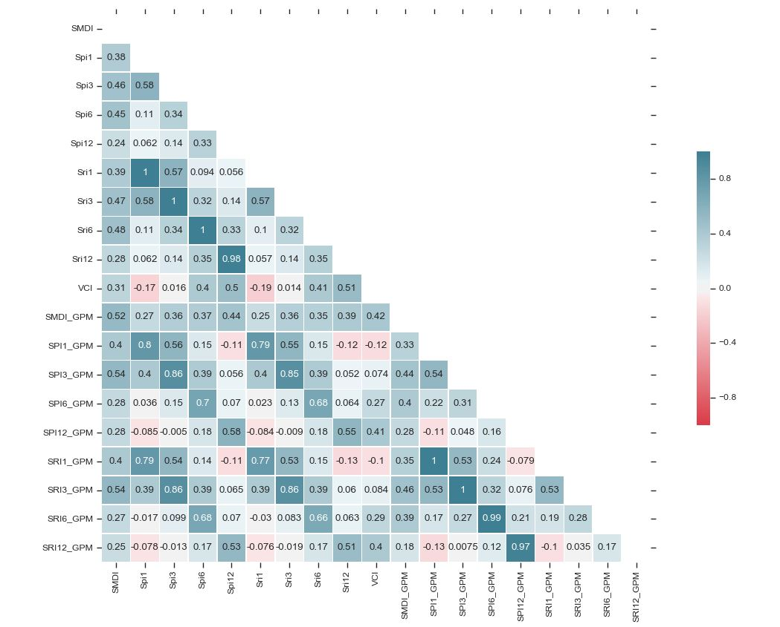

**Appendix E. Result Figures for Other Case Study Counties**

(a)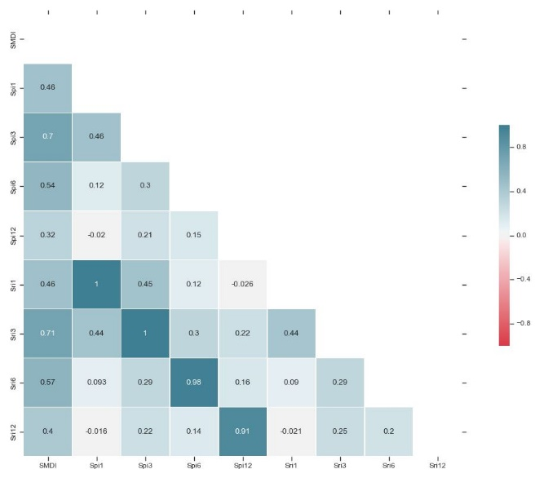(b)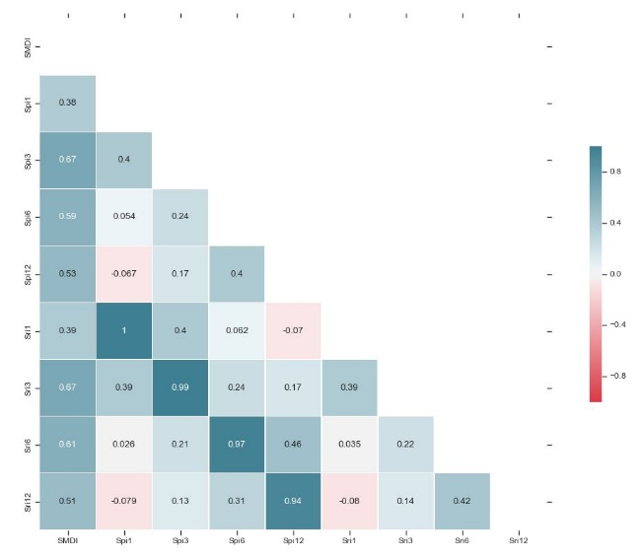

(c)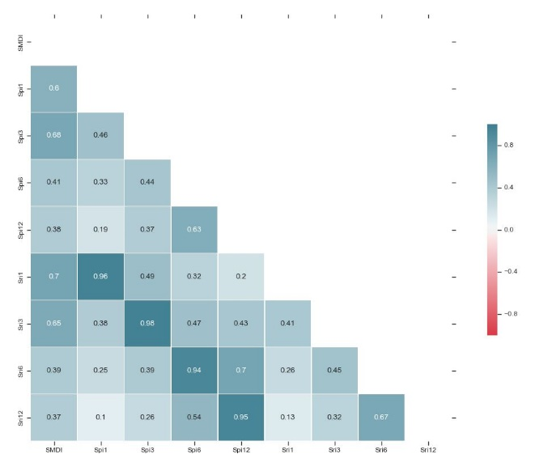 (d)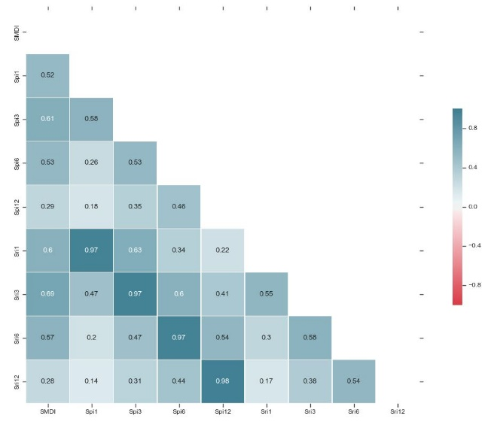

*Figure E1.*  These heatmaps display the correlation of the nine RHEAS-generated continuous indices against each other and NDMA’s VCI data for Wajir County (a), Mandera County (b), Kwale County (c), and Narok County (d).

Table E1.

*Principal Component Analysis Eigenvectors for Remaining Case Study Counties*

|  |  |  |  |  |  |  |  |
| --- | --- | --- | --- | --- | --- | --- | --- |
| **County** | **CDI** | **SMDI** | **SPI1** | **SPI3** | **SPI6** | **SPI12** | **VCI** |
| Wajir | 0.039364 | 0.01291 | 0.6686 | 0.26229 | 0.000307 | 0.002709 | 0.0137975 |
| Mandera | 0.03349 | 0.00949688 | 0.748354 | 0.2006 | 0.00024676 | 0.00739273 | 0.00038999 |
| Kwale | 0.05173469 | 0.09815265 | 0.3703228 | 0.46277296 | 0.00108304 | 0.00120394 | 0.01472985 |
| Narok | 0.04776 | 0.0345 | 0.20426991 | 0.47253491 | 0.18476362 | 0.03150162 | 0.0246399 |

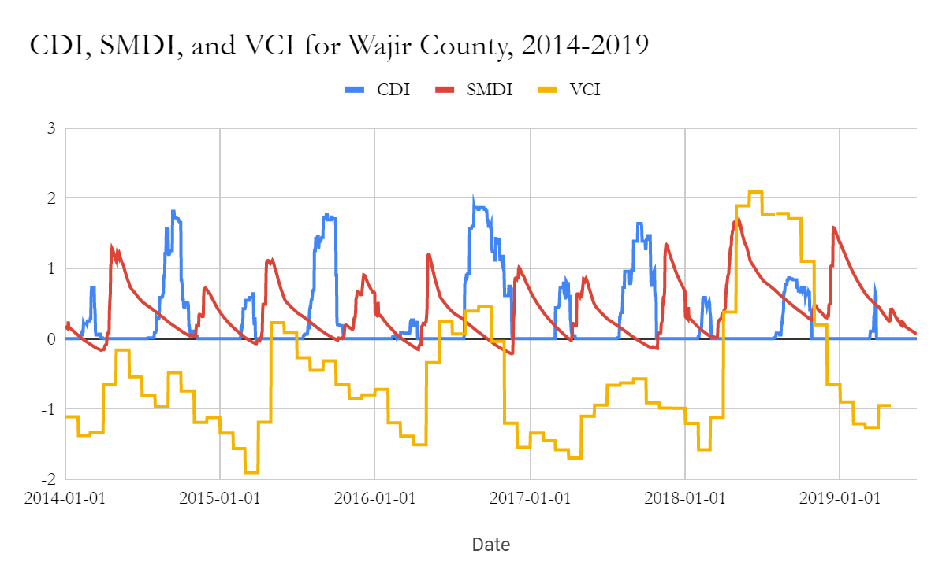

*Figure E2*. Time series graph for CDI, SMDI, and standardized VCI for Wajir County from 2014 to 2019.

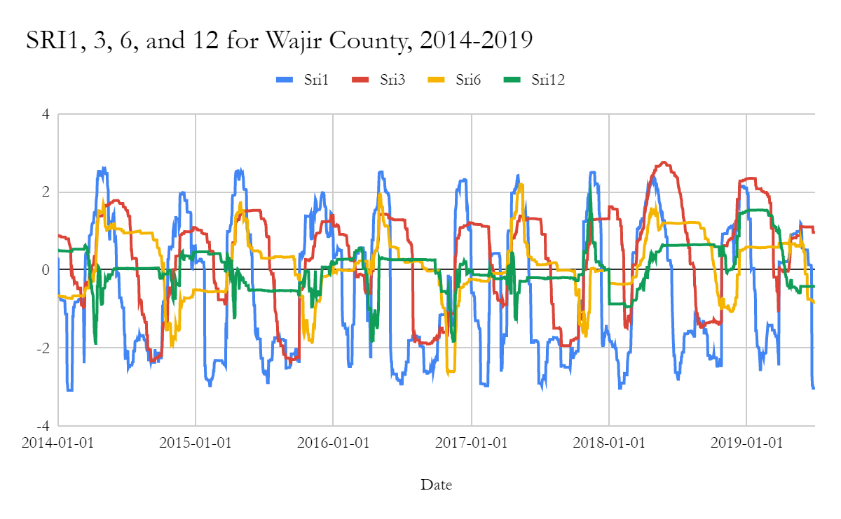

*Figure E3*. Time series graph for SRI at 1, 3, 6, and 12 month accumulation periods for Wajir County from 2014 to 2019.

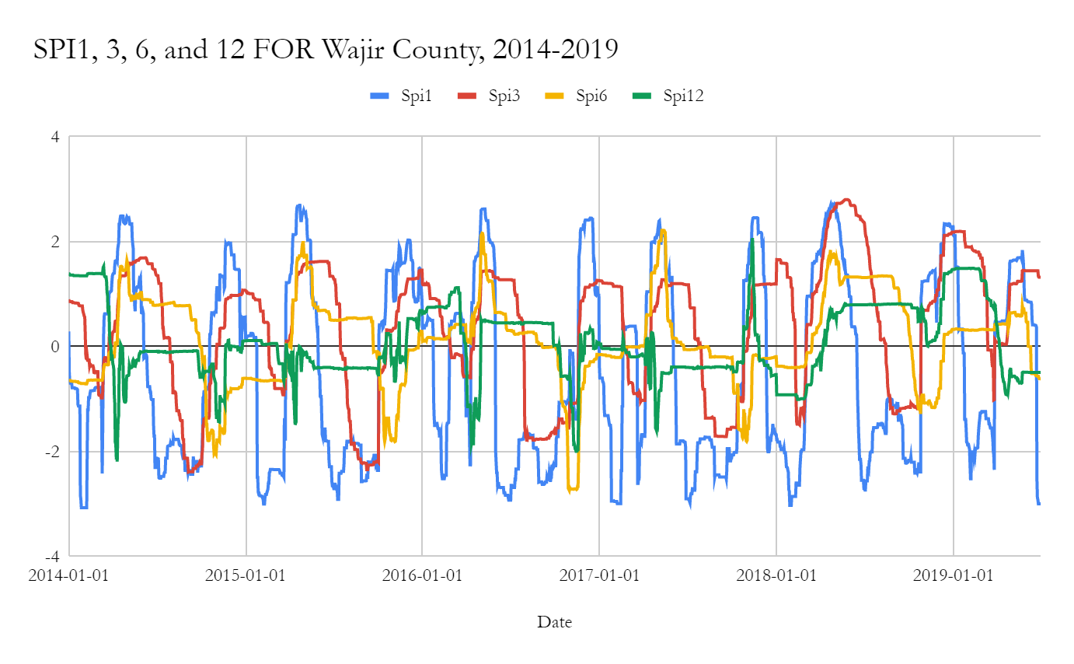

*Figure E4*. Time series graph for SPI at 1, 3, 6, and 12 month accumulation periods for Wajir County from 2014 to 2019.

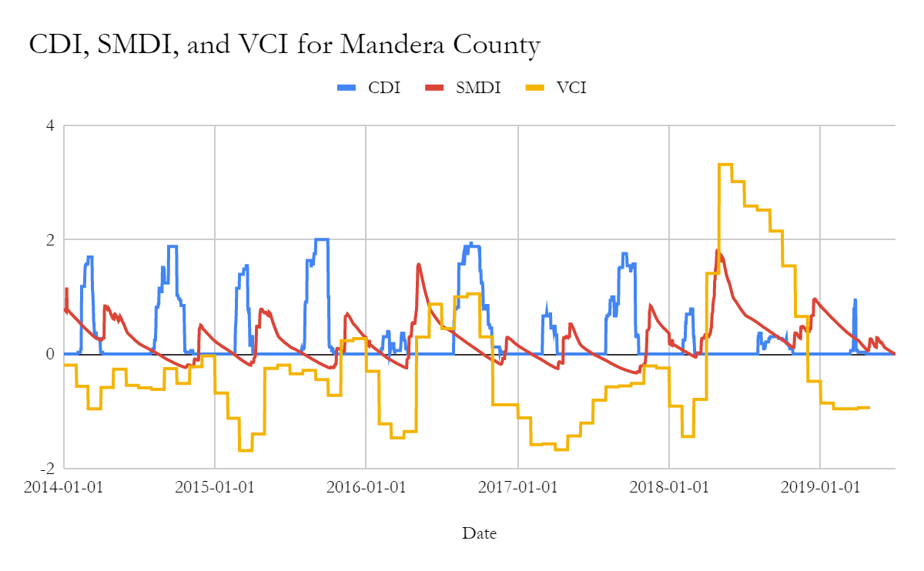

*Figure E5*. Time series graph for CDI, SMDI, and standardized VCI for Mandera County from 2014 to 2019.

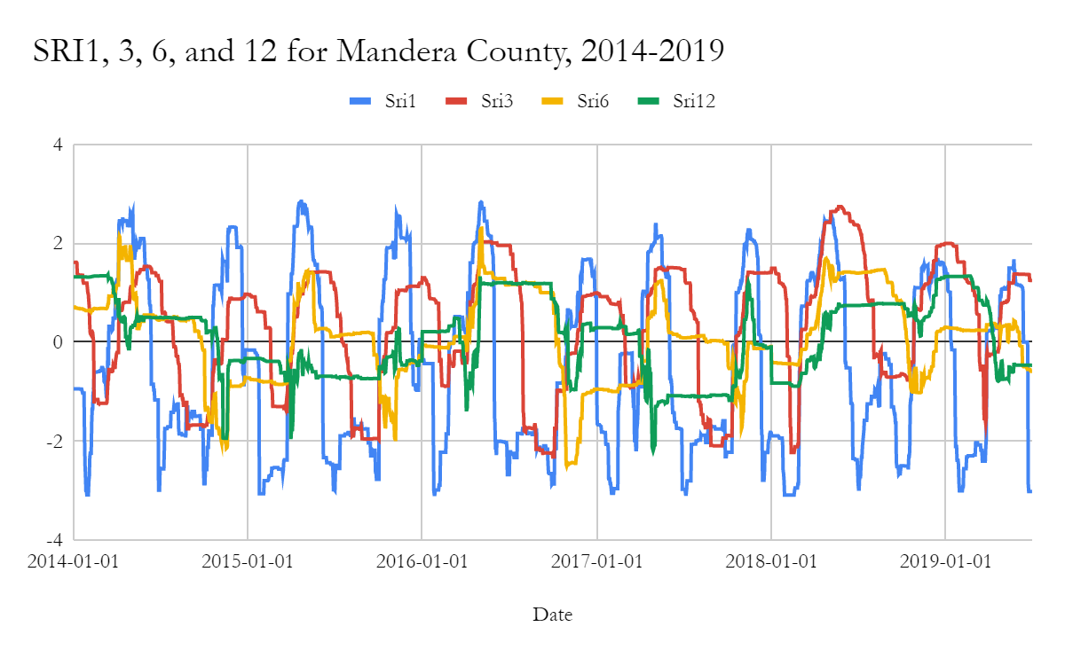

*Figure E6*. Time series graph for SRI at 1, 3, 6, and 12 month accumulation periods for Mandera County from 2014 to 2019.

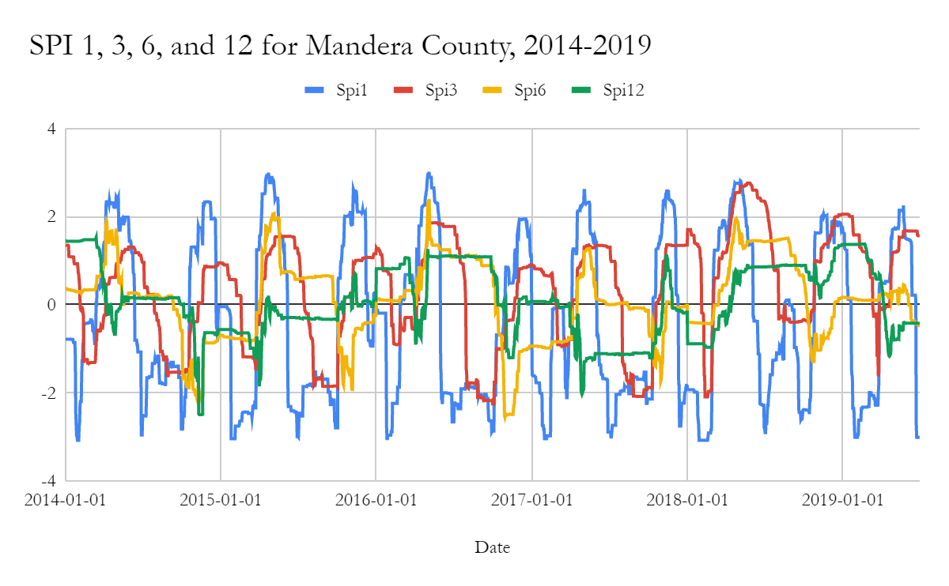

*Figure E7*. Time series graph for SPI at 1, 3, 6, and 12 month accumulation periods for Mandera County from 2014 to 2019.

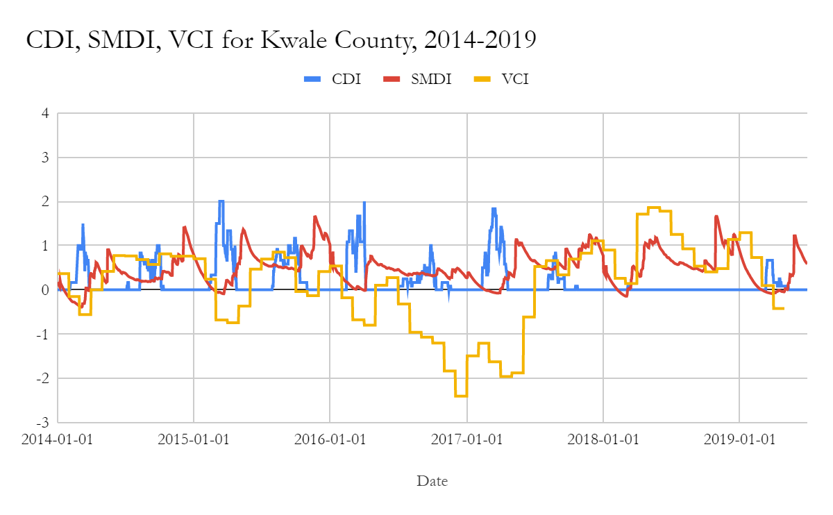

*Figure E8*. Time series graph for CDI, SMDI, and standardized VCI for Kwale County from 2014 to 2019.

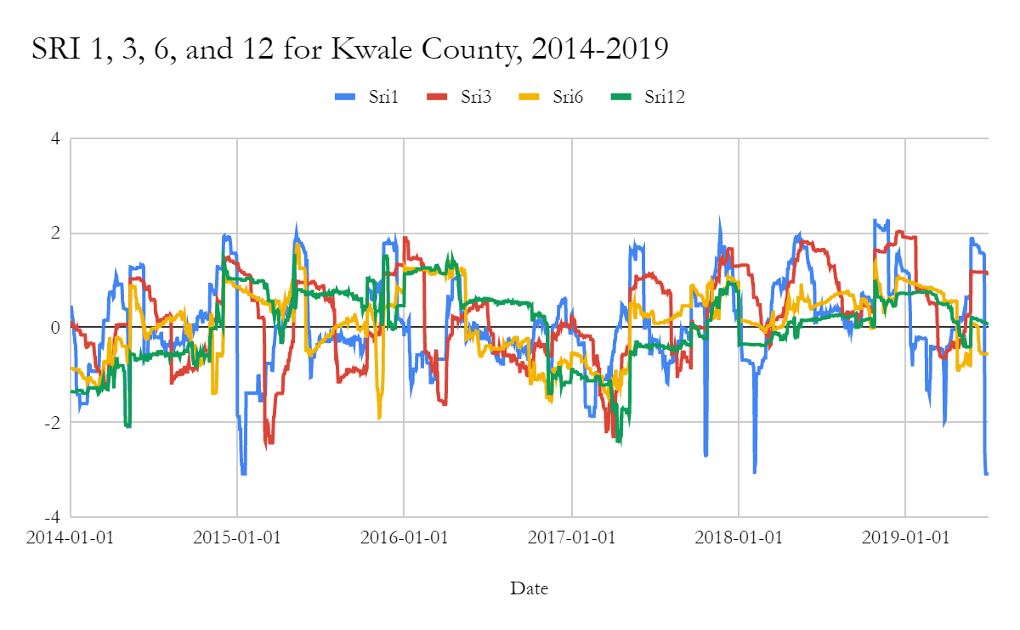

*Figure E9*. Time series graph for SRI at 1, 3, 6, and 12 month accumulation periods for Kwale County from 2014 to 2019.

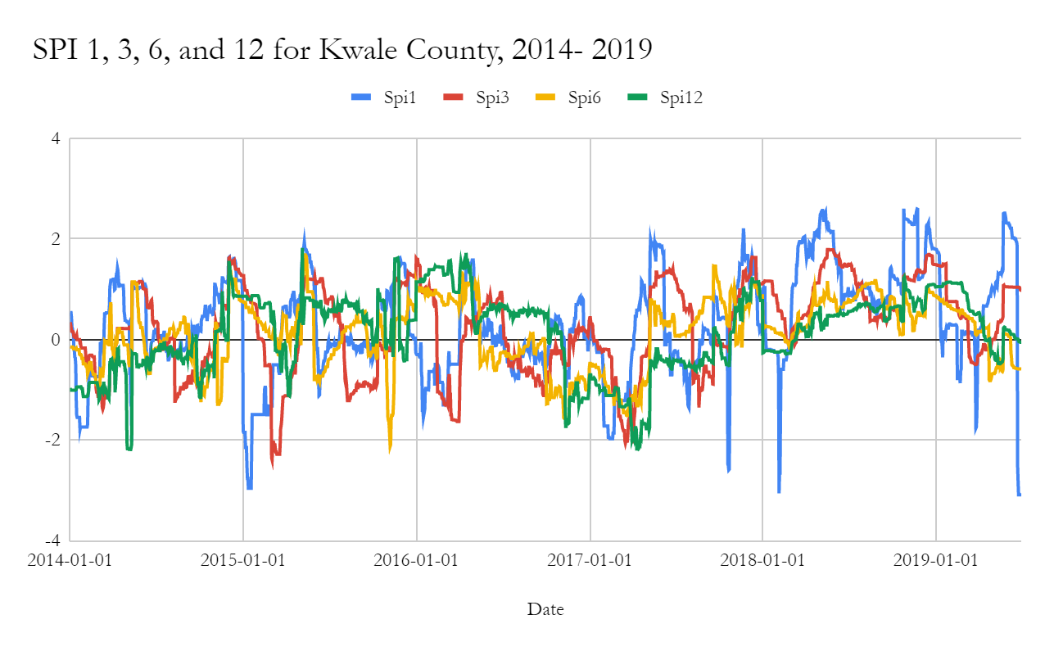

*Figure E10*. Time series graph for SPI at 1, 3, 6, and 12 month accumulation periods for Kwale County from 2014 to 2019.

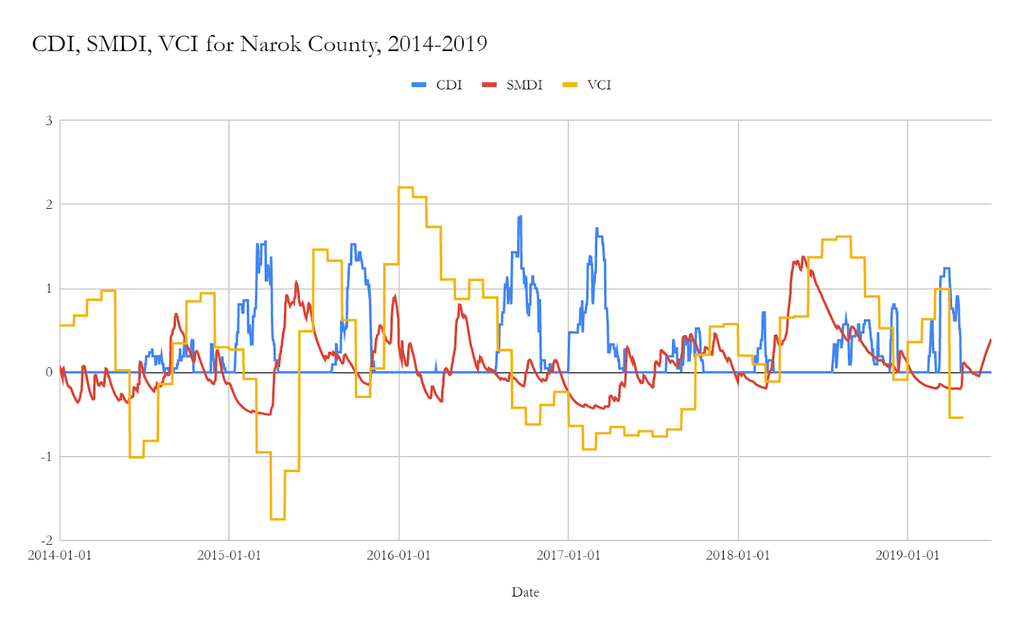

*Figure E11*. Time series graph for CDI, SMDI, and standardized VCI for Narok County from 2014 to 2019.

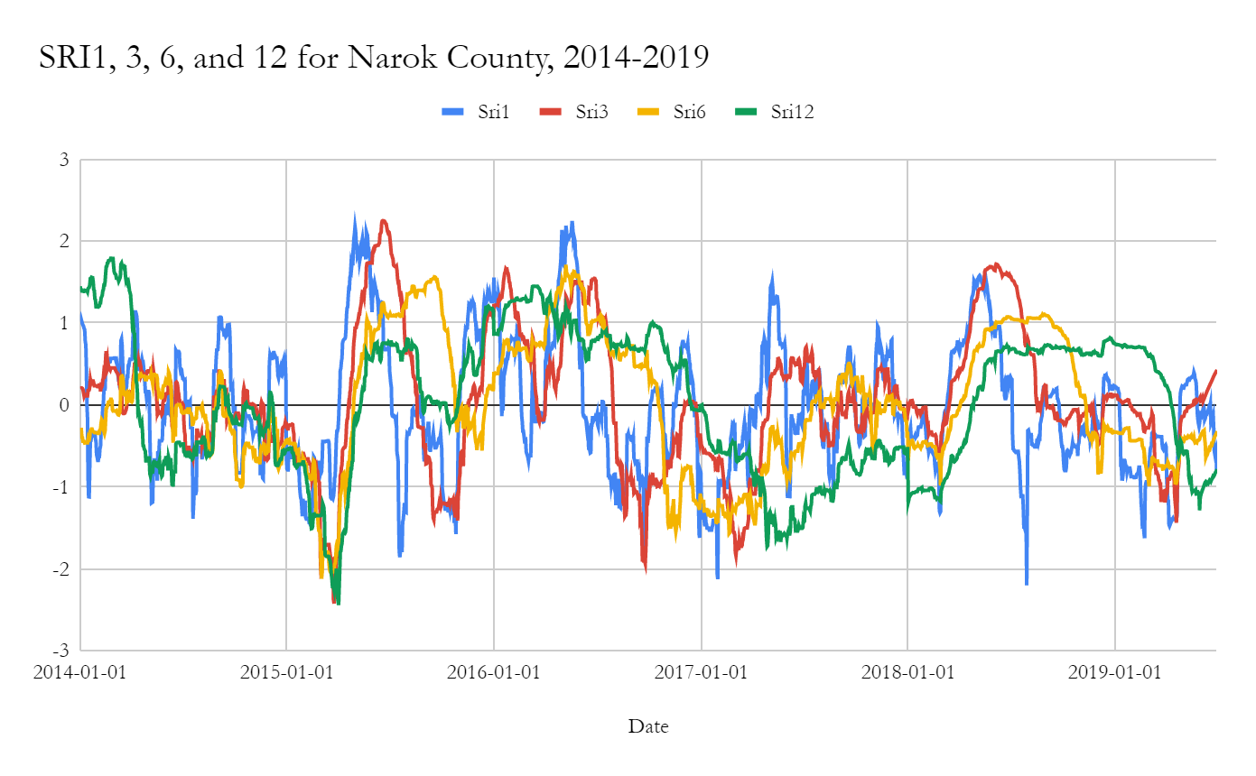

*Figure E12*. Time series graph for SRI at 1, 3, 6, and 12 month accumulation periods for Narok County from 2014 to 2019.

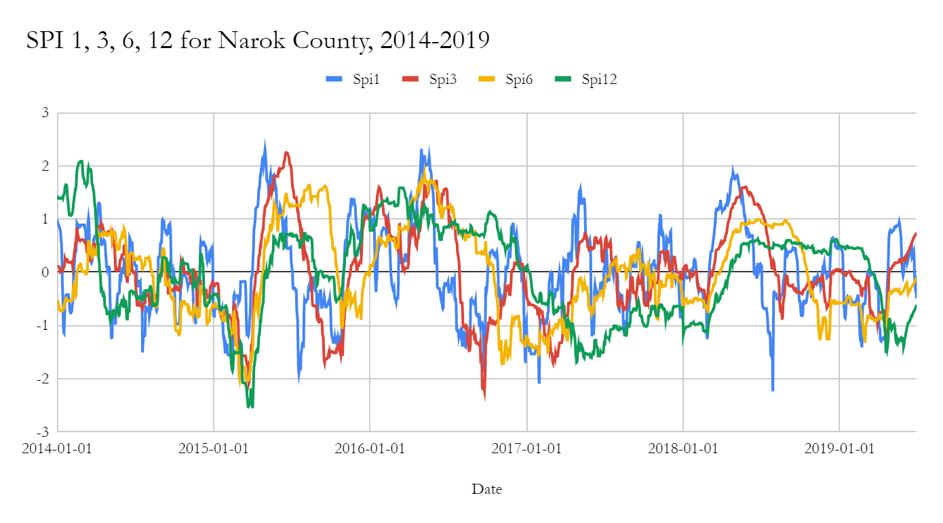

*Figure E13*. Time series graph for SPI at 1, 3, 6, and 12 month accumulation periods for Narok County from 2014 to 2019.