

**Characterization of Tick-borne Disease Risk using NASA Earth Observation Systems [Phase 4]**

NASA Marshall Space Flight Center - DEVELOP National Program

*at*

The University of Alabama at Birmingham

Laboratory for Global Health Observation

Summer 2010 Team:

Steve Padgett-Vasquez, M.S., Team Leader

Michael Behring, M.S., Team Leader

Taylor Poston, M.P.H.

Connor Whitley

Damien Willis, M.S.

Jonathan Adams, M.S.

Rusty Nall, B.S.

Donna Burnett, Ph.D., UAB Science Advisor

Jeff Luvall, Ph.D., NASA Science Advisor

**Characterization of Tick-borne Disease Risk using NASA Earth Observation Systems [Phase 4]**

11 August 2010

**Team Members:**

___________________________ ___________________________

Steve Padgett-Vasquez, **Team Lead**  Michael Behring, **Team Lead**

___________________________ ____________________________

Taylor Poston, **Team Member** Connor Whitley, **Team Member**

___________________________ ____________________________

Damien Willis, **Team Member**  Jonathon Adams, **Team Member**

___________________________ ___________________________

Rusty Nall, **Team Member** Donna Burnett, **Science Advisor**

**Mentors:**

___________________________

**Jeffrey C. Luvall, Ph.D.** NASA Marshall Space Flight Center

Senior Research Scientist 320 Sparkman Drive

Phone: (256) 961-7886 Mail Code VP61

Email: jluvall@nasa.gov Huntsville, AL 35805

___________________________

**Lauren Childs**  NASA Langley Research Center

DEVELOP Science Projects Manager 4 Langley Boulevard

Phone: (757) 864-4204 Building 647, Room 301

Email: Lauren.m.childs@nasa.gov Hampton, Virginia 23681-2199

___________________________

**Michael Ruiz** NASA Langley Research Center

DEVELOP Program Manager 4 Langley Boulevard

Phone: (757) 864-3748 Building 647, Room 313

Email: Michael.L.Ruiz@nasa.gov Hampton, Virginia 23681-2199

**1.0 Abstract**

The vectors for tick-borne illnesses (TBI) like Lyme Disease (LD) and Southern Tick-Associated Rash Illness (STARI) are found in Alabama; however the extent of disease risk in the state remains largely uncharacterized. The Marshall Space Flight Center-UAB DEVELOP study identified the presence of the chain of infection for LD and STARI, yet popular knowledge of the risks of TBI and approaches to primary prevention strategies are limited. To address these issues, remote sensing analysis incorporated *in situ* tick population and soil moisture data into satellite imagery-based habitat maps to produce an initial model of spatial risk. Further analysis of ASTER satellite imagery provided remotely sensed measurements for vegetation vigor (NDVI), which were combined with tick population data for predictive model development based on edge effect quantification. In addition, implementation of a risk perception survey and weekly presentations to local high-risk groups provided outreach and prevention efforts. Future study will attempt to characterize entomologic risk through STARI PCR analysis of collected tick specimens.

**2.0 Introduction**

The following project represents a multi-site risk assessment of tick-borne illness in the state of Alabama. Qualitative measures of risk focused on measuring perception of TBI hazard in a high risk group using an online survey instrument. In addition, a pilot outreach program was conducted at Camp Coleman to develop best practices of prevention in the state. Quantitative analysis used remote sensing, in-situ data, and other variables to characterize disease hazard as represented by density and species of tick in the Fort McClellan area.

**2.1 Project Background**

This project is part of a multi-stage effort starting in 2009. All phases are described below:

***Phase One*** of the Marshall Space Flight Center-UAB DEVELOP study of TBI identified the presence of the chain of infection for LD (*Ixodes scapularis* ticks carrying *Borrelia burgdorferi* bacteria) and STARI (*Amblyomma americanum* ticks and an as-yet-unconfirmed agent) in Alabama.

To improve prevention, recognition, and treatment of TBI in Alabama, ***Phase Two*** recommendedinitiating a health communication campaign utilizing vector habitat mapping and risk perception assessment for an at-risk group: outdoor recreation program participants at Alabama universities. Satellite data identified Oak Mountain State Park, Bankhead National Forest, and Talladega National Forest as likely tick habitats.

***Phase Three*** of this project combined remotely sensed environmental data with risk perception assessments to develop an ongoing primary prevention campaign. This phase formally broadens the scope of the project to include multiple tick-borne diseases and associated hosts, and not solely LD. This study also expands the vector habitat model to include *in situ* data, such as surveyed tick populations, which allow for spatial interpolation of risk related to edge effect. The *in situ* measurements were contributions of Jacksonville State University’s Department of Biology.

***Phase Four*** associates tick abundance and STARI PCR data with satellite imagery for edge effect analysis. The Jacksonville State team performed tick drags within various plots based on differing degrees of vegetation and ecotone types. In addition, outreach and prevention will be advanced through implementation of a risk perception survey and weekly presentations to local high-risk groups.

**2.2 Epidemiology of tick-borne illness (TBI)**

Ticks are vectors for a wide range of pathogenic viruses, bacteria, and protozoans which can manifest as LD, Rocky Mountain Spotted Fever, Southern Tick Associated Rash Illness, Babesiosis, Tularemia, Human monocytotrophic ehrlichiosis, Q Fever, and Powhassan encephalitis. Of these, Lyme disease is the most commonly reported vector-borne disease in the United States.[1]

**2.2.1 Lyme disease**

In Alabama, the primary vector for LD is *Ixodes scapularis,* or black legged tick. This tick has a life span of two years consisting of three feeding stages: larva, nymph, and adult.[2],[3] The tick acquires *B. burgdorferi* during the larval stage during its first blood meal. *Borrelia burgdorferi* is a bacterium of the spirochete class and is the causative agent of Lyme disease.

Early localized infection of *B. burgdorferi* (Lyme disease) is identified by the appearance of erythema migrans, a characteristic red skin rash, which presents itself in 80% of patients on the site of the tick bite (include citation). Fever, fatigue and headache are also indicative of early-disseminated infection,[4] as are meningeal irritation or cardiac involvement. If left untreated, approximately 60% of patients develop late, persistent infection that manifests as frank arthritis.[5] Early treatment can lead to quick and complete recovery.[6] Standard treatment for LD involves the administration of antibiotic regiments and pain relievers;[7] however, subgroups of treated LD patients continue to experience musculoskeletal pain, neurocognitive difficulties, or fatigue. Delayed treatment of LD may result in a longer convalescent period. Chronic LD or post-LD syndrome presents complications similar to those of chronic fatigue syndrome or fibromyalgia.[8]

Dr. Gary Mullen of Auburn University reported the first case of Lyme disease in the state of Alabama in 1986. A 42-year-old woman developed the characteristic skin lesion, *erythema chronic migrans*, after a tick bite in Choccolocco Wildlife Management Area, Cleburne County. The Centers for Disease Control and Prevention (CDC) confirmed the case through serological testing.[9] The CDC reported a total of 238 LD cases in the state of Alabama from the years 1986-2007.[10] In 1988, the Alabama Department of Public Health (ADPH) requested that physicians and laboratories begin reporting LD cases to calculate the incidence and prevalence rates.[11]

CDC recommendations for diagnosis of Lyme disease focus on objective, observable physical symptoms in the patient. [12] These include facial palsy, erythema migrans, and arthritis. Also considered is previous exposure to a potentially infected tick. It is important to note that lab tests are not recommended if EM is present. At the same time, a lab assay is not recommended for patients who do not present symptoms. Essentially this makes EM the strongest single marker for diagnosis. This is an important obstacle from a surveillance perspective, since it means that most cases are not serologically confirmed. Due to the limited human TBI surveillance within the southeastern US, DEVELOP research focused on entomologic risk and disease confirmation in ticks.

**2.2.2 Southern Tick-Associated Rash Illness (STARI)**

Complicating the diagnosis of Lyme disease is an emerging illness called Southern Tick-Associated Rash Illness (STARI), or Masters disease. The symptoms of STARI closely resemble those of Lyme disease. Dr. Edwin Masters first suggested that the rashes were not caused by Lyme disease spirochetes but by an unrecognized Lyme-like illness, which was initially termed Master’s disease. Barbour et al. first discovered the cause of STARI in 1996 using molecular techniques.[13] Their work revealed a newly discovered bacterium, *Borrelia*. *lonestari*, in *Amblyomma americanum* ticks. Since then, *B. lonestari* has been detected in *A. americanum* and hosts throughout the South[14],[15],[16],[17],[18],[19],[20] and in at least one human.[21] The spirochete resists culture in the Barbour-Stoenner-Kelly (BSK) medium suitable for *B. burgdorferi*, and requires a modified medium.[22] Additionally, only a small percentage of ticks have been shown to carry the spirochetes.[23] Furthermore, *B. lonestari* infections may cause many of the same symptoms as *B. burgdorferi* infections, including: *erythema migrans*, fatigue, malaise, arthritis, and central nervous system problems. Most epidemiology of STARI is case by case or case series, and the general incidence/prevalence is still largely unknown.

**2.2.3 STARI and Lyme Disease in the Southeast**

Because both serologic and entomologic risks of Lyme disease and STARI are largely unknown in the Southeast, this study attempts to better characterize disease risk with both habitat and molecular analysis. Disease risk is represented entomologically through drags/counts of tick species in the study area. Risk of infection will be further explored via DNA testing for the presence of STARI by real-time PCR.

**2.2.4 Other Tick-borne Diseases**

Ticks are known to be hosts of concurrent pathogens. While coinfection with other tick-borne diseases is not uncommon in humans and other hosts, frequency of occurrence is not well quantified. The following is a list of diseases that have the potential to be transmitted alone or together with Lyme/STARI.

Ehrlichiosis is the general name used to describe several bacterial diseases that affect animals and humans. These diseases are caused by organisms in the genus Ehrlichia. In the United States, there are currently two ehrlichial species that are known to cause disease in humans: Ehrlichia chaffeensis and Ehrlichia ewingii. Ehrlichia chaffeensis causes human ehrlichiosis, also described as human monocytic ehrlichiosis (HME). Many individuals infected with ehrlichiosis are also infected with Lyme disease or babesiosis. Most people infected with ehrlichiosis experience fever, persistent headache, chills, muscle aches, and fatigue. Some might also experience abdominal pain, nausea, vomiting, diarrhea, cough, and joint aches.[24]

Rocky Mountain spotted fever (RMSF) is the most severe tick-borne rickettsial illness in the United States. This disease is caused by infection with the bacterial organism Rickettsia rickettsii. Most people experience fever, nausea, vomiting, severe headache, muscle pain, or lack of appetite during the early stages of the disease. In the later stages, infected people experience a spotted rash, abdominal pain, joint pain, and diarrhea.[25]

Tularemia, also known as “rabbit fever,” is a disease caused by the bacterium Francisella tularensis. The signs and symptoms people develop depend on how they are exposed to tularemia. Possible symptoms include skin ulcers, swollen and painful lymph glands, inflamed eyes, sore throat, mouth sores, diarrhea or pneumonia. If the bacteria are inhaled, symptoms can include abrupt onset of fever, chills, headache, muscle aches, joint pain, dry cough, and progressive weakness. People with pneumonia can develop chest pain, difficulty breathing, bloody sputum, and respiratory failure.[26]

Babesiosis is an intraerythrocytic parasitic infection caused by protozoa of the genus *Babesia* and transmitted through the bite of the *Ixodes* *scapularis* tick. Many people who are infected with Babesia microti feel fine and do not have any symptoms. Some people develop nonspecific flu-like symptoms, such as fever, chills, sweats, headache, body aches, loss of appetite, nausea, or fatigue. Because Babesia parasites infect and destroy red blood cells, babesiosis can cause a special type of anemia called hemolytic anemia. This type of anemia can lead to jaundice and dark urine.[27]

**2.3 Tick Ecology**

**Table 1 – Review of tick species by transmission capability**

**Tick Species**

**Diseases Transmitted**

**Carried but not Transmitted**

Ixodes Scapularis

Lyme, babesiosis, anaplasmosis (human

granulocytic ehrlichiosis), Powassan encephalitis, tick

paralysis, tularemia, bartonella

Human monocytic ehrlichiosis (HME)

Ambylomma Americanum

Human monocytic ehrlichiosis, STARI (Southern

tick-associated rash illness), tularemia, tick paralysis,

Rocky Mountain spotted fever

Dermacentor Variabilis

Tick paralysis, Q fever, Rocky Mountain spotted

fever, tularemia, human monocytic ehrlichiosis

Lyme

**2.3.1 Blacklegged tick (*Ixodes scapularis*)**

The primary vector of LD in the United States is *Ixodes scapularis* (blacklegged tick). This tick has a life span of two years and has three feeding stages: larvae, nymph, and adult.[28],[29] It acquires *B. burgdorferi* during the larval stage when it gets its first blood meal. The bacteria reside in the gut of the tick and are transmitted to the host during nymphal feeding.[30][31] Nymphs usually parasitize small mammals including cotton mice. The proportion of nymphs infected with *B. burgdorferi* is substantially higher than adults of the same cohort. Because of their smaller size, nymphs are less likely to be detected on hosts, including humans, increasing the probability of transmission of *B. burgdorferi* resulting in LD. Most human cases of LD are seen during the spring and summer months when both tick activity and human outdoor activity is greatest.[32] The preferred host for adult ticks is the white-tailed deer, which plays a major role in the transportation of ticks and tick population sustainability, although adult ticks do not infect the deer with *B. burgdorferi*.32

**2.3.2 Lone Star tick (*Amblyomma americanum*)**

*A. americanum* is a very aggressive species of hard tick. Lone Star ticks are easy to identify because of the white dot appearing on the backs of adult females as well as their rounded shape. The mouthparts of *A. americanum* are also very large compared to many other ticks. The ticks are much more active in their questing behavior than most other species in the U.S. and are aggressive biters of humans.[33] *A. americanum* is the dominant hard tick species throughout much of the southern U.S.[34] The geographic range of *A. americanum* stretches from central Texas northward to Missouri and eastward in a broad swath across the southern United States continuing northward in a thin band up the coast to Maine.[35] Lone Star ticks have a three-year life cycle. Eggs hatch into six-legged larvae in late summer. The larvae seek a host and feed. Once fed, the larvae drop from the host and morph into nymphs. Nymphs typically feed on a second host in the spring and early summer. Once fed, the nymphs fall from the host and become dormant for a period (usually winter). During this dormancy period, the ticks mature to the adult stage. Adult ticks feed on a third host during spring, summer, and fall. Once feeding is complete, the adults mate. Males die shortly after mating, and females die soon after laying eggs in forest floor duff in the late fall to early spring. *A. americanum* are relatively easy to collect using drag sampling. They have been shown to harbor Lyme spirochetes but have not proven to be capable of transmission of *B. burgdorferi*.[36] All life stages of *A. americanum* are capable of transmitting spirochetes. Disease detection in unfed larvae provides evidence that the spirochetes can be transovarially transmitted.[37] PCR has been used to isolate *B. lonestari* DNA from Lone Star ticks removed from humans with symptoms of STARI.[38] Spirochetes from the *B. burgdorferi* group have also been detected in *A. americanum* although the capability of the Lone Star tick to transmit the spirochetes is not yet known.[39], [40], [41] *A. americanum* spends most of its time on the surface of plants or leaf litter, not buried in the leaf litter. The adult Lone Star ticks climb to a height of 3-36” on a plant and wait for a host to brush against the plant.[42] Overall, *A. americanum* is less susceptible to adverse habitat conditions, and is able to occupy diverse habitats.42 The hardiness of *A. americanum* and its aggressive nature are likely to be reasons for its high survivability compared to other species. It is now known as a vector for the emerging *B. lonestari* and many other pathogens, including *Ehrlichia chaffeensis*, the agent of human monocytic ehrlichiosis (HME), *E.* *ewingii* and *Anaplasma phagocytophila*, both agents of human granulocytic ehrlichiosis (HGE), *Francisella tularensis*, the agent of tularemia, *Coxiella burnetii*, the agent of Q fever, *Rickettsia rickettsii*, the agent of Rocky Mountain spotted fever, and other species of *Rickettsia*. *[43], [44]*, [45], [46], [47]

**2.3.3 American dog Tick (*Dermacentor variabilis*)**

American dog tick (*Dermacentor variabilis)* females are about 1/4 inch (6.35mm) long and are chestnut brown with a silvery-gray or creamy-white scutum. Male ticks are slightly smaller, and are chestnut brown with similar light-colored vertical markings on the dorsal surface. Larvae feed on small mammals, and nymphs feed on small-to medium-sized mammals. Adults, sometimes called wood ticks, occasionally attack humans but are more common on dogs and other medium-sized animals.[48] *Dermacentor variabilis* is a well known vector of *Rickettsia rickettsii*, a bacterium that causes Rocky Mountain spotted fever in humans.

**2.4 TBI prevention and control**

**2.4.1 Population at-risk**

Transmission of B. burgdorferi to humans or domestic animals can occur if a) there is sufficient opportunity for exposure to infected ticks and b) removal of the infected tick does not occur within 36 hours after attachment.[49],[50],[51] Exposure depends on demographic patterns, recreational, and occupational activities.[52] Outdoor work has been found to be positively associated with LD risk.[53] Outdoor recreation such as fishing, golfing, camping and hunting were also found to increase risk.[54]  Individuals living in forested areas have also been found to be more likely than those living in non-forested areas to have LD.[55] Finally, younger individuals (0-16 years of age) have been found to have the highest prevalence rate of LD[56],[57] and practice fewer preventive behaviors than older individuals.[58]

Individuals exposed to likely tick habitats are most at risk for Lyme and other tick-borne diseases.52 These individuals, our targets for intervention, include:

1. *Outdoors enthusiasts* *–* people who conduct recreational activities outdoors in tick infested areas, i.e. campers, hikers, rock climbers, off road bikers, hunters, fishermen.[59]
2. *Outdoor workers –* especially those who frequent high risk locations, including: fish and wildlife personnel, forest rangers, landscapers, utility and construction workers, military personnel conducting field training, farmers, large animal veterinarians making house calls, etc.[60]
3. *Rural/peripheral settlement dwellers –* people whose homes border woodlands or other likely tick habitats.[61]
4. *Pet owners and veterinarians –* particularly those exposed to animals that live or venture into tick infested areas.[62]
5. *Other –* anyone else who ventures into tick-infested areas during the spring, summer, and fall months.[63]

**2.4.2 Strategies for prevention of tick-borne diseases**

Possible strategies for preventing TBIs include reduction of host numbers, tick habitat modification, chemical control, biological control, pharmacologic control, and personal protection.[64] In theory, TBIs should be preventable with the use of tick-avoidance and tick-check/removal behaviors and with early secondary prevention with antibiotics; however, in practice, health behaviors aimed at interrupting the transmission of TBIs are not universally adopted.[65]

A study of ferry passengers to Martha’s Vineyard Island, MA, endemic for Lyme disease, demonstrated that good knowledge of Lyme disease was not associated with consistent application of preventive behaviors.[66] In this study, participants scored an average of 73% correct items on knowledge items but rated their practice of preventive behaviors as follows: 12% limited time in areas of tick-infestation, 16% wore protective clothing, and 22% checked for ticks. A similar study with ferry passengers to Nantucket, MA, suggested that behavioral changes as a result of an educational intervention alone were not long-term .68 However, a randomized trial (*n* = 30,164) conducted over three summers using persuasive messages targeting attitudes and beliefs about Lyme disease with participants visiting Nantucket Island, MA, for longer than 2 weeks, resulted in a 60% reduction in risk (relative risk [RR] = 0.41, 95% confidence intervals = 0.18 to 0.95, p < .038) compared to the control group (RR = 0.79).[67] Findings indicated that participants who completed the intervention for TBI prevention were more likely to check for ticks, wear protective clothing, limit exposure to tick areas, and use repellant. The health communication messages were composed based on theoretical constructs, including the Social Cognition Theory [68] the Health Belief Model[69], and the Theory of Reasoned Action/Theory of Planned Behavior[70] and targeted behavioral modeling of preventive practices previously determined to be inadequately utilized by the target population. The health messages were communicated in a 15-minute interactive session using an entertainment-education approach. The intervention covered issues of severity and susceptibility to TBIs and the health benefits of tick avoidance and tick check/tick removal and included a demonstration of tick removal. Social constructs of protecting children and significant others were introduced. Educational materials were provided to participants 69 including pictures of adult and nymphal deer ticks, a laminated reminder card for tick check and removal behaviors for use in the shower, coupons for reduced prices for tweezers and repellant, a color pamphlet on TBI from the American Lyme Foundation showing varieties of the Erythema Migrans rash, a tick habitat map, and lollipops in lime color printed with the message, “Lick Lyme.”

In the present research, communication of health messages aimed at the prevention of TBIs is addressed in two respects.  First, the research team developed an educational intervention for primary prevention of TBI comprising an interactive session for campers at an area Girl Scout camp, described in section 3.4. The theoretical basis of the educational session included constructs from the Health Belief Model 71:

a.       *Perceived susceptibility* – the belief that one is susceptible to the condition, i.e. it is possible to contract tick-borne diseases in Alabama;

b.      *Perceived severity* – the belief that the condition has serious consequences, i.e. the associated short- and long-term heath effects of tick diseases can be severe*;*

c.       *Perceived benefits* – the belief that taking action would reduce susceptibility to the condition or the severity of the disease, i.e. prevention methods are effective in reducing the risk of contracting tick-borne diseases*;*

d.      *Perceived barriers* – the belief that the cost of taking action is too high, i.e., it is not worth the time/expense to perform tick checks, use repellent, etc*;*

e.       *Cue to action* – exposure to factors that prompt action, i.e., a sign or public service announcement reminding the individual to perform prevention behaviors, avoid tick infected areas, etc.*;* and,

f.        *Self efficacy* – confidence in one’s ability to successfully perform a specific action, i.e., confidence in one’s ability to properly and safely remove a tick, use repellent, recognize and remove ticks, recognize symptoms of TBIs, perform tick checks, and/or seek a qualified health professional as required.[71],[72]

Second, the research team engaged in the first steps of planning for a health communication campaign targeting participants of a local college campus recreation center’s outdoor recreation program. According to the CDC (n.d.), steps of a health communication campaign need to include strategic planning including (a) identifying the target audience and best ways to reach the audience; (b) developing and testing communication concepts, messages and materials with the target audience; (c) implementing the health communication intervention based on testing, and (d) assessing the efficacy of reaching the target audience and modifying the program if required. Others have described the steps of developing a health communication campaign in more detail; however, due to the limitations of time and resources, the CDC guidelines have been adopted for this research. The present study identified key informants for the outdoor recreation program and obtained permission to conduct an online risk perception survey, described in section 3.5. The survey, pending approval by UAB’s Institutional Review Board, aims to identify salient attitudes and beliefs of the target population in terms of susceptibility and severity of TBI, and to identify current levels of tick avoidance, tick check, and tick removal behaviors. Results of the survey will be used to develop health communication messages and materials designed to raise levels of tick avoidance, tick check, and tick removal behaviors.

**3. Methodology**

**3.1 Model development**

The “edge effect” phenomenon can be described as the concentration of ticks along edges of forests and ecotones. Ecotones are the convergence of two different, distinct habitats. For ticks, this is often the confluence of older plant communities and newer, pioneer habitats, such as brush forests, thickets, and meadows.[73] These ecological boundaries are crossed frequently by host vertebrates, for reasons such as feeding, mating, and evasion of predators. The increased activity of suitable hosts along these ecotones provides an increased measure of suitability for tick survival and reproduction.[74] Ecotones, therefore, serve as habitats for a variety of vertebrates (i.e. deer, mice, birds) that act as mechanical vectors and reservoir hosts for tick-borne disease transmission. As a result, this principle serves as a variable for determining suitable tick habitats, based on ecotone analysis through remotely sensed data.

Spatial analysis of tick-borne disease largely consist of GIS studies related to *Ixodes scapularis*. These studies range from smaller, microhabitat studies to landscape-based modeling.[75],[76] Research indicates various environmental and climactic variables to have associations with tick abundance.[77] However, the use of remotely sensed data is largely underutilized as a tool in large-scale spatial landscape analysis for tick-borne disease transmission. The incorporation of remotely sensed and GIS data provides the potential for risk analysis of larger, undefined areas in a timely manner, while utilizing limited resources. These methods allow for the identification of areas with an increased risk for human transmission based on ecotone convergence, which remains largely underutilized in the remote sensing sciences. Modeling of remotely sensed and geo-coded tick data provides opportunity for spatial risk map development for tick-borne diseases in Alabama.

**3.2 Tick data collection**

A total of 12 sites in the McClellan community, Anniston, AL were selected for tick population sampling. Sites were selected through imagery and ground survey to select different size forested areas for analysis. Ticks were collected at the sites using a drag cloth and flag cloth method. The drag cloths used in the study were 1 meter x 1 meter squares of white flannel or corduroy material attached to a 5/8” x 40” wooden dowel via 75cm nylon rope[78]. Flag cloths were also 1 meter x 1 meter squares of white flannel or corduroy material attached to a 5/8” x 40” wooden dowel, forming a “flag” structure.[79] The cloths were dragged through vegetation and across the forest floor at each site for 30 minutes bi-weekly for consistency. Effort was made to ensure that sites were dragged thoroughly on each outing. The cloths were inspected approximately every 5-10 meters during the sampling. Ticks found on the cloths were immediately removed using steel forceps and preserved for future laboratory processing in 1.5 milliliter centrifuge tubes containing 70% ethyl or isopropyl alcohol. Tubes were labeled with the corresponding site number and date of collection. Samples were screened for the presence of *Borrelia lonestari* using real-time Polymerase Chain Reaction (PCR).

**3.3 NDVI**

Vegetation within the study sites were determined through the use of the Normalized Difference Vegetation Index (NDVI) used through ER MAPPER 7.1. This analytical technique compares the near infrared (NIR) and red bands from multispectral satellite imagery in order to measure vegetation vigor. [80] NDVI has been shown to be highly correlated with several vegetation parameters including green biomass, leaf area index, and crown closure. [81]The dominant factors governing leaf reflectance include the various leaf pigments in the palisade mesophyll, the scattering of NIR energy in the spongy mesophyll and the amount of water in the plant .[82]Chlorophyll concentration is in particular responsible for reflectance in the NIR. [83]NDVI is a ratio and results in values between -1 and 1. Values approaching -1 are non-vegetated areas associated with urban development and water. Values between 0 and 0.10 are associated with barren land while values from 0.10 and approaching 1 are associated with vegetation. The algorithm used to obtain the NDVI value is: NDVI = $(NIR-Red)/(NIR+Red)$.

The NDVI ratio reduces many forms of multiplicative noise and solar illumination effects on slope and aspect orientation [84],[85] and helps normalize differences in brightness values when processing multiple dates of imagery. [86] NDVI is also closely related to fractional vegetation cover where NDVI values greater than .60 also means that surface has 100% vegetation cover.[87]

**3.4 Tick processing/ DNA extraction**

Preserved ticks were screened for the presence of *Borrelia lonestari* deoxyribonucleic acid (DNA)*.* Ticks were identified by species, sex, and life stage (adult or nymph) (no larvae collected). Ticks were cut along the sagittal plane with a sterilized razor blade to yield 4 sections. The sections were then mechanically ground using sterile plastic tissue homogenizers in 500 microliters of phosphate buffered saline (PBS) in 1.5 milliliter centrifuge tubes to release gut contents. The supernatant was then removed via pipettor (filtered tips were used for all procedures to prevent pipettor contamination) and placed in a clean DNAase, RNAase- free 1.5 milliliter centrifuge tube. This step was then repeated using an additional 500 microliters of PBS. The homogenate was then centrifuged at 12,000*g* for ten minutes. DNA extractions were performed using a QIAamp DNA mini kit (Qiagen, Valencia, CA). The supernatant was then discarded and the pellet was re-suspended in 180 microliters of Buffer ATL and 20 microliters of Proteinase K (Qiagen, Valencia, CA). Samples were incubated in a water bath at 56 degrees Celsius overnight. After incubation, samples were pulse-centrifuged to pellet any undissolved tick parts. The remaining supernatant was then removed via pipettor and placed into a clean 1.5 milliliter centrifuge tube. Further extraction procedures followed the manufacturer’s protocol starting at step 4 (Qiagen, Valencia, CA). The only other significant modification of the protocol was the use of Elution Buffer (EB) instead of Buffer AE at step 11 of the protocol.

**3.5 DNA analysis**

Real-Time Polymerase Chain Reaction (PCR), using species-specific primers for *B. lonestari,* was used to screen samples for the presence of the bacteria. The target gene was the Glycerophosphodiester Phosphodiesterase (*glpQ*)gene in *B. lonestari.* PCR primers used amplify the complete coding sequence (607 nucleotides) of *glpQ* from *B. lonestari were* : Forward 5’_GGTATGCTTATTGGTCTTC_3’; Reverse 5’_TTGTATCCTCTTGTAATTG_3’). [88],[89] The Real time PCR thermocycler system used was a Cepheid Smart Cycler System (Cepheid, Sunnyvale, CA). The following reagents were added for each reaction: glpQ forward reverse primers (final primer concentrations were 0.8μM), a dual-labeled glpQ-specific FCTC25 probe (5’-CAACCGAGCTAGGGAAGACG GACGATATT ACT-3’) (final concentration was 75nM). A Smart Mix HM ½ bead (Cepheid, Sunnyvale, CA), which contained: 3U hot start *Taq* polymerase, 200μM deoxyneocleoside triphosphate (dNTP), 4mM Magnesium chloride and 4.25mM HEPES (pH 7.2 ± 0.1) was used. 5 μL sample DNA template (10-100ng) and 19.25μL molecular grade, DNAse/RNAse-free water were also used. Reactions were run for 45 cycles. Reaction conditions were: 95°C for 30 seconds and 60°C for 30 seconds. Each sample assay was performed in duplicate. Positive controls from previously sequenced pools were used. Negative controls contained all reagents with the exception of DNA (5μL DNAse/RNAse-free water were used to bring total volume to 25μL).

**3.6 Image collection**

The most recent ASTER imagery available for path 20 and row 37 that includes the current study site and is cloud free dates to September 20, 2006. Imagery was made available through The Global Visualization Viewer (GLOVIS) by the U.S. Geological Survey and was rectified and georeferenced to UTM projection (WGS 84 datum, Zone 16 North). Satellite imagery analysis was performed through ER MAPPER 7.1 (ERDAS Inc., Norcross, GA), a software that allows geospatial processing of satellite imagery. The satellite imagery was preprocessed to include the NIR (0.76 to 0.90 μm) and red (0.63 to 0.69 μm) visible portion of the electromagnetic spectrum. This translates in a band combination of 321 RGB for ASTER. The imagery was cropped to include the corresponding area of 250m radius from the centroid of each of the colleting site through the use of shapefiles, vector polygons, created in and exported from ArcGIS 9.3 (ESRI, Redlands, CA) into ER MAPPER 7.1. Images from each collection site were then classified and quantified according to NDVI group values using the ISOCLASS unsupervised classification algorithm, provided by ERMapper 7.1. The algorithm was set to the following specifications: 99,999 iterations, 50 maximum number of classes, and the minimum members in a class (%) set to 0.01. Positive NDVI values can be used to further group pixels based on the amount and type of vegetation biomass, indicated by NDVI values. For instance, NDVI values allow for distinction between grass, shrubs and forested areas.

**3.7 Study Variables**

Variables in this study were created to characterize three main areas: general image, edge effect/ecotone, and regression analysis.

**Response variable = Tick Density**



**3.7.1 Mean plot digital number**

In band 4 ASTER, the mean digital number (DN) for the pixels was included as a univariate measure. ASTER band 4 was meant to serve as a general measure of plot vegetation. It uses near infra red and works as an informal NDVI. It is hoped that using mean plot DN will serve as a baseline measure of plot vegetation for future statistical analysis and comparison.

**3.7.2 Patch area (m2) and Edge Length (m)**

For each plot (*n*=12), satellite imagery was cropped using a 250m radius from the centroid. An NDVI algorithm was used to measure the vegetation within each plot. The perimeter and area of the edge around the cells falling into the category containing the centroid (NDVI > 0.60) was measured.

**3.7.3 Distance to nearest edge from centroid (m)**

Using the polyline trace feature, the measurement between the centroid and the closest point from a different NDVI classification was recorded. Since some tick drag plots were located further in an ecotone than others, distance to nearest edge was created to measure whether the location of the plot(centriod) within the patch is a significant variable in determining tick density

**3.7.4 Edge length/patch area ratio**

A ratio of edge length over total patch area was then calculated for each plot to allow for an adjusted comparison of distance and area across plots.

**3.7.5 Model Variables**

Plot number and week of drag were included for regression modeling. Both measures were included for a non-image based evaluation of spatio-temporality.

**4. Analysis**

**Objectives**

**4.1** Assess the beliefs/behavior of high risk population

**4.2** Develop best outreach practices for high risk group

**4.3** Test the hypothesis that edge effect is associated with tick population dynamics using the following satellite remote sensing variables

**4.1 Risk assessment survey**

            The risk assessment survey developed for this research is included in a research protocol pending approval in UAB’s IRB office.  Once approved, the survey will be delivered electronically to members of the outdoor recreation program of UAB’s campus recreation center. The survey aims to identify salient attitudes and beliefs of the target population in terms of susceptibility and severity of TBI, and to identify current levels of tick avoidance, tick check, and tick removal behaviors.  Survey items were developed based on known risk factors and primary prevention measures for tick avoidance, tick check, and tick removal behaviors. 68 Demographic items were included to assist in describing the study sample. The survey is presented for review in its entirety in Appendix 1; however, since the survey will be administered online, skip logic will be used to allow responders to skip items that do not pertain to them. Results of the survey will be used to develop health communication messages and materials designed to raise levels of tick avoidance, tick check, and tick removal behaviors for the target population

**4.2 Community outreach**

The outreach program, specifically tailored to at-risk summer campers, focused on basic tick biology, tick-borne illnesses, and methods of prevention. Materials showed various images of ticks in Alabama, with discussions concerning associated vector-borne diseases (i.e. Lyme disease and STARI). Lectures provided information on the signs and symptoms of Lyme disease/STARI and proper treatment. The methods of prevention covered, included: proper clothing and attire, avoidance of tick populated areas, the use of DEET and prymethrin, daily tick checks, and the importance of proper tick removal. Other information included seeking medical attention at the camp immediately upon finding an attached tick. Additionally, the project introduced campers to how satellite imaging is used to address environmental factors and public health. Instruction illustrated a satellite image of Camp Coleman to elucidate potential tick-borne disease in the area.

Previous sessions of the DEVELOP project established that an outreach program be implemented to educate at-risk groups and the general public. Studies indicated the most at-risk group to be young outdoor enthusiasts. Contact with the Boy Scouts of America revealed tick prevention to currently be included in their curricula. However, Girl Scouts Inc. specified a lack of prevention training at Camp Coleman in Trussville, Alabama. Administrators at the camp portrayed specific interest in cooperating with an outreach program for staff and campers. Meetings with staff allowed for development of a tailored presentation for the specific age group of campers (ages five to fourteen). The risk group included both male and female day-campers and Girl Scouts. Presentations occurred once a week to a group of 70-80 campers.

Campers proved to have a reasonable knowledge and exposure to ticks, but very little awareness of the dangers related to tick-borne illnesses. Campers responded well to lectures and remained involved. A combination of visual aids and talking points provided a satisfactory level of attentiveness and information retention. An active display demonstrated the proper removal of a tick (using an enlarged model of a tick and tweezers), which showed effectiveness in keeping young campers interested.

Possible improvements include the future use of posters (to increase the size of visual aids) and small group exercises to deliver the presentation to age group subsets. Outreach efforts, particularly for this risk group, should continue prospectively in order to maintain adequate health awareness. Endeavors communicated to an interested group of advocates for Lyme disease prevention (Birmingham Lyme Foundation) provide initiative, using the methods and best practices created through the DEVELOP project, for future health education projects.

**4.3 Image Analysis**

**4.3.1 General image**

**Study Area**

Tick drag plots were chosen from Fort McClellan in Anniston, AL due to varying degrees of habitat fragmentation. As shown in the overall 321 ASTER image of the Fort (image 1), plots are located in differing patches of continuous forest (red) or no vegetation (blue). The degree of interruption in areas of red vegetation should result in more fragmented tick habitat. For example, plots 10, 11, and 12 are located in unbroken areas of vegetation. At the same time, plots 2 and 6 are located in areas of urban development and various ecological habitats.

**Image 1. Location of fort McClellan within Alabama and position of plots within Fort McClellan**

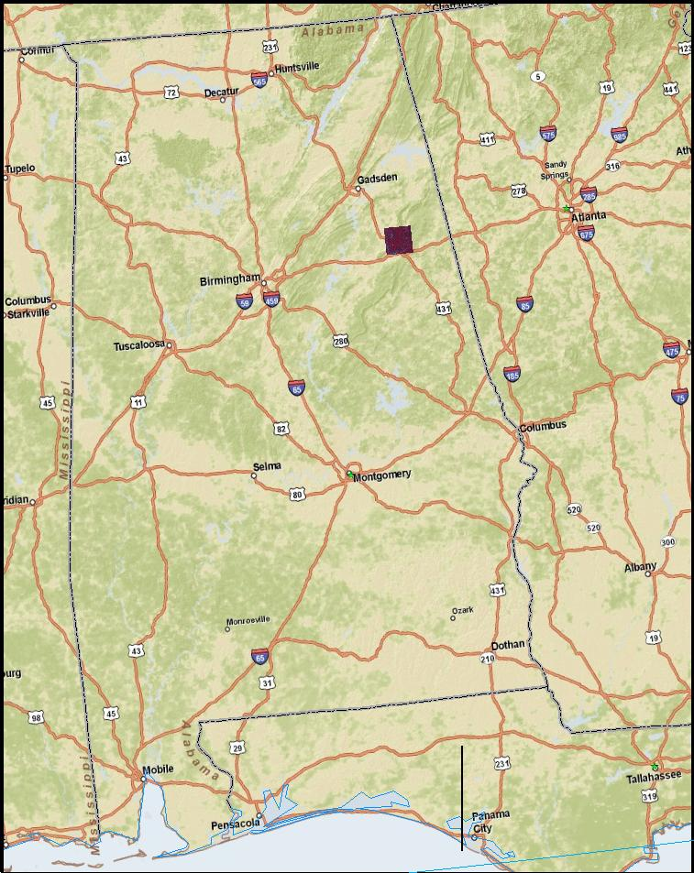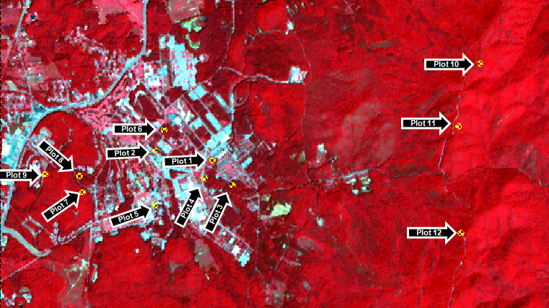

**% NDVI by Class**

We examined plots based on percentage of NDVI cover per class. Cut points for each class were designed to show the presence or absence of vegetation as well the degree of vegetative biomass per plot. Non-vegetated areas are shown as dark grey, with an NDVI value of <0.00. The next values show an ordinal increase in the range of vegetation from bare ground to fully forested regions. A varying NDVI range indicates landscape change, which affects tick habitat suitability. Therefore, using % NDVI values potentially shows change in tick population density. Figure 1 illustrates this point by sorting each plot by NDVI class and tick count. In general, plots with an over 90% of NDVI values in >0.60 had the lowest tick counts. Values of <0.00 had an undefined relationship with tick density. Any plot with values in the <0.00 NDVI range also has varying distribution in the middle (0.00-0.59) range. This may show an association between high <0.00 values and tick count. All other classes of NDVI were inconclusive in assessing tick population individually.

**Image 2. Percent NDVI class by plot**

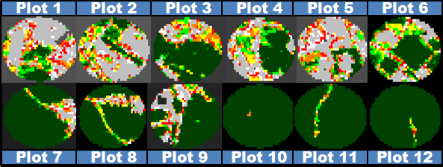

**Figure 1.Distribution NDVI by class and plot sorted by tick count**

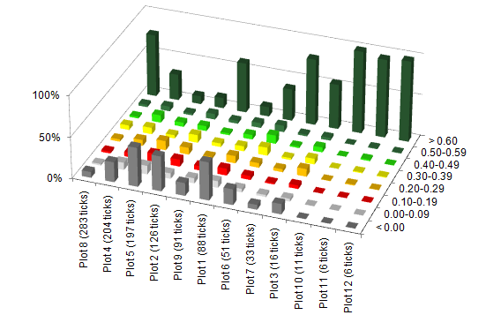

**4.3.2 Edge Effect Variables**The intent of the project was to fully characterize edge effect and ecotone using image analysis techniques. This will allow for further analysis that combines remote sensing with environmental theory. Table 1 shows descriptive statistics for each variable. While statistical analysis has not yet been done, a larger patch size and edge length seems to be positively associated with tick count in most plots. Since % NDVI class does not adequately explain tick density distribution, image-based edge effect variables are necessary for a thorough spatial analysis. Image 3 illustrates the need for a combined approach in using image-based, model-based, and general spatial variables to test project hypothesis.

**Table 1. Edge Effect variables by plot and tick density**



**Image 3.All variables by plot image**

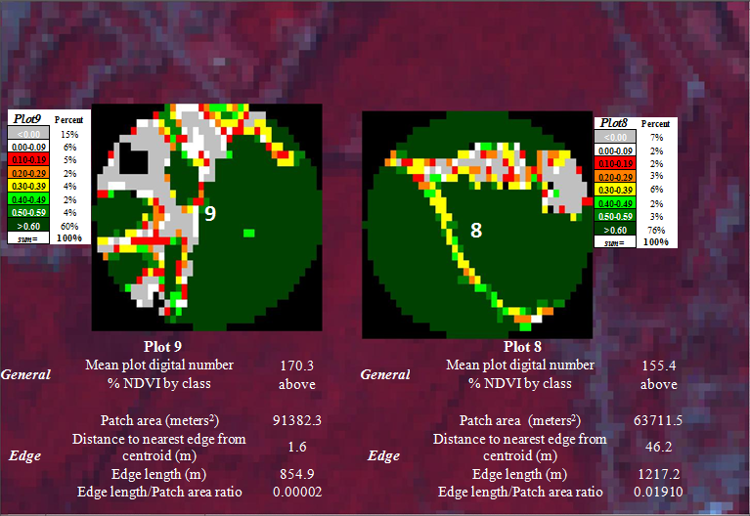

**4.3.3 Model Variables**

Variables for regression analysis were omitted from this phase.

**5. Discussion**

The remote sensing techniques outlined in the study provide a unique, novel component to surveillance of tick-borne diseases. These methods provide a proxy for measuring the level of entomologic risk, while also creating a basis for further expansion of techniques related to risk assessments of TBI. Based on the limited surveillance of TBI in humans, due to issues related to clinical diagnosis, laboratory testing, inadequate funding and awareness, utilization of remote sensing surveillance to identify areas of increased risk based on landscape variables allows for a cost-effective approach to TBI risk assessments. Identification and quantification of variables related to edge effect, ecotone, suitability of tick habitat, degree of human exposure, and temporal variables, allow for generation of a tick-borne disease risk model. These models are applicable to areas of land development, particularly high-risk environments, such as camping, military, athletics, recreation and leisure, etc. Within areas of landscape change, risk modeling provides the potential to discriminate based on region to region comparisons, and also spatially within concerned areas (i.e. military bases, campgrounds, suburban sprawl). Additionally, these measurements are ideal for reducing pet exposure to tick-infested areas, thereby further reducing human exposure to tick vectors. These analyses are integral for targeted interventions, related to tick-proofing suburban lawns, utilizing tick repellents, and promoting essential behavior changes, all serving to protect the public’s health. Inevitably, these techniques serve to provide another level of preparedness to mitigate or survey potential, emerging infectious agents.

**5.1 Limitations**

Various limitations exist within the scope of the study related to imagery, sampling, analysis, and general conclusions. The 15 meter resolution afforded by ASTER imagery is satisfactory, however higher resolution satellite imagery would provide improved remotely sensed data. Additionally, ASTER imagery matching the time-point for performed tick drags could not be obtained hindering statistical correlation efforts. Furthermore, single time-point image examination is not adequate for time series analysis. Other limitations related to image analysis exist, because methods for quantifying edge-effect and ecotone are not well-established. Within the present study, there is an unmet need to completely characterize ecotone through remotely sensed data. Tick collections provided a sample size pertinent only for Lone-star tick analysis; however statistical analysis for sample power was not performed. Resource limitations for individual-tick STARI PCR analysis, along with assay reliability, both restrict the breadth of DNA analysis. Lastly, entomologic risk is only part of the overall picture of tick-borne disease risk in Alabama.

**6. Conclusions**

Tick drag methods proved effective in collecting *A. Americanum* and *D. Variabilis* species. Since this method was not able to detect *I. Scapularis* species, general entomological risk for Lyme Borrelia in the area seems low. This project continued to show satellite remote sensing as a viable method of identifying environmental factors associated with likely tick habitats.

Initial findings show that tick density is inversely associated with plots where > 90% of area contains NDVI values over 0.60. Potential trends exist between variables related to edge length, patch area, distance to edge, and ratio of area to edge length with tick density. Statistical analysis performed in the fall 2010 term will help to identify degree of correlation between tick abundance and predictor variables. Expanding on variables used in this phase, fall 2010 will study the effects of forest fragmentation and terrestrial island biogeography in relation to tick habitat suitability. Due to pending IRB approval, the risk perception survey will be administered and analyzed during the fall 2010 DEVELOP term.

**7. Acknowledgements**

**Jeffrey C. Luvall, Ph.D.**

**Sarah Parcak, Ph.D.**

**Laura Elliot, Director Camp Coleman**

**References:**

1. Center for Disease Control and Prevention (CDC). June 14 2007. Lyme Disease Press Release. Available at: http://www.cdc.gov/media/pressrel/2007/r070614.htm. Accessed March 8, 2010
2. Hayes EB, Piesman J. How can we prevent Lyme disease? *N Engl J Med.* June 12, 2003; 348: 2424-30.
3. CDC Lyme Disease Transmission Web Page. Available at <http://www.cdc.gov/ncidod/dvbid/Lyme/ld_transmission.htm>. Accessed Nov. 3, 2009.
4. Tibbles CD, Edlow JA. Does this patient have erythema migrans? *JAMA.* June 20, 2007; 297(23): 2617-27.
5. Lyme disease Clinical Presentation, The Johns Hopkins Arhtritis Center. Available at: http://www.hopkins-arthritis.org/arthritis-info/lyme-disease/clinical-presentation.html. Accessed Nov. 25, 2009.
6. CDC Lyme Disease Transmission Web page. Available at http://www.cdc.gov/ncidod/dvbid/lyme/ld_humandisease_treatment.htm. Accessed Nov. 25, 2009.
7. Lyme Disease Transmission Web page. Available at http://www.cdc.gov/ncidod/dvbid/lyme/ld_humandisease_treatment.htm. Accessed Nov. 25, 2009.
8. Fibromyalga Symptoms, Available at: http://www.fibromyalgia-symptoms.org/fibromyalgia_lyme.html . Nov. 25, 2009
9. [Mullen GR](http://www.ncbi.nlm.nih.gov/sites/entrez?Db=pubmed&Cmd=Search&Term=%22Mullen%20GR%22%5BAuthor%5D&itool=EntrezSystem2.PEntrez.Pubmed.Pubmed_ResultsPanel.Pubmed_DiscoveryPanel.Pubmed_RVAbstractPlus), [Piesman J](http://www.ncbi.nlm.nih.gov/sites/entrez?Db=pubmed&Cmd=Search&Term=%22Piesman%20J%22%5BAuthor%5D&itool=EntrezSystem2.PEntrez.Pubmed.Pubmed_ResultsPanel.Pubmed_DiscoveryPanel.Pubmed_RVAbstractPlus). Serologically substantiated case of Lyme disease and potential tick vectors in Alabama. [*Ala J Med Sci.*](javascript:AL_get(this,%20'jour',%20'Ala%20J%20Med%20Sci.');) 1987 Jul;24(3):306-7.
10. CDC Lyme Disease Transmission Web page. Available at http://www.cdc.gov/ncidod/dvbid/lyme/ld_statistics.htm. Accessed Nov. 25, 2009.
11. Luckhart S, Mullen GR, Wright, C. Etiologic agent of Lyme Disease, Borrelia burgdorferi, detected in ticks (Acari:Ixodidae) collected at a focus in Alabama. *J. Med Entomol.* 1993; 28:652-657.
12. CDC. Notice to Readers Recommendations for Test Performance and Interpretation from the Second National Conference on Serologic Diagnosis of Lyme Disease. *MMWR* 1995:44(31);590-591. Available at: http://www.cdc.gov/mmwr/preview/mmwrhtml/00038469.htm. Accessed 7/13/2010
13. # Barbour A.G., G.O. Maupin, G. J. Teltow, C. J. Carter, J. Piesman. 1996. Identification of an uncultivable Borrelia species in the hard tick Amblyomma americanum: possible agent of a Lyme disease-like illness. Journal of Infectious Disease. 1996 Feb;173(2):403-9.

   
14. Armstrong, P. M., L. R. Brunet, A. Spielman, and S. R. Telford, III. 2001. Risk of Lyme

    disease: perceptions of residents of a lone star tick-infested community. Bulletin 78 of the World Health Organization 79:916-925.
15. Bacon, R. M., R. D. Gilmore, Jr, M. Quintana, J. Piesman, and B. J. B. Johnson. 2003.

    DNA evidence of *Borrelia lonestari* in *Amblyomma americanum* (Acari:

    Ixodidae) in southeast Missouri. Journal of Medical Entomology 40:590-592.
16. Bacon, R. M., M. A. Pilgard, B. J. B Johnson, J. Piesman, B. J. Biggerstaff, and M.

    Quintana. 2005. Rapid detection methods and prevalence estimation for *Borrelia*

    *lonestari glpQ* in *Amblyomma americanum* (Acari: Ixodidae) pools of unequal

    size. Vector-Borne and Zoonotic Diseases 5:146-156.
17. Burkot, T.R., G.R. Mullen, R. Anderson, B.S. Schneider, C.M. Happ, and N.S. Zeider. 2001. *Borrelia lonestari* DNA in Adult *Ambylomma americanum* ticks, Alabama*.* Emerging Infectious Diseases 2001; 7:471-473.
18. Moore, V. A., Iv, A. S. Varela, M. J. Yabsley, W. R. Davidson, and S. E. Little. 2003.

    Detection of *Borrelia lonestari*, putative agent of Southern Tick-Associated Rash

    Illness, in white-tailed deer (*Odocoileus virginianus*) from the southeastern

    United States. Journal of Clinical Microbiology 424-427.
19. Stegall-Faulk, T., Clark, D.C., and Wright, S.M. 2003. Detection of *Borrelia lonestari* in *Amblyomma americanum* (Acari: Ixodidae) from Tennessee. Journal of Medical Entomology. 40:100-102.
20. Varela, A.S., Luttrell, M.P., Howerth, E.W., Moore, V.A., Davidson, W.R., Stallknecht, D.E., and Little, S.E. 2004. First Culture Isolation of *Borrelia lonestari.* Putative Agent of Southern Tick-Associated Rash Illness. Journal of Clinical Microbiology. Vol. 42, No. 3 p. 1163-1169.
21. James, A. M., D. Liveris, G. P. Wormser, I. Schwartz, M. A. Montecalvo, and B. J. B.

    Johnson. 2001. *Borrelia lonestari* infection after a bite by an *Amblyomma*

    *americanum* tick. Journal of Infectious Diseases 183:1810-1814.
22. Varela, A. S., V. A. Moore, and S. E. Little. 2004. Disease agents in *Amblyomma*

    *americanum* from northeastern Georgia. Journal of Medical Entomology 41:753-

    759.
23. Mullen, G.R. and Wright, J.C. 1991. Etiologic Agent of Lyme Disease, *Borrelia burgdorferi* Detected in Ticks (Acari: Ixodidae) Collected at a Focus in Alabama. Journal of Medical Entomology. 28:652-657.
24. Center for Disease Control and Prevention (CDC). January 13, 2009a. Tickborne Rickettsial Diseases: Ehrlichiosis. Available at http://www.cdc.gov/ticks/diseases/ehrlichiosis/. Accessed March 8, 2010.
25. Center for Disease Control and Prevention (CDC). April 1, 2008. Tickborne Rickettsial Diseases: Rocky Mountain spotted fever. Available at http://www.cdc.gov/ticks/diseases/rocky_mountain_spotted_fever/. Accessed March 8, 2010.
26. Center for Disease Control and Prevention (CDC). October 8, 2003. Emergency Preparedness and Response: Frequently Asked Questions (FAQ) About Tularemia. Available at http://www.bt.cdc.gov/agent/tularemia/faq.asp. Accessed March 8, 2010.
27. Center for Disease Control and Prevention (CDC). May 5, 2009b. Babesiosis. Available at http://www.cdc.gov/babesiosis/. Accessed March 8, 2010.
28. Hayes EB, Piesman J. How can we prevent Lyme disease? *N Engl J Med.* June 12, 2003; 348: 2424-30.
29. CDC Lyme Disease Transmission Web Page. Available at http://www.cdc.gov/ncidod/dvbid/Lyme/ld_transmission.htm. Accessed Nov. 3, 2009.
30. CDC Lyme Disease Transmission Web Page. Available at http://www.cdc.gov/ncidod/dvbid/Lyme/ld_transmission.htm. Accessed Nov. 3, 2009.
31. Pal U, Ynag X, Chen M, et al. OspC facilitates *Borrelia Burgdorferi* invasion of *Ixodes scapularis* salivary glands. *Journal of Clinical Investigation.* January 15, 2004; 130(2): 220-230.
32. CDC Lyme Disease Transmission Web Page. Available at http://www.cdc.gov/ncidod/dvbid/Lyme/ld_transmission.htm. Accessed Nov. 3, 2009.
33. Luckhart, S., Mullen, G.R., and Wright, J.C. 1991. Etiolologic Agent of Lyme Disease, *Borrelia burgdorferi*, Detected in Ticks (Acari: Ixodidae) Collected at a Focus in Alabama. J. Med. Entomol. 28(5): 652-657.
34. Stegall-Faulk, T., Clark, D.C., and Wright, S.M. 2003. Detection of *Borrelia lonestari* in *Amblyomma americanum* (Acari: Ixodidae) from Tennessee. Journal of Medical Entomology. 40:100-102.
35. Keirans, J. E., and E. H. Lacombe. 1998. First records of *Amblyomma americanum*,

    *Ixodes* (Ixodes) *dentatus*, and *Ixodes* (Ceratixodes) *uriae* (Acari: Ixodidae) from

    Maine. Journal of Parasitology 84:629-631.
36. Stegall-Faulk, T., Clark, D.C., and Wright, S.M. 2003. Detection of *Borrelia lonestari* in *Amblyomma americanum* (Acari: Ixodidae) from Tennessee. Journal of Medical Entomology. 40:100-102.
37. Stromdahl, E.Y., Williamson, P.C., Kollars, T.M. II, Evans, S.R., Barry, R.K., Vince, M.A., and Dobbs, N.A. 2003. Evidence of *Borrelia lonestari* DNA in *Ambylomma americanum* (Acari:Ixodidae) Removed from Humans. Journal of Clinical Microbiology 41: 5557-5562.
38. Stromdahl, E.Y., Williamson, P.C., Kollars, T.M. II, Evans, S.R., Barry, R.K., Vince, M.A., and Dobbs, N.A. 2003. Evidence of *Borrelia lonestari* DNA in *Ambylomma americanum* (Acari:Ixodidae) Removed from Humans. Journal of Clinical Microbiology 41: 5557-5562.
39. Luckhart, S., Mullen, G.R., and Wright, J.C. 1991. Etiolologic Agent of Lyme Disease, *Borrelia burgdorferi*, Detected in Ticks (Acari: Ixodidae) Collected at a Focus in Alabama. J. Med. Entomol. 28(5): 652-657.
40. Schulze, T.L., Bowen, G.S., Bosler, E.M., Lakat, M.F., Parkin, W.E., Altman, R., Ormiston, B.G., and Shisler, J.K. 1984. *Amblyomma americanum*: a potential vector of Lyme disease in New Jersey. Science 224:601-603.
41. Levine, J.F., Apperson, C.S., and Nicholson, W.L. 1989. The occurrence of spirochetes in ixodid ticks in North Carolina. J. Med. Entomol. Sci. 24: 594-602.
42. Ginsberg, H.S., and Zhioua, E. 1999. Influence of Deer Abundance on the Abundance of Questing Adult *Ixodes scapularis* (Acari: Ixodidae). J. Med. Entomol. 36 (3) 376-381.
43. Bishopp, F. C., and H. L. Trembley. 1945. Distribution and hosts of certain North

    American ticks. Journal of Parasitology 31:1-51.
44. Childs, J. E., and C. D. Paddock. 2003. The ascendancy of *Amblyomma americanum* as

    a vector of pathogens affecting humans in the United States. Annual Review of

    Entomology 48:307-337.
45. Kollars, T. M., JR, J. H. Oliver, Jr., L. A. Durden, and P. G. Kollars. 2000. Host

    associations and seasonal activity of *Amblyomma americanum* (Acari: Ixodidae)

    in Missouri. Journal of Parasitology 86:1156-1159.
46. Stromdahl, E. Y., M. P. Randolph, J. J. O’brien, and A. G. Gutierrez. 2000. Ehrlichia

    chaffeensis (Rickettsiales: Ehrlichieae) infection in *Amblyomma americanum*

    (Acari: Ixodidae) at Aberdeen Proving Ground, Maryland. Journal of Medical

    Entomology 37:349-356.
47. Varela, A. S., V. A. Moore, and S. E. Little. 2004. Disease agents in *Amblyomma*

    *americanum* from northeastern Georgia. Journal of Medical Entomology 41:753-

    759.
48. Merten, H. A. and L. A Durden. 2000. A state-by-state survey of ticks recorded from humans in the United States. Journal of Vector Ecology. 25(1): 102-113.
49. Piesman, J. (1993). Dynamics of Borrelia burgdorferi transmission by nymphal Ixodes dammini ticks. *J Infect Dis, 167*, 1082-1085.
50. Sood, S.K., Salzman, M.B., Johnson, B.J., et al. (1997). Duration of tick attachment as a predictor of the risk of Lyme disease in an area in which Lyme disease is endemic. *J Infect Dis, 175,* 996-999.
51. Nadelman, R.B., Nowakowski, J., Fish, D., et al. (2001). Prophylaxis with single-dose doxycycline for the prevention of Lyme disease after an Ixodes scapularis tick bit. *N Engl J Med, 345*, 79-84.
52. Pennsylvania Department of Health. Available at

    http://www.dsf.health.state.pa.us/health/cwp/view.asp?a=171&Q=230464
53. Smith, P.F., Benach, J.L, et al. Occupational risk of Lyme disease in endemic areas of New York State. *Ann. NY Acad. Sci*. 1988; 539: 280-301.
54. Glass GE, Schwartz BS, et al. Environmental risk factors for Lyme disease identified with geographic information systems. *Am J Public Health.* 1995; 85:944-948.
55. Bronstein JS, Skelly DK, et al. Forest fragmentation predicts local scale heterogeneity of Lyme disease risk. *Oecologia*. 2005;146: 469–475.
56. Phillips, C., Liang, M.H., Sangha, O., Wright, E.A., Fossel, A.H., Lew, R.A., Fossel, K.K., & Shadick, N.A. (2001) Lyme disease and preventive behaviors in residents of Nantucket Island, Massachusetts. *Am J Prev Med, 20*(3), 219-224.
57. Centers for Disease Control and Prevention. (1996). Lyme disease-United States. *MMWR, 46*, 531-535
58. Phillips, C., Liang, M.H., Sangha, O., Wright, E.A., Fossel, A.H., Lew, R.A., Fossel, K.K., & Shadick, N.A. (2001) Lyme disease and preventive behaviors in residents of Nantucket Island, Massachusetts. *Am J Prev Med, 20*(3), 219-224.
59. Pennsylvania Department of Health. Available at

    http://www.dsf.health.state.pa.us/health/cwp/view.asp?a=171&Q=230464.
60. Piacentino JD, Schwartz BS. Occupational Risk of Lyme Disease: an epidemiological review. *Occup Environ Med.* 2002 February; 59(2): 75–84.
61. Allan B, Keesing F, Ostfeld RS. Effect of Forest Fragmentation on Lyme Disease Risk. *Cons. Biol.* 2003 Feb 17(1): p. 267-272.
62. Centers for Disease Control and Prevention. Available at

    http://www.cdc.gov/ncidod/dvbid/LYME/ld_transmission.htm)
63. Pennsylvania Department of Health. Available at

    http://www.dsf.health.state.pa.us/health/cwp/view.asp?a=171&Q=230464.
64. Center for Disease Control and Prevention (CDC). June 14 2007. Lyme Disease Press Release. Available at: http://www.cdc.gov/media/pressrel/2007/r070614.htm. Accessed March 8, 2010
65. Hayes EB, Piesman J. How can we prevent Lyme disease? *N Engl J Med.* 2003; 348: 2424-30.
66. Corapi, K.M., White, M.I., Phillips, C.B., Daltroy, L.H., Shadick, N.A., & Liang, M.H. Strategies for primary and secondary prevention of Lyme disease. *Nature Reviews Rheumatology* 2007;3:20-25.
67. Daltroy, L.H., Phillips, C., Lew, R., Wright, E., Shadick, N.A., Liang, L.H. A controlled trial of a novel primary prevention for Lyme disease and other tick-borne illnesses. *Health Education and Behavior* 2007; 34:543-545.
68. Bandura, A. Human agency in social cognitive theory. *American Psychologist* 1989;44: 1175.
69. Rimer, B. & Glanz, K. Theory at a glance: a guide for health promotion practice. 2005; NIH Publication No. 05-3896. Available at: http://www.cancer.gov/PDF/481f5d53-63df-41bc-bfaf-5aa48ee1da4d/TAAG3.pdf
70. Azjen, I. TPB diagram. 1991. Available at http://www.people.umass.edu/aizen/tpb.diag.html
71. CDC Lyme Disease Transmission Web Page. Available at http://www.cdc.gov/ncidod/dvbid/Lyme/ld_transmission.htm. Accessed Nov. 3, 2009.
72. Tibbles CD, Edlow JA. Does this patient have erythema migrans? *JAMA*. 2007; 297(23): 2617-27.
73. Stein KJ, Waterman M, Waldon JL. The effects of vegetation density and habitat disturbance on the spatial distribution of ixodid ticks. *Geospat Health*. 2008;2(2): 241-252.
74. Sonenshine DE. Biology of ticks. Volume 2. New York, USA: Oxford University Press; 1993.
75. Slowik TJ, Lane RS. Nymphs of the west black-legged tick (Ixodes pacificus) collected from tree trunks in woodland grass habitat. *J Vector Ecol.* 2001;26: 165-171.
76. Ostfeld RS, Hazler KR, Cepdea OM. Temporal and spatial dynamics of Ixodes scapularis (Acari: Ixodidae) in a rural landscape. *J Med Entomol.* 1996a;33: 90-95.
77. Bunnell JE, Price SD, Das A, Shields TM, Glass GE. Geographic Information Systems and Spatial Analysis of Adult Ixodes scapularis (Acari: Ixodidae) in the Middle Atlantic Region of the U.S.A. *J Med Entomol*. 2003;40(4): 570-576.
78. Falco, R.C. and D. Fish. A comparison of methods for sampling the deer tick, Ixodes dammini in a Lyme disease endemic area. *Experimental and Applied Acarology*. 1992;14:165-173.
79. Goddard, J. Ecological Studies of Adult Ixodes scapularis in Central Mississippi: Questing Activity in Relation to Time of Year, Vegetation Type, and Meteorologic Conditions. *Journal of Medical Entomology*. 1992;29(3):501-506.
80. Parcak, S. H. *Satellite Remote Sensing for Archaeology*. 2009. New York: Routledge.
81. Sader, S., Hayes, D., Hepinstall, J., Coan, M., & Soza, C. Forest Change Monitoring of a Remote Biosphere Reserve. *International Journal of Remote Sensing*. 2001; 22(10):1937–1950
82. Jensen, J. R. Remote Sensing of the Environment: An Earth Resource Perspective (2nd Edition ed.). 2007 Upper Saddle River, New Jersey: Pearson-Prentice Hall.
83. Zoran M, Stefan S. Climatic changes effects on spectral vegetation indices for forested areas analysis from satellite data. *Proceedings of the 2nd Environmental Physics Conference*, 18-22 Feb. 2006, Alexandria, Egypt. Available at: http://www.physicsegypt.org/epc06/epc610.pdf. Accessed 8/01/10
84. Huete, A. *Remote Sensing for Natural Resources Management and Environmental Monitoring:Manual of Remote Sensing*. 2004 (3rd Edition ed., Vol. 4). John Wiley & Sons, Inc.
85. Lillesand, T. M., Kiefer, R. W., & Chipman, J. W. *Remote Sensing and Image Interpretation*. 2004 (5th Edition ed.). (R. Flahive, Ed.) Hoboken, New Jersey, U.S.A: John Wiley & Sons.
86. Lyon, J. G., Yuan, D., Lunetta, R. S., & Elvidge, C. D. A Change Detection Experiment Using Vegetation Indices. *Photogrammetric Engineering & Remote Sensing*.1998;64(2):143-150.
87. Carlson, T. N., Ripley, D. A., & Schmugge, T. J. Rapid Soil Drying and its implications for remote sensing of soil structure and the surface energy fluxes. In D. A. Quattrochi, & J. C. Luvall, *Thermal Remote Sensing in Land Surface Processes* (pp. 185-204). 2000 Boca Raton, USA: CRC Press.
88. Bacon, R.M., Pilgard, M.A., Johnson, B.J.B., Raffel S.J., and Schwan, T.G. Glycerophosphodiester Phosphodiesterase Gene (glpQ) of Borrelia lonestari Identified as a Target for Differentiating Borrelia Species Associated with Hard Ticks (Acari:Ixodidae). *Journal of Clinical Microbiology*. 2004; 42(5): 2326–2328.
89. Bacon, R.M., Pilgard, M.A., Johnson, B.J.B., Piesman, J., Biggerstaff, B.J., and Quintana, M. Rapid Detection Methods and Prevalence Estimation for Borrelia lonestari glpQ in Amblyomma americanum (Acari: Ixodidae) Pools of Unequal Size. *Vector-Borne and Zoonotic Diseases*. 2005;5(2):146-156.

    **Appendix I** – Online Risk Perception Survey Instrument

    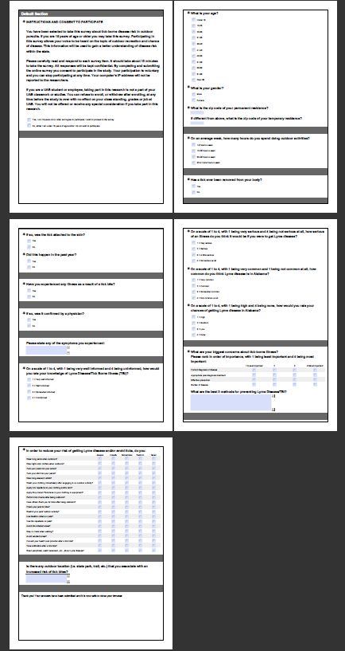

    **Appendix II** – Outreach best practices document

    