NASA DEVELOP National Program
USGS at Colorado State University
Summer 2017

Colorado River Basin Water Resources
Utilizing NASA Earth Observations to Evaluate Invasive Species Cover in Riparian Areas of the Colorado River Basin


Technical Report
Final Draft – August 10, 2017

Megan Vahsen (Project Lead)
Emily Campbell
Daniel Carver
Julia Sullivan
Chanin Tilakamonkul
Brian Woodward

Dr. Paul Evangelista, Colorado State University (Science Advisor)
Dr. Amanda West, Colorado State University (Science Advisor)
Nicholas Young, Colorado State University (Mentor)
Anthony Vorster, Colorado State University (Mentor)

Previous Contributors:
Sarah Carroll
Amandeep Vashisht
Leana Schwartz
Chanin Tilakamonkul

1. Abstract
Riparian corridors are inhabited by unique and biodiverse plant communities that control erosion, manage sediment loads, and filter pollutants. These ecosystems are transitional zones between terrestrial and aquatic systems that provide important wildlife habitat and maintain the overall health of rivers. The Colorado River Basin not only serves as an important ecological system, but also provides a water supply to more than 40 million people in the western United States. However, the spread of invasive species such as tamarisk (Tamarix spp.) impacts the ecosystem functionality of this river basin by altering flow regimes, sediment loads, and evapotranspiration rates. This project utilized Shuttle Radar Topography Mission (SRTM) topographic data, Landsat 8 Operational Land Imager (OLI), and Landsat 5 Thematic Mapper (TM) to map and distinguish tamarisk cover from that of riparian species in 2006 and 2016 in the Green River watershed of the Colorado River Basin. In addition, for 2016 tamarisk cover maps, we compared Landsat 8 to Sentinel-2 Multispectral Instrument (MSI) in a cross-platform analysis. We generated, invasive species cover maps and an in-depth tutorial which will allow our partners at the Walton Family Foundation to create effective management plans and to reproduce this methodology for future planning.

Keywords
Remote sensing, riparian corridor, habitat suitability modeling, Sentinel-2, tamarisk

2. Introduction
2.1 Background Information
Riparian corridors are critical ecosystems, providing habitat for a wide range of wildlife species (Dewine & Cooper, 2007) and serving as hotspots of biodiversity (Swift, 1984). Riparian areas are also economically beneficial as they directly influence water quality and support agriculture and recreation (Salo & Theobald, 2016). Across the western United States, the health and functionality of these ecosystems are threatened by invasive plant species (Poff et al., 2011). Although the spread of invasive species is a global concern (Mack et al., 2000), riparian ecosystems are disproportionately prone to invasion compared to other habitat types (Stohlgren et al., 1998; Jarnevich & Reynolds, 2011), possibly because these areas already harbor high native species richness (i.e. “the rich get richer” hypothesis; Stohlgren et al., 2003). Notably, riparian vegetation in arid environments of the western United States has decreased by more than 80% due to invasive species introduction and land use change (Hewitt, 1990).

The Colorado River Basin (CRB), one of the most prominent river systems in the West, spanning 2,300 kilometers across seven states (USGS, 2016), has been inundated by woody invasive plant species (Triedman, 2012). These invasive species displace native plants, such as cottonwood and willow, and can result in significant floodplain degradation (Birken & Cooper, 2006). Tamarisk (Tamarix spp.) is considered one of the most concerning invasive plants in the Colorado River Basin as it covers hundreds of thousands of acres and can form extremely dense monocultures (Bloodworth et al., 2016). Riparian zones dominated by tamarisk have been attributed with reduced water availability and habitat quality for wildlife (Griffith et al., 2005; Dennison et al., 2009; West et al., 2016). These effects are partially due to the extensive root systems of monoculture tamarisk stands that trap sediments, causing a reduction in channel width and increasing flooding potential (Graf, 1978; Sher & Quigley 2013).

Past attempts to control tamarisk in the CRB, such as manual removal and herbicide treatments, have proven expensive, unsuccessful, or have negatively impacted riparian ecosystems (Dennison et al., 2009). The United States Department of Agriculture approved the use of a biological agent, the tamarisk beetle (Diorhabda elongata), in 1996 to mitigate the spread of tamarisk in riparian zones (Dennison et al., 2009). The results of this management effort remain somewhat inconclusive. As there are few monitoring programs to track the beetle and its defoliation of tamarisk and ground-based monitoring is not always feasible, this can present challenges for model creation (Dennison et al., 2009).

Remote sensing has the potential to supplement ground-based surveys to monitor the extent of tamarisk invasion and evaluate the efficacy of management efforts. Tamarisk cover has been successfully mapped using remote sensing in the Arkansas River Basin (Evangelista et al., 2007, Evangelista et al., 2009, West et al., 2016) and to a broader extent in the western United States (Jarnevich et al., 2011). However, research is still needed to determine the effectiveness of this approach on distinguishing defoliated and dead tamarisk canopies (Young et al., 2015). To address this information gap, this project focused on mapping tamarisk in part of the Upper Colorado River Basin (UCRB) before (2006) and after (2016) species management in accordance with the Salt Cedar and Russian Olive Control Demonstration Act of 2006 (Figure 1).

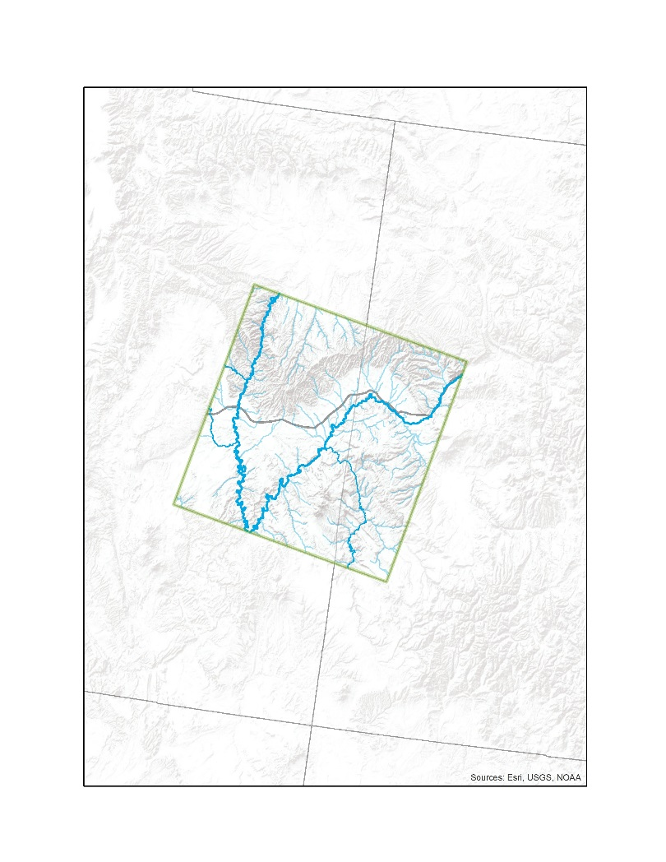
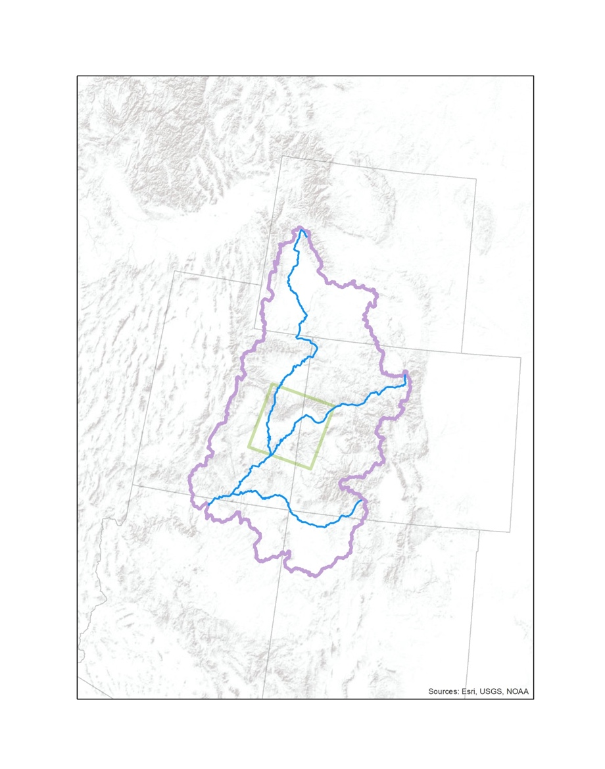
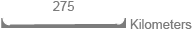
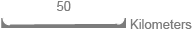
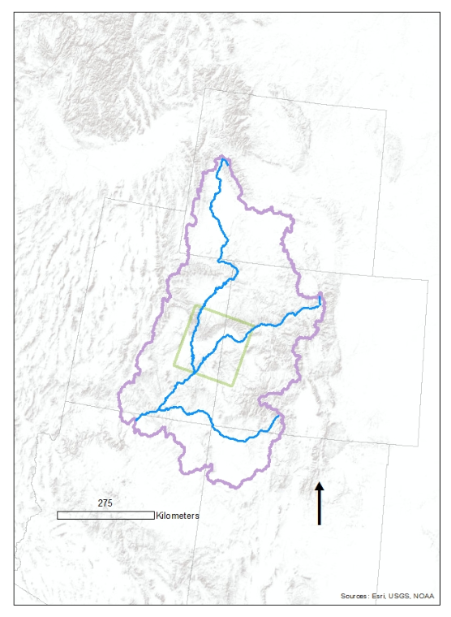
Our study area specifically encompassed riparian corridors in Landsat scene Path 36, Row 33, located in the UCRB, which were delineated utilizing methodology implemented by the NASA DEVELOP Arizona Water Resources team (Carroll et al., 2017). The climate in the UCRB is arid to semi-arid, with periods of drought becoming more pronounced in the past decade (Kopytkovskiy, 2009). Elevation in the region ranges from 4,850 to 13,000 feet, featuring canyons, valleys, and mountains predominantly comprised of limestone, sandstone, and shale (Kopytkovskiy, 2009). The major rivers in this area are the Colorado River, the Green River, and the San Juan River, which includes smaller watersheds within the UCRB, including the Gunnison, Upper Colorado-Dirty Devil, Upper Colorado, Dolores, Colorado Headwaters, White-Yampa, and Lower Green watersheds.
Study Area
Upper CRB
Streams
I-70
Green River
Utah
Colorado
Study Area
Map
Large Area
Map
Green River
Landsat P36/R33
Dolores River
Colorado River
Wyoming
Utah
Arizona
New Mexico
Colorado
Colorado River
San Juan River
Figure 1. The study area for this project is situated within the Upper Colorado River Basin (UCRB) encompassing sections of Colorado and Utah. The extent of the study area corresponds to the Landsat scene path 36 row 33. Field data were collected from the following major streams within the study area: Colorado, Green, Dolores, San Rafael, and Price.

  - Project Partners & Objectives
Our main objective was to use Landsat 5 Thematic Mapper (TM) and Landsat 8 Operational Land Imager (OLI) data to quantify the percent cover of tamarisk (Tamarix spp.) in riparian corridors of the UCRB (Figure 1). We specifically evaluated the change in tamarisk cover from 2006 to 2016 to assess the efficacy of management efforts that began in 2006. We also conducted a comparison of the efficacy of Landsat 8 and Sentinel-2 imagery in classifying tamarisk cover.

In collaboration with the US Geological Survey Fort Collins Science Center (USGS) and the Colorado State University’s Natural Resource Ecology Lab (NREL), this project provided our partners at the Walton Family Foundation with maps that quantify the current extent of tamarisk cover and how it has changed in the past decade. The Walton Family Foundation can use these products to evaluate existing management efforts and aid with creating informed future management plans. An in-depth tutorial describing the modeling process will allow end users to replicate our methodology for additional study areas and periods.

3. Methodology
3.1 Data Acquisition
Landsat 5 TM and Landsat 8 OLI data were acquired for WRS-2 Path 36, Row 33 from USGS Landsat Collection 1. Imagery captured during the tamarisk growing season (April-October) with less than 10% cloud cover were retrieved from the USGS Earth Explorer website for two time periods, 2005-2006 (for 2006 maps) and 2015-2016 (for 2016 maps), using the Earth Resources Observation and Science (EROS) Center Science Processing Architecture (ESPA) on-demand interface (USGS, 2016). Imagery for May 2015 or 2016 was not acquired as low cloud-cover images were not available. Data were acquired with a solar correction applied to top-of-atmosphere (TOA) reflectance.

We compared 2016 tamarisk cover maps that employed Landsat 8 imagery, to cover maps that used Sentinel-2 Multispectral Instrument (MSI) imagery. Sentinel-2 is an Earth observation satellite/mission that was launched in 2015 and includes thirteen spectral bands that vary in their spatial resolution. Bands that capture atmospheric processes (Bands 1, 9, and 10) are sampled at a coarser 60 m resolution, while bands that are more commonly used (e.g. blue, short-wave infrared; Bands 2, 11) are sampled at a finer 10 m or 20 m resolution. We acquired Sentinel-2 (Level 1-C) imagery from the European Space Agency (ESA) via the Copernicus Open Access Hub (ESA, 2016). The Sentinel imagery acquired overlapped part of our Landsat based study area, but was considerably smaller in area. Cloud-free Sentinel imagery was acquired for September 2016, November 2016, and June 2017.

We collected tamarisk percent cover field data within our study area in Colorado and Utah in June 2017. We recorded percent cover for vegetation by species or general taxa, and other land cover-types in 7.32 m circular plots that were opportunistically sampled (Appendix A). Tamarisk percent cover data for 2005 and 2006 were acquired from the National Institute of Invasive Species Science (NIISS) via the Tamarisk Coalition. The methodology used by the Tamarisk Coalition to collect percent cover data was comparable to our sampling methodology; however, no absence plots (0% tamarisk cover) were sampled. We supplemented 2006 and 2016 data with absence points sampled visually using the National Agricultural Imagery Program (NAIP) imagery. Absence points were centroids of 30m by 30m Landsat pixels classified as containing 0-5% riparian vegetation cover.

3.2 Data Processing
Field data collected in June 2017 and 2016 NAIP absence points were used to train classification models for the 2016 tamarisk cover maps. Ancillary data collected in 2005 and 2006 by the Tamarisk Coalition (via NIISS) and 2006 NAIP absence points were used to train tamarisk models for 2006 cover maps. This resulted in a total of 725 total points to build the 2006 Landsat models, 476 total points to build the 2016 Landsat model, and 160 total points to create the 2016 Sentinel models.

Landsat 5 TM (Path 36, Row 33) and Landsat 8 OLI imagery (Path 36, Row 33) were processed in R following methodology used in Arizona Water Resources (Carroll et al., 2017). We created additional indices and transformations for Landsat imagery in R including: Normalized Difference Vegetation Index (NDVI), Soil Adjusted Vegetation Index (SAVI), Specific Leaf Area Vegetation Index (SLAVI), Tasseled Cap Brightness (TCB) (Figure 2), Tasseled Cap Greenness (TCG), and Tasseled Cap Wetness (TCW). A total of 23 predictors were created for each Landsat image. The 2006 model incorporated 7 images resulting in 161 total predictors. The 2016 model incorporated 6 images resulting in 138 total predictors. Finally, the Sentinel-2 imagery (Military Grid Reference System 12S was processed in ArcMap, and indices were derived using Raster Calculator within ArcMap. This process resulted in 18 predictors within 3 images for a total of 54 predictors.

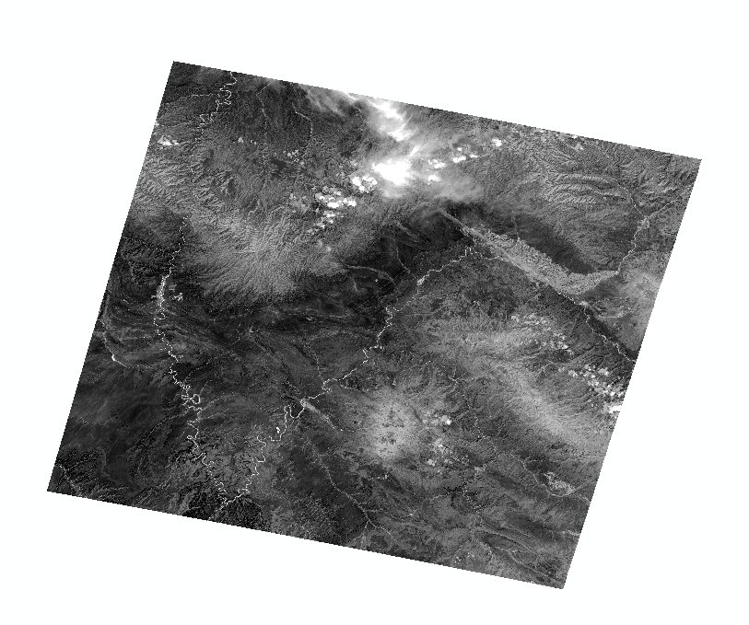
3.3 Data Analysis
We used the random forest machine-learning algorithm to classify tamarisk presence and quantify percent cover within our study area for 2006 and 2016. Random forests are a collection of decision trees that are used to inform predictions for classification and regression (Breiman, 2001; Liaw & Wiener, 2002). Random forest is a particularly robust classifier, which can provide highly accurate predictions and remains insensitive to overfitting (Belgiu & Dragut, 2016).

We used a two-step classification method to predict the percent cover of tamarisk within our study area. First, we executed a classification model using training points that were categorized as tamarisk presence or absence. Sampled field plots with 0% tamarisk cover and all NAIP absence plots were treated as absences. Plots with percent cover greater or equal to 20% for field sampled locations were treated as presence points, and locations with percent cover between 0 and 19% cover were removed to improve the model’s ability to distinguish between presences and absences. This resulted in 363 presence and 310 absence points for the 2006 Landsat classification model, 99 presence and 326 absence points for the 2016 Landsat classification model, and 82 presence and 54 absence points for the 2016 Sentinel classification model. Predictors for each model were determined using the VSURF (version 1.0.3) package in R. VSURF (Variable Selection Using Random Forests) implements a three-step method to remove unimportant variables, select predictors that are highly important to the response, and remove predictors that are redundant for prediction purposes. Predictors remaining after the last variable selection procedure were additionally assessed for high collinearity. If two predictors were highly correlated (Pearson’s coefficient, |r|>0.7), the variable with lower explanatory power was removed. The final set of predictors was used in a random forest classifier implemented with the randomForest (version 4.6-12) package in R. Second, we executed a regression model for continuous percent cover data (from 0 to 100% tamarisk cover) using random forest. Predictor selection was achieved using the same methods as for the classification model. An iterative process for parameter testing of the random forest models was performed to identify the optimal parameters for a given model.
Figure 2. Landsat 8 image of Tasseled Cap Brightness. The brightness transformation is found to be a strong predictor of tamarisk presence (Table 1). The major waterways of the study area are highlighted.

Figure 2. Landsat 8 image of Tasseled Cap Brightness. The brightness transformation is found to be a strong predictor of tamarisk presence (West et al., 2016). The major waterways of the study area are highlighted.

We created tamarisk percent cover maps using the outputs from both the classification and regression models. The predicted percent cover map from each regression model was first clipped to the extent of predicted presence from the classification model for each year (i.e. all pixels predicted as absences were removed). The clipped predicted percent cover map was then restricted to the study area: the extent of the riparian corridor delineated using methodology developed by Arizona Water Resources I. We clipped the predicted presence maps for 2006 and 2016 to the study area and estimated the percent change in tamarisk presence between years using the two Landsat regression maps. Pixels that either increased or decreased in predicted percent cover >20% between the two study years were considered areas of considerable change.

4. Results & Discussion
4.1 Analysis of Results
4.1.1 Analysis of classification modeling results
We evaluated the performance of our classification models using standard evaluation metrics and visual assessment of maps produced from classification models. The 2006 Landsat, 2016 Landsat, and 2016 Sentinel classification models performed reasonably well based on predictive metrics (Table 1). The Landsat 2016 model had the lowest out-of-bag error indicating that it correctly classified the highest proportion of its training dataset compared to other classification models.

Table 1. Predictive statistical metrics from classification models. Lower values of out-of-bag error and higher values of sensitivity and specificity indicate better model performance.
Earth Observation | Year | Predictors  (listed in order of importance) | Out-of-Bag Error | Sensitivity  (true + rate) | Specificity  (true - rate)
Landsat 5 TM | 2006 | August 2006 T Cap Brightness, July 2005 Blue, April 2005 Blue, April 2005 MNDWI, July 2005 CTVI, May 2006 MNDWI, October 2006 GEMI | 21.84% | 70.32% | 84.85%
Landsat 8 OLI | 2016 | September 2015 Blue, April 2015 GNDVI, July 2016 SLAVI, August 2015 GEMI, August 2015 NDWI2 | 15.06% | 64.65% | 91.10%
Sentinel-2 MSI | 2016 | June 2017 SWIR1, September 2016 MNDWI | 18.38% | 84.37% | 77.36%

However, both Landsat 2006 and 2016 models had considerably lower sensitivity compared to specificity, indicating that these models were more likely to fail to predict a presence correctly than an absence correctly. In comparing the Landsat 2006 and 2016 models, the 2006 model predicted a higher proportion of false positives (i.e. observed absence, predicted presence) than did the 2016 model (Figure 3). The Sentinel-2 2016 model predicted presences and absences correctly at a similar rate (Table 1) and predicted false positives at a similar rate to the Landsat 2016 model (Figure 3).

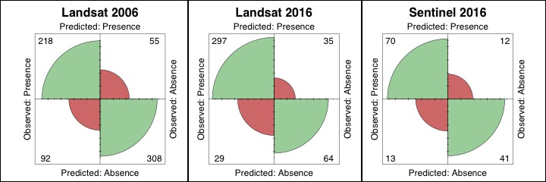
Figure 3. Confusion matrices for Landsat 2006, Landsat 2016, and Sentinel 2016 classification models. Green areas indicate the proportion of observations in the training dataset that were classified correctly. Red areas indicate the proportion of observations in the training dataset that were incorrectly classified. For example, the upper-right corner of each plot represents false positives (i.e. where the model classified a presence but the training point was an absence).

Visual assessment of the classification models indicated considerable variation across models in the percent of the riparian corridor that was classified as tamarisk presence. For example, Landsat 5 predicted that 31% of the riparian corridor was classified as presence while the Landsat 8 model predicted that only 5% was classified as presence.
Landsat 2006
Landsat 2016
Sentinel 2016
< 10
10 – 20
20 – 30
30 – 40
40 – 50
> 50
< 10
10 – 20
20 – 30
30 – 40
40 – 50
> 50
< 10
10 – 20
20 – 30
30 – 40
40 – 50
> 50
Predicted
Percent
Cover
Predicted
Percent
Cover
Predicted
Percent
Cover
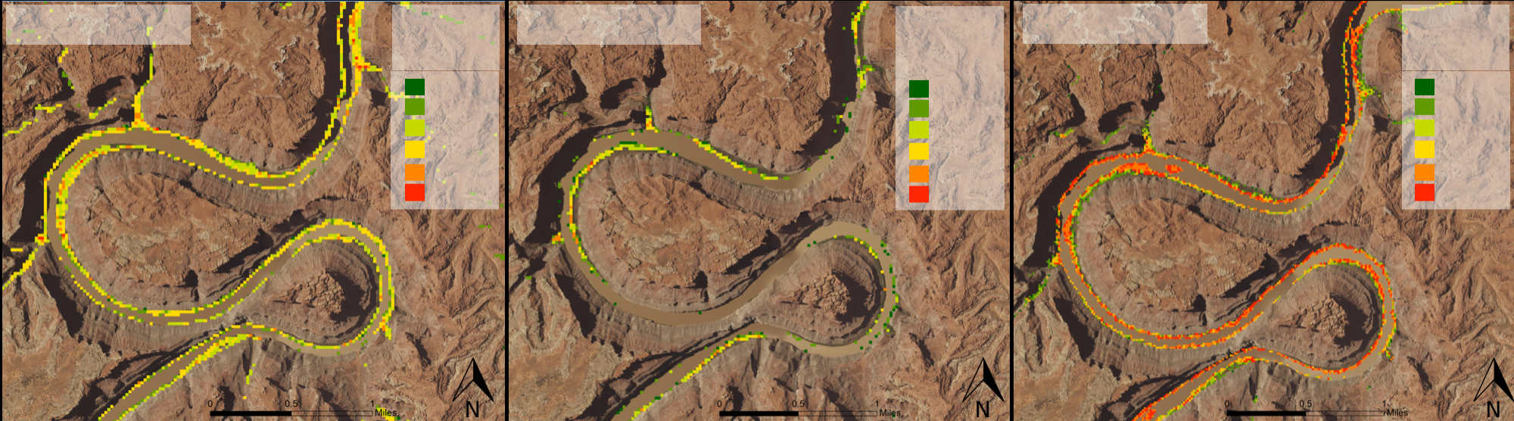
Figure 4. Predicted tamarisk cover for Landsat 2006, Landsat 2016, and Sentinel 2016 models. Maps show percent tamarisk cover from the continuous model for areas that were predicted as presences by the binary model.

4.1.2 Analysis of continuous modeling results
We evaluated the performance of continuous regression models using predictive metrics and visual assessment. The Landsat 2006 model was the weakest of the three regression models, with the lowest percent variance explained and the highest root mean squared error (Table 2). The Sentinel 2016 model explained more variance in the training data compared to the Landsat 2016 model (Table 2), but visual assessment of the regression models showed that the Sentinel 2016 model predicted considerably higher percentages in tamarisk cover overall (Figure 4).

Table 2. Predictive statistical metrics from regression models. Higher percent variance explained and lower root mean square error indicate better model performance.
Earth Observation | Year | Predictors  (listed in order of importance) | Percent variance explained | Root Mean Square Error
Landsat 5 TM | 2006 | April 2005 NIR, September 2006 MNDWI, August 2006 T-Cap Brightness, August 2006 CTVI, April 2005 MNDWI | 24.62% | 20.17
Landsat OLI | 2016 | August 2015 SLAVI, April 2015 GNDVI, July 2016 NDWI2, June 2016 MNDWI, September 2015 Blue | 31.90% | 15.14
Sentinel-2 MSI | 2016 | June 2017 SWIR2, June 2017 Red-edge NDVI, September 2016 MNDWI | 37.76% | 19.02

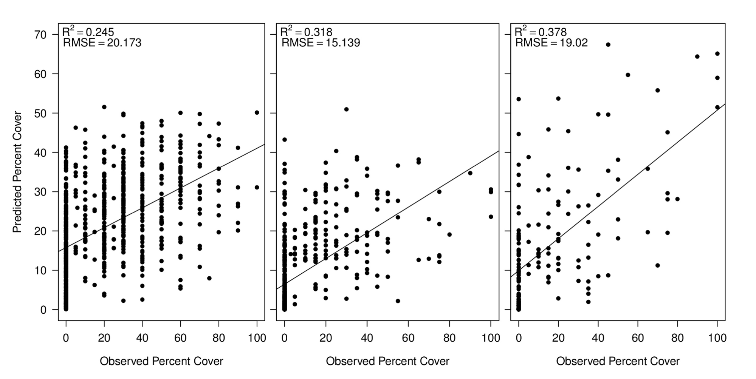
Figure 5. Predicted percent cover for Landsat 2006, Landsat 2016, and Sentinel 2016 models. Points represent training observations and lines represent the best fit of linear model predictions. R² and root mean square error (RMSE) are reported for each model as evaluations of model fit to the data.

4.1.3 Change in tamarisk cover between 2006 and 2016
Change maps identified areas where the predicted percent tamarisk cover increased or decreased by a value greater than 20% between 2006 and 2016. The regression outputs from the Landsat 2006 and Landsat 2016 models were used for this analysis, which showed that tamarisk cover increased 7.1 sq km accounting for 0.2% of the potential riparian area. Tamarisk cover decrease by 186.7 sq km, accounting for 4.5% of the potential riparian area (Figure 6.). This illustrates a net decrease in tamarisk across the scene by 179.6 sq km between 2006 and 2016. This change in tamarisk cover could represent an ecologically real effect in response to management, differences in the abilities of Landsat 5 and Landsat 8 models to distinguish tamarisk cover, or a combination of the two.

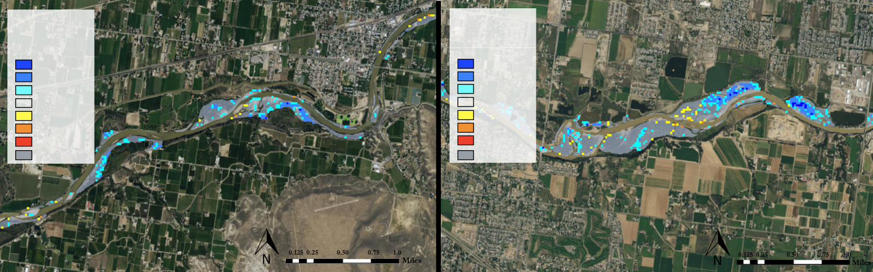
Predicted
Change in
Percent Cover
Predicted
Change in
Percent Cover
>40% ↓
30-40% ↓
20 – 30% ↓
No change
20-30% ↑
30-40% ↑
>40% ↑
Treatment
>40% ↓
30-40% ↓
20 – 30% ↓
No change
20-30% ↑
30-40% ↑
>40% ↑
Treatment
Figure 6. Change in percent tamarisk cover between 2006 and 2016 in tamarisk management areas on the Colorado River. Colored pixels represent areas where the predicted percent of tamarisk changed great than 20% from 2006 to 2016. Grey polygons outline treatment areas.

4.1.4 Cross-platform analysis between Landsat 8 and Sentinel-2
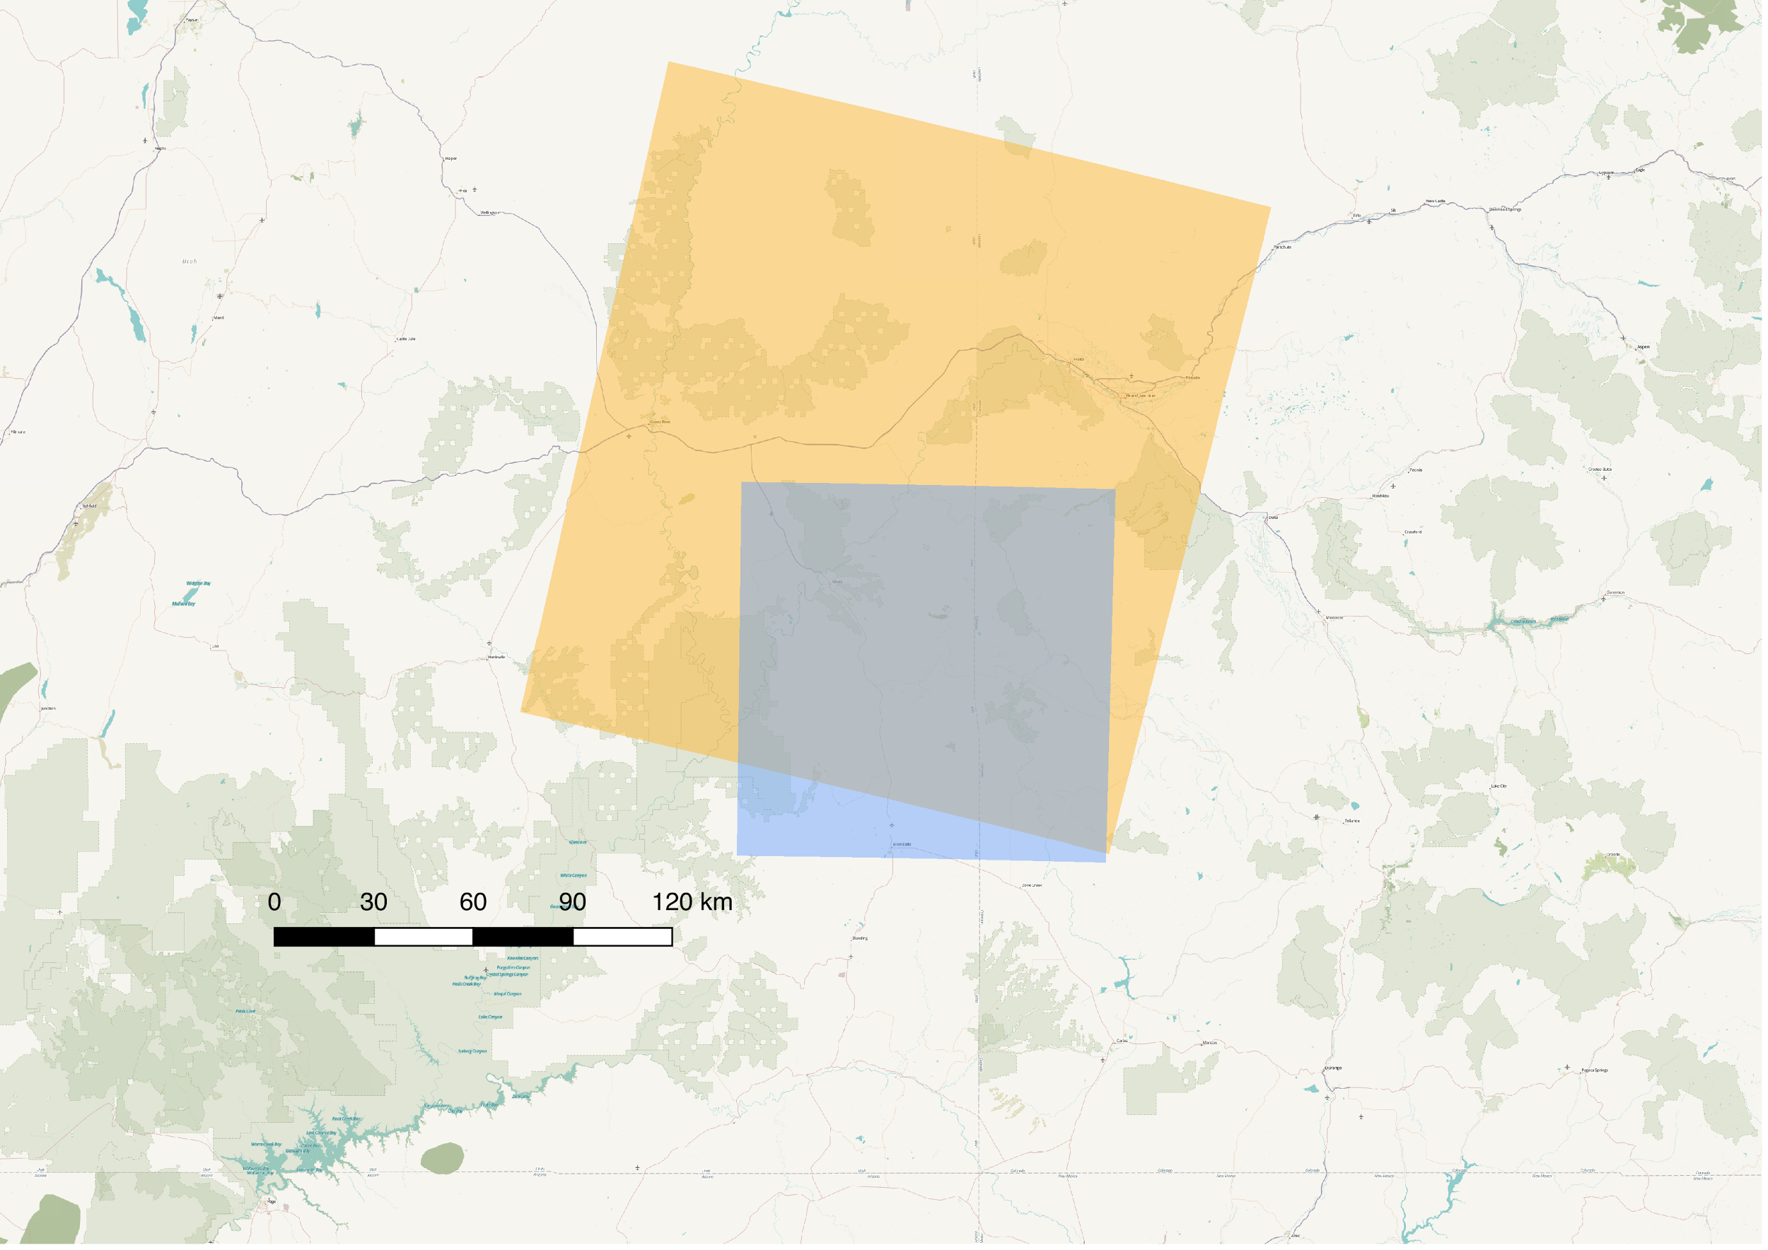
Models utilizing Landsat 8 imagery and Sentinel-2 imagery predicted considerably different tamarisk presence and percent cover (Figure 4). Within the Sentinel scene (Figure 7), the Landsat 2016 regression model predicted 5.9% of the riparian corridor to be tamarisk cover, while the Sentinel 2016 regression model predicted 14.8% to be tamarisk cover. To perform a change detection analysis between the two models, the Sentinel model was resampled to 30 m. A threshold of greater than 20 percent change in cover was used to produce the change detection map. The results show that 2.2 sq km of land (0.2% of the scene) was mapped as having a higher percent cover by Landsat, whereas 26.8sq km (2.8% of the scene) was mapped as having a higher percent cover by Sentinel. It is important to note that due to the different spatial extents of the Landsat and Sentinel scenes, the Sentinel model was trained with a subset of the Landsat 2016 training data. To improve this comparison the same training data should be used for both models.
Figure 7. Overlay of Landsat scene Path 36, Row 33 in yellow and Sentinel-2 tile T12SXH (Military Grid System) in blue.

4.2 Future Work
Future work with this project will focus on applying this methodology to map tamarisk cover across different regions of the Colorado River Basin. Future research will also seek to quantify potential evapotranspiration differences between tamarisk, native riparian vegetation, and another invasive riparian plant species, Russian olive (Elaeagnus angustifolia).

5. Conclusions
Tamarisk cover detected by our models decreased from 2006 to 2016. Change maps can be used to identify regions where the change is most significant. An evaluation of the change map in a known region of tamarisk management showed that our models did identify a substantial decrease in tamarisk. Continued validation efforts would greatly improve the overall confidence in the predictive capabilities of the models.

The results of the cross platform analysis between the Landsat 8 and Sentinel-2 clearly show that Landsat 8 predicts considerably lower tamarisk cover than models that used Sentinel-2 imagery. Due to the different scene extents and spatial resolution between Landsat 8 and Sentinel-2, it is difficult to state which better represents true tamarisk cover. Future work should include training models for Landsat 8 data using only the points within the extent of the Sentinel-2 scene.

We determined that due to the distribution of our tamarisk cover data, values at the upper end of the model held substantial weight in the predictive potential of the model. Model performance could be further improved by obtaining more tamarisk cover data, particularly plots showing a high percentage of tamarisk cover. The results of this study are a promising next step for project partners to utilize remote sensing to monitor the efficacy of management efforts throughout the Colorado River Basin and inform future management strategies.

6. Acknowledgments
Dr. Paul Evangelista (Colorado State University, Natural Resource Ecology Laboratory)
Dr. Amanda West (Colorado State University, Natural Resource Ecology Laboratory)
Brian Woodward (NASA DEVELOP, Fort Collins Center Lead)
Nicholas Young (Colorado State University, Natural Resource Ecology Laboratory)
Anthony Vorster (Colorado State University, Natural Resource Ecology Laboratory)
Dr. Catherine Jarnevich (US Geological Survey, Fort Collins Science Center)
Dr. Gabriel Senay (US Geological Survey, Fort Collins Science Center)
Peter Skidmore (Walton Family Foundation)

Any opinions, findings, and conclusions or recommendations expressed in this material are those of the author(s) and do not necessarily reflect the views of the National Aeronautics and Space Administration.

This material is based upon work supported by NASA through contract NNL16AA05C and cooperative agreement NNX14AB60A.

7. Glossary
Arizona Water Resources I – Spring 2017 NASA DEVELOP term that established the extent of riparian corridors and riparian vegetation and created products used by the CRB Water Resources team
Corrected Transformation Vegetation Index (CTVI) – vegetation indicator used to estimate greenness and photosynthetic capacity of leaves
Digital Elevation Model (DEM) – a 3-D representation indicating elevation at any given point on the surface of the Earth
Earth observations – satellites and sensors that collect information about the Earth’s physical, chemical, and biological systems over space and time
Enhanced Vegetation Index (EVI) – vegetation index designed to detect vegetation in high biomass regions while reducing atmospheric influences.
Global Environmental Monitoring Index (GEMI) – vegetation index designed for large-scale monitoring of vegetation while minimizing atmospheric effects
Land Surface Water Index (LSWI) – indicator used to highlight cropland and forest lands
NDMI (Normalized Difference Moisture Index) – indicator associated with vegetation moisture that is derived from near infrared and shortwave infrared spectral bands
NDVI (Normalized Difference Vegetation Index) – Indicator of green vegetation abundance derived from visual and near infrared spectral bands
Random Forest – a classification model that creates decision trees to delineate classes.
SAHM (Software for Assisted Habitat Modeling) – software that is used to expedite habitat modeling and facilitate workflow processing
Soil Adjusted Total Vegetation Index (SATVI) – vegetation indicator designed to detect change in biomass over time with vegetation greenness and senescence
Specific Leaf Area Vegetation Index (SLAVI) – indicator used to estimate specific leaf area, the ratio of leaf area to dry mass
Tasseled-Cap transformation – a conversion from original Landsat bands into a new set of bands, e.g. tcap brightness, tcap greenness, and tcap wetness, which are useful for vegetation mapping
Tributary – a river or stream that flows into a larger river or water body
Upper Colorado River Basin (UCRB) – a watershed that contains all the waterways within our study area
VBET (Valley Bottom Extraction Tool) – a GIS tool for delineating valley bottoms across drainage networks
Watershed – an area of land, defined by topographic features, that drains into a common outlet point

8. References

Birken, A.S. & Cooper, D.J. (2006). Processes of Tamarix invasion and floodplain development along the Lower Green River, Utah. Ecological Applications, 16, 1103-1120.

Bloodworth, B. R., Shafroth, P. B., Sher, A. A., Manners, R. B., Bean, D. W., Johnson, M. J., & Hinojosa-
Huerta, O. (2016). Tamarisk beetle (Diorhabda spp.) in the Colorado River basin: Synthesis of an expert
panel forum. Colorado Mesa University.

Carrol, S., Vashisht, A., Schwartz, L., & Tilakamonkul, C. (2017). Utilizing NASA Earth observations to delineate riparian corridors and evaluate invasive species cover in the Verde River watershed. Technical Report. NASA DEVELOP.

Dennison, P.E., Nagler, P.L., Hultine, K.R., Glenn, E.P. & Ehleringer, J.R. (2009). Remote monitoring of tamarisk defoliation and evapotranspiration following saltcedar leaf beetle attack. Remote Sensing of Environment, 113, 1462-1472.

DeWine, J.M. & Cooper, D.J. (2007). Effects of river regulation on riparian box elder (Acer negundo)
forests in canyons of the Upper Colorado River Basin, USA. Wetlands, 27, 278-289.

ESA. (2016). Copernicus and Open Access Hub. European Commission: European Space Agency,
2014-2017. Accessed July 2017. https://scihub.copernicus.eu/

Evangelista, P., Kumar S., Stohlgren, T.J., Crall, A.W., Newman, G.J. (2007). Modeling aboveground biomass of Tamaris rasmosissima in the Arkansas River Basin of Southeastern Colorado, USA. Western North American Naturalist, 67, 503-509.

Evangelista, P.H., Stohlgren, T.J., Morisette, J.T., & Kumar, S. (2009). Mapping invasive tamarisk
(Tamarix): a comparison of single-scene and time-series analyses of remotely sensed data.
Remote Sensing, 1, 519-533.

Graf, W.L. (1987). Fluvial adjustments to the spread of tamarisk in the Colorado Plateau region. Geological
Society of America Bulletin, 89, 1491-1501.

Griffith, J. A., McKellip, R. D., & Morisette, J. T. (2005, March). Comparison of multiple sensors for
identification and mapping of tamarisk in western Colorado: preliminary findings. In
Proceedings of the 2005 American society for photogrammetry and remote sensing (ASPRS) annual
conference, 7Á11 March.

Hewitt, M. J. (1990). Synoptic inventory of riparian ecosystems: the utility of Landsat Thematic Mapper data. Forest Ecology and Management, 33, 605-620.

Jarnevich, C.S., Evangelista, P., Stohlgren, T.J. & Morisette, J. (2011). Improving national-scale invasion maps: Tamarisk in the western United States. Western North American Naturalist, 71, 164-175.

Jarnevich, C.S. & Reynolds, L.V. (2011). Challenges of predicting the potential distribution of a slow-spreading invader: a habitat suitability map for an invasive riparian tree. Biological Invasions, 13, 153-163.

Kopytkovskiy, Marina. (2012). A study of climate change impacts of the Upper Colorado River Basin on water resources and hydropower production. Colorado School of Mines, 2012.

Mack, R.N., Simberloff, D., Lonsdale, W.M., Evans, H., Clout, M. & Bazzaz, F.A. (2000). Biotic invasions: causes, epidemiology, global consequences, and control. Ecological Applications, 11, 689–710.

Poff, B., Koestner, K.A., Neary, D.G. & Henderson, V. (2011). Threats to riparian ecosystems in Western North America: an analysis of existing literature. JAWRA Journal of the American Water Resources Association, 47, 1241-1254.

Salo, J. A., & Theobald, D. M. (2016). A Multi‐scale, Hierarchical Model to Map Riparian Zones.
River Research and Applications, 32, 1709-1720.

Sher, A. & Quigley, M. (2013). Tamarix: A case study of ecological change in the American West. Oxford University Press. pp 512.

Stohlgren, T.J., Bull, K.A., Otusuki, Y., Villa, C.A. & Lee, M. (1998). Riparian zones as havens for exotic plant species in the central grasslands. Plant Ecology, 1, 113-123.

Stohlgren, T.J., Barnett, D.T. & Kartesz, J.T. (2003). The rich get richer: patterns of plant invasions in the United States. Frontiers in Ecology and the Environment, 1, 11-14.

Swift, B. L. (1984). Status of Riparian Ecosystems in the United States. Water Resources Bulletin, 1,
223-228.

Triedman, N. (2012). Environment and ecology of the Colorado River basin. In: The 2012 state of the Rockies report card, pp 89-107.

USGS. (2016). LSDS Science Research and Development (LSRD). US Department of the Interior,
Geological Survey, May 2010. 15 June 2016. http://espa.cr.usgs.gov/

US Geological Survey. (2014). Provisional Landsat OLI Surface Reflectance. US Geological Survey Earth Resources Observation and Science Center. https://dx.doi.org/10.5066/F78S4MZJ

West, A.M., Evangelista, P.H., Jarnevich, C.S., Young, N.E., Stohlgren, T.J., Talbert, C., Talbert M.,
Morisette, J., & Anderson, R. (2016). Integrating remote sensing with species distribution
models: mapping tamarisk invasions using the software for assisted habitat modeling
(SAHM). Journal of Visualized Experiments: JoVE, 116, 54578.

Young, N.E., West, E., Anderson, R.S., Chignell, S., Evangelista, P.H. & Jarnevich, C. (2015). Mapping land cover and invasive tamarisk in Havasu National Wildlife Refuge, AZ. https://dx.doi.org/: 10.13140/RG.2.1.1847.2564

9. Appendices
Appendix A – Field Sampling

Field sampling with the following protocol occurred in June 2017 in areas of the Upper Colorado River Basin including the Colorado, Green, Dolores, Price, and San Rafael rivers. Center points of plots were chosen randomly in riparian corridors to accumulate observations both with and without tamarisk cover (Figure A1). A GPS coordinate was taken at the center of each plot. A 7.32 meter fixed radius was outlined using a measuring tape creating a circular plot (Figure A2). Percent cover (in 5% increments) was estimated in each plot for the following categories: live tamarisk, dead tamarisk, Russian olive, cottonwood, willow, other tree, rabbitbrush, sagebrush, other shrub, grass and forb, bare ground, rock, litter, water, and downed wood. All percent cover categories added up to 100% total in each plot. We recorded whether the plot was in a riparian area or if it was upland of the riparian corridor. We sampled 143 plots that contained at least some percent cover of tamarisk and 44 plots that had no tamarisk for a total of 187 plots.
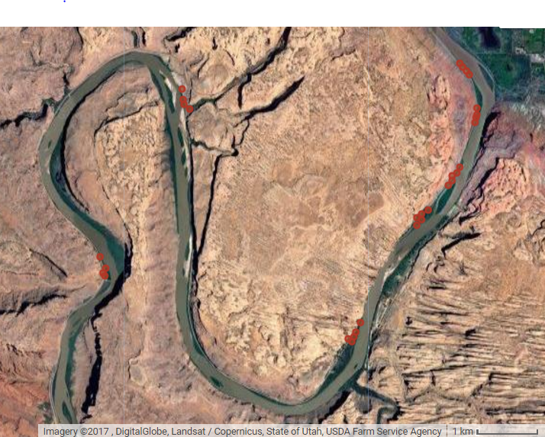

Figure A1: Red points represent sampling plots in riparian areas along the Colorado River just west of Moab, UT. A total of 27 sampling sites are present within this image.

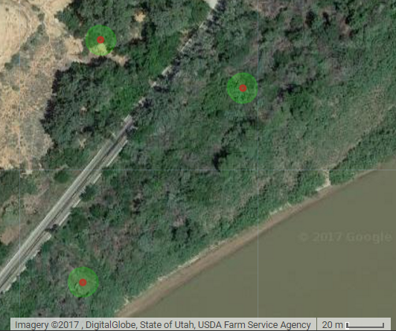
Figure A2: Detailed view of sampling sites with 7.32 m buffer. Values of species type, percent area cover, and vegetation height for all vegetation contained with the buffered area were measured by field sampling team.

