Chile Disasters

Automating Wildfire Risk and Occurrence Mapping in Google Earth Engine to Improve Wildfire Detection and Response Time Efforts

 **Technical Report**

Final– March 31st, 2022

Maria De Los Santos (Project Lead)

Cooper Campbell

Karen Alvarez

Hannah Ferriby

***Advisors:***

Benjamin Holt, Jet Propulsion Laboratory

Virginia Iglesias, University of Colorado Boulder (Science Advisor)

# 1. Abstract

Wildfires in Chile in the last decade were the worst on record, destroying homes and livelihoods, polluting the air, and displacing whole towns. To predict locations where wildfires were likely to start, the Corporación Nacional Forestal (CONAF) created a wildfire risk model within ArcGIS Pro and Google Earth Engine (GEE) that utilized the NOAA Global Forecast System (GFS) and the NASA Shuttle Radar Topography Mission (STRM) 90-meter datasets. The previous CONAF model was very resource-heavy and time-intensive to run. NASA DEVELOP, in partnership with CONAF, automated the previous model and transferred it fully into GEE where all Earth observation datasets could be used without downloading. The new model substantially reduced the runtime. The final model was used to create a near real-time wildfire monitoring application as well as fire severity maps. The end products will be used by CONAF for wildfire prediction and management to prevent more destruction in the future.

**Key Terms**

Fire Risk Location Automated Model (FLAMe), CONAF fire algorithms, Fire Risk ArcGIS ModelBuilder, Google Earth Engine, MODIS

# 2. Introduction

***2.1 Background Information***

Wildfires of increasing size and intensity annually threaten the Chilean landscape and its people with a growing frequency. The 2016–2017 wildfire season was the most disastrous on record in Chile, burning over 600,000 hectares (Dacre, 2018). These large, severe fires threaten the biodiversity of the ecosystems that are unadjusted to tolerate them, and due to the extensive wildland-urban interface in Chile, also threaten human lives, property, and communities (Villagra, 2021). Climatic studies of the region indicate that an all-season decrease in precipitation and increase in temperature will likely only continue to exacerbate the frequency and affected area of these disasters (Urrutia-Jalabert, 2018). Quickly accessible and accurate forecasting of wildfire risk parameters is paramount in fire detection, monitoring, prevention, and suppression to diminish these threats via the efficient deployment of forest resources.

A number of early-warning fire weather forecast systems have long been used to compile climactic variables into wildfire risk values in a similar fashion, such as the McArthur Forest Fire Danger Index and Canadian Fire Weather Index (Dowdy, 2009). Previous studies in Chile have explored the use of Earth Observations for wildfire forecasting to various degrees, often using a similar structure that yields discernable thresholds of fire risk as an end product. The Corporación Nacional Forestal (CONAF) model uses a similar process to these indices (Castillo, 2021). The CONAF model takes temperature, relative humidity, wind, and topographic data as inputs to calculate the probability of ignition (POI, or ‘Pig’) for a given area, a percentage value commonly used internationally to quantify wildfire risk. The POI is reclassified to identify areas that fall under ‘Red Flag’ warning under CONAF’s desired parameters. When a red flag warning area is identified, additional resources are directed to the location for preventative or proactive measures.

The methodology of this project was built upon the existing workflow of the CONAF's monitoring tools, which was divided between Google Earth Engine (GEE) and ArcGIS ModelBuilder and included time-intensive manual efforts. The CONAF’s Global Forecasting System (GFS) script (in GEE) utilized meteorological data from the National Oceanographic and Atmospheric Administration’s Global Forecast System to create study area outputs of temperature, humidity, wind, and precipitation. The structure of the GFS script was designed to pass these outputs to their ArcGIS ModelBuilder program. One of the goals of the project is to develop a wildfire risk GEE app to aid the near-real-time monitoring of wildfire conditions.

The case study to evaluate project success focused upon the O’Higgins, Maule, and Bíobío Regions of central Chile in January of 2017 — the area and period of the most catastrophic Chilean wildfires on record, shown in Figure 1. The project used Earth observations of the prior five years to the adjustable study date and current climatic data to create near-real time forecasts of fire risk in the study area.

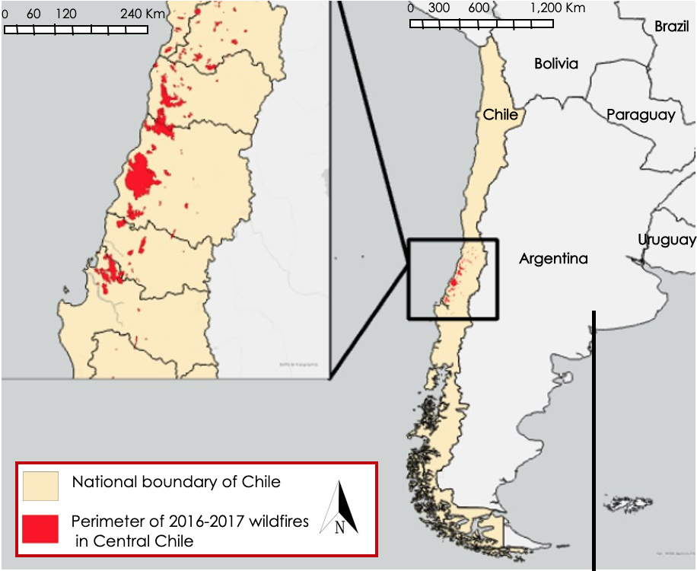

*Figure 1.* The national boundary of Chile and the perimeters of historic fires in the 2016–2017 case study area and period

***2.2 Project Partners & Objectives***

This project was conducted in collaboration with CONAF, a private entity under the Ministry of Agriculture of Chile that coordinates the conservation, management, and use of the country's forest resources. CONAF has used a number of software packages to monitor, prevent, and respond to wildfires, accomplishing this through meteorological data taken from the GFS and the NASA Shuttle Radar Topography Mission (STRM) elevation data. These parameters are then exported from GEE and input into an ArcGIS Model Builder to model fire risk. This current workflow can take up to 3-4 months to prepare all datasets utilized for fire risk, occurrence, and recovery monitoring. Therefore, CONAF and the Embassy of Chile are interested in improving their capacity to use more Earth observations to map wildfire risk and fire perimeters in near-real time to improve wildfire prevention and response time efforts. The primary benefits of this project include improving end users’ ability to monitor wildfire conditions, understand wildfire risks, and create informed response efforts.

This project aims to support partners' current disaster monitoring and response through remote sensing analysis and training materials. First, we identified key geoprocessing tools that partners use in their ArcGIS model. Next, we created fire severity maps and fire risk maps to identify possible vulnerability areas, and map burned areas when fires have occurred. Then we developed a wildfire risk GEE app to aid the near-real-time monitoring of wildfire conditions. In addition, our team carried out a case study of the 2017 wildfire season in Chile, explicitly examining the effects of the five largest fires to demonstrate the potential of our model for disaster analysis. Finally, we designed a code tutorial for the Wildfire Risk app to enhance the partner's monitoring capabilities.

# 3. Methodology

***3.1 Data Acquisition***

The team acquired the model outputs of temperature, relative humidity, wind and precipitation from NOAA’s GFS 348-Hour Predicted Atmosphere Data within the GEE data catalog. GFS generates a weather model four times a day with forecast of temperature, wind, humidity and precipitation data for the following 16 days. The system couples four separate models (atmosphere, ocean, land and sea ice) to accurately depict weather conditions. Sentinel-2 MSI and Landsat 8 Operation Land Imager (OLI) Collection 2 Tier 1 imagery from the GEE data catalog were used to calculate burned area. The team used the Normalized Burn Ratio (NBR) to identify burned areas and provide a measure of burned severity. Additional data included a digital elevation model (DEM) from the 2000 NASA Shuttle Radar Topography Mission (SRTM). Detailed information about the satellite imagery and products is found in Table 1 below.

Table 1.

*Satellite remote sensing data products, dates of coverage, and sources used.*

|  |  |  |  |  |
| --- | --- | --- | --- | --- |
| **Data Products** | **Data Parameters** | **Temporal Coverage Used for Study** | **Source** | **Use** |
| **Landsat 8 OLI** | Collection 2, Tier 1 OLI sensor imagery containing four visible and near-infrared (VNIR), two short-wave infrared (SWIR), and one thermal infrared (TIR) band at 30 meter resolution. | January-December (2015-2021) | United States Geological Survey (USGS); in GEE catalog | Severity maps and Wildfire Risk GEE App |
| **Sentinel-2 MSI** | Level 2A Surface Reflectance at 10-20 meter resolution and ~5 day revisit. | January-December (2015-2021) | European Space Agency (ESA) Copernicus Open Access Hub | Severity maps and Wildfire Risk GEE App |
| **SRTM** | 90 meter resolution Digital Elevation Model | February (2008) | NASA, Consortium for Spatial Information | Wildfire Risk GEE App |
| **CONAF Historical Fires** | Historical fires points and perimeters shapefiles | January-December (2015-2017) | Corporación Nacional Forestal | Fire Severity Maps and Wildfire Risk GEE App |
| **Global Forecast System (GFS)** | The 384-hour forecasts, with 3-hour forecast interval, are made at 6-hour temporal resolution. Model outputs: temperature, relative humidity and wind. | January-December (2015-2021) | NOAA; in GEE catalog | Severity maps and Wildfire Risk GEE App |

***3.2 CONAF Red Flag Warning ModelBuilder***

CONAF's current model is called Red Flag Warning ModelBuilder (RFWM). It utilizes nine days intervals of meteorological data, such as wind direction, wind speed, temperature, and relative humidity, and also a 250-meter elevation raster to generate Red Flag Warnings (RFW). All the forecasting data and the elevation raster are exported from GEE and imported into ArcGIS. All forecasting data undergoes a similar process. First, all temperature, wind, and relative humidity rasters are converted into points, since the next step, inverse distance weighted (IDW) interpolation, requires the use of vector data. IDW is a technique used to determine cell values from points. The value at an unknown point is calculated using a weighted average of the values of known points. The weighting is proportional to the inverse of the distance raised to the power gamma, where gamma is a parameter chosen by the user.

After IDW interpolation for temperature, wind and humidity, a separate step was taken to calculate Fine Fuel Moisture Content (FFMC). To calculate FFMC, relative humidity (HR) and temperature (Temp) GeoTiffs are added using a formula developed by the University of Chile (1). HR refers to the percent value from 1-100, while Temp is in Celsius. The output of this calculation is a raster and then follows the same steps as above, resulting in an FFMC shapefile.

$('0.297374+(0.262*HR)-(0.00982*Temp) (1)$

Next, all the forecast data that had been interpolated along with the FFMC and elevation rasters were reclassified to produce probability of ignition in ArcGIS Pro (2.8), using tables from CONAF. The Reclassify tool changes a range of values to a single value. CONAF uses reclassified values that were determined using the 2016-2017 fire season as a proxy (Tables A1-A7). To generate the final Red Flag Warnings shapefiles, the wind and the probability of ignition shapefiles were reclassified, combined, reclassified again, and finally converted into polygons.

***3.3 GEE FLAMe Model***

CONAF's model (RFWM) required the use of both GEE and ArcGIS. To optimize and condense their model within GEE, we used a variety of functions. The resulting modelwill be refrred to as the Fire Risk Location Automated Model (FLAMe) model. The GFS data in RFWM was coded to be filtered by region in ArcGIS. With FLAMe, the partners can now choose which region of Chile to analyze, cutting down on processing time and power. The team then took all the geoprocessing tools used within ArcGIS, like IDW, Reclass, and combination steps, and encoded them into Google Earth Engine. RFWM's ArcGIS module takes nine input rasters for each parameter and runs through each to create 9 RFW shapefiles (Figure B1).This process can be coded in GEE; however, it would result in 9 images per parameter, a total of 54 images, which would have to be processed individually. To optimize this process, the team used a variety of functions to create image collections. First, each meteorological parameter is converted to points. This results in five image collections for each parameter containing nine images. All the remaining processes were first run on these image collections. The results of each geoprocessing tool would create a new image with multiple bands that we would merge into an image collection. Each processing tool was coded as a function that could be applied to each image within an image collection.

To use IDW within GEE, we had to determine a gamma value that is not required in ArcGIS. We chose to input the default gamma value as this parameter was not partner-defined and was not used in the ArcGIS model. Next, we used mathematical operations like .add and .subtract within GEE to replicate the Raster Calculator tool in ArcGIS. Next, we used the .where function to reclassify the image collections. Each meteorological parameter, as well as the elevation raster, had different reclassification values. We used the reclass values used by CONAF (Tables A1-A7). The team used GEE expressions such as .where and .remap to reclassify each image. Lastly, RFWs had to be converted into polygons. This conversion cannot be performed on an image collection. Therefore, a function was defined using the .reduceToVectors expression in GEE, then applied to each image within each collection. This method creates centroids at the center of each pixel and uses those values to convert to polygons, resulting in 9 RFW shapefiles.

To aid the wildfire impact efforts of our partners, we added Burn Area (BA) mapping to the model, adapting code from the United Nations to calculate BA (UN, 2016). To calculate difference Normalized Burn Ratio (dNBR), we used surface reflectance data from Landsat 8 OLI and Sentinel-2 MSI data. We defined pre-fire start, pre-fire end, post-fire start, and post-fire end dates were defined and then clipped the data to our study area. A cloud mask was defined and applied to both sensors using the pixel QA cloud mask. After mosaicking the pre-fire and post-fire images, we calculated the normalized difference using the .normalizedDifference expression within GEE. The resulting pre-fire NBR image was subtracted from the post-fire image, creating a dNBR image representing burned area.

***3.4 Case Study***

The team compared three days of POI and Red Flag Warning results from the nine-day GFS output with the perimeters of wildfires that began on the same respective dates. The case study investigated the five largest wildfires of the 2016–2017 fire season, including the Nilahue Barahona, Las Cardillas, Las Maquinas, Santa Cruz, and San Antonio fires. These fires each grew to consume over 15,000 hectares, with the largest, the Las Maquinas, covering over 190,000 hectares. Each of the five wildfires began between January 14 and 20, 2017 and occurred in the O’Higgins, Maule, and Bíobío regions. Figure 2 displays these fires and the change in Normalized Burn Ratio – a metric for fire severity – within their boundaries between the pre-fire period (December 20, 2016 – January 13, 2017) and the post-fire period (February 20, 2017 – March 28, 2017).

***3.5 Data Analysis***

Given that the five wildfires began between January 14 and 20, 2017, the team ran the GEE FLAMe model for January 13, 2017, to evaluate model accuracy given these known fires. The data analysis occurred by comparing the RFW results in the GEE FLAMe model to where fires actually occurred in that same test period. In this instance, the period of comparison is January 13, 2017, to January 22, 2017, because of its high wildfire occurrence. For the comparison, we noted if the GEE FLAMe RFW zone intersected the historical fire perimeters from 2017 and what the GEE FLAMe POI for the historical fires was to evaluate whether the POI value had any indication of fire. In addition, the original process of exporting data from GEE to then run in an ArcGIS model took 3 to 4 months to complete. The team considered the speed of the GEE FLAMe model to be an improvement to data collection, as any time reduction is an improvement on overall model performance.

# 4. Results & Discussion

***4.1 Analysis of Results***

The results of the created Fire Risk Location Automated Model (FLAMe) tool showed successful practical applications when compared with historic wildfire data. The team observed that historic wildfires occurred directly adjacent to red flag warning zones from the model on day 1 and 4 of the model output, although they did not occur within the resultant zones. Additionally, on all days, wildfires began in or near areas calculated to have an exceptionally high POI. These results are displayed in Figure 3. It is also important to note that accuracy decreased in later dates of model results, with day 7 showing the least proximity of wildfires to red flag warnings and high POI areas. Day 1 of results showed the highest accuracy, with marginal overlap of the fire perimeter and red flag warning zone, and the POI for the fire location ranging between 30-80%. Day 4 showed no reported fires occurring within red flag warning zones, although fires occurred in close proximity, and the POI of the fire location was 60-70%. On day 7, no fires occurred within red flag warning zones, and fire location showed a wider range of POI from 20-70%. While fires did not occur within the boundaries of red flag warning zones, this is to be expected given the stochastic nature of wildfires and their ignition sources, and the model operated very successfully in its intended purpose. Despite a level of error and uncertainty, the model succeeded greatly in optimizing the forecasting process and expediting the speed of results. The Google Earth Engine model takes approximately five minutes to provide usable results, a significant improvement from the previous model which could require multiple months to produce results.

The case study showed that the model can best be used to provide a general assessment of fire risk level in Chile for the deployment of preventative resources over broader regions. As a predictive tool, FLAMe can best be used to identify areas of concern preliminarily, whereafter more specific and fine-scale fire risk factors such as slope, aspect, and human factors can then be evaluated and mitigated. As the model provided more accurate results for earlier output dates, it can best be applied when implemented daily during periods of high wildfire concern to continually monitor changes in red flag warnings, POI, and the additional resultant meteorological variable maps that contribute to fire risk. As a predictive tool, a number of relevant factors could not be included to more accurately predict wildfire risk. Notably, human presence was unaccounted for, and could greatly influence the occurrence of wildfires by increasing opportunities for ignition. Additionally, vegetation and fuel type are not incorporated into the model, and have important implications for fire risk and rate of spread. As such, it is important to view the FLAMe model not as a device to predict the exact location of future fires, but rather a decision-making tool to aid in the direction of prevention and suppression resources before an incident should occur.

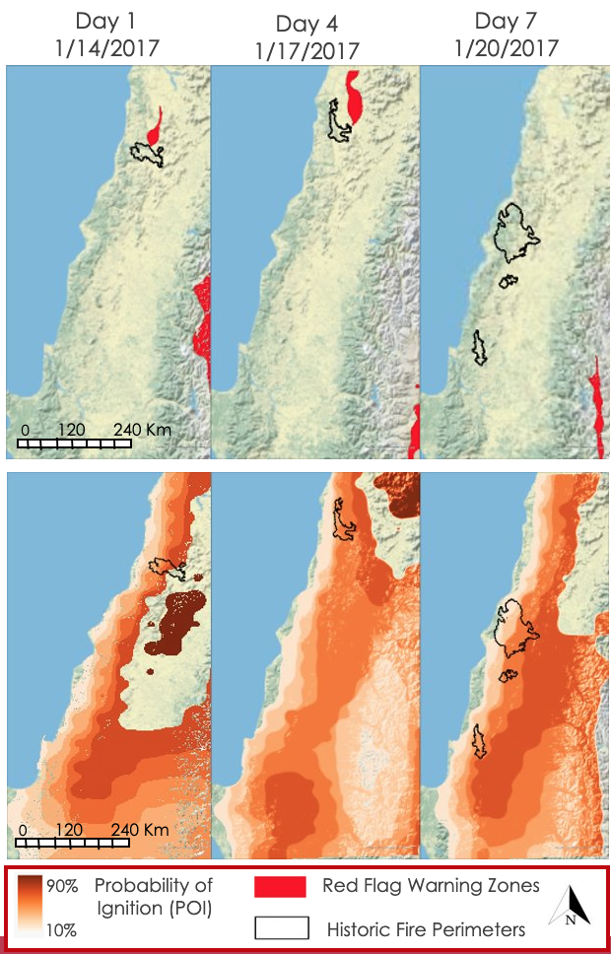

*Figure 2.* Model results of Red Flag Warning and POI values with perimeter of wildfires that began on respective days. The top panel shows RFW zones compared to historical fire perimeters. The lower panel shows POI in color scale.

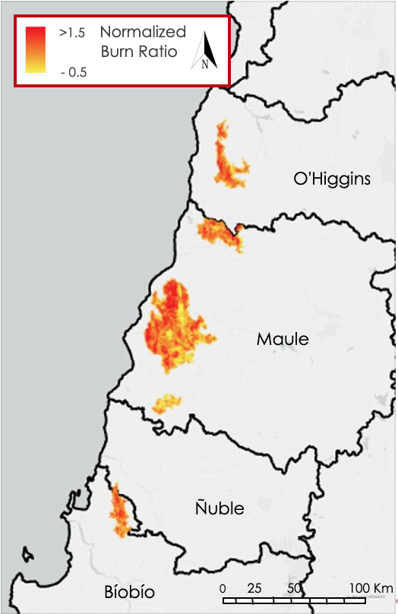

*Figure 3.* Change in Normalized Burn Ratio of the five case study wildfires

***4.2 Future Work***

Results from this project and others like it can help identify possible areas of vulnerability and map burned areas for future forest and land management, and environmental monitoring. Additionally, the integration of Earth observation data and different wildfire models will help reduce human error and variability, thus improving confidence of forecast assessment and resource allocation. Future projects can utilize datasets and models that detect dryness to predict areas that are more likely to burn. Results from this project show that the team was able to successfully transfer CONAF’s red flag warning model into GEE FLAMe model. The team has set up the framework so that all steps in CONAF’s workflow and data visualization can be done in GEE. Additional case study tests and evaluations of the model will allow users to see how well the code works at capturing burned areas and red flag warning locations over time. Partners will be able to make a close comparison with the GEE FLAMe model’s results and their ModelBuilder’s results. This will provide a more robust accuracy assessment. Future studies can refine the model’s reclassification code so that areas with a probability of ignition between 80-90% are not masked out.

# 5. Conclusions

# By using a combination of Earth observation data and in-situ data, the team was able to map wildfire risk and fire perimeters in near-real time to improve wildfire prevention and response time efforts. We used meteorological data from the Global Forecast System, surface reflectance data from Landsat 8 OLI, and elevation data from SRTM to streamline CONAF's RFW model. Our team observed that these methods improved partners' ability to monitor wildfire conditions and capture fire risk, occurrence, and severity as the partners can now produce RFW's faster. We gained confidence through our validation, iterative process, and related research that our fire risk and severity maps captured wildfires within the time periods and regions as hypothesized. All analyses are explained in a code tutorial, giving the partners the ability to apply these techniques and processes to monitor future disasters and fire events. Results from our case study indicate that some ignitions have occurred near red flag warnings and in areas of high POI. Predicting wildfires in Chile is particularly challenging as people ignite most fires. Results from this project could help identify vulnerable locations of potential wildfire-prone areas where partner groups can conduct targeted field campaigns to gather additional validation data. Moreover, the project's results could increase fire resiliency in other countries outside of Chile that also face wildfire issues. GEE scripts released for our partners and detailed methods workflow may be implemented in various studies and further refined to suit different objectives and datasets.

# 6. Acknowledgments

We gratefully acknowledge our node fellow, Erica Carcelén, for her constant support and mentorship and our science advisors Ben Holt and Dr. Virginia Iglesias for their technical guidance and project feedback. We would also like to thank our partners who collaborated on this project with us for providing valuable insight into the context of monitoring and management of wildfires in Chile: Jordi Brull, Jorge Saldias, Fernando Vasquez and Andrés Rodriguez.

This material contains modified Copernicus Sentinel data (2015-2021), processed by ESA.

Any opinions, findings, and conclusion or recommendations expressed in this material are those of the author(s) and do not necessarily reflect the views of the National Aeronautics and Space Administration.

This material is based upon work supported by NASA through contract NNL16AA05C.

# 

# 7. Glossary

Define field-specific terms and acronyms. The goal of this section is to help the reader better understand the work presented in the paper. Include vocabulary that the reader may not be familiar with, in addition to defining the acronyms in your paper.

**Earth observations** – Satellites and sensors that collect information about the Earth’s physical, chemical, and biological systems over space and time

**MODIS** – Moderate Resolution Imaging Spectroradiometer

**GFS** – Global Forecast System

**SMAP** – Soil Moisture Active Passive

G**PM IMERG** – Global Precipitation Measurement Integrated Multi—satellitE Retrievals

**POI** – Probability of Ignition, a commonly used metric for rating the likelihood a wildfire will begin if an ember should land on receptive fuels, displayed as a percentage in intervals of ten

**dNBR** – Change in Normalized Burn Ratio, a measure of the severity of a fire in a given area using pre-fire and post-fire imagery.

**ModelBuilder** – A visual programming language for building geoprocessing workflows. Geoprocessing models automate and document your spatial analysis and data management processes on ArcGIS.

**DEM –** Digital elevation model. DEM is an umbrella term that may refer to a DSM or a DTM.

# 8. References

Castillo, E. J., Fernández, A., Robles, R. F., & Ojeda, C. G. (2021). Data-based wildfire risk model for Mediterranean ecosystems – case study of the Concepción metropolitan area in central Chile.

Copernicus, (2021). *Sentinel-2 MSI Level-2A BOA Reflectance Product* (V1) [Dataset]. European Space Agency Copernicus Open Access Hub. Retrieved January 24, 2022, from [https://doi.org/10.5270/S2_-znk9xsj](https://linkprotect.cudasvc.com/url?a=https%3a%2f%2fdoi.org%2f10.5270%2fS2_-znk9xsj&c=E,1,yhkYupJ7SZx3J4jCWtNe6w6LTLcLqccUZrFo8Vzdd8hFxBQYsWEHP-Gn-pEJm35lnd_4PLQSHTZFKBPCtO5Pd3VIRYLR3LX6yl9YbPo7_CADWu1ToBpQ&typo=1)

Dacre, H. F., Crawford, B. R., Charlton-Perez, A. J., Lopez-Saldana, G., Griffiths, G. H., & Veloso, V. (2018). Chilean wildfires: Probabilistic prediction, emergency response, and public communication. *Bulletin of*  *the American Meteorological Society*, *99*(11), 2259–2274. <https://doi.org/10.1175/BAMS-D-17-0111.1>

Dowdy, A. J., Mills, G. A., Finkele, K., & de Groot, W. (2009). *Australian fire weather as represented by the*  *McArthur Forest Fire Danger Index and the Canadian Forest Fire Weather Index.* Australian Government Bureau of Meteorology, Centre for Australian Weather and Climate Research. <https://cawcr.gov.au/technical-reports/CTR_010.pdf>

Hawbaker, T.J., Vanderhoof, M.K., Schmidt, G.L., Beal, Y.-J., Picotte, J.J., Takacs, J.D., Falgout, J.T., Dwyer, J.L. (2020). *Landsat Collection 2 Level 3 Burned Area* (V2) [Data set]. NASA EOSDIS DAAC. Retrieved January 24, 2022, from [https://doi.org/10.1016/j.rse.2020.111801](https://linkprotect.cudasvc.com/url?a=https%3a%2f%2fdoi.org%2f10.1016%2fj.rse.2020.111801&c=E,1,2TqyOvxE5ViNbtzxUTt1KQgbMtvZHpo0__90Af-X6rJtLTKb505GBNZJ-nPgmJdr_D6J3FvJnSYcXp7kKU04v7DPh2c1ks5TuGv2b-tm4A,,&typo=1)

Jarvis, A., Reuter, H.I., Nelson, A., & Guevara, E. (2008). *Hole-filled SRTM for the globe* (V4) [Data set]. NASA CGIAR-CSI. Retrieved January 24, 2022, from [https://srtm.csi.cgiar.org](https://linkprotect.cudasvc.com/url?a=https%3a%2f%2fsrtm.csi.cgiar.org%2f&c=E,1,c7OqJ2yNMYcxKcfmWlY9bfO9tK2LPQkMYqLlFjWCYVq7ORwvKmBaZ_FPirS7GHB7ZJNlBnPeWwHjMjcbms5Cp62UrOHOZfraLVOdoTwjno0,&typo=1)

Urrutia-Jalabert, R., González, M. E., González-Reyes, Á., Lara, A., & Garreaud, R. (2018). Climate variability and forest fires in central and south-central Chile. *Ecosphere*, *9*(4). <https://doi.org/10.1002/ecs2.2171>

United Nations (UN) (2016) *Burn Severity Mapping* [https://un-spider.org/advisory-support/recommended-](https://un-spider.org/advisory-support/recommended-practices/recommended-practice-burn-severity/in-detail) practices/recommended-practice-burn-severity/in-detail

Villagra, P., & Paula, S. (2021). Wildfire management in Chile: Increasing risks call for more resilient communities. *Environment: Science and Policy for Sustainable Development*, *63*(3), 4–14. <https://doi.org/10.1080/00139157.2021.1898891>

Yang, F., & Tallapranga, V. (2022). *Global Forecast System 384-Hour Predicted Atmosphere Data* (V1) [Data set]. NOAA U.S. National Weather Service. Retrieved January 24, 2022, from <https://www.nco.ncep.noaa.gov/pmb/products/gfs/>

# 9. Appendices

**Appendix A**

Table A1. Reclassification values for Reclass A.

|  |  |
| --- | --- |
| Reclass A | |
| Original Value | New Value |
| -100000 – 0 | 1 |
| 0 – 5 | 2 |
| 5 – 10 | 3 |
| 10 – 15 | 4 |
| 15 – 20 | 5 |
| 20 – 25 | 6 |
| 25 – 30 | 7 |
| 30 – 35 | 8 |
| 35 – 40 | 9 |
| NoData | NoData |

Table A2. Reclassification values for Reclass B.

|  |  |
| --- | --- |
| Reclass B | |
| Original Value | New Value |
| 0 – 2 | 1 |
| 2 – 4 | 2 |
| 4 – 6 | 3 |
| 6 – 8 | 4 |
| 8 – 10 | 5 |
| 10 – 12 | 6 |
| 12 – 15 | 7 |
| 15 – 20 | 8 |
| 20 – 25 | 9 |
| 25 - 1000000 | 10 |
| NoData | NoData |

Table A3. Reclassification values for Reclass C.

|  |  |
| --- | --- |
| Reclass C | |
| Original Value | New Value |
| 0.0001 – 2 | 2000 |
| 2 – 3 | 3000 |
| 3 – 4 | 4000 |
| 4 – 5 | 5000 |
| 5 – 6 | 6000 |
| 6 – 7 | 7000 |
| 7 – 8 | 8000 |
| 8 – 9 | 9000 |
| 9 – 10 | 10000 |
| 10 - 11 | 11000 |
| 11 – 12 | 12000 |
| 12 – 13 | 13000 |
| 13 – 14 | 14000 |
| 14 – 15 | 15000 |
| 15 – 16 | 16000 |
| 16 – 30 | 17000 |
| NoData | NoData |

Table A4. Reclassification values for Reclass D.

|  |  |
| --- | --- |
| Reclass D | |
| Original Value | New Value |
| 0 – 10 | 1 |
| 10 – 20 | 2 |
| 20 – 30 | 3 |
| 30 – 40 | 4 |
| 40 – 50 | 5 |
| 50 – 60 | 6 |
| 60 – 70 | 7 |
| 70 – 80 | 8 |
| 80 – 90 | 9 |
| 90 - 100 | 10 |
| NoData | NoData |

Table A5. Reclassification values for Reclass E.

|  |  |
| --- | --- |
| Reclass E | |
| Original Value | New Value |
| .001 – 3 | 1 |
| 3 – 5 | 2 |
| 5 – 10 | 3 |
| 10 – 15 | 4 |
| 15 – 20 | 5 |
| 20 – 25 | 6 |
| 25 – 30 | 7 |
| 30 – 10000 | 8 |
| NoData | NoData |

Table A6. Reclassification values for Reclass F.

|  |  |
| --- | --- |
| Reclass F | |
| Original Value | New Value |
| .0001 – 19.99999 | 0 |
| 19.99999 – 1000 | 1 |
| NoData | NoData |

Table A7. Reclassification values for Reclass G.

|  |  |
| --- | --- |
| Reclass G | |
| Original Value | New Value |
| 0 – 123.5 | 200 |
| 123.5 – 247 | 100 |
| NoData | NoData |

**Appendix B**

Figure B1. CONAF’s RFW process in ArcGIS. This process generates one RFW. In total, nine RFW’s are generated.

Temperature

Raster to Point

Raster Calculator

Raster_TE

FFMC

SRTM90

Hillshade

IDW

Raster To Point

Hillshade_srtm

IDW_TE

RasterTP_FF

Reclassify

Reclassify

IDW

Reclass_Hill

Reclass_idwTe

IDW_FFMC

Raster Calculator

Raster To Polygon

Reclassify

Reclassify

HSxTE

Reclass_IDW_FF

MC_POI

Reclass_Idw_F

FMC

TE_1.shp

Raster Calculator

Raster To Polygon

PROB_IGNI_1

FFMC_1.shp

Reclassify

Reclass_POI_1

Raster To Polygon

Reclassify

Reclass_POI_2

PI_1.shp

Raster Calculator

VV_PI_RFW_1

Reclassify

Reclass_RFW

Raster To Polygon

RFW_1.shp

Relative

Humidity

Raster To Point

RasterT_HR_1

IDW

IDW_RH_1

Reclassify

Reclass_idw_RH

Raster To Polygon

RH_1_1.shp

Wind (VV)

Raster To Point

RasterT_VV_1

IDW

IDW_VV

Reclassify

Reclass_idw_VV

Raster To Polygon

VV_1.shp