**NASA DEVELOP National Program**



USGS at Colorado State University

**Fall 2016**

**Short Title: Rocky Mountain National Park Climate**

**Subtitle:** Monitoring Algal Productivity to Inform Spatiotemporal Alpine Lake Dynamics in Rocky Mountain National Park

**VPS Title:** Assessing Algal Productivity in Rocky Mountain National Park

**Project Team & Partners**

**Project Team:**

Amy Stuyvesant (Project Lead), amystuy@gmail.com

Emily Campbell

Benjamin Ignac

Muthukumaran Sampath

**Advisors & Mentors:**

Dr. Paul Evangelista (Colorado State University)   
Dr. Amanda West (Natural Resource Ecology Laboratory)

Tony Vorster (Colorado State University)

**Other Contributors:**

Brian Woodward (NASA DEVELOP)

**Partner Organizations:**

|  |  |  |  |
| --- | --- | --- | --- |
| **Organization** | **POC (Name, Position/Title)** | **Partner Type** | **Boundary Org?** |
| National Park Service, Rocky Mountain National Park | Dr. John Mack, Acting Chief of Resource Stewardship | End-User | No |
| United States Geological Survey, Fort Collins Science Center (FORT) | Dr. Jill Baron, Senior Scientist | End-User | No |

**Project Details**

**Applied Sciences National Applications Addressed:** Climate, Water Resources

**Study Area:** Rocky Mountain National Park, CO

**Study Period:** 2014 – 2016 (June – August)

**Earth Observations & Parameters:**

Landsat 8, Operational Land Imager (OLI) – algal productivity monitoring

**Ancillary Datasets Utilized:**

* USGS Fort Collins Science Center *in situ* data – field measurements of Chlorophyll-a
* NSF supported Niwot Ridge Long-Term Ecological Research project and the University of Colorado Mountain Research Station – field measurements of Chlorophyll-a

**Models Utilized:**

* Random Forests Classification Model
* Generalized Linear Model

**Software Utilized:**

* Exelis ENVI – image calibration and pre-processing
* ESRI ArcGIS – image processing, derivation of indices, map creation
* R – statistical analyses for index derivation, imagery pre-processing

**Project Overview**

**80-100 Word Objectives Overview:**

Alpine lakes in Rocky Mountain National Park provide critical ecosystem services for wildlife and invaluable recreational benefits for park visitors. Recent increases in algal productivity threaten the lakes’ water quality. The team explored the applicability Landsat 8 OLI data for use in the United States Geological Survey and National Park Service algal growth monitoring program. Attempting analyses using a variety of models, the team determined the best technique to discern algae from remotely-sensed data.

**Abstract:**

Rocky Mountain National Park has over 140 alpine lakes that provide critical habitats for animal and plant species. Since the 1960s, these lakes have experienced an increase in nitrogen and phosphorus depositions resulting in increased algal productivity. Beginning in 2005, algal biomass has continued to increase despite relatively constant nutrient deposition. The United States Geological Survey (USGS) and National Park Service (NPS) are exploring if recent temperature changes explain this trend. Excessive algal productivity negatively affects water quality through eutrophication and the creation of anoxic events. It is important to monitor algal productivity in Rocky Mountain National Park (RMNP) lakes to prevent associated environmental degradation and socio-economic decline. The team assessed the accuracy of Landsat 8 Operational Land Imager (OLI) in estimating chlorophyll-a levels compared to *in situ* measurements. Earth observations provided a comprehensive analysis that has potential to supplement partner *in situ* data collection methods. The best performing model produced by the team was used to create algal productivity maps for RMNP lakes and has potential to inform NPS adaptation management efforts.

**Keywords:**

Chlorophyll-a, eutrophication, Landsat, shallow lake, water quality, blue-green algae

**Community Concerns:**

* In 2015, Rocky Mountain National Park attracted over 4 million visitors last year and visitors spent more than 268 million dollars in the neighboring town, Estes Park. While algae is not inherently harmful, excess quantities reduce water quality. This can affect other organisms reliant on the lakes for survival, can decrease the aesthetic value of the national park, and can reduce the amount of fishing possible in these lakes. All of this would decrease RMNP and the City of Estes Parks’ profits that rely on tourists.
* Since 2005, nitrogen deposition has remained constant but air and water temperatures have increased by 2-4 °C. Project partners are exploring if climate change could be causing these recent changes. If so, environmental managers will need to either address the prevention of climate-change factors or prepare the ecosystem for future warming events. Either option will cost money and time.
* In 2008, it was estimated that the U.S. spent $4.3 million annually on the treatment of fresh water polluted by nitrogen and phosphorus.

**Current Management Practices & Policies**:

Intensive monitoring takes place in RMNP lakes located in the Loch Vale watershed on a weekly basis throughout the year to quantify physical, chemical, meteorological, and biological characteristics. Additional intensive research takes place in two lakes during the open water season to determine light penetration, photosynthetically active radiation, temperature, chemistry, chlorophyll-a concentrations, and species composition. While RMNP staff have employed NASA Earth observations in past research efforts, our project partners do not currently have the capacity, funding, or staff to complete a project of this nature.

**Decision Support Tools & Benefits:**

|  |  |  |  |
| --- | --- | --- | --- |
| **End-Product** | **Earth Observations Used** | **Benefit & Impact** | **Software**  **Release** |
| Comparison of the  Performance of Landsat 8 OLI for  Use in Algae  Monitoring  Relative to *In-Situ* Measurements | Landsat 8 OLI | Determine efficiency, accuracy and feasibility of using NASA Earth observations to supplement current monitoring efforts | 1 |
| Algal Productivity Map of The Loch and Sky Pond: 2014-2016 and case study years | Landsat 8 OLI | To augment partner knowledge of spatiotemporal trends in algal productivity | 1 |
| Statistics  Summarizing Within-lake Heterogeneity of Algal Abundance | Landsat 8 OLI | Knowledge of within-lake heterogeneity of algal abundance will help to inform our partner’s future sampling design | 1 |

**Project VPS/Booklet Imagery**

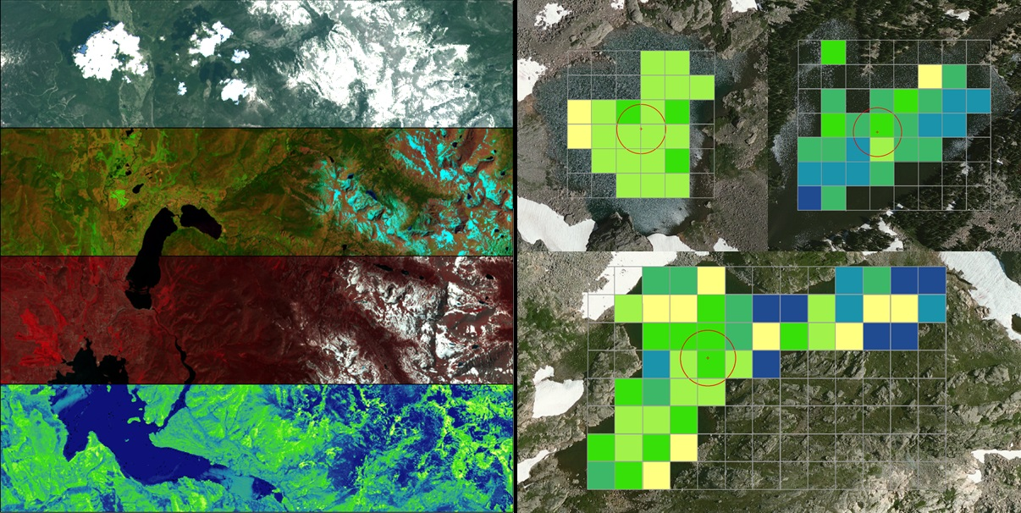

**Caption:** The Rocky Mountain National Park team used different band algebra to visualize chlorophyll-a in the study area lakes. Image Credit: Rocky Mountain National Park Team.

**Image:** 2016Fall_FC_RockyMountainClimate_FinalImage_FD