**NASA DEVELOP National Program**



NASA Langley Research Center

*Summer 2015*

Heat-Health & Spatial Variation in Maricopa County, Arizona

Enhancing Extreme Heat Intervention and Preparedness Activities Using Remote Sensing and Spatial Analysis of Heat-Related Risks in Maricopa County, Arizona

**Technical Report** 

Final Draft – August 6, 2015

Amy Stuyvesant (Project Lead)

Geordi Alm

Rocky Garcia

Emma Baghel

April Rascon

Bernardo Gracia

Dr. David Hondula, Arizona State University (Science Advisor)

Dr. Kenton Ross, NASA DEVELOP National Program (Science Advisor)

# I. Abstract

Extreme heat causes more human fatalities in the United States than most other natural disasters combined, elevating the concern of heat-related mortality. Maricopa County, Arizona is specifically known for its persistently high temperatures and is the leading megapolitan area in the U.S. for population growth and urbanization. As Phoenix expands, the increase in urban structures raises nighttime temperatures and induces a positive feedback loop, creating an urban heat island (UHI) effect. Individuals at higher risk are unequally distributed, leaving the poor, homeless, non-native English speakers, elderly, and socially isolated vulnerable to heat events. While heat-related mortality is a devastating occurrence, it can be prevented. The Arizona Department of Health Services and Maricopa County Department of Public Health, among others, are working to create more effectively placed cooling centers and heat warning systems to aid those with the highest exposure. Using NASA Earth observation technology from Landsat 8 and the MODIS sensor on the Aqua satellite, daily spatial and temperature variability within the UHI was quantified over the summer seasons of 2005 – 2014. A series of One-way Analysis of Variance revealed significant differences between daily surface temperature averages averaged monthly of the hottest 30% of census tracts within a single season. Visual analyses displayed shifts in intensity and how consistently the top 30% occur. These results provided detailed information regarding nuances within the UHI effect and will allow pertinent recommendations regarding the health department’s adaptive capacity. They also hold essential components for future policy regarding appropriate locations for cooling centers and efficient warning systems.

**Keywords**

Remote Sensing, Heat, Urban Climate, Spatial, Public Health, Vulnerability, Socioeconomic, Precision, Targeted

# II. Introduction

**Current Issue - Urbanization & Heat-Related Risks**

With compounding issues from a warming climate and the vastly increasing rates of land use change to include more impermeable surfaces and less vegetative cover, dense urban areas around the globe are experiencing amplified urban heat island effects with a possible consequence of an increase in heat related and heat caused deaths (Anderson & Bell, 2010, Greene et al., 2011, Hartz et al., 2012, and Zhang et al. 2013). Maricopa County is currently experiencing such a phenomenon. According to the U.S. Census Bureau, Maricopa County’s population increased by 10,160,000 individuals in a period of four years (USCB, 2015 and Hondula et al., 2014). Maricopa County is the leading megapolitan area in the U.S. for population growth and urbanization (Hondula et al., 2014). On top of this, the area is specifically recognized for its high temperatures (Hondula et al., 2014). The region’s hot desert climate and extended periods of high temperatures create conditions for adverse human health consequences. With the county’s increased rate of urbanization, extreme heat rises as a human health concern. (Coutts et al., 2007, Greene et al., 2011 and Hondula, 2014).

From 2006 to 2013, about 1,050 deaths due to extreme heat were reported in Maricopa County (MCDPH, 2014 and Uejio et al., 2011). Other common and important physical health symptoms include heat cramps and heat exhaustion (Harlan et al., 2006 and Uejio et al., 2011). Those who were considered to be the most vulnerable (lack of resources to cope with the environmental threat) mirror other cities facing this issue and included males, elderly, poor, homeless, socially isolated, and minorities (MCDPH, 2014, Harlan et al., 2006, Johnson & Wilson, 2009). Most heat-related illnesses and deaths were found in major cities at home, sports and recreational areas, construction and industrial sites, and streets and highways (MCDPH, 2014 and Davis et al., 2003). While county wide relief efforts exist, there is currently no overarching policy explicitly related to preventing heat caused and heat related deaths.

Recent studies examined this phenomenon in Maricopa county using satellite data for temperature on a larger time scale, including socioeconomic factors predicted and assumed from census type data (Dousset et al, 2011, Golden et al., 2008, Grossman-Clark et al., 2010, Harlan et al., 2012, and Hondula et al., 2015). However, these studies have yet to examine the nuances of extreme heat days and nights, such as potential differences within the hot days themselves as well as throughout an entire season. On top of that, recent surveys conducted by MCDPH provided novel content in the actual distribution and use of relief aid resources, such as warning system deployment and availability of home air conditioning (AC). With our data we established how these resources are used and how the daily heat threats vary in order to establish where future cooling centers and warning message systems could be deployed.

**Study Area and Study Period**

Maricopa County is a 9,203 square mile area located in the southwestern portion of Arizona (Rasmussen, 2012 and Golden, et al., 2008). This landscape includes steep, linear mountain ranges that alternate with lengthy deserts created from sand filling in the basins (Rasmussen, 2012). Due to Arizona’s diverse landscape, arid climate, and sparse cloud cover, the temperature varies dramatically from daytime to nighttime. July generally has the largest number of deaths as it is the hottest month, where the county’s highest temperature on record was 122 °F on July 27 and 28 in 1995. (Mesa.AZweather, 2014). Temperatures of 104-128 °F are NOAA’s Heat Index “danger” zone and serve as an appropriate threshold for severe heat stress as anything higher will likely result in sunstroke and heatstroke (Harlan et al., 2003, Harlan et al. 2014). In most cases, the majority of heat distress calls occur during the hot and moist North American Monsoon period later in the summer when the ground gets excessively heated and that moisture-filled air rises along the mountain ranges to produce thunderstorms (Golden et al., 2008). This research focused on the extreme heat during the hottest months of the year from May through September during the period between 2005 and 2014.

**National Applications Addressed and Project Partners**

Our project primarily addressed Health & Air Quality as well as Climate. Partnering with this project are Maricopa County Department of Public Health (MCDPH) and the GIS Lab at Arizona State University (ASU) with Arizona Department of Health Services (ADHS) as a potential end-user. ADHS coordinates the statewide heat safety task force, for which the MCDPH and ASU are active participants, and leads the state’s participation in Centers for Disease Control and Prevention’s (CDC) Building Resilience against Climate Effects initiative. Decision support tools and project findings were shared through statewide heat safety meetings.

**Project Objectives**

Our project created a hotspot consistency map of Maricopa County, Arizona for detection of extreme heat anomalies on primarily a daily scale. In conjunction, we determined the use of AC based on demographic factors and established how this correlates with current socioeconomic vulnerability assumptions in literature. From this, we analyzed the variability within anomalies and survey results as a means of determining where, when, and how relief efforts could intervene.

# III. Methodology

DATA ACQUISITION

Air temperature data to determine dates of extreme heat anomalies are available through the University of Utah’s MesoWest database. Utilizing the MesoWest API and python scripting, the data for 285 weather observation stations throughout Maricopa County were obtained from 2006 to present for the months of May through September (InlineSupp. 1). These data were then georeferenced in ArcMap and organized in a custom built geodatabase.

Surface temperature data came from NASA Earth observations as did data for the land use classification (Table 1).

**Table 1:** **NASA Earth observations utilized**. Most data came from the MODIS (Moderate Resolution Imaging Spectroradiometer) sensor on the Aqua satellite. Data downloaded with ‘dnppy’ module. *Source*: Land Processes Distributed Active Archive Center (LP DAAC) FTP collection

|  |  |  |  |  |
| --- | --- | --- | --- | --- |
| **Name** | **Source** | **Dates** | **Details** | **Bands** |
| Aqua MODIS | LP DAAC FTP | May - Sept (2005 - 2015) | MYD11A1 Grid: h08v05 | land surface temperature/emissivity |
| Landsat 8 OLI TIRS | LP DAAC FTP | May 2006 | Path 41 Row 33 | all |

Shapefiles of Maricopa County were collected from the ASU Repository of GIS data. Percent of impermeable surfaces was used from the 2011 National Land Cover Database (NLCD), hosted by United States Geological Survey (USGS). National Centers for Environmental Prediction (NCEP) reanalysis data were also utilized to examine synoptic atmospheric conditions (InlineSupp2). Community Assessment for Public Health Emergency Response (CASPER) survey data came from MCDPH from March 2015 and additional data on income and percent of the population that is non-white for Maricopa County came from the Census Bureau database.

DATA PROCESSING AND ANALYSIS

**Task 1: Determine and Analyze How and When Extreme Heat Anomalies Occur**

*Processing*

Using Python 2.7, each ‘.hdf’ file was converted into ‘.tif’ format and projected into ‘Sinusoidal’, performed with the ‘extract_from_hdf’ function in the ‘dnppy’ module. MODIS images were further subset to the contour line of Maricopa County. Census tract surface temperature averages were calculated and converted to Celsius (C) for each clipped MODIS image, day and night, in RStudio (InlineSupp 3).

*Analysis*

Temperature anomaly dates were isolated with the weather station data from the Phoenix airport station by running a script in Matlab to separate all days with a maximum temperature above 40°C. This resulted in 762 days, creating 1,524 images for day and night. A Python script to delete MODIS images not in this specified date file was then used (InlineSupp 4). To begin analysis, a chi-squared contingency table test for association where the variables tested were month (May – September) and year (2005 – 2014) and the count data compared was extreme heat days within each month for every year. Once this association was established, we isolated the average surface temperature of the hottest 30% of census tracts on all anomalous days.

Exploring measures of central tendency, a series of One-Way ANOVAs were performed in RStudio to compare how average daily temperatures averaged monthly of the top 30% hottest tracts compared throughout a season. Of seasons deemed significantly different, a post-hoc Tukey’s Honestly Significant Difference (HSD) test was performed to determine which months were statistically significant. The year 2012 was isolated for more in depth analysis as it had the most normal distribution and the most usable images due to lack of cloud cover interference (Appendix 1). These data figures examined trends throughout the season of each cloud free anomalous day and night where the season was split into representative dates of early-season (May 1 - 31), mid-season (June 29 - August 13), and late-season (August 28 - September 30) to expedite analysis.

**Task 2: Model Predictions for Access to Cooling Resources**

*Processing*

Survey results were converted from ‘.xlsx’ into a ‘.csv’ for analysis in RStudio. Once in RStudio data columns were stacked appropriately for the particular analysis and subsets were created to facilitate a more organized data analysis approach.

*Analysis*

A binary logistic regression was performed in RStudio to determine what demographic factors relate to certain uses of relief aid. This looked at if something actively prevented AC use (with the outcome variable as ‘yes’ or ‘no’) versus various predictor variables (income, if household contains non-English speaker, and percent non-white individuals).

**Task 3: Maps of Heat Recurrence with Surface Feature Classification**

*Processing*

The MODIS surface temperatures averaged over census tracts were utilized for the spatial consistency map.

For the purposes of classification, Landsat 8 Bands 2, 3, and 4 were first pan-sharpened to a 15m resolution and stacked. This image was then converted to reflectance by using the conversion information in the metadata using the following equations:

*ρλ'* = *MρQcal* + *Aρ* and *ρλ $= \frac{ρλ' '}{sin(θSE)}$*

**Equation 1**: Converting digital number of pixel to a reflectance value, where *Mρ* represents the multiplicative value, *Qcal* represents the band being converted, and *Aρ* represents the additive value. *Source*: Using the USGS Landsat 8 Product. *USGS* <[http://landsat.usgs.gov/Landsat8_Using_Product.php](http:///h)>, Accessed 17 June 2015.

*Analysis*

Using Model Builder in ArcGIS, each anomalous day was input for a season. The data were reclassified and an occurrence score was assigned to each tract. Resultant maps display the frequency of occurrence, normalized by a percent of the total, of each tract in the top 30% (InlineSupp 5). The spatial location of respondents answering something actively prevents them from using AC in their household was overlaid, creating hotspot regions of both parameters having high incidence. We compared these hotspot regions to already generated maps assessing heat vulnerability and incidence of heat-caused deaths by Sharon Harlan et al., (2013). We visually analyzed how daily anomalies compare with current maps.

To further this analysis, we completed a maximum likelihood supervised classification of the Landsat 8 images that were pre-processed and converted into reflectance to determine what surface features are under these hot spots. As an added measure, we looked at the NLCD’s information on percent of impermeable surfaces in the study area to see if there is a connection between consistently hot tracts and the percent of impermeable surfaces underneath.

# IV. Results & Discussion

**Task 1: Determine and Analyze How and When Extreme Heat Anomalies Occur**

A chi-squared contingency table test for association was performed (InlineSupp 6) to determine if there is a significant association between month (May – September) and year (2005 – 2014) for counts of extreme heat days. The analysis yielded a significant association (χ2(36) = 66.83, *p* = 0.001, α = 0.05) between month and year (Table 2).

**Table 2**: Temperature heat anomaly days (n = 768) for month (May – September) and year (2005–2014). *Source*: University of Utah’s MesoWest database from Phoenix KPHX airport station.

|  |  |  |  |  |  |  |  |  |  |  |
| --- | --- | --- | --- | --- | --- | --- | --- | --- | --- | --- |
|  | ***Study Years*** | | | | | | | | | |
| ***Month*** | **2005** | **2006** | **2007** | **2008** | **2009** | **2010** | **2011** | **2012** | **2013** | **2014** |
| **May** | 5 | 7 | 2 | 3 | 4 | 0 | 0 | 6 | 0 | 6 |
| **June** | 12 | 27 | 20 | 19 | 8 | 19 | 15 | 22 | 29 | 25 |
| **July** | 28 | 22 | 21 | 25 | 26 | 27 | 24 | 22 | 22 | 25 |
| **August** | 13 | 13 | 20 | 20 | 24 | 21 | 27 | 20 | 21 | 15 |
| **September** | 8 | 2 | 12 | 5 | 10 | 18 | 14 | 7 | 11 | 10 |
| ***Total*** | **66** | **71** | **75** | **72** | **72** | **85** | **80** | **77** | **83** | **81** |

Of note, July and August did not yield values very different from the expected count value. May, closely followed by June, revealed the most variation. Additionally, in 2006 May represented 9.8% of the extreme heat days while the two years with the highest overall count, 2010 and 2013, May represented 0% of the days. This will aid the focus of adaptive capacity for decision makers choosing when to focus on deploying additional relief resources, possibly improving mid-rage forecasting to anticipate start and end of the heat season.

Moving from weather station to remotely sensed data, one-way ANOVAs were performed to compare inter annual daily average of the top 30% hottest tracts averaged monthly surface temperature (C). While weather station data provided a good proxy for the health threshold, the remotely sensed surface temperature data was chosen based on its connection to the UHI effect. Using these values will allow further analyses to explore surface features relationship to any discovered patterns. This was completed for both daytime (Appendix 2/InlineSupp. 7) and nighttime (Appendix 3/InlineSupp. 8) values to start targeting what is going on within these extreme heat days between years. For daytime temperatures, tests revealed three patterns with significant results, depicted in the years 2005 (F(4,40) = 2.623 *p* = 0.049, α = 0.05; “cool August”), 2012 (F(4,29) = 5.102 *p* = 0.003, α = 0.05; “normal distribution”), and 2014 (F(4, 35) = 4.251 *p* = 0.006, α = 0.05; “hot May”). Post-hoc testing using Tukey’s HSD revealed significant differences (Figure 1). The same analyses were repeated for extreme heat nights, where all years were significant (Appendix 3). Matching the daytime example years, 2005 (F(3,25) = 5.60, *p* = 0.003), 2012 (F(4,27) = 10.63, *p* < 0.001), and 2014 (F(4,47) = 11.23, *p* < 0.001) post-hoc testing also demonstrated which months are significantly different (Figure 2).

**Summer Daily Average Surface Temperatures Averaged Monthly**

**in Maricopa County, AZ (2005, 2012, 2014)**

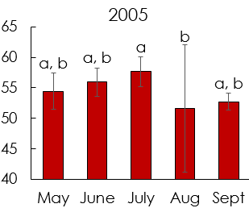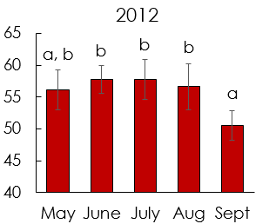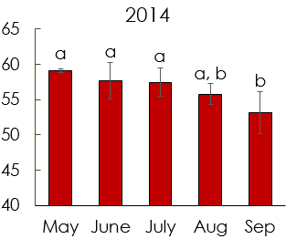

**Figure 1**: Average daily surface temperature (C) for each month in the year 2006 (left), 2012 (middle), and 2014 (right) in Maricopa County, AZ. Averages represent the hottest 30% of census tracts for each day that were then averaged monthly. Like letters above error bars indicate values that are not significantly different. *Source*: Aqua/MODIS MYD11A1 LST L3 product.

**Summer Nightly Average Surface Temperatures Averaged Monthly**

**in Maricopa County, AZ (2005, 2012, 2014)**

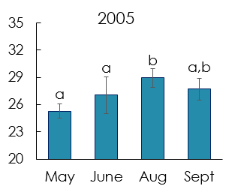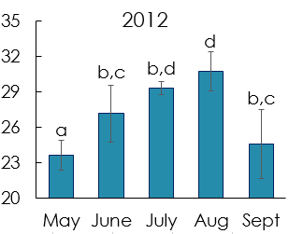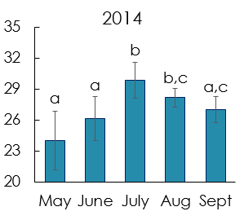

**Figure 2**: Average nightly surface temperature (C) for each month in the year 2006 (left), 2012 (middle), and 2014 (right) in Maricopa County, AZ. Averages represent the hottest 30% of census tracts for each day that were then averaged monthly. Like letters above error bars indicate values that are not significantly different. Note: Absent months indicate either no events or no cloud free images *Source*: Aqua/MODIS MYD11A1 LST L3 product.

Monthly averages do vary throughout the season, with a general peak of significantly higher values in the mid-season averages. Narrowing the scope to daily variation, averages of the hottest 30% tracts were visualized with the average of the rest of the tracts for individual days to have higher precision results in the intra annual variability.

For the daytime temperatures, large variability relative to neighboring days was found with as much as 10°C difference between days (Figure 3).

**Daily Average Surface Temperature in Maricopa County, AZ**

**(early-, mid-, and late-season)**

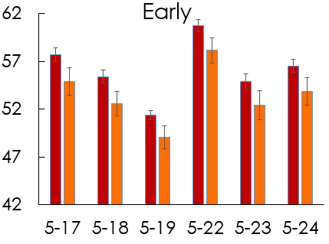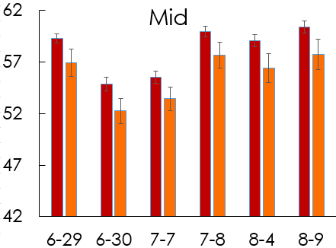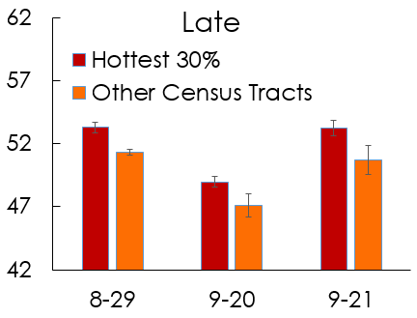

**Figure 3**: The top 30% hottest census tracts averaged daily next to the corresponding daily average of the rest of the census tracts in the same day. This is split between early season (May 1 - May 31), mid-season (June 29 - August 13), and late season (August 28 - September 30) for the year 2012 in Maricopa County, AZ. Source: Aqua/MODIS MYD11A1 LST L3 product.

On top of that, the highest average in the early season is comparable to mid-season averages. Although May’s monthly average is generally lower than July and August, isolated days can reach rivaling temperatures to July and August. Warning messages could reflect, as relief networks could need extra effort to prepare or communicate that the public’s health is still at risk early season. For night temperatures, each part of the season is fairly consistent and distinct (Figure 4) with a lag of warmer temperatures around 30°C, the high temperatures in July and August, lasting into the late season, not apparent in the daytime averages.

**Nightly Average Surface Temperature in Maricopa County, AZ**

**(early-, mid-, and late-season)**

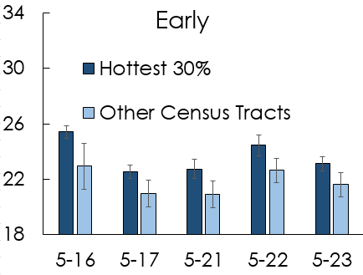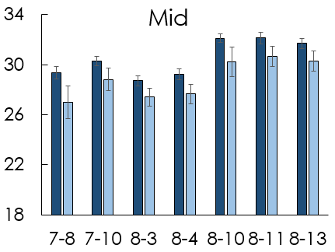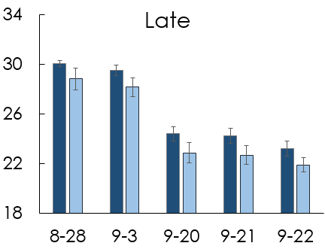

**Figure 4**: The top 30% hottest census tracts averaged nightly next to the corresponding nightly average of the rest of the census tracts in the same day. This is split between early season (May 1 - May 31), mid-season (June 29 - August 13), and late season (August 28 - September 30) for the year 2012 in Maricopa County, AZ. Source: Aqua/MODIS MYD11A1 LST L3 product.

Although daytime temperatures are lowering relative to earlier dates, down to about 49°C from 59°C, the heat is remaining trapped at night into the late season and these temperatures are not lowering compared to the mid-season. Considering both day and night, the difference between the average of 30% hottest tracts and the rest of the tracts remains fairly similar throughout the season. Other thresholds besides the 30% could be used to see if this pattern holds true or where it breaks down. Warning messages have the potential to ensure the public is knowledgeable about this sustained health risk into the late season, especially when exposed to heat at night.

**Task 2: Model Predictions for Access to Cooling Resources**

In an effort to add more context to the human concern of A/C, a binary logistic regression using median income to regress survey responses of individuals not using A/C for some reason, such as cost or their homes not being equipped with A/C (Table 3).

**Table 3**: Binary logistic regression results on likelihood of respondent answering that nothing prevents household from access to AC (success) with income, percent of non-white population, and having a non-English speaker in the household as predictor variables. Note coefficient represents odds, where < 1 means negative relationship. *Source*: Census Bureau and MCDPH’s CASPER survey results (March 2015).

|  |  |  |  |  |
| --- | --- | --- | --- | --- |
| **Term** | **Coefficient** | **St. Error** | **Z-Value** | ***p*-value** |
| **Intercept** | 1.84 | 0.432 | 1.415 | 0.157 |
| **Income** | 1.00 | 5.33E-06 | 1.236 | 0.216 |
| **Non-English (Yes)** | 0.369 | 0.3561 | -2.798 | 0.005 ** |
| **Percent Non-White** | 0.997 | 0.00717 | -0.34 | 0.734 |

Having someone in the household that does not speak English proved the only significant predictor of likelihood of AC use, where the odds of a household answering that nothing prevents them from using AC decreases by 63.1% as the household switches from one without non-English speakers to one with these individuals. Income not being significant may be because we used census bureau median income rather than the respondent's actual income, which was not collected in the survey. When we compared the percent of non-white residents between Census Bureau data and survey data, the survey regression still came back as insignificant but the p-value lowered greatly (p = 0.734 to p = 0.07). While this result was not significant, it does suggest utilizing income values of actual households could produce significant results.

**Task 3: Maps of Heat Recurrence with Surface Feature Classification**

In terms of spatial consistency, survey responses from the CASPER results of respondents answering they do not use AC was overlaid with consistency at which a tract falls in the top 30%. This highlighted three regions of high incidence throughout the study period, chosen based on a large survey response of participants feeling actively prevented from using AC located in tracts that are consistently hot (Figure 5).

Comparing results from Harlan et al. (2013), the northern two suburban regions, around Sun City West and Desert View matched (Appendix 4/InlineSupp. 9). Harlan’s study also highlighted the downtown area as having substantial deaths. While our study did show these as consistently hot tracts, there was not a clear clumping of survey respondents answering they do not use AC. Our study showed the area around Litchfield Park as a hotspot. Of note, hotspots in this study highlight other phenomena outside of mortalities, such as those suffering from heat related or heat caused illnesses possibly from not using AC during summer.

**Hotspots for Neighborhood Vulnerability to Extreme Heat Events for 2005 - 2014**

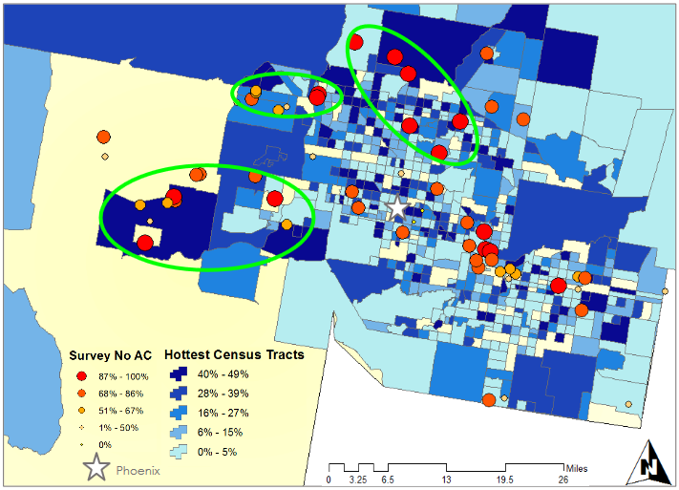

**Figure 5**: Daily average surface temperatures to determine consistency throughout season (blue shades, 2005 - 2014) mapped with CASPER responses to question regarding respondents not using A/C (red to orange). Note: Green circles identify regions of residents at highest risk throughout entire season. *Source*: Aqua/MODIS MYD11A1 LST L3 product and CASPER survey.

To begin addressing the ‘why’ questions related to urban heating we began a land use classification using pan-sharpened Landsat 8 images (Figure 6). We compared these to the NLCD percent land cover (Figure 6).

**Land Use Classification Assessment of Landsat 8 Imagery**

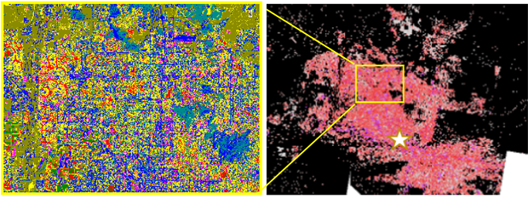

**Figure 6**: Land use classification for a pan-sharpened 15m Landsat 8 bands 4-3-2 on May 1, 2013 of specific urban surface (left) and NLCD percent of impervious surfaces for 2011(right). Note star represents Phoenix. *Source*: Landsat 8 OLI/TIRS and NLCD/USGS.

We aimed to assess the accuracy of implementing 15m resolution imagery to distinguish residential areas (yellow), urban areas (pink), major roads (blue), healthy green vegetation (light green), concrete (red), bare land (forest green), sparse vegetation (teal), and water (black). This resolution does not seem accurate for the necessary distinctions. Finer resolution or more advanced classifications using spectral mixing of individual pixels would provide more accurate results, providing a good opportunity for collaboration with more researchers at ASU examining land cover-UHI dynamics.

# V. Conclusions

Given the UHI effect, it was not surprising to find inter annual variability of daily averages averaged monthly. However, the association of number of extreme heat days between month and year could provide insight into forecasting beginning and ends of the heat season. Inter annual comparisons show daytime temperatures exhibit large differences of the hottest 30% tracts between individual dates near one another. Adding inter annual nighttime averages of the hottest 30% of tracts on extreme heat dates shows another pattern, where heat is held in surfaces longer into the season as compared to day. Because of this, the public is not receiving relief needed from heat at night, felt more prominently into the late season because of this lag. The spatial consistency analysis paired with locations of individuals not using AC targeted areas near Sun City West (a large retirement community), Litchfield Park (large mix of ethnicities), and Desert View (a mix of suburban neighborhoods). The addition of cooling centers or affordable AC programs could benefit from tailoring their area of impact towards these regions. More personalized warning messages could be deployed in these areas, potentially resulting in a larger rate of people seeking relief. Geographically, all areas highlighted are north or west of downtown Phoenix, where no areas south or east simultaneously satisfied both parameters of high incidence. Future studies may expand towards explorations into the ‘why’ questions, examining surface features and weather patterns around the delineated hotspots and seasonal variability. Furthermore, a suitability analysis of rooftop solar panel locations could provide a longer term solution, creating an inherently cooler building requiring less energy (and in turn less water and money) to cool while addressing larger issues of climate change. As the project progresses, stakeholder involvement in the interpretation of results provides a crucial context into the continuation and direction of this research.

# VI. Acknowledgments

Special thanks to David Hondula (Science Advisor), Dr. Kenton Ross (NASA Science Advisor), Emily Adams and Dan Wozniak (Center Lead and Assistant Center Lead), Jeff Ely (DEVELOP Geoinformatics), and Grant Mercer (DEVELOP participant). This material is based upon work supported by NASA through contract NNL11AA00B and cooperative agreement NNX14AB60A.

# VII. References

Anderson, G., & Bell, M. L., 2010, Heat Waves in the United States: Mortality Risk during

Heat Waves and Effect Modification by Heat Wave Characteristics in 43 U. S. Communities, Environmental health perspectives, v. 119,no. 2,p. 210-218.

Coutts, A. M., Beringer, J., & Tapper, N. J., 2007. Impact of increasing urban density on

local climate: spatial and temporal variations in the surface energy balance in

Melbourne, Australia, Journal of Applied Meteorology and Climatology, v. 46, no.

4, p. 477-493.

Davis, R.E., Knappenberger, P.C., Michaels, P.J., & Novicoff, W.M., 2003, Changing heat

related mortality in the United States: Environmental Health Perspectives, v. 111,

no. 14, p. 1712-1718.

Dousset, B., Gourmelon, F., Laaidi, K., Zeghnoun, A., Giraudet, E., Bretin, P., ... &

Vandentorren, S. (2011). Satellite monitoring of summer heat waves in the Paris

metropolitan area. *International Journal of Climatology*, *31*(2), 313-323.

Golden, J.S., Hartz, D.H., Brazel, A, et al., 2008, A biometeorology study of climate and

heat-related morbidity in Phoenix from 2001 to 2006: International Journal of

Biometeorology, v. 52, p. 471-480, doi: 10.1007/s00484-007-0142-3.

Greene, S., Kalkstein, L. S., Mills, D. M., & Samenow, J, 2011, An examination of climate

change on extreme heat events and climate-mortality relationships in large US cities, Weather, Climate, and Society, v. 3,no. 4,p. 281-292.

Grossman-Clarke, S., Zehnder, J. A., Loridan, T., & Grimmond, C. S. B, 2010, Contribution

of land use changes to near-surface air temperatures during recent summer

extreme heat events in the Phoenix metropolitan area, *Journal of Applied*

*Meteorology and Climatology*, v. *49*,no. 8,p. 1649-1664.

Harlan, S.L., Brazel, A.J., Prashad, L., et al., 2006, Neighborhood microclimates and

vulnerability to heat stress: Social Science & Medicine: v. 63, p. 2847-2863.

Harlan, S. L., Declet-Barreto, J. H., Stefanov, W. L., & Petitti, D. B., 2012, Neighborhood effects on heat deaths: social and environmental predictors of vulnerability in

Maricopa County, Arizona. Environmental health perspectives, v.121,no. 2,p. 197

204.

Hartz, D. A., Golden, J. S., Sister, C., Chuang, W. C., & Brazel, A. J, 2012, Climate and heat-related emergencies in Chicago, Illinois (2003–2006), *International journal of*

*biometeorology*, v. *56,no.* 1,p. 71-83.

Hondula, D.M., Georgescu, M., and Balling Jr., R.C., 2014, Challenges associated with

projecting urbanization-induced heat-related mortality: Science of the Total

Environment, v. 490, p. 538-544. doi:10.1016/j.scitotenv.2014.01.130

Hondula, D.M., Davis, R.E., Saha, M.V., et al., 2015, Geographic dimensions of heat

related mortality in seven U.S. cities: Environmental Research, v. 138, p. 439-452.

Johnson, D. P., & Wilson, J. S, 2009, The socio-spatial dynamics of extreme urban heat

events: the case of heat-related deaths in Philadelphia, Applied Geography, v.

29,no. 3,p. 419-434.

LoVecchio, F., Stapczynski, J.S., Hill, J., et al., 2005, Heat-related mortality-Arizona, 1993

2002, and United States, 1979-2002: Morbidity and Mortality Weekly Report, v. 54,

p. 628-630.

Maricopa County Department of Public Health: Division of Disease Control: Office of

Epidemiology (MCDPH), 2014, Heat-Associated Deaths in Maricopa County, AZ

Final Report For 2013,

[http://www.maricopa.gov/publichealth/Services/EPI/pdf/heat/2013annualrepo](http://www.maricopa.gov/publichealth/Services/EPI/pdf/heat/2013annualrepot.pdf)

[t.pdf](http://www.maricopa.gov/publichealth/Services/EPI/pdf/heat/2013annualrepot.pdf) (accessed June 2015).

Mesa.AZweather, 2014, Annual Data Table:

<http://www.mesa.azweather.com/archives/history-table.html> (accessed June 2015).

National Weather Service, 2015, National Oceanic and Atmospheric Administration:

NWS Heat Index: <http://www.nws.noaa.gov/om/heat/heat_index.shtml>

(accessed June 2015).

Rasmussen, J.C., 2012, Geologic History of Arizona: Rocks and Minerals, v. 87, no. 1, p.

56-63.

Uejio, C.K., Wilhelmi, O.V., Golden, J.S., et al., 2011, Intra-urban societal vulnerability to

extreme heat: The role of heat exposure and the built environment,

socioeconomics, and neighborhood stability: Health & Place, v. 17, p. 498-507.

United States Census Bureau (USCB), 2015, QuickFacts Beta: Maricopa County, AZ:

<http://www.census.gov/quickfacts/table/POP010210/00> (accessed June 2015).

U.S. Climate Data, 2015, Climate Maricopa - Arizona:

[http://www.usclimatedata.com/climate/maricopa/arizona/united](http://www.usclimatedata.com/climate/maricopa/arizona/united%09states/usaz0131)

[states/usaz0131](http://www.usclimatedata.com/climate/maricopa/arizona/united%09states/usaz0131) (accessed June 2015).

USA, 2015, Maricopa County Weather: [http://www.usa.com/maricopa-county-az](http://www.usa.com/maricopa-county-az%09weather.htm)

[weather.htm](http://www.usa.com/maricopa-county-az%09weather.htm) (accessed June 2015).

Zhang, H., Qi, Z. F., Ye, X. Y., Cai, Y. B., Ma, W. C., & Chen, M. N, 2013, Analysis of land

use/land cover change, population shift, and their effects on spatiotemporal

patterns of urban heat islands in metropolitan Shanghai, China, Applied Geography, v. 44,p. 121-133.

# VIII. Content Innovation

KMZ File of final map in developexchange folder.

Inline Supplementary files in developexchange folder

# IV. Appendices

**Appendix 1**: Count of extreme heat days each month for each year with the corresponding amount of useable days due to lack of cloud cover.

A major consideration of using space based observation platforms is the data quality limitations set forth by cloud cover and other sensor inhibitors. For this reason we established a method to only utilize MODIS images that are among the best quality for this analysis framework. Once the MODIS image was clipped to the county census tracts and those values extracted, every image that reported an “NA” value for 150 or greater tracts was discarded. Below are graphs depicting the number of heat days per month, as well as the number of useable day and night images. The most apparent observation tis the disparity in monthly data quality. The July and August season mark the beginning of the summer Monsoon, which contributes a large amount of cloud cover to the region and is the primary inhibitor of MODIS satellite image quality. A more nuanced observation was the diurnal effects on data quality, which is assumed to be attributed to the lack of thunderstorm convection overnight and the building of atmospheric subsidence aloft which decreases the amount of cloud cover overnight.

**Count of Extreme Heat Days in Maricopa, County for May - October (2005 - Present) and the Useable, Non-Cloudy, Day and Night Imagery**

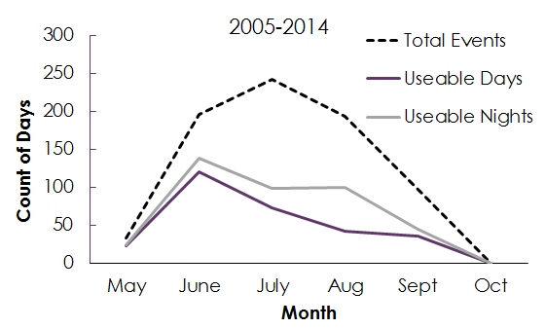

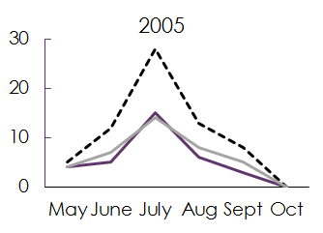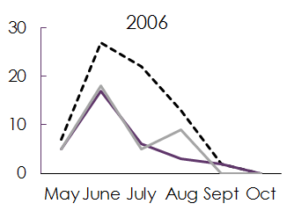

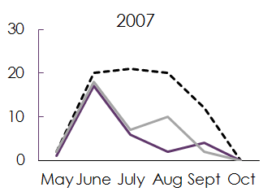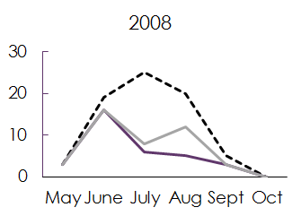

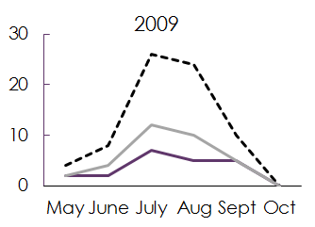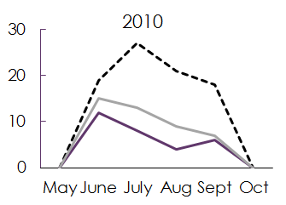

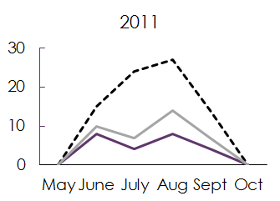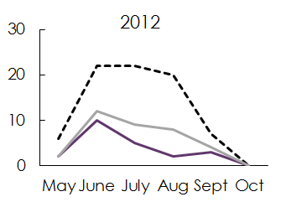

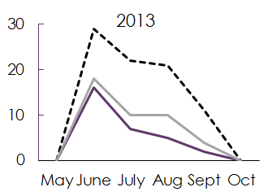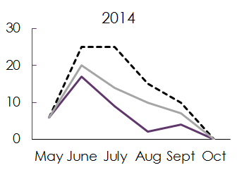

**Figure 7:** Count of total extreme heat days, the total events (dashed line), or days above the threshold of 104°F 2-meter air temperature, compared to the usable images due to low cloud cover for day (purple line) and night (grey line) images for the summer season, May - October, in Maricopa County, AZ. Dates shown include the entire study period, 2005 - 2014, as well as each individual year breakdown. *Source*: University of Utah’s MesoWest database from Phoenix KPHX airport station.

**Appendix 2**: ANOVA and post-hoc testing for all daily averages averaged monthly

**Summer Nightly Average Surface Temperatures Averaged Monthly**

**in Maricopa County, AZ (2006 - 2013)**

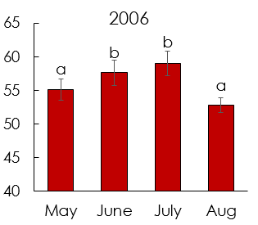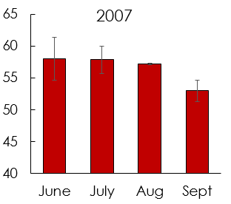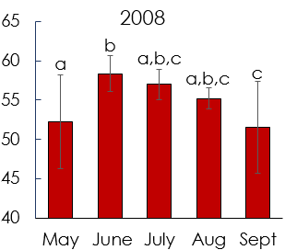

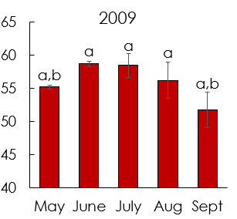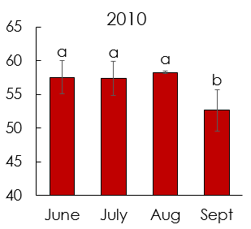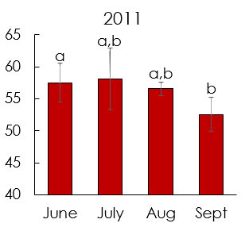

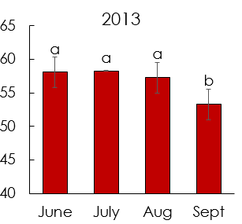

**Figure 8**: Daily averages further averaged monthly of the hottest 30% of census tract for months. All years, except 2007, showed significant results – 2006 (F(3,27) = 10.80, *p* < 0.001), 2008 (F(4,29) = 5.56, *p* = 0.002), 2009 (F(4,30) = 8.12, *p* < 0.001), 2010 (F(3,38) = 10.69, *p* < 0.001), 2011 (F(3,22) = 4.51, *p* < 0.01), and 2013 (F(3,32) = 7.34, *p* < 0.001). Post-hoc testing determined which months are significantly different. Note: like letters indicate months that are not significantly different. In addition, missing years are in body of technical paper and missing months are due to either a lack of cloud free images or the month did not have any extreme heat days (see chi-squared table for count of extreme heat days). *Source*: Aqua/MODIS MYD11A1 LST L3 product.

**Appendix 3**: ANOVA and post-hoc testing for all nightly averages averaged monthly

**Summer Nightly Average Surface Temperatures Averaged Monthly**

**in Maricopa County, AZ (2006 - 2013)**

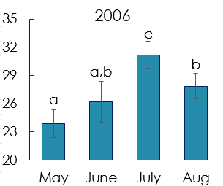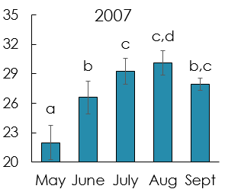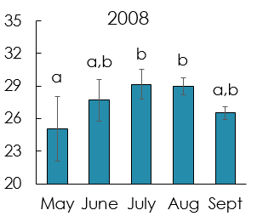

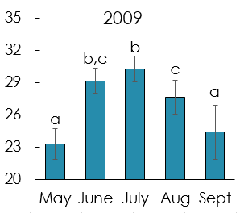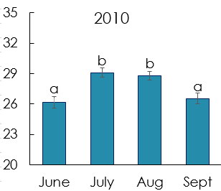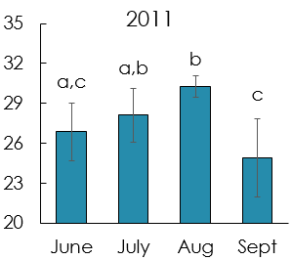

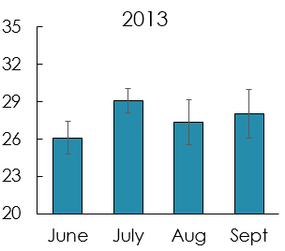

**Figure 9**: Nightly averages further averaged monthly of the hottest 30% of census tract for months. All years showed significant results – 2006 (F(3,37) = 22.61, *p* < 0.001), 2007 (F(4,45) = 24.80, *p* < 0.001), 2008 (F(4,34) = 4.80, *p* = 0.004), 2009 (F(4,36) = 19.50, *p* < 0.001), 2010 (F(3,49) = 8.84, *p* < 0.001), 2011 (F(3,41) = 13.27, *p* < 0.001), and 2013 (F(3,29) = 7.58, *p* < 0.001). Post-hoc testing determined which months are significantly different. Note: like letters indicate months that are not significantly different. In addition, missing years are in body of technical paper and missing months are due to either a lack of cloud free images or the month did not have any extreme heat days (see chi-squared table for count of extreme heat days). *Source*: Aqua/MODIS MYD11A1 LST L3 product.

**Appendix 4**: Maps created by Harlan et al., 2013.

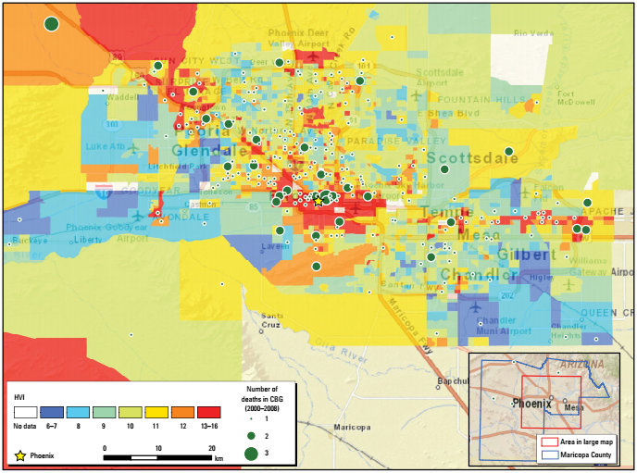

**Figure 10**: “HVI scores (using a method modified from Reid et al. 2009) mapped for 2,081 census block groups (CGBs) in Maricopa County, Arizona. Higher scores represent higher vulnerability. The map inset in the lower right corner indicates the urbanized area of Maricopa County (red box) shown in the larger map. The county, which also contains a much larger area of uninhabited desert and sparse settlement, is outlined in blue. The urbanized area covers all the cities and all but one of the major towns in the county. Residences of only four people who died from heat exposure were located outside the urbanized area (green circles in inset).” *Source*: Harlan et al., 2013.

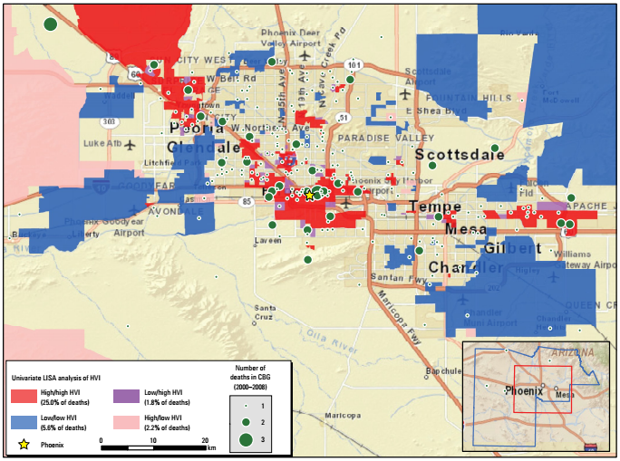

**Figure 11**: “Univariate analysis of the LISA-identified clusters of census block groups (CBGs) in Maricopa County, Arizona, with similar or dissimilar HVI scores (*p*-value ≤ 0.05). High/high areas in the map are clusters of neighboring CBGs with uniformly high vulnerability scores; low/low areas are clusters with low vulnerability scores; low/high areas represent a CBG with a low vulnerability score neighbored by high vulnerability CBGs; high/low areas represent a CBG with a high vulnerability score neighbored by low vulnerability CBGs. Entries in the legend (next to the colored boxes) also show the percentages of 2000–2008 heat-related decedents who were residents in each type of cluster.” *Source*: Harlan et al., 2013.

**Appendix 5**: Additional Maps and Figures

The following figures, hot seasons 2006-2013, display ECMWF Reanalysis Data (2-Meter Air Temperature). The synoptic type classification indicates a consistent hot weather regime in the desert southwest, particularly located in the Arizona Basin and Range region.

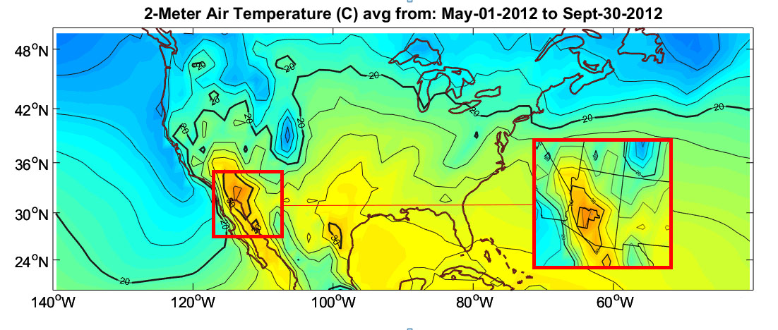

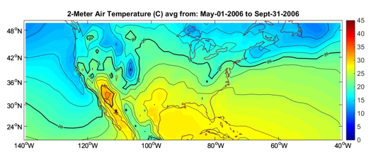

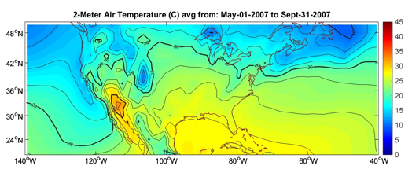

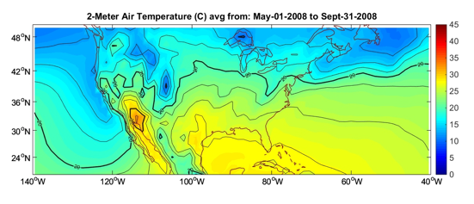

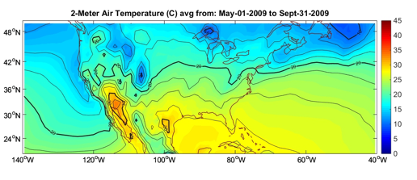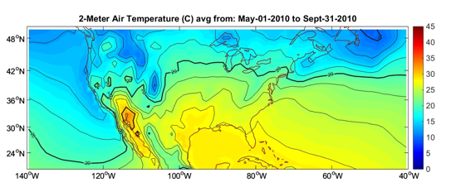

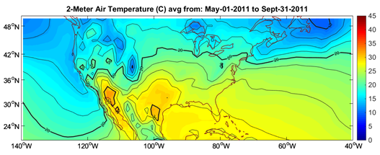

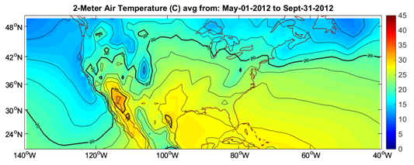

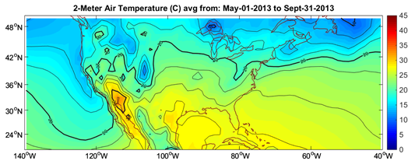

**Figure 12:** – The summer season for each year displays the average 2 – meter air temperature maxima located in the Arizona Basin and Range, covering the southwestern most area of the state. This region consistently contains the highest air temperatures in the country. *Source*: University of Utah’s MesoWest database.