**NASA DEVELOP National Program**

USGS at Colorado State University – Fort Collins, CO

**Fall 2015**

**Short Title: Colorado Agriculture**

**Subtitle:** Mapping Forest Species Composition in the Colorado State Forest State Park using Landsat 8 with Integrative Spatial Modeling

**VPS Title:** Seeing the Forest for the Trees: Mapping Species Composition in Colorado

**Project Team & Partners**

**Project Team:**

Brian Woodward (Project Lead), brdwoodward@gmail.com

Sarah Carroll

Nicholas Kotlinski

Eric Rounds

**Advisors & Mentors:**

Dr. Paul Evangelista (Natural Resources Ecology Lab, CSU)

Tony Vorster (Bioenergy Alliance Network of the Rockies)

**Partner Organizations:**

Bioenergy Alliance Network of the Rockies (BANR) (End-User), POC: Tony Vorster

Colorado State Forest Service (CSFS) (End-User) POC: John Twitchell

**Project Details**

**Applied Sciences National Application Addressed:** Agriculture

**Study Area:** Colorado State Forest State Park, CO

**Study Period:** July & August 2002, June & September 2014

**Earth Observations & Parameters:**

Landsat 8, OLI – land cover

Landsat 7, ETM+ – land cover

Landsat 5, TM – land cover

SRTM – digital elevation model

**Ancillary Datasets Utilized:**

* Colorado State Forest (CSF) - Management boundaries
* BANR 2015 Forest Species Inventory - Plot and species characteristics
* National Agriculture Imagery Program (NAIP) - Imagery for model input bands

**Models Utilized:**

* Montana State University, Shannon Savage - svm.rf_10xloop.R
* Montana State University, Shannon Savage - generic_ZImodeling_rinput.txt

**Software Utilized:**

ArcGIS - Raster manipulation/analysis, image enhancement & map creation

R (RStudio) - Statistical analysis, model application, figure creation

**Project Overview**

**80-100 Word Objectives Overview:**

This project utilizes imagery from NASA Landsat 8 (OLI), 7 (ETM+), and 5 (TM) in addition to ancillary datasets from NAIP and forest surveys as inputs into a novel zero-inflated regression model to map forest species composition. The primary objective is to bridge the gaps in knowledge of forest composition in Colorado State Forest State Park and other regional forests. By creating a more thorough and comprehensive record of species distribution, the results of this project will better inform forest management and potential harvesting of bioenergy feedstocks, while simultaneously improving the understanding of the ecological dynamics of forest species distribution.

**Abstract:**

State and National forests are actively managed for a variety of objectives including timber, recreation, wildlife, and livestock grazing. In Colorado, concerns about potential fire severity, aesthetics, and falling dead trees, as a result of the recent mountain pine beetle epidemic, are shared by our partners at Colorado State Forest Service (CSFS) and communities across the Rocky Mountain region. In addition, the Bioenergy Alliance Network of the Rockies (BANR) is assessing the feasibility of using beetle-kill wood as a source of biofuels. These diverse objectives and concerns highlight the need for current and accurate species composition maps to inform management decisions. Past species composition mapping has shown gaps in the ability to accurately highlight individual species at a fine scale over large forested landscapes, and these maps remain relatively coarse in terms of resolution and their usefulness to forest managers. This project utilizes scenes from Landsat 8 (OLI), 7 (ETM+), and 5 (TM), NAIP imagery, forest survey data, and an integrative model developed by researchers at Montana State University in order to create a detailed and highly accurate map of species composition in the Colorado State Forest State Park. Using this combined methodology, this project produced species composition maps for dominant species in Colorado State Forest, including lodgepole pine (*Pinus contorta*), subalpine fir (*Abies lasiocarpa*), Engelmann spruce (*Picea engelmannii*), and aspen (*Populus tremuloides*).

**Community Concerns:**

* The Colorado State Forest State Park is actively managed for timber, recreation, wildlife, and grazing. An accurate and up-to-date map of species composition is needed to manage for this diverse range of objectives. A map of species composition can be used as a baseline for past and future ecological studies. Additionally, communities in the Rocky Mountains are concerned about potentially severe fires, forest aesthetics, and falling dead trees as a result of the recent mountain pine beetle epidemic.
* In 2014, over 890,000 acres of Colorado forests were impacted by insect or disease activity. Species composition data are becoming an increasingly informative management tool in areas of bark beetle outbreak, as forest recovery trajectories are often dependent upon pre-outbreak species composition. These same data can aide foresters in identifying areas susceptible to severe outbreaks as well as with predicting future spread.
* BANR is assessing the feasibility of using beetle-kill wood as a feedstock for biofuel production. A map of species composition could be used by BANR to map live and dead biomass as they assess the location and quantity of potential feedstocks.

**Current Management Practices & Policies:**

The Colorado State Forest Service has an adaptive and active management strategy that requires accurate and current data to inform management decisions. Presently, these decisions are based primarily on historical records, field observations, and NAIP imagery. The Colorado State Forest Service does have a species composition map of the State Forest State Park; however, the map is inaccurate because it used outdated technology for the mapping process and the map has not been revised over time. These datasets are not sufficient to provide a forest-wide, accurate, map detailing forest species composition, which is important for understanding forest health, potential for insect infestation, and allotments for timber harvests.

**Decision Support Tools & Benefits:**

|  |  |  |
| --- | --- | --- |
| **End-Product** | **Earth Observations Used** | **Benefit & Impact** |
| Maps depicting location of specific forest species within Colorado State Forest State Park | Landsat 8 OLI, 7 ETM+, 5 TM, SRTM | These visualizations will assist partners in recognizing potential locations for profitable and ecologically sustainable bioenergy feedstock harvesting, in addition to species-specific pest outbreak monitoring. |
| A tutorial describing simplified steps for imagery pre-processing and running of the Zero-Inflated model in R | Landsat 8 OLI, 7 ETM+, 5 TM, SRTM | A step-by-step tutorial will help partners and future model users to better navigate the model inputs and parameters, allowing for the expedited use of the model. |
| Interactive ArcGIS Online (AGOL) dataset and story map of species composition process, end-results and benefits to partners and community | Landsat 8 OLI, 7 ETM+, 5 TM, SRTM | This will allow partners to access data visualizations online as well as providing an informative story map layout explaining the specific benefits of the map product to potential future partners and to educate the general public. |

**Project Imagery**

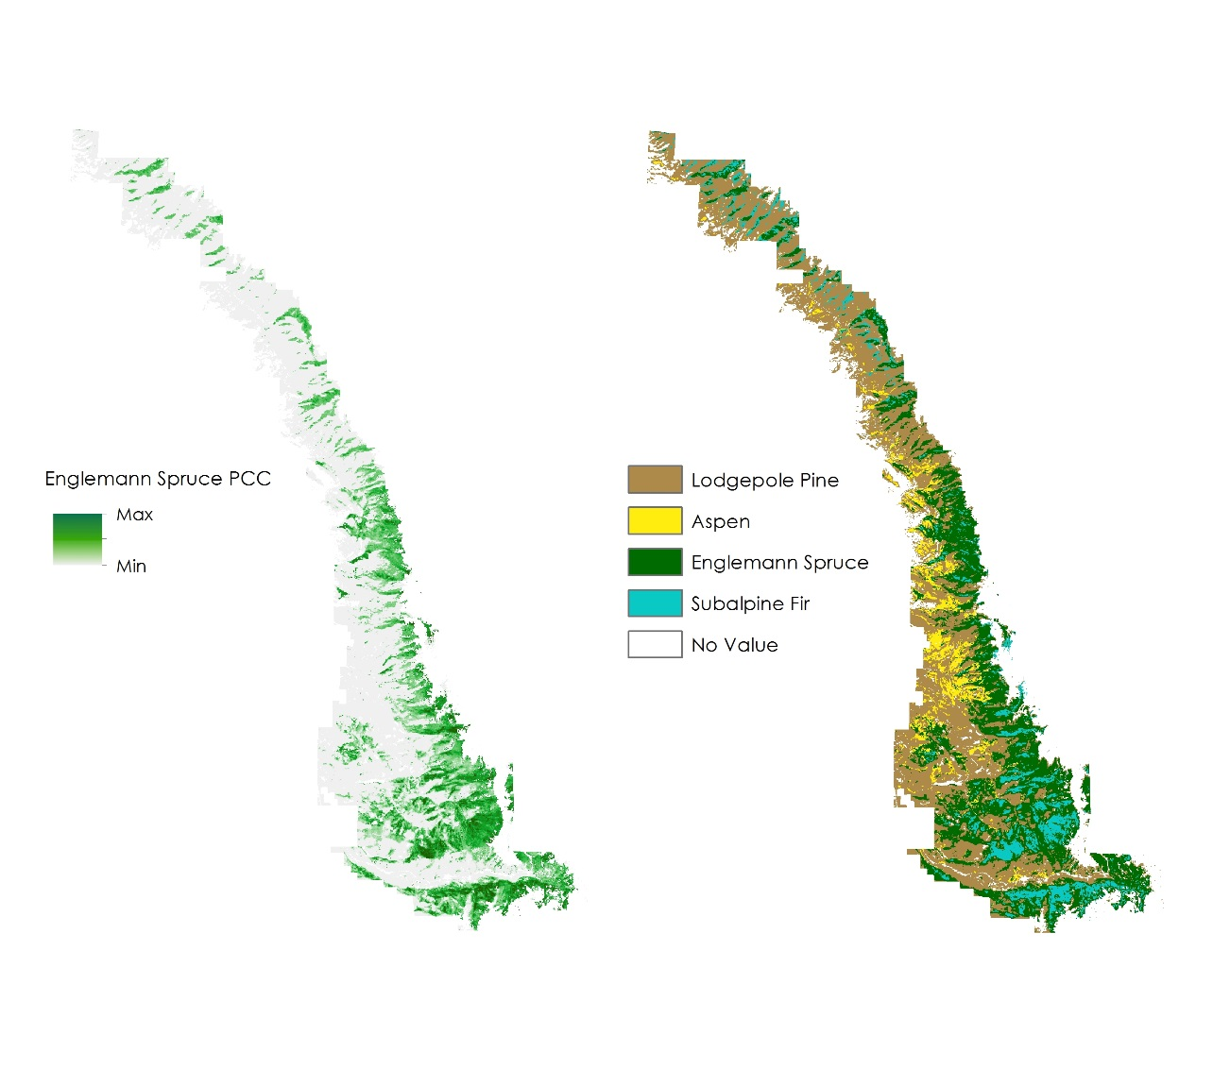

Caption: Map outputs depicting continuous percent canopy cover (PCC) of Spruce (left) and species distribution based on maximum canopy cover likelihood for each focal species in the study area (right). Image Credit: Colorado Agriculture Team

Image: COAG_2015_Fall_VPS_Image.jpg

**Software Release Requirements**

Category I