Great Lakes Water Resources

Improving Wetland Change Mapping using Optical and Radar Satellite Sensors to Assess Wetland Gain and Loss Metrics in Minnesota

 **Technical Report**

Final Draft – April 4th, 2019

Erica O’Connor (Project Lead)

Melissa Ferriter

Alice Lin

Christopher Notto

Bruce Chapman, NASA Jet Propulsion Laboratory, California Institute of Technology (Science Advisor)

Benjamin Holt, NASA Jet Propulsion Laboratory, California Institute of Technology (Science Advisor)

# 1. Abstract

Wetlands are a critical feature of our landscape for the ecological services they provide, including protecting water quality, providing habitat to rare species, mitigating erosion, and providing opportunities for recreation. Despite this, wetlands are facing increasing threats from a variety of anthropogenic sources, including pollution, change in climate, and commercial development. Although an accurate baseline inventory of wetland extent is essential for addressing these threats and quantifying future wetland change, traditional wetland mapping methods are time intensive, costly, and difficult to implement on a large scale. Here we show that statewide, fully-automated wetland mapping is possible to a high degree of accuracy by combining recent advances in remote sensing and cloud computing. Using a multi-source, multi-temporal, object-based random forest classification approach in Google Earth Engine, we generated 30 m resolution maps of wetland extent and change for the growing seasons (May through September) of 2017 and 2018 in Minnesota. In particular, the inclusion of Sentinel-1 C-Band Synthetic Aperture Radar (C-SAR) composites, Landsat 8 Operational Land Imager (OLI) composites, and a topographically derived wetness index allowed us to achieve an overall accuracy of 87%when compared to the National Wetland Inventory. Our partners included US Fish and Wildlife Service (USFWS) National Wetlands Inventory (NWI), Minnesota Department of Natural Resources (MN DNR), Environmental Protection Agency (EPA), Ducks Unlimited (DU), National Oceanic and Atmospheric Administration (NOAA) Office for Coastal Management, and the University of Minnesota (UMN). We anticipate that our tool can be of immediate use to these end users in Minnesota who rely on accurate wetland data to inform their research, policy, and development decisions. Furthermore, these methods can quickly be applied to any region of the United States for which adequate training data exists.

**Keywords**

remote sensing, GIS, Google Earth Engine (GEE), Landsat 8 Operational Land Imager (OLI), Sentinel-1 C-Band Synthetic Aperture Radar (C-SAR), automation

# 2. Introduction

* 1. ***Background Information***

Wetlands provide crucial ecosystem services, including flood mitigation, carbon sequestration, regulation of erosion and water quality, and habitat to rare species (Nyman, 2011). The importance of these functions and the subsequent need to track and maintain them is internationally recognized by the Ramsar Convention, an intergovernmental treaty aimed at the conservation of wetland ecosystems (Nyman, 2011). It is also acknowledged within the United States as the US Fish and Wildlife Service (USFWS) is mandated by the United States Congress under the Emergency Wetlands Resources Act to monitor and update the status of our nation’s wetlands (Dahl, 2011). To accomplish this, the USFWS maintains the National Wetlands Inventory (NWI), which disseminates wetland maps that inform stakeholders on wetland change, extent, and characteristics (US Fish & Wildlife Service, 2018a).

Traditionally, wetland delineation has involved interpretation of aerial orthophotography in conjunction with *in situ* data (US Fish & Wildlife Service, 2018a). Due to the resource intensive nature of conventional mapping methods, it is difficult to consistently update such geospatial inventories in a reliable and comprehensive manner. As a result, there are still portions of the NWI that have not been updated since the 1970s (US Fish & Wildlife Service, 2018b).

Various groups have investigated the utility of remote sensing to address this issue. The advantages of using remotely sensed data include a high frequency of data collection, landscape-scale data coverage, and access to multispectral information (Tiner, Lang, & Klemas, 2015). These qualities allow for the monitoring of wetland extent and interaction between land cover types that could illuminate drivers of wetland changes (Tiner et al., 2015). Several studies have investigated the use of optical datasets, such as data from the US Geological Survey (USGS) Landsat program, for wetland mapping (Huang, Peng, Lang, Yeo, & McCarty, 2014). One challenge with using optical imagery is that the occurrence of clouds and other atmospheric effects hinder the ability to detect features on the ground (Ozesmi & Bauer, 2002). In response, there have been recent efforts in investigating the efficacy of using synthetic aperture radar (SAR) satellite sensors to map wetlands due to the ability of radar to penetrate cloud cover and its sensitivity to moisture (Huang et al., 2018; Lang, Kasischke, Prince, & Pittman, 2008; Mahdianpari, Salehi, Mohammadimanesh, & Motagh, 2017). Synthesizing optical and radar datasets has allowed for an enhanced ability to detect not only the extent of wetland features but also the determination of wetland classes (Mahdianpari, Salehi, Mohammadimanesh, Homayouni, & Gill, 2019). Achieving the latter has been streamlined by using machine learning algorithms, such as the random forest method (Corcoran, Knight, & Gallant, 2013).

The abundance of remote sensing data and the desire to combine large datasets are often hindered by the hardware and software limits for most remote sensing scientists. However, the rise of cloud computing services has provided a new way to remotely access data that can be pre-processed and analyzed on-demand. For example, Google Earth Engine (GEE) is a cloud computing platform that allows for the processing of datasets that are hosted on its servers (Gorelick et al., 2017). It contains a suite of algorithms and functions that can be incorporated in a JavaScript code, which makes batch processing possible. Past studies have utilized GEE to access and process both optical and SAR data to produce wetland maps (Mahdianpari et al., 2019; Tang et al., 2016).

This study focused on wetlands in the state of Minnesota (*Figure 1*) with future plans to expand across the Great Lakes region. Our study period was the growing seasons (May through September) for 2017 and 2018, as wetlands during these dates were not frozen. Anderson & Craig (1984) have estimated that Minnesota has lost about half of its original wetlands. To mitigate wetland losses, the state has enacted a “no net-loss” policy regarding wetland area and quality (Minnesota Office of the Revisor of Statutes, 2018). Ensuring the success of this policy requires a wetland inventory with a reliable degree of confidence and frequent updates.

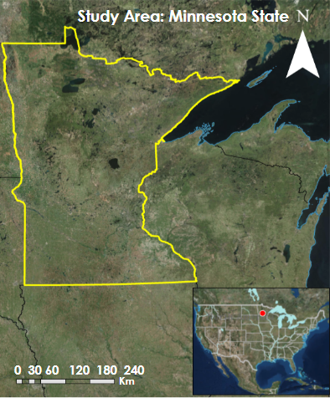

*Figure 1*. Map of the study area with the Minnesota state boundary in yellow.

* 1. ***Project Partners & Objectives***

The NASA DEVELOP Great Lakes Water Resources team worked in conjunction with end users and collaborators at the US Fish and Wildlife Service National Wetland Inventory (USFWS NWI), Minnesota Department of Natural Resources (MN DNR), the Environmental Protection Agency (EPA), Ducks Unlimited (DU), the National Oceanic and Atmospheric Administration Office for Coastal Management (NOAA), and the University of Minnesota (UMN) to create an automated wetland delineation tool hosted on GEE. Each of these partners was interested in the project because this preliminary tool will benefit them by providing accurate and current wetland maps that can inform their decisions regarding conservation and restoration. Typically for these partners, wetland mapping in Minnesota has been laborious and time-consuming, but with the creation of this delineation tool, mapping the extent of wetland inundation is automated. Our partners were involved in a recent update to the NWI map for the state of Minnesota that involved a semi-automated process that incorporated optical imagery, radar imagery, and topography and soil datasets (Kloiber, Macleod, Smith, Knight, & Huberty, 2015). However, a completely automated tool could complement their wetland mapping efforts.

The objective of this project was to improve wetland change mapping using both radar and optical datasets, including NASA Earth observations (EO), by creating an automated tool in GEE. This tool utilizes Landsat 8 Operational Land Imager (OLI) and Sentinel-1 C-Band Synthetic Aperture Radar (C-SAR) datasets hosted on the cloud to generate classified wetland maps. By directly and freely accessing the datasets from the GEE platform, the partners can use and build upon the tool that we built. The tool also builds and improves their capacities to use the GEE platform in conjunction with radar imagery and NASA EO data. A host of ancillary datasets are also used in the classification and validation process. Ultimately, this automated tool saves time and resources that would otherwise be spent on field surveying and traditional mapping and remote sensing approaches.

# 3. Methodology

***3.1 Data Acquisition***

Our team acquired Landsat 8 OLI Level-2 Surface Reflectance and Sentinel-1 C-SAR Level-1 Ground Range Detected (GRD) imagery within a date range determined to be the last frost of spring to the first frost of fall in northern Minnesota (Minnesota Department of Natural Resources, 2017) (Table 1). Additionally, we acquired Dual polarized C-Band Level 1 Ground Range Detected (GRD) Sentinel-1 C-SAR imagery for the growing seasons of 2017 and 2018 through the GEE application programming interface (API). Although a variety of resolutions and polarizations are distributed through Sentinel-1, we focused on the combination of 10 m dual polarized vertical transmit vertical receive and vertical transit horizontal receive (VV and VH) imagery available. Despite only providing half the information of a fully polarimetric dataset, dually polarized datasets like this one cover a larger area and have been used to produce highly accurate wetland classification maps (Mahdianpari et al., 2017).

We gathered ancillary data and utilized them for the creation of the wetland delineation tool from our partner sources. These data include an updated and revised NWI map for the state of Minnesota that was provided by the MN DNR. Also provided by MN DNR were 7,723 field validation points that were used to test and assess the accuracy of the developed delineation tool. We were provided a 3-meter Digital Elevation Model (DEM) from our partners at the MN DNR, which we used to calculate a Topographic Wetness Index (TWI). This topographic dataset was originally used in conjunction with the ArcGIS toolkit, Arc Hydro, in order to identify flow pathways and potential riparian areas that could contain wetlands (Kloiber et al., 2015). The combination of the field validation points and LiDAR elevation data allowed our team to have a more comprehensive analysis of the factors that affect and determine wetland delineation.

|  |  |  |  |  |  |
| --- | --- | --- | --- | --- | --- |
| Table 1  *Description of Earth observations used in classifications* | | | | | |
| **Platform & Sensor** | **Product Level** | **Image Dates** | **Image**  **Source** | **Parameter** | **Use** |
| Landsat 8 OLI | Level-2 | 05/24/17  to  09/23/17  05/27/18  to  09/26/18 | USGS via Google Earth Engine | Surface reflectance | Optical and infrared bands in addition to spectral indices were used to classify wetland areas at a spatial resolution of 30 m |
| Sentinel-1 C-SAR | Level-1 | 05/21/17  to  09/26/17  05/21/18  to  09/26/18 | ESA Copernicus via Google Earth Engine | Backscatter | Used to identify inundated areas |

***3.2 Data Processing***

*3.2.1 Overview*

We produced a 30 m resolution wetland map for 2017 and 2018 from our Sentinel-1 C-SAR composite and Landsat 8 OLI optical indices composites in addition to our DEM-derived layers. Our team followed four primary steps to produce this wetland classification map for Minnesota, including pre-processing, segmentation, classification via manual thresholding or the random forest algorithm, and validation. Data from each satellite were filtered to only include scenes within the Minnesota state boundary and the date range of Minnesota’s growing season. Landsat 8 surface reflectance data were filtered for cloud cover and Sentinel-1 data were also filtered for interferometric width (IW) and resampled from 10 m to 30 m resolution.

*3.2.2 Software and Scripting*

A combination of software was used in the process of creating the wetland delineation tool. The automated tool for remote sensing data collection, pre-processing, and delineation of wetlands was created entirely using the GEE API. Harris Corporation ENVI, a remote sensing image analysis software, was used in order to assess the accuracy of the map products created by the GEE tool, while map product visualizations were created with ESRI ArcMap. The final end product tool utilizes Landsat 8 OLI and Sentinel-1 C-SAR datasets hosted on Google’s cloud to generate classified wetland maps.

*3.2.3 SAR Imagery*

SAR imagery was accessed and filtered by state bounds, our predetermined date ranges for the growing season, Interferometric Wide instrument mode in GEE, and resampled from 10 m to 30 m resolution. The spatial coverage of our image collection is shown in Appendix A. After this initial extraction, the resulting image collection was processed image-by-image before any analysis was performed. The SAR scenes hosted by GEE undergo processing by the European Space Agency (ESA) Sentinel-1 toolbox that includes terrain correction using a digital elevation model (DEM), the application of an orbit file, noisy border removal, radiometric calibration, and conversion from natural values to decibels (dB) (Google Developers, 2019). For the purposes of this project, we converted dB values back to natural values (Equation 1). Some scenes retained dark borders, which were removed using a threshold value determined through visual inspection. The resulting VV and VH geo-coded backscatter intensity image collection was then reduced to mean composites for the growing seasons of 2017 and 2018.

*Natural values* = ${\text{ 10}}^{\frac{\text{dB}}{\text{10}}}$ (1)

*3.2.4 Optical Imagery*

The presence of clouds and snow complicates the classification of wetlands, especially in regions like Minnesota that have year-round cloud cover and dense snow during the winter and spring months. To mitigate these issues, we excluded highly cloudy scenes and masked out the remaining cloudy pixels. Additionally, we created composites for only the growing season months of 2017 and 2018 when the area is not frozen. By creating these cloud free composites, we preserved phenological information and simplified the pre-processing of optical imagery (Tang et al., 2016).

We used Landsat 8 Surface Reflectance Tier 1 data in this study to create cloud free composites. The tier 1 Landsat collections hosted on GEE were already radiometrically and geometrically corrected, so we took no further calibration steps. In total, 183 and 193 images at 30 m resolution were available for 2017 and 2018, respectively (Appendix A). Initially, we filtered the collections by the state boundary of Minnesota and by the growing season date ranges. To address the frequent cloud cover present in these time periods, we used bits 3 and 5 from the pixel Quality Assessment (QA) band of the Landsat 8 data to mask out cloud shadows and clouds. Specifically, by setting both flags to zero, we filtered the images to only display clear conditions. We composited the resulting collections by year using a mean reducer and calculated both the Modified Normalized Difference Water Index (MNDWI) and the Tasseled Cap Wetness Greenness Difference Index (TCWGD) for each yearly composite. We used the Tasseled Cap Transformation (TCT) coefficients specifically for the Landsat 8 OLI sensor. MNDWI (Equation 2) and TCWGD (Table 2) are two widely used indices for wetland classification that aid in discriminating vegetation, wetlands, and water from other landscape features (Gao, 1996; Rouse Jr., Haas, Schell, Deering, & Harlan, 1974). The red (band 4), Near-Infrared (NIR band 5), green (band 3), and Short-Wave Infrared (SWIR band 6) bands from all image dates were used to compute these optical indices.

MNDWI= $\frac{\text{Green - NIR}}{\text{Green} \text{+} \text{NIR}}$   (2)

|  |  |  |  |  |  |  |
| --- | --- | --- | --- | --- | --- | --- |
| Table 2  *Tasseled cap transformation coefficients* | | | | | | |
| **Index** | **Blue** | **Green** | **Red** | **NIR** | **SWIR1** | **SWIR2** |
| Greenness | -0.294 | -0.243 | -0.5424 | 0.7276 | 0.0713 | -0.1608 |
| Wetness | 0.1511 | 0.1973 | 0.3283 | 0.3407 | -0.7117 | -0.4599 |
|  |  |  |  |  |  |  |

*3.2.5 Ancillary Data*

Digital elevation models (DEMs) derived from lidar data were used to determine various topographic metrics, including slope, contributing area, and Topographic Wetness Index (TWI). Topography not only affects wetland hydrology, one of the defining variables in delineation, but also wetland type and position. Several studies have noted increased classification accuracy of wetland location and inundation periodicity when topographic input data are included, especially in difficult to map regions (Cocoran et al., 2013; Lang, McCarty, Oesterling, & Yeo, 2013). Slope and contributing area were the primary topographic metrics we derived using the flow accumulation function in ESRI ArcGIS. The TWI is the second derivative of slope and contributing area that is traditionally used to map vegetation and characterize soils. However, TWI has also been used to successfully map wetlands (Kloiber et al., 2015). Higher TWI values correspond to areas that are likely to be wetter when compared to areas with low values (Lang et al., 2013). The MN DNR provided LiDAR data at 3 m resolution, and we resampled our derived DEMs to 30 m.

Our partners at the MN DNR provided 7,723 reliable reference points compiled from field site visits, existing wetland monitoring programs, and manual photo interpretation of high-resolution imagery. These points contain information on the wetland classification based on the Cowardin system as well as other details describing the biotic and abiotic characteristics of those locations. After a discussion with our partners, we reclassified the field points into three classes: upland, wetland, and open water. The reclassification criteria are described in Appendix Table B1. Their recent NWI update for the state of Minnesota was also provided and reclassified according to Appendix Table B2.

***3.3 Object-Based Image Analysis***

*3.3.1 SNIC Segmentation*

Object-based image segmentation reduces noise in final classification maps by integrating spectral and contextual information about an image neighborhood. Pixel-based classification, on the other hand, relies solely on single pixel values, which results in lower accuracy speckled classification maps (Blaschke, 2010). Simple Non-Iterative Clustering (SNIC) is a faster, noniterative version of Simple Linear Iterative Clustering (SLIC) superpixel segmentation that has shown increased segmentation quality. Both methods rely on small clusters of connected pixels called superpixels, which are roughly uniform and compact, but the SNIC algorithm visits all pixels only once when creating objects whereas lengthy iterative pixel visits are performed during the SLIC method (Achanta & Süsstrunk, 2017). By enforcing connectivity from the start, the SNIC algorithm only selects candidate pixels that are 4 or 8 pixels connected to the growing cluster to determine which pixels are added in. Therefore, computing fewer distances between pixels and reducing computation time (Mahdianpari et al., 2019). Compared to other similar clustering algorithms, SNIC demonstrates low segmentation error and increased efficiency and accuracy.

We carried out an object-based image analysis (OBIA) in a two-stage approach: first, segmentation using SNIC and second, classification using a random forest (RF) classifier and manual thresholds. We chose to use both thresholds and RF to compare the accuracy between these two classification methods. Before segmenting our layers, we used the GEE “addBands” function to combine our five inputs into a single image with a separate band for each dataset. The resulting image contained bands for a Sentinel-1 VV and VH backscatter composite, a Landsat 8 OLI MNDWI and TCGWD composite, and a TWI layer. This aggregating method was repeated for the 2017 and 2018 date ranges and then each image was segmented using the SNIC algorithm. Conveniently, GEE provides a built-in SNIC segmentation algorithm with the ability to adjust the size, compactness, connectivity, neighborhood size, and configuration of seeds.

*3.3.2 Index Value Thresholding*

We performed a manual index value thresholding in GEE using our SNIC-derived image objects. We first identified indices that were likely to distinguish between land cover types by extracting pixel values of each index located at our training data points. We then visualized the distribution of these values compared to each land cover type using box-and-whisker plots (*Figure* 2). After omitting indices that contained considerable overlap between land cover types, we qualitatively identified thresholds for the remaining indices that could be used to classify our image objects (Table 3). Our thresholding procedure consisted of independently identifying open water and wetland areas, combining these into one raster, and reclassifying overlapping areas as open water. The last step was included after a visual inspection indicating that most of these overlapping areas were located on open water. We classified all remaining areas as upland, and the thresholds were adjusted until it resembled the most recent NWI update of Minnesota.

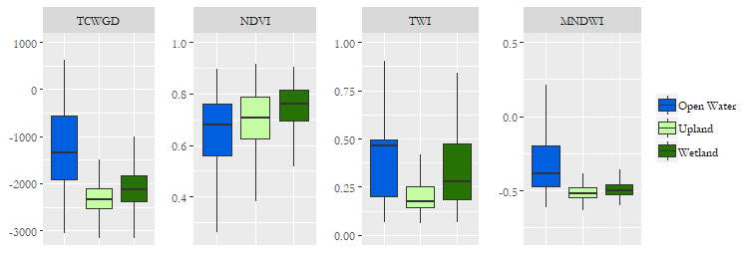

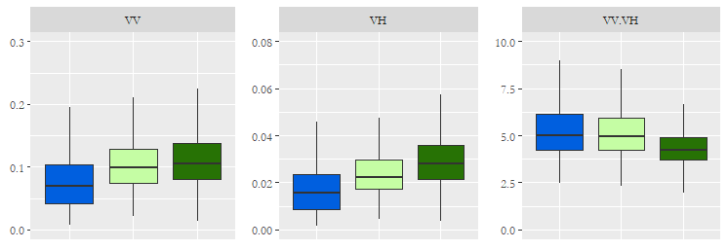

*Figure 2.* Boxplots of thresholding index values.

|  |  |  |
| --- | --- | --- |
| Table 3  *Threshold rules for each cover type* | | |
| **Land cover type** | **Indices/bands used** | **Thresholds** |
| Open water | MNDWI, VV, VH | VV < 0.1 and VH < 0.02 and MNDWI > -0.4 |
| Wetland | MNDWI, TWI | TWI > 0.2 and MNDWI < -0.4 |

*3.3.3 Random Forest Classification*

The RF classifier is a non-parametric ensemble learning technique that has been widely used for land cover classification (Rodriguez-Galiano, Ghimire, Rogan, Chica-Olmo & Rigol-Sanchez, 2012). We selected this classification method because it can handle non-normally distributed inputs, has a higher classification accuracy than other advanced learning tools (such as support vector machine and decision trees), and can also handle highly dimensional multisource data while remaining insensitive to overfitting and noise (Mahdianpari et al., 2019). Although computation time is not as operationally important when using GEE, the RF method is considered to be much lighter and efficient when compared to other classifiers with similar error rates (Gislason, Benediktsson, & Sveinsson, 2006).

We implemented an RF classification in GEE using the “Classifier.randomForest” algorithm. The main objective of our classification was to identify three land cover types: upland, open water, and wetland (Table 4). Our classifier used a stratified random sample of 50 percent of the 7,723 reference samples provided by the MN DNR for both 2017 and 2018, and we determined through trial and error that the optimal number of trees was 100 for both years. We compared the original NWI and the updated Minnesota wetland inventory to our classified results and created additional training polygons for weak land cover classes.

|  |  |
| --- | --- |
| Table 4  *Descriptions of primary land cover classes* | |
| **Class** | **Description** |
| Upland | Dryland |
| Wetland | Inundated land |
| Open water | Rivers, lakes, ponds |

# *3.4 Accuracy Assessment*

Accuracy assessment is an important part of wetland classification since the Federal Geographic Data Committee (FGDC) Wetland Mapping Standard requires wetland attribute accuracy to be at least 85 percent and wetland feature accuracy to be at least 98 percent in order for a classification to be included in the National Spatial Data Infrastructure (NSDI). Using the recent NWI update for Minnesota as a proxy for ground truth data, we evaluated the positional and thematic accuracy of the classification results using four standard indices, including overall accuracy, Kappa coefficient, user’s accuracy, and producer’s accuracy. Overall accuracy indicates what percentage of reference sites were correctly classified and the Kappa coefficient evaluates how well the classification performed compared to a random classification of pixels. User’s and producer’s accuracy are important indicators of commission and omission error and are a measure of how often the class on the map will actually be present on the ground and how often real features on the ground are correctly shown on the classified map, respectively (Redmon, 1995).

# 4. Results & Discussion

***4.1 Index Evaluation***

The ability to discriminate between our land cover classes varied depending on the index or band of interest. The VV and VH pixel value distributions strongly resembled each other with the lowest backscatter values for the open water class and the highest values for the wetland class. Lower values are expected over open water as the smooth surface would result in specular scattering. Wetland areas tend to result in higher backscatter values due to a double bounce effect occurring when emitted energy reflects off the water surface and then the vertical structure of vegetation before returning to the SAR sensor (Lang et al., 2008). Due to the strong resemblance between VV and VH distributions, the resulting VV/VH ratio distributions were not as useful in discerning between our classes. Between our optical indices, the TCWGD best distinguished between all three classes. However, MNDWI is most useful for extracting open water bodies from other land cover types. There was considerable overlap in the NDVI distributions for each class, resulting in removal from our final threshold equation. The TWI distributions for open water and wetland were similar, indicating that this index could be useful for identifying areas of high water content. The TWI range of values was much lower than the other two classes, indicating its ability to distinguish between wet and dry areas. The final inputs into our random forest classification included the TCWGD, MNDWI, VV, VH, and TWI layers.

***4.2 Classifications***

Final classification results maps are found in Appendix C as *Figures C1 to C3*. Our random forest classification map for the year 2017 achieved an overall accuracy of 87 percent when compared to the field data, which was most recently updated in 2013. Although our random forest map accurately classified 77 percent of upland areas and 87 percent of wetland areas when compared to the NWI, it had much lower accuracy for wetland areas, 59 percent, (*Figure* *3*) and had trouble differentiating between open water and wetland (Appendix Tables D2 and D4). We concluded that further spectral separation of open water from wetland was necessary since our threshold tool mapped 39 percent wetland areas as open water when compared to the field data points. When comparing our 2017 threshold map to the field validation points provided by our partners, our tool achieved an overall accuracy of 48.9 percent. Our threshold tool correctly classified 44.8 percent of upland areas, 27.1 percent of open water areas, and 63.1 percent of wetland areas. However, when comparing the updated 2018 Minnesota NWI to our partner’s field validation points, they had an overall accuracy of 69.9 percent and a correct classification of 57.2 percent of wetland areas. These discrepancies highlight the need for updated field validation points to improve and test the accuracy of these classification methods.

Our random forest classified map for the year 2017 achieved an overall accuracy of 86.36 percent when compared to the NWI. The random forest tool accurately classified 80 percent of upland areas and 12 percent of open water areas, although what the NWI classified as open water is being confused for wetland 48.6 percent of the time. Our user’s accuracy for our wetland class was 59 percent, most likely due to over classifying wetland areas as open water. When comparing our 2017 random forest map to the field validation points given to us by our partners, the overall accuracy was 86.6 percent, and we successfully classified 87.2 percent of upland areas, 76.9 percent of open water areas and 90.3 percent of wetland areas.

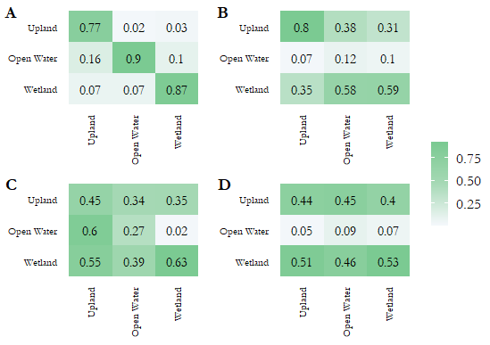

*Figure 3.* Confusion matrices obtained from the: (A) random forest map compared to field points, (B) random forest map compared to the updated NWI map, (C) threshold map compared to field points, and (D) threshold map compared to the updated NWI map.

***4.3 Future Work***

The approach in this study can be further expanded upon by including multiple levels of wetland classification and extending the study area to the neighboring states around Minnesota. Creating a multi-state, hierarchical classification poses challenges in finding consistent high coverage imagery and training data as well as in having the processing power to support automated large-scale mapping. Although GEE addresses some of these concerns by hosting and processing a wide variety of imagery and spatial data, it has limitations in analyzing big data and providing statistical, classification, and validation tools that are readily available on other platforms. As GEE adds more functionality, future research can validate and adjust our tool using Ducks Unlimited’s recent wetland mapping data and perform further comparisons with DigitalGlobe and RADARSAT-2 imagery that has been acquired over 10 pilot sites in Minnesota. Additionally, to identify which method produces the most accurate wetland classification in Minnesota, we propose the further exploration of pixel- and object-based classification techniques and experimentation with the inclusion of supplemental radar and optical datasets.

Future work that would need to be done on our tool hosted on GEE would be to further separate the classification classes into a level-2 classification. Spectrally separating wetland areas from open water areas would be important to successfully classify specific wetland types that usually have vegetation and water in one area. Furthermore, collecting updated and evenly distributed field validation points would be crucial to achieving this class separation.

# 5. Conclusions

Advances in cloud computing and the widespread availability of high-resolution remote sensing data have made the creation of on-demand land cover maps possible. Leveraging these advances and using radar and optical datasets in addition to training and elevation data provided by our partners, we produced the first fully automated tool to map wetland change and extent in the state of Minnesota. Specifically, we created a statewide growing season composite wetland inventory for 2017 and 2018 with the option to adjust the spatial and temporal scale.

After exploring which methods and datasets were best able to discriminate between our land cover types, we concluded that an object-based random forest classification that included VV backscatter, VH backscatter, TCWGD, MNDWI, and TWI yielded the highest overall accuracy of 87 percent. Although the manual thresholds produced were able to sufficiently classify the wetland class, it had a lower overall accuracy of 49 percent and failed to accurately classify open water. Though our results are preliminary, our tool provides a scalable solution to the urgent need to update and standardize wetland inventories across the country. This study benefits stakeholders in Minnesota specifically by providing accurate maps that will inform their conservation, agriculture, and infrastructure decisions and contribute to their efforts to update wetland inventories on local scales.

# 6. Acknowledgments

We would like to thank our Science Advisors Bruce Chapman and Benjamin Holt at NASA JPL for their guidance on creating our wetland mapping tool. We would also like to thank our Center Lead Erika Higa and Assistant Center Lead Neda Kasraee.

Finally, we would like to acknowledge the contributions of our project partners Brian Huberty, Steve Kloiber, Tom Hollenhorst, Robb Macleod, Brandon Krumwiede, and Joe Knight whose expert knowledge and field data made this project possible.

This material contains modified Copernicus Sentinel data (2017-2018), processed by ESA.

Any opinions, findings, and conclusions or recommendations expressed in this material are those of the author(s) and do not necessarily reflect the views of the National Aeronautics and Space Administration.

This material is based upon work supported by NASA through contract NNL16AA05C.

# 

# 7. Glossary

**Earth observations** – Satellites and sensors that collect information about the Earth’s physical, chemical, and biological systems over space and time

**Google Earth Engine** – Cloud-based programming platform for various planetary-scale environmental data analysis that can perform highly interactive algorithm development

**Landsat 8** – Global satellite that consists of two science instruments: the Operational Land Imager (OLI) and the Thermal Infrared Sensor (TIRS); these two sensors provide seasonal coverage of the global landmass at a spatial resolution of 30 meters

**LiDAR** – A remote sensing method that uses light in the form of a pulsed laser to measure ranges to the Earth; these light pulses, combined with other data recorded by the airborne system, generate precise, three-dimensional information about the shape of the Earth and its surface characteristics

**Random forest (RF) classifier** – An ensemble learning method for classification, regression, and other tasks that operates by constructing a multitude of decision trees at training time and outputting the class that is the mode of the classes (classification) or mean prediction (regression) of the individual trees

**Sentinel-1 C-SAR** – A satellite sensor that carries an advanced radar instrument to provide an all-weather, day-and-night supply of imagery of Earth’s surface

# 8. References

Achanta, R., & Süsstrunk, S. (2017). *Superpixels and polygons using simple non-iterative clustering*. Paper presented at the 2017 IEEE Conference on Computer Vision and Pattern Recognition (CVPR). https://doi.org/10.1109/CVPR.2017.520

Anderson, J. P., & Craig, W. J. (1984). *Growing energy crops on Minnesota’s wetlands*: The land use perspective. Retrieved from http://www.cura.umn.edu/publications/catalog/e1037

Blaschke, T. (2010). *Object based image analysis for remote sensing.* *ISPRS Journal of Photogrammetry and Remote Sensing, 65*(1), 2-16. https://doi.org/10.1016/j.isprsjprs.2009.06.004

Corcoran, J. M., Knight, J. F., & Gallant, A. L. (2013). Influence of multi-source and multi-temporal remotely sensed and ancillary data on the accuracy of random forest classification of wetlands in northern Minnesota. *Remote Sensing, 5*(7), 3212-3238. https://doi.org/10.3390/rs5073212

Dahl, T. E. (2011). *Status and trends of wetlands in the conterminous United States 2004 to 2009.* Washington DC: US Department of the Interior, Fish and Wildlife Service. Retrieved from https://www.fws.gov/wetlands/documents/Status-and-Trends-of-Wetlands-in-the-Conterminous-United-States-2004-to-2009.pdf

Gao, B. (1996). NDWI—A normalized difference water index for remote sensing of vegetation liquid water from space. *Remote Sensing of Environment, 58*(3), 257-266. https://doi.org/10.1016/S0034-4257(96)00067-3

Gislason, P. O., Benediktsson, J. A., & Sveinsson, J. R. (2006). Random forests for land cover classification*.* *Pattern Recognition Letters, 27*(4), 294-300. https://doi.org/10.1016/j.patrec.2005.08.011

Google Developers. (2019, February 15). Sentinel-1 algorithms. *Google Earth Engine API*. Retrieved 28 March 2019 from https://developers.google.com/earth-engine/sentinel1

Gorelick, N., Hancher, M., Dixon, M., Ilyushchenko, S., Thau, D., & Moore, R. (2017).Google Earth Engine: Planetary-scale geospatial analysis for everyone. *Remote Sensing of Environment, 202*, 18-27. https://doi.org/10.1016/j.rse.2017.06.031

Huang, C., Peng, Y., Lang, M., Yeo, I.-Y., & McCarty, G. (2014). Wetland inundation mapping and change monitoring using Landsat and airborne LiDAR data. *Remote Sensing of Environment, 141*, 231-242. https://doi.org/10.1016/j.rse.2013.10.020

Huang, W., DeVries, B., Huang, C., Lang. M. W., Jones, J. W., Creed, I. F., & Carroll, M. L. (2018). Automated extraction of surface water extent from Sentinel-1 data. *Remote Sensing, 10*(5), 797. http://doi.org/10.3390/rs10050797

Kautz, S. (2018). Landsat 8 OLI (Operational Land Imager) [Dataset]. US Geological Survey. https://doi.org/10.5066/f71835s6

Kloiber, S. M., Macleod, R. D., Smith, A. J., Knight, J. F., & Huberty, B. J. (2015*).* A semi-automated, multi-source data fusion update of a wetland inventory for East-Central Minnesota, USA. *Wetlands, 35*(2), 335-348. https://doi.org/10.1007/s13157-014-0621-3

Lang, M., McCarty, G., Oesterling, R., & Yeo, I.-Y. (2013). Topographic metrics for improved mapping of forested wetlands. *Wetlands, 33*(1), 141-155. http://doi.org/10.1007/s13157-012-0359-8

Lang, M. W., Kasischke, E. S., Prince, S. D., & Pittman, K. W. (2008). Assessment of C-band synthetic aperture radar data for mapping and monitoring Coastal Plain forested wetlands in the Mid-Atlantic Region, U.S.A. *Remote Sensing of Environment, 112(*11), 4120-4130. https://doi.org/10.1016/j.rse.2007.08.026

Mahdianpari, M., Salehi, B., Mohammadimanesh, F., Homayouni, S., & Gill, E. (2019). The first wetland inventory map of Newfoundland at a spatial resolution of 10 m using Sentinel-1 and Sentinel-2 Data on the Google Earth Engine cloud computing platform. *Remote Sensing, 11*(1), 43. https://doi.org/10.3390/rs11010043

Mahdianpari, M., Salehi, B., Mohammadimanesh, F., & Motagh, M. (2017). Random forest wetland classification using ALOS-2 L-band, RADARSAT-2 C-band, and TerraSAR-X imagery. *ISPRS Journal of Photogrammetry and Remote Sensing, 130*, 13-31. https://doi.org/10.1016/j.isprsjprs.2017.05.010

Minnesota Department of Natural Resources. *Climate*. (2017). Retrieved from https://www.dnr.state.mn.us/faq/mnfacts/climate.html

Minnesota Office of the Revisor of Statutes. (2018). *2018 Minnesota Statutes: 103A.201 Regulatory Policy*. Retrieved from https://www.revisor.mn.gov/statutes/cite/103A.201

Nyman, J. A. (2011). Ecological functions of wetlands. In B. A. LePage (Ed.), *Wetlands: Integrating Multidisciplinary Concepts* (pp. 115–128). Dordrecht: Springer Netherlands. https://doi.org/10.1007/978-94-007-0551-7_6

Ozesmi, S. L., & Bauer, M. E. (2002). Satellite remote sensing of wetlands. *Wetlands Ecology and Managemen*t, *10*(5), 381-402. https://doi.org/10.1023/A:1020908432489

Redmond, R. (1995). *Tau coefficients for accuracy assessment of classification of remote sensing data,* 5. Retrieved from https://www.asprs.org/wp-content/uploads/pers/1995journal/apr/1995_apr_435-439.pdf

Rodriguez-Galiano, V. F., Ghimire, B., Rogan, J., Chica-Olmo, M., & Rigol-Sanchez, J. P. (2012). An assessment of the effectiveness of a random forest classifier for land-cover classification. *ISPRS Journal of Photogrammetry and Remote Sensing, 67*, 93–104. https://doi.org/10.1016/j.isprsjprs.2011.11.002

Rouse Jr., J. W., Haas, R. H., Deering, D. W., Schell, J. A., & Harlan, J. C. (1974*). Monitoring the vernal advancement and retrogradation (greenwave effect) of natural vegetation*. College Stations, TX: Texas A&M University Remote Sensing Center. Retrieved from https://ntrs.nasa.gov/search.jsp?R=19750020419&hterms=Monitoring+Vernal+Advancement+Retrogradation+Greenwave+Effect+Natural+Vegetation&qs=N%3D0%26Ntk%3DAll%26Ntt%3DMonitoring%2520The%2520Vernal%2520Advancement%2520and%2520Retrogradation%2520%28Greenwave%2520Effect%29%2520of%2520Natural%2520Vegetation%26Ntx%3Dmode%2520matchallpartial

Tang, Z., Li, Y., Gu, Y., Jiang, W., Xue, Y., Hu, Q., … Li, R. (2016*).* Assessing Nebraska playa wetland inundation status during 1985–2015 using Landsat data and Google Earth Engine. *Environmental Monitoring and Assessment, 188*(12), 654. https://doi.org/10.1007/s10661-016-5664-x

Tiner, R. W., Lang, M. W., & Klemas, V. V. (2015). *Remote sensing of wetlands: Applications and advances.* Boca Raton, FL: CRC Press. https://doi.org/10.1201/b18210

US Fish & Wildlife Service. (2018a). *NWI Program Overview.* Retrieved from https://www.fws.gov/wetlands/nwi/Overview.html

US Fish & Wildlife Service. (2018b*). Wetlands Mapper*. Retrieved from https://www.fws.gov/wetlands/data/Mapper.html

# 9. Appendices

**Appendix A.** Coverage and density of images for (A) Landsat 8 OLI and (B) Sentinel-1 C-SAR datasets for the growing seasons of 2017 and 2018

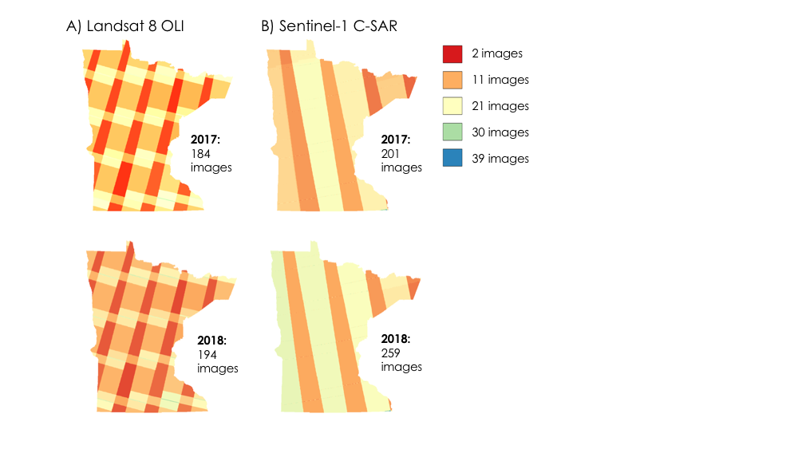

**Appendix B.** Reclassification schemes

|  |  |  |  |  |
| --- | --- | --- | --- | --- |
| Table B1  *Reclassification scheme for field validation points where:* *1 = upland; 2 = open water, 3 = wetland* | | | | |
| **Cowardin** | **Primary class** |  | **Cowardin** | **Primary class** |
| L1UB | 2 |  | PSS | 3 |
| L2AB | 2 |  | PSS1 | 3 |
| L2EM2 | 3 |  | PSS2 | 3 |
| L2UB | 2 |  | PSS3 | 3 |
| L2US | 2 |  | PSS3q | 3 |
| PAB | 2 |  | PUB | 2 |
| PEM | 3 |  | PUBx | 2 |
| PEM1 | 3 |  | PUS | 2 |
| PEM1f | 3 |  | R2AB | 2 |
| PFO | 3 |  | R2EM | 3 |
| PFO1 | 3 |  | R2UB | 2 |
| PFO1/4 | 3 |  | R3UB | 2 |
| PFO2 | 3 |  | R4SB | 2 |
| PFO2/4 | 3 |  | UPL | 1 |
| PFO4 | 3 |  |  |  |

|  |  |
| --- | --- |
| Table B2  *Reclassification scheme for National Wetlands Inventory Update raster where: 1 = upland; 2 = open water, 3 = wetland* | |
| **NWI Class** | **Primary class** |
| Lake | 2 |
| Freshwater Pond | 2 |
| Freshwater Emergent Wetland | 3 |
| Freshwater Forested Wetland | 3 |
| Freshwater Shrub/Emergent Wetland | 3 |
| Freshwater Shrub Wetland | 3 |
| Riverine | 2 |
| Freshwater Forested/Emergent Wetland | 3 |
| Freshwater Forested/Shrub Wetland | 3 |
| Freshwater Shrub Wetland/Pond | 3 |
| Freshwater Emergent/Shrub Wetland | 3 |
| Freshwater Emergent Wetland/Pond | 3 |
| Freshwater Pond/Shrub Wetland | 3 |
| No Data | 1 |

**Appendix C.** Classification results figures

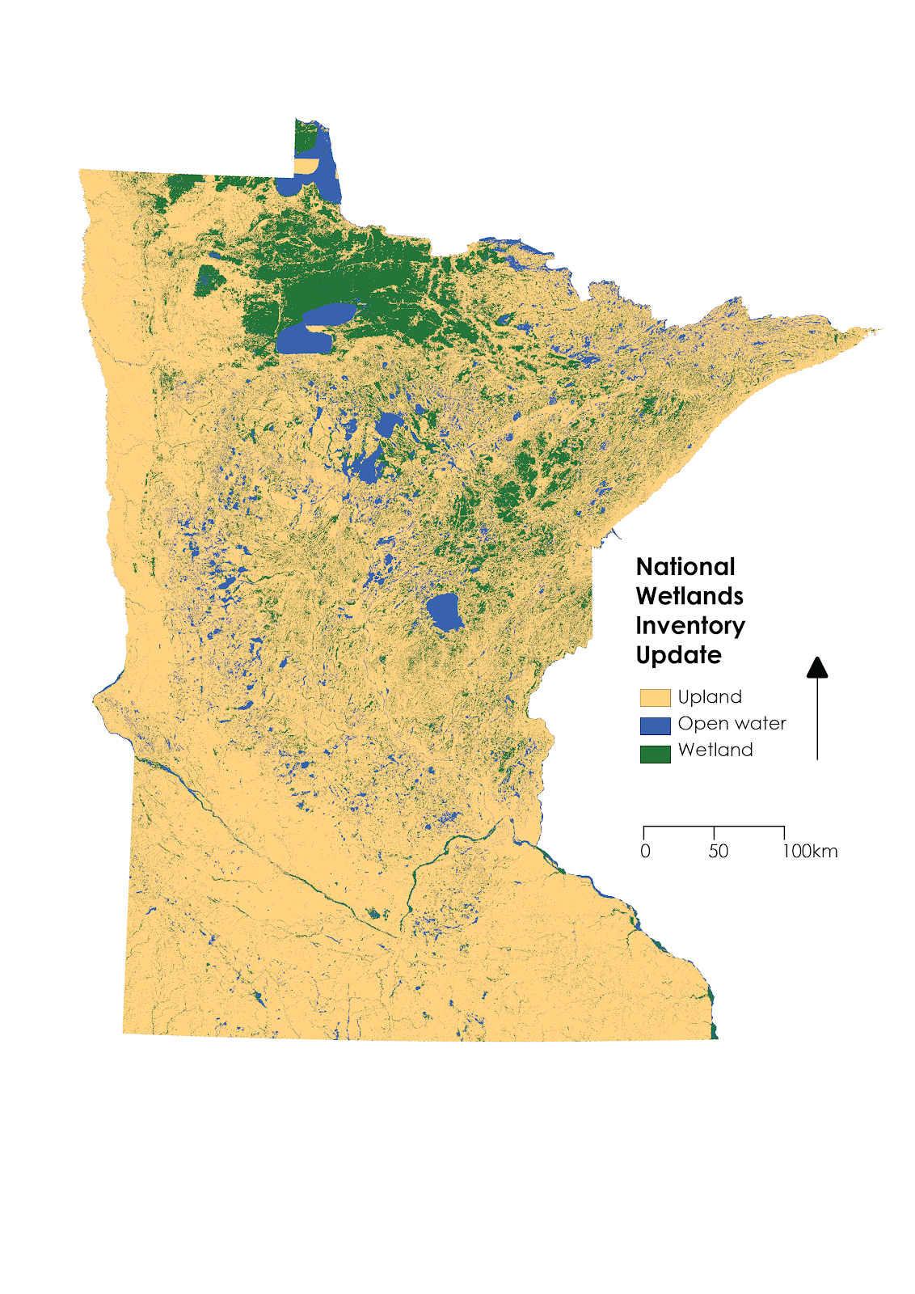

*Figure C1.* 2018 statewide National Wetlands Inventory map produced by our partners.

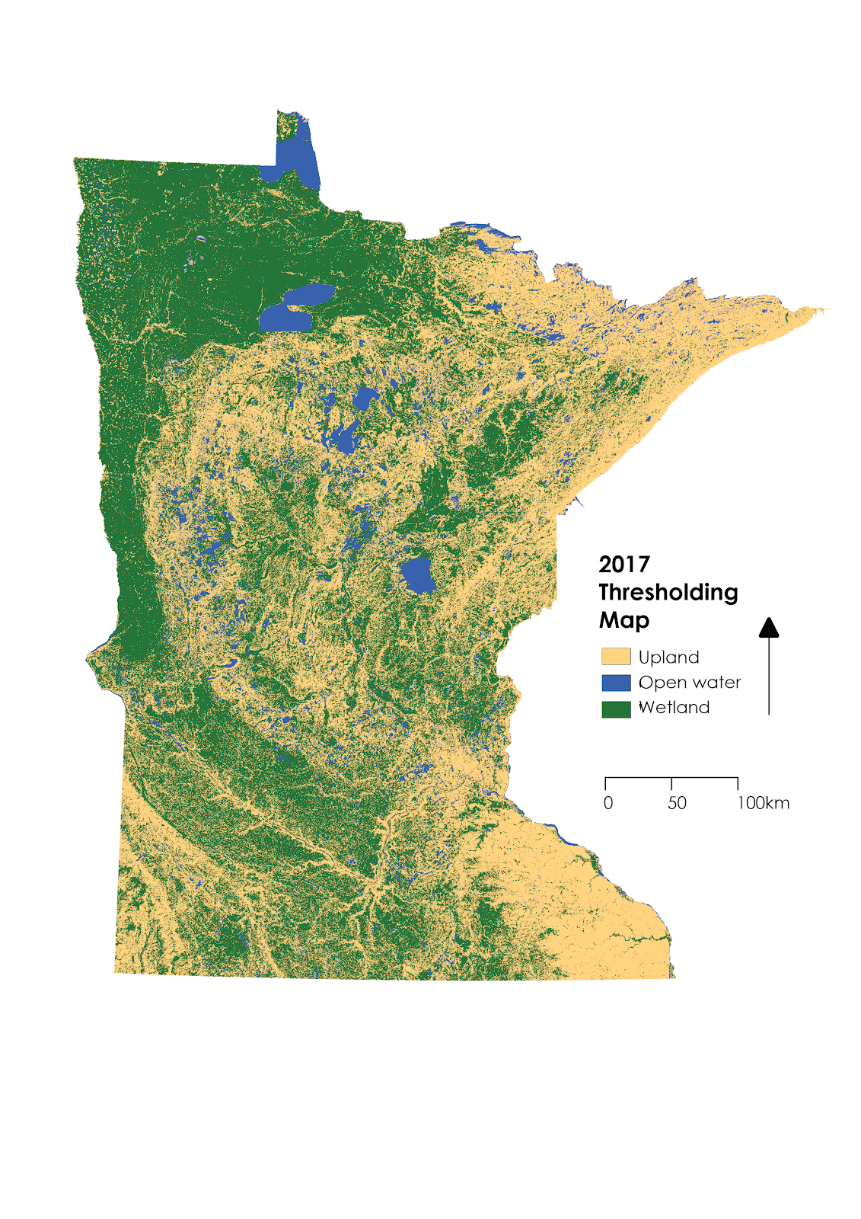

*Figure C2*. Statewide map produced by thresholding for 2017.

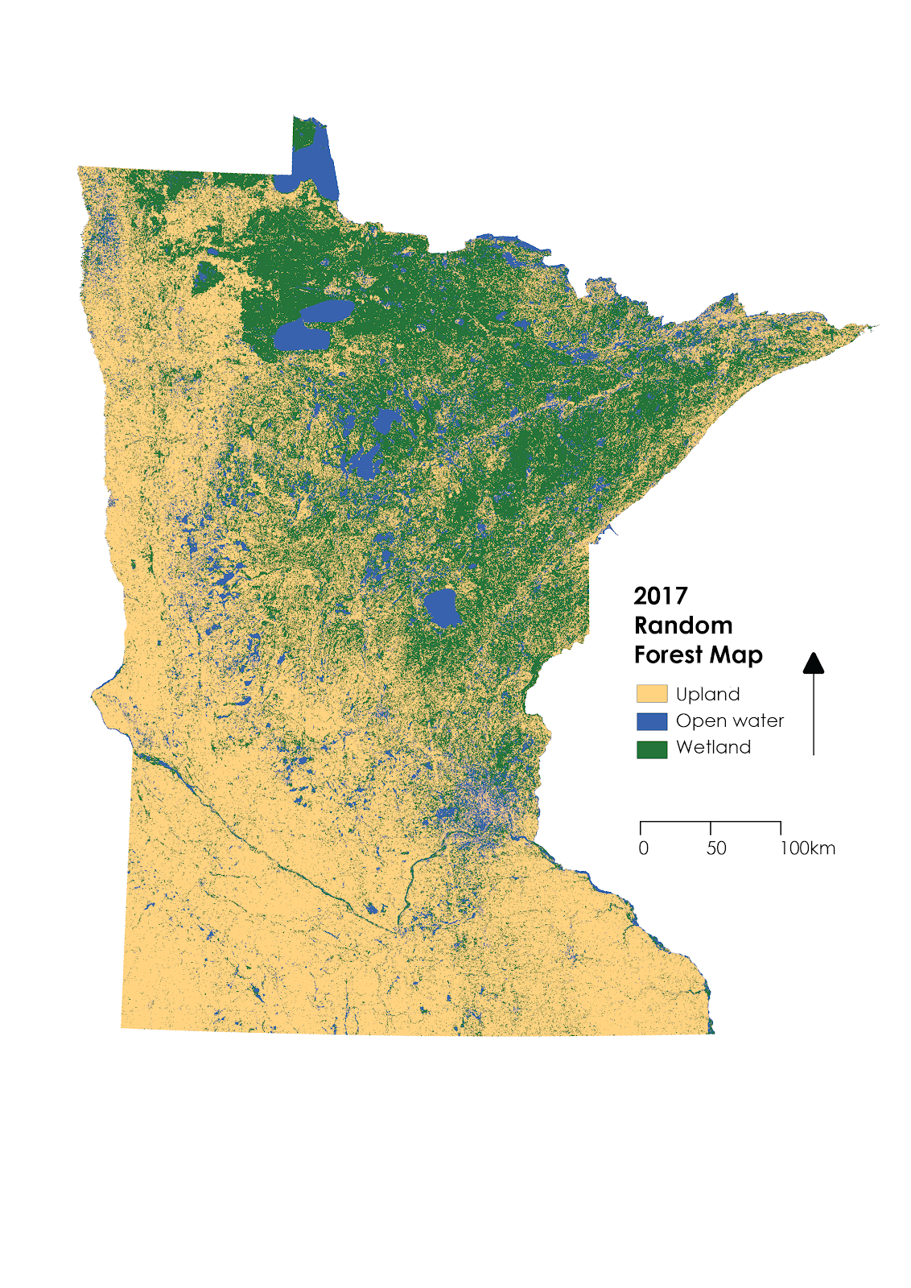

*Figure C3.* Statewide map produced by the random forest algorithm for 2017.

**Appendix D.** Accuracy assessment tables

|  |  |  |  |  |
| --- | --- | --- | --- | --- |
| Table D1  *Accuracy assessment for the 2017 threshold map compared to the NWI update (values in percent)*  Overall Accuracy = 43.96%; Kappa Coefficient = 0.023 | | | | |
|  |  | NWI Update | | |
| 2017 Threshold Map |  | Wetland | Upland | Open water |
| Wetland | 53.48 | 50.84 | 45.96 |
| Upland | 39.71 | 44.19 | 45.15 |
| Open water | 6.81 | 4.97 | 8.89 |

|  |  |  |  |  |
| --- | --- | --- | --- | --- |
| Class | Commission | Omission | Prod. Accuracy | User Accuracy |
| Wetland | 78.89 | 46.52 | 53.48 | 21.21 |
| Upland | 24.81 | 55.81 | 44.19 | 75.19 |
| Open water | 90.43 | 91.11 | 8.89 | 9.57 |

|  |  |  |  |  |
| --- | --- | --- | --- | --- |
| Table D2  *Accuracy assessment for the 2017 random forest map compared to the NWI update (values in percent)*  Overall Accuracy = 55.25%; Kappa Coefficient = 0.16 | | | | |
|  |  | NWI Update | | |
| 2017 Random Forest Map |  | Wetland | Upland | Open water |
| Wetland | 59.12 | 34.98 | 50.62 |
| Upland | 31.00 | 57.74 | 37.72 |
| Open water | 9.88 | 7.28 | 11.66 |

|  |  |  |  |  |
| --- | --- | --- | --- | --- |
| Class | Commission | Omission | Prod. Accuracy | User Accuracy |
| Wetland | 70.65 | 40.88 | 59.12 | 29.35 |
| Upland | 16.71 | 42.26 | 57.74 | 83.29 |
| Open water | 91.33 | 88.34 | 11.66 | 8.67 |

|  |  |  |  |  |
| --- | --- | --- | --- | --- |
| Table D3  *Accuracy assessment for the 2017 threshold map compared to field validation points (values in percent)*  Overall Accuracy = 48.88% | | | | |
|  |  | Field Validation Points | | |
| 2017 Threshold Map |  | Upland | Open water | Wetland |
| Upland | 44.75 | 33.97 | 34.65 |
| Open water | 0.59 | 27.07 | 2.23 |
| Wetland | 54.66 | 38.96 | 63.12 |

|  |  |  |  |  |
| --- | --- | --- | --- | --- |
| Table D4  *Accuracy assessment for the 2017 random forest map compared to field validation points (values in percent)*  Overall Accuracy = 86.56% | | | | |
|  |  | Field Validation Points | | |
| 2017 Random Forest Map |  | Wetland | Upland | Open water |
| Wetland | 87.25 | 7.48 | 7.32 |
| Upland | 2.54 | 76.92 | 2.33 |
| Open water | 10.21 | 15.60 | 90.35 |