**NASA DEVELOP National Program**

****NOAA National Centers for Environmental Information

**Spring 2016**

**Short Title: Levant & Central American Climate**

**Subtitle:** Monitoring Heavy Precipitation and Drought to Enhance U.S. Air Force Predictions and Decision-Making in the Levant and Central American Regions

**VPS Title:** Decoding Vegetation: analyzing drought conditions in desert and rainforest environments

**Project Team & Partners**

**Project Team:**

Alec Courtright (Project Lead), alec.courtright@noaa.gov

Christie Stevens

Hayley Hajic

Jessica Sutton (Center Lead)

**Advisors & Mentors:**

Major Ryan Harris (14th Weather Squadron)

Raymond Kiess (14th Weather Squadron)

Dr. L. DeWayne Cecil (Global Science & Technology, Inc.)

**Partner Organizations:**

US Air Force, 14th Weather Squadron (end-user), POC: Major Ryan Harris, Operations Officer; Boundary Organization

**Project Details**

**Applied Sciences National Applications Addressed:** Climate, Water Resources, and Agriculture

**Study Area (Country Codes):** The Levant Region, made up of Syria (963), Lebanon (961), Israel (972), Iraq (964), and Jordan (962).

Central America, including Honduras (504), El Salvador (503), Guatemala (502), and Nicaragua (505).

**Study Period:** June 1981 - December 2014

**Earth Observations & Parameters:**

Terra, MODIS - Normalized Difference Vegetation Index

NOAA-7,-9,-11,-14,-16,-17,-18, AVHRR - Normalized Difference Vegetation Index

**Software Utilized:**

ArcGIS - raster manipulation/analysis, image enhancement & map creation of Terra MODIS

R Statistical Program – statistical analysis and data processing

**Project Overview**

**Objectives Overview:**

This project seeks to enhance the United States Air Force 14th Weather Squadron’s forecasting of heavy precipitation and drought in the Levant and Central America regions. Maps and climatologies of Normalized Difference Vegetation Index (NDVI) data will assist the Air Force with predicting areas within the study regions that are vulnerable to climate extremes. Drought stresses the water supply and agricultural community. Heavy precipitation increases flooding and has many negative environmental consequences. The Levant and Central America’s unremitting sensitivities to drought and heavy precipitation create the need for better insight into the ties between conflict and incidences of severe climate variability.

**Abstract:**

The Levant region, comprising Syria, Lebanon, Jordan, Israel and Iraq, as well as countries along the Central American “Dry Corridor,” including Guatemala, El Salvador, Honduras, and Nicaragua, suffer from frequent drought and heavy precipitation events. Drought induces stress on water resources and the agricultural community, which can serve as catalysts to conflict. Drought as a catalyst is exemplified in the start of the Syrian civil war in 2011. Heavy precipitation events also have the potential to negatively affect communities through landslides and flooding. The US Air Force 14th Weather Squadron uses authoritative climate data to inform military intelligence and planning in regions impacted by extreme weather events. The 14th Weather Squadron currently focuses on analyzing precipitation data to monitor drought. This project seeks to incorporate additional climatic variables to augment their drought-monitoring techniques. A more comprehensive examination of several climatic variables can enhance military planning and intelligence in areas susceptible to conflict. Normalized Difference Vegetation Index (NDVI) is a useful estimation of vegetation conditions. By analyzing historic vegetation patterns (ranging from June 1981 to November 2015) this project identifies vegetative trends measuring the onset, extent, intensity, and duration of several climatic events on vegetative stress, such as: droughts, El Niño Southern Oscillation events and seasonal climate changes. Vegetation is also closely related to short-term atmospheric dynamics and provides valuable insight into crop assessment and early drought detection when paired with other drought monitoring systems. This project utilizes NDVI data from both NASA and NOAA Earth Observations to diversify the data and variables used by the 14th Weather Squadron’s current drought and heavy precipitation monitoring systems in the Levant and Central American regions.

**Community Concerns:**

* Heavy precipitation in the Levant and Central American regions are causing extreme flooding, water contamination, and landslides. These events put a strain on resources, cause significant loss of life, and isolate towns.
* Drought threatens the water supplies and puts stress on agricultural communities.
* Recent severe droughts in both regions have resulted in crop failure and the die off of livestock. The high human and economic cost of these droughts has caused rural villagers to migrate to urban areas.
* In the Levant, mismanagement of water resources by the government and competition of resources by large populations in overcrowded cities has led to disaffection and civil conflict in Syria.
* Central America is classified by the United Nations as one of the regions of the world most heavily impacted by climate change. More consistent *in situ* monitoring and remote sensing is needed to prepare both regions for inevitable changes in their annual precipitation patterns.
* The 14th Weather Squadron is interested in monitoring Central American climate because of its proximity to the United States. Any extreme weather events may cause changes in the import and export of goods between the two regions, a contributing factor of unrest and changes in immigration. The Levant’s climate is of interest because of current military concerns in the region and how drastic changes in weather may exacerbate civil conflict.

**Current Management Practices & Policies**:

As part of the US Air Force’s 2nd Weather Group, the 14th Weather Squadron collects, protects, and exploits climate data to utilize in military operations and planning. The squadron monitors and analyzes several variables, such as temperature and precipitation, to improve predictive modeling and help the Department of Defense as well as other partner organizations plan for long-range climatic changes in all regions of the world. Currently, they use many remote sensing datasets as well as *in situ* data to examine a variety of parameters. They are constantly striving to provide higher resolution data over longer periods of time. Their work aids in navigating societal challenges including globalization, coastal urbanization and population growth. Currently, the 14th Weather Squadron is focusing heavily on precipitation and drought. They are hoping to augment their findings with evapotranspiration and NDVI data in sensitive regions of the world.

**Decision Support Tools & Benefits:**

|  |  |  |
| --- | --- | --- |
| **End-Product** | **Earth Observations Used** | **Benefit & Impact** |
| Long-term Climatology | NOAA AVHRR – NDVI  MODIS, Terra satellite - NDVI | Will give end-users (USAF, 14th Weather Squadron) historical NDVI values to better understand seasonal and climatic trends in vegetation |
| Maps and Figures | NOAA AVHRR – NDVI  MODIS, Terra satellite - NDVI | Will provide end-users with communication resources and help the DEVELOP team communicate results |

**Project Imagery**

**Caption:** Project image highlighting study regions and example analyses.

**Image:**

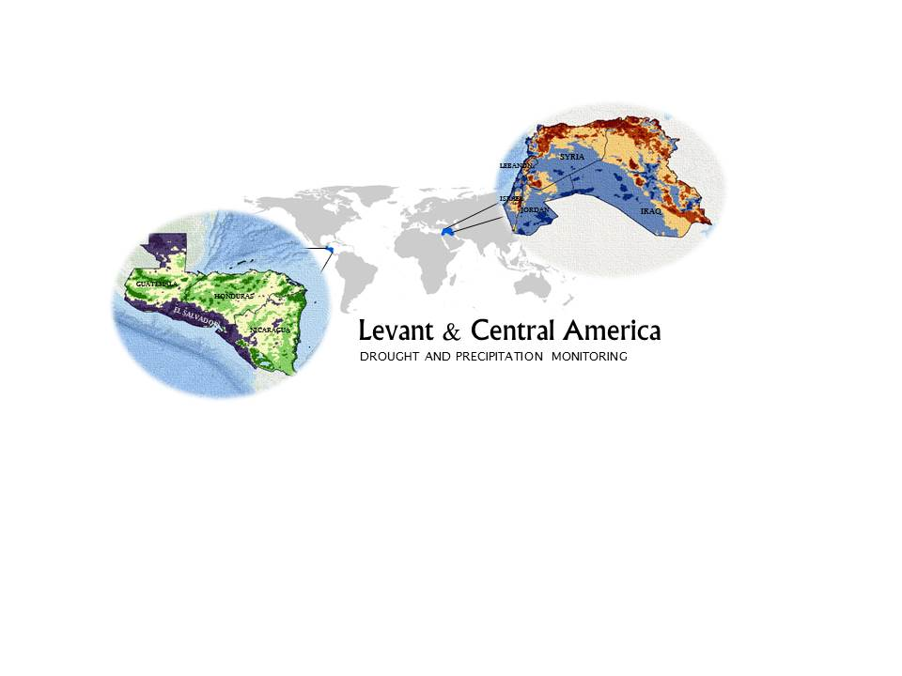

**Software Release Requirements**

Category III

**List the software or libraries used, under what license they were obtained, and the URL for the license in the table below:**

|  |  |  |
| --- | --- | --- |
| **Name** | **License** | **License URL** |
| R | Individual license | https://cran.r-project.org/bin/windows/base/ |

**Full Software Description and Plan**

**Introduction/Objective:**

The motivation of this software developed from speaking with Major Harris of the US Air Force, 14th Weather Squadron. The 14th Weather Squadron currently uses satellite, modelled, and *in situ* data to monitor drought in vulnerable countries for the Department of Defense. They would like to incorporate higher resolution data products and additional data products (i.e. NDVI, ground water, evapotranspiration, etc.) to enhance their current monitoring efforts.

**Applications and Scope:**

The code and software developed for this project will be used by the 14th Weather Squadron to access and process data more easily. If the coding proves useful, they will incorporate it into their current operational tool for drought monitoring.

**Capabilities:**

The code and software will download, subset, and analyze parameters on a daily, monthly, and annual time step. It will be made to provide maps and figures to the 14th Weather Squadron. More information is needed to determine the format that the 14th Weather Squadron would like the final products.

**Interfaces:**

The code is written in R and uses many R libraries. The team will work with the 14th Weather Squadron to produce a complimentary code in python. The users will be using the code to add data into their current operational tool.

**Assumptions, limitations, & Errors:**

The code will be limited in use to specific parameters and will need to be updated according to dataset changes. It will be written to subset based on two regions, but can be changed to include other geographical extents. The output/final products of the code will change depending on what the 14th Weather Squadron request.

**Testing:**

The subset data is compared to another source of NDVI data (typically NASA’s Terra MODIS with a spatial resolution of 1 kilometer and a temporal resolution of 16 days) to validate that the data values are not altered.

**Additional Information**

**Software Classification & Justification**

This software is considered to be Class E software per NPR 7150.2.

**This software is used to:**

* + Perform minor desktop analysis of science or experimental data.

**The software is not used to:**

* + make decisions for an operational Class A, B, or C system or to-be built Class A, B, or C system
  + support engineering development
  + test other Class D software systems
  + support mission planning or formulation
  + operate a research, development, test, or evaluation laboratory
  + provide decision support for non-mission critical situations
  + in a Major Engineering/Research Facility
  + perform research associated with airborne vehicles or systems

The software will not:

* + operate, directly support, or be flight qualified to support an operational system
  + be used in technical decision concerning an operational system
  + directly affect primary or secondary mission objectives
  + adversely affect the integrity of engineering/scientific artifacts
  + have an impact on operational vehicles

Additionally, if the software had anomalous behavior, that behavior would not cause or contribute to a failure of a system function:

* + resulting in a minor failure condition for the airborne vehicle
  + with an effect on airborne vehicle operational capability or pilot workload

When these criteria are no longer valid, categorization/classification will be reevaluated and the project will start following the procedures for the higher class.

**Not Safety Critical**: The software does not:

* Reside in a safety-critical system with at least one of the following being applicable to the software:
  + Causes or contributes to a hazard
  + Provide control or mitigation for hazards
  + Controls safety-critical functions
  + Processes safety-critical commands or data
  + Detects and reports, or takes corrective action, if the system reaches a specific hazardous state
  + Mitigates damage if a hazard occurs
  + Resides on the same system (processor) as safety-critical software
  + Process data or analyze trends that lead directly to safety decisions (e.g. determining when to turn power off to a wind tunnel to prevent system destruction)
  + Provide full or partial verification or validation of safety-critical systems, including hardware or software systems