**NASA DEVELOP National Program**

 NASA Goddard Space Flight Center

Wise County and City of Norton Clerk of Court's Office

**Summer 2015**

**Short Title: Thailand Disasters**

**Subtitle:** Monitoring Risk and Extent of Drought for Enhanced Decision Making and Resource Allocation in the Kingdom of Thailand

**VPS Title:** The Trifecta of Drought: Monitoring 3 Types of Drought in Thailand

**Project Team & Partners**

**Project Team:**

Sean McCartney (Project Lead), [sean.mccartney@nasa.gov](mailto:sean.mccartney@nasa.gov)

Nobphadon Suksangpanya

Chisaphat Supunyachotsakul

Srisunee Wuthiwongyothin

Sahakait Benyasut

Thanapat Vichienlux

**Advisors & Mentors:**

Dr. John Bolten (NASA GSFC)

Colin Doyle (NASA GSFC)

**Partner Organizations**

Royal Thai Embassy, Collaborator/Boundary Organization, POC: Bunyakiat Raksaphaeng

Asian Disaster Preparedness Center/SERVIR Mekong, Collaborator/Boundary Organization,

POC: Pete Cutter

Thai Department of Disaster Prevention and Mitigation, End-User, POC: TBD

National Safety Council of Thailand, End-User, POC: TBD

**Project Details**

**Applied Sciences National Applications Addressed:** Disasters

**Study Area:** Kingdom of Thailand

**Study Period:** Jan 1998 - June 2015

**Earth Observations & Parameters**

### TRMM, TMI - Precipitation measurements

GPM, GMI - Precipitation measurements

Terra/Aqua, MODIS - Evapotranspiration, Land Surface Temperature, Vegetation Indices

SMOS, MIRAS - Soil moisture

**Ancillary Datasets Utilized**

* Royal Irrigation Department - *In situ* stream-flow measurements

**Software Utilized**

ArcGIS - Raster Manipulation/Analysis, Image Enhancement & Map Creation of Aqua/Terra MODIS, TRMM TMI, GPM GMI

TerrSet - Image processing of Aqua/Terra MODIS, TRMM PR, GPM GMI and SMOS MIRAS

MatLab - Data acquisition of TRMM PR and GPM GMI

Python - Scripting of drought monitoring tool and incorporation of tool into web service

**Project Overview**

**80-100 Word Objectives Overview**

As the biggest exporter of rice in the world, Thailand depends on monsoon rains to provide precipitation for on-season and off-season rice. Water stored in reservoirs during the monsoon rains provides needed irrigation during the off-season when precipitation is limited. When unfavorable meteorological conditions lead to drought, this affects the economy and livelihoods of Thai citizens. This study monitored three type of drought: meteorological, hydrological and agricultural within the Kingdom of Thailand. Using data derived from Earth observing satellites and *in situ* stations, tools were created that will aid in mitigating risk and improve resource allocation in the country.

**Abstract**

Drought is a natural disaster impacting agricultural, environmental, and economic livelihoods. The Kingdom of Thailand is impacted by drought due to the variability of monsoon rains as well as other unfavorable meteorological conditions. The drought of 2015 was the worst drought to impact Thailand in over 15 years. As one of the biggest exporters of rice in the world, drought has the ability to impact the economy of Thailand in a big way. The available drought monitoring system in Thailand looked at only agricultural drought. This was insufficient for analyzing accurate risk management and decision-making. Using data from various Earth observing satellites, such as Terra Moderate Resolution Imaging Spectroradiometer (MODIS), Aqua MODIS, Tropical Rainfall Measuring Mission (TRMM) and Global Precipitation Measurement (GPM), and *in situ* stations, this study utilized three indices to analyze and monitor the current state of meteorological, hydrological and agricultural drought across Thailand. The Standardized Precipitation Index was used in monitoring meteorological drought, the Stream-Flow Drought Index was used in monitoring hydrological drought, and the Drought Severity Index was used in monitoring agricultural drought. All indices were based on a monthly temporal resolution for monitoring drought. The study demonstrated how a combination of various indices can offer better understanding of drought conditions, with data derived from Earth observing satellites offering the ability to monitor drought across the entire country and in near-real time.

**Community Concerns**

* Drought diminishes crop yields with effects to the economy and livelihoods of citizens
* The Office of Agricultural Economics (OAE) of Thailand estimated the 2015 drought will reduce Thailand’s off-season crops export by higher than 30%
* Government policies must be enacted to conserve water and provide for the welfare of the people
* Government expenditures increase to install water pumps and provide mobile water tanks in the most drought affected areas

**Current Management Practices & Policies**

In 2015, the Royal Thai Government established a four-part integrated plan for drought management. The first strategy focuses on drought prediction and developing a reliable warning system for drought-prone areas. The second strategy focuses on drought preparation. The third and fourth strategies focus on emergency management and post-disaster management. Currently, the drought monitoring system is provided by the Geo-Informatics and Space Technology Development Agency (GISTDA). This system contributes Normalized Difference Vegetation Index and Normalized Difference Water Index products derived from MODIS data from the platforms of Terra and Aqua to monitor agricultural drought, but there are no systems in place to monitor other droughts that also impact the population. This information is published on a near-real-time web-based service (7 days) at http://drought.gistda.or.th/. Vegetation indices are characteristic of agricultural drought which is of considerable concern for such a large rice-exporting country.

**Decision Support Tools & Benefits**

|  |  |  |
| --- | --- | --- |
| **End-Product** | **Earth Observations Used** | **Benefit & Impact** |
| Meteorological Drought Index (Time Series) | TRMM - TMI  GPM - GMI | Index allows Thai government agencies and NGOs the ability to identify the timing and severity of meteorological drought from 1998 - present. This allows for better allocation of resources to target the most affected areas of the country. |
| Hydrological Drought Index (Time Series) | None | Index allows Thai government agencies and NGOs the ability to identify the timing and severity of hydrological drought from 1998 - present. This allows for better allocation of resources to target the most affected areas of the country. |
| Agricultural Drought Index (Time Series) | Terra/Aqua - MODIS  TRMM - TMI  GPM - GMI | Index allows Thai government agencies and NGOs the ability to identify the timing and severity of agricultural drought from 1998 - present. This allows for better allocation of resources to target the most affected areas of the country. |
| Agricultural Drought Near-Real Time Monitoring Tool | Terra/Aqua - MODIS | Tool allows Thai government agencies and NGOs the ability to monitor agricultural drought in near-real time (monthly). This improves decision making to better allocate resources to areas most affected by drought. |

**Project Imagery**

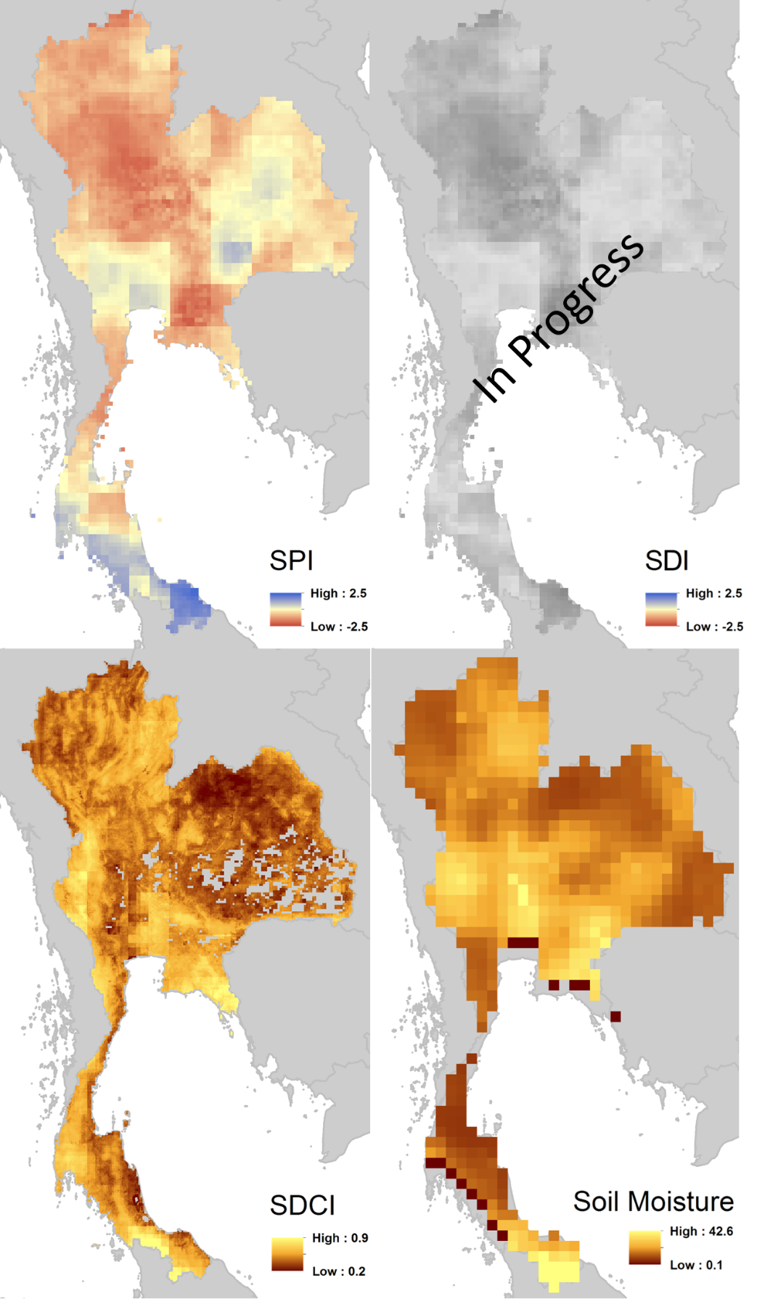

**Caption:** SPI, SDI, SDCI, and Soil Moisture over the Kingdom of Thailand for April 2005. Image Credit: Thailand Disaster Team.