**NASA DEVELOP National Program**



NOAA National Centers for Environmental Information

*Summer 2017*

Philippines Disasters II

Utilizing NASA and NOAA Earth Observations to Enhance Cyclone Movement and Intensity Measurements to Improve Disaster Relief Planning in the Philippines

 **Technical Report**

Final Draft – August 10, 2017

Michael Marston (Project Lead)

Aaron Mackey

Brittany Thomas

Dr. Ken Knapp, NOAA National Centers for Environmental Information (Science Advisor)

Dr. Carl Schreck, NOAA National Centers for Environmental Information, Cooperative Institute for Climate and Satellites-North Carolina (Science Advisor)

Previous Contributors:

Daniel T. Martin

Allison Daniel

Kelly Meehan

Jessica Vermillion

# 1. Abstract

The Philippine islands, located within the northwestern Pacific Ocean basin, are frequently affected by tropical cyclones. During and after tropical cyclones, the number of gender-based violence (GBV) crimes increase. To assist the United Nations Office for the Coordination of Humanitarian Affairs (OCHA), a cyclone vulnerability assessment for each municipality within the Philippines was created and streamlined with demographic data to identify at risk communities. For this effort, hurricane satellite (HURSAT-B1) data were downloaded for each tropical cyclone that affected the Philippines from 1985 to 2009. To include the recent record, data were gathered for tropical cyclones affecting the study area from 2010 to 2015 from the Cooperative Institute for Research in the Atmosphere’s (CIRA) Multiplatform Tropical Cyclone Surface Wind Analysis (MTCSWA). The HURSAT and CIRA products were used to derive estimates of the 18 m/s, 26m/s, and 33 m/s wind radii for each of the four quadrants (i.e. northwest, northeast, southeast, southwest) of each tropical cyclone at a 6-hour temporal resolution. The wind speed data were used to estimate the Integrated Kinetic Energy (IKE) of each tropical cyclone in the study period. IKE values were then accumulated over the entire study period for the Philippines and used to generate a climatology of cyclone intensity for each municipality.

**Keywords**

Tropical cyclones, Philippines, disaster response preparation, remote sensing, population vulnerability, gender sensitivity, IBTrACS, HURSAT

# 2. Introduction

* 1. ***Background Information***

The Republic of the Philippines in the northwestern Pacific Ocean is an archipelago composed of over 7,000 islands (Figure 1). The climate of the Philippines can be divided into two distinct seasons: the dry season, and the wet season. The dry season occurs December to May while the wet season occurs between June and November. The wet season carries the bulk of annual precipitation as the Southwest Monsoon pulls high winds and heavy rain from the Indian Ocean over land.

The wet season also brings the greatest threat of tropical cyclones to the islands. Nearly half (48%) of tropical cyclones form during the early wet season (July-September) with most landfalls (53%) occurring between October and December (Corporal‐Lodangco & Leslie, 2017). Climate scientists expect the total number of tropical cyclones to remain stable but the seasonal proportion of high-intensity tropical cyclones to increase (Knutson et al., 2010). This will be detrimental to the Philippines as one of the most at-risk nations to tropical cyclones. The trend of increasing cyclone intensity will exacerbate destruction to property and internal population displacement (Shoemaker, 1991). Common cyclone intensity scales such as the Saffir-Simpson scale and maximum sustained surface wind speeds are inadequate metrics when estimating a tropical cyclone’s damage potential, due to their lack of consideration of the wind field size (Powell & Reinhold, 2007).

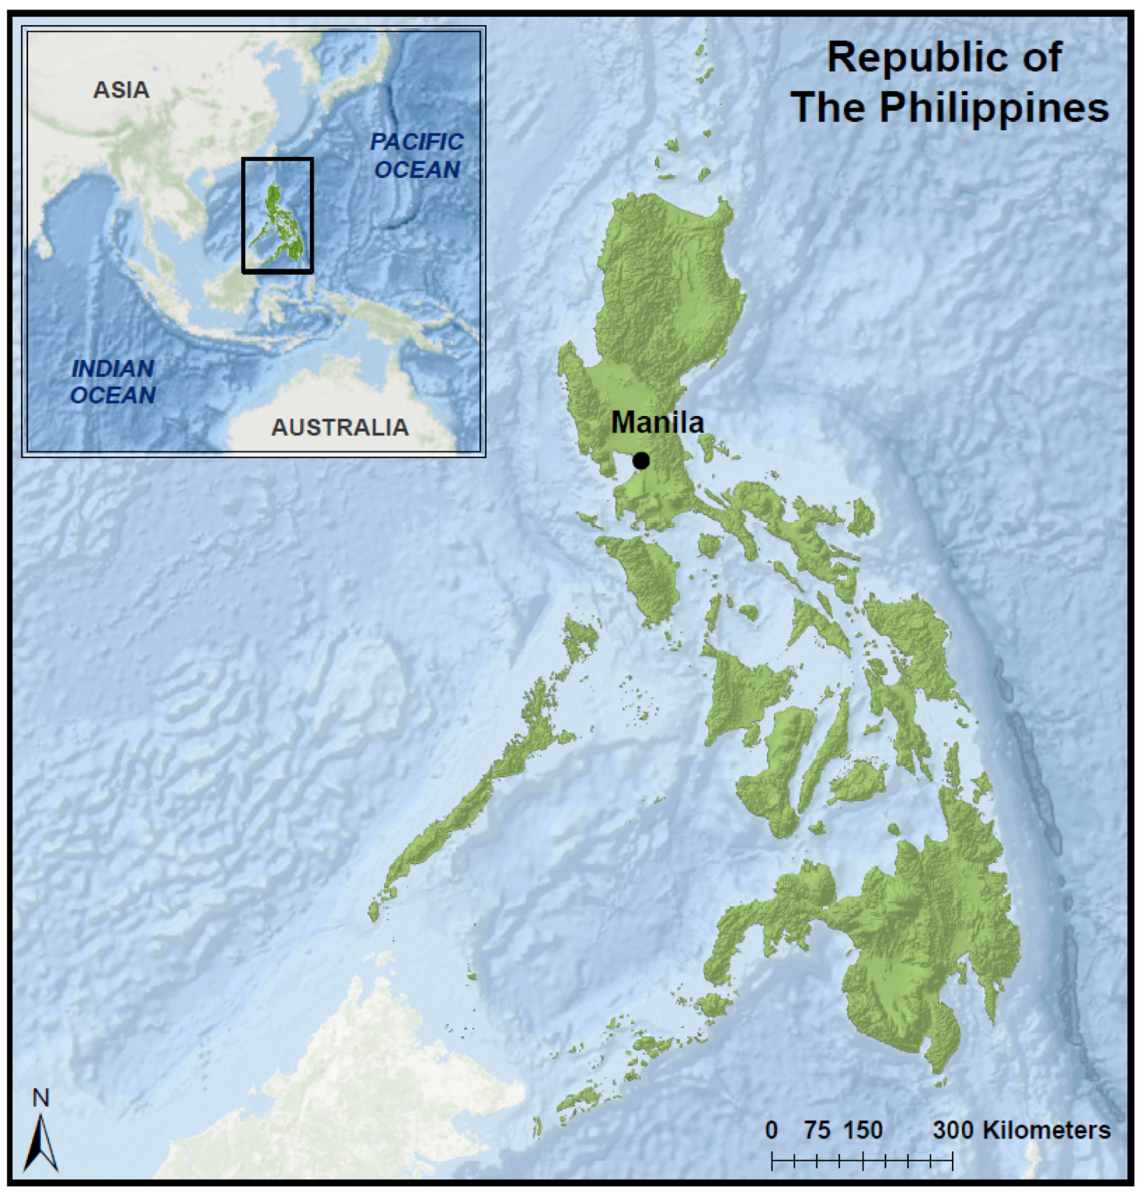

*Figure 1.* The study area of this project. As seen in the corner inset map, the Republic

of the Philippines lies near Southeast Asia.

Some of the most at-risk populations during and after natural disasters, including tropical cyclones, are women and children (International Federation of Red Cross and Red Crescent Societies, 2015). Women often wait for hours at aid centers for food and clean drinking water. However, women are also expected to continue their traditional responsibilities during disasters to provide those resources to their husbands, children, and parents before themselves. (Delica, 1996). The primary threat to children from these events is related to their mental health. In the wake of a disaster, social and family structures are disrupted and food can be limited (Delica, 1996). These conditions have a negative impact on the long-term mental health and development of a child as they lack for proper nutrition and a stable social environment (Delica, 1996). The impacts of natural disasters on women and children are particularly troublesome because these populations are critical to the long-term recovery of a region devastated by tropical cyclones. To combat this chronic issue, in 2012 President Aquino and the Philippines Department of Science and Technology launched the Nationwide Operational Assessment of Hazards (NOAH). A component of Aquino's broader initiative to reduce the hazards associated with tropical cyclones, NOAH has become the nation's flagship disaster prevention and mitigation program (Enano, 2017). The program has installed over 500 automated weather stations (AWS) and automated rain gauges (ARG) to enhance data gathering capabilities (Enano, 2017). The government has also developed a master flood management plan for Manila, and the Department of Public Works and Highways has initiated over 400 projects to improve drainage systems (The Official Gazette). These great strides in disaster prevention and mitigation are dependent on the agenda of the present administration. President Duterte's administration has eliminated funding for NOAH effective March 2017 (Enano, 2017). Fortunately, the University of the Philippines has adopted NOAH, continuing critical operations for the foreseeable future (Enano, 2017). Funding will always be a concern to broader hazard prevention and mitigation. To address this issue, NASA DEVELOP at NCEI partnered with the United Nations Office for the Coordination of Humanitarian Affairs (OCHA), United Nations Institute for Training and Research’s Operational Satellite Applications Program (UNOSAT), and the Netherlands Red Cross to leverage NOAA and NASA datasets, such as tropical cyclone tracks, infrared (IR) data, and digital elevation models (DEM) to study the characteristics and effects of cyclones on the Philippines from 1985 to 2015.

* 1. ***Project Partners & Objectives***

The NASA Applied Sciences’ national application areas addressed in this project are Disasters and Weather. Using NOAA Hurricane Satellite (HURSAT) imagery, International Best Track Archive for Climate Stewardship (IBTrACS) data, landslide susceptibility data derived from NASA’s Shuttle Radar Topography Mission (SRTM), and demographic data, this project aimed to enhance cyclone vulnerability maps of the Philippines with a special focus on storm size and intensity to improve impact analysis and mitigation on a municipal level. Project partners included OCHA, UNOSAT, the Netherlands Red Cross and NOAA’s National Environmental Satellite, Data, and Information Service (NESDIS). Distribution of results presented in this study is critical to ensuring an organized response to assist populations vulnerable to natural disasters in the Philippines. Cyclone climatology maps and figures can be integrated into OCHA’s current disaster preparation and mitigation procedures to improve the location of areas of dangerous cyclone activity and assess the vulnerable populations at those locations. This project enhanced our partners’ understanding of where the most vulnerable populations and the most devastating cyclones are located, and their impact relative to size and intensity. The final product will enhance prevention and preparation plans for future disaster risk from tropical cyclones.

# 3. Methodology

***3.1 Data Acquisition***

***3.1.1 Philippines Disasters I (previous)***

This research project is a continuation of the Philippines Disasters I project, which was completed during the Spring 2017 DEVELOP term. The focus of their project was to acquire and examine demographic data for each municipality within the Philippines, and assess the risk of Gender-Based Violence (GBV). The demographic data used by the Philippines Disasters I team were downloaded from the Humanitarian Data Exchange and from Philippine government. Data used in their analysis included population density, gender distribution, number of single mother households, and access to resources such as clean water and housing. These data were handed off to the current Philippines Disasters II team to continue the project.

***3.1.2 Philippines Disasters II (current)***

The second term’s focus was to build on the preliminary term’s findings by calculating a physical exposure score for each municipality within the Philippines. To calculate the physical exposure score, historical tropical cyclone and landslide data were gathered. Data were gathered from NOAA’s Hurricane Satellite (HURSAT-B1) dataset, which combines multi-sourced geostationary hurricane-tracking satellite data; however, for our purposes, the Geostationary Meteorological Satellite 1 (GMS-1) through GMS-5 sourced data were used to maintain consistency. HURSAT-B1 data maintains 3-hourly temporal resolution, a spatial resolution of ~8 km, and includes data in IR, near-infrared (NIR), and the visible spectra (Mueller et al., 2006). The temporal coverage begins in 1978, however this project incorporated HURSAT data from 1985 to 2009 to avoid known data quality issues within IBTrACS for the pre-1984 data (Chu et al., 2002). Additionally, data were gathered for tropical cyclones affecting the study area from 2010 to 2015 from the Cooperative Institute for Research in the Atmosphere’s (CIRA) Multiplatform Tropical Cyclone Surface Wind Analysis (MTCSWA). The CIRA data are spatially and temporally consistent with HURSAT data. The HURSAT and CIRA products were used to derive estimates of the 18 m/s, 26m/s, and 33 m/s wind radii for each of the four quadrants (i.e. northwest, northeast, southeast, southwest) of each tropical cyclone at a 6-hour temporal resolution. The wind radii estimates were provided by Dr. John Knaff at NESDIS. These data were used to calculate storm size and intensity; critical pieces of information needed to understand each storm’s damage potential.

Cyclone track data were collected from the IBTrACS v03r09 (Knapp et al., 2010). The IBTrACS dataset is a global compilation of best track datasets incorporating data resources from several international weather centers. In order to maintain consistency, this project exclusively used information provided by the United States Military’s Joint Typhoon Warning Center (JTWC); using data from one agency avoids parsing conflicting information between the four monitoring centers of the western Pacific Basin (Knapp & Kruk, 2010; Schreck et al., 2014). Although the IBTrACS dataset has historically complete data from JTWC from 1945 to present, this project will focus on data from 1985 to 2015 to avoid data quality issues (Chu et al., 2002) and align with the historical record of other datasets used for this research. IBTrACS provided critical storm information such as International Organization for Standardization (ISO) date, time, and storm center coordinates over each cyclone’s lifetime. These data were estimated by tropical cyclone forecasters after the event using all available data. In most cases, satellite estimates are the primary inputs (Velden et al., 2006).

Landslide data were obtained from the Shuttle Radar Topography Mission (SRTM) derived global landslide susceptibility map created by Stanley and Kirschbaum (2017). Proxies for landslide data were previously limited to raw SRTM data that were averaged over the total municipality. Data from Stanley and Kirschbaum (2017) uses several proxies including: nearby roadways, burned forests, major tectonic fault proximity, weak bedrock, and steepness derived from SRTM. Also involved was an exhaustive inquiry into historic landslides of regions around the world to aid validation and alignment of these proxies (Kirschbaum et al., 2009). The data are available in raster format at approximately 0.008 decimal degrees, with each cell corresponding with a rating between 0 and 5, indicating unlikely to very likely landslide susceptibility.

***3.2 Data Processing***

***3.2.1 Philippines Disasters I (previous)***

The preliminary term’s processed data that were reused for the current project comprise of municipality level risk components including: number of households with single mothers, female-child-led households, disabled females, elderly females, as well as households of unsafe water, unsanitary toilets, unsafe water quality, unsafe roof, or unsafe outer walls. The team used R software to streamline multiple datasets into one database file, which were subjected to a weighting scheme. The output from the R script contained the final GBV risk scores.

***3.2.2 Philippines Disasters II (current)***

The latitude, longitude, maximum wind, date, and time were extracted from IBTrACS for the entire lifetime of each tropical cyclone. HURSAT and CIRA data were used to estimate cyclone wind speeds for each quadrant of the storm (i.e. northwest, northeast, southwest, southeast) at radii (r) of 52 km, 102 km, 152 km, and 182 km. These wind field estimates were calculated following the methods of Knaff et al. (2014). The wind field estimates, which were provided every 6 hours for the lifetime of each tropical cyclone, were used with the estimated maximum cyclone wind speed (also available every 6 hours) to calculate the estimated storm total Integrated Kinetic Energy (IKE). The storm total IKE was calculated by simply integrating the wind field of the entire storm (Equation 1). The calculation of IKE follows the methods of Powell and Reinhold (2007), who stated that IKE is a good estimator of a storm’s destructive potential. Estimated IKE values were calculated for all storms at 6-hour intervals to match the temporal resolution of IBTrACS data. The size of each tropical cyclone, at each temporal increment, was determined using the estimated maximum radius of 34 knot winds. The IKE value for each temporal increment was assigned to the entire estimated area of the tropical cyclone. The 6-hourly tropical cyclone size estimates and IKE values of each storm were then interpolated to an hourly temporal resolution to capture the time a storm spent over an area. Next, the Spatially Accumulated Integrated Kinetic Energy (SpIKE) was calculated for each storm by summing the hourly IKE values for the entire lifespan. The SpIKE methods were developed by this study to examine tropical cyclone intensity, size, and length of impact.

$IKE= \int_{v}{\frac{1}{2}} ρAV^{2}$, (Equation 1)

where $ρ$ is air density (1.15 kg m-3), A is the area (m2), and V is the mean 10-m wind speed (m s-1) of the contributing portion of the tropical cyclone.

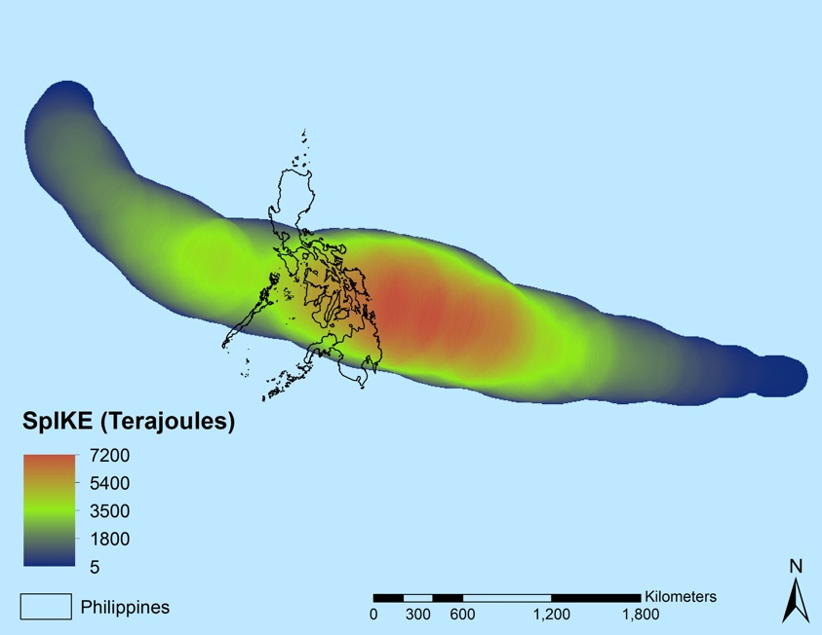

*Figure 2.* The estimated SpIKE of Typhoon Haiyan, which made landfall in the Philippines on November 8th, 2013 as one of the strongest cyclones in recorded history. SpIKE was calculated or each tropical cyclone that affected the Philippines from 1985 – 2015.

***3.3 Data Analysis***

***3.2.1 Philippines Disasters I (previous)***

The weighting scheme used in the preliminary term to create the final threat map was updated to include the data from this research. The scheme includes two separate data classifications: demographic (50%) and physical exposure (50%) (Figure 3). Each of the six demographic and five physical exposure variable were evaluated at the municipality-level. The demographic variables used in the previous term remained the same and include: number of elderly women, female child-led households, unsanitary toilets, unsafe drinking water, disabled females, and single mother households. Several of the physical exposure variables were kept from the previous term including: number of unsafe roofs, number of outer walls, and number of households. The slope and tropical cyclone exposure variables were updated to include data from this study. The physical exposure weighting scheme was derived from the Netherlands Red Cross (Veen, 2016), while the demographic weighting scheme was derived from OCHA.

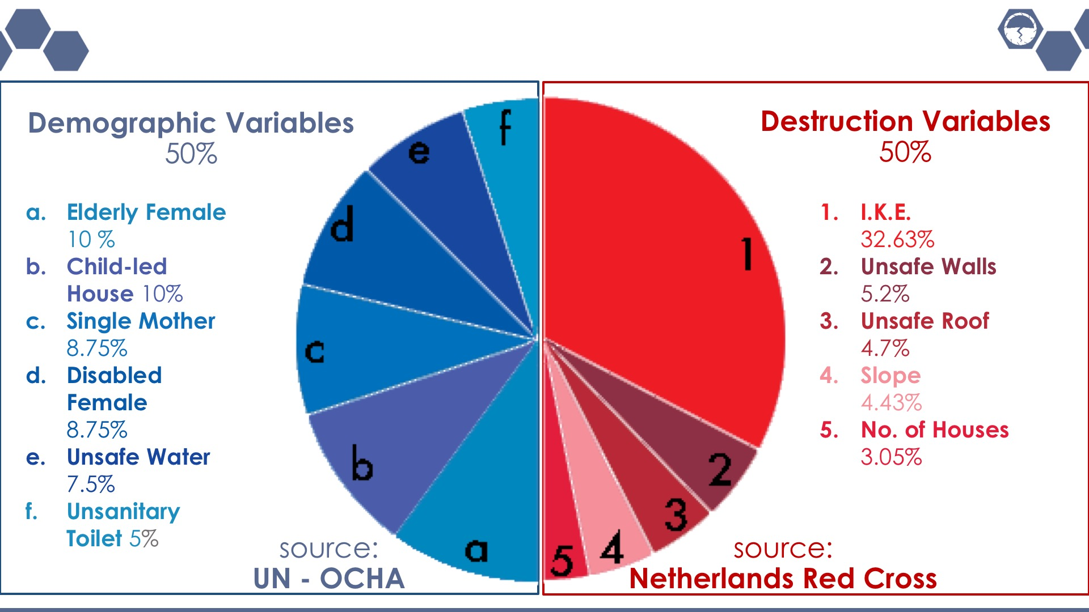

**Figure 3.** Weighting scheme used to calculate the demographic risk and physical exposure of each municipality within the Philippines.

***3.2.2 Philippines Disasters II (current)***

The SpIKE from all storms within each calendar year were summed annually to generate a time series of total SpIKE for each 4 km grid-cell in the western Pacific Basin. Annual SpIKE values for each grid-cell were calculated to examine visual trends in the spatial distribution of SpIKE values over the historical record. The annual values of SpIKE for each 4 km grid-cell were then averaged over the study period. These climatological values of SpIKE for each grid-cell were examined visually to locate areas that have historically experienced large amounts of SpIKE. The climatological values of SpIKE were also used to calculate the typhoon risk index, which was a variable in the physical exposure weighting scheme, for each municipality. For each municipality, all 4 km grid-cells that are located within (majority within) the municipalities’ boundary were averaged. The average climatological values of SpIKE for each municipality were used as the typhoon risk metric. The incorporation of SpIKE was an improvement from the previous term which used the accumulated cyclone energy (ACE) to assess destructive potential. ACE assesses a storm’s destructive potential by summing the squares of the maximum 6-hour wind speeds (Bell et al., 2000) and assigning those values to segments along the path of the storm center. SpIKE addresses the pitfalls of ACE by accounting for size, wind field variability, and forward speed of cyclones.

The previous term calculated landslide risk assessments using SRTM data and averaging the slope values of each municipality, the higher slopes indicate a higher risk. This term used the global landslide susceptibility data gathered from Stanley and Kirschbaum (2017), which specifically addressed rain-induced landslide risk. These upgraded data are better suited for the assessment of landslide risk when compared to raw slope data used by previous research, since it not only includes slope steepness data derived from SRTM, but also takes into account several other indicators such as bedrock weakness, proximity to roadways or major tectonic faults, and soil type. The data are available in raster format at approximately .008 decimal degree resolution with each cell referencing a rain-induced landslide risk rating between 0 and 5, from unlikely to very likely. We chose the majority rating from each municipality to serve as the municipalities’ rain-initiated landslide risk assessment.

The weighting scheme used to determine the demographic risk and physical exposure of each municipality within the Philippines follows the Philippines Disasters I scheme (Figure 3). This weighting scheme was derived from the Netherlands Red Cross (physical exposure) and OCHA (demographic risk). Prior to executing the weighting scheme, each variable was normalized (i.e. re-scaled to values between 0 and 1) in order to eliminate biases. For this study, the results of the overall physical exposure for each municipality were of particular interest.

# 4. Results & Discussion

***4.1 Analysis of Results***

From 1985 to 2015 the location of maximum average annual SpIKE, which was 11864 KJ, was located 500 km northeast of the Santa Ana municipality (Figure 4). However, a broad area of over 10,000 KJ of average annual SpIKE was located 50 km off the northeastern coast of the Philippines. The municipality of Basco, which is located in the northern portion of the Batanes province, experienced 8764 KJ of SpIKE annually from 1985 to 2015 - the most of any municipality within the Philippines. In general, annual SpIKE values increase from southwest (SpIKE ~ 0 KJ) to northeast (SpIKE ~ 8764 KJ) across the Philippines (Figure 4). The normalized municipality averaged SpIKE values were next categorically ranked by quantiles (Figure 5) and compared visually with the results from the previous term (not shown). The spatial distribution of the typhoon risk map generated by this research is more representative of the size and movement of tropical cyclones across the Philippines when compared to the typhoon risk map produced during the previous term. SpIKE is also less sensitive to the exact path of individual storms when compared to using storm tracks exclusively.

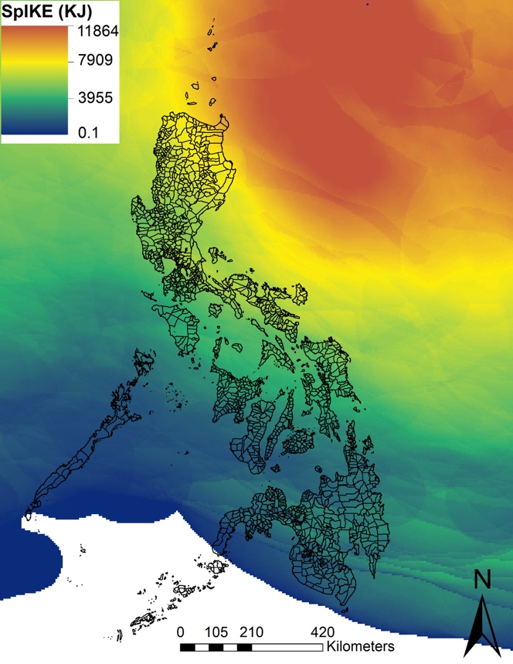

*Figure 4.* Average annual IKE from 1985 to 2015 across the western Pacific Basin. The White oval indicates the Philippines municipality that experienced the most average SpIKE from 1985 to 2015 (Basco), while the black oval represents the area that experienced the maximum average SpIKE across the study area from 1985 to 2015.

The landslide risk for each municipality was also improved during this research. The data used in this research included several variables aside from averaged SRTM derived steepness to calculate rain-induced risk. There is a general trend of risk following the steep mountain ranges, but it is offset to areas where it is more likely that slope failure will occur due to factors such as disturbances in land use or presence of susceptible soil types (Figure 5).

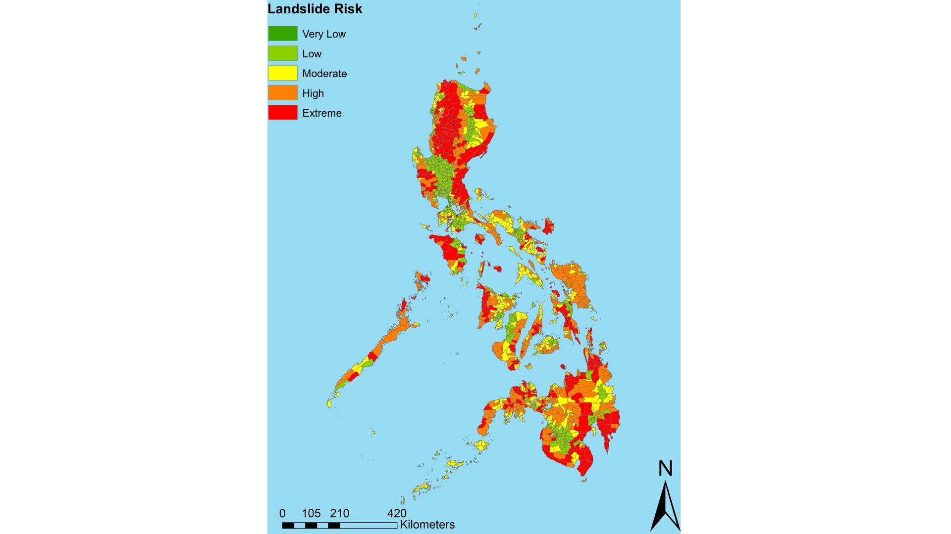 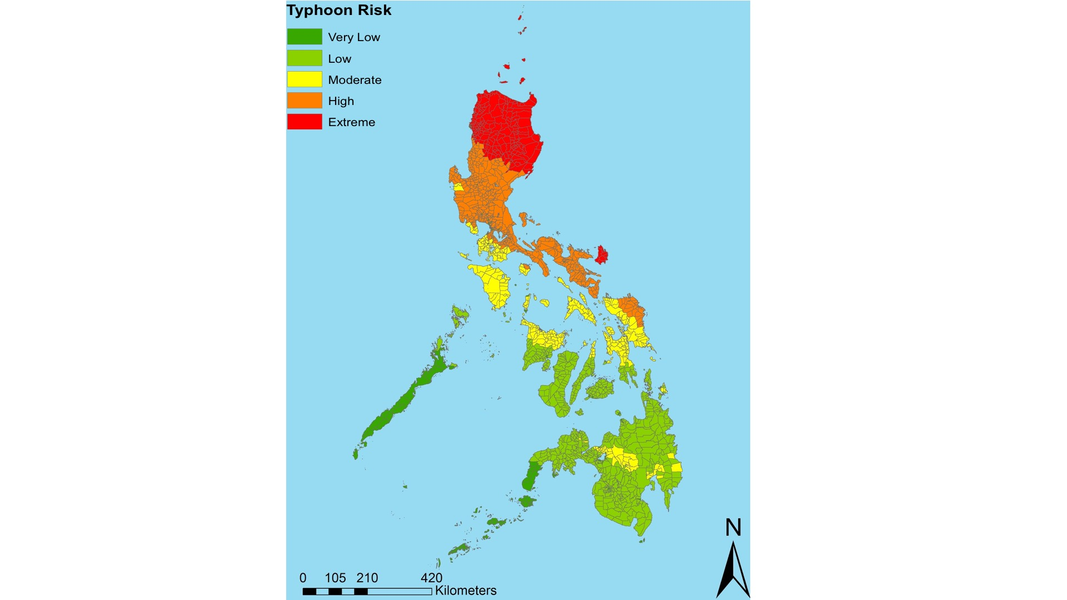

*Figure 5.*The landslide risk (left) and typhoon risk (right) of each municipality within the Philippines.

The updated typhoon and landslide risk data were combined with the number of outer walls, number of households, and number of unsafe roods to produce an updated physical exposure score for each municipality (Figure 6). The physical exposure is the highest (high to extreme) across the northern portion of the Philippines, and generally decreases to the south. However, there is a noticeable area of moderate physical exposure, which is surrounded by areas of low to very low exposure, across portions of the mountainous southern region. Using the aforementioned equal weighting scheme of physical exposure and demographic risk data, a comprehensive vulnerability score was generated (Figure 7). In general, physical exposure scores were greatest in northern portions of the Philippines (i.e. Luzan), while the demographic vulnerability remained greatest to the south in Mindanao (Figure 7). It is important to note that the combination of physical exposure and demographic risk data may ultimately lead to misleading results (e.g. assigning some southern municipalities an “extreme” comprehensive vulnerability score based exclusively on the demographic risk). However, the combination of physical and demographic data also illuminate areas of particular concern, including several municipalities across northcentral portions of the Philippines (e.g. Balbalan, kabugao, Lacub, Pasil, Pinukpuk, Tanudan, Tineg, and Tinglayan), and other municipalities along the eastern coastline of the Philippines (e.g. Caramoan, Garchitorena, Palanan, Pandan, Presentacion, and Viga).

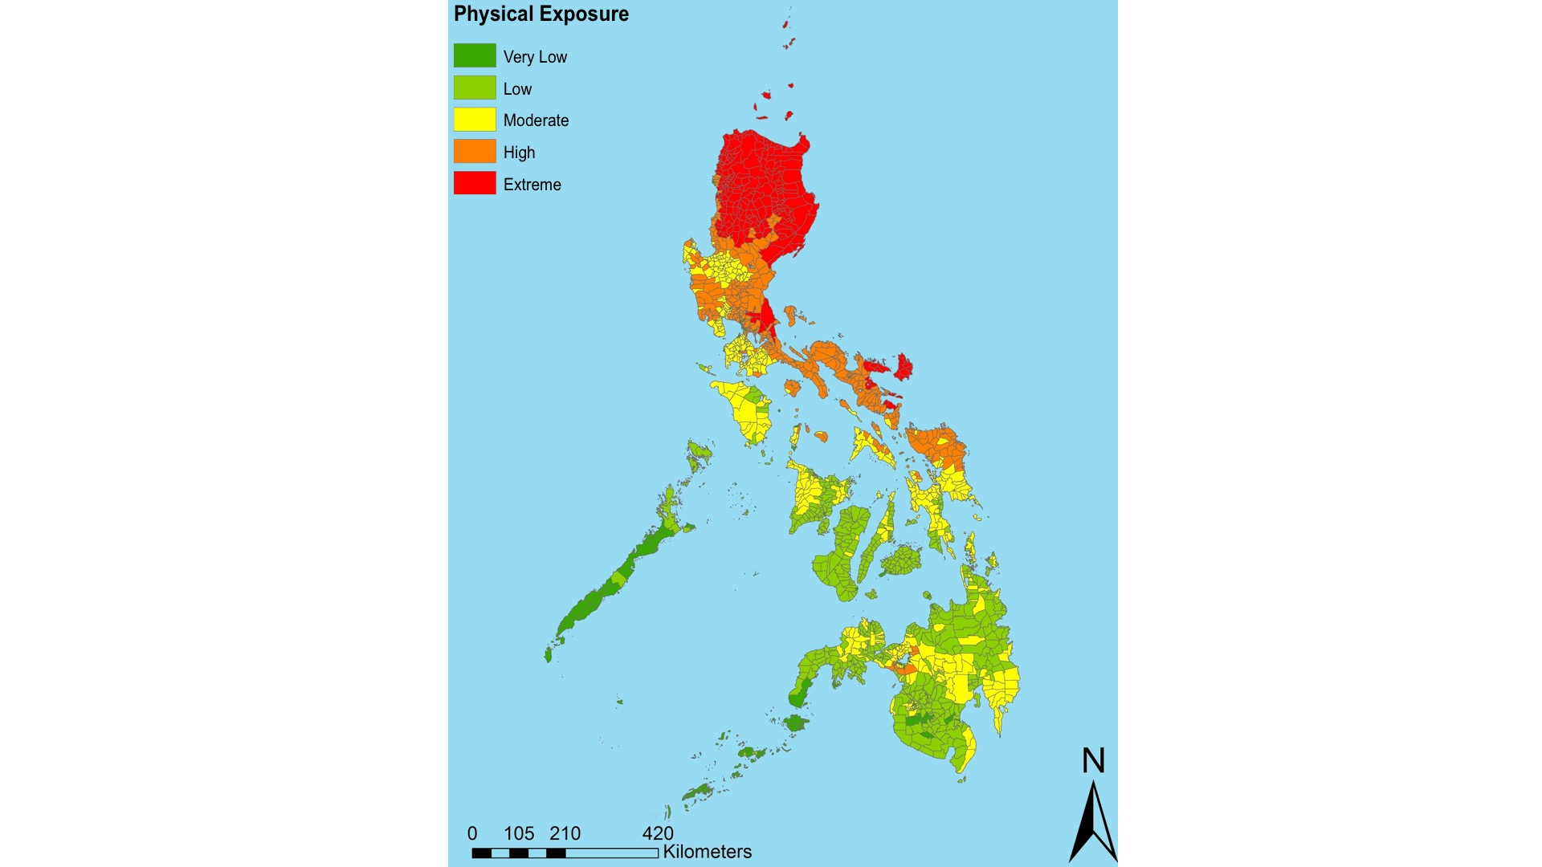 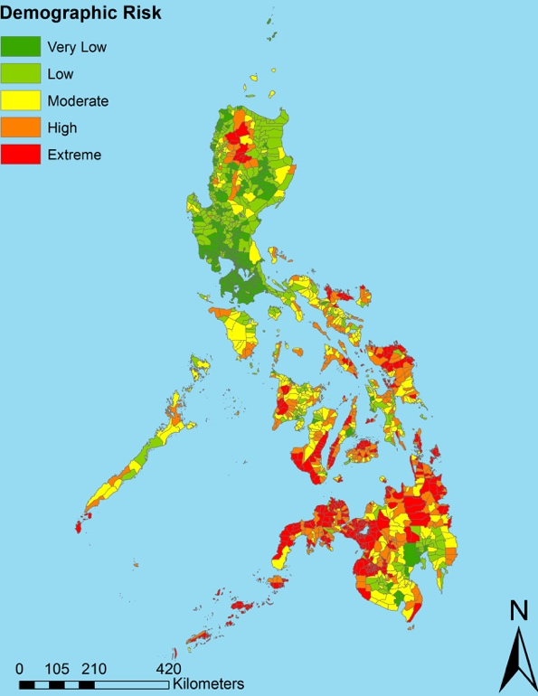

*Figure 6.* The overall physical exposure (left) and the overall demographic risk (right) of each municipality within the Philippines.

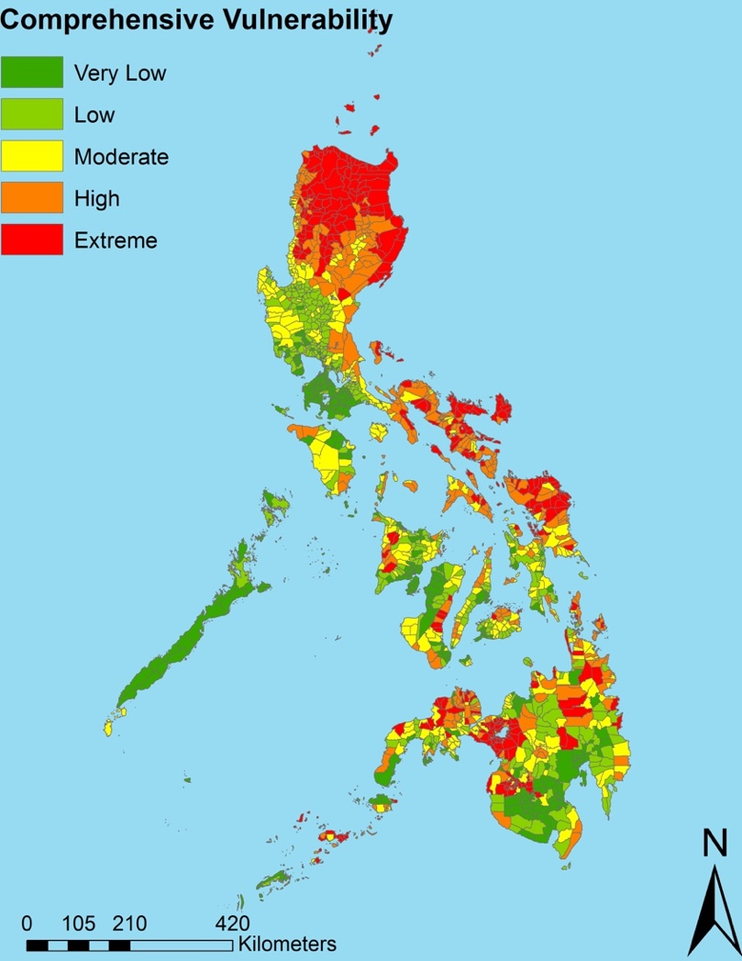

*Figure 7***.** The comprehensive vulnerability of each municipality within the Philippines.

***4.2 Future Work***

Using the improved combination of physical exposure and demographic vulnerability data affords OCHA the ability to improve its decision making regarding management and aid strategies. Future work could improve upon this research by including vulnerability induced by other natural hazards such as earthquakes and flooding. Future work could also improve upon this research by creating a more robust weighting scheme.

# 5. Conclusions

The Philippines is one of the most at-risk nations in the world to the hazards of tropical cyclones. These hazards will likely increase in severity with the advent of global climate change. Despite cyclones being common in this area, efforts to analyze vulnerability with a longer-range climatology have been minimal and remain at risk of being defunded. This study improved upon previous research by quantifying historical tropical cyclone size, intensity, and ultimately damage potential by using SpIKE. The combination of improved cyclone and landslide risk data has improved the identification of areas with the greatest natural hazard exposure. Combining the physical exposure results with demographic vulnerability data, this project was able to provide partners and end-users with information that details the portions of the Philippines which have the greatest need for disaster mitigation preparation. The methods used in this study may be expanded to other nations vulnerable to tropical cyclones.

# 6. Acknowledgments

The Philippines Disasters II team thanks our science advisors and project partners for their time and support throughout the project.

Science Advisors & Mentors

* Dr. Carl Schreck, Cooperative Institute for Climate and Satellites - North Carolina, NOAA National Centers for Environmental Information
* Dr. Ken Knapp, NOAA National Centers for Environmental Information
* Dr. L. DeWayne Cecil, Global Science and Technology, NOAA National Centers for Environmental Information

Project Partners

* Joseph Addawe, Information Management Analyst, United Nations Office for the Coordination of Humanitarian Affairs
* Rowena Dacsig Gender Advisor, United Nations Office for the Coordination of Humanitarian Affairs
* Luca Delloro, United Nations Institute for Training and Research, Operational Satellite Applications Programme (UNOSAT), Programme Specialist
* Dr. John Knaff, NOAA National Enviromental Satellite, Data, and Information Service, Tropical/Satellite Meteorologist
* Maarten van der Veen, Netherlands Red Cross, Initiator

Any opinions, findings, and conclusions or recommendations expressed in this material are those of the author(s) and do not necessarily reflect the views of the National Aeronautics and Space Administration.

This material is based upon work supported by NASA through contract NNL16AA05C and cooperative agreement NNX14AB60A.

# 7. Glossary

**ARG –** Automated Rain Gauges

**AWS –** Automated Weather Stations

**GBV –** Gender Based Violence, this is particularly in reference to acts of abuse faced by women

**HURSAT** **–** Hurricane Satellite Data, a multi-sourced, worldwide hurricane dataset compiled at NOAA-NCEI

**IBTrACS** **–** International Best Track Archive for Climate Stewardship, a multi-resourced cyclone track dataset from NOAA-NCEI

**IKE –** Integrated Kinetic Energy

**IR –** Infrared

**JTWC** **–** Joint Typhoon Warning Center, US military Pacific/Indian Ocean weather center

**NIR –** Near infrared

**NOAH** **–** The Nationwide Operational Assessment of Hazards, a Philippines-based natural hazard warning and research center

**SRTM –** Satellite Radar Topography Mission, a worldwide topography dataset developed by NASA-JPL

**UNITAR-UNOSAT** **–** The United Nations Institute for Training and Research’s Operational Satellite Application Program

**OCHA –** The United Nations Office for the Coordination of Humanitarian Affairs, a UN- based global initiative to develop better response and rebuilding efforts made to areas affected by various hazards

**SpIKE –** Spatially accumulated Integrated Kinetic Energy

# 8. References

Chu, J.-H., Sampson, C. R., Levine, A. S., & Fukada, E. (2002). The joint typhoon warning center tropical cyclone best-tracks, 1945–2000. *Ref. NRL/MR/7540‐02*, *16*.

Corporal‐Lodangco, I. L., & Leslie, L. M. (2017). Climatology of Philippine tropical cyclone activity: 1945–2011. *International Journal of Climatology*, *37*(9), 3525–3539.

Delica, Z. (1998). Balancing vulnerability and capacity: Women and children in the Philippines. In E. Enarson & B. H. Morrow (Eds.), *The Gendered Terrain of Disaster: Through Women’s Eyes* (109-113). Westport, Conn.: Praeger*.*

International Federation of Red Cross and Red Crescent Societies. (2015). *Unseen, unheard: Gender-based violence in disasters*.

Enano, J. O. (2017). UP keeps Project Noah afloat. Retrieved June 27, 2017, from http://newsinfo.inquirer.net/875154/up-keeps-project-noah-afloat

Kirschbaum, D. B., R. Adler, Y. Hong, S. Hill & Lerner-Lam, A. L. (2010). A global landslide catalog for hazard applications: Method, results and limitations. *Natural Hazards, 52*(3), 561-575. DOI: 10.1007/s11069-009-9401-4.

Knapp, K. R., Kruk, M. C., Levinson, D. H., Diamond, H. J., & Neumann, C. J. (2010). The international best track archive for climate stewardship (IBTrACS) unifying tropical cyclone data. *Bulletin of the American Meteorological Society*, *91*(3), 363–376.

Knapp, K. & Kossin, J. (2011) Hurricane Satellite (HURSAT) from International Satellite Cloud Climatology Project (ISCCP) B1. NOAA National Climatic Data Center. https://doi.org/10.7289/v54m92hh

Mueller, K. J., DeMaria, M., Knaff, J., Kossin, J. P., & Vonder Haar, T. H. (2006). Objective estimation of tropical cyclone wind structure from infrared satellite data. *Weather and Forecasting*, *21*(6), 990–1005.

Powell, M. D., & Reinhold, T. A. (2007). Tropical cyclone destructive potential by integrated kinetic energy. *Bulletin of the American Meteorological Society*, *88*(4), 513-526.

Shoemaker, D. N. (1991). Characteristics of tropical cyclones affecting the Philippine Islands. *Naval Oceanography Command Center/Joint Typhoon Warning Center Technical Note*, 91–1.

Schreck III, C., Knapp, K., & Kossin, J. (2014). The impact of best track discrepancies on global tropical cyclone Climatologies using IBTrACS. *Monthly Weather Review, 142,* 3881-3899. DOI: 10.1175/MWR-D-14-00021.1

Stanley, T., and Kirschbaum, D.B. (2017). A heuristic approach to global landslide susceptibility mapping. *Natural Hazards*, *87*(1), 1–20, [doi](https://pmm.nasa.gov/resources/acronyms#DOI):10.1007/s11069-017-2757-y

The Official Gazette, Republic of the Philippines. *Disaster Preparedness.* Retrieved from http://www.gov.ph/aquino-administration/disaster-preparedness/

Veen, M. V. (2016, November 09). A priority index for humanitarian aid after a typhoon. Retrieved June 27, 2017, from https://510.global/philippines-typhoon-haima-priority-index/

Velden, C., Harper, B., Wells, F., Bevin II, J.L., Zehr, R., Olander, T., … & McCrone, P. 2006. The Dvorak tropical cyclone intensity estimation technique: A satellite-based method that has endured for over 30 years. *Bulletin Of the American Meteorological Society*, *87*, 1195–1210. doi:10.1175/BAMS-87-9-1195.