**NASA DEVELOP National Program**



NOAA National Centers for Environment Information

*Summer 2016*

Pacific Water Resources II

Enhancing Decision Making to Help Manage Freshwater Resources: Using NASA Earth Observations and NOAA CDR’s to Provide Near Real-Time Precipitation Estimates for Forecasters in the U.S. Affiliated Pacific Islands

 **Technical Report**

Final Draft – August 11th, 2016

Nicholas Luchetti (Project Lead)

Kyle Jones

Zachary Vozzelli

Michael Kruk, Earth Resources Technology (ERT), (Science Advisor)

Dr. John Marra, NOAA Regional Climate Services, Director, Pacific Region, (Science Advisor)

Previous Contributors:

Jessica Sutton

Ethan Wright

# 1. Abstract

The United States Affiliated Pacific Islands (USAPI) are extremely vulnerable to precipitation shifts associated with the El Niño Southern Oscillation (ENSO). In the past, scientists in the region utilized a spatially-limited, *in situ*-based, ENSO climatology to inform their seasonal precipitation outlooks. To fill this spatial gap, the Pacific Water Resources I team successfully delivered an updated, ENSO-based precipitation climatic reference atlas derived primarily using remotely-sensed data. While the atlas has been heavily utilized by scientists in the region, it is somewhat limited in that it does not provide near real-time precipitation estimates. The Pacific Water Resources II project filled this limitation through the utilization of near real-time precipitation data from NASA’s Global Precipitation Measurement (GPM) mission which provides 30-minute rainfall estimates at 0.1° spatial resolution. To fully understand whether satellite-derived rainfall estimates from GPM can be used operationally in a near-real-time anomaly product, an analysis comparing the satellite products (PERSIANN-CDR, GPM) to 27 Global Historical Climate Network Daily (GHCN-D) stations in the west Pacific was completed. Results suggest that daily trends in raw station values and satellite-derived rainfall estimates were consistent. Therefore, results herein confirm the usefulness of using GPM precipitation estimates to accurately capture the recent seasonal precipitation trends found across the USAPI. The end results from this project provided a suite of near real-time precipitation estimate tools that can be used by decision makers in the region to mitigate and/or adapt to ongoing and future water resource emergencies.

**Keywords**

Drought, TRMM, GPM, Remote Sensing, PERSIANN-CDR, Precipitation Estimates, ENSO, GHCN

# 2. Introduction

* 1. ***Background Information***

The United States Affiliated Pacific Islands (USAPI) are an often forgotten region in regards to climate change and extreme weather. Yet, for many of these islands, the local inhabitants are extremely susceptible to drought and flooding events (Schroeder et al., 2012). Many of these events can become catastrophic for local islanders, especially during prolonged drought periods. Drought is particularly an issue as many of the islands’ freshwater resources are almost entirely dependent on the amount of precipitation that falls in a given month, season, or year (Kruk et al., 2015). Because of this, forecasters in the region are increasingly concerned with the spatial distribution of precipitation throughout the region, and the resulting impacts on freshwater availability. In the past, forecasters utilized a blend of observations, weather model outputs, and climatologies, derived from a rather sparse *in situ* station network, to inform their seasonal precipitation outlooks (Hamnett et al., 1999; Schroeder et al., 2012). The tropical Pacific covers a large area making it difficult to communicate weather data effectively. Adding to the communication issues is the lack of quality-controlled, long-term *in situ* stations found within the region (Wright et al., 2016). Most of the *in situ* stations are separated by large stretches of oceans, and are almost entirely located on the capital islands. This presents a spatial issue as many of the outer islands are often 100 km or further from these capital islands (Luchetti et al., 2016). It was evident to decision-makers that blending remotely sensed data with the already present *in situ* data was a necessary compliment for the advancement of managing freshwater resources across the region.

To fill this spatial void between the *in situ* stations, the Pacific Water Resources I project successfully created and delivered an updated precipitation climatic reference atlas that was sub-set by five phases (weak El Niño, moderate-strong El Niño, neutral, weak La Niña, moderate-strong La Niña) of the El Niño Southern Oscillation (ENSO) (Luchetti et al., 2016). The atlas was derived utilizing the National Oceanic and Atmospheric Administration (NOAA) Precipitation Estimation from Remotely Sensed Information Using Artificial Neural Networks–Climate Data Record (PERSIANN-CDR) (Ashouri et al., 2015) which provides 30-year global daily precipitation at 0.25° resolution. Forecasters in the region were immediately pleased with the atlas and mentioned its usefulness during the 2015-2016 strong El Niño event (Luchetti et al., 2016). The atlas was particularly useful in providing forecasters with a long-term seasonal climatological reference of how the distribution of anomalous precipitation changes by ENSO phase.

While this atlas has been extremely useful to decision makers in the region, it does not provide near real-time precipitation estimates. Understanding how much precipitation has fallen to date is critical for short-term forecasting confidence, as well for confidence in freshwater resources management. This project aimed to build upon the climatic reference atlas by providing a suite of near-real time forecasting tools to climate scientists in the region. To create these tools, remotely sensed data from the National Aeronautics and Space Administration’s (NASA)’s Global Precipitation Measurement (GPM) mission which provides 30-minute rainfall estimates at 0.1° resolution were utilized over the western Pacific in conjunction with precipitation data from the PERSIANN-CDR. Additionally, verification analyses between the *in situ* station data, PERISANN-CDR, Tropical Rainfall Measuring Mission (TRMM) Multi-satellite Precipitation Analysis (TMPA) (Huffman et al., 2007), and GPM were conducted for the purposes of determining the usefulness and accuracy of these products in depicting daily, monthly, seasonal, and yearly precipitation trends in the USAPI.

The end products from this project built upon the PERSIANN-CDR ENSO precipitation atlas (Luchetti et al., 2016) by providing near-real time precipitation estimates as well as near-real time anomalies to decision makers in the region. The end tools highlighted herein can provide further insight into how precipitation varies throughout the USAPI, how much precipitation has deviated from climatology in recent days, months, and seasons, and the usefulness of blending remotely sensed data with *in situ* data.

* 1. ***Study Area & Study Period***

Exclusive Economic Zones (EEZs) surrounding Guam, the Republic of the Marshall Islands (RMI), the Federated States of Micronesia (FSM), the Republic of Palau, and the Commonwealth of the Northern Mariana Islands (CNMI) were utilized to define the boundaries of the study area (**Figure 1**).

The period for this project was from March 2000 to August 2016.

* 1. ***Project Objectives***

The main objective of this project was to build upon the previous term’s precipitation atlas by providing a suite of near-real time precipitation tools using the higher-resolution GPM mission dataset. The tools were created so that our partners, as well as scientists in the region will be able to analyze near real-time data well after the project is finished.

* 1. ***Partners***

Dr. John Marra is the NOAA, National Centers for Environmental Information (NCEI), Regional Climate Service Director (RCSD) for the Pacific region. Dr. Marra and Michael Kruk, a Research Scientist with Earth Resources Technology (ERT) also at NOAA’s NCEI, have been heavily involved with the USAPI for several years. They provide support to the Weather Station Office (WSO) forecasters by issuing quarterly climate impacts and seasonal outlook reports. The information that they provide is utilized by WSO forecasters to help inform their seasonal precipitation forecasts, as well as to facilitate discussions of water resources management decisions, and is widely used amongst the academic and agricultural communities. Mr. Kruk and Dr. Marra will utilize the project’s near-real time precipitation tools to enhance their quarterly climate and observational reports.

* 1. ***National Applications Addressed***

The national application areas addressed in this project included Water Resources and Climate. This project was geared towards short-term water resource management, while the Pacific Water Resources I project was geared towards long-term water resource management. The near real-time forecasting tools developed from this project provide decision-makers in the region with an enhanced spatial and temporal understanding of how the distribution of precipitation has unfolded in the past few months, and where water resource mitigation management, such as water rationing, should be applied. The verification analysis between the *in situ* data and the satellite products provides a better understanding of the long and short-term climatological capabilities of using remotely sensed precipitation data in the USAPI.

# 3. Methodology

***3.1 Data Acquisition & Processing***

*3.1.1 Remotely-sensed Satellite Data Processing*

Global TMPA-3B42RT daily derived precipitation data were downloaded via FTP protocol for the years 2000-2014 from the NASA’s TRMM website (**Table 1 in the Appendix**). TMPA-3B42RT is a microwave-based precipitation product. It incorporates data from the TRMM Microwave Imager (TMI), Special Sensor Microwave Imager (SSMI), Special Sensor Microwave Imager/Sounder (SSMIS), Advanced Microwave Scanning Radiometer-EOS (AMSR-E), Advanced Microwave Sounding Unit-B (AMSU-B), and Microwave Humidity Sounder (MHS) (Huffman et al., 2011; Huffman and Bolvin, 2012). TMPA-3B42RT is a real-time product and therefore available with minimal latency. However, it is a purely microwave-based product and is not gauge-adjusted or calibrated. The TMPA-3B42RT daily, 0.25° resolution data were processed in ArcGIS by creating monthly, seasonal, and yearly sums. Monthly and annual averages were also computed in ArcGIS.

Archived NOAA PERSIANN-CDR data from the Pacific Water Resources I project were also accessed via the NASA DEVELOP National Program at NCEI’s archives for verification purposes. The NOAA PERSIANN-CDR uses primarily infrared data as its main source. However, it is also pre-trained using the National Centers for Environmental Prediction (NCEP) stage IV hourly precipitation data. Additionally, to eliminate potential bias, the PERSIANN-CDR is monthly adjusted to Global Precipitation Climatology Project (GPCP) 2.5°data (Ashouri et al., 2015). The archived PERSIANN-CDR 0.25° resolution data were also sub-set over the years 2000-2014 into monthly and annual sums. Monthly and annual averages were computed.

Additionally, daily PERSIANN-CDR 0.25° resolution data were downloaded via FTP protocol for the year 2015 from the NOAA NCEI’s website (**Table 1 in the Appendix**) for daily verification purposes. Lastly, PERSIANN-CDR daily data from the period 1984 to 2014 were downloaded and processed using R statistical language to create daily averages for the entire calendar year, daily averages during periods of strong El Niño conditions, and daily averages during periods of strong La Niña conditions.  
  
Archived PERSIANN-CDR seasonal averages were also accessed via the NASA DEVELOP National Program at NCEI’s archives to be used as the normal seasonal precipitation input in the anomalous precipitation tool developed in this project.

Global GPM-IMERGE daily aggregated precipitation data were downloaded via FTP protocol from the NASA’s GPM website (**Table 1 in the Appendix**). GPM was developed by NASA and the Japan Aerospace Exploration Agency (JAXA) and launched in February, 2014 as the successor to the NASA TRMM mission. GPM is a blended product in that it uses a constellation of both active and passive microwave-based and infrared-based satellites. It also utilizes a dual-frequency phased array precipitation radar (DPR). However, because GPM-IMERG is a near real-time product (4 hour latency), it is not gauge-adjusted (Hou et al., 2014). The GPM-IMERG daily, 0.1° resolution data was processed using R statistical language and in ArcGIS to seasonal sums. The GPM-IMERG was used throughout each tool as the near real-time precipitation input.

*3.1.2 In Situ Station Data Processing*

Archived NOAA Global Historical Climatology Network Daily (GHCN-D) station data from the Pacific Water Resources I project was accessed via the NASA DEVELOP National Program at NCEI’s archives for verification purposes. Using the completeness of record standards documented by Kruk et al. (2013), 31 high-quality, long-term western Pacific stations were utilized in this analysis. The station data had previously been processed over a 30-year period (1984-2014), and monthly sums and averages were available from the previous term. The data were re-processed to the years 2000-2014 and subset by monthly and annual sums. Additionally, GHCN-D station data for 27 high-quality, long-term western Pacific stations for the year 2015 were downloaded for daily verification purposes. Four of the 31 stations used in the long-term climatology verification analysis did not have daily data available for the year 2015 and were therefore excluded from the daily verification analysis.

***3.2 Data Analysis***

*3.2.1 Verification Analysis*

A long-term climatological verification analysis comparing precipitation estimates from the PERSIANN-CDR, the TMPA-3B42RT, and the GHCN *in situ* stations was conducted at the mean annual and mean monthly temporal scales over the years 2000-2014. For each of the satellite products, a single pixel analysis was performed at the location of the GHCN stations.

To fully understand whether satellite-derived rainfall estimates from GPM-IMERG and PERSIANN-CDR can be used operationally in a near-real-time anomaly product, an analysis comparing the satellite products (PERSIANN-CDR, GPM-IMERG) to 27 Global Historical Climate Network Daily (GHCN-D) stations in the west Pacific was completed. To evaluate the performance of the satellite products, five statistics were used in this analysis. The bias statistic is defined as the average difference between the station observation and the satellite observation. It can be either negative or positive. A negative bias indicates underestimation by the satellite while a positive bias indicates overestimation by the satellite. The multiplicative bias (MBias) represents the ratio of the satellite estimation to the station observation. An MBias of 1 represents a perfect estimation by the satellite. An MBias less than 1 represents underestimation by the satellites, while a MBias greater than 1 represents overestimation. The relative bias (RBias) represents the percentage bias of the satellites and behaves the same as bias. The roots mean square error (RMSE) represents the average error magnitude. Lastly, the correlation coefficient (CC) represents the agreement between the satellite estimates and the station observations. A CC value of +1 represents a perfect positive fit, while a CC value of exactly -1 represents a perfect negative fit. The analysis was broken down into months, but performed at the daily temporal scale incorporating all 27 stations.

*3.2.2 Near-real Time Precipitation Estimate Methods*

Three near-real time precipitation estimate tools were created. The first tool was labeled as a “Spatial Anomaly Mapping Generator”. To compute these anomalies, GPM-IMERGEDE daily data were summed in ArcGIS to the March-April-May (MAM) season. The GPM-IMERG 2016 MAM sum was then compared against the 30-year PERSIANN-CDR derived MAM seasonal average accessed via the NASA DEVELOP at NCEI archives. The resulting output shows percentage of normal precipitation for the most recent 2016 MAM season. The tool can also be used for reanalysis purposes dating back to April, 2015.

The second and third tools developed displayed similar results, but visualized in different ways. The second tool was labeled as a “Virtual Station Generator”. This tool acquires daily precipitation estimates from the GPM-IMERG product, and then compares them to the daily 30-year PERSIANN-CDR average at specific station locations scattered throughout the USAPI. The resulting output shows daily departures from climatology over the past 90 days.

The final tool was labeled as a “Haywood Plot Generator”. This tool calculates and plots accumulated precipitation to date using precipitation estimates from GPM-IMERG and compares to accumulated precipitation from other major factors in time derived using the PERSIANN-CDR. These comparisons include comparing the GPM-IMERG near real-time accumulated precipitation to the PERSIANN-CDR –derived 30-year normal, the PERSIANN-CDR-derived composite of strong El Niño and strong La Niña events, and the PERSIANN-CDR-derived accumulated precipitation estimates during the historic 1997-1998 El Niño and 1988-1989 La Niña events.

# 4. Results & Discussion

***4.1 Verification Analysis Results***

*4.1.1 Long-term Climatology Comparison Results*

Results from the 2000-2014 verification analysis suggest that both the TMPA-3B42RT as well as the PERSIANN-CDR often underestimate the amount of precipitation collected by the GHCN stations in any given month, or year. Despite this, both satellite products accurately follow the monthly, seasonal, and yearly long-term precipitation trends (**Figure 2 in the Appendix**). When comparing the mean annual precipitation from the GHCN stations to the PERSIANN-CDR and the TMPA-3B42RT (**Table 2 in the Appendix**), the PERSIANN-CDR (R2 = .44) outperforms the TMPA-3B42RT (R2 = .39) (**Figure 3 in the Appendix**). The PERSIANN-CDR also outperforms the TMPA-3B42RT for every mean monthly comparison except for the months of September and November (**Figure 4 in the Appendix**). Interestingly, both the PERSIANN-CDR and the TMPA-3B42RT do rather poorly in the months of August, September, and October. This is of particular interest because the August, September, and October months encompass the height of the western Pacific Typhoon seasons. When comparing the PERSIANN-CDR to the TMPA-3B42RT at the mean annual and monthly temporal scales, the results were almost always greater than a R2 value of 0.90 (**Figure 4 in the Appendix**).

Generally, it would be expected that a microwave-based precipitation algorithm such as the TMPA-3B42RT would have superior precipitation detection algorithms because infrared-based products, such as PERSIANN-CDR, utilize cold cloud top temperatures to derive precipitation rates, which does not always correlate well with rainfall. High, non-precipitating, cirrus clouds could easily be mistaken as precipitating systems if infrared data alone is used. Additionally, heavy rainfall is not always associated with cold cloud tops. For example, precipitation in the Pacific intertropical convergence zone (ITCZ) often occurs in warm, low clouds (Joyce et al., 2004). Microwave sensors, on the contrary, utilize a range of microwave frequencies to derive rainfall estimates. Using low frequency signals (10-37 GHz), microwave sensors sense the thermal emissions of raindrops. Using high frequency signals, microwave sensors sense scattering due to ice crystals in the cold sector of precipitation complexes (Joyce et al., 2004). Using these frequency sensing techniques together, microwave-based precipitation products generally are more accurate at depicting rainfall rates in precipitation systems than infrared-based products. In this study, however, the primarily infrared-based PERSIANN-CDR was the superior product. The PERSIANN-CDR is bias-adjusted using station gauges from GPCP as well as using NCEP stage IV precipitation estimates. The TMPA-3B42RT on the contrary, is a non-gauge adjusted product. It is purely a microwave satellite product. Potentially, the results from this analysis would suggest that climatologically, satellite products that are bias-adjusted to ground observations will outperform satellite-only products over the western Pacific region. It would be interesting to see if the TMPA-3B42V7, a gauge-adjusted TRMM product, would perform more comparably against the PERSIANN-CDR.

*4.1.2 2015 Daily Comparison Results*

Results of the 2015 daily validation study suggest that both the PERSIANN-CDR and GPM-IMERG tend to underestimate the daily precipitation estimates when compared to the GHCN observations. The bias is higher in the GPM-IMERG product compared to the PERSIANN-CDR product. Specifically, both satellite products tend to miss extremely robust precipitation events. However, this varies further depending on the island’s physiography. The satellite rainfall products tend to perform better over the low elevation atolls during these heavier precipitation days when compared to the higher islands (**Figure 5).** The underestimation bias of these two satellite products is not unexpected over the USAPI. As was stated earlier, the PERSIANN-CDR is monthly bias adjusted back to stations used in the GPCP 2.5° product. The USAPI has very few of these stations used in the GPCP algorithm (Luchetti et al., 2016). A higher density of GPCP stations would be needed for the PERSIANN-CDR to better capture daily rainfall estimates (Miao et al., 2015). The GPM-IMERG product is not gauge-adjusted at all. Therefore, it would be expected to underestimate the daily precipitation estimates. Lastly, because the satellite products provide the data over an averaged grid cell, it is expected that this smoothing would lead to disagreement between the station observations and the satellite products.

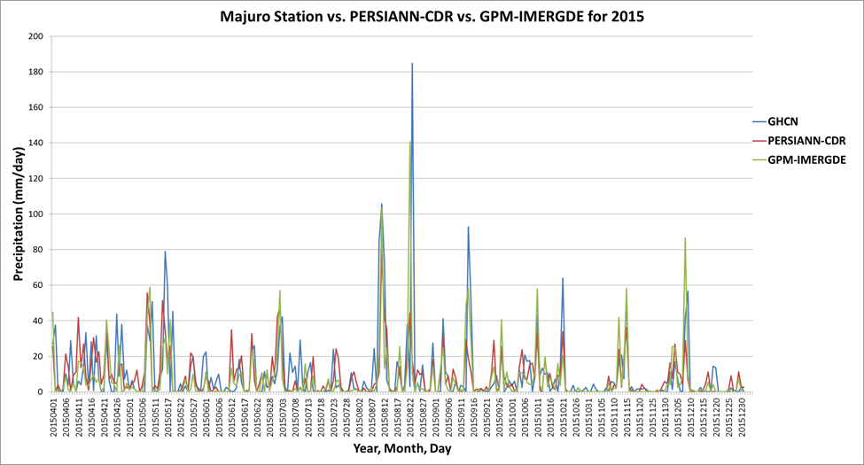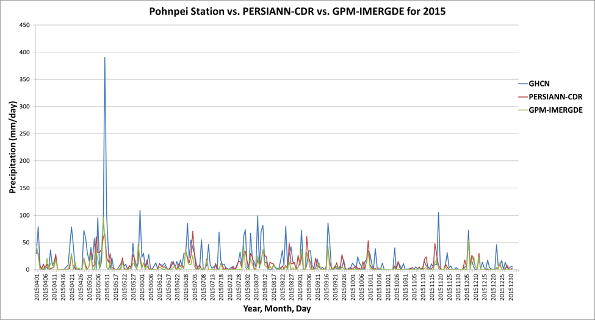

**Figure 5:** Time-series comparison of daily precipitation estimates derived from GHCN-D station observations, the PERSIANN-CDR, and GPM-IMERG for both the Majuro and Pohnpei stations.

Quantification of the satellite product’s underestimation is displayed in **Table 3 in the Appendix.** The results in **Table 3** suggest that the PERISIANN-CDR has less bias, smaller magnitude of error, and higher correlations in each month of 2015 when compared to the GPM-IMERG. In August, 2015 the GPM-IMERG had a particularly high bias (-5.53 mm/day), RBias (-41.84 %), and RMSE (149.99 mm) when compared to the PERSIANN-CDR bias (-2.89 mm/day), RBias (-21.85%), and RMSE (78.34 mm). Similarly, in September, 2015 the GPM-IMERG had a particularly high bias (-4.15 mm/day), RBias (-37.90 %), and RMSE (110.99 mm) when compared to the PERSIANN-CDR bias (-2.39 mm/day), RBias (-27.72%), and RMSE (62.58 mm). Results from this daily comparison confirm the hypothesis mentioned above that satellite products that are bias-adjusted to ground stations will outperform satellite-only products over the western Pacific region. Again, it would be interesting to see if the GPM-IMERGDF, a gauge-adjusted GPM product, would perform more comparably to the PERSIANN-CDR. However, the GPM-IMERGDF product was not used in this verification analysis, nor in any of the near real-time precipitation tools, because it is not a real-time product (two month latency) and therefore does not align with the objectives of this project.

While the raw station values do not necessarily line up exactly with those from satellite-derived rainfall estimates, the direction of the trends is the same. For example, when the station data suggests periods of dryness, satellite estimates also suggest the same, and visa-versa (**Figure 5)**. Additionally, when comparing the ratios of the precipitation amounts between the stations and the satellite products, the results were almost always a close match.

***4.2 Near Real-Time Forecasting Tools***

*4.2.1 Seasonal Spatial Anomalous Tool*

**Figure 6** shows an example of the spatial near-real time anomalous tool’s potential. This map shows the March-April-May (MAM) 2016 anomalous precipitation derived using daily precipitation estimates from GPM-IMERG compared against the PERSIANN-CDR-derived average MAM season over the past 30 years. The brown areas represent below average precipitation for the MAM 2016 season, and the turquoise areas represent above average precipitation. The MAM 2016 season occurred during the remnants of a moderate-strong El Niño event, and therefore it is not surprising to see significantly below average precipitation for many of the USAPI EEZs. The MAM 2016 anomalous map can also be compared to the Moderate-Strong El Niño Year (+1) MAM climatological regional map located in the PERSIANN-CDR reference atlas (Luchetti et al., 2016). After comparison, the MAM 2016 season was drier than the average Moderate-Strong El Niño Year (+1) MAM season, confirming that the effects of the near-historic 2015-2016 El Niño event were crippling across the USAPI region.

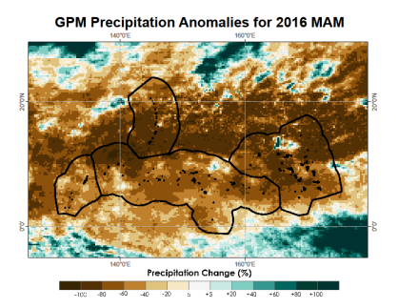

**Figure 6**: Precipitation anomalies at 0.25° resolution for the 2016 March-May season. Precipitation estimates from the GPM-IMERG were used to generate the seasonal real-time estimates and are compared against precipitation estimates from the NOAA PERSIANN-CDR 30-year seasonal normal climate atlas (Luchetti et al. 2016).

*4.2.2 Virtual Station Generator Tool*

**Figure 7** displays example output from the Virtual Station Generator tool. In this plot, the green shaded region represents the daily normal precipitation derived from the 30-year PERSIANN-CDR at this specific station location. The blue shaded region represents daily precipitation estimates collected by the GPM-IMERG satellite product over this specific station location. The Virtual Station Generator tool is configured to produce plots that display anomalous precipitation over the past 90 days. Additionally, on the right side of each plot, the 90-day accumulated GPM-IMERG daily precipitation estimates are compared against the 90-day accumulated PERISANN-CDR average daily precipitation estimates. The resulting bar graph shows the precipitation percentage from normal for that specific station location over the past 90 days. The benefit of this tool is it allows the user to look at daily and accumulated precipitation departures from normal and do so over a specified temporal scale.

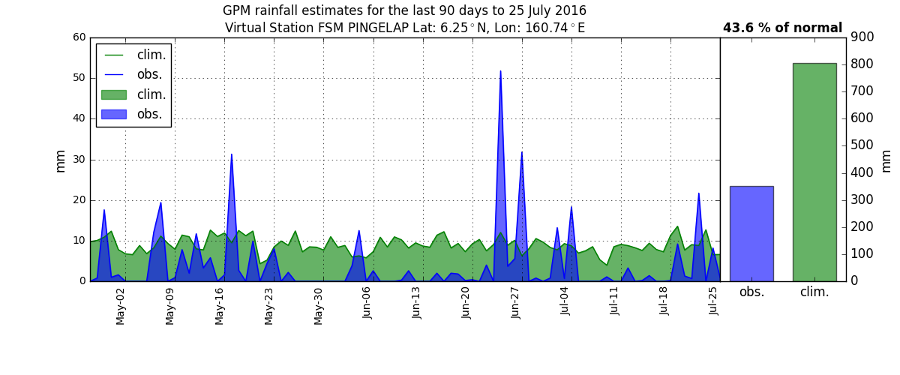**Figure 7:** Virtual station plot for Pingelap Island. The green shaded area represents the daily normal precipitation derived from the 30-year PERSIANN-CDR. The blue shaded area represents real-time precipitation estimates from the GPM-IMERG satellite product. The bar graph to the right displays the 90-day accumulated GPM-IMERG daily precipitation estimates compared against the 90-day accumulated PERSIANN-CDR average daily precipitation estimates.

*4.2.3 Haywood Plots Generator Tool*

**Figure 8** displays example output from the Haywood Plots Generator tool over the Yap Island station. This plot shows a variety of different accumulated precipitation to-date lines. The green line and shaded region represents the GPM-IMERG-derived accumulated precipitation from January 1, 2016 to June 30, 2016 at the Yap Island station. The black line represents the accumulated daily average precipitation derived from the 30-year PERSIANN-CDR from January 1, 2016 to June 30, 2016. The solid red line represents a PERSIANN-CDR-derived daily accumulation of the composite of six strong El Niño events (1986/1987; 1987/1988; 1991/1992; 1997/1998; 2002/2003; 2009/2010) from January 1 to June 30. The solid blue line represents a PERSIANN-CDR-derived daily accumulation of the composite of five strong La Niña events (1988/1989; 1998/1999; 1999/2000; 2007/2008; 2010/2011) from January 1 to June 30. The dashed, light red line represents a PERSIANN-CDR-derived daily accumulation of the 1997-1998 historic El Niño event from January 1, 1998 to June 30, 1998. Lastly, the dashed, light blue line represents a PERSIANN-CDR-derived daily accumulation of the 1988-1989 historic La Niña event from January 1, 1989 to June 30, 1989. An analysis of **Figure 8** shows that for the Yap Island station, the 2016 GPM-IMERG-derived accumulated precipitation is significantly below the 30-year PERISANN-CDR-derived normal accumulated precipitation. Additionally, the Yap Island 2016 GPM-IMERG-derived accumulated precipitation is at times below the historic 1997-1998 El Niño accumulated precipitation line, confirming that the 2015-2016 El Niño event was absolutely crippling for the Yap Island region.

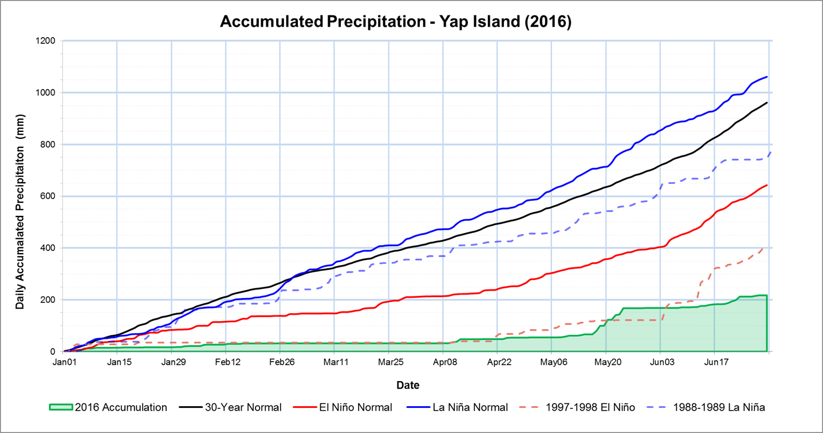

**Figure 8:** Satellite-derived accumulated precipitation for the Yap Island station through June 30, 2016. The 2016 Accumulation line was derived using daily precipitation estimates from the GPM-IMERG satellite product. The 30-year Normal line was derived using daily precipitation estimates from the PERSIANN-CDR averaged over the years 1984-2014. The El Niño Normal line was derived using daily precipitation estimates from the PERSIANN-CDR composited over six strong El Niño events (1986/1987; 1987/1988; 1991/1992; 1997/1998; 2002/2003; 2009/2010). The La Niña Normal line was derived using daily precipitation estimates from the PERSIANN-CDR composited over five strong La Niña events (1988/1989; 1998/1999; 1999/2000; 2007/2008; 2010/2011). The 1997-1998 El Niño line and the 1988-1989 La Niña line were derived using daily precipitation estimates from the PERSIANN-CDR.

# 5. Conclusions

This project attempted to build upon the successful Pacific Water Resources I project’s PERSIANN-CDR ENSO precipitation atlas by creating a suite of near real-time precipitation tools using precipitation estimates from the NASA GPM product. The resulting tools allow forecasters, emergency responders, and decision makers in the USAPI to easily assess the spatial distribution of anomalous precipitation in the near recent past. By utilizing the tools highlighted herein, decision makers in the region can enhance their decisions in mitigating and/or adapting to ongoing water resource emergencies. Considering that the region lacks a dense, high quality *in situ* station network, the satellite-derived tools highlighted herein provide an enhanced spatial representation of the short-term, climatological variability in precipitation experienced by the region.

To assess confidence in using precipitation estimates from GPM-IMERG and PERSIANN-CDR in the near real-time precipitation tools generated in this project, a daily verification analysis was completed comparing the satellite products to 27 GHCN-D stations scattered throughout the west Pacific. Results suggest that both the GPM-IMERG and PERSIANN-CDR tend to underestimate the daily precipitation totals when compared to the GHCN-D stations. Despite this, both the GPM-IMERG and PERSIANN-CDR do follow the wet/dry trends experienced by the GHCN-D stations. For example, when the GHCN-D stations observed periods of dry weather, the satellite products do the same and vice-versa. Therefore, there was high confidence in using both the GPM-IMERG and PERSIANN-CDR as inputs in the tools generated in this project, and in their ability to accurately depict the precipitation trends over the USAPI.

It was decided that from a user perspective, it should be made known the potential limitations of these satellite-derived tools. As a result, a guide to interpreting these satellite-derived rainfall anomalous tools was created with input and guidance from local experts involved in the dissemination of climate information in the USAPI. The resulting guide will be disseminated to users in the region so that they can enhance their decision making by understanding the potential limitations in using these satellite-derived tools.

Each of the near real-time precipitation tools have been fully operationalized and the output generated by them will be heavily incorporated by our science advisors into quarterly climate reports and decision-making sessions well beyond this term.

# 6. Acknowledgments

The authors would like to acknowledge Mike Kruk (ERT), John Marra (NOAA), Alec Courtright (NASA DEVELOP), Emma Baghel (NASA DEVELOP), James Potemra (IIRC), Nico Fauchereau (NIWA), James Adams (ERT), Ryan Berkheimer (GST), Tom Burnet (GST), and the NASA DEVELOP National Program Office for their support, suggestions, and edits that have fundamentally strengthened this research.

Any opinions, findings, and conclusions or recommendations expressed in this material are those of the author(s) and do not necessarily reflect the views of the National Aeronautics and Space Administration.

This material is based upon work supported by NASA through contract NNL11AA00B and cooperative agreement NNX14AB60A.

# 7. References

Ashouri, H., Hsu, K. L., Sorooshian, S., Braithwaite, D. K., Knapp, K. R., Cecil, L. D., ... & Prat, O. P. (2015). PERSIANN-CDR: Daily precipitation climate data record from multisatellite observations for hydrological and climate studies. Bulletin of the American Meteorological Society, 96(1), 69-83.

Hamnett, M. P., Anderson, C. L., & Guard, C. P. (1999). The Pacific ENSO Applications Center and the 1997-98 ENSO warm event in the US-affiliated Micronesian Islands: minimizing impacts through rainfall forecasts and hazard mitigation. Pacific ENSO Applications Centre.

Huffman, G. J., Bolvin, D. T., Nelkin, E. J., Wolff, D. B., Adler, R. F., Gu, G., ... & Stocker, E. F. (2007). The TRMM multisatellite precipitation analysis (TMPA): Quasi-global, multiyear, combined-sensor precipitation estimates at fine scales. *Journal of Hydrometeorology*, *8*(1), 38-55.

Huffman, G. J., & Bolvin, D. T. (2013). TRMM and other data precipitation data set documentation. *NASA, Greenbelt, USA*, 1-40.

Joyce, R. J., Janowiak, J. E., Arkin, P. A., & Xie, P. (2004). CMORPH: A method that produces global precipitation estimates from passive microwave and infrared data at high spatial and temporal resolution. Journal of Hydrometeorology, 5(3), 487-503.

Klepp, C., & Huffman, G. (2011). 5th International Precipitation Working Group Workshop, Workshop Program and Proceedings, Hamburg, Germany, 11-15 Oct 2010.

Kruk, M. C., Lorrey, A. M., Griffiths, G. M., Lander, M., Gibney, E. J., Diamond, H. J., & Marra, J. J. (2015). On the state of the knowledge of rainfall extremes in the western and northern Pacific basin. International Journal of Climatology, 35(3), 321-336.

Kruk, M. C., Marra, J. J., Ruggiero, P., Atkinson, D., Merrifield, M., Levinson, D., & Lander, M. (2013). Pacific Storms Climatology Products (PSCP): Understanding extreme events. *Bulletin of the American Meteorological Society*, *94*(1), 13-18.

Luchetti, N. T., Sutton, J. R., Wright, E. E., Kruk, M. C., & Marra, J. J. (2016). When El Niño rages: How satellite data can help water-stressed islands. *Bulletin of the American Meteorological Society*, (2016). doi:10.1175/BAMS-D- 15-00219.1, in press. [EOR Available at [http://journals.ametsoc.org/doi/abs/10.1175/BAMS-D- 15-00219.1](http://journals.ametsoc.org/doi/abs/10.1175/BAMS-D-%2015-00219.1)].

Miao, C., Ashouri, H., Hsu, K. L., Sorooshian, S., & Duan, Q. (2015). Evaluation of the PERSIANN-CDR daily rainfall estimates in capturing the behavior of extreme precipitation events over China. *Journal of Hydrometeorology*, *16*(3), 1387-1396.

Schroeder, T. A., Chowdhury, M. R., Lander, M. A., Guard, C. C., Felkley, C., & Gifford, D. (2012). The role of the Pacific ENSO applications climate center in reducing vulnerability to climate hazards: Experience from the US-affiliated Pacific islands. *Bulletin of the American Meteorological Society*,*93*(7), 1003-1015.

Sutton, J. R. P., N. T. Luchetti, E. E. Wright, M. C. Kruk, and J. J. Marra, 2015: An El Nino Southern Oscillation (ENSO) based Precipitation Climatology for the United States Affiliated Pacific Islands (USAPI) Using the PERSIANN Climate Data Record.  National Aeronautics and Space Administration DEVELOP National Program, 478 pp. [Available at <ftp://ftp.ncdc.noaa.gov/pub/data/coastal/ENSO_Rainfall_Atlas.pdf>]

Wright, E. E., J. R. P. Sutton, N. T. Luchetti, M. C. Kruk, and J. J. Marra (2016), Closing the Pacific rainfall data void, *Eos, 97,*doi:10.1029/2016EO055053. Published on 07 July 2016.

# 8. Content Innovation

**Content Innovation #1**  
Inline Supplementary Material

* **Figure 5:** Daily Comparison of Precipitation Estimates from GPM-IMERG, PERSIANN-CDR and the Majuro and Pohnpei GHCN-D Stations
* **Figure 6:** GPM-IMERG Precipitation Anomalies for the 2016 MAM Season
* **Figure 7:** Example Output from the Virtual Station Generator Tool
* **Figure 8:** Example Output from the Haywood Plots Generator Tool

**Content Innovation #2**

Featured Multimedia for this Article – VPS

**Content Innovation #3**Glossary Viewer

**Climate Data Record (CDR) –** a time series of measurements used to determine climate variability and change that are of ample length, uniformity, and progression.

**Exclusive Economic Zones** **(EEZs) –** a coastal zone falling within a specified distance of a country's coastline. The country have the right to conduct economic activities, such as fishing, drilling, etc..

**Global Historical Climate Network Daily** (**GHCN-D) –** A database of daily climate summaries from land surface, *in situ* stations that are run through regular quality assurance and quality control measures.

**Global Precipitation Measurement (GPM) –** A precipitation measurement mission developed by NASA and the Japan Aerospace Exploration Agency (JAXA) and launched in February, 2014 as the successor to the NASA TRMM mission. Data collected from this mission provides global observations of rain and snow.

**Integrated Multi-satellitE** **Retrievals for** **GPM Day Early (IMERG) –** a real-time global precipitation data set available at 30 minute, 0.1° (~11km) resolution. This is a merged product that utilizes both infrared and microwave sensors. It also utilizes dual-frequency phased array precipitation radar (DPR). However, because it is a near-real-time product (only 4 hour lag) it is not gauge-adjusted.

**National Oceanic and Atmospheric Administration – National Centers for Environmental Information (NOAA – NCEI) –** Headquartered in Asheville, North Carolina, NCEI provides comprehensive atmospheric, coastal, oceanic, and geophysical data. This large repository of data is available to the public.

**Precipitation Estimation from Remotely Sensed Information Using Artificial Neural Networks–Climate Data Record (PERSIANN-CDR) –** a global precipitation data set covering the latitude band 60°S to 60°N for the period of 01/01/1983 to the delayed present. Data is available at daily, 0.25° resolution (~25km). The NOAA PERSIANN-CDR uses primarily infrared data as its main source. Given its data record, this data set can be utilized in long-term Climatology.

**Tropical Rainfall Measuring Mission (TRMM) –** a satellite precipitation mission developed to study rainfall for weather and climate research. Collaboration between NASA and the Japan Aerospace Exploration (JAXA) Agency led to the success of the mission which concluded on April 15, 2015.

**TRMM Multi-satellite Precipitation Analysis (TMPA-3B42RT) –** a microwave-based precipitation product. It incorporates data from the TRMM Microwave Imager (TMI), Special Sensor Microwave Imager (SSMI), Special Sensor Microwave Imager/Sounder (SSMIS), Advanced Microwave Scanning Radiometer-EOS (AMSR-E), Advanced Microwave Sounding Unit-B (AMSU-B), and Microwave Humidity Sounder (MHS). TMPA-3B42RT is a real-time product and therefore available with minimal latency. However, it is a purely microwave-based product and is not gauge-adjusted or calibrated.

# 9. Appendices

|  |  |  |  |  |
| --- | --- | --- | --- | --- |
|  |  | RESOLUTION | |  |
| **Product** | **Type** | **Spatial** | **Temporal** | **Website** |
| PERSIANN-CDR | Satellite | 0.25° | Daily | http://www.ncdc.noaa.gov/cdr/operationalcdrs.html |
| GHCN | *In-situ* | point | Daily | http://www1.ncdc.noaa.gov/pub/data/ghcn/daily |
| TMPA-3B42RT | Satellite | 0.25° | Daily | ftp://disc2.nascom.nasa.gov/data/TRMM/Gridded/Derived_Products/3B42RT/Daily |
| GPM | Satellite | .1° | 30 min | http://gpm1.gesdisc.eosdis.nasa.gov/data/GPM_L3/GPM_3IMERG.03/ |
| World Exclusive Economic Zones (EEZ) | Shape File |  |  | http://www.marineregions.org/downloads.php |

**Table 1**: Sources of the data sets used in this study.



**Table 2**: Mean annual (2000-2014) precipitation comparison between GHCN stations, the TMPA-3B42RT, and the PERSIANN-CDR.

|  |  |  |
| --- | --- | --- |
| **April, 2015 Daily** |  |  |
|  | **PERSIANN-CDR vs. GHCN** | **GPM-IMERG vs. GHCN** |
| **Bias (mm/day)** | -0.76 | -3.69 |
| **Mbias** | 0.87 | 0.57 |
| **Rbias (%)** | -13.60 | -42.87 |
| **RMSE (mm)** | 21.30 | 100.59 |
| **CC** | 0.32 | 0.32 |
|  |  |  |
| **May, 2015 Daily** |  |  |
|  | **PERSIANN-CDR vs. GHCN** | **GPM-IMERG vs. GHCN** |
| **Bias (mm/day)** | -3.20 | -4.45 |
| **Mbias** | 0.72 | 0.61 |
| **Rbias (%)** | -27.83 | -39.20 |
| **RMSE (mm)** | 88.16 | 120.77 |
| **CC** | 0.45 | 0.33 |
|  |  |  |
| **June, 2015 Daily** |  |  |
|  | **PERSIANN-CDR vs. GHCN** | **GPM-IMERG vs, GHCN** |
| **Bias (mm/day)** | -1.11 | -3.21 |
| **Mbias** | 0.88 | 0.64 |
| **Rbias (%)** | -12.49 | -35.96 |
| **RMSE (mm)** | 30.39 | 85.26 |
| **CC** | 0.39 | 0.34 |
|  |  |  |
| **July, 2015 Daily** |  |  |
|  | **PERSIANN-CDR vs. GHCN** | **GPM-IMERG vs. GHCN** |
| **Bias (mm/day)** | -2.42 | -4.54 |
| **Mbias** | 0.75 | 0.53 |
| **Rbias (%)** | -24.80 | -46.64 |
| **RMSE (mm)** | 67.45 | 126.74 |
| **CC** | 0.37 | 0.44 |
|  |  |  |
| **August, 2015 Daily** |  |  |
|  | **PERSIANN-CDR vs. GHCN** | **GPM-IMERG vs. GHCN** |
| **Bias (mm/day)** | -2.89 | -5.53 |
| **Mbias** | 0.78 | 0.58 |
| **Rbias (%)** | -21.85 | -41.84 |
| **RMSE (mm)** | 78.34 | 149.99 |
| **CC** | 0.41 | 0.33 |
|  |  |  |
| **September, 2015 Daily** |  |  |
|  | **PERSIANN-CDR vs. GHCN** | **GPM-IMERG vs. GHCN** |
| **Bias (mm/day)** | -2.39 | -4.15 |
| **Mbias** | 0.78 | 0.62 |
| **Rbias (%)** | -21.72 | -37.89 |
| **RMSE (mm)** | 62.58 | 110.99 |
| **CC** | 0.18 | 0.18 |
|  |  |  |
| **October, 2015 Daily** |  |  |
|  | **PERSIANN-CDR vs. GHCN** | **GPM-IMERG vs. GHCN** |
| **Bias (mm/day)** | -1.29 | -2.16 |
| **Mbias** | 0.83 | 0.71 |
| **Rbias (%)** | -16.52 | -29.14 |
| **RMSE (mm)** | 35.53 | 62.07 |
| **CC** | 0.36 | 0.34 |
|  |  |  |
| **November, 2015 Daily** |  |  |
|  | **PERSIANN-CDR vs. GHCN** | **GPM-IMERG vs. GHCN** |
| **Bias (mm/day)** | -1.32 | -2.09 |
| **Mbias** | 0.77 | 0.63 |
| **Rbias (%)** | -23.25 | -36.86 |
| **RMSE (mm)** | 26.34 | 41.77 |
| **CC** | 0.44 | 0.43 |
|  |  |  |
| **December, 2015 Daily** |  |  |
|  | **PERSIANN-CDR vs. GHCN** | **GPM-IMERG vs. GHCN** |
| **Bias (mm/day)** | -0.76 | -1.96 |
| **Mbias** | 0.87 | 0.67 |
| **Rbias (%)** | -13.60 | -34.94 |
| **RMSE (mm)** | 21.30 | 55.80 |
| **CC** | 0.32 | 0.32 |

**Table 3:** Statistical comparison of daily precipitation estimates derived from the PERSIANN-CDR, GPM-IMERG, and the GHCN-D data sets.

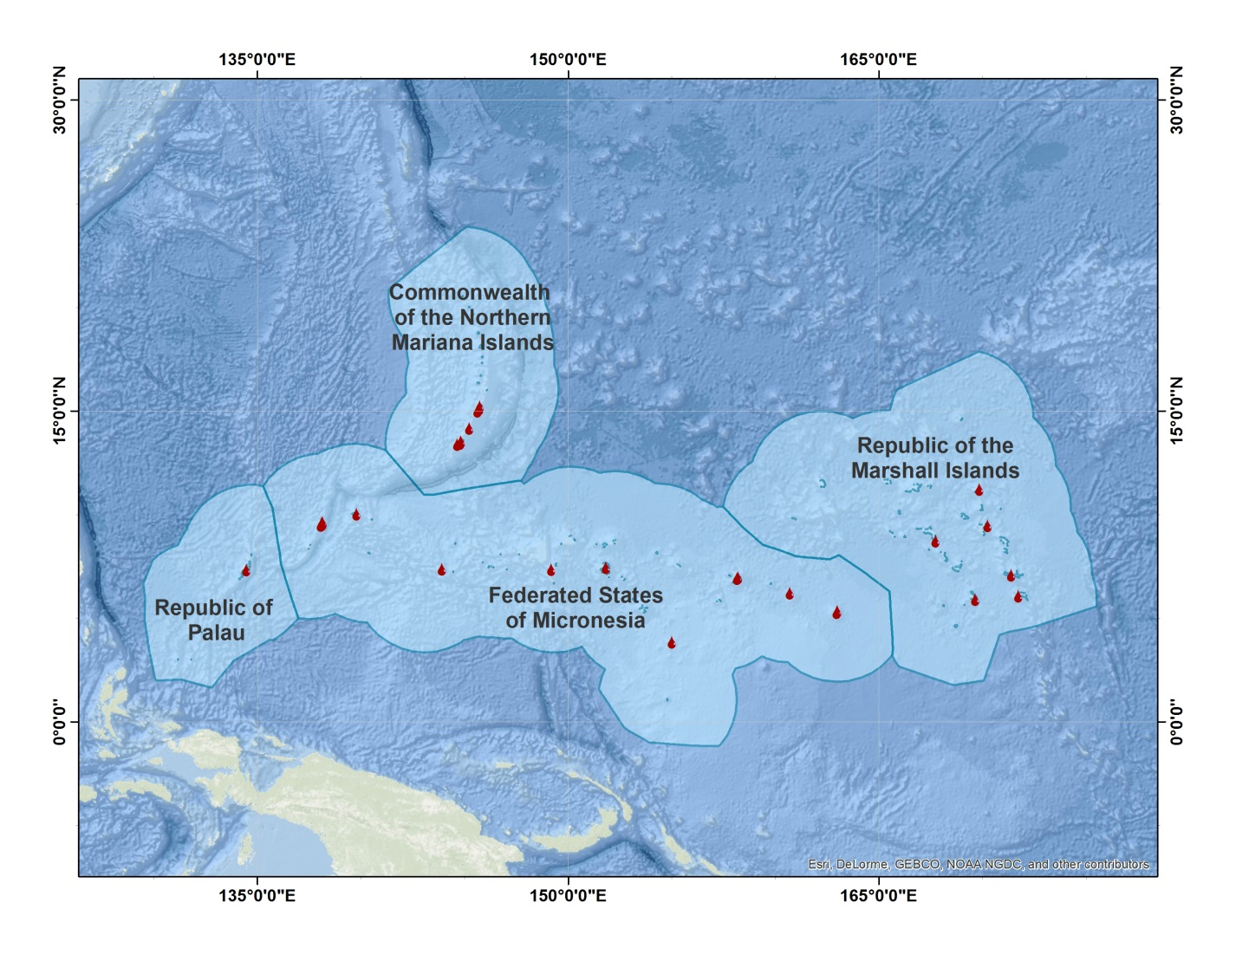

**Figure 1:** Map of study area with the Exclusive Economic Zones (EEZs) highlighted for each U.S. Affiliated Pacific Island (USAPI) chain, as well as the 31 GHCN stations utilized for verification purposes.



**Figure 2:** Year and month comparison or precipitation estimates at the Yap Island station in the Federated States of Micronesia.

**Figure 3:** Mean annual (2000-2014) comparison between the GHCN stations and TMPA-3B42RT (left), and GHCN stations and PERSIANN-CDR (right).





**Figure 4:** January mean monthly precipitation comparison between the GHCN stations and TMPA-3B42RT (left), GHCN stations and PERSIANN-CDR (right), and TMPA-3B42RT and PERSIANN-CDR (bottom)