**NASA DEVELOP National Program**

****Wise County Clerk of Court’s Office

**Spring 2016**

**Short Title: African Great Lakes Weather II**

**Subtitle:** Utilizing NASA Earth Observations to Identify Indicators to Help Predict Deadly Storms over the African Great Lakes

**VPS Title:** The Calm Before the Storm: Lake Victoria Severe Weather Indicators

**Project Team & Partners**

**Project Team:**

Annabel White (Project Lead), [apwhite11@gmail.com](mailto:apwhite11@gmail.com)

Jakub Blach

Michael Brooke

Megan Buzanowicz

Katherine Dooley

Rajkishan Rajappan

Ryan Umberger

**Advisors & Mentors:**

Dr. Kenton Ross (NASA DEVELOP National Program)

Kristopher Bedka (NASA Langley Research Center – Climate Science Branch)

Dr. DeWayne Cecil (Global Science & Technology National Centers for Environmental Information [NCEI])

Robert VanGundy (University of Virginia’s College at Wise)

April Huff (NASA DEVELOP at Wise)

Mike Bender (NASA DEVELOP National Program)

**Past or Other Contributors:**

William Wilson

Grant Bloomer

Juan Antonio Chacón Castro

**Partner Organizations:**

Kenya Meteorological Department (End-User), POC: John Mungai; Boundary Organization

**Project Details**

**Applied Sciences National Applications Addressed:** Weather, Disasters

**Study Area:** Lake Victoria and the immediate surrounding areas in Kenya, Tanzania, and Uganda

**Study Period:** March 2005 – November 2013

**Earth Observations & Parameters:**

Meteosat, SEVIRI – infrared monitor

Aqua, AIRS – temperature, water vapor, weather forecasting

**Ancillary Datasets Utilized:**

* MERRA IAU 2D Atmospheric Single-Level Diagnostics – gridded data on geopotential height, wind components, temperature, humidity, vertical pressure velocity, surface skin temperature
* NASA Langley Research Center Hazardous Storm Event Database – overshooting top database

**Software Utilized:**

MATLAB R2015a – data processing within Hazardous Storm Event Database

ArcMap 10.1 – NetCDF data import and image visualization

**Project Overview**

**80-100 Word Objectives Overview:**

The objective of this project was to contribute to research at NASA Langley Research Center’s Climate Science Branch with regards to storm development over the African Great Lakes—focusing on Lake Victoria. Measurements of certain environmental aspects were compiled from MERRA products at intensity levels chosen to highlight extreme storm activity from typical weather. These parameters were then compared to detect indicators that can be used in forecasting efforts.

**Abstract:**

The African Great Lakes lie along the East African Rift Valley and play an important role in the economy and culture of the millions of people in the region. Intense storms can develop around the lakes with little warning and create life-threatening hazards to fisherman caught out on the lakes during these events. This project aims to find correlations between climatic indicators and the onset of storms. The results will help the Kenya Meteorological Department to improve the forecasting accuracy of local and regional authorities. For the years 2005 to 2013, the NASA DEVELOP team compared potential storm indicators on days of heightened and average overshooting top (OT) detections. The Hazardous Storm Event Database (HSED), derived from the Spinning Enhanced Visible and Infrared Imager (SEVIRI) sensors present on Meteosat 8 & 9 satellites, contained the OT detection information used in this project. Aqua Atmospheric Infrared Sounder (AIRS) sensors, along with various Modern-Era Retrospective Analysis for Research and Applications (MERRA) products, provided meteorological data for statistical and spatial comparisons.

**Community Concerns:**

* Storms along the African Great Lakes can bring torrential rainfall, lightning, hail, and/or high winds, producing hazards that pose a major threat to the local population and infrastructure.
* The affected areas have the highest population density in all of Africa due to the vital economic opportunities of fishing, tourism, and agriculture that the lakes provide.
* Approximately 5,000 people are killed every year by storms on Lake Victoria alone. Most of the victims are fishermen who depend on the lakes for their livelihood.
* No early warning system is in place to inform the public of storm events. This prevents fisherman and others from being able to adequately prepare for the dangers associated with the storms.

**Current Management Practices & Policies**:

Atmospheric monitoring practices in the East African Great Lakes are a collaborative effort between meteorological agencies from Kenya, Uganda, and Tanzania. Most of their work revolves around the forecasting of weather patterns from a series of ground-based meteorological observation sites. Recording temperature, pressure, relative humidity, and precipitation amounts, these sites forward information, at 15 minute to 1 hour intervals, to central forecasting offices in near real-time so that surface conditions can be assessed and mapped. Based on this information, the prospects of severe thunderstorms are included in both 24 hour and 4-day forecasts. Regional and mesoscale models adapted from global forecasting systems also contribute to daily forecasts. These models do not take into account the aforementioned surface data and are often uniform over large areas. Forecast information is often circulated over a patchwork system of television reports, radio, and print media. A mobile text message alert system pilot program established in 2011 provided daily forecasts and other hazard information but did not cover the whole extent of the lake.

**Decision Support Tools & Benefits:**

|  |  |  |
| --- | --- | --- |
| **End-Product** | **Earth Observations Used** | **Benefit & Impact** |
| Contour Maps and Statistical Analyses | Compiled data from MERRA  Aqua – AIRS | Provides End User with potential thunderstorm indicators to aid in local forecasting efforts |

**Project Imagery**

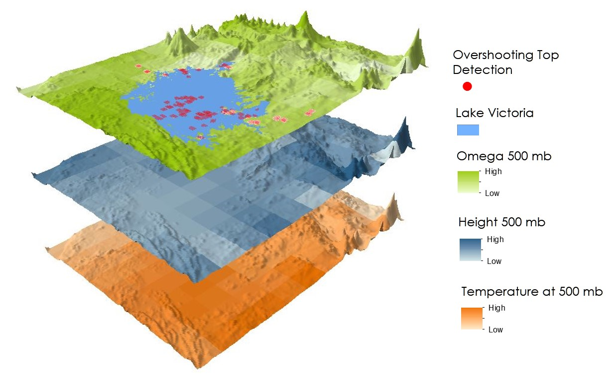

**Caption:** Overshooting top detections and weather variables collected from MERRA over Lake Victoria and the surrounding area during a storm event. Image Credit: African Great Lakes Weather II Team.

**Image:** 2016Spring_WC_AfricanGreatLakesWeatherII_FinalImage

**Software Release Requirements**

What category do the tools your project is creating fall within?

Category I