**NASA DEVELOP National Program**

****University of Georgia

**Summer 2015**

**Short Title:** Costa Rica Water Resources II

**Subtitle**: Utilizing NASA Earth Observations to Develop a Comprehensive Water Budget for the Arenal-Tempisque Watershed of Costa Rica

**VPS Title:** Every Drop Counts: Developing a Water Budget for Costa Rica

**Project Team & Partners**

**Project Team:**

Veronica Fay (Project Lead), vfay333@gmail.com

Steve Padgett-Vasquez

Caren Remillard

Eduardo Rendon

Kamala Kanta Sahoo

Xuan Zhang

**Advisors & Mentors:**

Javier Artiñano Guzmán (SENARA – Costa Rica’s National Service of Underground Water, Irrigation, and Drainage)

Dr. Marguerite Madden (University of Georgia)

Dr. Quint Newcomer (University of Georgia Costa Rica)

Dr. Adam Milewski (University of Georgia)

Dr. Kenton Ross (NASA DEVELOP National Program)

**Past or Other Contributors:**

Rachel Will

Benjamin Page

Grant Bloomer

Sarah Medley

**Partner Organizations**

Costa Rica’s National Service of Underground Water, Irrigation, and Drainage (SENARA), End-

User and Boundary Organization, POC: Javier Artiñano Guzmán

University of Georgia Costa Rica, Collaborator and Boundary Organization, POC: Dr. Quint

Newcomer

Costa Rican Embassy to the United States, End-User, POC: HE Ambassador Roman Macaya and Alejandra Solano

**Project Details**

**Applied Sciences National Applications Addressed:**

Water Resources

**Study Area:** The Arenal-Tempisque Watershed, Guanacaste, Costa Rica

**Study Period:** January 1979- December 2013

**Earth Observations & Parameters**

Landsat 8, TM – Land cover

Terra, ASTER – Digital Elevation Model (DEM)

Terra, MODIS - MOD16 Global Evapotranspiration (ET)

**Ancillary Datasets Utilized**

* Climate Forecast System Reanalysis (CFSR) - weather parameter data sets

(relative humidity, solar radiation, precipitation, temperature, and wind speed)

* World Harmonized Soil Database (WHSD) - digital soil map
* Costa Rica’s National Service of Underground Water, Irrigation, and Drainage

(Servicio Nacional de Aguas Subterráneas Riego y Avenamiento, SENARA) - land cover data

* Global Runoff Data Centre (GRDC) - *in situ* stream discharge data

**Models Utilized**

* The Texas A&M University’s Soil and Water Assessment Tool (SWAT) Model
* The Texas A&M University’s Soil and Water Assessment Tool - Calibration and

Uncertainty Procedures (SWAT-CUP)

**Software Utilized**

ArcGIS - raster and vector data manipulation/analysis, image enhancement & map creation of Landsat 8 OLI and Terra ASTER, and ArcSWAT tool usage

SWAT-CUP - integrate calibration/uncertainty analysis program for SWAT model

**Project Overview**

**80-100 Word Objectives Overview**

The goal of this project was to create a comprehensive water budget using datasets derived from Terra ASTER Digital Elevation Models and Landsat 8 OLI imagery. The hydrological end-product will be used to help guide Costa Rica’s National Service of Underground Water, Irrigation, and Drainage (Servicio Nacional de Aguas Subterráneas Riego y Avenamiento, SENARA) decision-making process as they modify their water resource management plan for the Arenal-Tempisque Watershed. Incorporating NASA Earth observations into their policy decisions will help increase efficient water management and provide partners both temporal and spatial data source.

**Abstract**

For the past three years, the Arenal-Tempisque Watershed has experienced drought conditions complicating water management and agricultural production. To facilitate a responsive water management decision-making process, the Costa Rica Water Resources team collaborated with Servicio Nacional de Aguas Subterráneas Riego y Avenamiento (SENARA), UGA Costa Rica, and the Costa Rican Embassy. The team created a model in the Soil and Water Assessment Tool (SWAT) modeling software for the Arenal-Tempisque Watershed using NASA Earth observations, ancillary data sources, and *in situ* data. The model’s results were calibrated and validated through the use of the Soil and Water Assessment Tool- Calibration and Uncertainty Procedures software (SWAT-CUP). The evapotranspiration data (MOD16) from Terra’s Moderate Resolution Imaging Spectroradiometer (MODIS) sensor were used to offer another source of continuous data to supplement the SWAT model’s outputs. Additionally, the project partners were provided with a tutorial that will enable the SWAT model’s hydrological outputs to be calibrated and validated for different future scenarios. The results obtained from the SWAT model and the MOD16 data provided greater insight into the region’s hydrologic processes, which allowed for the development of a water resource inventory for the study area. Upon receiving the hydrological data and tools, SENARA will be able to replicate the project’s methods to continuously update their water budget; this will allow them to make a more efficient water management plan, benefitting the local inhabitants and stakeholders.

**Community Concerns**

* The Arenal-Tempisque Watershed in Costa Rica has experienced more than three consecutive years of drought which not only negatively affected local people’s daily life but also limited local agricultural production.
* The demand of available water resources for all uses will increase from 5% to 35% (until 2020). Rapid urbanization and overexploitation of water resources have made the use of surficial water and groundwater more complex.
* The Arenal-Tempisque Watershed’s water management policies impact the livelihoods and the socioeconomics of 1,125 families that live and grow their agricultural products in this area. These families produce products such as sugarcane, rice, and fodder; they gross roughly $163.7 million for this region.
* Areas in the Arenal-Tempisque Watershed experience an extensive dry season (5 months). In order to sustain the region’s agriculture, it depends heavily on its water management plan to help maintain its irrigation practices and infrastructure.
* An effective water management policy is also important for this region because roughly a quarter of Costa Rica’s annual electric power is produced in the Arenal-Tempisque Watershed.

**Current Management Practices & Policies**

SENARA is responsible for water management and helps coordinate water usage with the agricultural and environmental agencies of Costa Rica. In an effort to increase efficiency in water usage, SENARA has begun to incorporate GIS into their data management and decision support tools. Even though remote sensing is not currently being used, SENARA is interested in incorporating NASA Earth observations into their decision support tools. SENARA currently calculates certain parameters, such as ET, using *in situ* data. NASA Earth observations will not only give them better datasets (DEM, Evapotranspiration etc.) of the whole country, but will allow the utilization of more continuous spatio-temporal data. Their field measurements will help validate and calibrate derived models.

**Decision Support Tools & Benefits**

|  |  |  |
| --- | --- | --- |
| **End-Product** | **Earth Observations Used** | **Benefit & Impact** |
| Watershed & Sub-Basin Delineation Map | Terra, ASTER - DEM | The SWAT model creates a map to visualize the location of the watershed, its sub-basins, and its outlets. Knowing the location of these boundaries and outlets allows end-uses to create more informed water management plans for the entire district. |
| End-Product 2 SWAT Model hydrological simulation data | Terra, ASTER - DEM | The SWAT model produces simulation tables, datasets, and ancillary images that will enable the end-user to obtain a better understanding of the area’s hydrological processes, resulting in more efficient water management. |

**Project Imagery**

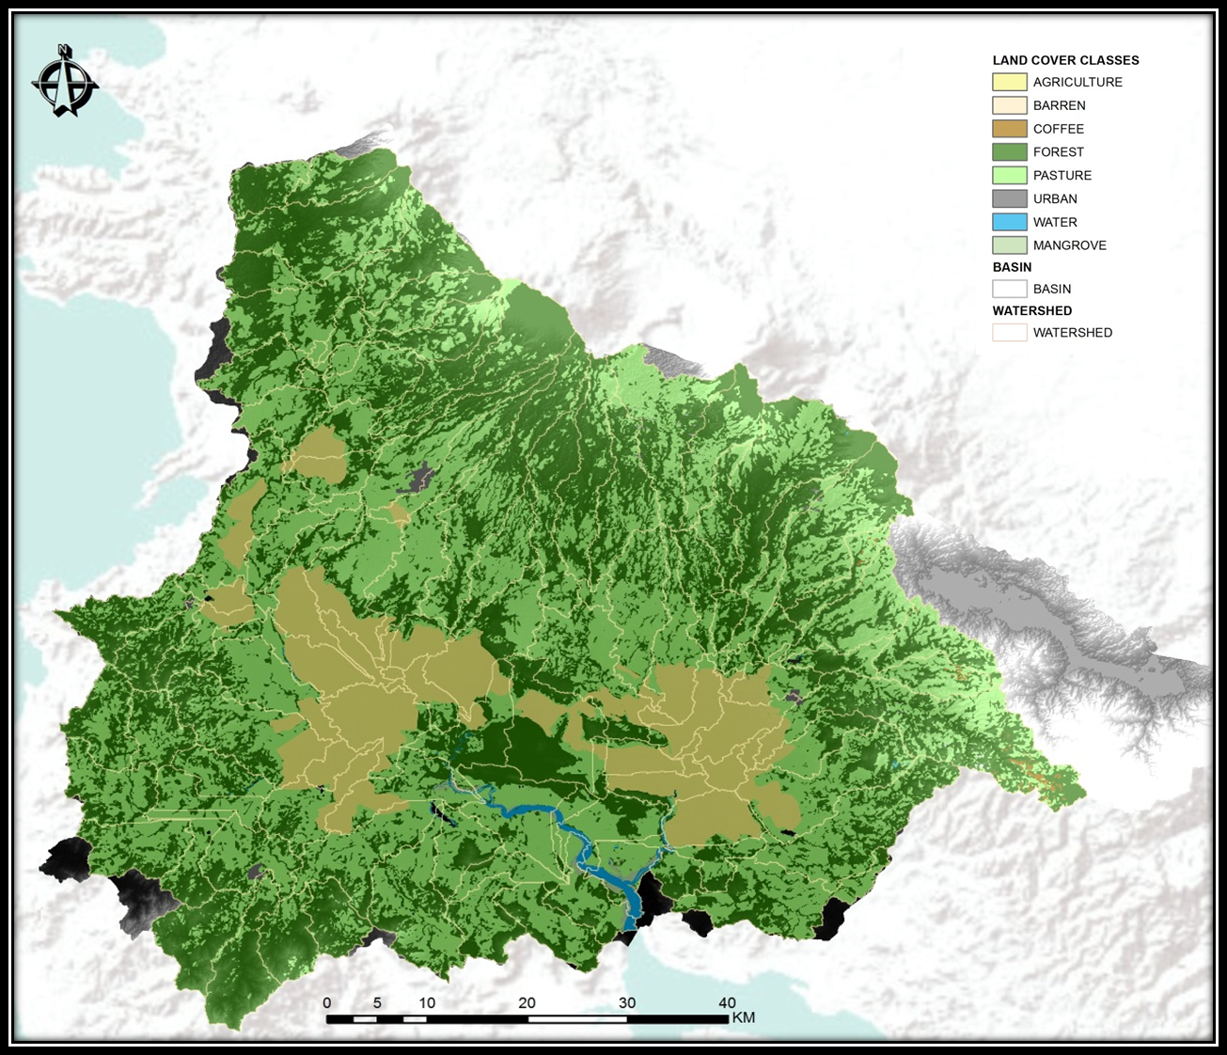

**Caption:** [Delineated watershed and sub-basins and defined land cover of Arenal-Tempisque Watershed derived from processing in SWAT model] Image Credit: Costa Rica Water Resources II Team.

**Image:** 2015Sum_UGA_CostaRicaWaterII_ProjectSummaryImage