South Carolina Water Resources

Implementing the Unvegetated-Vegetated Ratio to Assess Salt Marsh Vulnerability in South Carolina Using Airborne and Space-Based Remote Sensing Imagery

 **Technical Report**

Final Draft – August 6th, 2020

Adriana Le Compte

Derek Nguyen

Elspeth Gates

Jacob Stid

***Advisor***

Dr. Kenton Ross, NASA Langley Research Center (Science Advisor)

# 1. Abstract

Among the most productive ecosystems on earth, salt marshes provide crucial ecosystem services including water filtration, shoreline protection, storm surge buffering, and flood mitigation. Marshes are largely dependent on their sediment budget which can significantly vary across a region. Upstream land use change near Charleston, South Carolina, along with rising sea levels, are expected to alter sediment budgets and threaten marsh stability and long-term health. The unvegetated-vegetated ratio (UVVR) is a scalable and efficient method to assess vulnerability. This NASA DEVELOP project collaborated with the South Carolina Department of Natural Resources, the South Carolina Department of Health and Environmental Control, and the United States Geological Survey Woods Hole Coastal and Marine Science Center. Marsh vulnerability was analyzed using UVVR derived from Landsat 8 Operational Land Imager (OLI) and Landsat 7 Enhanced Thematic Mapper Plus (ETM+) in conjunction with National Agriculture Imagery Program (NAIP) high-resolution aerial imagery. A Landsat random forest regression showed low correlation (r2 = 0.247) between Landsat 7 ETM+ bands and NAIP aggregated UVVR suggesting the need for a more complex model and higher resolution sensors. Google Earth Engine scripting provided a novel approach to UVVR methodology that will allow decision makers to input new marsh areas and easily calculate UVVR without external data downloading.

**Key Terms**

Landsat, NAIP, UVVR, Google Earth Engine, ENVI, ArcGIS Pro, Random Forest, R

# 2. Introduction

* 1. ***Background Information***

Salt marshes serve as a habitat for diverse species, support recreational and commercial fisheries, and provide numerous ecosystem services such as carbon sequestration and water filtration (South Carolina Department of Natural Resources [SCDNR], 2014). These highly productive ecosystems contain rich soils that protect the coastline from erosion and inundation by absorbing water from large storm surges (SCDNR, 2014). As a geomorphic feature, salt marshes partially depend on external sediment imports (Ganju, 2019). Coastal land loss of a salt marsh is driven by an insufficient supply of sediment to replace sediment lost from wave energy and sea level rise. Along the coast, sea level rise could alter marsh sediment balance, and understanding this balance is critical for quantifying marsh vulnerability (Morton, 2020; Fagherazzi, 2013). Predictive models have shown that given a wide range of expected sea level rise within the next century (20 to 180cm), sediment accretion will allow marshes to maintain vegetated elevations, but only up to a certain point (Schile et al., 2014). Marshes with adjacent upland area are expected to gain new marsh habitat while marshes that lack upland area are expected to be mostly unvegetated in 100 years (Schile et al., 2014). Urban development and channel dredging in Charleston, South Carolina, paired with sea level rise, could result in an altered sediment budget for salt marsh ecosystems, threatening their stability and long-term health.

Salt marsh sediment budgets are a spatially integrated metric of marsh vulnerability to erosion (Ganju et al., 2017). A healthy salt marsh requires the import of sediment to counter waves and tidal currents, and sea level rise prescribes that a salt marsh must import more sediment for survival. Salt marshes with high vegetative cover and low open water areas tend to trap and retain sediment, while marshes with less plant cover lose sediment and eventually convert to open water (Ganju et al., 2017). The unvegetated-vegetated ratio (UVVR) was developed by researchers at USGS Woods Hole Coastal and Marine Science Center as a methodology to predict salt marsh vulnerability. In previous studies, UVVR consistently scaled with marsh sediment budgets, making it a useful indicator of marsh vulnerability in spatial analysis (Ganju et al., 2017).

This study focused on the coastal South Carolina county of Charleston and neighboring Berkeley County (*Figure 1*). Located in the Lowcountry of South Carolina, Charleston County faces natural and anthropogenic changes to its natural ecosystems (Natural Resources, 2020). The majority of Charleston County is near sea level and is frequently impacted by South Atlantic hurricanes and major flooding events. Rural land development in Charleston and Berkeley Counties places increasing pressure on the health of the estuarine system (Natural Resources, 2020). Berkeley County, which lies north of Charleston, abuts the Cooper and Wando Rivers. The Cooper River has experienced dredging to accommodate maritime vessels, as the Charleston Naval Base is located on the west bank. These combined natural and anthropogenic changes pose an increased risk to the salt marsh sediment dynamic.

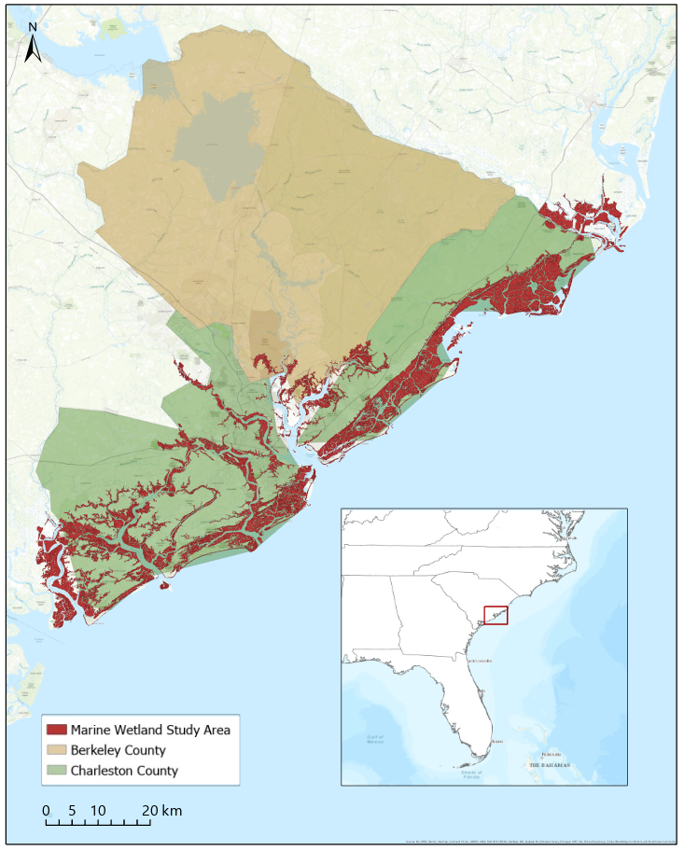

*Figure 1*. Marine Estuarine Areas in Charleston and Berkeley Counties, South Carolina

* 1. ***Project Partners & Objectives***

The South Carolina Department of Natural Resources (SCDNR) conducts research and monitoring programs to assess the condition of South Carolina’s coastal resources, including estuarine environments. They currently use remote sensing data, both spaceborne and airborne, for their monitoring practices. They also use GIS as an integral tool to understand the spatial component of this work. Before our analysis, the SCDNR mainly used Light Detection and Ranging (LiDAR), aerial imagery, and Landsat data, but were eager to increase their knowledge of other available NASA data. Researchers at the United States Geological Survey (USGS) Woods Hole Coastal and Marine Science Center have created and piloted the UVVR methodology. Dr. Neil Ganju, a principal researcher using UVVR, provided expert knowledge from his previous UVVR studies. UVVR has been implemented to assess salt marsh vulnerability across the Atlantic East Coast, including the Plum Island Estuary in northern Massachusetts, Cape Cod National Seashore, and Assateague Island in Maryland. The South Carolina Department of Health and Environmental Control (DHEC) collaborated with the team to provide insight on final products. The DHEC manages development and alterations of coastal and estuarine tidelands and have direct permitting authority over marshes and estuaries.

For our project we analyzed salt marsh vulnerability using UVVR derived from Landsat 8 Operational Land Imager (OLI), Landsat 7 Enhanced Thematic Mapper Plus (ETM+) and NAIP imagery to achieve three main objectives. First, we sought to reproduce USGS's UVVR methodology in Google Earth Engine to enhance project reproducibility, applicability to diverse study sites, and accessibility to partner organizations. Second, we designed vulnerability maps for the SCDNR to enhance their decision making, using the results from this analysis. Finally, we created an accessible tutorial describing the methodology to enable users to apply these methods to other areas throughout the region and successfully reproduce results. The SCDNR will share our results with the City of Charleston and the US Army Corps of Engineers, who are interested in seeing the effects of dredging and sea level rise on the marshes. The SCDNR will also share our analysis results with the DHEC so that they can reach the public and the wider scientific community.

# 3. Methodology

***3.1 Data Acquisition***

National Agriculture Imagery Program (NAIP) is ideal for highly detailed vegetated land use classification because of its fine spatial resolution (0.6-2m) and the presence of a near infra-red (NIR) band. However, its low temporal resolution (2-3 years) was insufficient for the regular change analysis required to observe natural or anthropogenic phenomena. Therefore, the relatively high spectral, spatial, and temporal resolution of Landsat 7 ETM+ and Landsat 8 OLI made these sensors ideal for observing change in UVVR. Google Earth Engine (GEE) was the primary data acquisition and processing tool due to its ability to easily and quickly access petabytes of data over many regions and time scales. GEE’s cloud servers contain mostly corrected and pre-processed imagery (level 3) that is easily indexable, which was the case for both the NAIP and Landsat imagery. Four-band NAIP imagery for the study area was accessed from Google’s cloud servers for 2009, 2015, and 2017 (Table 1) and additional imagery for 2019 was provided by the SCDNR. Landsat 7 ETM+ and Landsat 8 OLI imagery for the study area was accessed from Google’s cloud servers from June 1st to September 31st from 2009 to 2019 (Table 1). Additionally, a digital elevation model (DEM) was required for both the marsh unit delineation and as a classification parameter. A one-meter resolution 2017 LiDAR DEM from the 3D elevation program (3DEP) at USGS was acquired via the National Map Download service. The study area boundary was determined using the National Wetland Inventory (NWI) wetland data layer shape files and was downloaded from the NWI wetlands data mapper. These data were supplied by the U.S. Fish & Wildlife Service. Wetland shapefiles were downloaded for five Hydrologic Unit Code 8 (HUC-8) watersheds lining the coasts of Charleston and Berkeley counties.

*Table 1:* Airborne and space-based remote sensing imagery used in salt marsh vulnerability analysis

|  |  |  |  |
| --- | --- | --- | --- |
| **Platform & Sensor** | **Image Dates** | **Spatial Resolution** | **Temporal Resolution** |
| Landsat 7 ETM+, Level 3 | June 1st to September 31st, 2009 - 2019 | 30m | 16 days |
| Landsat 8 OLI, Level 3 | June 1st to September 31st, 2009 - 2019 | 30m | 16 days |
| NAIP Aerial Imagery, Level 3 | 2009, 2015, 2017 | 1m | N/A |

*Table 2:* Ancillary datasets used in salt marsh vulnerability analysis

|  |  |  |
| --- | --- | --- |
| **Data Type** | **Source** | **Spatial Resolution** |
| LiDAR from 3D elevation program (3DEP) | USGS TMN Download Service | 1m |
| Wetland data layer shapefile | National Wetland Inventory | N/A |

***3.2 Data Processing***

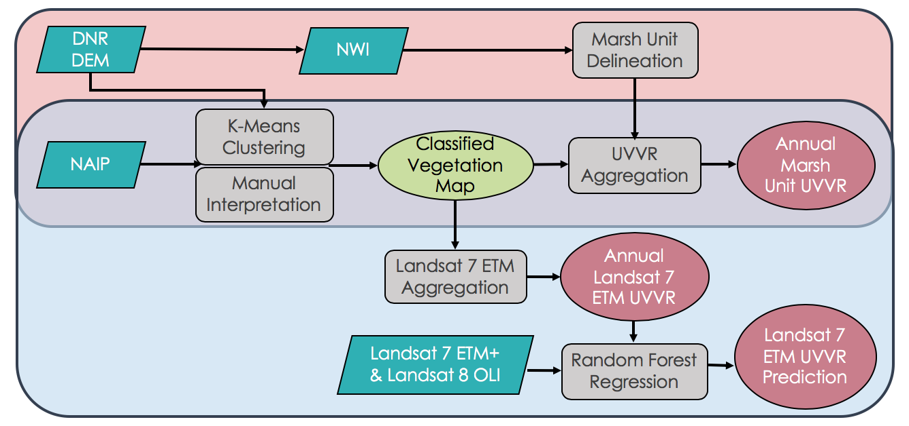*Figure 2*. Flowchart of the UVVR processing workflow. Input imagery including Landsat 7 ETM+, Landsat 8 OLI, NAIP, and DEM (SCDNR) is denoted by the parallelograms, input shape files are denoted by the green oval, processes are denoted by the rectangles, and products are denoted by the red ovals. Processes within the light blue rectangle are implemented entirely in GEE.

For both NAIP and Landsat imagery, the normalized difference vegetation index (NDVI) and the green normalized difference water index (GNDWI) were calculated. Additionally, the normalized difference built-up index (NDBI) was calculated for Landsat, which is a function of Short-wave infrared (SWIR) and Near infrared (NIR). These equations are shown below:

$NDVI= \frac{NIR-Red}{NIR+Red}$ (1)

$GNDWI= \frac{NIR-Green}{NIR+Green}$ (2)

$NDBI= \frac{SWIR1-NIR}{SWIR1+NIR}$ (3)

Landsat 7 ETM+ and Landsat 8 OLI imagery have a revisit time of 16 days. Therefore, due to the acquisition of 4 months of imagery, a temporal reducer was applied to the image collection by choosing the image pixel values that corresponded temporally with the maximum NDVI among the images. Once NAIP and Landsat imagery were temporally mosaiced, both the image collection and the DEM were clipped by the ‘Estuarine and Marine Wetland’ wetland type of the NWI wetland shapefile (*Figure 2*). This was repeated for each year of the analysis, keeping the NWI wetland layer constant, and updating the NAIP, Landsat, and DEM where imagery was available.

To determine a conceptual ‘unit’ for aggregation where sediment budget correlates with UVVR, the LiDAR derived DEM was delineated by geoprocessing surface elevation data using ArcGIS Pro software. This method was fine-scale watershed delineation was replicated from a USGS publication, Defne et al. 2018. NWI watershed and wetland shapefiles were used to mask the study areas to individual HUC-8 watersheds. Emergent, scrub-shrub, rooted vascular aquatic bed, and organic unconsolidated shore classes within the marine estuarine wetland feature type were selected as NWI attributes to be exported. A ± five-meter buffer was created using the NWI shapefile to account for the influence of surrounding terrain along border marsh polygons. Voids in the NWI map were then excluded to create the mask polygon layers. The DEM raster was masked to the ± five-meter buffered layer and disaggregated to a cell size of 1 meter. Resolution was increased from 3 meters to 1 meter to visualize horizontal polygon boundaries at a finer scale. The elevation raster was filled to calculate flow direction and begin the basin analysis. Orphan marsh units smaller than 5000 m2 were merged to the nearest parent unit using a python script and Hydrounitloop Tool created by Defne et al., 2018. Final marsh units were processed after removing artifacts, repairing geometry, and clipping to the boundaries of the salt marsh. Conceptual marsh units were created using this methodology for both 2009 and 2019. These marsh units were then ingested into Google Earth Engine to begin the process of determining the vegetated and unvegetated areas.

***3.3 Data Analysis***

Once the spatiotemporal parameters of the imagery were set, a K-means clustering algorithm was performed on the NAIP imagery with the DEM elevation band by taking 10,000 random pixel samples and assigning 32 unique multispectral ‘classes’ delineating different arbitrary land cover classes (Ganju et al., 2017). Image channels considered in the clustering were the R, G, B, N, NDVI, NDWI (NAIP), and Elevation (DEM) channels. A random point was generated for each class and researchers manually interpreted the 1-meter NAIP imagery to assign each class as either ‘vegetated’ (1) or ‘unvegetated’ (0). The clustered image of 32 classes was reclassified using the binary manually assigned values, producing a raster of vegetated and unvegetated pixels.

This raster was aggregated using two different methods. The first was the Marsh Unit Aggregation described by Ganju et al. 2017. Area images were generated for binary classification resulting in two images: an image containing only vegetated pixels with a value equal to their pixel area, and an image containing only unvegetated pixels with a value equal to their pixel area. A function was written and applied for each marsh unit to calculate the raster sum for each area image and to calculate UVVR, as shown in Equation 4. According to Ganju et al. 2017, marsh unit UVVR can be correlated to sediment budget using Equation 5, which can then be extrapolated to calculate the life span of the marsh under current sea level rise conditions, and accounting for the rate of increase in sea level rise.

$UVVR= \frac{Unvegetated Area}{Vegetated Area}$ (4)

$Sediment Budget \left(kg*m^{-2}*y^{-1}\right)= -0.42*\ln\left(UVVR\right)-1.07$ (5)

The second method of aggregation was the reprojection and mean aggregation of the binary vegetation classified NAIP raster to Landsat 7 ETM+ and Landsat 8 OLI resolution. Because vegetation was classified with a value of ‘1’ and unvegetated was classified with a value of ‘0’, the mean aggregation yielded high values for highly vegetated areas, and low values for unvegetated areas. Essentially, this means the resulting aggregation was an inversion of the UVVR (1-UVVR). This raster was added to the original Landsat image as a band and exported as a GEE asset. A random forest regression within GEE was performed using Landsat channel reflectance and indices as input variables and the Landsat UVVR aggregation as the response variable. To reduce covariance, a covariance matrix was generated and thus bands were removed leaving the B, NIR, SWIR1, NDVI, NDWI, and NDBI channels to use as predictors in the random forest regression. This process was performed for both Landsat 7 ETM+ and Landsat 8 OLI.

# 4. Results & Discussion

***4.1 Analysis of Results***

To validate our methodology, we tested the GEE methodology over the Plum Island Estuary in Massachusetts. The USGS has calculated UVVR for this study area before using their conventional methods that do not include GEE. From our analysis of Plum Island Estuary, we achieved an R2 of 0.935 (*Figure 3*). This indicates that these two methods are in good agreement and lends confidence to our methods for South Carolina.

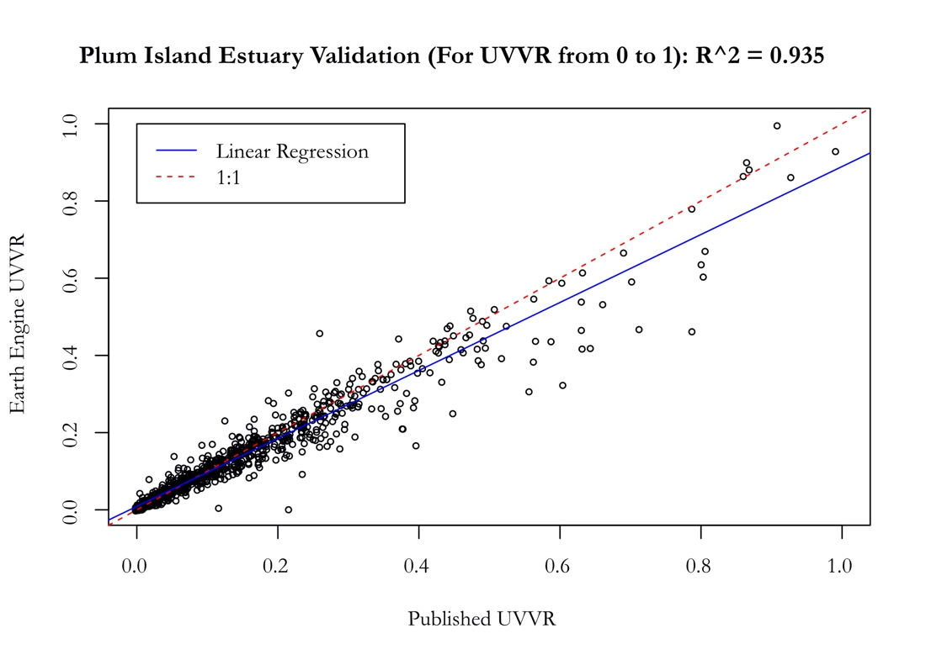

*Figure 3:* Plum Island Estuary Validation Scatterplot to ensure that methodology is robust and reproducible across different areas of interest.

The GEE tool was deployed over the Cooper Watershed Estuarine and Marine Wetlands using the derived 2017 marsh units. Figure 4 shows the resulting UVVR values for 2019. This figure shows the spatial variation of UVVR in 2019. These UVVR values were used in the change map analysis show in Figure 5 and Figure 6.

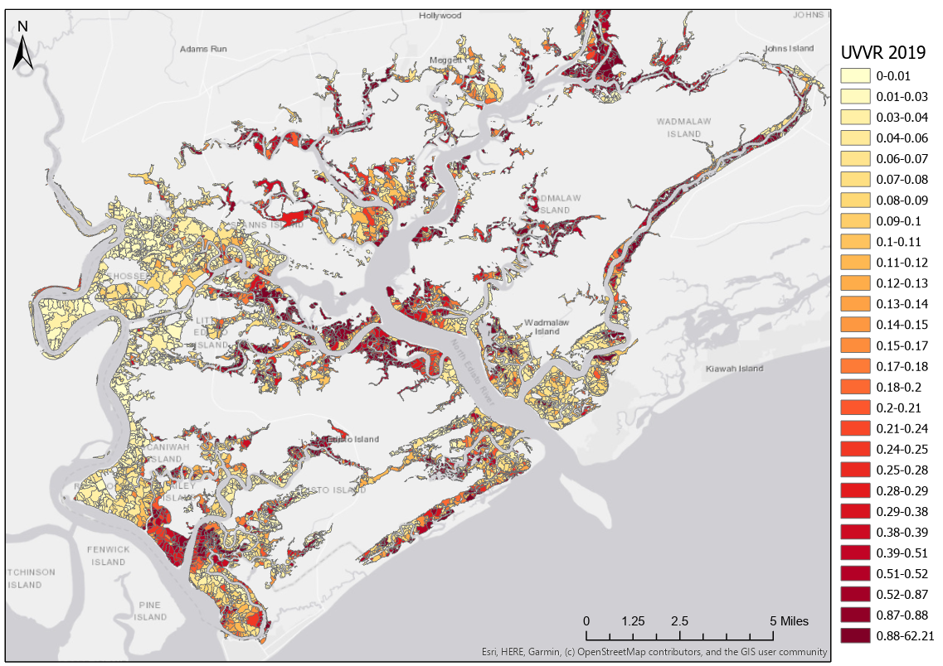*Figure 4:* 2019 Marsh Unit UVVR

To visualize marsh health, we created a marsh unit lifespan change map that accounts for sea level rise (Figure 5). Sediment budget-based lifespan is an indicator for when the salt marsh reaches a threshold where it is no longer able to keep up with sea level rise. To do this, we followed the lifespan methods described in Ganju et al., 2020. We denoted highly vulnerable marsh units in red, vulnerable in yellow and stable in green. Highly vulnerable marsh units had a negative lifespan, while stable marsh units had an increasing or indefinite lifespan.

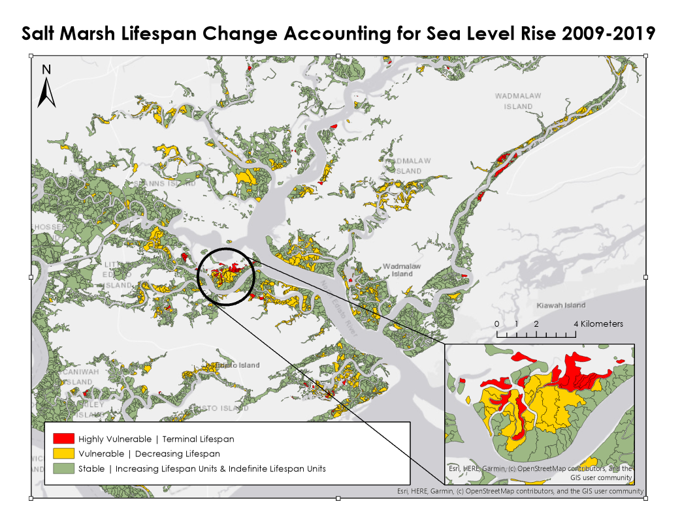

*Figure 5*: Salt marsh lifespan change accounting for sea level rise from 2009 to 2019.

Our decadal change map results (2009 - 2019) showed that 12.5% (roughly 16.2 km2) of the marsh has experienced a decrease in lifespan. The average decrease for each of these marsh unit was 59.8 years. An additional 1.2% of the marsh (roughly 1.1 km2) has lost enough sparse vegetation that the we disregarded their lifespan calculations since they were above the threshold UVVR value, and would therefore be negligible. It can be assumed that these marsh units have also drastically decreased their life spans over the last decade and are near the end of their life.

A comparison between common marsh units of decreasing lifespan in the decadal change map and the 2015 – 2019 change map (363 of 6396 shared units with decreasing lifespan) showed that the rate of the decrease in lifespan varied across time periods. Of the 62.73-year decrease in life span over 10 years, 52.98 years (84.46%) occurred over four years between 2015 and 2019, while only 9.75 years (15.54%) of decrease in lifespan occurred between 2009 and 2015. Figure 4 shows this drastic shift in the rate of lifespan change from 1.63 for 2009 to 2015, to a rate of change of 13.25 for 2015 – 2019. This shift occurs after the several severe storm events that occurred after 2015 enforcing the negative effect of severe storms on salt marsh complexes.

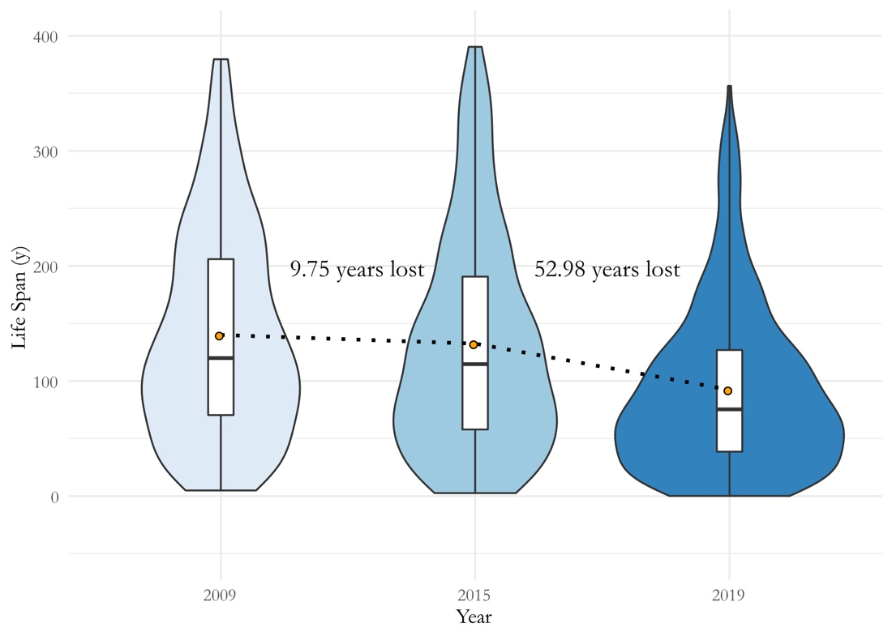

*Figure 6:* South Carolina Salt Marsh Lifespan Distributions from 2009, 2015, and 2019.

Figure 7 portrays a NAIP classified vegetation image that has been aggregated to Landsat 7 ETM+ resolution and projection. These rasters were used as the response variable in the Random Forest Regression along with the blue band, near infrared band, short wave infrared band 1, and three indices (NDVI, NDBI, and NDWI) to predict UVVR. The random forest regression prediction resulted in an R2 of 0.247 with a probability of correctness 0.2% to 65%. That low r-squared value identifies the need for further research into more complex methods of classification and regression, as well as potential improvements in futures spaced based sensors. Areas highlighted in yellow denotes high UVVR values and thus, low vegetation while areas in purple denotes low UVVR values and thus more relative vegetation.

*Figure 7:* UVVR Landsat Aggregation 2019

***4.2 Limitations***

The resulting low R2 values from the Landsat aggregation in our attempt to predict UVVR at Landsat resolution have potential to be improved. Previous studies show that reflectance and NDVI from different sensors are not equivalent (Huang et al., 2013). Due to this, we expect some level of uncertainty when predicting UVVR values at Landsat resolution.

Each team member wanted to complete manual interpretation for the GEE tool, however due to time constraints, only one researcher was able to complete the manual interpretation. Because of this, the designated researcher completed all manual interpretation to maintain consistency between maps. However, this may have resulted in uncertainties within the classification because the unvegetated and vegetated areas were determined by only one person.

***4.3 Future Work***

Due to our limited time frame, there are multiple aspects of our project that can be improved on through future research. We originally planned to investigate the use of Sentinel-1 C-SAR and Sentinel-2 MSI data in our results, given that Sentinel data have been used to map wetlands in Newfoundland, Canada (Mahdianpari, et al., 2019). Sentinel-2 MSI could be used for classification of land cover while surface reflectance from Sentinel-1 MSI could be used to calculate UVVR and the UVVR values can then be compared to Landsat imagery.

Furthermore, we wanted to use Landsat-based Detection of Trends in Disturbance and Recovery (LandTrendr) which is an automated mapping tool that can assess salt marsh changes. This provides an additional option to develop change maps (Kennedy et al. 2010). To do so, a machine learning derived relationship can be implemented in LandTrendr, where change parameters are manually adjusted and set, where change maps can then be generated for the study area annually from 1984 to 2019. An additional machine learning direction our project could expand upon are the application of neural networks (NN). Neural networks would aid in the complex classification of Landsat reflectance to UVVR where the random forest regression fell short. Despite these limitations, this methodology can still be deployed across all continental US coastlines, and the enhanced temporal resolution provided by incorporating Landsat data would aid in national salt marsh preservation and restoration efforts.

# 5. Conclusions

Salt marshes provide crucial ecosystem services including commercial fisheries, carbon sequestration, storm surge buffering and flood mitigation. Both natural and anthropogenic phenomenon such as storm events, sea level rise, dredging and urban development, threaten salt marsh sediment budgets, and thus the stability and long-term health of the marsh complexes within South Carolina. Over the last decade, the increasing occurrences of these phenomenon have drastically effected sediment dynamics within the marshes. This posed a need to focus preservation efforts in marsh regions affected most by these events in order to ensure their survival. This project sought to identify, assess, and predict high areas of vulnerability within the salt marshes of South Carolina to help our partners better allocate resources within the marshes.

Partners will also be able to implement the newly streamlined Google Earth Engine methodology into further areas of study along the coast of South Carolina. With the expansion of this methodology along the entire coast of South Carolina, our partners will be able to calculate UVVR and lifespan within the marsh to determine units that are at highest risk of extinction. Lifespan calculations, which take into consideration sea level rise, sediment loss, and lateral erosion to the marsh, will provide partners the ability to correlate natural and anthropogenic changes to negative impacts on the marsh units. Lifespan calculations from 2009-2019 in comparison to the study years 2015-2019 will demonstrate the marsh impact of extreme weather events that occurred after the baseline year of 2015. Of particular interest are protected areas along the coastline as well as popular beaches and residential areas.

These assessments of marsh vulnerability and marsh vulnerability change over time will provide local and state managers with tools to estimate the vulnerability of estuarine ecosystems throughout the state and evaluate the associated ecosystem service potential. Understanding the response and resilience of coastal wetlands to physical factors such as changing sediment loads and shifting shorelines can help managers assess ensuing changes in vulnerability and prioritize areas for conservation or restoration. This metric will provide a meaningful measure of vulnerability that is less costly and less labor-intensive than a complete sediment budget evaluation, which will help our partners complete more comprehensive and frequent estuary evaluations. With these results, our partners will be able to better allocate resources for restoration and protection efforts within these vulnerable marsh areas.

# 6. Acknowledgments

* Dr. Neil Ganju, USGS Woods Hole Coastal and Marine Science Center (Collaborator)
* Dr. Zafer Defne, USGS Woods Hole Coastal and Marine Science Center (Collaborator)
* Tanner Arrington, South Carolina Department of Natural Resources (End User)
* Katie Luciano, South Carolina Department of Natural Resources (End User)
* Evan Cook, South Carolina Department of Natural Resources (End User)
* Adam Bode, South Carolina Department of Health and Environmental Control
* Dr. Kenton Ross, NASA Langley Research Center Science Advisor
* Sydney Neugebauer, NASA Langley Research Center (Fellow)

Any opinions, findings, and conclusions or recommendations expressed in this material are those of the author(s) and do not necessarily reflect the views of the National Aeronautics and Space Administration.

This material is based upon work supported by NASA through contract NNL16AA05C.

# 7. Glossary

**UVVR –** Unvegetated-Vegetated Ratio, an indicator of marsh vulnerability due to its relationship with marsh sediment budget.

**DEM –** Digital Elevation Model, a 3D representation of terrain.

**NAIP Imagery** – Aerial imagery acquired by the National Agriculture Imagery Program during the agricultural growing season in the United States.

**GEE** – Google Earth Engine, a cloud-based computing platform.

**NDVI** – Normalized Difference Vegetation Index

**NDBI** – Normalized Difference Built-Up Index

**GNDWI** – Green Normalized Difference Water Index

# 8. References

Defne, Z., Ganju, N., (2018) Conceptual marsh units for Plum Island Estuary and Parker River salt marsh

complex, Massachusetts. United States Geological Survey. https://doi.org/10.5066/P9XF54QF

Fagherazzi, S. (2013). The ephemeral life of a salt marsh. *Geology*, *41*(8), 943–944.

https://doi.org/10.1130/focus082013.1

Ganju, N. K., Defne, Z., & Fagherazzi, S. (2020). Are elevation and open-water conversion of salt

marshes connected? *Geophysical Research Letters,* *47*(3). https://doi.org/10.1029/2019GL086703

Ganju, N. K. (2019). Marshes are the new beaches: integrating sediment transport into restoration

planning. *Estuaries and Coasts*, *42*(4), 917–926. https://doi.org/10.1007/s12237-019-00531-3

Ganju, N. K., Defne, Z., Kirwan, M. L., Fagherazzi, S., D’Alpaos, A., & Carniello, L. (2017). Spatially

integrative metrics reveal hidden vulnerability of microtidal salt marshes. *Nature Communications*, 8. <https://doi.org/10.1038/ncomms14156>

Huang, W., Huang, J., Wang, X., Wang, F., & Shi, J. (2013). Comparability of red/near-infrared

reflectance and NDVI based on the spectral response function between MODIS and 30 other

satellite sensors using rice canopy spectra. *Sensors*, *13*(12), 16023–16050.

https://doi.org/10.3390/s131216023

Kennedy, R. E., Yang, Z. & Cohen, W. B. (2010) Detecting trends in forest disturbance and recovery using yearly Landsat time series: 1. LandTrendr — Temporal segmentation algorithms. *Remote Sensing of Environment, 114*(12)*,* 2897–2910. <https://doi.org/10.1016/j.rse.2010.07.008>

Mahdianpari, M., Salehi, B., Mohammadimanesh, F., Homayouni, S., & Gill, E. (2019). The first wetland inventory map of Newfoundland at a spatial resolution of 10 m using Sentinel-1 and Sentinel-2 data on the Google Earth Engine cloud computing platform. *Remote Sensing*, *11*(1). https://doi.org/10.3390/rs11010043

Morton, R.A. (2020). Sediment Budget - Waves, Currents, and Storm Surges - An Overview of Coastal Land

Loss: With Emphasis on the Southeastern United States. USGS.gov.

https://pubs.usgs.gov/of/2003/of03-337/budget.html

Schile, L. M., Callaway, J. C., Morris, J. T., Stralberg, D., Thomas Parker, V., & Kelly, M. (2014). Modeling

tidal marsh distribution with sea-level rise: Evaluating the role of vegetation, sediment, and upland

habitat in marsh resiliency. *PLoS ONE*, *9*(2). https://doi.org/10.1371/journal.pone.0088760

South Carolina Department of Natural Resources. (2014). Dynamics of the Salt Marsh.

Retrieved June 15, 2020, from http://dnr.sc.gov/marine/pub/seascience/dynamic.html.