Hampton Roads Urban Development II

Assessing Urban Tree Canopy and Impervious Surface Distribution to Inform Urban Planning in Hampton, VA

 **Technical Report**

Final Draft – August 9th, 2019

Stephanie Kealy (Project Lead)

Sophie Barrowman

Paige Haley

Alina Schulz

Dr. Kenton Ross, NASA Langley Research Center (Science Advisor)

Previous Contributors:

Eric Deutsch

Holly Gould

Shaifali Prajapati

Danielle Ruffe

1. **Abstract**

Hampton Roads’ 1.6 million residents thrive on bustling military, harbor, and environmental industries. The region’s stakeholders identified an increasing flood and water quality risk due to urbanization, a changing climate, and sea-level rise. These hazards threaten not only the livelihood of Hampton Roads residents but also the well-being of the entire country as several key federal facilities exist in the region. Impervious surface cover and urban tree canopy cover are two known variables that influence flood risk. Using Landsat 5 Thematic Mapper and Landsat 8 Operational Land Imager, the team created maps of impervious surface and tree canopy cover change from 2000 to 2019 for the City of Hampton. These maps supported City of Hampton officials in directing resiliency efforts towards areas of greatest vulnerability within their municipality. Additionally, the team used the Impervious Surface Analysis Tool (ISAT) to illustrate how changes in impervious surface coverage impact local water quality and how different land management scenarios might alter these consequences. The team’s methodology will allow city officials to create updated impervious surface and tree canopy cover maps any time new imagery becomes available. Moreover, the team supported the city officials’ goals of using a place-based approach by demonstrating how the methodology can be applied to the smaller Newmarket Creek watershed in order to empower residents as active custodians of the environment.

**Keywords**

remote sensing, Landsat, impervious surface, tree canopy, coastal resiliency, urban development

# 2. Introduction

* 1. ***Background Information***

Environmental problems, particularly flooding and stormwater runoff, are often intensified by urbanization. Impervious surfaces, such as paved roads, parking lots and buildings, prevent infiltration, decrease groundwater recharge, and increase runoff volume, which all contribute to flooding (Weng, 2001). Coastal cities also face the threat of storm surge flooding caused by extreme weather. This threat is exacerbated by the presence of impervious surfaces. Therefore, urban areas in low-lying elevations with extensive impervious surfaces have a high risk of flooding.

Trees in urban environments provide a number of ecological services to urban areas, including water management. Healthy tree canopy helps to reduce runoff by intercepting rainfall in the leaves and branches, thereby reducing the quantity and energy at which precipitation reaches the impervious surfaces. Additionally, trees absorb groundwater into their trunks and leaves through their roots. This process leads to both the storing and evaporating of water through transpiration, which in turn helps to lower the water table and absorb surplus groundwater. Lastly, trees are able to filter pollutants and excess nutrients from the water, thus improving water quality in urban areas (Livesely, McPherson, & Calfapietra, 2016). For these reasons, healthy tree canopy is important for urban water management.

* 1. ***Scientific Basis***

Land cover maps may be generated using a variety of different techniques, each with their own merits (Stocker, 1998). The older method of hand digitizing land cover based on aerial imagery can be tedious and time-consuming. While the results are extremely accurate and reliable, other methods can be used to ease the process and make a finished product much faster. Remote sensing is one of the methods for classifying land cover that is very effective and easily accessible. The benefit of using remote sensing is that satellite data can be acquired for any point on the globe across a large timespan (Weng, 2001). Mapping tree canopy and impervious surface cover can help urban planners visualize areas with water storage impairments. Applying remote sensing to these parameters allows for up-to-date maps to be created as soon as imagery becomes available.

Previous work has been done to map both tree canopy and impervious surface cover through remote sensing techniques. Some methods commonly used for mapping impervious surface are land cover classification through machine learning, regression, and sub-pixel classification (Weng, 2012). Regression is one of the tools that works well with medium to coarse spatial resolution data, like Landsat 5 Thematic Mapper (TM) and Landsat 8 Operational Land Imager (OLI). In one study using Landsat 5 TM data, a regression modelling approach to impervious surface classification in the Twin Cities of Minnesota yielded results that were well correlated with ground truth data (Yuan, Wu, & Bauer, 2008). Likewise, remote sensing methods used to map tree canopy in urban environments. Simple and multiple linear regression models were used to find tree canopy cover on the Iberian Peninsula (Carreiras, Pereira, & Pereira, 2006). Overall, the results proved that this remote sensing technique was well-suited for monitoring growth in areas with dense canopy (Carreiras et al., 2006). The success of these studies and many related works prove that regression and remote sensing can be a fast, reliable solution when classifying land cover on a large scale.

* 1. ***Study Area***

Hampton Roads is an example of a coastal urban area in need of urban water management due to its location at the mouth of the Chesapeake Bay. Sea level rise, extreme weather, flooding, and erosion threaten the livelihoods of the region’s 1.6 million residents. The City of Hampton is actively working to improve its resilience as a coastal city and has published a plan for this process called *Resilient Hampton* (Steinhilber, Boswell, Considine, & Mast, 2016). The plan tackles challenges from extreme weather to recurring flooding, in a way that improves the resident’s quality of life, environmental health and economic viability (Waggonner & Ball Architecture/Environment, 2018). Responsible water management protects the water quality of the bay and supports flood resiliency for the region.

In the previous term of this project, the Hampton Roads Urban Development team used Landsat imagery to create maps of coastal change from 2000 to 2019. The team’s results identified areas of coastal accretion and erosion. These maps enhanced the City of Hampton’s understanding of the area’s coastal resiliency in the face of extreme weather and storm surges. To understand how additional parameters influence the region’s hydrology, an extension of the project was designed to analyze urban tree canopy and impervious surfaces as these factors relate to runoff. The project is a feasibility study for the application of NASA Earth observation data to visualize and calculate percentages of these two land covers. While Hampton Roads refers to all the counties and cities at the mouth of the Chesapeake Bay, for the purposes of this project, the boundary of the City of Hampton was used to define the study area (*Figure 1*).

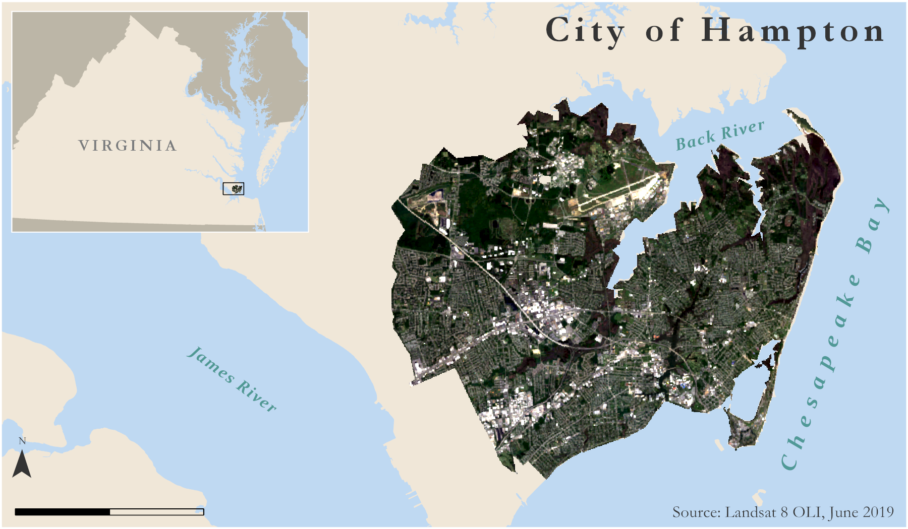

5

Miles

*Figure 1*. This study area map of the City of Hampton shows Landsat 8 imagery from June 2019 in true color.

* 1. ***Project Partners & Objectives***

The end user for this project was the City of Hampton. Due to its interests in engaging the community through the *Resilient Hampton* (Steinhilber et al., 2016) initiative and establishing an efficient, robust land cover assessment process, the city will benefit from the replicability of this project’s methodology and ease of access to NASA Earth observation data. Currently, GIS analysts for the city manually digitize their land cover, which is both labor and time intensive. The methodology developed in this study helped the partners because it provides a method to classify impervious surface and tree canopy in less time. Maps produced by the Hampton Roads Urban Development II team display the spatial distribution of impervious areas and tree canopy throughout the city. These maps will inform Hampton city planners and consultants of areas with particularly poor infiltration as they target pilot areas for installing green infrastructure. Another benefit to the partners included sharing the methodology and final products with Waggonner & Ball Architects, consultants to the city and another partner of the DEVELOP team. Finally, the city can share these tools with its collaborators in the Hampton Roads area and beyond.

# 3. Methodology

***3.1 Data Acquisition***

*3.1.1 Data Acquisition through Google Earth Engine API*

All of the NASA Earth observation data were acquired through Google Earth Engine Application Programming Interface (GEE API). For this project, the team used both Landsat 5 and Landsat 8 imagery (Table 1). The collection of Landsat images from GEE were ingested with some corrections already applied, including dark object subtraction and cloud masks. Using GEE’s pre-existing code, the team displayed the data with the cloud mask and then applied additional code to filter the image collection by date and location. Then, the reduce function was used to create a composite of the median pixel taken across all images in the filtered collection. Finally, all bands from both sensors were selected from the composite image and exported as a GeoTIFF file to be processed in ArcMap 10.6.

Table 1

*Information on the sensors used in this study*

|  |  |  |  |
| --- | --- | --- | --- |
| **Platforms/Sensors** | **Product Level** | **Dates** | **Metadata** |
| Landsat 5 TM Surface Reflectance Tier 1 | Collection 1, Level 1 | January to February 2000  July to August 2000  July to August 2006  August 2011 | GEE ImageCollection ID:  LANDSAT/LT05/C01/T1_SR |
| Landsat 8 OLI Surface Reflectance Tier 1 | Collection 1, Level 1 | June to August 2016  January 2019  April to June 2019 | GEE ImageCollection ID: LANDSAT/LC08/C01/T1_SR |

*3.1.2 Ancillary Data Acquisition*

In addition to Landsat 5 TM and Landsat 8 OLI imagery, the team acquired an additional land cover map to assist with the total percent land cover estimations (Table 2). The map, tailored to the City of Hampton, came from the city’s GIS manager, Allan Lambert. This map was imported into ESRI ArcGIS Pro to calculate percentages for land cover type in 30 by 30 meter squares. Finally, the team obtained several shapefiles and attribute tables from the city’s partners, Waggonner & Ball Architecture/Environment.

*3.1.3 Data Acquisition for the Impervious Surface Analysis Tool*

The Impervious Surface Analysis Tool (ISAT), which is available as a GIS script, is used to calculate the percentage of impervious surface area within user-selected geographic areas, such as watersheds, municipalities or subdivisions. The team acquired the necessary inputs outlined in the tool’s tutorial, provided by the National Oceanic and Atmospheric Administration (NOAA) and referenced at the end of this document (Eslinger, Pendleton, & Burkhalter, 2013). To customize the ISAT output for the City of Hampton, various resources were used for acquiring the necessary data (Table 2). Since most of these acquisitions came from national or regional databases, the next step in the data acquisition process was redefining the projected coordinate reference system to UTM Zone 18N and clipping to the City of Hampton political boundary supplied by the City of Hampton in ArcMap.

Table 2

*Data acquired as inputs for ISAT*

|  |  |  |
| --- | --- | --- |
| **Data Layer and Source** | **Year** | **Retrieved from** |
| Impervious Surface Percentages - National Land Cover Database | 2016 | [Multiresolution Land Cover Consortium](https://www.mrlc.gov/data?f%5B0%5D=category%3Aurban%20imperviousness) |
| Land Cover Grid - Conservation Innovation Center Chesapeake Bay High Resolution Land Cover Project | 2016 | [Chesapeake Conservancy](https://chesapeakeconservancy.org/conservation-innovation-center/high-resolution-data/) |
| Census Blocks - US Census Bureau | 2016 | [US Census Bureau - American Factfinder](https://factfinder.census.gov/faces/nav/jsf/pages/searchresults.xhtml?refresh=t) |
| Population Density - American Community Survey | 2016 | [US Census Bureau - American Factfinder](https://factfinder.census.gov/faces/nav/jsf/pages/searchresults.xhtml?refresh=t) |

***3.2 Data Processing***

*3.2.1 Tree Canopy and Impervious Surface Data Processing*

To complete the objectives of the project, the team needed to calculate the percent land cover. This goal was accomplished using regression, a form of data analysis that creates an equation in $\text{y} \text{=} \text{mx + b}$ format that can predict values for a dependent variable ($\text{y}$). Before regression analysis can be applied to the dataset, it is necessary to derive coefficients and intercepts for the equation. A sufficient number of data points must first be acquired to fit the line. This study used 100 random sample sites within the Hampton boundaries. Random points were generated in ArcMap 10.6, and 30 x 30 meter squares were created around these test sites. The classified, high resolution raster from the city was split into these random squares and pixel counts of the land cover were recorded in Excel. From there, the team calculated the percent tree canopy and impervious surface cover for each pixel. Then, the spectral information at each random point was extracted for each of the Landsat bands and appended to the percent land cover for each associated square in the spreadsheet. The final parameter the team added to the spreadsheet was a Normalized Difference Vegetation Index (NDVI) calculation to serve as a predictor variable.

*3.2.3 Calculating Impervious Surface Coefficients and running the ISAT script*

The impervious surface coefficients necessary to run the ISAT script must be derived for each new study area. To derive the coefficients, the team formatted a new Microsoft Excel spreadsheet in .csv format and used ArcMap version 10.6 with the ISAT scripts available in the ISAT toolbox. Using the 1-meter resolution land cover grid acquired from the Conservation Innovation Center referenced in Table 3, the team populated all of the land cover classes in the Excel spreadsheet that must be assigned a coefficient through this process. This is similar to giving each land cover class a unique weight, depending on its correlation to the National Land Cover Database’s (NLCD) percent imperviousness layer. It is important to note that while the land cover grid and the NLCD’s percent imperviousness layer differ in spatial resolution, this process is still possible as long as the resolution of the land cover grid is the same as or finer than the imperviousness layer. This process was conducted three times, based on user-determined low, medium, and high population density census blocks. The final spreadsheet (*Figure 2*) will always display logical values between 0 and 100 if performed correctly.

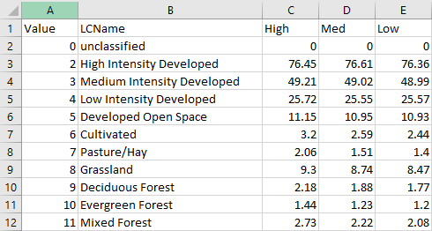

*Figure 2*. Screen capture of the impervious surface coefficient values spreadsheet; derived for use in the ISAT script used to analyze the impact of impervious surfaces on water quality.

***3.3 Data Analysis***

*3.3.1 Regression and Percent Change Maps*

Once the data were processed, the team was able to run regressions using the Analysis ToolPak in Excel. The dependent ($y$) variables used were the land cover percentages calculated using the high resolution land cover classification. The independent ($x$) variables were each of the bands from Landsat and the NDVI. Calculating regressions resulted in a table that shows the coefficients and intercepts for the equation (Table 3, cells A1 to A3). These values were then applied to the imagery in ArcMap using the raster calculator tool to find the percent land cover for each pixel. An example equation is given below.

*Percent tree canopy = (B11 * 0.008) + (B10 * -0.011) + (B7 * 0.0006) + (B6 * -0.00094) + (B5 * 0.00023) + (B4 * 0.00055) + (B3 * 0.00013) + (B2 * -0.00084) + (B1 * 0.00058) + (NDVI * 0.73) + 9.15*

Table 3

*Tree canopy regression coefficients*

|  |  |  |  |  |  |  |
| --- | --- | --- | --- | --- | --- | --- |
| ***Summary output*** | | | | | | |
| ***Regression Statistics*** | | | | | | |
| Multiple R | 0.68354 |  |  |  |  |  |
| R Square | 0.46723 |  |  |  |  |  |
| Adjusted R Square | 0.40381 |  |  |  |  |  |
| Standard Error | 0.23869 |  |  |  |  |  |
| Observations | 95 |  |  |  |  |  |
| ***ANOVA*** | | | | | | |
|  | ***df*** | ***SS*** | ***MS*** | ***F*** | ***Significance F*** |  |
| Regression | 10 | 4.19693 | 0.41969 | 7.36671 | 2.83521E-08 |  |
| Residual | 84 | 4.78561 | 0.05697 |  |  |  |
| Total | 94 | 8.98254 |  |  |  |  |
|  | ***Coefficients*** | ***Standard Error*** | ***t Stat*** | ***P-value*** | ***Lower 95%*** | ***Upper 95%*** |
| Intercept | 9.15014 | 4.27050 | 2.14264 | 0.03504 | 0.65778 | 17.64251 |
| B11 | 0.00793 | 0.00930 | 0.85257 | 0.39632 | -0.01056 | 0.02642 |
| B10 | -0.01095 | 0.00860 | -1.27272 | 0.20663 | -0.02805 | 0.00616 |
| B7 | 0.00057 | 0.00021 | 2.77259 | 0.00685 | 0.00016 | 0.00098 |
| B6 | -0.00094 | 0.00022 | -4.21910 | 0.00006 | -0.00139 | -0.00050 |
| B5 | 0.00023 | 0.00009 | 2.50123 | 0.01432 | 0.00005 | 0.00041 |
| B4 | 0.00055 | 0.00057 | 0.96330 | 0.33816 | -0.00059 | 0.00168 |
| B3 | 0.00013 | 0.00061 | 0.21846 | 0.82760 | -0.00109 | 0.00135 |
| B2 | -0.00084 | 0.00195 | -0.43031 | 0.66807 | -0.00471 | 0.00303 |
| B1 | 0.00058 | 0.00227 | 0.25535 | 0.79907 | -0.00393 | 0.00509 |
| NDVI | 0.73258 | 0.25617 | 2.85970 | 0.00535 | 0.22315 | 1.2420 |

These values were generated using Landsat 8 reflectance values from June 2019.

Because the reflectance values for some pixels were higher or lower than the reflectance values for the test points, the equation estimated some land cover percentages outside of the 0-100 percent range. To account for this, the team rescaled all values to be between 0 and 100 to help with continuity. Once the values were rescaled, further analysis could be conducted with the data. Because the map of percent land cover was continuous, some of the pixels with lower percentage values did not accurately represent the area of tree cover within the pixel. For example, grass often displayed a tree canopy percentage value of 10 percent. The team then had to decide on a threshold for what percent tree canopy or impervious surface cover accurately represented the ground truth. This was done by comparing the outputs to high resolution imagery. For tree canopy, pixels with values greater than 50 percent tree canopy were designated as true tree canopy pixels. For impervious surface, the threshold was pixel values of 30 percent or greater. Removing the pixels below the threshold reduced unnecessary data, like grass and marshes, as well as highlighted the real areas of imperviousness and tree cover.

The final step for data analysis was determining the tree canopy and impervious surface change in the entire city and the Newmarket Creek watershed. Values for change were calculated by finding the percentage of land cover in 2000 and subtracting it from the land cover values in 2019. To best visualize the change, the 2019 raster was subtracted from the 2000 raster for each respective land cover and displayed, using the raster calculator in ArcMap.

*3.3.2 Impervious Surface Analysis Tool Outputs*

After the completion of the impervious surface coefficients spreadsheet, the team ran a basic analysis using the ISAT script. The dialogue box prompts the user to specify a land cover raster, a statistical zone layer (census blocks layer), and the coefficient file (Excel spreadsheet) as the inputs. All of these were prepared in the data acquisition and data processing steps. After indicating which row of coefficients to use (high, medium, or low), the script ran and an output was generated using the original ISAT theme. The preliminary results prior to data analysis and symbology manipulation are displayed in *Figure 3*.

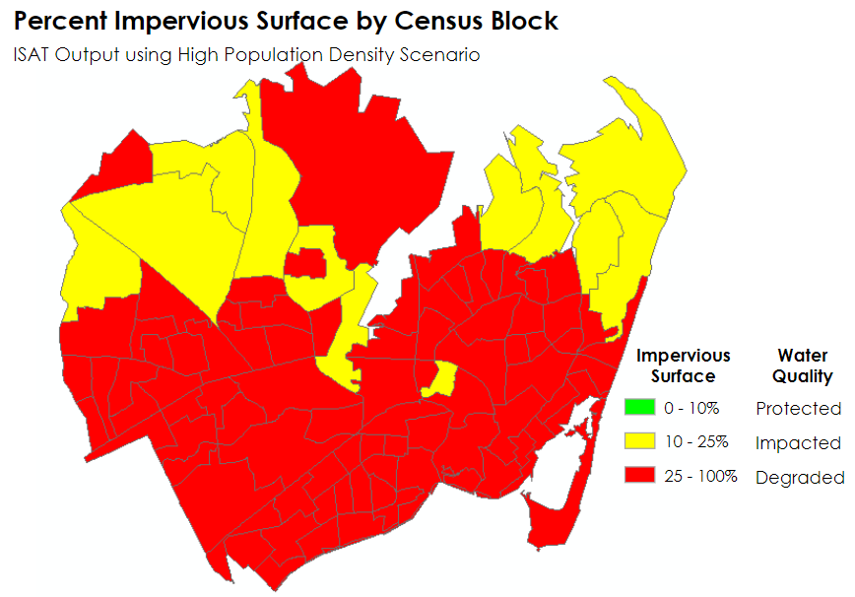

*Figure 3*. This map of the City of Hampton displays the output from the ISAT script in ArcMap. The prominence of red-colored census blocks indicates the significantly degraded water storage ability of the land in that unit area.

The default legend indicates the potential impact to water quality based on the inputs specified in the previous steps. According to ISAT documentation, green areas correspond to <10% impervious surface (Protected), yellow areas correspond to 10% to 25% impervious surface (Degraded), and red areas correspond to >25% impervious surface (Impacted) (Eslinger et al., 2013). Because the City of Hampton has no census blocks falling in the first category (Protected), the team used the output’s attribute table that calculated the percentage of impervious surface within each analysis field to redistribute the symbology color scheme and classes to those seen in *Figure 4*.

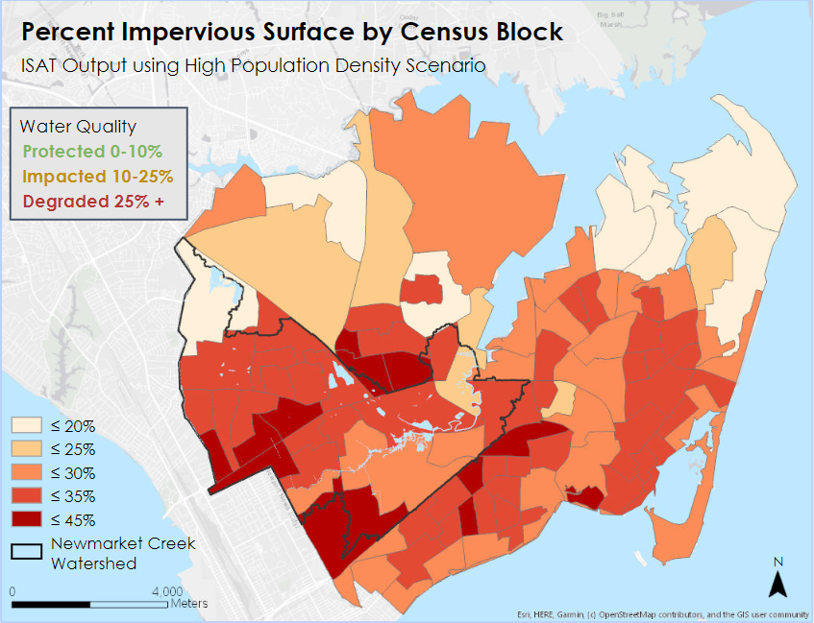

*Figure 4*. This map of the City of Hampton displays the same percent impervious surface by census blocks created in *Figure 3*, with a modified symbology that captures the diversity of the values in previously red-colored census blocks.

# 4. Results & Discussion

***4.1 Analysis of Results***

*4.1.1 Regression*

The outputs for regression were maps of continuous values for percent tree canopy and impervious surface for the entire City of Hampton (*Figures B1 to B7*). Maps of tree canopy cover were generated for the years 2000, 2006, 2011, 2016, and 2019. All of the maps showed high concentrations of tree canopy in the northern part of the city, with little tree cover in the residential and commercial areas. There was significant variability in the tree canopy maps across all years. The 2006 map shows a large decrease in tree canopy cover when compared to the 2000 map, but canopy increases steadily for all years after 2006. Impervious surface maps were created for the years 2000 and 2019. Both maps revealed that impervious surface sprawls across all parts of the city. Commercial areas are dense with impervious surface with almost no space for grass or tree cover. When the previously discussed thresholds were applied to the data, the map more clearly demonstrated the clumping of tree canopy and the sprawling of impervious surface (*Figure 5*).

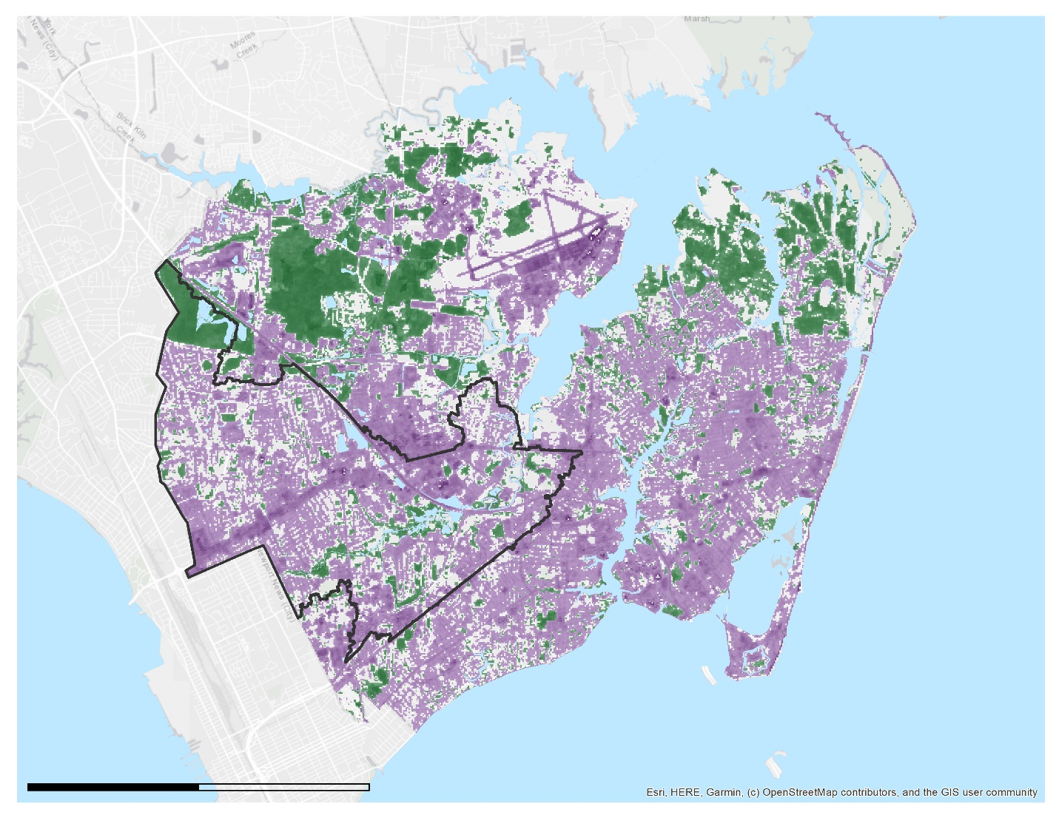

Newmarket Creek Watershed

100%

Impervious surface

Tree canopy

30%

100%

50%

0

4,000

Meters

*Figure 5.* The map above shows the percent impervious surface and tree canopy cover in the entire City of Hampton with the thresholds applied. All values greater than 30 percent impervious surface and 50 percent tree canopy are represented.

Next, the change maps were generated by subtracting the 2000 raster from the 2019 raster. In the initial run of this process, it appeared as though the change was occurring everywhere throughout Hampton. Even if a change of only 1 percent occurred, the map would display that change. To meet the project’s needs, the team went back to the thresholds to determine what percentage of change was significant. If a pixel were to go from 0% tree canopy to 50% tree canopy, then that pixel could be designated as a new tree canopy pixel. As a result, the change maps for tree canopy and impervious surface only display a percent change greater than the threshold. Change maps were created for the Newmarket Creek watershed in favor of a place-based approach to the data (*Figures 6 and 7*). The maps show that tree canopy loss occurs mostly in the new development areas, and areas of tree canopy growth mainly follow the boundaries of the Creek itself. Comparatively, the impervious surface has changed much more dramatically over the past 19 years. Like with tree canopy, increases in impervious surface form large clusters of change where developments have been brought in; however, the majority of the change is in the residential areas. Impervious surface increases and decreases in a salt and pepper pattern.

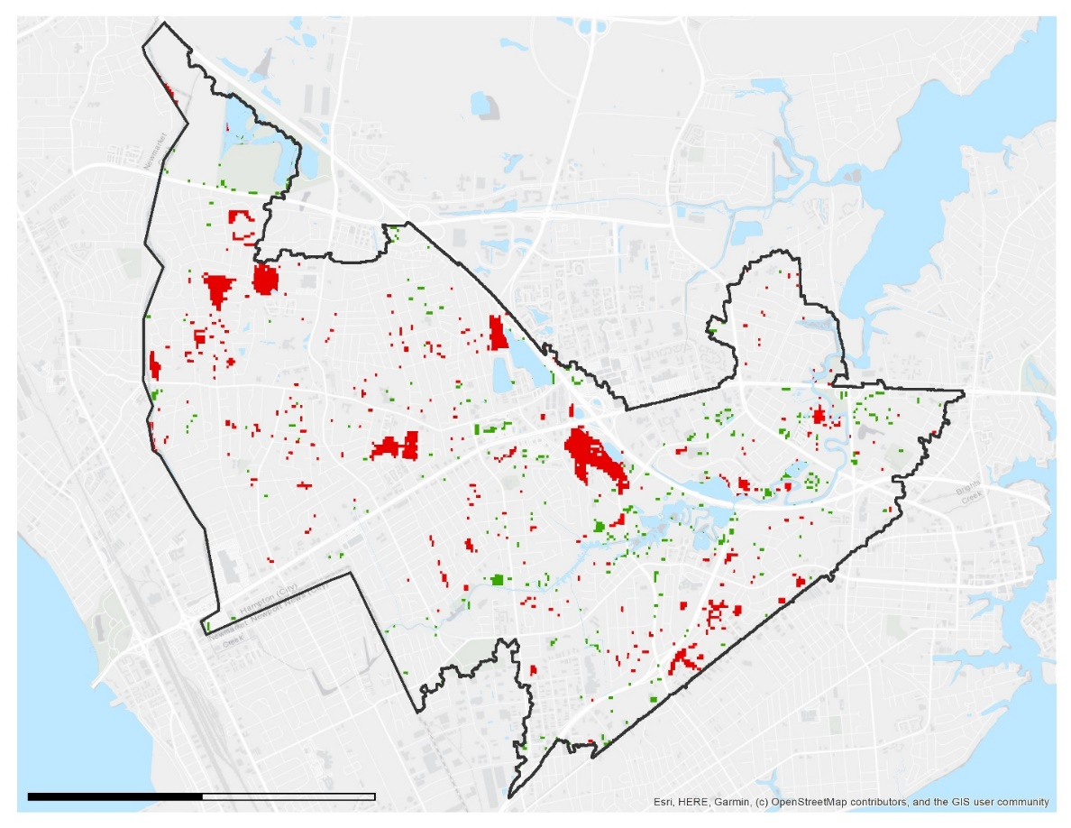

Newmarket Creek Watershed

0

4,000

Meters

Tree canopy decrease

Tree canopy increase

*Figure 6*. The map above shows any tree canopy change greater than 50% for the Newmarket Creek Watershed in Hampton.

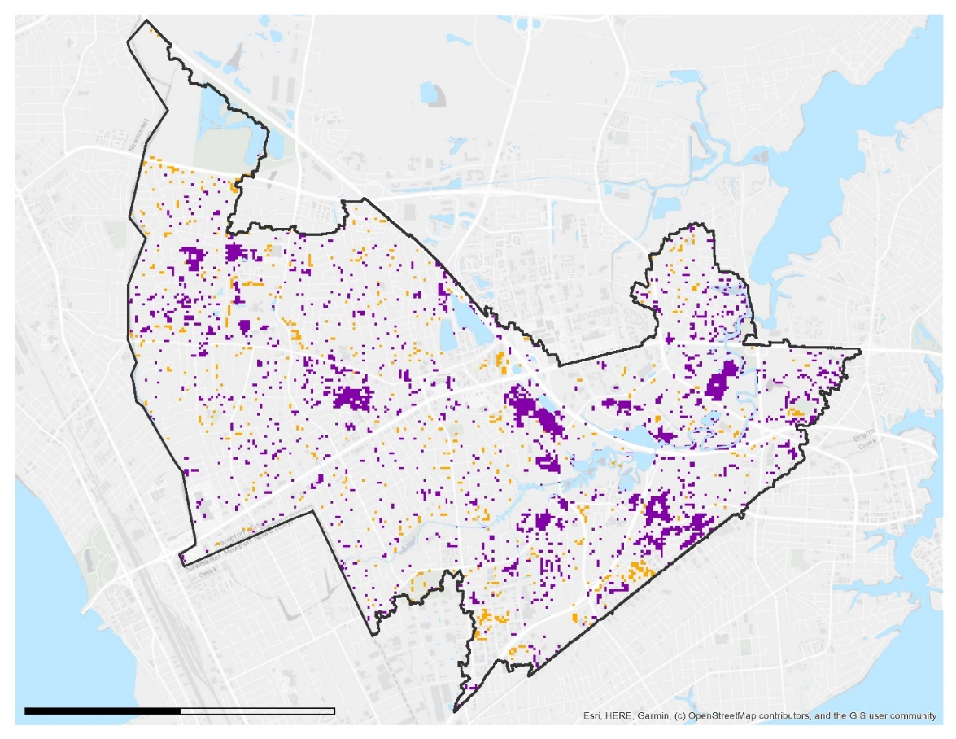

0

4,000

Meters

Newmarket Creek Watershed

Impervious surface increase

Impervious surface decrease

*Figure 7*. The map above shows any impervious surface change greater than 30% for the Newmarket Creek Watershed in Hampton.

Finally, percent change was calculated for both the City of Hampton and the Newmarket Creek watershed (Table 4). While the city saw an increase in both tree canopy and impervious surface cover, the Newmarket Creek watershed has a slight decrease in canopy and a large increase in imperviousness. Certain factors, such a tree maturation, may be contributing to these results. Newmarket Creek did not originally have any forests, therefore the increases in impervious surface are not proportional to a decrease in tree canopy.

Table 4

*Land cover percentages by study area*

|  |  |  |  |  |  |  |
| --- | --- | --- | --- | --- | --- | --- |
|  | **Impervious surface** | | | **Tree canopy** | | |
| *January 2000* | *January 2019* | *% Change* | *August 2000* | *June 2019* | *% Change* |
| City of Hampton | 53% | 61% | + 8% | 17% | 23% | + 6% |
| Newmarket Creek Watershed | 48% | 67% | + 19% | 16% | 15% | - 1% |

Inherently, there was considerable error involved in this process. The imagery used for these coefficients was collected over a short period of time, therefore the values do not represent average conditions but conditions for a short period of time. To better represent the area as a whole, the imagery could be filtered by a longer time period. The team forwent a more robust time scale for high resolution data. Also, the results of this study have not been validated by either ground truthing or comparison with high resolution land cover data. The current maps show both over and under estimation of impervious surface across the entire city, but work has not been done to quantify this error. Finally, the data had to be rescaled between 0% and 100%, which reduced the significance of each percentage value and the percentage calculations.

*4.1.2 ISAT*

The outputs generated by ISAT not only emphasized the degraded water storage capacity experienced by the city as a whole but also indicated how the most severe impact is spatially clustered in the Newmarket Creek watershed. While the tool does not account for the dynamic facets of urban hydrology, it does clearly indicate the relationship between people and land use as it pertains to impervious surface and its counterweight, tree canopy. In lieu of a complex water infiltration vs. runoff model, the team opted to provide the city planners with an easy-to-use and customizable way of applying NASA Earth observations. The ISAT scripts provided city officials with the opportunity to customize land management scenarios that reflect real policy choices. Their partnerships with other urban water management advisors and architects have equipped them with the spatial analysis tools necessary to prepare accurate and realistic inputs for ISAT. Finally, the correlation between an increase in impervious surfaces and a decrease in water quality has been well established. The City of Hampton can use the information derived from ISAT to predict how different management scenarios might impact local water quality and replicate the process to inform the land management practices of neighboring communities in the Hampton Roads area.

***4.2 Future Work***

Additional analyses for future endeavors in this area of study would benefit from calibrating other sensors, such as Sentinel-2 MultiSpectral Instrument (MSI), which is equipped with higher spatial resolution and is consequently more capable of distinguishing the fine features of an urban heterogeneous landscape. Calibrating more Earth-observing sensors to the observed local phenomena could widen the breadth of the applications for regional urban development planners. The Urban Flood Risk Mitigation Model, a part of the Natural Capital Project’s Integrated Valuation of Ecosystem Services and Tradeoffs (InVEST) software package, could also be incorporated into this analysis to further analyze the ecosystem services that are provided by tree canopies. Outputs from this model can assign a monetary value to land cover changes pertaining to natural infrastructure and inform city officials and residents which areas in the city are most financially vulnerable. This type of financial analysis could quantify the value of the civil engineering and adaptation strategies that are already being pursued by the City of Hampton. Alternatively, future terms might consider broadening the scale of this analysis from the Newmarket Creek watershed to the larger Hampton Roads area. Ultimately, there are multiple components related to structural, environmental, and social dimensions of coastal communities that can be considered in the future to generate a more comprehensive urban runoff and infiltration model.

# 5. Conclusions

# The Earth observations used in this feasibility study assessing urban tree canopy and impervious surface distribution gave the partners the opportunity to access data that will influence immediate urban planning decisions. Land cover change maps over the course of 19 years (2000 through 2019) revealed how urbanization has changed the City of Hampton’s landscape and emphasized the variability of natural infrastructure. The team’s place-based local level of analysis gives the City the data needed to communicate with its residents and other stakeholders.

# 6. Acknowledgments

The team would like to acknowledge our partners at the City of Hampton and Waggonner & Ball, our Science Advisor Dr. Kenton Ross, the Hampton Roads Urban Development I team members, and the Virginia – Langley Center Lead, Sydney Neugebauer.

Any opinions, findings, and conclusions or recommendations expressed in this material are those of the authors and do not necessarily reflect the views of the National Aeronautics and Space Administration.

This material is based upon work supported by NASA through contract NNL16AA05C.

# 7. Glossary

**Earth observations** – Satellites and sensors that collect information about the Earth’s physical, chemical, and biological systems over space and time  
**GEE** – Google Earth Engine  
**GeoTIFF** – Georeferenced raster file format  
**Impervious surface** – land surfaces that repel rainwater and do not permit it to infiltrate the ground

**MSI** – MultiSpectral Instrument  
**NASA** – National Aeronautics and Space Administration; a federal agency devoted to air and space exploration and research development  
**NDVI** – Normalized Difference Vegetation Index; a numerical indicator for the presence of healthy green vegetation  
**Remote sensing** – The scanning of the earth by satellite or high-flying aircraft in order to obtain information about it  
**Resiliency** – The capacity to recover quickly from difficulties  
**Scene** – An area on the ground that is covered by an image or photograph  
**TM** – Thematic Mapper  
**Transpiration** – The process where plants absorb water through their roots and then give off water vapor through pores in their leaves  
**Tree canopy** – The layer of leaves, branches, and stems of trees that cover the ground when viewed from above  
**Water table** – The level below which the ground is saturated with water  
**Watershed** – An area or ridge of land that separates waters flowing to different rivers, basins, or seas

# 8. References

Carreiras, J. M. B, Pereira, J. M. C., & Pereira, J. S. (2006). Estimation of tree canopy cover in evergreen oak woodlands using remote sensing. *Forest Ecology and Management, 223*(1-3), 45-53. doi:10.1016/j.foreco.2005.10.056

Chesapeake Conservancy Conservation Innovation Center (2016). *Chesapeake Bay High-Resolution land cover* [Data file]*.* Retrieved from <https://chesapeakeconservancy.org/conservation-innovation-center/high-resolution-data/>

Eslinger, D, Pendleton, M., & Burkhalter, S. (2013). Impervious Surface Analysis Tool (ArcGIS 10.x) [Software]. Retrieved from <https://coast.noaa.gov/digitalcoast/tools/isat.html>

Livesely, S. J., McPherson, E. G., & Calfapietra, C. (2016). The urban forest and ecosystem services: Impacts on urban water, heat, and pollution cycles at the tree, street, and city scale. *Journal of Environmental Quality, 45*(1),119-124. https://doi.org/10.2134/jeq2015.11.0567

National Land Cover Database. (2016). *Urban imperviousness* [Data file]. Retrieved from <https://www.mrlc.gov/data?f%5B0%5D=category%3Aurban%20imperviousness>

Steinhilber, E. E., Boswell, M., Considine, C. & Mast, L. (2016). Hampton Roads sea level rise preparedness and resilience intergovernmental pilot project Phase 2 report: Recommendations, accomplishments and lessons learned. *Hampton Roads Intergovernmental Pilot Project: Reports 2.* Retrieved from <https://digitalcommons.odu.edu/cgi/viewcontent.cgi?article=1003&context=hripp_reports>

Stocker, J. (1998). Methods for measuring and estimating impervious surface coverage. *Nonpoint Education for Municipal Officials, Technical Paper 3*, 1-3. <https://nemo.uconn.edu/tools/impervious_surfaces/pdfs/NEMO_tech_3.pdf>

U.S. Census Bureau (2016). *ACS population count estimates 2017* [Data file]. Retrieved from <https://factfinder.census.gov/faces/nav/jsf/pages/searchresults.xhtml?refresh=t>

U.S. Geological Survey (2001). 2001 *National Land Cover Data Set (NLCD)* [Data file]. Retrieved from <https://www.mrlc.gov/data/nlcd-2001-land-cover-conus>

U.S. Geological Survey Earth Resources Observation and Science Center. (2012). Landsat TM Level-2 Surface Reflectance (SR) Science Product. U.S. Geological Survey. https://doi.org/10.5066/f7kd1vz9

US Geological Survey Earth Resources Observation and Science Center. (2014). Provisional Landsat OLI Surface Reflectance. Retrieved from https://dx.doi.org/10.5066/F78S4MZJ

Waggonner & Ball Architecture/Environment. (2018). *Living with water Hampton: A holistic approach to addressing sea level rise and resiliency.* New Orleans, LA. Retrieved from <https://hampton.gov/DocumentCenter/View/20644/Resilient-Hampton-Phase-I-Report?bidId=>

Weng, Q. (2001). Modeling urban growth effects on surface runoff with the integration of remote sensing and GIS. *Environmental Management, 28*(6), 737-748. doi:10.1007/s002670010258

Weng, Q. (2012). Remote sensing of impervious surfaces in the urban areas: Requirements, methods, and trends. *Remote Sensing of Environment, 117*, 34-49. doi:10.1016/j.rse.2011.02.030

Yuan, F., Wu, C., & Bauer, M. E. (2008). Comparison of spectral analysis techniques for impervious surface estimation using Landsat imagery. *Photogrammetric Engineering & Remote Sensing, 74*(8), 1045-1055. doi:10.14358/pers.74.8.1045

# 9. Appendices

**Appendix A (Regression Coefficient Tables)**

Table A1

*The table above shows the regression coefficients for impervious surface cover calibrated using reflectance values from Landsat 8 in January 2019.*

|  |  |  |  |  |  |  |
| --- | --- | --- | --- | --- | --- | --- |
| ***Summary output*** | | | | | | |
| ***Regression Statistics*** | | | | | | |
| Multiple R | 0.78873 |  |  |  |  |  |
| R Square | 0.62209 |  |  |  |  |  |
| Adjusted R Square | 0.57710 |  |  |  |  |  |
| Standard Error | 0.22410 |  |  |  |  |  |
| Observations | 95.00000 |  |  |  |  |  |
| ***ANOVA*** | | | | | | |
|  | ***df*** | ***SS*** | ***MS*** | ***F*** | ***Significance F*** |  |
| Regression | 10 | 6.94437 | 0.69444 | 13.82737 | 4.60659E-14 |  |
| Residual | 84 | 4.21864 | 0.05022 |  |  |  |
| Total | 94 | 11.16302 |  |  |  |  |
|  | ***Coefficients*** | ***Standard Error*** | ***t Stat*** | ***P-value*** | ***Lower 95%*** | ***Upper 95%*** |
| Intercept | -15.37543 | 4.00956 | -3.83469 | 0.00024 | -23.34888 | -7.40197 |
| B11 | 0.01747 | 0.00873 | 2.00159 | 0.04856 | 0.00011 | 0.03483 |
| B10 | -0.01217 | 0.00808 | -1.50727 | 0.13549 | -0.02823 | 0.00389 |
| B7 | 0.00066 | 0.00019 | 3.44069 | 0.00091 | 0.00028 | 0.00105 |
| B6 | -0.00066 | 0.00021 | -3.15554 | 0.00222 | -0.00108 | -0.00025 |
| B5 | 0.00013 | 0.00008 | 1.53569 | 0.12837 | -0.00004 | 0.00030 |
| B4 | 0.00070 | 0.00054 | 1.30605 | 0.19510 | -0.00037 | 0.00177 |
| B3 | -0.00063 | 0.00058 | -1.09299 | 0.27752 | -0.00178 | 0.00052 |
| B2 | 0.00177 | 0.00183 | 0.96831 | 0.33567 | -0.00187 | 0.00541 |
| B1 | -0.00186 | 0.00213 | -0.87404 | 0.38459 | -0.00609 | 0.00237 |
| NDVI | 0.14164 | 0.24052 | 0.58888 | 0.55753 | -0.33666 | 0.61994 |

Table A2

*The table above shows a regression table for tree canopy calibrated using Landsat 5 reflectance values from August 2011.*

|  |  |  |  |  |  |  |
| --- | --- | --- | --- | --- | --- | --- |
| ***Summary output*** | | | | | | |
| ***Regression Statistics*** | | | | | | |
| Multiple R | 0.62758 |  |  |  |  |  |
| R Square | 0.39385 |  |  |  |  |  |
| Adjusted R Square | 0.33747 |  |  |  |  |  |
| Standard Error | 0.25162 |  |  |  |  |  |
| Observations | 95 |  |  |  |  |  |
| ***ANOVA*** | | | | | | |
|  | ***df*** | ***SS*** | ***MS*** | ***F*** | ***Significance F*** |  |
| Regression | 8 | 3.53779 | 0.44222 | 6.98493 | 4.61751E-07 |  |
| Residual | 86 | 5.44475 | 0.06331 |  |  |  |
| Total | 94 | 8.98254 |  |  |  |  |
|  | ***Coefficients*** | ***Standard Error*** | ***t Stat*** | ***P-value*** | ***Lower 95%*** | ***Upper 95%*** |
| Intercept | 6.28444 | 6.34474 | 0.99050 | 0.32471 | -6.32849 | 18.89737 |
| B11 | 0.00040 | 0.00067 | 0.59167 | 0.55562 | -0.00094 | 0.00174 |
| B10 | -0.00065 | 0.00070 | -0.91602 | 0.36222 | -0.00205 | 0.00076 |
| B7 | 0.00051 | 0.00058 | 0.88071 | 0.38093 | -0.00064 | 0.00167 |
| B6 | 0.00022 | 0.00011 | 1.93135 | 0.05673 | -0.00001 | 0.00044 |
| B5 | -0.00038 | 0.00020 | -1.90936 | 0.05955 | -0.00077 | 0.00002 |
| B4 | -0.00212 | 0.00216 | -0.98261 | 0.32856 | -0.00641 | 0.00217 |
| B3 | -0.00006 | 0.00028 | -0.19549 | 0.84547 | -0.00062 | 0.00051 |
| B2 | 0.42299 | 0.27504 | 1.53794 | 0.12773 | -0.12376 | 0.96975 |
| B1 | 6.28444 | 6.34474 | 0.99050 | 0.32471 | -6.32849 | 18.89737 |
| NDVI | 0.00040 | 0.00067 | 0.59167 | 0.55562 | -0.00094 | 0.00174 |

Table A3

*The table above shows the regression coefficients for impervious surface calibrated using Landsat 5 reflectance values from January 2011.*

|  |  |  |  |  |  |  |
| --- | --- | --- | --- | --- | --- | --- |
| ***Summary output*** | | | | | | |
| ***Regression Statistics*** | | | | | | |
| Multiple R | 0.70676 |  |  |  |  |  |
| R Square | 0.49951 |  |  |  |  |  |
| Adjusted R Square | 0.45296 |  |  |  |  |  |
| Standard Error | 0.25488 |  |  |  |  |  |
| Observations | 95 |  |  |  |  |  |
| ***ANOVA*** | | | | | | |
|  | ***df*** | ***SS*** | ***MS*** | ***F*** | ***Significance F*** |  |
| Regression | 8 | 5.57607 | 0.69701 | 10.72906 | 2. 40313E-10 |  |
| Residual | 86 | 5.58695 | 0.06496 |  |  |  |
| Total | 94 | 11.16302 |  |  |  |  |
|  | ***Coefficients*** | ***Standard Error*** | ***t Stat*** | ***P-value*** | ***Lower 95%*** | ***Upper 95%*** |
| Intercept | -12.03433 | 7.75587 | -1.55164 | 0.12442 | -27.45248 | 3.38382 |
| B11 | 0.00094 | 0.00024 | 3.89619 | 0.00019 | 0.00046 | 0.00142 |
| B10 | 0.00440 | 0.00283 | 1.55457 | 0.12372 | -0.00123 | 0.01002 |
| B7 | -0.00051 | 0.00021 | -2.43301 | 0.01705 | -0.00092 | -0.00009 |
| B6 | -0.00019 | 0.00016 | -1.20486 | 0.23156 | -0.00051 | 0.00012 |
| B5 | -0.00019 | 0.00042 | -0.43899 | 0.66177 | -0.00102 | 0.00065 |
| B4 | 0.00011 | 0.00049 | 0.22233 | 0.82458 | -0.00087 | 0.00109 |
| B3 | 0.00049 | 0.00039 | 1.25555 | 0.21268 | -0.00029 | 0.00127 |
| B2 | 0.56407 | 0.28330 | 1.99112 | 0.04964 | 0.00090 | 1.12725 |
| B1 | -12.03433 | 7.75587 | -1.55164 | 0.12442 | -27.45248 | 3.38382 |
| NDVI | 0.00094 | 0.00024 | 3.89619 | 0.00019 | 0.00046 | 0.00142 |

**Appendix B (Percent tree canopy and impervious surface maps)**

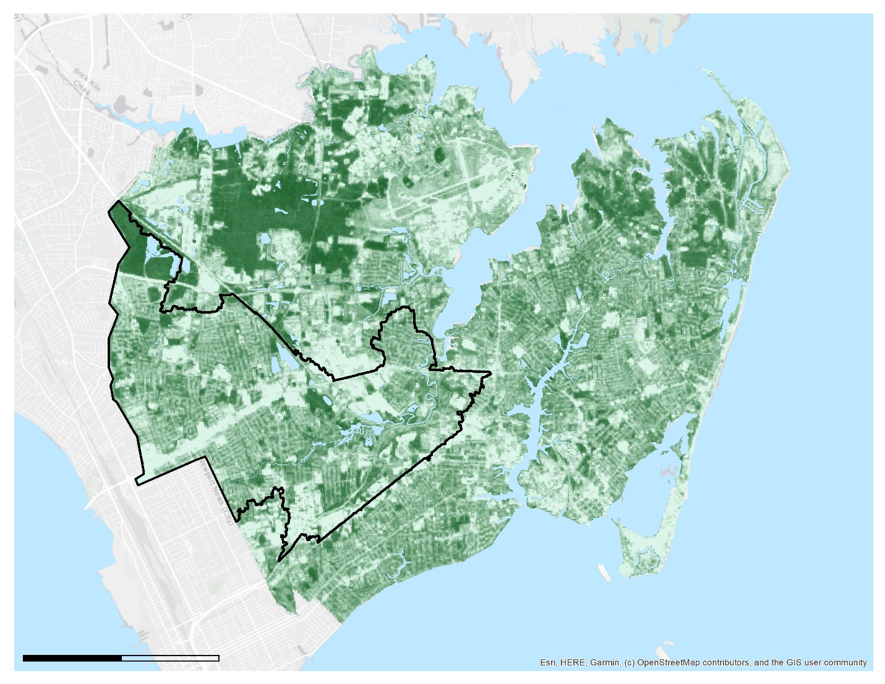

0%

100%

Newmarket Creek Watershed

0

4,000

Meters

*Figure B1.* The figure above shows the rescaled percent tree canopy map derived from August 2000 Landsat 5 imagery.

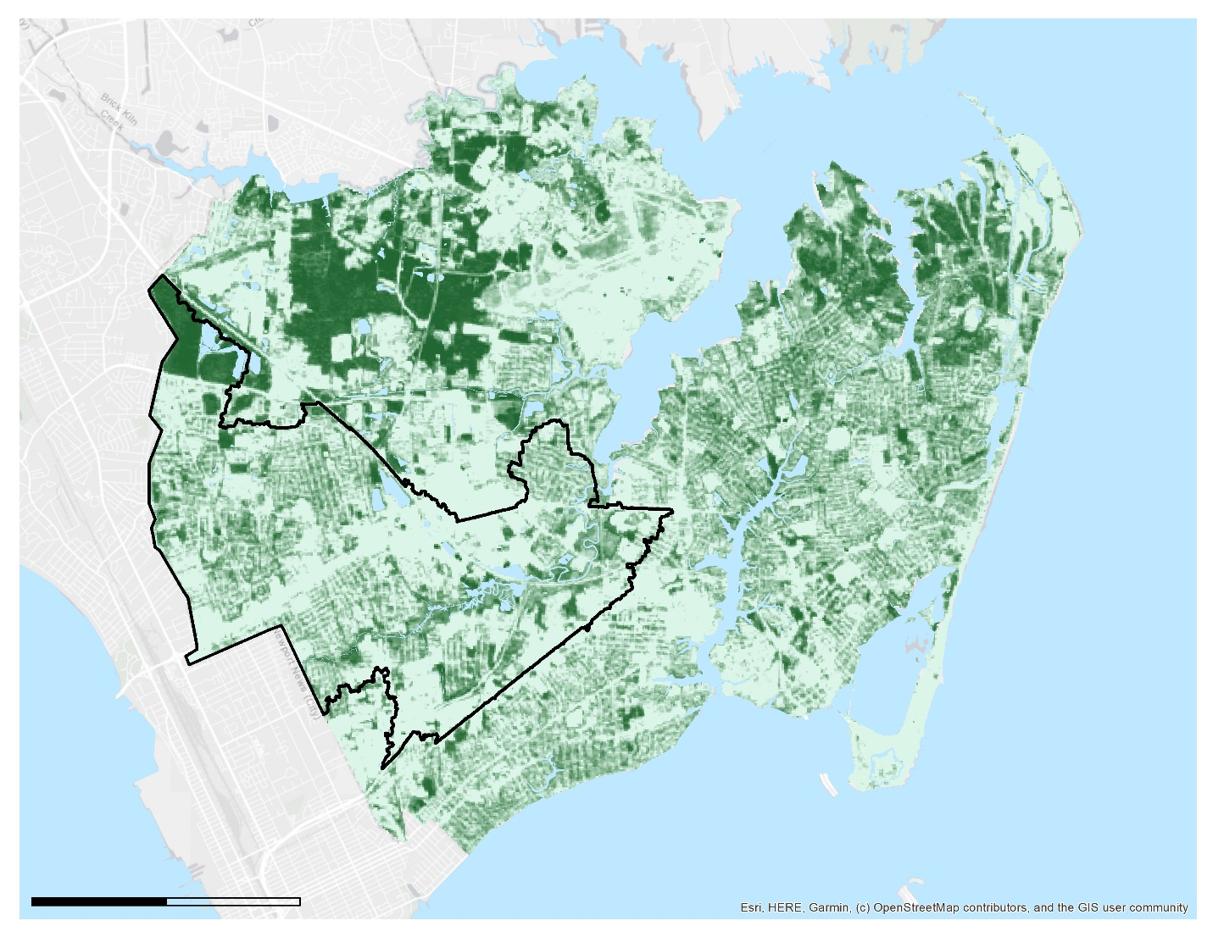

0%

100%

Newmarket Creek Watershed

Meters

0

4,000

*Figure B2.* The figure above shows the rescaled percent tree canopy map derived from August 2006 Landsat 5 imagery.

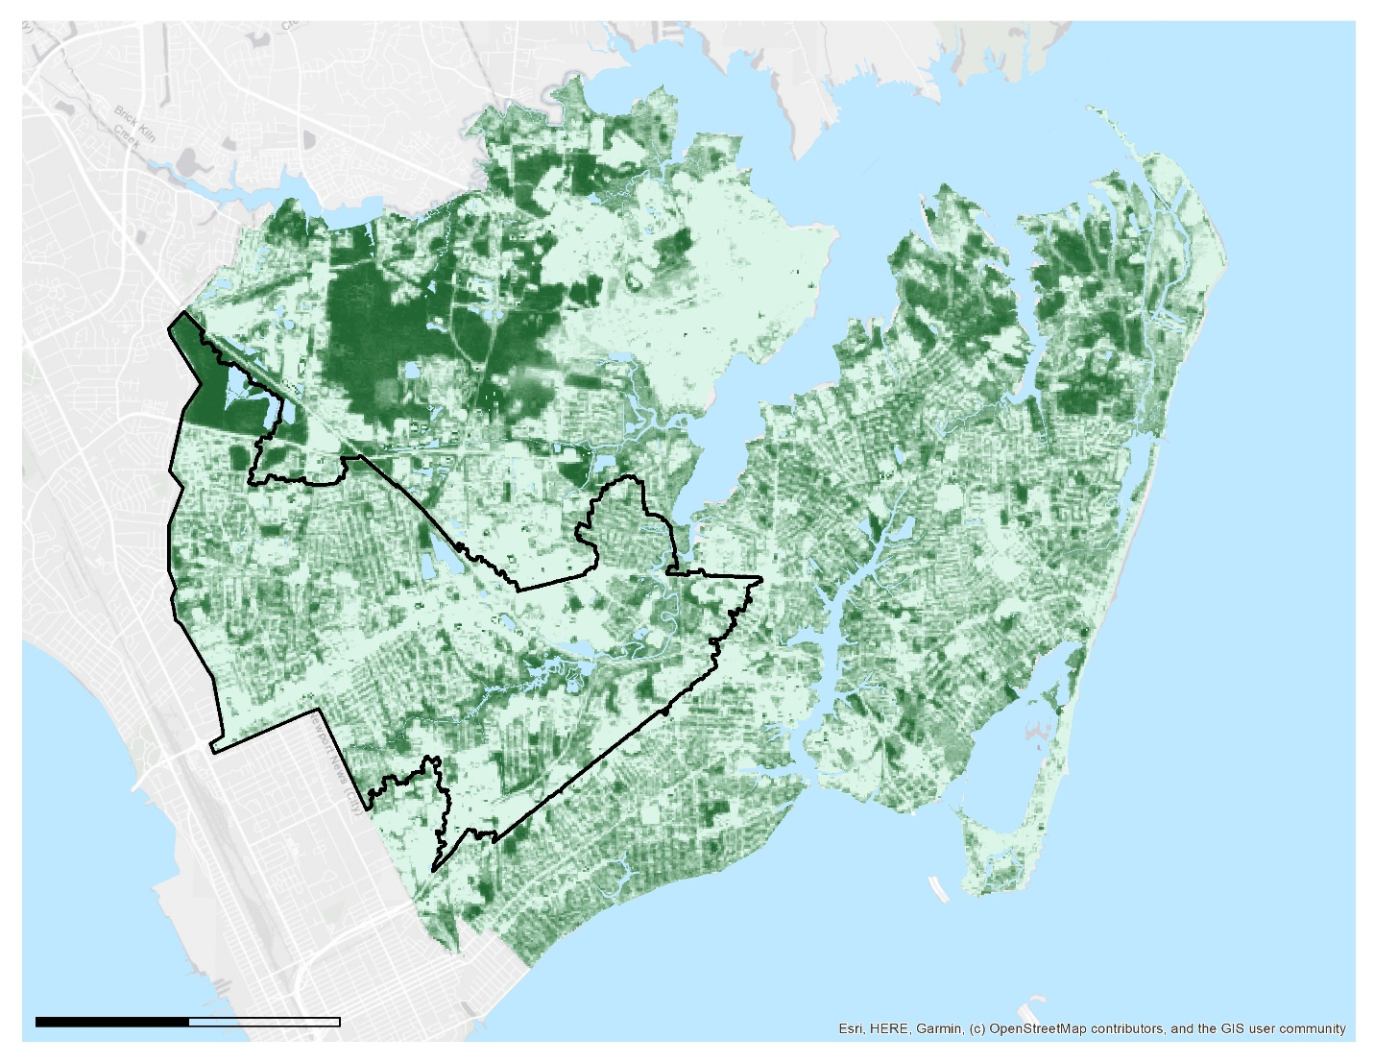

0

4,000

Meters

0%

100%

Newmarket Creek Watershed

*Figure B3.* The figure above shows the rescaled percent tree canopy map derived from August 2011 Landsat 5 imagery.

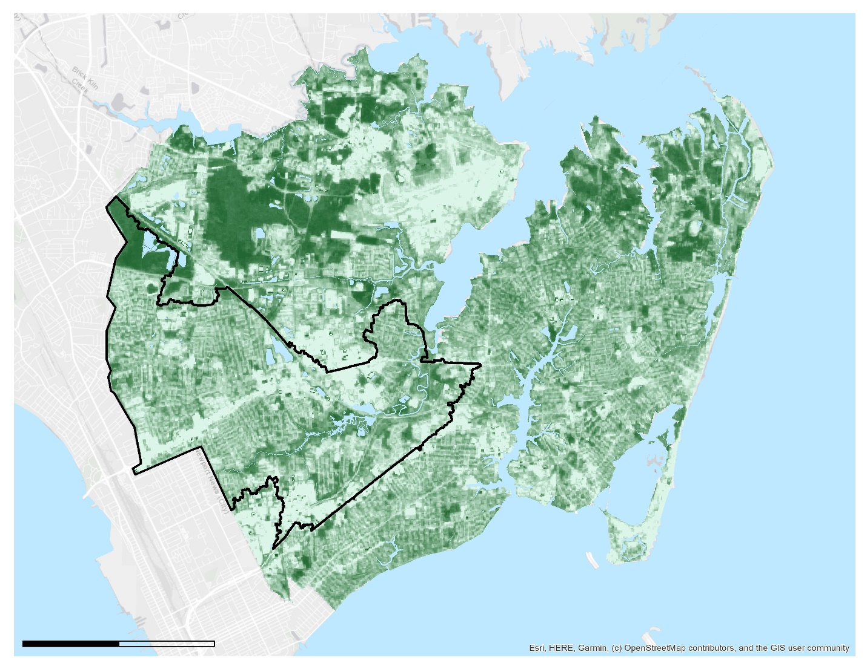

0%

100%

Newmarket Creek Watershed

Meters

0

4,000

*Figure B4.* The figure above shows the rescaled percent tree canopy map derived from August 2016 Landsat 8 imagery.

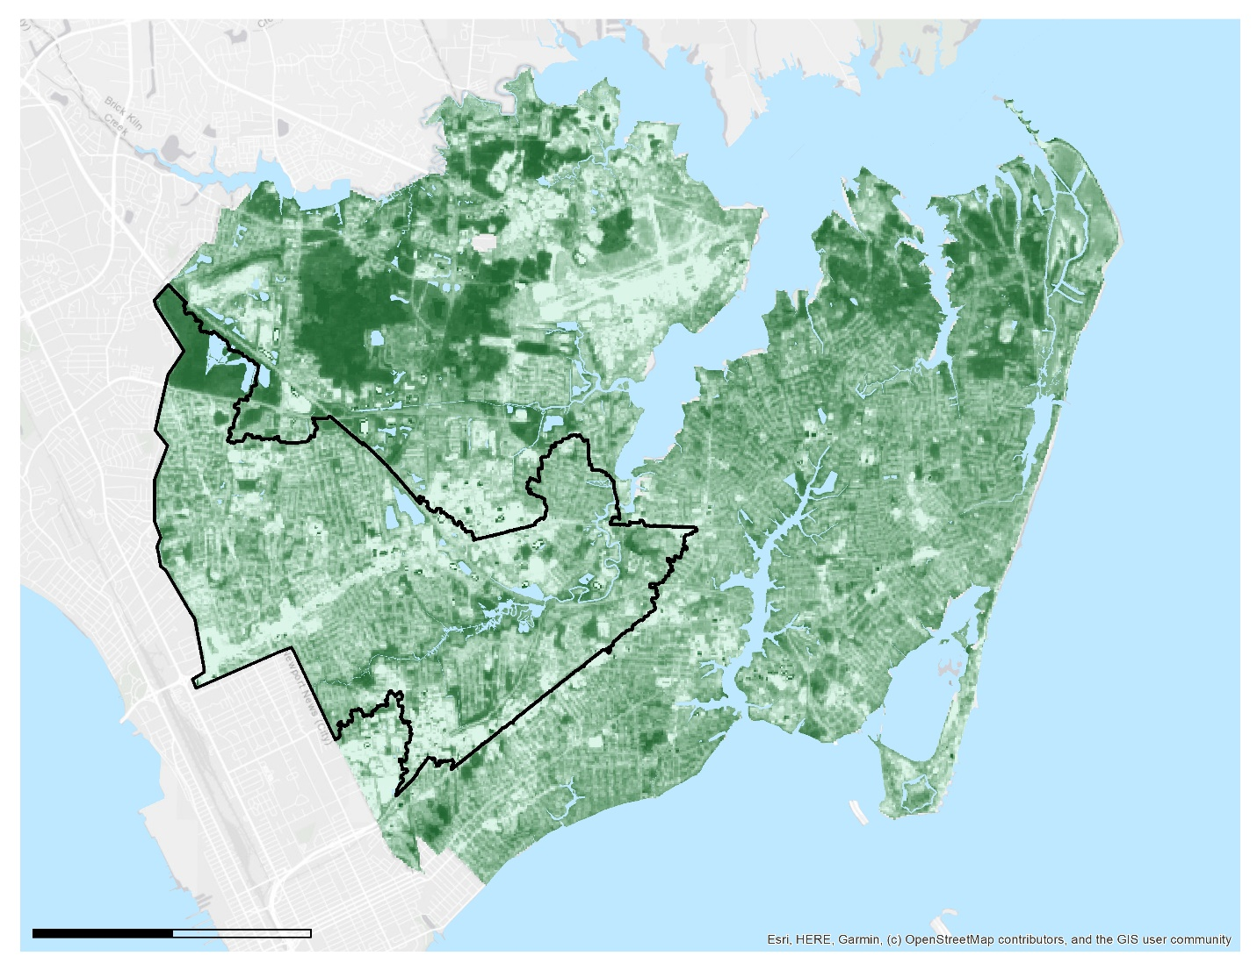

0%

100%

Newmarket Creek Watershed

Meters

0

4,000

*Figure B5.* The figure above shows the rescaled percent tree canopy map derived from June 2019 Landsat 8 imagery.

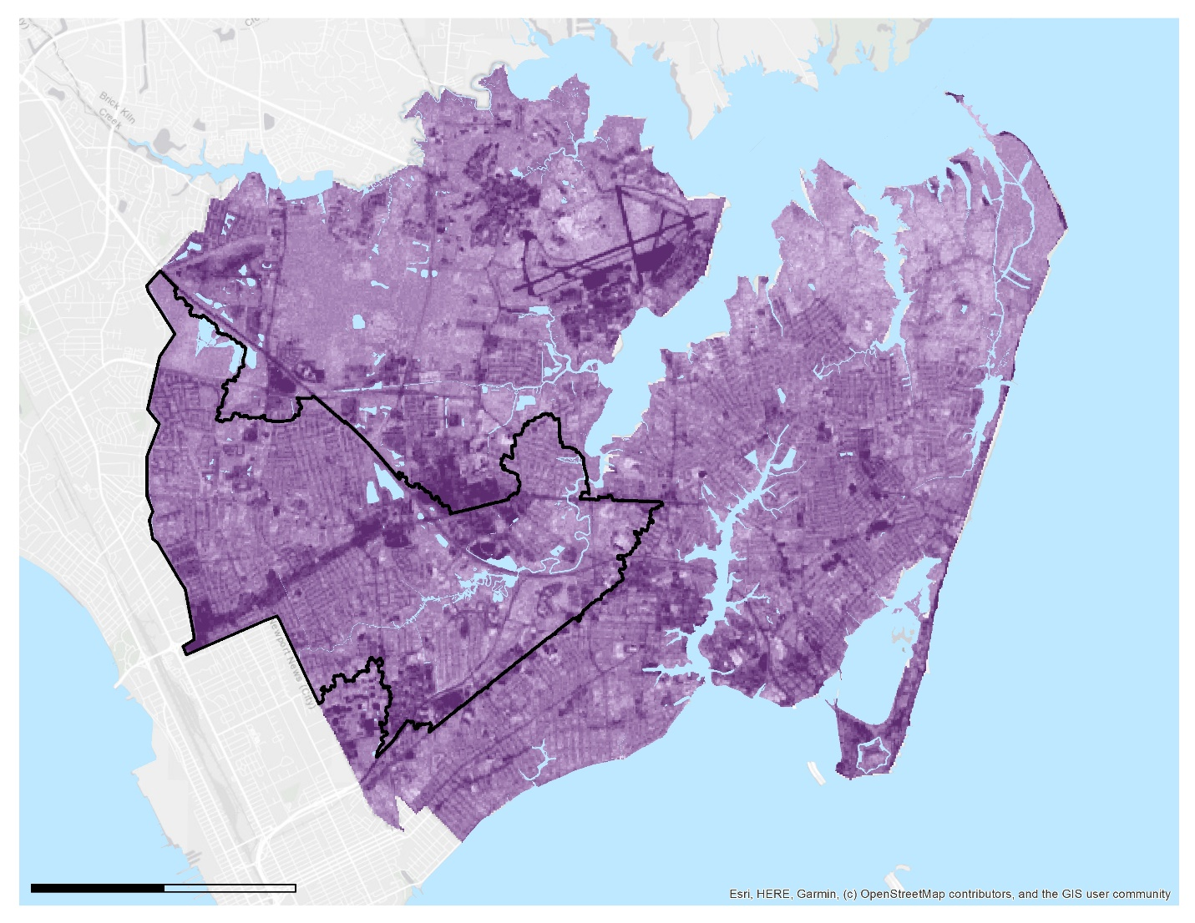

0%

100%

Newmarket Creek Watershed

Meters

0

4,000

*Figure B6.* The figure above shows the rescaled percent impervious surface map derived from January 2000 Landsat 5 imagery.

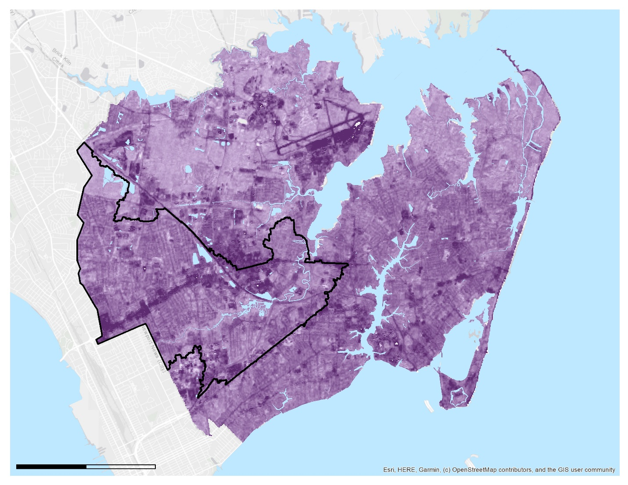

0%

100%

Newmarket Creek Watershed

Meters

0

4,000

*Figure B7.* The figure above shows the rescaled percent impervious surface map derived from January 2019 Landsat 8 imagery.