**NASA DEVELOP National Program**

 BLM at Idaho State University GIS TReC

**Fall 2016**

**Short Title: Southeast Idaho Water Resources**

**Subtitle:** Leveraging NASA Earth Observations to Identify Existing Surface Water Features and Improve Water Management and Resource Allocation in Southeast Idaho

**VPS Title:** Got Water? Locating Surface Water in the Idaho Desert

**Project Team & Partners**

**Project Team:**

Traci Olson (Project Lead), olsotra3@isu.edu

Cody O’Dale

Dylan Thomas

Caitlin Toner

Courtney Ohr

**Advisors & Mentors:**

Keith Weber, Lead Science Advisor (GIS Training and Research Center at Idaho State University)

Charles Peterson (Biology Department, Idaho State University)

Mark Carroll (NASA GSFC)

**Partner Organizations:**

|  |  |  |  |
| --- | --- | --- | --- |
| **Organization** | **POC (Name, Position/Title)** | **Partner Type** | **Boundary Org?** |

|  |  |  |  |
| --- | --- | --- | --- |
| Bureau of Land Management (BLM) | Karen Kraus, Natural Resource Specialist | End-User | No |
| Idaho Department of Water Resources (IDWR) | Linda Davis, Senior GIS Analyst | End-User | No |
| RECOVER Science Team | Keith Weber, GIS Director | Collaborator | Yes |

**Project Details**

**Applied Sciences National Applications Addressed:** Water Resources

**Study Area:** Southeastern Idaho

**Study Period:** May 2016 to July 2016

**Earth Observations & Parameters:**

Landsat 8, Operational Land Imager (OLI) – Spectral classification

SRTM Version 2 – elevation, slope, and aspect

**Ancillary Datasets Utilized:**

* USGS Dynamic Surface Water Extent (DSWE) – water classification
* USGS National Hydrography Dataset –surface water

**Software Utilized:**

* Google Earth Engine – Image processing, classification, and analysis
* ESRI ArcGIS– Image processing and analysis

**Project Overview**

**80-100 Word Objectives Overview:**

Personnel at the Bureau of Land Management (BLM) and Idaho Department of Water Resources (IDWR) in Southeastern Idaho need current and dynamic data when managing sensitive aquatic habitats and anthropic water supplies. Currently, partners rely on local knowledge and outdated information for identifying water bodies. This project utilized NASA Earth observations and Google Earth Engine to produce a model that finds surface water more accurately than currently available information. This model is as a user-friendly tool that allows our partners to identify surface water from the latest imagery and monitor temporal changes of surface water in their management area.

**Abstract:**

Understanding the water dynamics in Southeastern Idaho is critical to planning and improving water management practices. Organizations that focus on water management, such as Bureau of Land Management (BLM) and Idaho Department of Water Resources (IDWR) currently use unreliable data to identify water bodies. Methods include local knowledge and the National Hydrography Dataset, a nation-wide dataset that fails to accurately predict water bodies in southeast Idaho. This fosters ineffective use of resources and puts sensitive species at risk, while allowing invasive species to thrive. This study utilizes NASA Earth Observations and Google Earth Engine to create a tool that allows end-users to identify and track water bodies within their assigned management area. The Surface Water Indicator Model (SWIM) tool incorporates multiple water indices, topographic data, and a decision tree classifier. Each method alone is susceptible to falsely classifying mountain shadows, urban asphalt, basaltic lava flows, or dark vegetation as surface water. However, this study combines these methods into a single tool to create a more accurate surface water indicator. The developed SWIM tool will be user friendly, will allow surface water indication with the most currently available Landsat 8 imagery, and can monitor temporal changes of surface water. The team developed the tool within Google Earth Engine and created a parallel model in Python code for ArcGIS. This duplication gives the end-users a choice of platform that best fits their needs. The SWIM tool will help natural resource managers with project planning, field assignments, and allocation of resources.

**Keywords:**

Surface water, CART, Landsat, Water Index, water resources, SWIM, Google Earth Engine

**Community Concerns:**

* Existing maps are out-of-date and inaccurate, so land managers commit resources towards protecting nonexistent water, or finding unexpected water during field work which includes invasive removal.
* Water rights are a controversial topic in Southeastern Idaho, and land managers often find themselves in the middle of political battles while they try to balance anthropogenic demand with ecological protections.
* The spatial extent and flow dynamics of water sources are important to know when improving management decisions.

**Current Management Practices & Policies**: Currently our end-user agencies, the Bureau of Land Management and the Idaho Department Water Resources (BLM and IDWR), are responsible for the management of surface waterbodies and habitats with threatened or protected species in Southeastern Idaho. Neither of our end-users leverage satellite data to identify surface water features. Instead they rely on the National Hydrological Database (NHD) and legacy knowledge to determine areas which require special management practices. The NHD, although considered a standard resource, includes features identified as far back as the 1950’s that originally included any feature with the potential to store water. Using this outdated information has led to inefficient management practices. For instance, the BLM is required to place a buffer around each river or stream in the NHD before they can spray for weeds. This includes areas that no longer contain water, which results in a continued inhabitation of invasive species. The Idaho Department of Water Resources (IDWR) uses the NHD combined with local knowledge and maps to identify water sources, but this can be time consuming and resource intensive. IDWR relies on this information about surface water bodies to decide annual allowances of water usage and diversions. For both partners, the standard use of NHD increases costs and could lead to making important decisions with inaccurate data.

**Decision Support Tools & Benefits:**

|  |  |  |  |
| --- | --- | --- | --- |
| **End-Product** | **Earth Observations Used** | **Benefit & Impact** | **Software**  **Release** |
| Surface Water Map | Landsat 8 OLI  Shuttle Radar Topography Mission (SRTM) Version 2 | The initial results will help our project partners focus resources in areas known to hold water, and thereby, eliminating outdated data provided by the NHD. The second term will further analyses by discerning intermediate versus perennial water bodies, and excluding ephemeral water bodies. | N/A |
| Surface Water Indication Model (SWIM) | Landsat 8 OLI  Shuttle Radar Topography Mission (SRTM) Version 2 | This model give our partners the ability to compile their own water indication map from the latest Landsat data, and compare current and historical water extents. | III |
| Tutorial |  | This will give partners the ability to apply project methodologies to other study areas, or time frames. | N/A |

**Project VPS/Booklet Imagery**

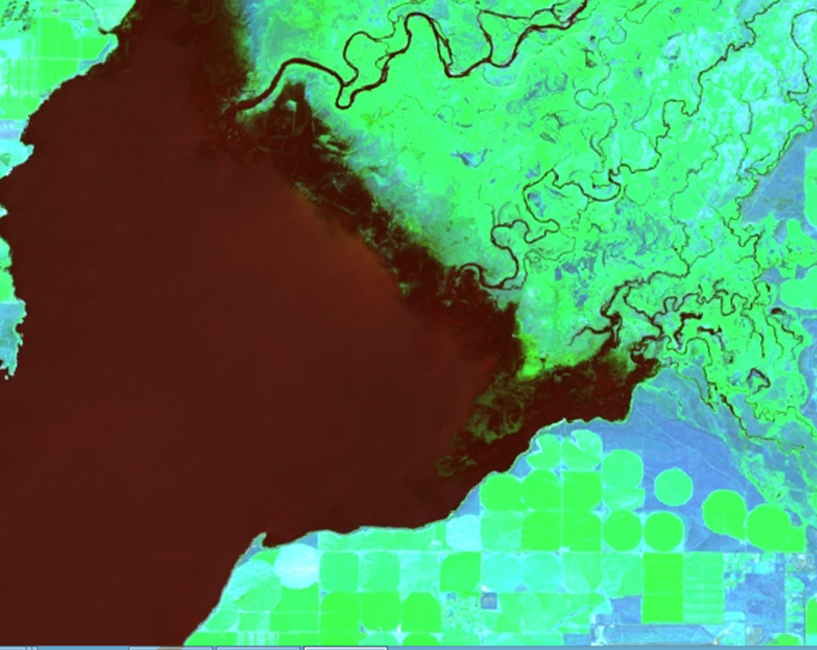

**Caption:** The North end of American Falls Reservoir in false color composite. A separate .jpeg file of this image is also available. Image Credit: Google Earth Engine Southeast Idaho Water Resources Team.

**Image:** 2016Fall_ID_SoutheasternIdahoWaterResources_VPSimage