**NASA DEVELOP National Program**



NASA Ames Research Center

**Summer 2015**

**Short Title: Navajo Nation Climate II**

**Subtitle:** A Drought Monitoring Decision Support Tool for Customized Calculation of a Standardized Precipitation Index Value in the Navajo Nation

**VPS Title:** Beyond a Shadow of a Drought II: Monitoring Severity from Space

**Project Team & Partners**

**Project Team:**

Cheryl Cary (Project Lead), cheryl.t.cary@nasa.gov, cheryl.t.cary@gmail.com

Michael Gao

Vickie Ly

Anton Surunis

Sophie Turnbull-Appell

**Advisors & Mentors:**

Dr. J. W. Skiles (NASA Ames Research Center)

Dr. Venkat Lakshmi (University of South Carolina)

Amber Brooks (DEVELOP National Program, Ames Research Center)

**Past or Other Contributors:**

Clayton Sodergren (DEVELOP National Program, Ames Research Center)

Amber Brooks (DEVELOP National Program, Ames Research Center)

**Partner Organizations**

Navajo Nation Department of Water Resources (NNDWR), Water Management Branch, End-User, POC: Maurice Upshaw, Robert Kirk, Jason John, and Teresa Showa

Navajo Technical University, Geographic Information Science Lab, End-user, POC: Ramsey Seweingyawwa

**Project Details**

**Applied Sciences National Applications Addressed:**

Climate, Water Resources

**Study Area:** The Navajo Nation, located at the intersection of Arizona (AZ), New Mexico (NM), and Utah (UT).

**Study Period:** 1901 - Present

**Earth Observations & Parameters**

TRMM, Precipitation Radar (PR) – Rainfall measurements

GPM – Rainfall measurements

**Ancillary Datasets Utilized**

* NNDWR Products - Infrastructure (roads, irrigation areas, dams, political boundaries), lakes, rivers, wells, springs, dams, snowpack, precipitation, streamflow
* Northwest Alliance for Computational Science and Engineering - PRISM (Parameter-elevation Relationships on Independent Slopes Model)
* United States Geological Survey (USGS) – Stream Gauge data
* Goddard Earth Sciences (GES) Data and Information Services Center (DISC) North American Land Data Assimilation System (NLDAS)- evaporation, transpiration, soil moisture

**Models Utilized**

**Software Utilized**

Esri ArcGIS Desktop 10.3.1 - Spatial Analysis Toolbox, TRMM, PRISM and GPM raster processing and analysis using ModelBuilder

R Statistical Package - Calculation of SPI values with SPI package utilizing PRISM, TRMM, and GPM data

**Project Overview**

**80-100 Word Objectives Overview**

Currently, the Navajo Nation monitors drought intensity using national-scale Standardized Precipitation Index (SPI) values calculated by the Western Regional Climate Center (WRCC). These values do not provide the spatial resolution needed to examine variety in drought severity across the entire Nation. This project created a geo-processing tool to calculate SPI values for user-specified areas within the Nation. The team applied the tool to examine the relationship between drought intensity and deep soil moisture. Furthermore, this project illustrated the effectiveness of NASA Earth observations as a more efficient and less costly approach to drought monitoring in areas with limited *in-situ* data.

**Abstract**

The Navajo Nation, a 65,700 km2 Native American territory located in the southwestern United States, has been increasingly impacted by severe drought events and changes in climate. These events are coupled with a lack of domestic water infrastructure and economic resources, leaving approximately one-third of the population without access to potable water in their homes. Current methods of monitoring drought are dependent on state-based monthly Standardized Precipitation Index value maps calculated by the Western Regional Climate Center. However, these maps do not provide the spatial resolution needed to illustrate differences in drought severity across the vast Nation. To better understand and monitor drought events and drought regime changes in the Navajo Nation, this project created a geodatabase of historical climate information specific to the area, and a decision support tool to calculate average Standardized Precipitation Index values for user-specified areas. The tool and geodatabase use Tropical Rainfall Monitoring Mission and Global Precipitation Monitor observed precipitation data and Parameter-elevation Relationships on Independent Slopes Model modeled historical precipitation data, as well as NASA’s modeled Land Data Assimilation Systems deep soil moisture, evaporation, and transpiration data products. The geodatabase and decision support tool will allow resource managers in the Navajo Nation to utilize current and future NASA Earth observation data for increased decision-making capacity regarding future climate change impact on water resources.

**Community Concerns**

* 70,000 people in the Navajo Nation are without direct access to public water systems, and rely heavily on groundwater sources, which are failing to recharge due to prolonged drought.
* Climate change is projected to continue to decrease precipitation, increase temperatures, and exacerbate drought in the Navajo Nation.
* The Navajo Nation does not currently have the data needed to calculate its own Nation-specific SPI.

**Current Management Practices & Policies**

The NNDWR currently relies on SPI values calculated by the WRCC due to the lack of coverage from ground station networks within the Nation to calculate Nation-specific SPI values. However, the WRCC uses state-based climate divisions which do not take the Navajo Nation’s political boundaries into consideration. In addition, neither of these agencies currently obtains or processes NASA Earth observation data for drought monitoring purposes.

**Decision Support Tools & Benefits**

|  |  |  |
| --- | --- | --- |
| **End-Product** | **Earth Observations Used** | **Benefit & Impact** |
| Historical Navajo Nation Precipitation Geodatabase | TRMM GPM | A geodatabase of historical and current precipitation data will give the Navajo Nation access to precipitation data without relying on *in-situ* data. |
| Drought Severity Assessment - Decision Support Tool | TRMM GPM | The tool will utilize the Historical Navajo Nation Precipitation Geodatabase to calculate SPI values for user-selected areas and time periods within the study site. |

**Project Imagery**

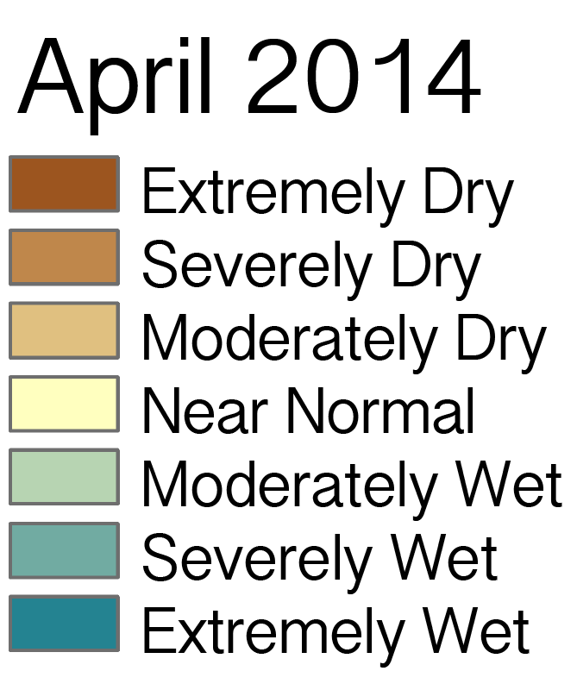

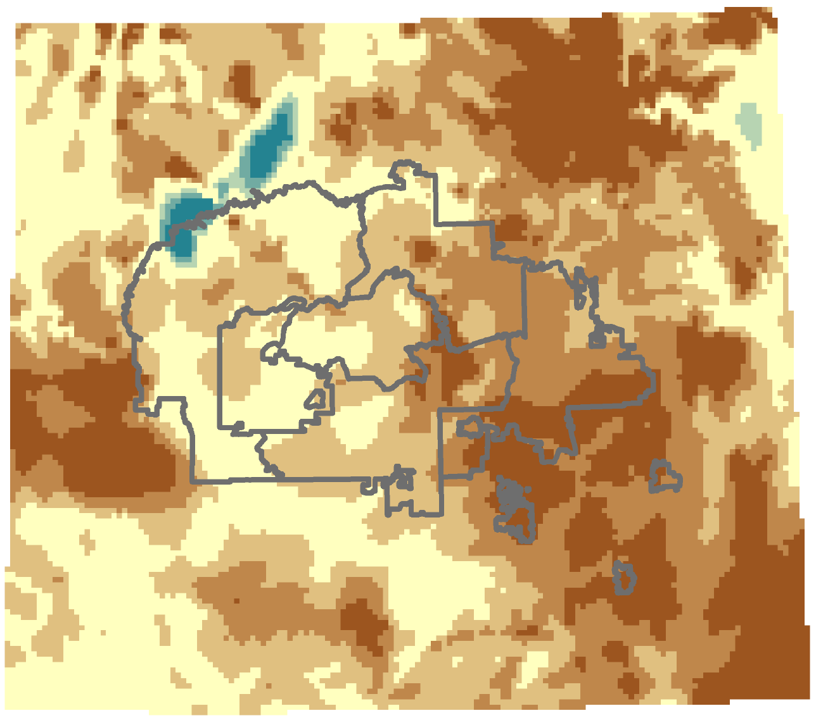

**Caption:** Drought severity for the month of April 2014 Image Credit: Navajo Climate II Team.

**Image:** NNII_Sum2015_VPS_Image.png ; NNII_Sum2015_VPS_Image_Legend.png