**NASA DEVELOP National Program**

MSFC / UGA

**Summer 2013**

**Great Smoky Mountains Ecological Forecasting**

*Utilizing NASA Earth Observations to Monitor Loss of Hemlock Forest and Advance Mitigation Practices Against the Invasive Hemlock Woolly Adelgid*

**Team Leads:**

Austin Stanforth, MS (Indiana University in Indianapolis), Austin.Stanforth@gmail.com

Jiaying He (University of Georgia), hejiaying0608@gmail.com

**Team Members:**

Erica Lauren Craft (University of Alabama in Huntsville)

Pornampai Narenpitak (University of Wisconsin-Madison)

Xiyu Li (Clark University)

**Advisors & Mentors:**

Jeffrey Luvall, PhD (NASA Global Hydrology and Climatology Center)

Marguerite Madden, PhD (University of Georgia)

**Past or Other Contributors:**

Auryn Baruch (University of Georgia)

Ning Chen (University of Georgia)

Steve Padgett-Vasquez (University of Georgia)

**Applied Sciences National Applications Addressed:** Ecological Forecasting, Health and Air Quality

**Study Area:** Great Smoky Mountains National Park in North Carolina and Tennessee

**Study Period:** 2001-2010, concentrating within the autumn (leaf-off) season

**Community Concerns**

* Hemlock groves provide a unique habitat for many diverse and endangered species; loss of the groves put these species at increased risk
* The invasive insect has a high reproduction rate which, with few native predators, allows it to spread quickly
* The infestation has also impacted commercial and residential tree entities
* The surrounding region has many factories, power plants, and other pollution creating industries which negatively impact air quality and are believed to further strain Hemlock health

**80-100 Word Blurb**

NASA Earth Observation data can be utilized to create vegetation indices to detect Eastern Hemlock defoliation and destruction caused by the Hemlock Woolly Adelgid infestation. GIS and remote sensing techniques, such as change detection, can be implemented to more efficiently identify infested areas and migration patterns, improving mitigation monitoring and planning procedures. Regression analysis of air quality data can help identify additional impacts on the trees. Hemlock provides an important ecosystem for many endangered flora and fauna, therefore deterring the loss of Hemlock is particularly important.

**Abstract**

Eastern hemlocks (*Tsuga Canadensis L*.) play an ecologically vital role within the Great Smoky Mountains (GRSM) by providing a unique habitat for many species of flora and fauna, which thrive in shaded and cool aquatic or terrestrial landscapes. The hemlocks are currently facing an infestation of the non-native Hemlock Woolly Adelgid (HWA, *Adelges tsugae*), which feed on and kill the trees. Discovered in the park circa 2002, the HWA have rapidly spread through the forest due to a lack of native predators. This project was designed to map the extent of hemlock defoliation, and investigate its relation to ozone concentration. Landsat 5 Thematic Mapper (TM) images, acquired during autumn leaf-off conditions, were used to create Normalized Difference Vegetation Index (NDVI) maps of the coniferous hemlock. Difference change detection methods identified defoliation extent across years from the NDVI. Hemlock decline regions and 8-hour maximum ozone concentration data, collected by the Environmental Protection Agency (EPA) Air Quality Systems, were combined into a regression model to analyze characteristics of spatial discontinuities of defoliation within the GRSM National Park.

**Partners/Collaborators**

National Parks Service, Great Smoky Mountains National Park, Gatlinburg, TN (POC: Thomas Remaley – Inventory and Monitoring Coordinator and Ecologist)

Environmental Protection Agency, Research Triangle Park, NC (POC: Christine Davis – Office of Air Quality Planning and Standards)

ForWarn, Eastern Forest Environmental Threat Assessment Center and USDA Forest Service, Asheville, NC (POC: William Hargrove, PhD, and William Christie, MS - EFETAC), and NASA Stennis Space Center, MS (POC: Joseph Spruce)

**Current Management Practices & Policies**

Forestry personnel investigate the adelgid infestation through expensive and time consuming field observations. Similar departments have used fixed and rotary wing aircraft to collect expensive aerial imagery to identify areas of Hemlock decline within parks and surrounding areas. These methods are expensive and lack a temporal resolution capabilities. This study area is defined as a federal forest preserve, and is considered the largest remaining virgin forest in the eastern USA. The forest is also a guideline for the EPA National Ambient Air Quality Standards.

**Benefit to End-User**

* Updated maps of infestation
* Change detection imagery/maps from infestation to current
* Methodologies for continued infestation mapping
* Quantification of previous mitigation procedure’s effectiveness
* Identify priority locations for future mitigation practices

**Decision Support Tools**

* Vegetation index change detection maps to visualize and quantify Hemlock decline
* Infestation Risk map
* Methodology for continued monitoring of Hemlock decline
* Regression analysis to relate Hemlock decline and ozone concentration

**Earth Observations & Parameters**

Landsat 5 Thematic Mapper (TM) – Vegetation Index and change detection imagery, maps, and methodology

**Future Applicable NASA Missions**

Landsat 8 – Vegetation indices

Terra/Aqua MODIS – Vegetation indices

Aura OMI – Atmospheric parameters, Giovanni derived products

**Models Utilized**

ForWarn - collaborative effort by NASA, USDA Forestry Service, and EFETAC

**Ancillary Datasets Utilized**

EPA Air Quality System dataset

UGA vegetation classification dataset and park boundary shapefiles

**Software Utilized**

ESRI Arcmap – Raster manipulation/analysis, spatial interpolation, and map creation

ENVI – Raster manipulation, vegetation index, and image preparation

ERDAS Imagine – Raster manipulation and end user model product creation

MATLAB – Regression analysis between hemlock decline and ozone concentration

SAS - Time series statistical analysis of monitoring station data

Figure 1. This image shows decline and growth within Hemlock areas in the Southeast portion of the study region. The result is a difference of NDVI images acquired Nov. 10, 2001 and Nov. 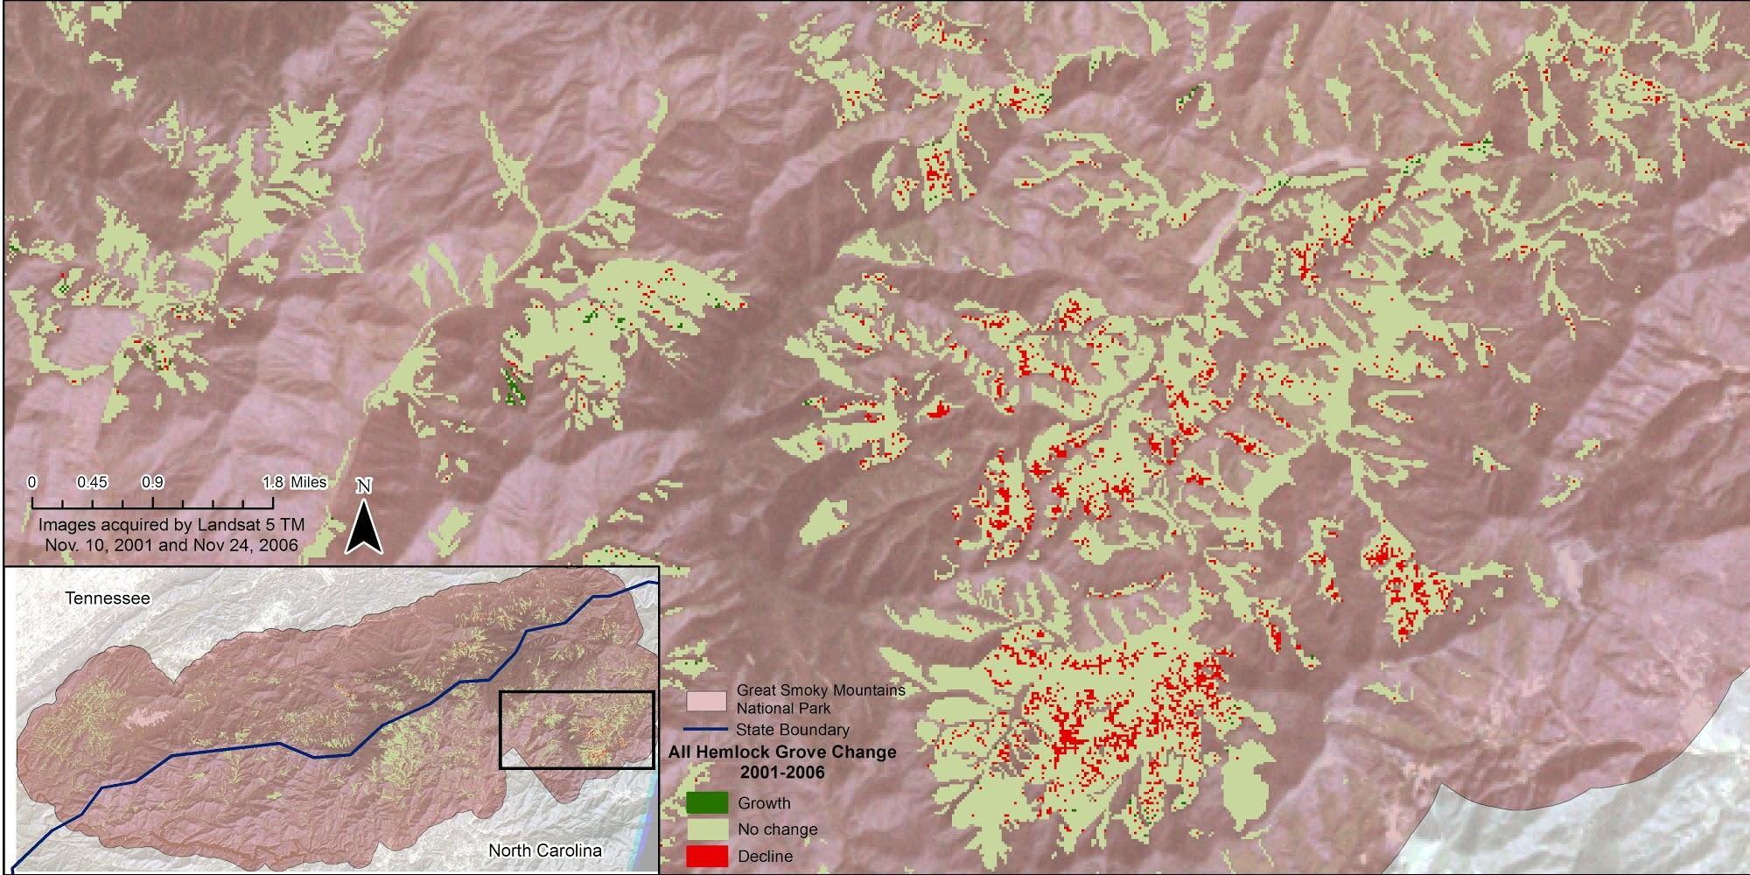

24, 2006.

Figure 2. This image shows decline and growth of Hemlock within the Great Smoky Mountains National Park through a difference change detection calculation on Landsat 5 TM NDVI images acquired Nov. 10, 2001 and Nov. 19, 2010. The change detection is comparable to the MODIS derived ForWarn 10 year Evergreen Decline map set beneath the Landsat derived data..