Baltimore Energy and Infrastructure

Assessing Urban Heat Vulnerability in Baltimore Neighborhoods to Inform Transportation Resiliency Planning Efforts

**Technical Report**

March 29th, 2024

Maya Clark (Project Lead)

Karla Monroy

Lena Kufferman

Brian Arruda

***Advisor:***

Sean McCartney, NASA Goddard Space Flight Center, Space Systems & Applications Inc. (Science Advisor)

***Lead:***  
Stephanie Willsey (Maryland – Goddard)

# **1. Abstract**

Across the world, climate change is altering cities and their local climate systems. Following global trends of rising mean temperatures, Baltimore, Maryland is projected to experience more frequent extreme heat events. Exacerbated by Urban Heat Island (UHI) effects, residents of the city face high temperatures from limited tree canopy, highly paved and impervious surfaces, limited air flow, and high concentrations of localized emissions. Urban heat is dispersed asymmetrically, with historically marginalized populations experiencing disproportionately severe heat. Recognizing the impacts of extreme urban heat, the Maryland Transit Administration (MTA) collaborated with us, the Spring 2024 Goddard Energy and Infrastructure NASA DEVELOP team to assess urban impacts of MTA users and assets and explore opportunities to enhance resiliency planning. We evaluated the feasibility of NASA Earth observations (EOs) in visualizing heat vulnerability in Baltimore City and County. We mapped UHI and extreme heat using remote sensing observations, tailored a Heat Priority Score (HPS) to analyze heat data in tandem with socioeconomic data from American Community Survey (ACS), and utilized SOlar and LongWave Environmental Irradiance Geometry (SOLWEIG) model to estimate MTA riders’ thermal comfort. NASA EOs served to quantify the distribution and severity of extreme heat at the block group level, which was found to correlate with a lack of vegetation and presence of densely built-up surroundings. The HPS revealed that extreme heat events most negatively impact communities that exhibit social vulnerability through indicators such as age, race, and income. These findings will inform neighborhood resiliency plans for the MTA that can be incorporated into their Adaptation Resiliency Toolbox (ART).

***Key Terms***

Baltimore, Human Vulnerability Index, Maryland Transit Administration, PCA, SOLWEIG, Urban Heat Island Effect, UHEAT

# **2. Introduction**

***2.1 Background Information***

Urban heat is a modern challenge impacting both urban livability and sustainability (Nazarian et al., 2022). Amidst global warming and climate change, the frequency and intensity of extreme heat events and compound urban heat island (UHI) effects are set to increase (Intergovernmental Panel on Climate Change [IPCC], 2023). Extreme heat is a leading cause of weather-related human mortality throughout much of the world and the United States, where more Americans are dying from heat related events than all other natural disasters combined (Song et al., 2021; U.S. Centers for Disease Control and Prevention [CDC], 2020). These deaths are concentrated in urban areas and thus further urbanization and rapid development may amplify this trend (Harlan et al., 2013). Understanding how heat affects cities, particularly their transportation networks, at a granular scale, explores a gap between studies of susceptibility to heat and broadly comparative studies of temperature-vulnerability relationships in metropolitan areas (Harlan et al., 2013). Recent literature has found correlations between historically marginalized communities and disproportionate heat exposure, often with urban development patterns shaping and influencing human vulnerability (Manware et al., 2022; Iqbal et al., 2022; Harlan et al., 2006, 2013).

***2.2 Study Area***

Baltimore is a midsized city of about 570,000 residents located in north-central Maryland, stretching around the Patapsco River that flows into Chesapeake Bay (U.S. Census Bureau, 2022; Maryland Geological Survey, 2024). The city is located along the border of the Piedmont Plateau and the Atlantic Coastal Plain, dividing Baltimore into the ‘lower city’ and ‘upper city’. Baltimore County is home to 846,000 people and extends north from Baltimore City to Maryland’s border with Pennsylvania (U.S. Census Bureau, 2022).

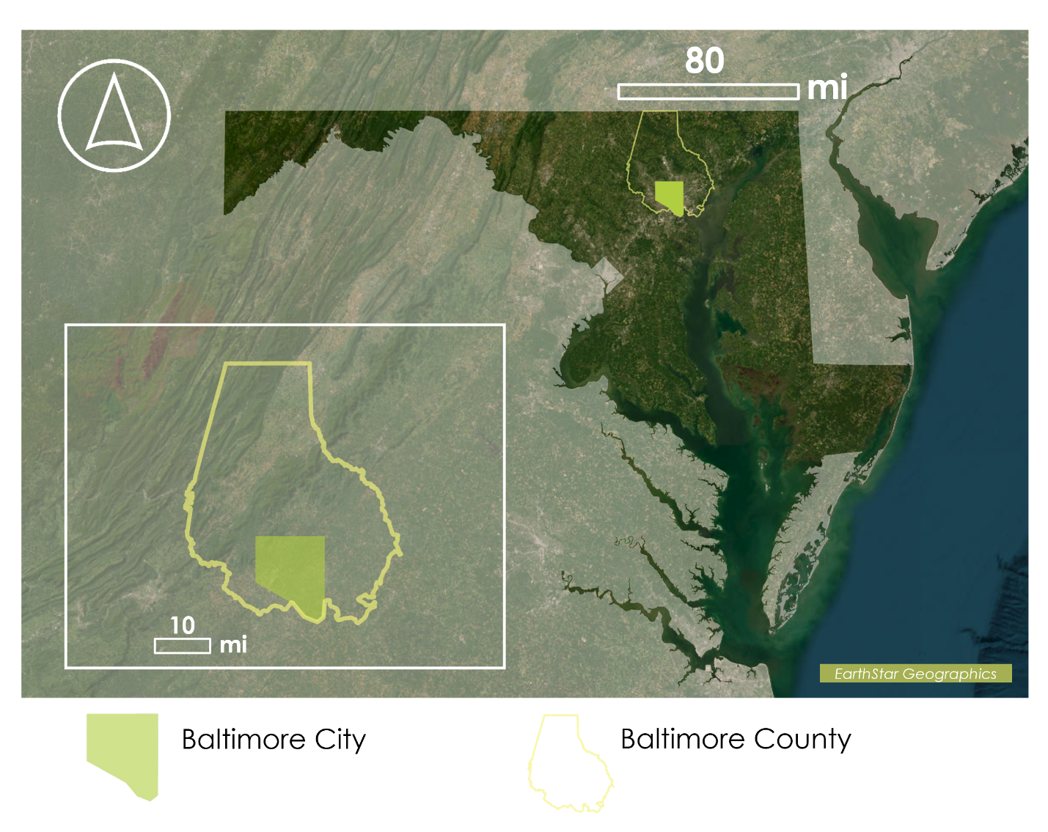*Figure 1.* Study area map showing Baltimore City and Baltimore County in relation to the state of Maryland.

Baltimore faces many challenges due to climate change, limited not only to heat, but also increased coastal flooding, extreme precipitation, and other alterations to local climate systems (National Academies of Science, Engineering, and Medicine; 2019). The number of danger days, or days with a heat index above 105°F, are expected to increase from 8 in 2000 to 47 by 2050 (Climate Check, 2024). While these extreme weather trends affect large swaths of the United States, their impacts are not felt uniformly. A host of recent literature in urban political ecology and urban studies details how the legacies of racism and redlining and historical lack of investment in underserved communities, often communities of color, have affected urban settings in the US and more specifically in Baltimore (Grove et al. 2017; Hsu et al., 2021; Wilson, 2020). Baltimore, through de jure and de facto segregation, has become a heterogenous mosaic of environmental amenities and dis-amenities (Grove et al., 2017). These intersecting realities manifest most clearly in the Butterfly Effect (Appendix A), the Highway to Nowhere, and other phenomena well documented in Baltimore City (Brown, 2022; Phillips de Lucas, 2020; Boone et al., 2014). Baltimore presents an interesting case study given its history as a Long-Term Ecological Research (LTER) site through the National Science Foundation since 1998 and its vulnerability to the effects of climate change, some of which are already playing out (Maryland Department of the Environment, 2020).

There is a continued need to characterize heat in cities to provide data for heat mitigation planning. Remote sensing and NASA EOs have the potential to aid in this effort and address transportation resiliency efforts in Baltimore. Past DEVELOP projects have done similar work with both urban heat and transportation systems (Schindelman et al., 2023; Boogaard et al., 2020; Barbakova et al., 2021; Keyes et al., 2022; Kessler et al., 2023; Krisch et al., 2024).

***2.3 Project Partners & Objectives***

Maryland Transit Administration (MTA), a subagency of Maryland’s Department of Transportation (MDOT), operates buses, light rail, and trains in and around Baltimore City and County. MTA has already conducted studies focusing on other extreme climate issues such as hurricanes and flooding, and now is expanding their scope to assess extreme heat and UHI. Assessing how urban heat affects transit ridership and the broader community will allow MTA to target their mitigation strategies towards people that are more at risk of experiencing increased chronic and extreme heat at Baltimore bus stops. The MTA’s Adaptation and Resiliency Toolbox (ART) includes water-based disaster data, such as flooding, but lacks regional heat data. Starting with this DEVELOP study, MTA will be able to expand this resource to incorporate updated extreme heat and UHI related data and enhance their existing capacity to manage their resiliency dashboard to ultimately inform mitigation and efforts surrounding bus infrastructure in an equity framework. Creating accessible visualizations of recent UHI and extreme heat data will allow MTA to integrate heat metrics into their existing framework and provide science-based evidence for action. To accurately represent recent trends of heat vulnerability and its impacts, we collected and analyzed data from the summer and early fall months of the last 10-years (2013-2023). Utilizing NASA EOs, we provided visualizations synergizing the relationship between neighborhood-level socioeconomic assemblages with heat vulnerability to inform MTA on how UHI affect commuters, thus guiding MTA’s equity-informed heat mitigation and climate resiliency efforts. We produced visualizations of social vulnerability, environmental exposure, a prioritization index, and an Outdoor Thermal Comfort (OTC) assessment within Baltimore City and County using remote sensing, programming, and GIS software to inform transportation resiliency education and efforts.

**3. Methodology**

***3.1 Data Acquisition***

*3.1.1 Earth Observations*

We used publicly available, open-source data for most of the analysis conducted. To perform heat mapping, we accessed Landsat 8 Level 2/ Collection 2 products from the Operational Land Imager (OLI) and Thermal Infrared Sensor (TIRS) instruments to calculate albedo and daytime Land Surface Temperature (LST) via the Google Earth Engine (GEE) catalog. We repeated this process for the Normalized Difference Vegetation Index (NDVI) and Normalized Difference Built-up Index (NDBI), clipping each dataset to Baltimore City and County and filtering the data from June to October between 2013 to 2023. Terra and Aqua Moderate Resolution Imaging Spectroradiometer (MODIS) data was accessed via the GEE catalog for the same period and study area for nighttime LST and Normalized Difference Water Index (NDWI) respectively. We chose these indices to encapsulate various natural and built environmental factors that would influence heat distribution and would factor into the heat vulnerability assessment (Table 1).

Table 1

*NASA Earth observations collected for indices within Heat Island Assessment*

|  |  |  |  |  |  |  |
| --- | --- | --- | --- | --- | --- | --- |
| **Platform/ Program** | **Sensor** | **Product ID** | **Purpose** | **Dates Used** | **Acquisition Method** | **Spatial Resolution** |
| Landsat 8 | Operational Land Imager (OLI) | LANDSAT/OLI/LT08/C02/  Level-2 | NDVI, NDBI, Albedo | June 15th – September 15th from 2013 – 2021 | GEE | 30-meter |
| Thermal Infrared Sensor (TIRS) | LANDSAT/TIRS/LT08/C02/  Level-2 | LST | 100-meter |
| Terra | Moderate Resolution  Spectral Radiometer  (MODIS) | MOD11A2 Version 6 average Surface Temperature and Emissivity Product | Nighttime  LST | June 15th - October 15th from 2013 – 2023 | 1 kilometer (km) |
| Aqua | MODIS | MYD09A1 Version 6.1 Surface Reflectance Product | NDWI | June 15th- October 15th from 2013 – 2023 | 500-meter |

*3.1.2 HVI and Bus User Data Acquisition*

We acquired a range of ancillary datasets to develop a Heat Vulnerability Index, Heat Exposure Index, and a Heat Priority Index that both captures the unique social and environmental context of Baltimore City and County. The partners provided a geodatabase with MTA bus stop and bus route data, which was accessed via ArcGIS Pro 3.2.0. We collected socioeconomic data at the block group level for several variables (Table 2) via the US Census Bureau’s American Community Survey (ACS) accessed through RStudio 4.3.3 using the Tidycensus package. We chose population density, ethnic minority, poverty, ages 65 and over, and adults without a high school diploma for analysis in conjunction with literature on assessing heat vulnerability (Cutter et al., 2003).

Table 2

*Ancillary datasets collected for constructing heat vulnerability index (HVI)*

|  |  |  |  |  |  |
| --- | --- | --- | --- | --- | --- |
| **Dataset** | **Variable Name** | **Source** | **Geography** | **Year(s)** | **Data Type** |
| Baltimore City and Baltimore County Shapefile | Transit | MTA | Block Group | 2023 | Shapefile (.shp) |
| Total Population  (Table B01003) | Population | U.S. Census Bureau, ACS | Block Group | 5-Year Estimates  2018 – 2022 | Comma-Separated Values (.csv) |
| Hispanic or Latino Origin by Race (Table B03002) | Ethnic Minority |
| Poverty Status of Individuals in the Past 12 Months by Living Arrangement  (Table B17021) | Poverty |
| Sex by Age (Table B01001) | Ages 65 and Over |
| Educational Attainment for the Population 25 Years and Over  (Table B15003) | Adults Without a High School Diploma |

*3.1.3 SOLWEIG Data Acquisition*

The Solar Longwave Environmental Irradiance Geometry, or SOLWEIG model, is a 3-D model that simulates mean radiant temperature (Tmrt), a more accurate measurement for felt temperature by people (Lindberg and Grimmond, 2011). It is derived by modeling shortwave and longwave radiation fluxes in six directions, upward, downward and from the four cardinal points, including angular factors. It requires the allocation of spatial data of the same resolution and extent with corresponding meteorological data for the selected area of interest. We acquired 2014 Light Detection and Ranging (LiDAR) point cloud data for Baltimore City via USGS National Map Viewer. We acquired 2021 1-meter Land Cover data for Baltimore City via the National Agricultural Imagery Program (NAIP). Meteorological data was sourced from Virtual Crossing and was modeled on a random summer day in August 2023, to simulate a high temperature example.

Table 3

*Ancillary datasets collected for processing at differing elevations and modeling using SOlar and LongWave Environmental Irradiance Geometry model (SOLWEIG)*

|  |  |  |  |  |
| --- | --- | --- | --- | --- |
| **Dataset** | **Source** | **Use** | **Date(s)** | **Data Type** |
| Temperature °C | Virtual Crossing Meteorological Data | Meteorological Data input for SOLWEIG | 08/15/2023 | Comma Separated Values (.csv) |
| Relative Humidity (%) |
| Incident shortwave radiation (W m-2) |
| Wind Speed (m/s) |
| Precipitation (mm) |
| Digital Elevation Model (DEM) | LiDAR Point Cloud USGS National Map | Input to SOLWEIG to model OTC and TMRT | 09/16/2014 | Raster (.tif) |
| Digital Surface Model (DSM) | Generate Normalized Building and Tree Digital Surface Models (nDSM) to model TMRT in SOLWEIG  (DEM – DSM = nDSM) |
| Canopy Digital Surface Model  (CDSM) | Generate Building and Tree Digital Surface Models (DSM) to model TMRT in SOLWEIG  (nDSM-DEM=CHM) |
| Land Cover | 1-m NAIP Imagery via the Google Earth Engine Catalog | Generate Land Cover Grid via supervised classification for SOLWEIG | June – October 2021 |

***3.2 Data Processing***

*3.2.1 Rural Reference*

To assess the intensity of heat in Baltimore City, we needed to identify a rural reference, or a point of comparison of the magnitude of heat between an urban and non-urban space (Martin-Vide et al., 2015). Given that our study area covers Baltimore County, which contains rural and undeveloped tracts of land, the upper quartile of Baltimore County served, by proxy, as our rural reference. This allowed us to establish the intensity of heat centered in Baltimore City and its expanding transit corridors.

*3.2.2 Heat Island Assessment*

Due to the high volume of data processed over the 10-year study period, Google Earth Engine was used to acquire, process, and analyze all of the Earth observations used for the heat island assessment. We utilized a set of code that was adapted and published by a previous DEVELOP team, Tempe Arizona II from Fall of 2020, to evaluate and assess urban heat data (Boogaard et al., 2020). We adapted the code to the study area of Baltimore City and Baltimore County, over the study period of June 15th to September 15th, 2013 – 2023. A study period of 10 years was used to aggregate enough data from Landsat 8, which only provides coverage of Baltimore every 16-days and is sometimes unusable due to excess cloud coverage. Aqua MODIS and Terra MODIS, however, provide an average pixel per eight days and more consistent coverage but at the compromise of a lower resolution.

First, LST was acquired directly from the Landsat 8 Thermal Band 10. Normalized Difference Vegetation Index (NDVI) was calculated using the Near Infrared (NIR) and red bands. Normalized Difference Built-up Index (NDBI) was calculated using the Shortwave Infrared (SWIR) 1 and NIR bands. Finally, median albedo, or solar reflexivity, was calculated using NIR, SWIR1, SWIR2, Red, Green, and Blue Bands. A Land surface temperature and emissivity product from Terra MODIS was used to access nighttime LST. Lastly, a surface reflectance product from Aqua MODIS was used to calculate Normalized Difference Water Index (NDWI). All equations used and their corresponding citations can be found in Table 4 (Below). All Earth observation data was masked for cloud cover and water bodies as written in UHEAT 1.0. Thus, cloud and water pixels were excluded from final surface temperature and reflectance calculations. In preparation for analysis, all temperature calculations were converted from Kelvin to Fahrenheit and exported in a csv format.

Table 4

*Equations and products for deriving environmental indices.*

|  |  |  |
| --- | --- | --- |
| **Name** | **Equation/Product** | **Citation** |
| Daytime LST | Sensor: Landsat 8 TIRS  Band: ST_B10 | U.S. Geological Survey (n.d.;b) |
| NDVI | Bands: NIR(SR_B5), RED(SR_B4)  Equation: (NIR - RED) /  (NIR + RED) | U.S. Geological Survey (n.d.;a) |
| NDBI | Bands: SWIR (SR_B6), NIR(SR_B5)  Equation: (SWIR - NIR) / (SWIR +NIR) | Hoshangabad et. al (2018) |
| Albedo | Bands: NIR, SWIR 1, SWIR 2, RED, GREEN, BLUE  Equation:  (BLUE * 0.246 + GREEN * 0.146 + RED * 0.191 + 0.304 * NIR + 0.105 * SWIR1 + 0.008 * SWIR2) * 0.0001 | Guillermo et. al (2016) |
| Nighttime LST | Product: MODIS/Terra Land Surface Temperature/ Emissivity 8-Day L3 Global 1 km SIN Grid  (MODIS/061/MOD11A2)  Band: LST_Night_1km | Wan et. al (2021) |
| NDWI | Product: MODIS/Aqua Surface Reflectance 8-Day L3 Global 500 m SIN Grid(MYD09A1 v061) Equation: Rho857(sur_refl_b02), rho1241(sur_refl_b05)  (rho857 - rho1241) / (rho857 + rho1241) | Bo-cai Gao (1996) |

*3.2.2 Demographic Data*

Using the Tidycensus package in R Studio 4.3.3, we obtained socioeconomic demographic data inputs for the Principal Component Analysis (PCA) from the U.S. Census Bureau ACS 2022 five-year estimates. We utilized UHEAT 1.0 code to pull variables for percent below the poverty line, ethnic minority, 65 and older, and percent without a high school diploma (Table 2). These variables were used to assess race, income, age, and education demographics to formulate a basis for calculating social vulnerability and sensitivity.

***3.3 Data Analysis***

*3.3.1 Heat Vulnerability Assessment & Index*

It is widely accepted that vulnerability can be quantified by aggregating calculations of sensitivity, exposure, and adaptive capacity (Cheng et al. 2021; Szagri et al., 2023). To create a Heat Vulnerability Index Composite Score specific to Baltimore City and County, we identified variables in two categories, sociodemographic properties, and environmental properties (Yigitcanar et al., 2022; Niu et al., 2021; Tables 2 and 4). Health data was excluded, given the data was inaccessible, and that the PCA does not disaggregate social determinants of health (Kauh et al., 2021). The variables in table 2 were chosen based on HVI literature and in consultation with expert opinion and the MTA to both match their existing HVI in their ART program and follow Title VI guidelines for equitably assessing government (Cheng et al., 2021; Yigitcanar et al., 2022; Nguyen and Liou, 2019; ACS/US Census Bureau, 2023; Quinn et al. 2020). We accessed natural and built environment data from Landsat 8 Level 2 and calculated their corresponding indices via GEE (Table 4). Block group level socio-demographic data came from the US Census Bureau ACS five-year estimates (2018-2023), accessed using the Tidycensus package in R Studio. Together, these variables were assessed using a PCA, run in R Studio to produce quantitative heat vulnerability indices in section 4.1.2.

The variables pulled from the Census were: percentage below poverty level, ages 65 and over, ethnic minority, and adults without a high school diploma. Two additional variables, percent unemployed and houses built pre-1980, were accessed as well but due to time constraints, had to be left out of the final analysis. Through the utilization of the UHEAT code, census data was pulled and corrected for standard error and coefficient of variation and run through the Principal Component Analysis to identify which variables capture the largest variation in the data. The principal components found to be most impactful were the percent ethnic minority and percent below the poverty level. Created by Charlotte C. Wagner and modified by Blake Steiner, UHEAT first calculates a heat exposure score, based solely on the environmental variables; LST, nighttime LST, albedo, NDVI, NDBI, and NDWI. Next, a heat vulnerability score is calculated solely with sociodemographic variables. Lastly, a heat priority score is produced through the combination of both environmental and sociodemographic factors. All heat scores were spatialized by census block group and later visualized through ArcGIS Pro.

*3.3.2 Outdoor Thermal Comfort Model – SOLWEIG*

LST is helpful in heat analysis for multiple reasons, primarily because LST is a direct measure of the Earth’s surface and can thus be useful in approximating heat. However, there is a considerable discrepancy between the temperature of the Earth’s surface, and the body’s experience of heat. Therefore, we ran a thermal comfort model to visualize meal radiant temperature (TMRT), a measure in thermal comfort analysis that represents the average ambient temperature as perceived by the individual. TMRT calculates the temperature of surrounding surfaces, considering whether these surrounding objects amplify or reduce heat (Kim et al., 2023).

To manipulate the LiDAR data in the raster inputs needed for SOLWEIG, we processed the .laz files using RStudio in consultation with online resources and our GSFC Lead to rasterize a Digital Elevation Model (DEM) and Digital Surface Model (DSM).

SOLWEIG was accessed as the Urban Multiscale Environmental Predictor (UMEP) 4.0.4 plug-in through QGIS 3.34.3 Prizren. In QGIS, we created a Normalized Digital Surface Model (nDSM) and Canopy Digital Surface Model (CDSM) of the same spatial resolution and extent.

To produce a land cover raster, we used NAIP Imagery via GEE to create a supervised classification using the UMEP land cover classes in the UMEP manual chapter three section 18 (Lindberg et al., 2019). We then exported the land cover raster into QGIS from GEE. We utilized LiDAR-derived products (DEM, nDSM, CDSM) and the land cover raster in conjunction with local meteorological data to produce an outdoor thermal comfort (OTC) model for an area of interest. In addition, it should be noted that users create a Sky View Factor (SVF) and wall aspect and height outputs that are needed to run SOLWEIG.

We struggled to choose an area of interest as we did not get heat vulnerability results until later in the term, therefore we chose the neighborhood of McElderry Park because of its reputation of being a marginalized community that suffers some of the most extreme heat in Baltimore and is serviced by MTAs Locallink lines 21 and 56 and sits along the Citylink Blue and Orange lines.

# **4. Results & Discussion**

***4.1.1 UHI Assessment***

The average maximum daytime LST values across the entire study area ranged from 86°F to 150°F (Figure 2a). Meanwhile, mean maximum daytime LST values for Baltimore City and County combined ranged from 73°F to 132°F (Figure 2b). Notably, Baltimore City exhibited higher temperatures compared to the surrounding County, experiencing both higher average temperatures and more intense maximum temperatures. On average, temperatures in the city were 20°F to 30°F higher (Figure 2b). It is important to note that the spatial distribution of heat in both the city and county was not uniform. The hottest neighborhoods, as indicated by mean maximum LST, were predominantly located in central and east-central Baltimore.

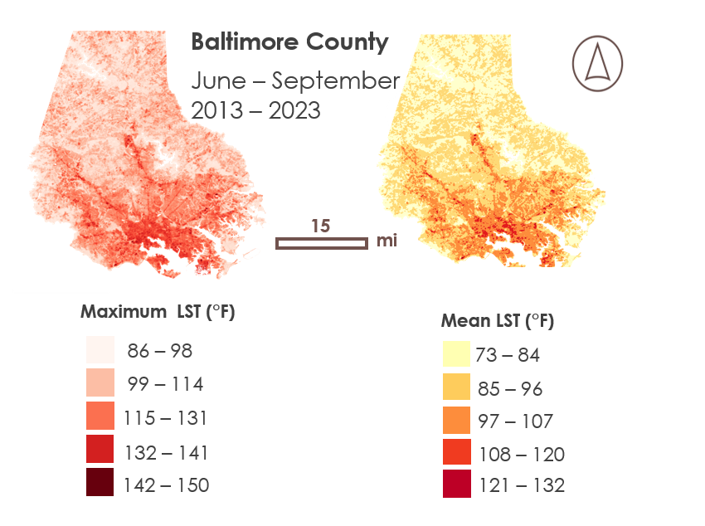

*Figure 2a.* Maximum Daytime LST for Baltimore City and County between June and September of 2013 to 2023. *Figure 2b***.** Mean Daytime LST for Baltimore City and County between June and September of 2013 to 2023.

A discernable pattern of heat clustering is observed in the city center and along roadways and major transit corridors, with water bodies excluded from the visualizations. The visual contrast in heat distribution between Baltimore City and its surroundings is striking. Specifically, the upper quartile of Baltimore County does not bear the same heat load as Baltimore City. With higher LST values, surfaces in Baltimore City retain larger quantities of heat. The areas registering the highest LST tend to be highly impervious, densely built-up, and often with low albedo. Consequently, they possess a greater capacity for heat absorption, leading to prolonged heat retention. Further, the concrete canopy of buildings and the built canyons impede the dispersion and dissipation of heat. It is important to note that while LST correlates somewhat with perceived heat, it does not accurately reflect the ambient air temperature experienced by people.

***4.1.2 Principal Component Analysis and Heat Vulnerability Distribution***

Our investigation revealed a concentration of extreme heat within Baltimore City. Due to the limitation of performing a PCA on multiple geographic regions simultaneously, our focus was exclusively on Baltimore City for this analysis. We conducted the PCA using four sociodemographic variables: (1) percent poverty, (2) percent ethnic minority, (3) percent over 65, and (4) percent no high school diploma in conjunction with natural and built environment indices (Table 4). The PCA produced three indices: (1) Heat Vulnerability Index Composite Score (HVI), (2) Heat Exposure Score (HES), and (3) Heat Priority Score (HPS). HVI assessed aggregated social vulnerability, while HES aggregated the natural and built environmental variables. The HPS aggregated social, natural, and built environmental variables to produce a composite human vulnerability score (Figure 3). Our analysis revealed that communities exhibiting high social vulnerability and high exposure, as indicated by HVI and HES respectively, also demonstrated elevated HPS. These communities, characterized by high sensitivity and high exposure, face increased challenges in adapting to heat stress. This finding aligns with our earlier observations (Section 4.1.1.) that heat-affected communities not only lack vegetative buffers, but also experience compounded social vulnerability, thereby exacerbating their ability to cope with heat.

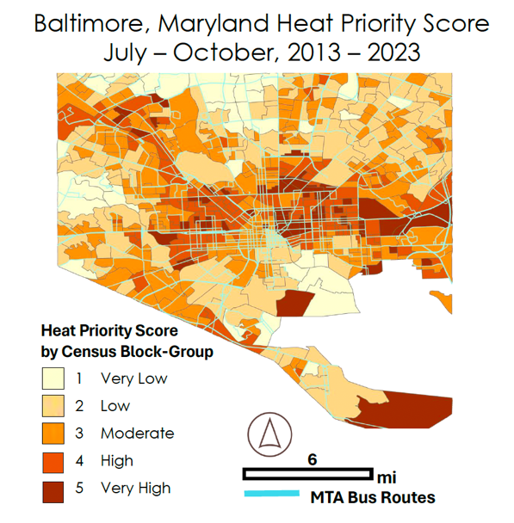

*Figure 3.* Heat Priority Scores of Baltimore City Block Groups between July to October of 2013 to 2023.

The analysis revealed that 32 percent of city census-blocks were classified as high or very priority according to the HPS, indicating elevated levels of both social vulnerability and heat exposure. This grouping of high HPS census-blocks, spreading from east to west across central Baltimore, underscores the concentrated vulnerability within these areas, necessitating targeted intervention. Notably, this region coincides with a significant portion of MTA serviced bus routes and experiences heavy traffic flow from both MTA users and single-passenger vehicles. These communities face heightened vulnerability to heat stress due to a lack of vegetative cover, financial resources, and inadequate infrastructure for adaptation.

***4.1.4. Identifying and Visualizing Vulnerable Bus Corridors***

Our analysis of MTA bus user data revealed that the North Penn Metro Station is the most heavily trafficked area in terms of bus usage. Serving as a vital transit hub connecting core services to the Baltimore Metro Subwaylink, this transit corridor emerges as a high-priority asset with significant impact on users. Furthermore, our examination indicated that the Metro Station is situated adjacent to an area classified as high to very high priority based on the HPS (Figure 4). This underscores the importance of considering heat vulnerability alongside transit usage when assessing the significance of transportation infrastructure.

*Figure 4.* Metro Ridership in Relation to Heat Priority Score; Zoom in to North Penn Metro Station

***4.1.5 Modeling High Vulnerability Bus Corridors***

We attempted to map thermal comfort in Baltimore by pinpointing areas of interest derived from our heat vulnerability findings. Among these areas, we identified the McElderry Park neighborhood situated along a major transit corridor in Southeast Baltimore. This choice was informed by its high heat priority score, spatial data availability, and moderate to high ridership rates according to MTA data. Notably, MTA Locallink routes 21 and 56 pass through and around the neighborhood. The resulting visualization and Tmrt values revealed significant heat accumulation in the neighborhood, particularly at ground level, where bus infrastructure and users are exposed. These findings corroborate the heat priority score calculated via the PCA. It is important to note that the Tmrt values are averaged over a 24-hour period and may not fully capture heat distribution during peak afternoon hours. Nevertheless, the data indicate sustained heat throughout the day. The left side of the visualization (Figure 4) exhibits a higher prevalence of cooler ‘pockets’ of land. This area of the neighborhood boasts more canopy cover and higher albedo due to roofing materials, both of which quantitatively reduce Tmrt even at ground level. These observations suggest that implementing patchy vegetative and shading interventions can effectively mitigate heat in the area.

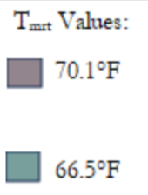

*Figure 5.* Mean Radiant Temperature Tmrt of a section of McElderry Park Neighborhood via SOLWEIG, mean over a 24-hour period; 15 August 2023.

**4.2 Discussion**

*4.2.1 Implications for Transit Service*

Our study aligns with existing scientific literature and previous DEVELOP projects, revealing the intricate nuances of urban heat and its implications for transportation systems. In Baltimore, our aim was to offer MTA informative visualizations to enhance their understanding of how UHI effects and extreme heat events impact their operations. We approached our analysis through an equity-oriented lens, shedding light on the complex interplay between social factors within a heat vulnerability framework.

One prominent finding from our research underscores the imperative of addressing both heat exposure and social vulnerability, as improvements in one aspect positively affect the other and vice versa. Baltimore’s aging infrastructure, particularly in downtown areas, is ill-equipped to mitigate extreme urban heat, and the coping capacity of many neighborhoods is inadequate. While studies have explored initiatives such as urban greening and innovative infrastructure upgrades, transportation services also have a pivotal role in mitigating urban heat (Veerkamp et al., 2021).

The MTA stands in a unique position to integrate urban heat resilience planning into their operations. Currently, bus on-time performance in Baltimore hovers around 72 percent, as of December 2023 (MDOT, 2024), with a short-term goal of reaching 80 percent. However, a more ambitious goal would not only enhance service reliability but also reduce user’s exposure to prolonged wait times during adverse summer conditions, ultimately encouraging greater utilization of MTA services. Furthermore, initiatives to promote core bus service utilization can significantly reduce car dependency in the city, thereby mitigating traffic congestion and emissions from single-occupancy vehicles. This approach also frees up resources for investment in sustainable initiatives such as electrifying the bus fleet and enhancing shade infrastructure as bus stops, consequently reducing heat vulnerability for both MTA assets and users. Our findings underscore the necessity of prioritizing interventions and actions within communities most vulnerable to heat stress, particularly those reliant on public transit for essential activities such as commuting and accessing amenities. Importantly, our research emphasizes that even empty buses contribute substantially to carbon emissions, highlighting the urgency of sustainable transportation strategies (Reason Foundation, 2010).

*4.2.2 Feasibility for Partner Use*

NASA EOs proved invaluable in characterizing urban heat dynamics at the macro scale. Landsat 8 TIRS played a crucial role by consistently providing heat data throughout our study period with its 100-meter resolution. Landsat 8 OLI provided additional natural and built-environmental data at a resolution of 30-meters that provided the context of environmental conditions that either exacerbated or diminished the intensity of heat events. An additional advantage we encountered with Landsat 8 was its pass over time over Baltimore, typically at 10:39 am local time, which was able to accurately and consistently capture peak heat conditions. Terra MODIS and Aqua MODIS satellites and sensors were integral to our analysis, allowing us to study nighttime LST and NDWI across our study area despite their coarse spatial resolution of 500 meters to one kilometer, which limited detailed nighttime heat assessments in Baltimore City, Terra MODIS provided a suitable alternative to ISS ECOSTRESS due to its consistent coverage throughout our study period and ease of access via various software tools. Although MODIS is scheduled for decommissioning, we encourage studies to explore its utility. For assessing thermal comfort via Tmrt, NASA EO products due to their insufficient resolution and lack of elevation data required for UMEP processing in SOLWEIG. Access to open-source, high resolution, up-to-date EO data is essential for addressing earth science inquiry. Leveraging NASA EOs was foundational to our study and holds promise for future urban energy and infrastructure investigations.

Our partners will have access to and can utilize & update the visualizations we created in the ArcGIS Pro platform for resiliency planning. They can follow our workflows by integrating elements of our HVI work into their existing resiliency toolbox. We used publicly accessible data throughout our project, thereby enhancing the MTA’s ability to replicate our work and extend it to analyze other types of transit and counties across Maryland.

**4.3 Limitations and Considerations**

*4.3.1 Limitations*

We encountered two main challenges: navigating the learning curve and streamlining workflows. On a technical level, limitations arose due to the high thermal band resolution for LST analysis being 100 meters, posing difficulties in pinpointing heat distribution block by block. Similar challenges were encountered with Aqua and Terra MODIS, which offered resolutions of 500 meters to 1 kilometer. Additionally, there were struggles in efficiently collecting the necessary data for various analyses. Time constraints forced us to hardcode additional variables into the PCA model without adequate validation, ultimately reverting to the original variables from the UHEAT 1.0. Another hurdle was the inability to obtain combined census data for Baltimore County and Baltimore City, as Tidycensus only accommodates census data acquisition for one geographic level. Attempts to run a Thermal Comfort Assessment (OTC) using the SOLWEIG Model in QGIS were hindered by the lack of recent spatial inputs, necessitating the use of outdated elevation data.

Given the outdated data used to run the SOLWEIG model, the results should be approached with skepticism. Furthermore, while SOLWEIG demonstrates better performance than other models such as RayMan and ENVI-met (Du et al. 2021), the inability to access current and usable data posed a significant obstacle to the model’s success in this project. Overall, the project faced a demanding schedule that required learning and adapting on the go, with tight turnarounds for deliverables. Despite utilizing all available tools, limited time and experience constrained the extent of our analysis. Given more time and opportunities to work with up-to-date data, a more comprehensive analysis could have been achieved.

*4.3.2 Considerations*

The lack of resources from partners presents a significant challenge as teams often struggle to acquire data that is inaccessible, unusable, or outdated. This perpetuates a cycle where these groups rely on third parties to access the necessary data and information for informed decision-making. This issue is a particularly concerning hurdle in the public sector, where some agencies lack access to up-to-date data essential for effective climate change adaptation and mitigation efforts. This dependency on external sources hinders partners’ ability to replicate our work successfully. Despite the hurdles encountered in obtaining usable data, particularly for input into the SOLWEIG model, we managed to provide the MTA with products that could be integrated into their existing ArcGIS Pro platform, enhancing their resiliency toolbox.

**4.4 Future Recommendations**

*4.4.1 HVI Improvements*

For future iterations of this project or similar endeavors, a more comprehensive HVI is strongly recommended. Due to time constraints, only four social variables were included in the construction of the HVI, which does not fully capture the complexity and diversity of vulnerable factors in urban communities. Originally, we intended to incorporate additional variables such as (1) percent unemployed, (2) houses built before 1980, and (3) percent non-English speaking. Additionally, given the project’s focus on the intersecting relationship between extreme heat, public transportation, and urban needs, transit-related data should have been integrated into the HVI. Suggestions for future transit-related variables include household vehicle ownership and proximity to public transit stops. Enriching the array of social variables within the HVI framework would provide a more comprehensive and holistic analysis of the true indicators of social vulnerability present in urban communities.

*4.4.2 Data Resolution*

While NASA EOs represent a crucial component of publicly available satellite and sensor data, there is a clear opportunity for NASA to leverage emerging technologies in their next generation of satellites and sensors that can provide higher resolution imagery and measurements. Advancements that enable higher resolution imagery and measurements would significantly enhance their accuracy and applicability of EOs in both research and broader earth science endeavors. Future urban heat studies stand to benefit from this enhanced granularity, facilitating more precise analysis of heat distribution and land cover trends over time. Additionally, data management presented a significant challenge for our team, reflecting broader issues encountered by society. In future work, we hope for enhanced accessibility and user-friendliness of data resources to streamline workflows and minimize the learning curve.

*4.4.3 Environmental Justice*

In the future, urban heat studies could greatly benefit from integrating a public outreach and community engagement component. This would involve informing communities experiencing extreme heat conditions about the associated dangers and encouraging them to share their lived experiences with organizations conducting these studies. Urban heat affects different demographics unequally, considering factors such as age, race, and socioeconomic status. By incorporating input from a diverse range of community members, agencies can develop tailored and effective mitigation strategies. This collaborative approach not only fosters trust but also empowers communities to actively participate in risk reduction efforts. Additionally, sharing information about the initiatives undertaken by organizations like the MTA can enhance transparency and instill optimism among communities regarding progress and future steps. Providing communities with insights into ongoing efforts can inspire and empower them to engage and contribute to these initiatives. With access to comprehensive heat data and input from the local communities, agencies can make informed decisions on implementing adaptive strategies in urban areas and safeguarding MTA assets from the impacts of extreme heat conditions.

# **5. Conclusions**

While previous heat vulnerability studies have been conducted in urban areas, this project sought to tackle the issue of vulnerability in conversation with public transportation, specifically core urban bus services. Through a comprehensive heat assessment, our team visualized heat distribution across Baltimore City and County. This data was then combined with social vulnerability parameters to analyze heat vulnerability distributions in Baltimore City. Additionally, the project delved deeper by providing a case study illustrating thermal comfort at bus stops in the city to facilitate further exploration and discussion by our partners of next steps forward in their resiliency planning and actions. These products will enable MTA to be a more informed and equitable stakeholder in its transportation operations in Baltimore City, Baltimore County and beyond as they grapple with increased pressures from urban heat.

Our work provides valuable insights for the MTA to identify areas where site-specific interventions can yield substantial reductions in overall heat vulnerability. By integrating bus user data with heat data, the MTA can establish a prioritization system for interventions targeting both users and assets, streamlining their heat resiliency planning efforts. Using the HPS system, the MTA can monitor progress, track changes, and set goals over time in identified neighborhoods (Figure 4). Furthermore, SOLWEIG modeling offers a benchmark assessment of thermal comfort for bus users in neighborhoods requiring heat mitigation interventions.

In the future, leveraging batch processing capabilities to run SOLWEIG for multiple areas of interest could enhance visualization of Tmrt conditions at various bus stops. This would enable the MTA to assign values to bus routes and assets, prioritizing feasible interventions within budgetary constraints. Ideally, the MTA can identify win-win opportunities that deliver high-impact resiliency interventions benefitting both users and assets. We encourage future urban heat studies and the MTA to explore synergies between heat vulnerability and transportation, utilizing heat mapping to overlay with different modal types. Furthermore, community-driven approaches, guided by environmental justice principles, should be central in future endeavors to ensure interventions effectively serve marginalized communities.

# **6. Acknowledgements**

We acknowledge those who contributed to the success of this project including, our partners from the MTA:

* Jennifer Martin, (MTA)
* Kokuei Chen (MTA)
* Lauren Molesworth (MTA)
* Kelly Lyles (MTA)
* Paola Ariza (MTA)
* Leah Visakowitz (MTA)
* Kyle Kim (MTA)
* LaToya Eff (MTA)

the DEVELOP Advisors:

* Stephanie Willsey, Center Lead at GSFC
* Sean McCartney, Science Advisor at GSFC
* Dr. Kent Ross, DEVELOP Program Manager
* Laramie Plott, DEVELOP Senior Fellow

and Outside Advisors:

* Blake Steiner, Former DEVELOP Participant
* Medhi Heris, Professor at Hunter College

Any opinions, findings, and conclusions or recommendations expressed in this material are those of the authors and do not necessarily reflect the views of the National Aeronautics and Space Administration.

This material is based upon work supported by NASA through contract 80LARC23FA024.

# **7. Glossary**

**Albedo** – the fraction of light that is reflected by a surface

**Cooling Capacity** –a measure of a system’s ability to remove hea**t**

**Canopy Digital Surface Model (CDSM) -** Represents the height of trees. Not an elevation value, rather the height or distance between the ground and the top of the trees (or buildings or whatever object that the lidar system detected and recorded) **De jure segregation**- Refers to regulations, policies and laws enacted by government entities that promote racial segregation

**De facto segregation-** Refers to segregation of racial groups that exists despite being unenforceable by law

**Digital Elevation Model (DEM) –** a 3D representation of the bare ground (bare earth) topographic surface of the Earth excluding trees, buildings, and any other surface objects

**Digital Surface Model (DSM) –** a 3D an elevation model that captures both the environment's natural and artificial features

**Earth Observations (EO)** – Satellites and sensors that collect information about the Earth’s physical, chemical, and biological systems over space and time

**Evapotranspiration (ET)** – the sum of evaporation of water from land and other surfaces and through transpiration by plants

**Google Earth Engine (GEE)** – Open-source application programming interface that allows users to access satellite imagery and other geospatial data through the GEE catalogue

**Hotspots** – areas of high land surface temperature

**Landsat 8** – an American Earth-imaging satellite in collaboration between NASA and the United States Geological Survey, launched on February 11, 2013

**Land Surface Temperature (LST**) – the temperature of the surface of the Earth

**MODIS** – Moderate Resolution Imaging Spectroradiometer

**Normalized Difference Building Index (NDBI)** – Index that measures the amount of building density in a given area

**Normalized Digital Surface Model (nDSM) -** Represents the height of features above ground, rather than the elevation of features relative to mean sea level, or an ellipsoid. These relative height values are essential for estimating vegetation height

**Normalized Difference Vegetation Index (NDVI)** – Index that measures the amount of healthy vegetation in a given area

**Normalized Difference Water Index (NDWI)** –Index that measures the amount of water content present in a given area and used for identifying water bodies

**Operational Land Imager (OLI)** – sensor aboard the Landsat 8 satellite that measures visible, near-infrared, and shortwave infrared wavelengths

**R** – Programming language utilized for statistical computing and data visualization

**QGIS** – Open-source geographic information system

**SOlar and LongWave Environmental Irradiance Geometry model (SOLWEIG)** – 3-D Model used to calculate outdoor thermal comfort

Tidycensus – Package within R programming language to extract U.S. Census data

**Thermal Infrared Sensor (TIRS)** – sensor aboard the Landsat 8 satellite that measures both Earth’s surface temperature and atmosphere temperature

**Urban Multiscale Environmental Predictor (UMEP) -** a climate service tool, presented as a plugin for QGIS. This tool can be used for a variety of applications related to outdoor thermal comfort, urban energy consumption, climate change mitigation etc. and consists of a coupled modelling system which combines “state of the art” 1D and 2D models related to the processes essential for scale independent urban climate estimations.

**Urban Heat Island (UHI)** – Anomaly in which urban areas experience higher temperatures than their rural counterparts

# **8. References**

Barbakova, T., Agrawal, A., Trakas, A. Pecsok, K. Mahoney, L. (2021). *Yonkers Urban Development: Leveraging*

*NASA Earth Observations to Support Modeling Urban Cooling Interventions and Urban Heat Vulnerability in Yonkers, New York* [Unpublished Manuscript]. NASA DEVELOP National Program, Arizona –

Tempe.

Bo-cai Gao (1996). *NDWI—A normalized difference water index for remote sensing of vegetation liquid water from space*, Remote Sensing of Environment, 58, 3, 257-266.

Boogaard, S., Dialesandro, J., Steiner, B., Pang A. (2020). *Tempe Urban Development II: Establishing an Urban Heat Exposure Score for Infrastructure Prioritization in Tempe, Arizona, Using NASA Earth Observations and*

*LiDAR* [Unpublished Manuscript]. NASA DEVELOP National Program, Arizona – Tempe.

Boone, C. G., Fragkias, M., Buckley, G. L., & Grove, J. M. (2014). A long view of polluting industry and environmental justice in Baltimore. *Cities*, *36*, 41–49. <https://doi.org/10.1016/j.cities.2013.09.004>

Brown, L. T. (2022). *The Black Butterfly the Harmful Politics of Race and Space in America*. Johns Hopkins University Press.

CDC (U.S. Centers for Disease Control and Prevention). 2020. Indicator: Hear-related mortality. National

Environmental Public Health Tracking Network. Accessed in February 2024.

[https://ephtracking.cdc.gov](https://ephtracking.cdc.gov/)

Cheng, W., Li, D., Liu, Z., & Brown, R. D. (2021). Approaches for identifying heat-vulnerable populations and locations: A systematic review.

<https://www.sciencedirect.com/science/article/pii/S0048969721044910?via%3Dihub>

Climate Check, CMIP5 multi-model ensemble dataset. (2024). *Baltimore, Maryland Climate Change Risks and*  *Hazards: Precipitation, Heat, and Drought*.

Cutter, S. L., Boruff, B. J., & Shirley, W. L. (2003). Social Vulnerability to Environmental Hazards n. In *699 Social Science Quarterly* (Vol. 84). https://doi.org/10.1111/1540-6237.8402002

Dialesandro, J., Kruskopf, M., Vargas, M., Marvin, M.(2021). *San Diego Urban Development AZ: Utilizing NASA Earth Observations to Identify Drivers of Extreme Urban Heat and Generate a High-Resolution Vulnerability Index for Urban Planning and Climate Resiliency in San Diego, California* [Unpublished Manuscript] NASA DEVELOP National Program, Arizona – Tempe

Grove, M., Ogden, L., Pickett, S., Boone, C., Buckley, G., Locke, D. H., Lord, C., & Hall, B. (2017). The legacy effect: Understanding how segregation and environmental injustice unfold over time in Baltimore. *Annals of the American Association of Geographers*, *108*(2), 524–537. <https://doi.org/10.1080/24694452.2017.1365585>

Harlan, S. L., Brazel, A. J., Prashad, L., Stefanov, W. L., & Larsen, L. (2006). Neighborhood microclimates and vulnerability to heat stress. *Social Science &amp; Medicine*, *63*(11), 2847–2863. <https://doi.org/10.1016/j.socscimed.2006.07.030>

Harlan, S. L., Declet-Barreto, J. H., Stefanov, W. L., & Petitti, D. B. (2013). Neighborhood effects on heat deaths: Social and environmental predictors of vulnerability in Maricopa County, Arizona. *Environmental Health Perspectives*, *121*(2), 197–204. <https://doi.org/10.1289/ehp.1104625>

Hsu, A., Sheriff, G., Chakraborty, T., & Manya, D. (2021). Disproportionate exposure to urban heat island intensity across major US cities. *Nature Communications*, *12*(1). <https://doi.org/10.1038/s41467-021-22799-5>

IPCC (2023). *Chapter 11: Weather and Climate Extreme Events in a Changing Climate*. IPCC Sixth Assessment Report Working Group 1: The Physical Science Basis. <https://www.ipcc.ch/report/ar6/wg1/downloads/report/IPCC_AR6_WGI_Chapter11.pdf>

Iqbal, N., Ravan, M., Jamshed, A., Birkmann, J., Somarakis, G., Mitraka, Z., & Chrysoulakis, N. (2022). Linkages between typologies of existing urban development patterns and human vulnerability to heat stress in Lahore. *Sustainability*, *14*(17), 10561. <https://doi.org/10.3390/su141710561>

Kauh, T. J., Read, J. G., & Scheitler, A. J. (2021). The Critical Role of Racial/Ethnic Data Disaggregation for Health Equity. *Population research and policy review*, *40*(1), 1–7. <https://doi.org/10.1007/s11113-020-09631-6>

Keyes, N., McLaren, C., Phan, N., & Vazquez, D. (2022). *Milwaukee Urban Development II VEJ: Assessing*

*Climate Vulnerability through InVEST Models on Urban Cooling in Milwaukee Using NASA Earth Observations* [Unpublished Manuscript]. NASA DEVELOP National Program, Virtual Environmental Justice.

Kessler, K., Gross, H., Larson, J., Nayak, A. (2023). *Portland Urban Development VEJ: Quantifying and Visualizing*

*Urban Heat with Compounding Vulnerabilities to Support Community Depaving Initiatives* [Unpublished

Manuscript]. NASA DEVELOP National Program, Virtual Environmental Justice.

Kim, Y., Li, D., Xu, Y., Zhang, Y., Li, X., Muhlenforth, L., Xue, S., & Brown, R. (2023). Heat vulnerability and street-level outdoor thermal comfort in the City of Houston: Application of google street view image derived svfs. *Urban Climate*, *51*, 101617. <https://doi.org/10.1016/j.uclim.2023.101617>

Kirsch, S., Hocknell, J., Roseto, M., Tomlinson, C. (2024). *Bridgeport Urban Development MA: Leveraging NASA*  *Earth Observations and Sociodemographic Data to Asssess Urban Heat Vulnerability and Inform Cool Corridors*  *in Bridgeport, Connecticut* [Unpublished Manuscript]. NASA DEVELOP National Program, Massachusetts.

Lindberg, F. and Grimmond, C. (2011) Nature of vegetation and building morphology characteristics across a city: Influence on shadow patterns and mean radiant temperatures in London. [Urban Ecosystems 14:4, 617-634.](https://link.springer.com/article/10.1007/s11252-011-0184-5)

Lindberg, F, Grimmond, C., Gabey, A., Jarvi, L., Kent, C.W., Krave, N., Sun, T., Wallenberg, N., & Ward, H.C. (2019). *Urban Multi-scale Environmental Predictor (UMEP) Manual University of Reading UK, University of Gothenburg Sweden, SIMS China.*[*https://umep-docs.readthedocs.io/*](https://umep-docs.readthedocs.io/)

Manware, M., Dubrow, R., Carrión, D., Ma, Y., & Chen, K. (2022). Residential and race/ethnicity disparities in heat vulnerability in the United States. *GeoHealth*, *6*(12). <https://doi.org/10.1029/2022gh000695>

Martin-Vide, J., Sarricolea, P., & Moreno-García, M. C. (2015). On the definition of urban heat island intensity: The “rural” reference. *Frontiers in Earth Science*, *3*. <https://doi.org/10.3389/feart.2015.00024>

Maryland Department of the Environment; Scientific and Technical Working Group Maryland Commission on Climate Change. (2020). (rep.). *Comprehensive Assessment of Climate Change Impacts in Maryland* (pp. 1–92).

Maryland Geological Survey. (2024). *Geography fact sheets*. Maryland Geology. <http://www.mgs.md.gov/geology/>

MDOT. (2024). *MTA Performance Improvement*. Maryland Transit Administration. <https://www.mta.maryland.gov/performance-improvement>

Nazarian, N., Krayenhoff, E. S., Bechtel, B., Hondula, D. M., Paolini, R., Vanos, J., Cheung, T., Chow, W. T., de Dear, R., Jay, O., Lee, J. K., Martilli, A., Middel, A., Norford, L. K., Sadeghi, M., Schiavon, S., & Santamouris, M. (2022). Integrated assessment of urban overheating impacts on human life. *Earth’s Future*, *10*(8). <https://doi.org/10.1029/2022ef002682>

Nguyen, K.-A., & Liou, Y.-A. (2019). Mapping global eco-environment vulnerability due to human and nature disturbances. *MethodsX*, *6*, 862–875. <https://doi.org/10.1016/j.mex.2019.03.023>

Niu, Y., Li, Z., Gao, Y., Liu, X., Xu, L., Vardoulakis, S., Yue, Y., Wang, J., & Liu, Q. (2021). A systematic review of the development and validation of the heat vulnerability index: Major factors, methods, and spatial units. *Current Climate Change Reports*, *7*(3), 87–97. <https://doi.org/10.1007/s40641-021-00173-3>

Phillips de Lucas, A. K. (2020). Producing the “Highway to nowhere”: Social understandings of space in Baltimore, 1944-1974. *Engaging Science, Technology, and Society*, *6*, 351–369. <https://doi.org/10.17351/ests2020.327>

Quinn Jr. , K., Plano, B., & Calhoun, J. (2020). *MTA Office of Equal Opportunity Compliance Programs*. Maryland Transit Administration (MTA) 2020-2023 Title VI Implementation Program. <https://s3.amazonaws.com/mta-website-staging/mta-website-staging/files/Title%20VI/MTA_TitleVIProgram_2020-2023_05.15.2020.pdf>

Reason Foundation, & Moore, A. (2010, April 5). *Does bus transit reduce greenhouse gas emissions?*. Reason Foundation. <https://reason.org/commentary/does-bus-transit-reduce-greenhouse/>

Schindelman, T., Culling, E., Mendez German, G., Chapman J. (2023). *New York City Transportation and Infrastructure: Assessing Urban Heat Island Effects at Bus Stops in New York City to Support Cooling Interventions* [Unpublished Manuscript]. NASA DEVELOP National Program, Virtual Environmental Justice.

Song, J., Yu, H., & Lu, Y. (2021). Spatial-scale dependent risk factors of heat-related mortality: A multiscale geographically weighted regression analysis. *Sustainable Cities and Society*, *74*, 103159. <https://doi.org/10.1016/j.scs.2021.103159>

Szagri, D., Nagy, B., & Szalay, Z. (2023). How can we predict where heatwaves will have an impact? – A literature review on Heat vulnerability indexes. *Urban Climate*, *52*, 101711. <https://doi.org/10.1016/j.uclim.2023.101711>

U.S. Census Bureau. (2022). *U.S. Census Bureau Quickfacts: Baltimore City, Maryland*. Population Estimates, July 1, 2022.

U.S. Geological Survey. (n.d.)Landsat Normalized Difference Vegetation Index | U.S. Geological Survey. [www.usgs.gov/landsat-missions/landsat-normalized-difference-vegetation-index?qt-science_support_page_related_con=0#qt-science_support_page_related_con](http://www.usgs.gov/landsat-missions/landsat-normalized-difference-vegetation-index?qt-science_support_page_related_con=0#qt-science_support_page_related_con).

U.S. Geological Survey. (n.d.) USGS EROS Archive – Landsat Archives – Landsat 8-9 OLI/TIRS Collection 2 Level-2 Science Products. [https://doi.org/10.5066/P9OGBGM6.](https://doi.org/10.5066/P9OGBGM6)

Veerkamp, C. J., Schipper, A. M., Hedlund, K., Lazarova, T., Nordin, A., & Hanson, H. I. (2021). A review of studies assessing ecosystem services provided by Urban Green and Blue Infrastructure. *Ecosystem Services*, *52*, 101367. <https://doi.org/10.1016/j.ecoser.2021.101367>

Wan, Z., Hook, S., Hulley, G. (2021). *MODIS/Terra Land Surface Temperature/Emissivity 8-Day L3 Global 1km SIN Grid V061* [Data set]. NASA EOSDIS Land Processes Distributed Active Archive Center. Accessed 2024-04-25 from <https://doi.org/10.5067/MODIS/MOD11A2.061>

Wilson, B. (2020). Urban heat management and the legacy of Redlining. *Journal of the American Planning Association*, *86*(4), 443–457. <https://doi.org/10.1080/01944363.2020.1759127>

# **9. Appendices**

**Appendix A**

**The Butterfly Effect**

Our mapping of environmental vulnerability in ArcGIS Pro yielded findings that align with the phenomenon known as the Butterfly Effect, as described in existing literature. This effect reflects historical legacies such as redlining, which led to the segregation of ethnic communities from predominantly white areas. Our analysis revealed that this historical segregation not only influences social vulnerability but also contributes significantly to heat vulnerability These findings underscore the importance of addressing social vulnerabilities in resilience efforts, as reducing social vulnerability correlates positively with reducing heat vulnerability.

Within the city limits, our analysis uncovered finer inequities. For example, our visualization of the Normalized Difference Built-Up Index (NDBI) indicated a concentration of impervious surfaces in downtown Baltimore and its eastern and western regions, while northern Baltimore, characterized by higher concentrations of wealth and white populations, exhibited lower concentrations of impervious surfaces. This suggests that residents and commuters in northern Baltimore experience lower exposure to heat and possess higher adaptive capacities.

Our final bivariate visualization further supports these intra-cities heat spatial patterns and supports (Morgan State University’s) Dr. Lawrence Brown’s “black butterfly” effect, which illustrates the butterfly-shape of segregated black communities across the city’s east and west sides. Notably, both the eastern and western halves of the city exhibit high heat vulnerability scores and a high percentage of minority populations.

These findings emphasize the imperative of incorporating equity considerations into heat studies and highlight the growing need to explore the intersections and hidden dimensions of climate change (Figure A1).

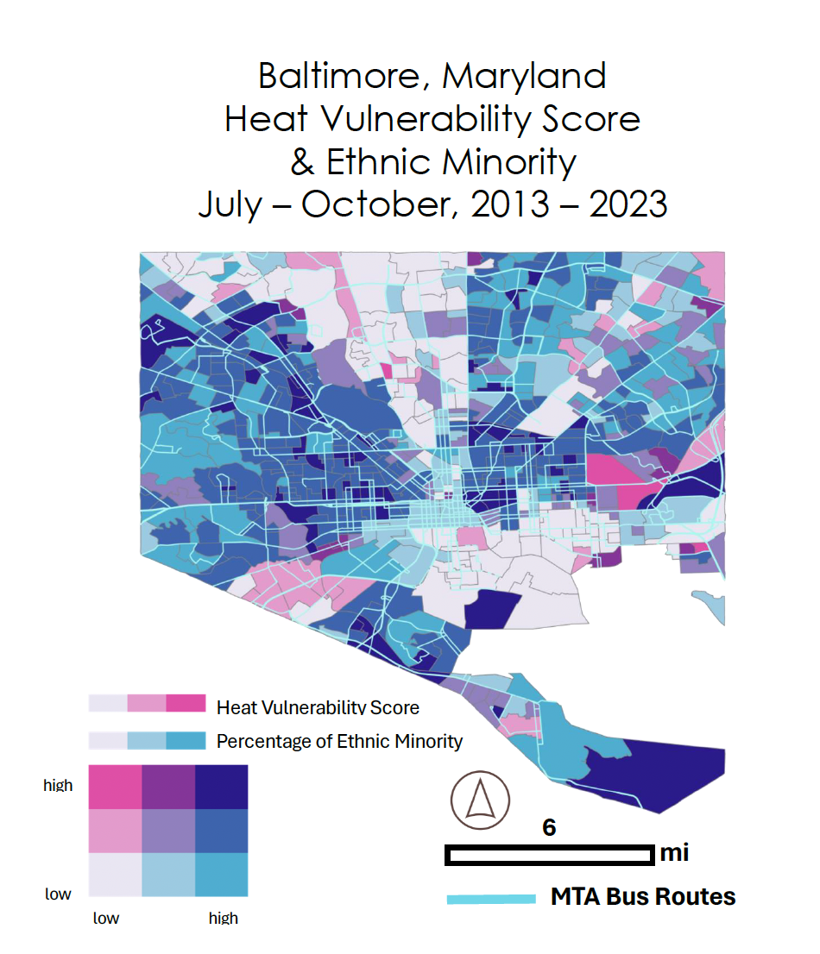

*Figure A1*. Bivariate Map of Baltimore, Maryland’s Heat Vulnerability Score and Percentage of Ethnic Minority between July to October from 2013 to 2013.