**NASA DEVELOP National Program**



Colorado – Fort Collins

*Fall 2017*

Intermountain West Ecological Forecasting

Utilizing NASA Earth Observations to Forecast Forest Vulnerability to

Bark Beetle Attack in Support of a Forest Bioenergy Feasibility Assessment

**Technical Report**

Final Draft – November 16, 2017

Julia Sullivan (Project Lead)

Jillian LaRoe

Timothy Mayer

Jennifer Mehren

Gary Olds

Dr. Paul Evangelista, Colorado State University, Natural Resource Ecology Laboratory (Science Advisor)

Dr. Amanda West, Colorado State University, Natural Resource Ecology Laboratory (Science Advisor)

Anthony Vorster, Colorado State University, Natural Resource Ecology Laboratory (Mentor)

Brian Woodward, Colorado State University, Natural Resource Ecology Laboratory (Mentor)

# 1. Abstract

The mountain pine beetle (*Dendroctonus ponderosae*) is an endemic species and a natural driver of forest ecosystems. This beetle has impacted millions of acres of coniferous forest in the western United States since the early 2000s. Forest ecosystems provide critical habitat for wildlife, filter air, improve water quality, offer erosion control, and sequester carbon. In addition to their ecological importance, pine forests provide economic services; they are sources of timber production and serve as a backdrop for recreation. Drought, coupled with warming temperatures, has increased the vulnerability of forests, specifically lodgepole pine (*Pinus contorta*), to bark beetle epidemics. Though recent attacks have largely subsided, major outbreaks in the future are likely due to the cyclical nature of bark beetle attacks. The forests at greatest risk to future mountain pine beetle outbreaks are those with higher proportions of live lodgepole pine host trees. This project identified these vulnerable forests by mapping existing live lodgepole pine. The team utilized Google Earth Engine to map forest structure across Colorado, Idaho, Montana, and Wyoming using topographic data from NASA’s Shuttle Radar Topography Mission (SRTM) in conjunction with spectral imagery from Landsat 5 Thematic Mapper (TM), and Landsat 8 Operational Land Imager (OLI) and Thermal Infrared Sensor (TIRS). These resulting lodgepole pine map products will inform forest monitoring efforts and assessment of the feasibility of using beetle-killed wood as a biofuel for end users at the Bioenergy Alliance Network of the Rockies (BANR).

**Keywords**: forecasting, lodgepole pine, mountain pine beetle, outbreak, Random Forest, Risk assessment, Remote sensing,

# 2. Introduction

* 1. ***Background Information***

The mountain pine beetle (*Dendroctonus ponderosae*) has impacted approximately 6.5 million hectares of forest throughout the intermountain west which includes Colorado, Idaho, Montana, and Wyoming (Bentz et al., 2010). As an endemic species, the mountain pine beetle is an essential component of forest ecosystem dynamics. However, the recent cycle of mountain pine beetle outbreaks, from 2001 to 2010, has resulted in some of the largest and most severe mortality of lodgepole pine (*Pinus contorta*), creating new challenges in forest management (Bentz et al., 2010; Cohen et al., 2016).

Susceptibility of host pine trees to mountain pine beetle outbreak depend on three main factors: climate, beetle pressure, and forest structure. Drought and warming conditions negatively impact these trees, especially lodgepole pine (Chapman, Veblin, & Schoennagel, 2012). Beetle pressure in this case is defined as population size of the mountain pine beetle. Forest structure, specifically age, diameter, and density, is also critical for understanding susceptibility to mountain pine beetle. Older, larger, and more dense stands are more often attacked (Chapman, Veblin, & Schoennagel, 2012). Risk, defined as the short-term expectancy of mortality from mountain pine beetle, is a function of the three factors going into susceptibility (Bone, Wulder, White, Robertson, & Nelson, 2013). Because the mountain pine beetle prospers in these altered environmental conditions, it results in the expansion of suitable habitat both climatically and geographically (Sidder et al., 2016). Identifying susceptible forest stands at risk to beetle attacks aids in the mitigation and prevention of outbreaks as well as informing managers in utilizing beetle-killed wood in bioenergy production (Bone, Wulder, White, Robertson, & Nelson, 2013). Limitations exist in that climate and beetle pressure cannot be accurately predicted. Forest structure is a greater focus because it can be assessed using remote sensing processes.

Attacking host pine trees and laying eggs from mid-July to early-August, the beetle life cycle is completed when the next generation of beetles in the following year (Goodwin et al., 2008). Population level large scale beetle attacks on lodgepole pine reduce individual tree defense mechanisms. An array of fungi and bacteria vectored by the beetle disrupt translocation of nutrients within the host pine tree, furthering the decline of the trees defense mechanisms (Raffa et al., 2008). From these effects tree mortality begins in late-summer and early-autumn, with needles transitioning from green to red, and then finally to gray (Goodwin et al., 2008). Beetle populations across the intermountain region have declined in the past ten years (Vorster et al., 2017).

There are currently available spatial data utilized by forest managers from sources such as aerial detection surveys (United States Forest Service, 2017), Forest Inventory and Analysis (United States Forest Service, 2017), Landscape Fire and Resource Management Planning Tool (LANDFIRE, 2016), Forest Health Technology Enterprise Team (United States Forest Service, 2017), and host pine tree maps. These maps are useful for general reference but are not comprehensive; they may only display lodgepole pine habitat and no bark beetle impact, or may display both but at a poor resolution.

An objective of this project is to provide a scalable methodology which can be utilized by land managers to detect both live as well as dead lodgepole pine across a large study area.

* 1. ***Project Partners & Objectives***

DEVELOP partnered with the Bioenergy Alliance Network of the Rockies (BANR), which is a network of academic researchers, federal agencies, industry leaders, and policy makers interested in addressing the feasibility of utilizing insect-killed trees for bioenergy. Part of BANR’s work looks to locate and quantify both live and dead forest biomass. This project provides BANR with information which guides the assessment of the economic, social, and environmental feasibility of using beetle-killed wood for bioenergy. DEVELOP enabled BANR to assess mountain pine beetle at a large scale utilizing NASA Earth Observations while providing a reproducible methodology across the region.

We addressed the ecological forecasting national application area of NASA’s Applied Sciences Program, using NASA Earth observations. This project facilitated a more comprehensive analysis of the feasibility of harvesting beetle-killed wood. These results will be integrated into BANR’s decision making processes.

It is difficult to model both altered climatic conditions as well as beetle pressure. Further understanding of the forest structure, especially the geographic distribution of live and dead trees, can provide managers within sight towards bark beetle attack severity as well as forest stands at potential risk as a means to more effectively manage forest.

The objectives of this project were to produce separate maps indicating live and dead lodgepole pine following the recent severe mountain pine beetle outbreak across the Intermountain West Region. Live lodgepole pine cover distinguishes areas at potentially heightened risk to future mountain pine beetle outbreaks. The production of current dead lodgepole pine cover captures the impact of recent mountain pine beetle outbreaks allowing BANR to identify prospective areas that may have sufficient amounts of beetle-kill wood to merit locating a bioenergy facility.

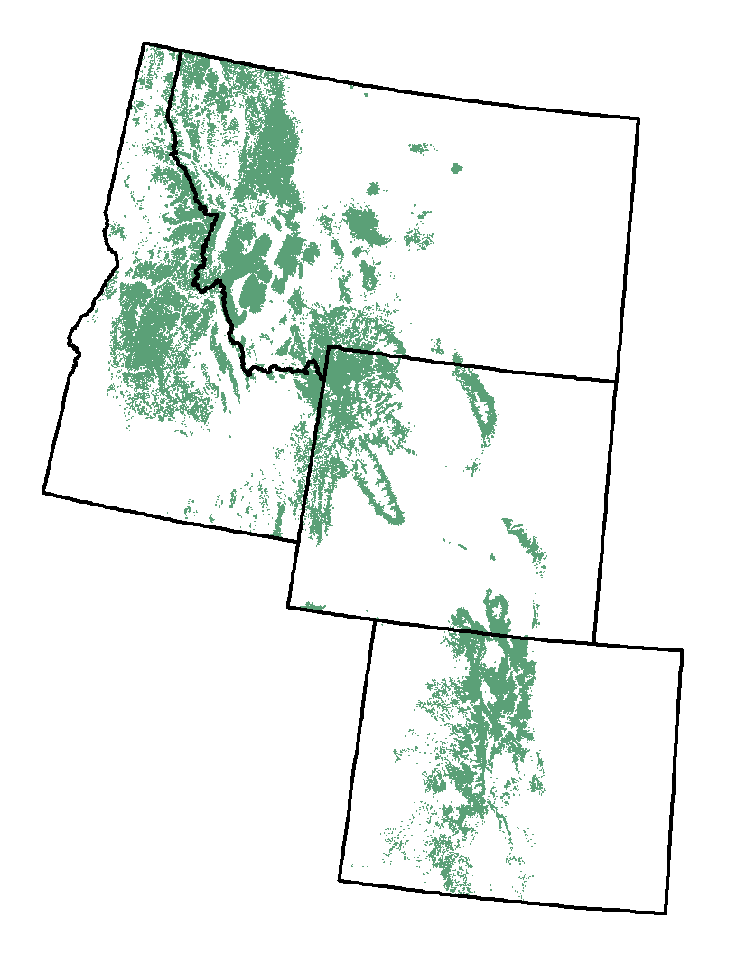

Lodgepole pine

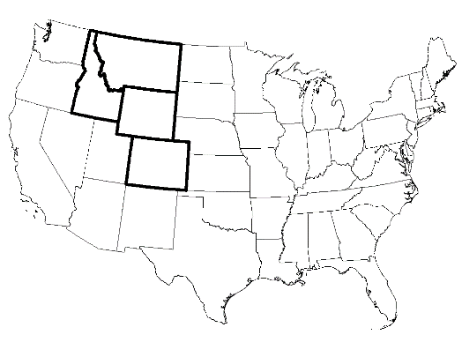

**Figure 1.** Intermountain West study area and lodgepole pine extent (source: LANDFIRE).

# 

# 3. Methodology

***3.1 Data Acquisition***

This study examined lodgepole pines stands across coniferous forests in Colorado, Idaho, Montana, and Wyoming (the intermountain west) for the years 2000 and 2013 which denote the beginning and end of the most recent mountain pine beetle outbreak. The time between June and October is known for beetle outbreak and the resulting tree mortality, so these months were specifically targeted for inquiry. This study period was chosen to compare the change in percent live forest (i.e. forest not impacted by mountain pine beetle) over the thirteen-year period to gauge the extent and severity of the recent outbreak.

We acquired Landsat 5 Thematic Mapper (TM) and Landsat 8 Operational Land Imager (OLI) and Thermal Infrared Sensor (TIRS) satellite imagery for the intermountain west for the years 2000 and 2013 using Google Earth Engine’s coding interface. Imagery for each year (2000 and 2013) between July and October with less than 30% cloud cover was composited with a median reducer for each year to minimize the inclusion of deciduous forest cover and normalize spectral values across the spatial and temporal scales. The Landsat imagery obtained was preprocessed to surface reflectance (spectral bands) and top of atmosphere brightness temperature (thermal) within this time period (Table 1). Specifically, for the normalized difference vegetation and wetness indices (Table 3, NDVI and NDWI), the 32-day composite products from NASA were used within September of each year. A 30 m Shuttle Radar Topography Mission (SRTM) digital elevation model was also acquired via Google Earth Engine.

**Table 1.** Landsat 5 TM and 8 OLI and TIRS spectral band designation, wavelength, and resolution (Barsi, Lee, Kvaran, Markham, & Pedelty, 2014).

|  |  |  |  |  |  |
| --- | --- | --- | --- | --- | --- |
| Band Name | Landsat 5 TM | Landsat 8 OLI and TIRS | Wavelength Landsat 5 TM (micrometers) | Wavelength Landsat 8 OLI and TIRS (micrometers) | Resolution (meters) |
| Ultra Blue | N/A | Band #1 | N/A | 0.435 - 0.451 | 30 |
| Blue | Band #1 | Band #2 | 0.45-0.52 | 0.452 - 0.512 | 30 |
| Green | Band #2 | Band #3 | 0.52-0.60 | 0.533 - 0.590 | 30 |
| Red | Band #3 | Band #4 | 0.63-0.69 | 0.636 - 0.673 | 30 |
| Near Infrared  **(Nir)** | Band #4 | Band #5 | 0.76-0.90 | 0.851 - 0.879 | 30 |
| Short Wave Infrared 1 **(Swir1)** | Band #5 | Band #6 | 1.55-1.75 | 1.566 - 1.651 | 30 |
| Short Wave Infrared 2 **(Swir2)** | Band #7 | Band #7 | 2.08-2.35 | 2.107 - 2.294 | 30 |
| Thermal | Band #6 | Band #10 (TIRS 1)  Band #11 (TIRS 2) | 10.40-12.50 | 10.60 - 11.19  11.50 - 12.51 | Landsat 5 = 120*30  Landsat 8 = 100*30 |
| Panchromatic | N/A | Band #8 | N/A | 0.503 - 0.676 | 15 |
| Cirrus | N/A | Band #9 | N/A | 1.363 - 1.384 | 30 |

**Table 2.** Tasseled Cap Transformation coefficients for Landsat 5 and Landsat 8 (Baig, Zhang, Shuai, & Tong, 2014; Huang, Wylie, Yang, Homer, & Zylstra, 2002).

|  |  |  |  |  |  |  |  |
| --- | --- | --- | --- | --- | --- | --- | --- |
| Landsat 5 TM | | | | Landsat 8 OLI | | | |
| Band Name | Tasseled Cap Brightness Coefficient | Tasseled Cap Greenness Coefficient | Tasseled Cap Wetness Coefficient | Band Name | Tasseled Cap Brightness Coefficient | Tasseled Cap Greenness Coefficient | Tasseled Cap Wetness Coefficient |
| Band 1 (Blue) | 0.2043 | -0.1603 | 0.0315 | Band 2 (Blue) | 0.3029 | -0.2941 | 0.1511 |
| Band 2 (Green) | 0.4158 | -0.2819 | 0.2021 | Band 3 (Green) | 0.2786 | -0.243 | 0.1973 |
| Band 3 (Red) | 0.5524 | - 0.4934 | 0.3102 | Band 4 (Red) | 0.4733 | -0.5424 | 0.3283 |
| Band 4 (Nir) | 0.5741 | 0.7940 | 0.1594 | Band 5 (Nir) | 0.5599 | 0.7276 | 0.3407 |
| Band 5 (Swir 1) | 0.3124 | -0.0002 | -0.6806 | Band 6 (Swir 1) | 0.508 | 0.0713 | -0.7117 |
| Band 7 (Swir 2) | 0.2303 | -0.1446 | -0.6109 | Band 7 (Swir 2) | 0.1872 | -0.1608 | -0.4559 |

**Table 4.** The spectral and topographic variables used as inputs to Random Forest. These variables were filtered and the top predictors were selected using rfUtilities to be used as inputs to the separate live and dead lodgepole pine models.

**Table 3.** Spectral Indices derived for 2000 and 2013 from Landsat 5 TM and Landsat 8 OLI.

|  |  |
| --- | --- |
| **Spectral Index** | **Formula** |
| Normalized Difference Vegetation Index  **(NDVI)** | (Nir – Red)  (Nir + Red) |
| Normalized Difference Wetness Index  **(NDWI)** | (Green – Nir)  (Green+ Nir) |
| Normalized Difference Moisture Index  **(NDMI)** | (Nir – Swir1)  (Nir + Swir1) |
| Normalized Difference Soil Index  **(NDSI)** | (Swir2 – Green)  (Swir2 + Green) |
| Green Red Vegetation Index  **(GRVI)** | (Green – Red)  (Green + Red) |
| Normalized Burn Ratio  **(NBR)** | (Nir – Swir2)  (Nir + Swir2) |
| Aspect **(North)** | sin((aspect/180) × π) |
| Aspect **(East)** | cos((aspect/180) × π) |

|  |  |
| --- | --- |
| **Environmental Predictor Variables** | |
| **Spectral Variables** | **Topographic Variables** |
| Each Spectral Band (Table 1) | Elevation |
| NDVI | Slope |
| NDWI | Aspect (North) |
| NDMI | Aspect_1 (East) |
| NDSI |
| GRVI |
| NBR |
| TCB (Tasseled Cap Brightness) |
| TCG (Tasseled Cap Greenness) |
| TCW (Tasseled Cap Wetness) |
| Differenced 2013 – 2000 for each spectral variable |

***3.2 Field Data***

Field data was obtained for percent live and dead lodgepole pine as a training dataset for a random forest model. We created 1,000 random sampling points within a lodgepole pine mask acquired from the Landscape Fire and Resource Management Planning Tools Program (LANDFIRE, 2016). We then generated 30 m quadrats based off the sampling point which were aligned with Landsat pixels. Ocular imagery surveys of percent live and dead tree cover using 2012 (WY) and 2013 (CO, MT, ID) National Agriculture Imagery Program (NAIP). These years were selected based on the end of the beetle outbreak and availability of NAIP imagery. We categorized percent cover for live lodgepole pine, dead lodgepole pine, shadow (topographic shadow introduced via NAIP), and other (i.e. bare ground, urban, water, etc.).

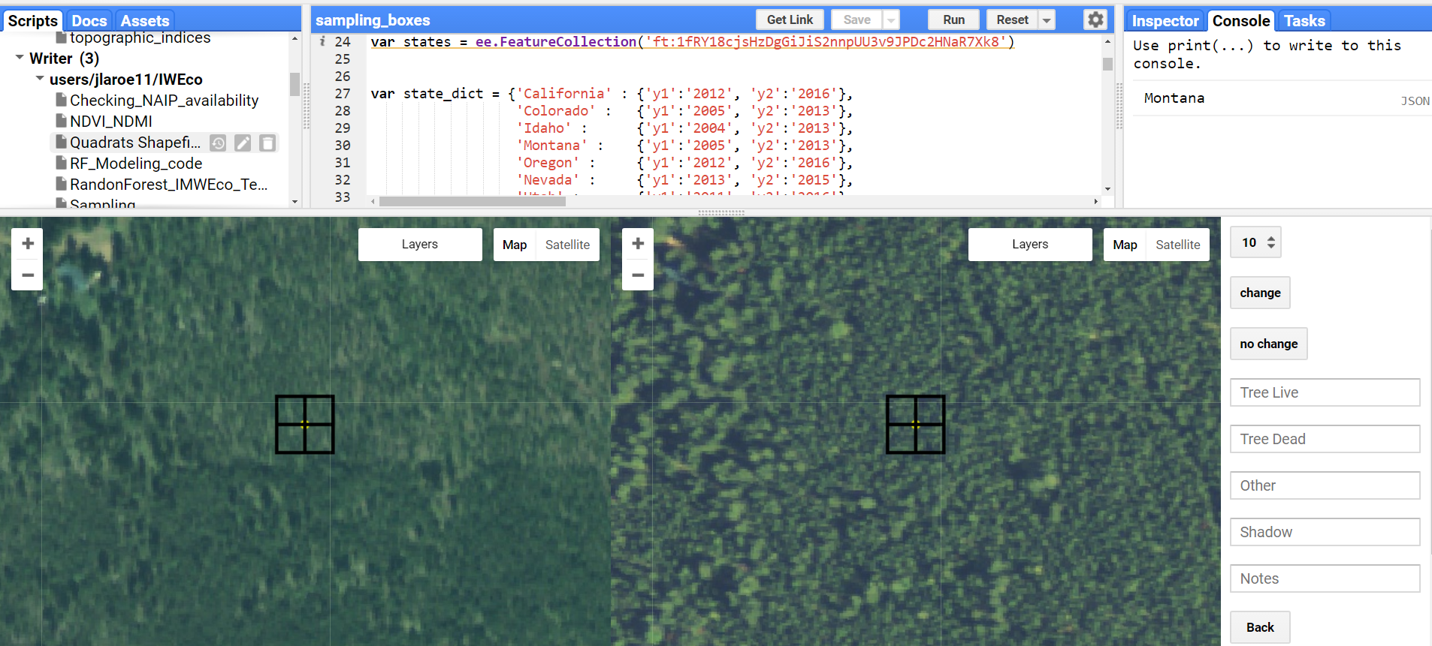

**Figure 2.** Google Earth Engine interface sampling code (code credit to Steven Filippelli at Colorado State University, Natural Resource Ecology Lab) for NAIP imagery in 2012(WY) and 2013(CO, MT, ID) to estimate percent live, dead, other, and shadow cover within each quadrat. The quadrats are aligned to Landsat imagery surrounding each randomly generated point within the LANDFIRE lodgepole pine mask.

***3.3 Data Processing***

The SRTM digital elevation model and Landsat 5 TM and Landsat 8 OLI and Thermal Infrared Sensor (TIRS) imagery were processed in Google Earth Engine to create the necessary indices. The topographic indices elevation, slope, and aspect were derived from the SRTM digital elevation model (Table 3 and 4). We used a Tasseled Cap Transformation (Table 2 see coefficients) of Brightness, Greenness, and Wetness as an orthogonal transformation of the Landsat surface reflectance imagery to highlight these characteristics relative to vegetation within the region. Additional spectral indices generated from Landsat imagery include those listed in Table 3 and 4, and each individual spectral band was applied in the variable selection process as well (Table 1). Differenced predictors were generated for each variable from 2000 and 2013 by subtracting 2013 – 2000, resulting in a total of thirty-four predictor variables. In addition to the predictor variables, the sampling points of presence and percent cover of live trees were used to train the random forest classification model for the separate live and dead lodgepole pine binary and continuous maps.

***3.4 Data Analysis***

To classify presence and percent cover of live lodgepole pine within the study area, the random forest machine learning algorithm was applied. Random forest methods construct a collection of decision trees that are used to inform predictions for classification and regression (Breiman, 2001). Random forest has been used to successfully map forest habitats, identify tree health, and map tree canopy cover (Belgiu & Dragut, 2016).

We employed a two-step classification method to map the extent of live lodgepole pine (Savage, Lawrence, & Squires, 2015). First, we applied a binary classification model, training points of presence or absence of live trees were used. From the percent cover sampled plots, a threshold was set where >0% was denoted as live trees. Sampled plots of live trees equal to 0% were considered absences. This resulted in 936 presence and 64 absence points of live tree plots. Predictors for the models were determined using the rfUtilities (2.1.2) package in R. After variable selection using rfUtilities, the remaining predictors were assessed for high collinearity. If two variables were highly correlated (Pearson’s coefficient > |0.7|), the predictor with lower explanatory power was removed. The final set of predictors was used in a random forest classifier in Google Earth Engine. Second, a regression model was implemented using digitally sampled points of continuous percent cover (0-100%) of live lodgepole pine, employing the same predictor selection methods as in the binary classification model. A continuous model of live lodgepole pine was also completed using random forest in Google Earth Engine.

These methods were also used to classify dead lodgepole pine within our study area. Training points of presence or absence of dead lodgepole pine were used in a binary classification model. A threshold of >0% was considered dead trees, and sampled plots equal to 0% were considered absences. The same variable selection methods using rfUtilities were employed to find the top predictors. Final binary and continuous classification models for dead lodgepole pine were executed in Google Earth Engine using random forest.

We created two percent cover maps showing both live and dead tree cover using outputs from the classification and regression models. We clipped the regression model to live tree presences in the binary model (i.e. areas denoted as absences were removed from the continuous model).

# 4. Results & Discussion

We conducted preliminary tests on the input sampling data prior to modeling and final map production to evaluate the impact of different sample sizes. We randomly reduced input sample points by thresholding to 600, 700, 800, 900, and 1000 input plots. The statistical metrics variance explained and RMSE were identified at each threshold to distinguish the impact of fluctuating the size of the training data. (Table 5). We observed a tapering off of variance explained and RMSE at 800 points.

**Table 5.** We tested our training data to see the amount of gain our models would predict as we increased the number of sampling points.

|  |  |  |
| --- | --- | --- |
| Number of Points | Variance Explained | RMSE |
| 600 | 41.40% | 21.92 |
| 700 | 43.42% | 21.59 |
| 800 | 44.47% | 21.11 |
| 900 | 44.46% | 20.77 |
| 1000 | 44.90% | 20.62 |

We also explored utilizing two separate methods for variable selection, the R packages VSURF and rfUtilities (Evans & Murphy, 2017; Genuer, Poggi, & Tuleau-Malot, 2015). RfUtilities was employed due to the speed and accuracy of the variable selection process.

***4.1 Live***

We created a live lodgepole pine map using a two-step classification method. The outputs indicate locations of potential percent canopy cover for lodgepole pine (Fig. 2). The derived environmental predictor variables elevation, aspect, slope, GRVI, NDMI, NDWI, TCB TCG, TCW, GRVI, SWIR, NIR, NBR, and differenced spectral indices were inputs into our model.

**Table 6**. Top predictor variables for live lodgepole pine which indicate relative importance with higher values of %IncMSE.

|  |  |
| --- | --- |
| Predictor variable | % Increase in MSE |
| Short Wave Infrared 1 (SWIR1) | 62% |
| Green-Red Vegetation Index (GRVI) | 48% |
| Tasseled Cap Wetness (TCW) | 47% |
| Normalized Burn Ration (NBR) | 47% |
| Tasseled Cap Brightness (differenced; TCB) | 46% |
| Tasseled Cap Greeness (TCG) | 41% |
| Normalized Difference Wetness Index (NDWI) | 34% |
| Normalized Difference Vegetation Index (differenced; NDVI) | 30% |
| Normalized Difference Moisture Index (differenced; NDMI) | 28% |
| Thermal | 25% |
| Elevation | 24% |
| Aspect (eastness) | 18% |
| Aspect (northness) | 15% |

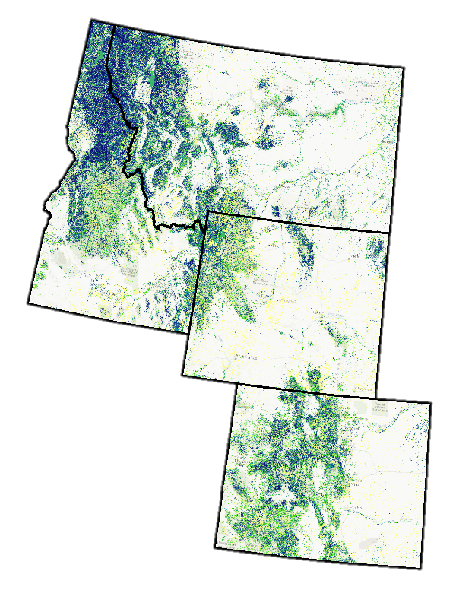

**Figure 2.** This two-step classification model shows percent cover of live lodgepole pine over the Intermountain West.

Model outputs display that the variables GRVI, SWIR1, NBR, TCW, TCG, NDWI, differenced NDVI, differenced TCB, differenced NDMI, thermal, elevation, aspect northness, and aspect eastness most strongly predicted the presence of live canopy cover (Table **X**). These predictors explain 49.24% of the variance in the model, and have a root mean square error (RMSE) of 20.27% (Fig. 5). In addition to variance explained and RMSE, predicted vs. observed graphs and confusion matrices were other standard statistical methods used to evaluate our models (Fig. 3, Fig. 4).

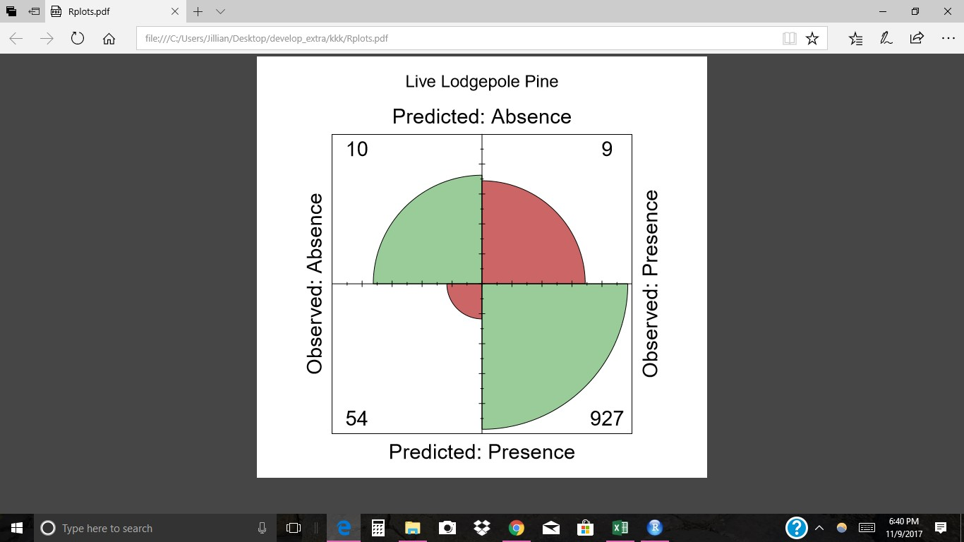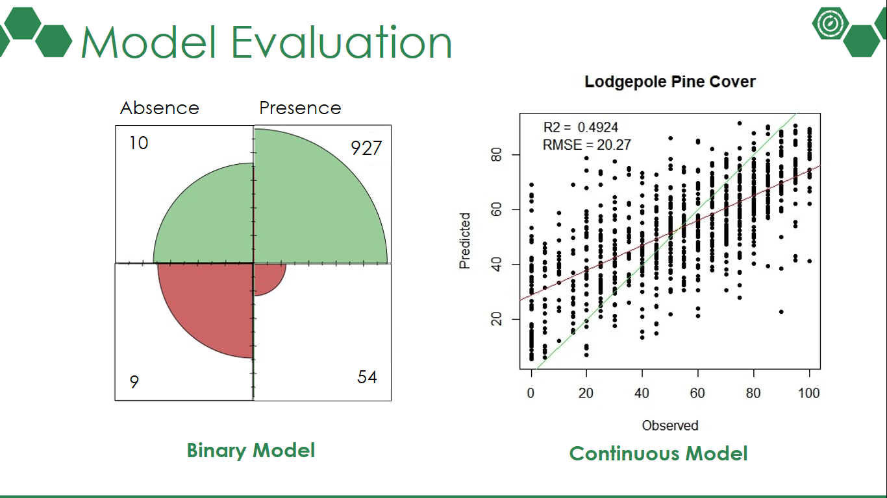

**Binary Live Lodgepole Pine Cover**

Absence

Presence

**Figure 3.** A confusion matrix for the binary model of live lodgepole pine. Green areas indicate correctly classified plots, whereas red areas indicate plots that were incorrectly classified.

**Figure 4**. Predicted percent cover of the live lodgepole pine model. The points represent training observations, the red line represents the best fit of the model prediction, and the green line is a one to one line.

***4.2 Dead***

A close up of a map

Description generated with high confidence

**Table 7.** Top predictor variables for dead lodgepole pine which indicate relative importance with higher values of %IncMSE.

**Figure 5.** This two-step classification model shows percent cover of dead lodgepole pine over the Intermountain West.

|  |  |
| --- | --- |
| Predictor variable | % Increase in MSE |
| Normalized Difference Moisture Index (differenced; NDMI) | 45% |
| Near-infrared (NIR) | 44% |
| Short Wave Infrared 2 (differenced; SWIR2) | 40% |
| Normalized Burn Ration (NBR) | 26% |
| Green-Red Vegetation Index (GRVI) | 25% |
| Tasseled Cap Greenness (differenced; TCG) | 24% |
| Normalized Difference Vegetation Index (differenced; NDVI) | 23% |
| Normalized Difference Vegetation Index (NDVI) | 22.7% |
| Green-Red Vegetation Index (differenced; GRVI) | 22.9% |
| Normalized Difference Wetness Index (NDWI) | 19% |
| Thermal (differenced) | 17% |
| Elevation | 15% |

We used the same two-step methodology to create the dead lodgepole pine map, which indicates locations of potential percent cover of lodgepole pine (Fig. 5). Variables that robustly predicted dead lodgepole pine in order of importance were differenced NDMI, NIR, differenced GRVI, differenced SWIR2, differenced TCG, NBR, GRVI, NDWI, differenced thermal, differenced NDVI, NDVI, and elevation. These predictors explained 33.8% of the variance for the dead lodgepole pine model, and have an RMSE value of 14.83%. Predicted vs. observed graphs were also produced to evaluate the dead lodgepole pine models.

***4.3 Caveats and Data Limitations***

This project had several caveats and limitations. We performed ocular surveys of 1,000 points across an area of 112,021,000 hectares. Potentially misclassified quadrat plots could significantly affect the modeling efforts of the project due to the vast size of the study area, the immense variability in the landscape, and limited sample size of input training data. We recommend a drastic increase in the sample size, upwards of double, would offer an increase in variance explained and a decrease in RMSE from our preliminary models. Due to the vast size of the study area, collecting consistent normalized values for predictor variables across the images was a challenge. This potential inconsistency of the values could possibly be influencing the final model outputs. This can be observed in the striping displayed of the Landsat paths (Figure 6).

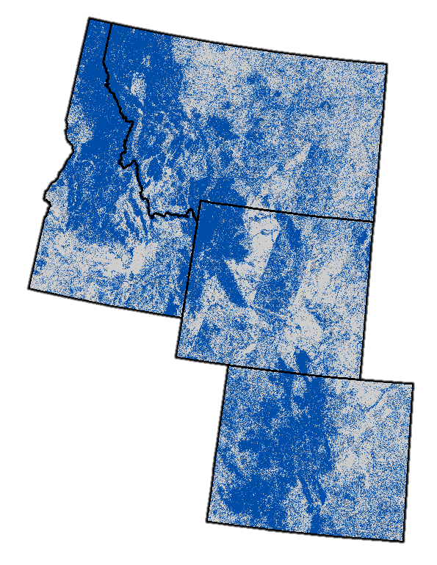The randomly generated sampling points were created with the LANDFIRE mask. We relied on this boundary, assuming it to be highly accurate. Both the accuracy of the sampling points and the produced maps are constrained by the accuracy of the LANDFIRE mask.

**Figure 6.** This binary classification model of live lodgepole pine shows blue areas as presence and gray areas as absence. Striping from the Landsat paths can be seen over the middle of Wyoming up into southern Montana.

Lastly the live lodgepole pine masks do not equate to forest stands at risk to future mountain pine beetle attacks. The maps display live trees that are possibly at risk to future outbreaks.

***4.4 Future Work***

With future work, this project would be able to explore more predictor variables, and potentially expand the study area to include portions of Canada. We recommend the development of more ecologically meaningful covariates. There are many more abiotic and biotic predictor variables that could be integrated into the study. Predictor variables for altered climate, geological processes, disturbance, and environmental stress are options that could be included in future models’ efforts. To improve future models, creating thresholds for what is considered a presence could be increased.

# 5. Conclusions

This project produced two maps investigating the current percent live lodgepole pine and percent dead lodgepole pine across the intermountain west region. The percent live lodgepole pine will aid BANR is identifying locations of forests potentially susceptible to future bark beetle. While the percent dead lodgepole pine map can provide BANR is insight to the severity of bark beetle and subsequent effected forest structure. Both of these maps are key to future management efforts. This project also expands upon the scale of previous work. We generated a modeling technique which in encompassed a vast area with a high level of variability. This project employed a scalable methodology utilizing NASA Earth Observations and Google Earth Engine which can be replicated on an annual basis to provide managers with an up-to-date dataset and the most informed models possible.

# 6. Acknowledgements

Dr. Paul Evangelista (Colorado State University, Natural Resource Ecology Lab)

Dr. Amanda West, Colorado State University, Natural Resource Ecology Laboratory)

Anthony Vorster (Colorado State University, Natural Resource Ecology Lab)

Brian Woodward (Colorado State University, Natural Resource Ecology Lab)

Stephen Leisz (Colorado State University, Anthropology)

Steven Filippelli (Colorado State University, Natural Resource Ecology Lab)

Peder Engelstad (Colorado State University, Natural Resource Ecology Lab)

Emma Zink Hatcher (Colorado State University, Natural Resource Ecology Lab)

Robert Sturtevant (Colorado State University, Natural Resource Ecology Lab)

Any opinions, findings, and conclusions or recommendations expressed in this material are those of the author(s) and do not necessarily reflect the views of the National Aeronautics and Space Administration.

This material is based upon work supported by NASA through contract NNL16AA05C and cooperative agreement NNX14AB60A.

# 7. Glossary

**Earth observations** – satellites and sensors that collect information about the Earth’s physical, chemical, and biological systems over space and time

**Digital Elevation Model** – a 3-D representation indicating elevation at any given point on the surface of the Earth

**Forecast** – to calculate or predict a future event or condition

**Google Earth Engine (GEE)** – a cloud computing platform providing access to satellite imagery options and analytical tools

**LANDFIRE Program** – (Landscape Fire and Resource Management Planning Tools Program) a collection of geospatial products and databases designed to support fire and natural resource management

**Landsat 5 TM** – (Landsat 5 Thematic Mapper) a low Earth orbit satellite that collected imagery of the Earth’s surface

**Landsat 8 OLI** – Operational Land Imager (Landsat 8), an instrument that collects high resolution data in the visible, near infrared, and shortwave infrared portions of the energy spectrum

**NAIP** (National Agriculture Imagery Program) – high quality “leaf on” 1m aerial imagery made available to the public from the United States Department of Agriculture’s Farm Service Agency

**NDMI** (Normalized difference moisture index) – a vegetation index that detects subtle changes in vegetation moisture conditions.

**NDVI** (Normalized difference vegetation index) – an indicator of green vegetation abundance derived from visual and near infrared spectral bands

**Outbreak** – a sudden increase in numbers of a harmful organism, such as an insect, within a particular area.

**Quadrat** – a square plot used to isolate a standard unit of area for study

**Random forest** – a classification modeling method trained using decision trees to guide analysis and prediction patterns of a large dataset

**Remote Sensing** – the art and science of obtaining information about objects, areas, or phenomena from a distance, typically from aircraft or satellites

**SRTM** (Shuttle Radar Topography Mission) – an international research effort that obtained global 30m digital elevation models

**Tasseled-Cap Transformation** – the conversion of the original bands of an image to a new set of bands with defined interpretations used for vegetation mapping (e.g. brightness, greenness, wetness)

**8. References**

Baig, M.H.A., Zhang, L., Shuai, T., and Tong, Q. (2014). Derivation of tasselled cap transformation based on Landsat 8 at-satellite reflectance. *Remote Sensing Letters 5(5)*: 423-431.

Barsi, J.A., Lee, K. Kvaran, G., Markham, B.L., Pedelty, J.A. (2014). The Spectral Response of the Landsat-8 Operational Land Imager. Remote Sensing (6): 10232-10251.

Belgiu, M. and Dragut, L. (2016). Random forest in remote sensing: A review of applications and future directions. *ISPRS Journal of Photogrammetry and Remote Sensing, 114*: 24-31.

Bentz, B. J., Régnière, J., Fettig, C. J., Hansen, E. M., Hayes, J. L., Hicke, J. A., Kelsey, R. G., Negron, J. F., and Seybold, S. J. (2010). Climate change and bark beetles of the western United States and Canada: Direct and indirect effects. *BioScience*, *60*(8), 602-613.

Bone, C., Wulder, M. A., White, J. C., Robertson, C., and Nelson, T. A. (2013). A GIS-based risk rating of forest insect outbreaks using aerial overview surveys and the local Moran's I statistic. *Applied Geography*, *40*, 161-170.

Breiman, L. (2001). Random forest. *Machine Learning, 45*(5).

Chapman, T. B., Veblen, T. T., and Schoennagel, T. (2012). Spatiotemporal patterns of mountain pine beetle activity in the southern Rocky Mountains. *Ecology*, *93*(10), 2175-2185.

Cohen, W. B., Yang, Z., Stehman, S. V., Schroeder, T. A., Bell, D. M., Masek, J. G., Huang, C., and Meigs, G. W. (2016). Forest disturbance across the conterminous United States from 1985–2012: The emerging dominance of forest decline. *Forest Ecology and Management*, *360*, 242-252.

Evans, J. and Murphy M.A. (2017). Random Forests Model Evaluation and Performance Evaluation. *The Comprehensive R Archive Network*. https://cran.r-project.org/web/packages/rfUtilities/rfUtilities.pdf

Genuer, R., Poggi, J. M., and Tuleau-Malot, C. (2015). VSURF: An R Package for Variable Selection Using Random Forests. *The R Journal*, *7*(2), 19-33.

Goodwin, N. R., Coops, N. C., Wulder, M. A., Gillanders, S., Schroeder, T. A., and Nelson, T. (2008). Estimation of insect infestation dynamics using a temporal sequence of Landsat data. *Remote sensing of environment*, *112*(9), 3680-3689.

Huang, C., Wylie, B., Yang, L., Homer, C., and Zylstra, Z. (2002). Derivation of a tasseled cap transformation based on Landsat 7 at-satellite reflectance. *International Journal of Remote Sensing 23(8)*: 1741-1748.

LANDFIRE. (2016, September). *Home*. Retrieved from LANDFIRE website, http://www.landfire.gov/

NASA JPL. (2013). NASA Shuttle Radar Topography Mission Global 1 arc second [Data set]. NASA EOSDIS Land Processes DAAC. doi: 10.5067/MEaSUREs/SRTM/SRTMGL1.003

Raffa, K. F., Aukema, B. H., Bentz, B. J., Carroll, A. L., Hicke, J. A., Turner, M. G., and Romme, W. H. (2008). Cross-scale drivers of natural disturbances prone to anthropogenic amplification: The dynamics of bark beetle eruptions. *AIBS Bulletin*, *58*(6), 501-517.

Savage, S. L., Lawrence, R.L., Squires, J.L. (2015). Predicting relative species composition within mixed conifer forest pixels using zero-inflated models and Landsat imagery. *Remote Sensing of the Environment 171*(326-336).

Sidder, A. M., Kumar, S., Laituri, M., and Sibold, J. S. (2016). Using spatiotemporal correlative niche models for evaluating the effects of climate change on mountain pine beetle. *Ecosphere*, *7*(7).

United States Forest Service. (2017, September). Forest Health Technology Enterprise Team. Retrieved from United States Forest Service website, https://foresthealth.fs.usda.gov/portal

United States Forest Service. (2017, September). Forest Inventory and Analysis National Program. Retrieved from United States Forest Service website, https://www.fia.fs.fed.us/

United States Forest Service. (2017, September). GIS & Spatial Analysis. Retrieved from United States Forest Service website, https://www.fs.fed.us/foresthealth/applied-sciences/mapping-reporting/gis-spatial-analysis/detection-surveys.shtml

U.S. Geological Survey Earth Resources Observation and Science Center. (2013). Provisional Landsat OLI Surface Reflectance, TOA, 32-day NDVI, and 32-day NDMI. US Geological Survey. https://doi.org/10.5066/F7KD1VZ9

U.S. Geological Survey Earth Resources Observation and Science Center. (2000). Provisional Landsat TM Surface Reflectance, TOA, 32-day NDVI, and 32-day NDMI. US Geological Survey. https://doi.org/10.5066/F7KD1VZ9

Vorster, A. G., Evangelista, P. H., Stohlgren, T. J., Kumar, S., Rhoades, C. C., Hubbard, R. M., Cheng, A. S., & Elder, K. (2017). Severity of a mountain pine beetle outbreak across a range of stand conditions in Fraser Experimental Forest, Colorado, United States. *Forest Ecology and Management*, *389*, 116-126.