**NASA DEVELOP National Program**

****Ames Research Center

**Fall 2013**

**Sierra Nevada DSS Ecological Forecasting**

*Implementing a Decision Support System for the Sierra Nevada to Monitor, Report, and Forecast Ecological Conditions*

**Team Lead:** Andrew Nguyen (San Jose State University), Andrew.nguyen@nasa.gov

**Team Members:**

Chase Mueller (University of Texas at San Antonio)

James Brennan (Villanova University)

Erika Edgar (University of Alaska Fairbanks)

Esther Essoudry (University of California, Berkeley)

**Advisors & Mentors:**

Carlos Ramirez (U.S. Forest Service)

Dr. Yeqiao Wang (University of Rhode Island)

Cindy Schmidt (Bay Area Environmental Research Institute, DEVELOP National Program)

**Past or Other Contributors:**

N/A

**Applied Sciences National Applications Addressed:**

Ecological Forecasting, Climate

**Study Area:** Sierra Nevada, California

**Study Period:** 1982-2013 (Due to the length of historical vegetation datasets included in this study)

**Community Concerns**

* Due to future and current climatic variability, it is difficult to predict long-term changes in temperature and precipitation and their projected impacts on ecosystems, such as an increase in flooding, reduced snowpack levels, and increased wildfire risk.
* These future climatic changes pose a major threat to biodiversity in the Sierra Nevada that are of conservation concern. This can ultimately lead to the disruption Sierra Nevada ecosystems along with animal and plant species.
* Despite current forest monitoring and planning efforts, there remain gaps and inconsistencies in predictions of future forest conditions.

**80-100 Word Blurb**

According to the California Department of Water Resources (DWR), the Sierra Nevada provides over 23 million people with drinking water. Sierra Nevada forests are vital ecosystems that are being impacted by climate change, such as decreases in snowmelt, peak runoff, forest health, and changes in the distribution of species. In order to monitor the health of the Sierra Nevada, forest managers need tools to assess the variables affecting these changes. The DEVELOP Sierra Nevada DSS project will create a unique ecological forecasting tool to be utilized by forest managers to facilitate best management practices in the Sierra Nevada.

**Abstract**

The Sierra Nevada contains vital ecosystems that are being impacted by climate change, such as decreases in snowmelt, peak runoff, forest health, and changes in the distribution of species. Currently, the USDA Forest Service Region 5 is undergoing Forest Plan revisions to implement climate change impacts into mitigation and adaptation strategies. However, there are few processes in place to conduct quantitative assessments of forest conditions while easily and effectively delivering that information to forest managers. To assist the USDA Forest Service, this study is the first of a three-term project to create a decision support system (DSS) featuring data integration, data viewing, reporting, and forecasting of ecological conditions within the Sierra Nevada. The Sierra DSS Viewer will allow users to view spatially represented layers of past, current, and future climate and surface conditions along with vegetation properties for the entire Sierra Nevada. The purpose of this viewer is to provide an online integration of satellite, modeled, and field data, while allowing users to select specific variables based on the questions of interest. Future climate conditions and vegetative properties derived from the NASA Terrestrial Observation and Prediction System (TOPS) and the Lund-Potsdam-Jena Dynamic Global Model (LPJ) will be summarized for each eco-section for the Sierras. This term focused on identification and processing of all climatic and land surface data sets of interest, conducting initial model calibration, and the creation of the DSS framework.

**Partners/Collaborators**

U.S. Forest Service (POC: Carlos Ramirez)

The University of Rhode Island (POC: Yeqiao Wang)

**Current Management Practices & Policies**

The Region 5 (California) U.S. Forest Service remote sensing lab currently provides landscape-scale information on current conditions of forest resources to forest managers. However, they lack the capacity to generate future assessments of forest health with climate change to better inform management decision-making processes.

**Benefits to End-User:**

* Provide a coherent framework for data integration, monitoring, reporting, and forecasting of ecological conditions.
* Enable the U.S. Forest Service and broader user communities to benefit from the NASA Earth science assets.
* Quick access to information to support ecological studies and management decisions within the Sierras.
* Facilitate the climate change adaptation process that is required in forest planning and management.

**Decision Support Tools**

* Product 1 - Decision Support System (DSS) for the Sierra Nevada M261D, M261E, and M261F ecological sections
* Product 2 – Comprehensive collection of data products for the DSS

**Earth Observations & Parameters**

* Aqua and Terra, MODIS - Land Cover Dynamics, Snow Cover, Land Cover Type, Vegetation Indices, Leaf Area Index FPAR, NDVI, Land Surface Temperature, Soil Moisture derived from NDVI and LST
* Landsat 5 TM, Landsat 7 ETM+, and Landsat 8 OLI/TIRS - NDVI

**Future Applicable NASA Missions**

Global Precipitation Measurement (GPM) - February 2014

Soil Moisture Active Passive (SMAP) - October 2014

Geostationary Operational Environmental Satellite-R Series (GOES-R) - October 2015

**Models Utilized**

* NASA [Terrestrial Observation and Prediction System (TOPS)](http://ecocast.arc.nasa.gov/)/(BGC Models)

(POC: Forrest Melton, CSU Monterey Bay, NASA Ames Research Center)

* Lund-Potsdam-Jena Dynamic Global Model (LPJ) (POC: Cindy Schmidt, Bay Area Environmental Research Institute, DEVELOP National Program)

**Ancillary Datasets Utilized**

National Wetland Inventory (NWI)

National Elevation Dataset (10 m spatial resolution)

NLCD data products (1990, 2001, 2006)

USFS Forest Disturbance ADS

PRISM (Max Temperature, Min Temperature, Total Precipitation)

SNODAS (Snow water equivalent)

CIMP5 Downscaled Future Climate data A1B Scenario (Precipitation and

Temperature)

LANDFIRE data products:

* Existing Vegetation Type (EVT)
* Existing Vegetation Cover (EVC)
* Canopy Height (CH)
* Existing Vegetation Height (EVH)
* Canopy Cover (CC)
* Biophysical Settings (BpS)
* Environmental Site Potentials (ESP)

**Software Utilized**

* ArcGIS - Raster Manipulation/Analysis, Image Enhancement & Map Creation of Aqua/Terra MODIS
* Arc GIS Viewer for Flex- Used to build a custom mapping application and create the framework for the DSS Viewer.
* TIMESAT- Software package for analyzing time-series of satellite sensor data.

**Imagery & Captions**

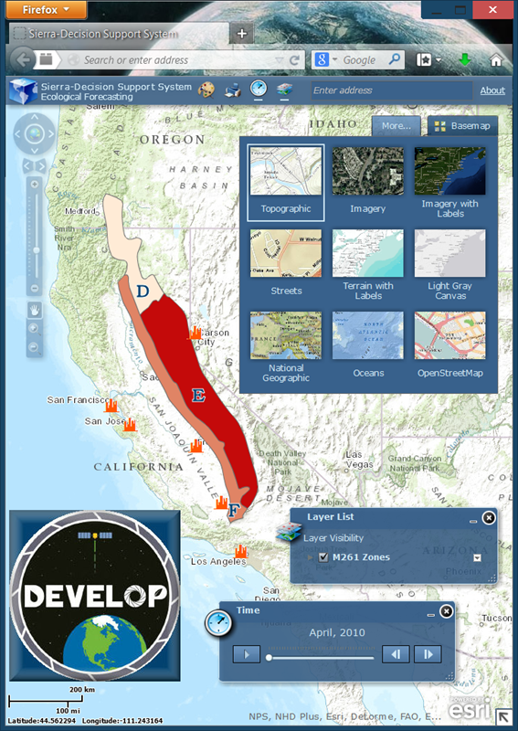

Caption: The Sierra DSS will feature viewer and time slider components. The viewer will allow users to turn on/off geospatial climatic and surface datasets of interest. Users are able to layer any combination of these data, similar to a GIS. The time slider toolbar enables a temporal visual of vegetation, precipitation, and temperature conditions for the Sierra Nevada Range.