ArcGIS StoryMap

Project Short Title | NASA DEVELOP | Term Year

Project Long Title



Author 1 (Project Lead)

Author 2

Author 3

Author 4

***Advisors:***

Advisor 1, Affiliation (Science Advisor)

Advisor 2, Affiliation (Science Advisor)

***Previous Contributors:***

Contributor 1

Contributor 2

***Lead:***  
Center Lead (Node Name)

# **Overview**

Host organization(s) of the StoryMap:

Intended audience:

DEVELOP Team POC:

# **StoryMap Content**

Draft your content here. Please include all intended text, layouts, image credits, and images--you will also submit images as PNGs/JPEGs in a folder with a copy of your content document. Explore StoryMaps’ formatting requirements and creative layouts prior to drafting. Find a suggested content layout at the end of this template.

# **References**

NASA DEVELOP uses APA 7 formatting. Please ensure that all references in this section are cited in the content. Don’t copy-paste a citation from elsewhere without checking the format. Even automatic citation generators cannot be trusted to format correctly! We want to be consistent within DEVELOP. Include a Digital Object Identifier (DOI) for NASA and other satellite data products, as well as all journal articles for which it is available.

# **Legal Statements**

The host organization must include NASA DEVELOP’s legal statements at the end of the StoryMap as follows: *This material is based upon work supported by NASA through contract 80LARC23FA024. Any opinions, findings, and conclusions or recommendations expressed in this material are those of the author(s) and do not necessarily reflect the views of the National Aeronautics and Space Administration (NASA). NPR 2200.2C D.6.4.1: Trade names and trademarks are used in this report for identification only. Their usage does not constitute an official endorsement, either expressed or implied, by the National Aeronautics and Space Administration.*

# **StoryMap Handoff *delete this section before submission\***

Please notify your DEVELOP Lead/POC when the StoryMap has been published by the host organization. A DEVELOP representative will review the content and our impact analysis team will save the link in our records.

## **Example: Spring 2024 GA Platte River Basin**

Suggested cover image: project website image

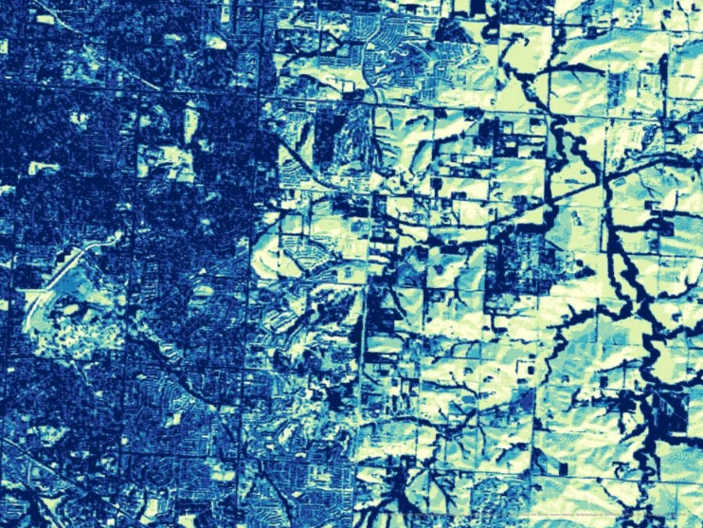

1. Landsat 8 imagery of land surface temperature of the Platte River Basin, Nebraska. Image credit: Spring 2024 NASA DEVELOP Platte River Basin team: Jennifer Mathis, Jackie Encinas, Olivia Kirkland, Emma Vail.

Title: Assessing Urban Flood Vulnerability for Restoration Subtitle: Assessing Urban Flood Vulnerability to Select Restoration Sites for Urban Woods and Prairies in the Great Plains

* Background (Audubon Great Plains/Urban Woods and Prairies Initiative)
  + *Text block (quote)*
    - “Our mission is to protect birds and the places they need, today and tomorrow.” (“Audubon Great Plains”)
  + *Text block*
    - Audubon Great Plains is a nonpartisan bird conservation organization that works to protect birds and their habitats by combining science, habitat restoration, public outreach, and environmental education. (“Audubon Great Plains”)
  + *Text block*
    - The Urban Woods and Prairies Initiative of Audubon Great Plains aims to combine natural and urban landscapes to provide high-quality habitat for bird and wildlife species and encourage community members to explore and learn about local ecosystems. With the help of local partners, Audubon Great Plains seeks to expand the UWP Initiative into 13 cities across the Platte River Basin. (“Audubon Great Plains”)
  + *Image*
    - Insert map of Platte River Basin with state boundary lines and focal cities highlighted.

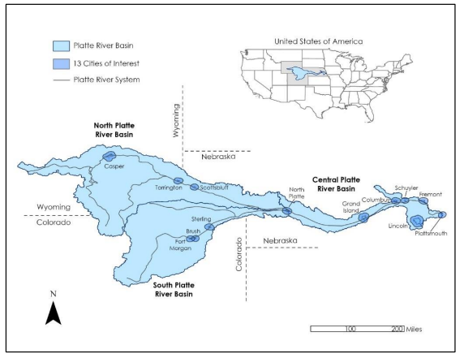

1. Map created by spring 2024 NASA DEVELOP Platte River Basin team: Jennifer Mathis, Jackie Encinas, Olivia Kirkland, Emma Vail. Credit: ESRI EarthStar Geographics, U.S. Census Bureau

* Background/Purpose
  + *Recommended format: “sidecar”*
    - Text: Wetlands are an essential habitat for wildlife; the wetlands along the Platte River in Central Nebraska provide habitat for more than 150 species of birds and other wildlife (Adalian, 2024). Wetlands act as a sponge to slow and capture excess rainwater during flooding events and facilitate the return of water into the soil.
    - Include partner image of Platte River riparian wetlands, local and migratory bird species.