South Slough Water Resources

Monitoring Changes in Water Quality to Identify Stressors in Eelgrass Extent Throughout the Coos Estuary

 **Technical Report**

August 11th, 2023

Maya Hall

Gabriel Halaweh

Sean McCollum

Zoë Siman-Tov

***Advisors:***

Dr. Juan Torres-Pérez

Britnay Beaudry

Dr. Liane Guild

***Fellow:***  
Lisa Tanh (Ames Research Center)

# 1. Abstract

The Coos estuary in Southern Oregon supports a variety of habitats, including eelgrass (*Zostera marina*) meadows. Eelgrass meadows provide shelter and sustenance to local and migratory wildlife, including commercially important fishes, and cultural resources to local communities. These ecosystem services establish eelgrass as an ecologically, economically, and culturally important resource. However, the extent and density of eelgrass meadows within this estuary have declined substantially since 2005, threatening the ecosystem services they provide. NASA DEVELOP partnered with the South Slough National Estuarine Research Reserve and the Confederated Tribes of the Coos, Lower Umpqua, and Siuslaw Indians’ Department of Natural Resources to generate time-series maps of the water quality conditions (chlorophyll-a, turbidity) and eelgrass extent in the Coos estuary from 2016 to 2023 to better understand the conditions driving eelgrass decline. The DEVELOP team used NASA Earth observations including Landsat 8 Operational Land Imager (OLI), Landsat 9 OLI-2, and the European Space Agency’s Sentinel-2 Multispectral Instrument (MSI) to generate these time-series maps. The team faced limitations in the feasibility of detecting eelgrass within the Coos Estuary, including spectral resolution, tidal phase, and turbidity. These limitations indicate additional *in situ* data collection will be necessary for accurate eelgrass assessment. Meanwhile, the team determined it is feasible to assess turbidity and chlorophyll-a within the Coos Estuary using remote satellite data. These tools enabled the research partners to assess water quality characteristics within the Coos Estuary at a greater spatial scale and may provide a method of inexpensive preliminary investigation of eelgrass meadow locations.

**Key Terms**

eelgrass, remote sensing, Sentinel, Landsat, warming, submerged aquatic vegetation, water resources, water quality

# 2. Introduction

***2.1 Background Information***

Eelgrass (*Zostera marina*) is a common seagrass species that forms meadows in coastal and estuarine habitats throughout the temperate northern hemisphere (Short et al., 2007). Eelgrass meadows provide a myriad of critical ecosystem services. Across their distribution, eelgrass meadows support local economies by providing nursery habitat for fishery species, serving as a vital food source for migratory wildlife, and increasing recreational opportunities for local communities (Nordlund et al., 2016). However, eelgrasses have experienced substantial declines globally (Orth et al., 2006). These declines threaten the ecosystem services which eelgrass meadows provide and foreshadow economic and cultural costs to local communities (Orth et al., 2006).

Globally, eelgrass meadow declines have been attributed to habitat destruction and water quality degradation driven by anthropogenic activities (Orth et al., 2006). Eelgrass is sensitive to changes in various water quality conditions, including temperature, nutrient availability, and turbidity (Lee et al., 2007; Nejrup & Pederson, 2008; Touchette & Burkholder, 2000). These conditions impose direct and indirect effects on the resource acquisition and physiology of eelgrass (Lee et al., 2007; Nejrup & Pederson, 2008; Touchette & Burkholder, 2000). As a result, when these conditions exceed optimal bounds, eelgrass meadow health declines (Lee et al., 2007; Nejrup & Pederson, 2008; Touchette & Burkholder, 2000). Given the importance of eelgrass and their rapid decline, efforts to monitor the extent of eelgrass and the water quality conditions impacting them have increased in recent decades (Dunic et al., 2021).

The study area for this feasibility project is limited to the Coos estuary, in Southern Oregon, with a particular interest in the South Slough region. The Coos estuary stretches across 54 km2 and supports a variety of habitats including eelgrass meadows (Figure 1; Jarrin et. al., 2022; Rumrill, 2007). These meadows most commonly occur as narrow fringe beds along the edges of deep tidal channels (Rumrill & Sowers, 2008). Coos estuary water quality conditions, such as sea surface temperature (SST), salinity, nutrient availability, and dissolved oxygen, are heavily influenced by annual and interannual coastal cycles, such as the California Current System (CCS), the El Niño Southern Oscillation (ENSO), and seasonal storm run-off (Jarrin et al., 2022). Since 2005, eelgrass meadow extent and density have declined dramatically throughout the estuary. Following the 2013 to 2016 warm water event, during which SST were often 1.5°C greater than average, eelgrass shoot density declined from a long-term average of 33 shoot per m2 to only 5 shoots per m2 (Jarrin et. al., 2022).

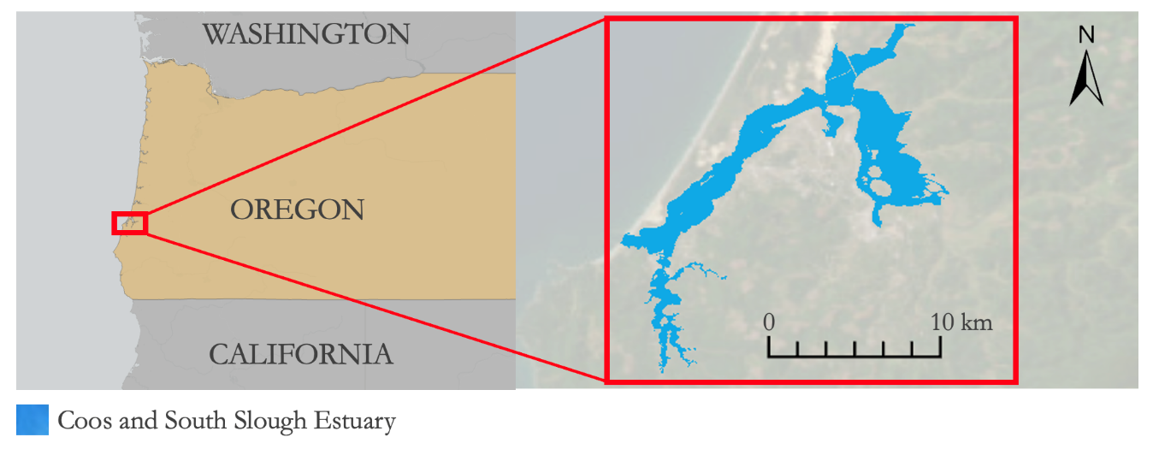

*Figure 1.* Coos estuary with suitable eelgrass habitat highlighted in blue.

The DEVELOP team considered NASA Earth observations including Landsat 8 Operational Land Imager (OLI), Landsat 9 OLI-2, and the European Space Agency’s Sentinel-2 Multispectral Instrument (MSI) to generate time-series maps of eelgrass extent, chlorophyll-a, and turbidity throughout the Coos estuary from 2010 to 2023. This methodology has previously been used by the NASA DEVELOP Louisiana Water Resources team in the summer of 2021 to successfully assess the change in seagrass meadow extent in Breton National Wildlife Refuge (Moeen et al., 2021). These maps revealed trends in eelgrass decline and recovery and lent insight into which water quality conditions drove these changes.

***2.2 Project Partners & Objectives***

The NASA DEVELOP team is partnered with the South Slough National Estuarine Research Reserve (SSNERR) and the Confederated Tribes of the Coos, Lower Umpqua, and Siuslaw Indians’ (CTCLUSI) Department of Natural Resources. SSNERR is responsible for managing and monitoring the Coos estuary with the goal of conserving its natural resources for research and educational opportunities. CTCLUSI is responsible for conserving and managing natural resources on tribally held land. These organizations prioritize habitat restoration and understanding how climate change and water quality influence estuary habitat health.

SSNERR and CTCLUSI have used monitoring stations, field surveys, and infrequent unmanned aerial vehicle (UAV) remote sensing to monitor water quality and eelgrass extent (Anderson, 2020; Jarrin et al., 2022). These efforts have revealed substantial declines in eelgrass extent since 2005 (Jarrin et al., 2022). However, the data gained from these methods are spatially and temporally limited. The NASA DEVELOP team’s objectives were to develop methods to monitor eelgrass extent and water quality throughout the Coos estuary using remote sensing data. Through this project, SSNERR and CTCLUSI aimed to develop remote sensing and spatial mapping methods to enhance their data collection and better understand the drivers of eelgrass decline. Using these results, SSNERR and CTCLUSI will be able to develop management decisions related to the identified drivers of eelgrass decline and maintain monitoring of these habitats through remote sensing.

# 3. Methodology

***3.1 Data Acquisition***

The team accessed Earth observation data from Google Earth Engine that spanned from 2016 to 2023 (Table 1). The team acquired surface reflectance products from Landsat 8 Operational Land Imager (OLI) and Landsat 9 OLI-2 through Google Earth Engine (GEE). The team used these products, which all have a resolution of 30 meters, to produce preliminary visualizations of submerged aquatic vegetation (SAV), turbidity, and chlorophyll-a. The team also acquired top-of-atmosphere (TOA) products from Sentinel-2 MultiSpectral Instrument (MSI) through Google Earth Engine (GEE). The team used this product to classify eelgrass and assess the extent of SAV, turbidity, and chlorophyll-a concentration within the estuary.

Table 1

*Earth observation datasets utilized in this study*

|  |  |  |  |  |
| --- | --- | --- | --- | --- |
| **Sensor** | **Processing Level** | **Original Data Source** | **Spatial Resolution** | **GEE Image Collection ID** |
| Landsat 8 OLI | Surface Reflectance Collection 1, Tier 1 | USGS Earth Explorer | 30m | LANDSAT/LC08/C01/T1_SR |
| Landsat 9 OLI-2 | Level 2 Surface Reflectance Collection 2, Tier 1 | USGS Earth Explorer | 30m | LANDSAT/LC09/C02/T2_L2 |
| Sentinel-2 MSI | Level 2-A Top-Of-Atmosphere | European Space Agency (ESA) Open Access Hub | 10m (Red, Green, Blue, Near-infrared)  20m (Red-edge 1-4)  60m (Aerosols) | COPERNICUS/S2 |

In addition to Earth observation data, the team used existing ancillary data (Table 2) provided by SSNERR and CTCLUSI. SSNERR and CTCLUSI operate water quality and weather monitoring stations which provide water and air temperature, turbidity, salinity, pH, and dissolved oxygen measurements in 15-minute intervals (National Estuarine Research Reserve System, 2023). The team used these data to validate remote sensing measurements of chlorophyll-a and turbidity and to track temperature and salinity alongside remotely sensed measurements. SSNERR also provided shapefiles of eelgrass extent in 2016 from the Pacific Marine and Estuarine Fish Habitat Partnership (PMEP; Pacific States Marine Fisheries Commission (PSMFC); GIS, 2018). The team used these data to produce training data for supervised classification and perform accuracy assessments of the resulting classified maps.

Table 2

*Ancillary datasets used in this study*

|  |  |
| --- | --- |
| **Dataset Source** | **Data Parameters** |
| SSNERR Water Quality and Weather Monitoring Stations | Water/air temperature, turbidity, salinity, pH, dissolved oxygen provided in 15-minute intervals |
| Pacific Marine and Estuarine Fish Habitat Partnership (PMEP) | Maximum observed extent of eelgrass map layers from 2016 |

***3.2 Data Processing***

The team processed Level 1 Top-of-Atmosphere (TOA) data from Sentinel-2 MSI to adjust for atmospheric interference using the Modified Atmospheric Correction for INland waters (MAIN) atmospheric correction program. MAIN is a tool that is specialized for coastal and inland water applications. The team applied this correction to Sentinel imagery using the ORCAA tool in Google Earth Engine. In addition to correcting for atmospheric interference, the team filtered available corrected imagery to select images taken during high tide and with a maximum of 10% cloud cover. This excluded images where clouds obstructed observations and where intertidal meadows were emerged.

The team used multiple indices to assess water quality and eelgrass extent in the Coos Estuary. The team used the Normalized Difference Turbidity Index (NDTI) to assess the intensity of turbidity throughout the estuary (Table 3; Lacaux et al., 2007). The team determined the concentration of algae using the Normalized Difference Chlorophyll-a Index (NDCI; Table 3; Mishra and Mishra, 2012; Vermote et al., 2016). Finally, the team used the Normalized Difference Aquatic Vegetation Index (NDAVI), which was adapted from the Normalized Difference Vegetation Index (NDVI), to visualize the extent of submerged aquatic vegetation (Table 3; Villa et al., 2014). These indices use the normalized difference of the red, red edge, green, blue, and/or near-infrared (NIR) spectral bands’ surface reflectance to highlight specific features such as the unique reflectance of photosynthetic organisms. The team calculated each of these indices and produced visualizations using ArcGIS Pro 3.1.0.

Table 3

*Remote sensing indices used in this study*

|  |  |  |
| --- | --- | --- |
| **Index** | **Equation** | **Source** |
| Normalized Difference Turbidity Index (NDTI) | $$1. NDTI =\frac{\left(Red - Green\right)}{\left(Red + Green\right)}$$ | Lacaux et al., 2007 |
| Normalized Difference Chlorophyll-a Index (NDCI) | $$2. NDCI = \frac{\left(Red Edge - Red\right)}{\left(Red Edge + Red\right)}$$ | Mishra and Mishra, 2012 |
| Normalized Difference Aquatic Vegetation Index (NDAVI) | $$3. NDAVI = \frac{\left(NIR - Blue\right)}{\left(NIR + Blue\right)}$$ | Villa et al., 2014 |

***3.3 Data Analysis***

The team assessed the extent of eelgrass through supervised classification using machine learning algorithms in ArcGIS Pro. The team used the Training Samples Manager tool in ArcGIS Pro to generate training samples of pixels assigned to the class of either ‘water’ or ‘eelgrass’, which the team determined using the 2016 PMEP eelgrass extent map. The team used these samples and the Sentinel-2 image of the estuary from 2016 to train three supervised classification algorithms in ArcGIS Pro: Support Vector Machine (SVM), Random Trees (RT), and Maximum Likelihood (ML). The team determined that the SVM method had the greatest accuracy by calculating a confusion matrix with 2000 stratified random accuracy assessment points. The team used the SVM Esri Classifier Definition to classify the pixels of each Sentinel-2 image of the Coos Estuary for each year from 2016 to 2023.

# 4. Results & Discussion

***4.1 Analysis of Results***

The team assessed the change of eelgrass extent and water quality from 2016 to 2023 in the Coos Estuary using the ORCAA tool in Google Earth Engine and ArcGIS Pro. Our analysis used two approaches, Normalized Difference Aquatic Vegetation Index and Supervised classification to visualize eelgrass extent within the estuary. Using time series maps, the team was able to identify patterns in eelgrass decline and highlight areas of concern. The analysis of water quality focused on the trends of turbidity and chlorophyll-a through time. These analyses demonstrated the feasibility of using ORCAA to obtain useful index values and allowed us to examine the water quality of the Coos Estuary across seasons and years.

*4.1.1 Eelgrass extent*

Supervised classification of eelgrass in the Coos Estuary in the summer of 2016 achieved a fair accuracy (Appendix 1; Kappa = 0.24; Accuracy = 87.95%). Eelgrass extent maps were only available for 2016, limiting accuracy assessments to that year. The team classified imagery for each subsequent year to 2023 to produce a time-series map that illustrates eelgrass extent change (Figure 2). This time-series map illustrates a marked decline in eelgrass extent throughout this timespan. However, there is also an inconsistency in the displayed rate of decline across years. This inconsistency may be reflecting variation in factors that influence the visibility of eelgrass, such as turbidity and tidal height, and indicates that there is a limited ability to ascertain eelgrass declines.

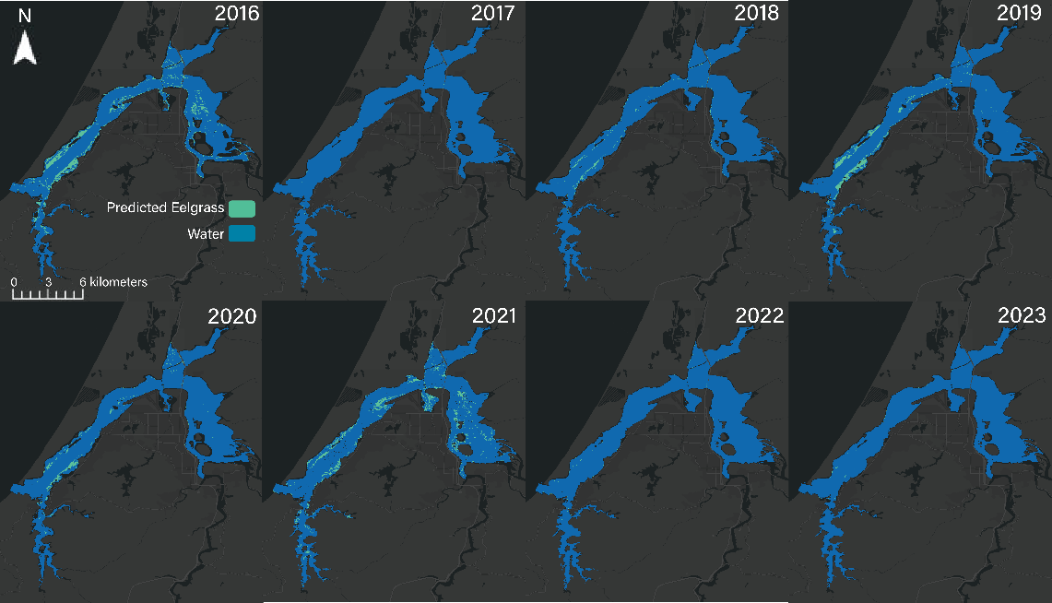

*Figure 2.* Time-series of eelgrass presence as determined by Support Vector Machine supervised classification in the summer of each study year.

In addition to classified imagery, the team also visualized the extent of submerged aquatic vegetation (SAV) using NDAVI (Figure 3). These visualizations do not distinguish eelgrass, but they do allow end users to identify possible locations of eelgrass meadows for in-the-field verification. The time series of NDAVI from 2016 to 2023 does not reflect the decline in eelgrass observed in the classified imagery. This may be due to inaccuracies in classification possibly caused by other benthic components, influence of water column dissolved and particulate matter, or a combination of these factors.

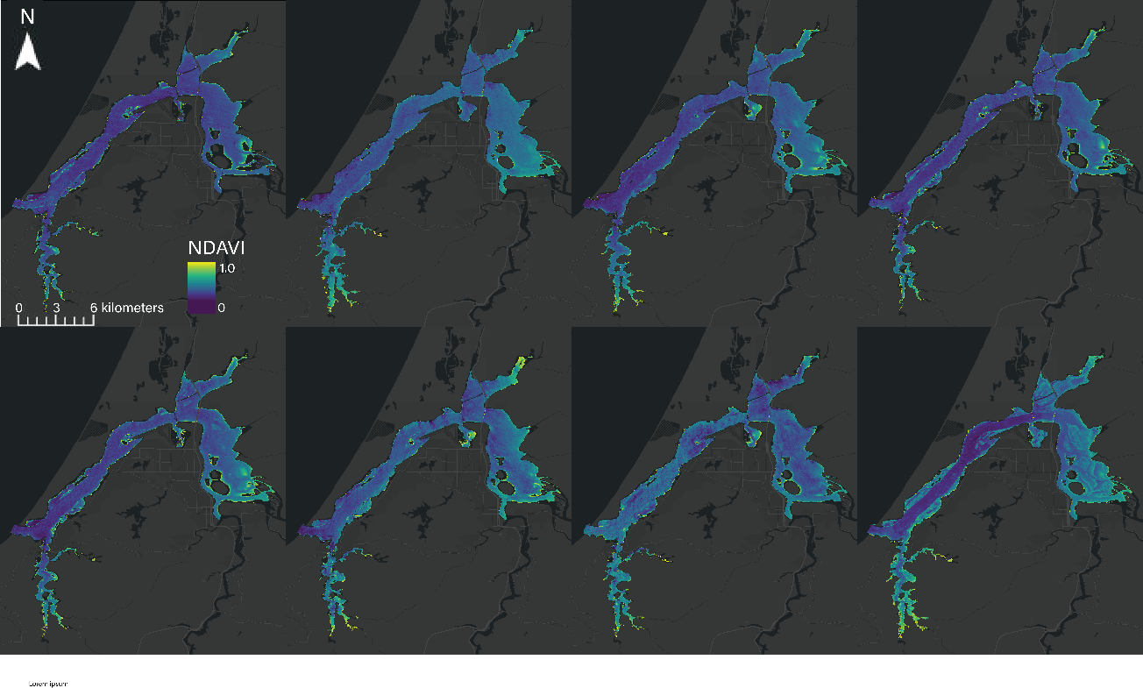

*Figure 3.* Time-series map of Normalized Difference Aquatic Vegetation Index throughout Coos Estuary in the summer of each study year.

***4.1.2 Chlorophyll-a***

The time-series map of NDCI the team produced visualizes the spatial distribution of chlorophyll-a throughout the Coos Estuary during the summer season of each study year (Figure 4). Chlorophyll-a is contained within photosynthetic organisms and is especially useful for detecting the distribution and abundance of phytoplankton in the water column (Millette et al., 2019). Phytoplankton rapidly proliferates under ideal water column conditions and their prevalence can be used to indicate changes in these conditions (Racault et al., 2014). High NDCI values within the Coos Estuary may indicate regions impacted by nutrient enrichment and/or warm water. In addition to their role as indicators of water quality, the abundance of phytoplankton can have consequences for eelgrass meadow health. As phytoplankton proliferate, they increase the turbidity of the water column and limit the light available to eelgrass, impacting their health (Touchette and Burkholder, 2000). Remote sensing allows researchers to track the distribution of chlorophyll-a within the Coos Estuary and consequently track water quality anomalies and regions of concern for eelgrass health.

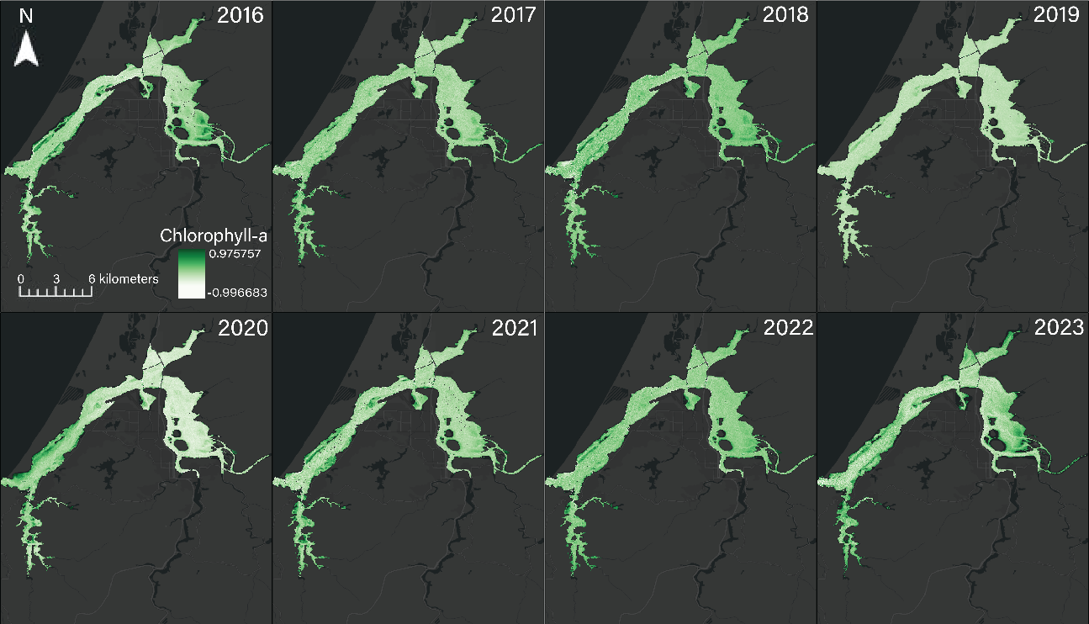

*Figure 4.* Time-series map of Normalized Difference Chlorophyll-a Index throughout the Coos Estuary in the summer of each study year.

To better examine chlorophyll-a concentrations throughout the estuary, the team retrieved daily and monthly NDCI values from ORCAA and plotted the data across our study period (Figure 5). The plot reveals daily and seasonal fluctuations in chlorophyll-a. There appears to be higher instances of chlorophyll-a in the middle of each year, which may be in response to summer upwelling. The increase of NDCI values during the summer months also provides insight into when SAVs may be obscured by other photosynthetically active organisms and presents opportunities to identify chlorophyll-a anomalies.

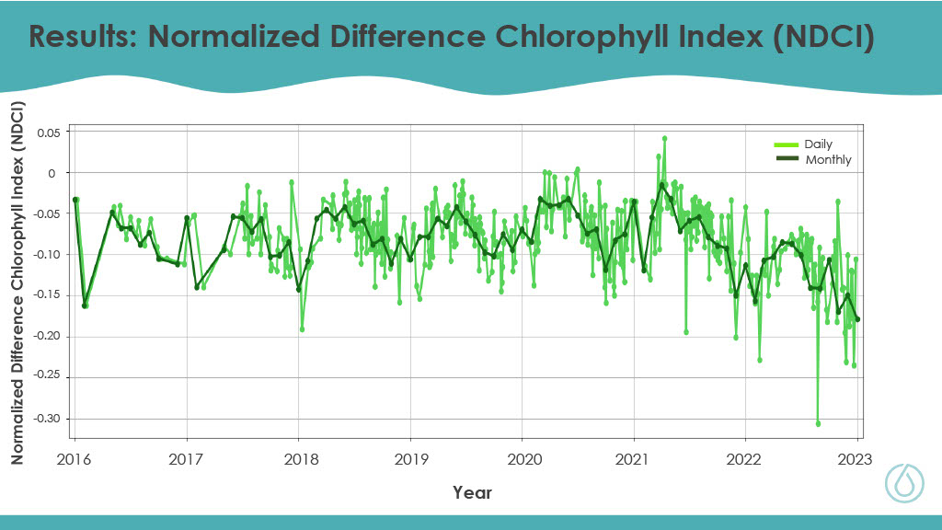*Figure 5.* Daily and monthly Normalized Difference Chlorophyll Index (NDCI) obtained from ORCAA.

***4.1.3 Turbidity***

The time-series map of NDTI the team produced visualizes the spatial distribution of turbidity throughout the Coos Estuary (Figure 6). Turbidity is a measurement of water clarity that is influenced by suspended matter, including sediments and organic debris (World Health Organization, 2017). Turbidity limits the penetration of photosynthetically active radiation into the water column, reducing the irradiance available to eelgrass meadows. This can impact the productivity of eelgrass and, in extreme cases, lead to die-offs when eelgrasses consume more energy than they produce (Lee et al., 2007). Understanding the distribution of turbidity is important to identify locations where shading may impact eelgrass health and infer the source of suspended matter. In addition to the spatial variation of turbidity, the team also visualized the variation of the average turbidity of the Coos Estuary across time in 2016, 2020, and 2023 (Figure 7). This figure demonstrates the variability of turbidity through time and compares remotely sensed turbidity patterns to the measurements of turbidity collected *in situ* by SSNERR monitoring stations.

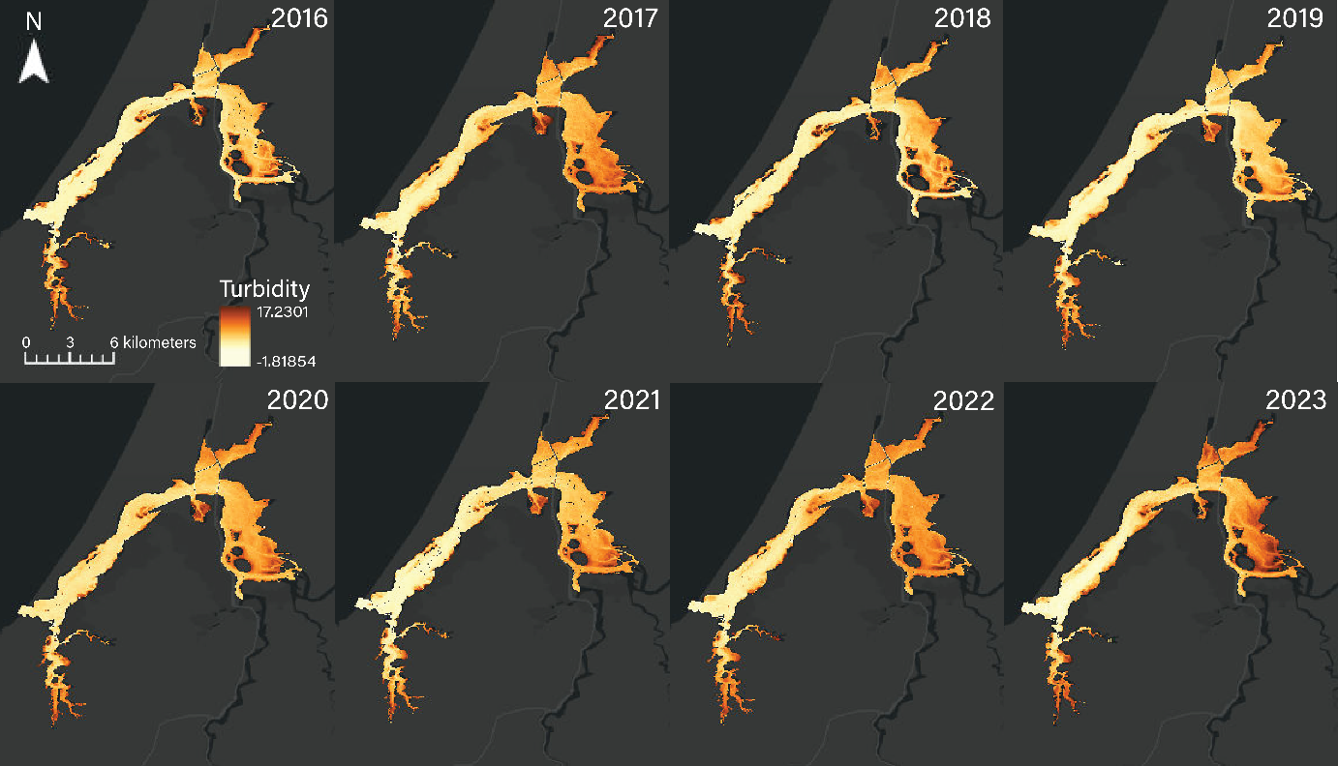

*Figure 6.* Time-series map of Normalized Difference Turbidity Index throughout the Coos Estuary in the summer of each study year.

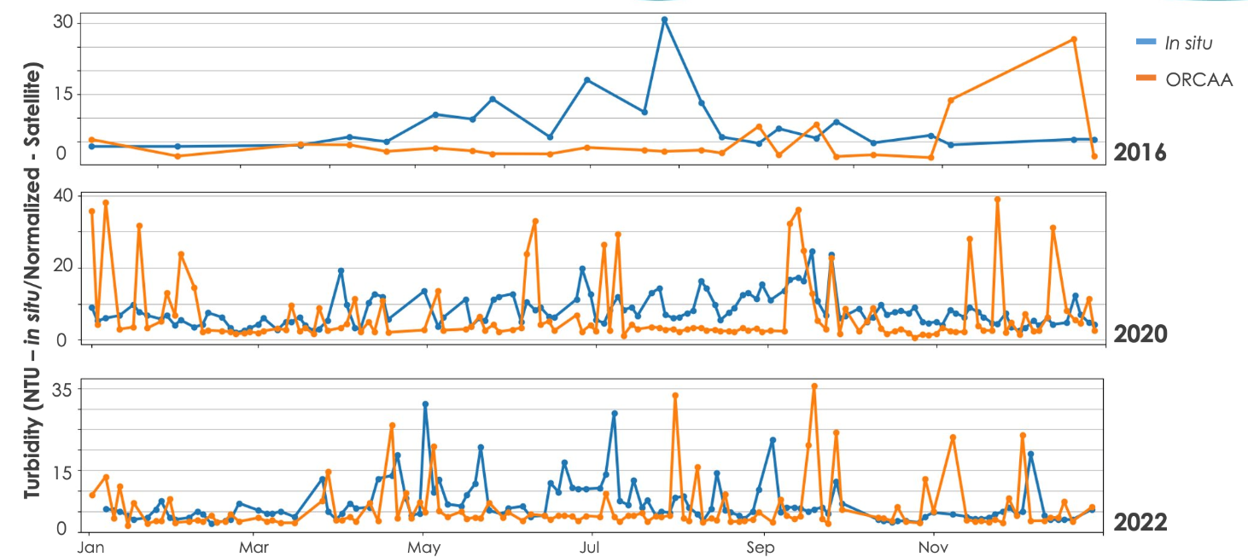*Figure 7. Normalized Difference Turbidity Index (NDTI) obtained from ORCAA vs in situ data.*

***4.2 Feasibility Assessment***

The constraints of this project, which include coarse spatial resolution satellite data, turbid & cloudy study area conditions, and the prevalence of non-eelgrass photosynthetic organisms, negatively affected the applicability and success of the team’s methodology. Ultimately, the partners can use the team’s methods and end products to further their understanding of eelgrass extent and decline in the Coos Estuary. However, additional data, such as *in situ* eelgrass density counts, should be incorporated into the methodology to improve eelgrass identification and classification.

***4.3 Future Work***

Our study investigated the feasibility of mapping eelgrass extents and performing water quality analyses in the Coos Estuary. For future work, increasing the quantity and diversity of data points by including other estuaries with eelgrass may improve the accuracy of models such as the support vector machine. In addition, the use of commercial satellite imagery with higher spatial, spectral, and or temporal resolution may improve the identification of eel grass and water parameters using satellite data. Finally, the use of UAS imagery assisted by ground-truthing may improve the monitoring of eelgrass and water quality.

# 5. Conclusions

This project used satellite remote sensing to assess the turbidity and chlorophyll-athroughout the Coos Estuary and determine the feasibility of mapping eelgrass meadows. The team visualized the spatial distribution of each water quality parameter, which highlighted regions where turbidity and/or chlorophyll-a were especially high. For instance, turbidity was especially high in the South Slough and eastern portion of the Coos Estuary, implicating surface water run-off in driving turbidity. Identifying turbidity and chlorophyll-a hotspots allow the partners to determine areas where these water quality conditions can impact eelgrass and infer the drivers of the conditions. Moreover, the team assessed the variation in the turbidity and chlorophyll-*a* indices averaged across the estuary through time to identify seasonal patterns. Though turbidity lacked a clear seasonal pattern, chlorophyll-a concentration was generally greater during the summer season, revealing a seasonal pattern in this parameter. Understanding temporal patterns in these water quality conditions allows the research partners to infer drivers of the conditions and prioritize specific time frames for sample and data collection. The team provided the research partners with the tools to generate additional maps and graphs which enable them to further identify spatial and temporal patterns of turbidity and chlorophyll-a. In addition, the team determined that there is limited feasibility to map eelgrass extent in the Coos Estuary using satellite data. The team attempted to assess eelgrass extent using NDAVI and support vector machine supervised classification. Each method faced challenges due to coarse image resolution, water column interference, spectral mixing, and the presence of other submerged photosynthetic organisms. These challenges limited the utility of NDAVI and restricted the accuracy of supervised classification to a “fair” rating. This feasibility assessment grants guidance to the research partners in how to prioritize methodologies and how to improve upon these mapping efforts. Though their accuracy is limited, remotely sensed eelgrass maps can still be useful for exploratory investigation of potential eelgrass meadows to assess on-the-ground.

# 

# 6. Acknowledgements

The team would like to honor the stewards of our study area, our partners the Confederated Tribes of Coos, Lower Umqua, and Siuslaw Indians (CTCLUSI) who protect and monitor the Coos Estuary. The team is grateful to CTCLUSI for working with NASA DEVELOP and thanks them for providing guidance and data. The team understands that as geographically removed researchers they are unable to fully understand the impact that climate, land, and natural resource management decisions have on the people who live and work around the Coos Estuary. The team would like to thank the following people who helped guide and support this project:

* Dr. Juan Torres-Pérez
* Dr. Liane Guild
* Britnay Beaudry
* Lisa Tanh
* Alicia Helms
* Jenni Schmitt
* Jennifer Kirkland
* Janet Niessner
* Laramie Plott
* Ames Marin County Wildland Fires II Team

This material contains modified Copernicus Sentinel data (2016-2023), processed by ESA.

Any opinions, findings, and conclusions or recommendations expressed in this material are those of the author(s) and do not necessarily reflect the views of the National Aeronautics and Space Administration.

This material is based upon work supported by NASA through contract NNL16AA05C.

# 7. Glossary

**CCS –** California Current System

**CTCLUSI** – Confederated Tribes of Coos, Lower Umpqua, and Siuslaw Indians

**Chlorophyll-a** – The main form of chlorophyll found in plants. It can be used as an indicator of the trophic condition of a given waterbody

**Earth observations** – Satellites and sensors that collect information about the Earth’s physical, chemical, and biological systems over space and time

**Eelgrass** – An abundant marine flowering plant that forms meadows in subtidal and intertidal habitats, providing habitat and forage to many animals

**ENSO –** El Niño Southern Oscillation

**GEE** – Google Earth Engine

**MSI** – Multispectral Instrument

**NDAVI** – Normalized Difference Aquatic Vegetation Index

**NDCI** – Normalized Difference Chlorophyll-a Index

**NDTI** – Normalized Difference Turbidity Index

**ORCAA** – Optical Reef and Coastal Area Assessment Tool

**OLI** – Operational Land Imager

**SAV** – Submerged aquatic vegetation

**SSNERR** – South Slough National Estuarine Research Reserve  
**SST** – Sea surface temperature

**Turbidity** – Opaque suspended particles that scatter and or absorb light

**UAV** – Unmanned Aerial Vehicle

# 8. References

Copernicus Sentinel-2 MSI Level-2A Data [2010-2023]. Retrieved from Google Earth Engine, processed by ESA.

Dunic, J., Brown, C. J., Connolly, R. M., Turschwell, M. P., Côté, I. M. (2021). Long-term declines and

recovery of meadow area across the world’s seagrass bioregions. *Global change biology*, *27*, *4096-4109.*  <https://doi.org/10.1111/gcb.15684>

Jarrin, M. J., Sutherland, D. A., Helms, A. R. (2022). Water temperature and variability in the Coos estuary and its potential link to eelgrass loss. *Frontiers in Marine Science, 9*. <https://doi.org/10.3389/fmars.2022.930440>

Lacaux, J. P., Tourre, Y. M., Vignolles, C., Ndione, J. A., & Lafaye, M. (2007). Classification of ponds from high-spatial resolution remote sensing: Application to Rift Valley Fever epidemics in Senegal. *Remote Sensing of Environment*, *106*(1), 66–74. <https://doi.org/10.1016/j.rse.2006.07.012>

Lee, K., Park, S. R., Kim Y. K. (2007). Effects of irradiance, temperature, and nutrients, on growth dynamics of seagrasses: A review. *Journal of Experimental Marine Biology and Ecology, 350*(1), 144-175. <https://doi.org/10.1016/j.jembe.2007.06.016>

Millette, N.C., Kelbe, C., Linhoss, A., Ashby, S., Visser, L. August 2019. Using Spatial Variability in the Rate of Change of Chlorophyll-a to Improve Water Quality Management in a Subtropical Oligotrophic Estuary. Estuaries and Coasts volume 42, pages1792–1803. https://link.springer.com/article/10.1007/s12237-019-00610-5

Mishra, S. & Mishra, D. R.. (2012). *Normalized difference chlorophyll index: A novel model for remote estimation of chlorophyll-*a *concentration in turbid productive waters*. *Remote Sensing of the Environment*, *117*, 394-406. <https://doi.org/10.1016/j.rse.2011.10.016>

Moeen, M., Babin, D., Tentoglou, T., Waite, T., Young, K. (2021). *Louisiana Water Resources: Using NASA Earth Observations to Monitor Historical Changes in the Extention of Seagrass Meadows in the Breton National Wildlife Refuge in Louisiana.* [https://ntrs.nasa.gov/citations/20210021323]. NASA DEVELOP National Program, California – Ames.

National Estuarine Research Reserve System. (NERRS) (2023). *South Slough, Oregon*. Centralized Data Management Office. National Oceanic and Atmospheric Administration (NOAA). https://cdmo.baruch.sc.edu/aqs/zips.cfm

Nejrup, L. B., & Pendersen, M. F. (2008). Effects of salinity and water temperature on the ecological performance of Zostera marina. *Aquatic Botany, 88I*(3), 239-246.<https://doi.org/10.1016/j.aquabot.2007.10.006>

NOAA National Estuarine Research Reserve System (NERRS) (2023) *System-wide monitoring program* (NOAA NERRS Cent. Data Manag. Off). Available at: [http://www.nerrsdata.org](http://www.nerrsdata.org/) (Accessed July 7, 2023).

Nordlund, L. M., Koch, E. W., Barbier, E. B, Creed, J. C. (2016). Seagrass Ecosystem Services and Their Variability across Genera and Geographical Regions. *PLOS ONE, 12*(1), 1-18. https://doi.org/10.1371/journal.pone.0169942

Orth, R. J., Carruthers T. J. B., Dennison, W. C., Duarte, C. M., Fourqurean, J. W., Heck, K. L, Hughes, A. R., Kendrick, G. A., Kenworthy, W. J., Olyarnik, S., Short, F. T., Waycott, M., Williams, S. L. (2006). A Global Crisis for Seagrass Ecosystems. *BioScience*, *56(12*), 987–996. https://doi.org/10.1641/0006-3568

PSMFC GIS. (2018). PMEP West Coast Eelgrass Source Datasets [Data set]. <https://www.pacificfishhabitat.org/data/west-coast-usa-eelgrass-habitat/>

Racault, Marie-Fanny, Platt, Trevor, Sathyendranath, Shubha, Ağirbaş, Ertuğrul, Vincete, Victor Martinez, Brewin, Robert. March 2014. Plankton indicators and ocean observing systems: support to the marine ecosystem state assessment. Journal of Plankton Research, Volume 36, Issue 3, May/June 2014, Pages 621–629, https://doi.org/10.1093/plankt/fbu016.

Rumrill, S. S. (2007). The ecology of the South Slough estuary: Site profile of the South Sough Estuarine Research Reserve. Oregon Department of State Lands.

Rumrill, S. S., & Sowers, D. C. (2008). Concurrent Assessment of Eelgrass Beds (*Zostera marina*) and Sakt Marsh Communities along the Estuarine Gradient of South Slough, Oregon. *Journal of Coastal Research,* 121-134. <https://doi.org/10.2112/SI55-016.1>

Short, F., Carruthers, T., Dennison, W., & Waycott, M. (2007). Global seagrass distribution and diversity: A bioregional model. *Journal of Experimental Marine Biology and Ecology*, *305*, 3–20. <https://doi.org/10.1016/j.jembe.2007.06.012>

US Geological Survey Earth Resources Observation and Science Center. (1984). Landsat 5 TM Level-1 Data Products - Surface Reflectance [Dataset]. https://doi.org/10.5066/F7KD1VZ9

US Geological Survey Earth Resources Observation and Science Center. (1999). Landsat 7 ETM+ Level-1 Data Products - Surface Reflectance [Dataset]. https://doi.org/10.5066/F7WH2P8G

US Geological Survey Earth Resources Observation and Science Center. (2014). Landsat 8 OLI/TIRS Level-1 Data Products - Surface Reflectance [Dataset]. <https://doi.org/10.5066/F71835S6>

Villa, P., Mousivand, A., Bresciani, M. (2014). Aquatic vegetation indices assessment through radiative transfer modeling and linear mixture simulation. *International Jounal of Applied Earth Observation and Geoinformation*, *20*, 113-127.

World Health Organization. (2017). Water Quality And Health - Review Of Turbidity: Information for regulators and water suppliers. Retrieved August 8, 2023 from https://apps.who.int/iris/bitstream/handle/10665/254631/WHO-FWC-WSH-17.01-eng.pdf