**NASA DEVELOP National Program**

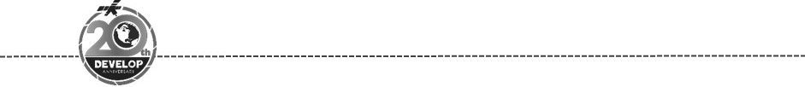California - Ames

*Spring 2018*

Richmond Urban Development

Quantifying Changes in Urban Tree Canopy Cover and Land Surface Temperature to Understand Their Impacts on Neighborhoods throughout Richmond, California

**Technical Report**

Final Draft – March 29, 2018

Fadwa Bouhedda (Project Lead)

Jerrold Acdan

Casey Mais

Dr. Juan Torres-Pérez, Bay Area Environmental Research Institute (Science Advisor)

# 1. Abstract

With the aim of improving air quality and mitigating increases in land surface temperature (LST), the city of Richmond, California, and partnering organizations have planted 35,000 trees over the past decade. Groundwork Richmond (GR) a local partner, has approximately 22,000 tree planting opportunities to further increase the urban tree canopy (UTC). This project utilized a multi-resolution approach by leveraging Landsat 5 Thematic Mapper (TM), Landsat 8 Operational Land Imager (OLI) and Thermal Infrared Sensor (TIRS), and Planet RapidEye satellite imagery to quantify the impact of Groundwork Richmond’s tree planting campaigns. Historical analysis of Richmond between 1985 and 2015 revealed that a 6.2% increase in impervious surface area has been accompanied by an average change in LST of 6 oF between 2015 and the 30-year mean. Current analysis quantified UTC cover for 2015 and 2017. Combining these findings with socioeconomic and demographic data, disadvantaged, tree deficient neighborhoods that are susceptible to high land surface temperatures were identified. The results of this project will help Groundwork Richmond determine if they are achieving canopy coverage and locate neighborhoods that could benefit the most from increased green infrastructure. Lastly, educational materials were produced that can be used during Groundwork Richmond’s canvassing campaigns to educate the local community about the benefits of trees from a scientific perspective.

**Keywords**

urban tree canopy, urban heat island, land surface temperature, normalized difference vegetation index, modified normalized difference impervious surface index, Landsat, urban green infrastructure

# 

# 2. Introduction

* 1. ***Background Information***

After World War II, Richmond, California, was transformed into a transportation hub and center of growing industry in the San Francisco Bay Area. As a result, the city is now enclosed by five oil refineries, three chemical companies, two rail yards, a port, marine terminals, and busy highways. Development, however, has had a major impact on residents in the city of Richmond due to a high pollution burden (OEHHA, 2017). Studies show that exposure to air pollution has both acute and chronic effects on human health, including heart disease and asthmatic attacks (Guarnieri & Balmes, 2014; Kampa & Castanas, 2007). It is estimated that 20.3% of people between the ages of 1 and 17 in Contra Costa, Richmond’s home county, were diagnosed with asthma between 2009 and 2012 (Contra Costa Health Services, 2016). This high rate of asthma prevalence is more than double the national average (Cohen et al., 2017) and can partially be attributed to the local air quality.

Richmond residents also face the threat of increasing land surface temperatures. For the past 30 years, the city has experienced a resurgence in urban development, which in turn increases the abundance of impervious surfaces (IS), such as concrete and asphalt. Due to the urban heat island effect (Xiao et al., 2007), impervious surfaces increase local surface temperatures higher than that of surrounding rural areas. As Earth’s temperatures continue to rise due to changes in Earth’s climate, the amount of heat absorbed by Richmond’s impervious surfaces will increase, causing residents to experience increasingly higher temperatures. This is a concern because increased heat stress can exacerbate existing health problems like asthmatic attacks (McMichael et al., 2006).

Furthermore, Harlan et al. (2006) states that: “low-income and minority groups have higher health risks related to climatic conditions,” largely because they live in urban areas that are simultaneously susceptible to extreme summer temperatures and near sources of urban pollution where housing is more affordable. Between 2010 and 2012, 39% of Richmond residents lived below two times the Federal Poverty Level (Contra Costa Health Services, 2016), a metric used in California due to high costs of living. Simultaneously, about 81% of Richmond’s population is made up of ethnic minority groups (Data USA). These statistics reveal that the city’s environmental problems are inherently environmental justice issues.

Attempting to mitigate these environmental problems, Richmond has planted 35,000 trees throughout the city because trees are known to provide ecosystem services that benefit urban communities, such as temperature reduction by providing shade and the removal of air pollutants (Nowak, 2002). Today, Richmond has partnered with non-profit organizations to continue to increase the city’s green infrastructure. Many of these organizations have created tree planting programs with an emphasis on community understanding and participation in the changing of the city’s landscape.

* 1. ***Project Partners***

For this project, we partnered with Groundwork Richmond, CA (GR), which is a local chapter of Groundwork USA, a larger network of non-profit organizations dedicated to urban greening in the context of environmental justice. One of GR’s main projects is partnering with the city of Richmond to restore the urban forest. Using a tree planting opportunities map provided by city officials alongside CalEnviroScreen 3.0 Maps, GR identifies which tree planting opportunities are in socioeconomically disadvantaged neighborhoods. These potential sites are visited by Green Team (GR) members who verify or reject them based on their viability. Trees that are planted are logged into a shared Tree Tracking Program database to monitor the progress of these campaigns. While remotely-sensed imagery was used to detect tree planting opportunities, it is not used to analyze the impact of GR’s efforts regarding changes to the city’s green infrastructure.

***2.3 Project Objectives***

In this project, we set out to: 1) utilize satellite imagery to assess and compare changes in land cover and land surface temperatures in order to provide historical context of the city of Richmond in regards to its geography; 2) estimate changes in current UTC cover to quantitatively assess the impacts of Groundwork Richmond’s urban forestry projects; 3) investigate the relationship between canopy cover and quality-of- life indicators; 4) identify neighborhoods that are socioeconomically disadvantaged, vulnerable to high heat exposure, and currently lacking UTC cover; and 5) provide GR with educational materials and geospatial data incorporating project results that can be used to educate youth volunteers and the local community about the science behind the benefits of trees as well as be leveraged to gain support from potential funding sources for future tree-planting campaigns.

***2.4 Study Area, Study Period, and Scientific Basis for Methods***

The study area encompassed the city of Richmond excluding Wildcat Regional Park as determined by the 2010 US Census block groups (Figure 1). The study period for historical analyses included the years 1985, 1996, 2005, and 2015 while current impact analyses included the years 2015 and 2017. All analyses performed in this project followed well established methods used in published peer-reviewed scientific articles. Land cover classifications were performed using supervised classification. Results of the classifications were compared to impervious surface layers derived using the Modified Normalized Difference Impervious Surface Index (MNDISI) (Zhongchang et al., 2017). Land surface temperatures were calculated using Jimenez-Munoz’s & Sobrino’s (2004) single band method. Socioeconomic data was visually compared to the spatial distribution of urban canopy through a series of choropleth maps, a common way to display how a measurement varies across a geographic area. All results were combined to create a social vulnerability index, similar to one used in a previous DEVELOP project (O’Brien et al., 2017), in order to suggest areas of focus for future tree planting campaigns.

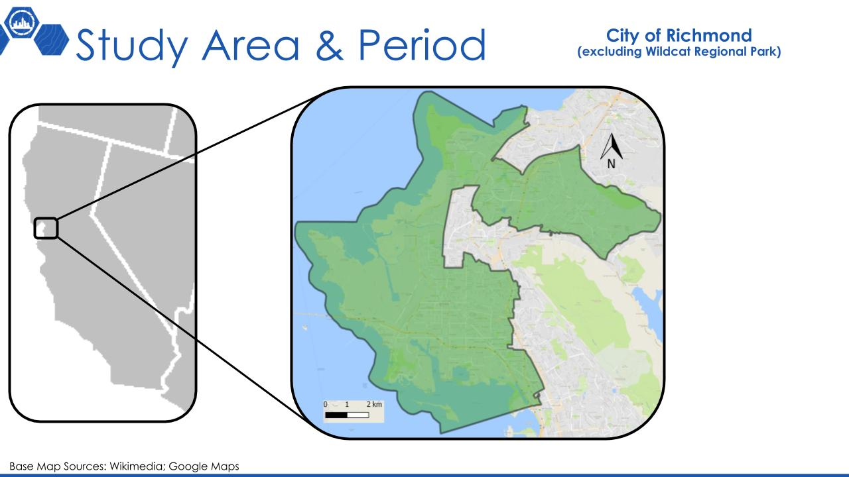

*Figure 1.* Map of study area spanning the city of Richmond, California, excluding Wildcat Regional Park.

# 3. Methodology

**3.1 Data Acquisition**

***3.1.1 Historical Land Cover Classification Time Series and Current UTC Analysis***

Tier 1 Landsat 5 TM Surface Reflectance imagery from the years 1985, 1996 and 2005, and Tier 1 Landsat 8 TOA Reflectance (Orthorectified) imagery from 2015 were extracted in Google Earth Engine (GEE) by setting the parameters to select a single image in July with the least amount of cloud cover. July was the targeted month because in California, trees maintain their leaves during July while grass tends to be dead or dying, allowing for easier detection of trees when running a land classification. To aid in the classification process, National Agriculture Imagery Program (NAIP) imagery collected in GEE was used as a reference for the 2005 and 2015 classifications when selecting training sites. For current UTC analysis, images acquired by the Planet Rapideye Satellite Constellation in 2015 and 2017 were downloaded from the Open California database on Planet’s webpage. We decided to use RapidEye imagery because it has a spatial resolution of 5 m that enabled better detection of trees within the urban environment.

***3.1.2 LST Assessment & IS Layer***

Landsat 5 TM and Landsat 8 OLI-TIRS top of atmosphere reflectance level 1 data products were used for the years 1985, 1996, 2005, 2015, and 2017. Images were collected for path 44, row 33 using the United States Geological Survey (USGS) EarthExplorer portal. Within each year, the image with the least amount of cloud cover in the month of July was selected because the urban heat island effect is prevalent during summer months. This also allowed for consistency as land classification images were also acquired for the month of July.

***3.1.3 Socioeconomic Analysis***

Poverty and property value data were retrieved in block groups from the US Census Bureau via American Factfinder. Crime incident data were downloaded from the Contra Costa Sheriff’s Office webpage. Other supporting data including where the locations of previously planted trees (Tree Traking Program database) and tree planting opportunities as well as city zoning districts, was collected from the City of Richmond Geospatial team.

**3.2 Data Processing and Analysis**

***3.2.1 Study Area Shapefile Creation***

A 2010 TIGER/Line® shapefile by US Census block groups was downloaded for the state of California and uploaded to ArcMap. Next, we uploaded a CSV file containing the geo-identification numbers of block groups within the study area to ArcMap and joined it to the shapefile of California so only matching records were retained. The remaining polygons contained the city of Richmond but excluded Wildcat Regional Park because GR focuses on trees in the urban environment. This layer containing the block group polygons was re-projected to the WGS 1984 UTM Zone 10N coordinate system and saved as a shapefile for socio-economic analyses. These polygons were then dissolved to create a single polygon that outlined the final boundaries of the study area. This shapefile was re-projected to the same coordinate system and used during land classification and land surface temperature analyses.

***3.2.2 Historical Land Cover Time Series***

After acquiring the relevant images in Google Earth Engine (GEE), we uploaded the study area shapefile into a Google Fusion Table. We then clipped the images to the shapefile by calling upon the fusion table as a feature collection. Normalized Difference Vegetation Index (NDVI, Equation 1) was calculated by using the normalized difference function in GEE. NDVI was added as a map layer and served as a proxy when choosing training points for the land classification along with NAIP imagery for 2005 and 2015 classifications. Six classes (urban, grass, soil, trees, water and marsh) were created as separate feature collections. Within each feature collection 80 to 100 points were selected for training and a random forest classifier was chosen to run the classification. Of the training points selected 80% of the points were used to classify the image while the other 20% was used to validate the classification. The comparison allowed for calculation of an error matrix, overall accuracy, and kappa coefficient. If the accuracy assessment did not reached 90% or higher, then training points were reviewed and re-selected if necessary. This process was continued until training sites provided adequate results. Once the classification was finalized, area was calculated in hectares for individual classes. Final land classification results were exported to Google Drive to for later analysis. Classification results of the Landsat images for the years 1985, 1996, 2005, and 2015 can be found in the Appendix in Figure A1.

$\text{NDMI=}\frac{\text{NIR}\text{ band }\text{-}\text{ Red b}}{\text{NIR}\text{ band }\text{+}\text{ Red b}}$ (1)

The spatial resolution of 30 m for Landsat images was too coarse to identify tree canopy within the neighborhoods of Richmond, CA. As a result, we shifted our objective to focus on observing if the city has become greener (more vegetation) from 1985 to 2015. To do this we imported the land classifications for 1985 and 2015 into ArcMap and used the combine tool to merge the 1985 and 2015 classifications so that a unique output value was assigned to each combination of input values. The resulting maps displayed how land cover change over the 30-year period. To quantify land cover change, we calculated the percent change for individual class by using area in hectares.

***3.2.3 Current UTC Cover Analysis***

RapidEye satellite imagery of our study area is split into two separate image scenes for both 2015 and 2017. Because of this, we mosaicked the images on ArcMap using the mosaic to new raster tool so that the output raster had 16-bit unsigned pixels. The single image was then imported into GEE as an asset. Classification was executed following the same methodology used to create the historical land cover time series. In order to visualize changes in UTC cover, the RapidEye land classification layers were processed in ArcMap to display only the tree class while making all others transparent. The results from the 2015 classification is displayed in Figure 2 while the 2017 image can be found in the Appendix in Figure A2.

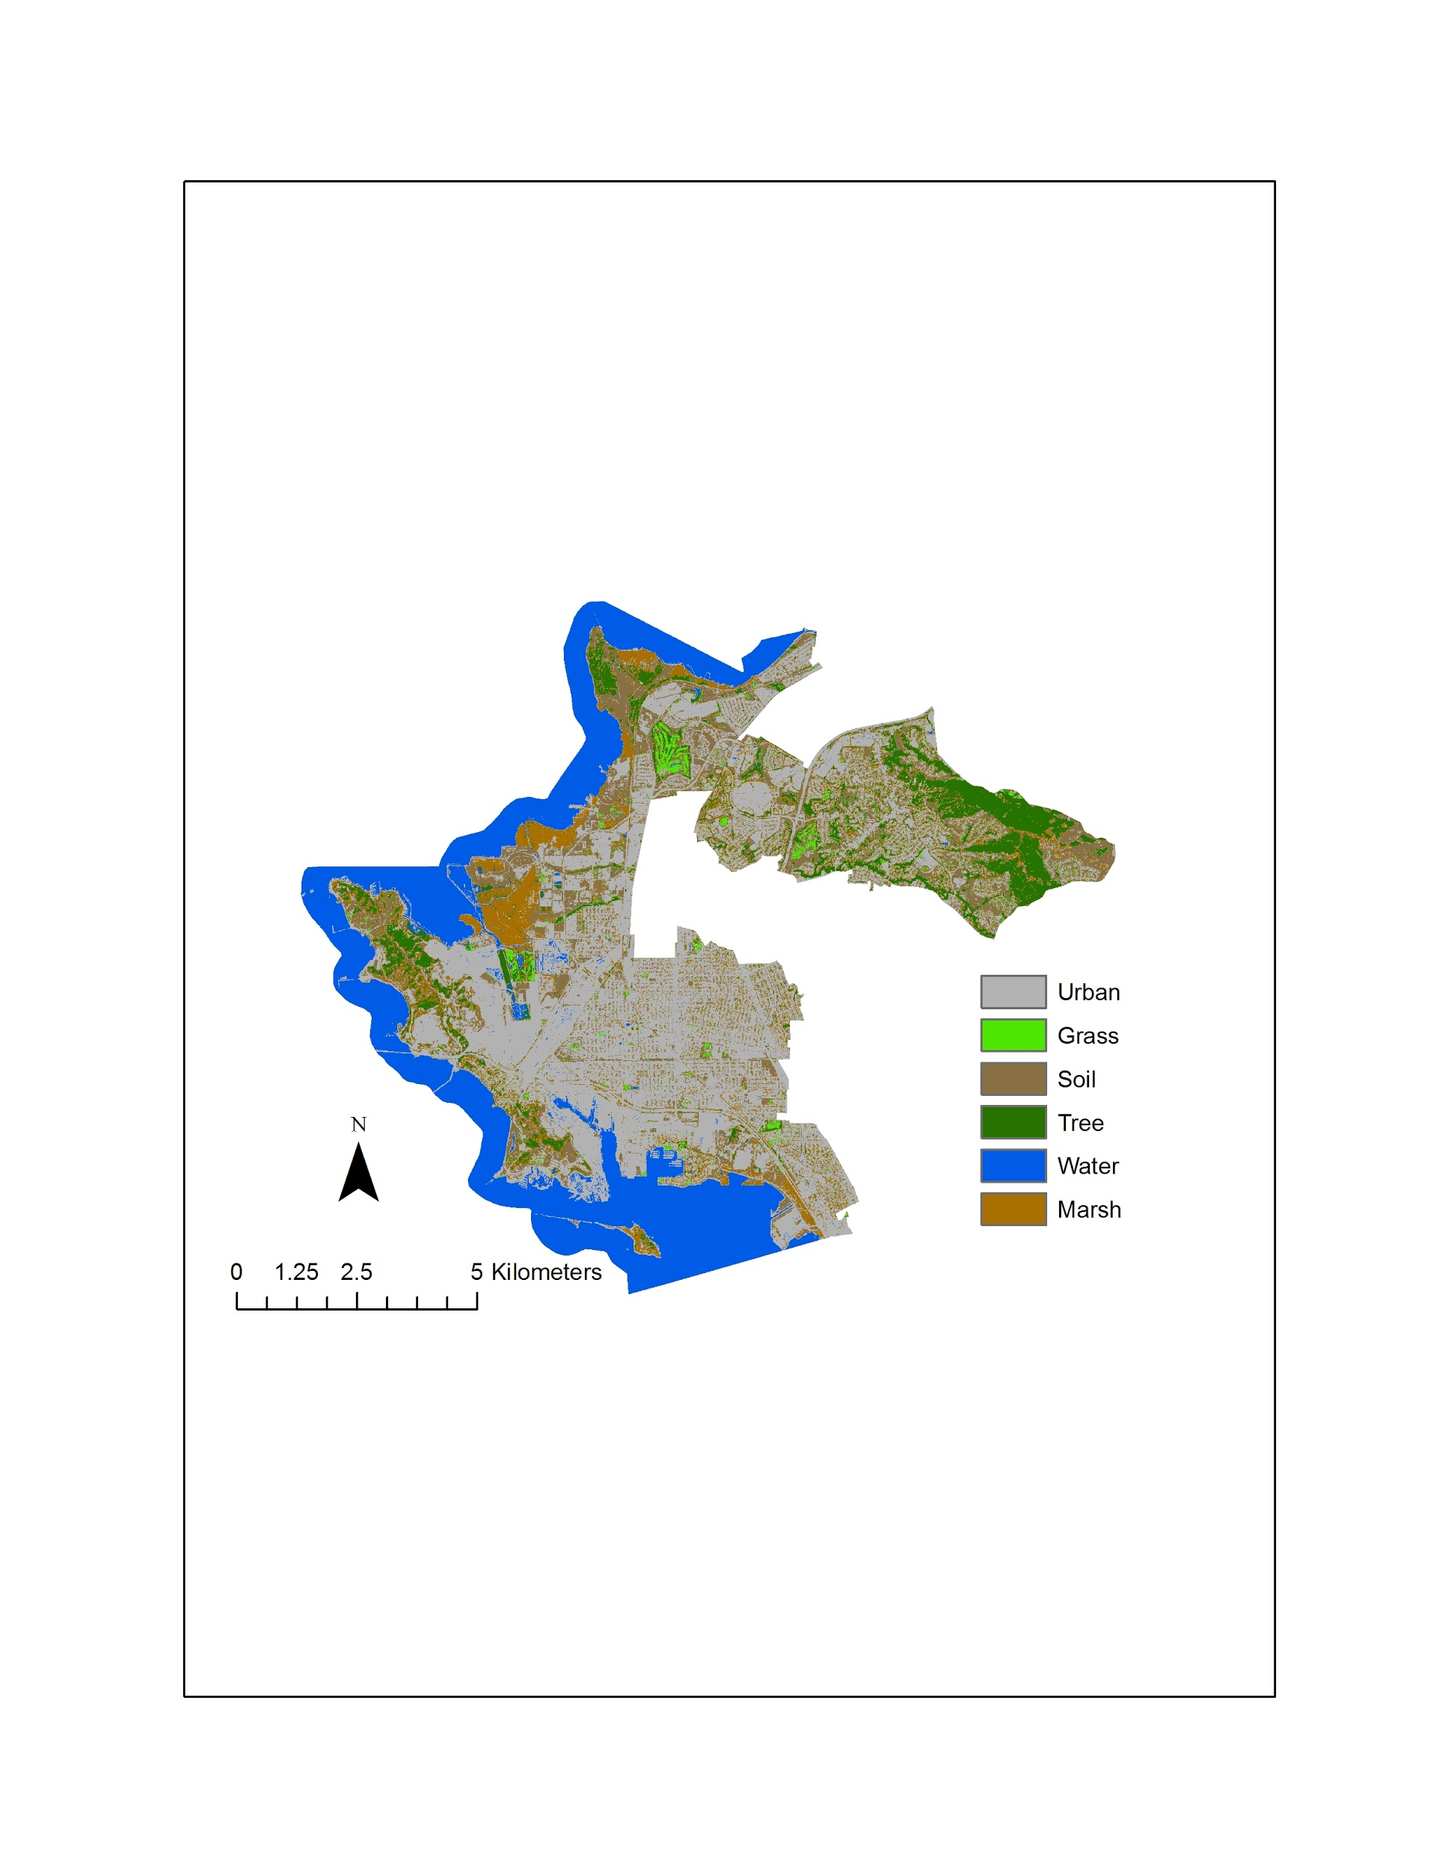

*Figure 2.* 2015 Land Classification (RapidEye).

***3.2.4 LST Assessment***

We derived LST by following Jimenez-Munoz’s & Sobrino’s (2004) single band method. After being uploaded to QGIS, the images were atmospherically corrected using dark object subtraction and then clipped to the study area shapefile (each layer created in the following steps were also clipped to the shapefile at the end of each step). An NDVI (Equation 1) layer was then created and used to derive emissivity layers according to Sobrino et al.’s (2004) NDVI thresholds method. LST was calculated using Equation 2, where Tb is the atmospherically corrected thermal band in units of Kelvin, $λ$ is the central wavelength of the thermal band in meters, and $ρ$ = $1.438 × {10}^{-2}$ mK. We then converted the LST layers from Kelvin to degrees Fahrenheit. LST layers for the years 1985, 1996, 2005, and 2015 can be found in the Appendix in Figure A3.

$\text{LST=}\frac{\text{T}\text{b}}{\text{1 + (}\text{λT}\text{b}\text{/ρ)ln(ε)}}$ (2)

To analyze changes in LST, a layer was created by taking the average of the 1985, 1996, 2005, and 2015 layers to represent the 30 year mean. To see areas where LST has deviated from the 30 year average, a new layer was created by subtracting the 2015 and 30-year mean layers (Figure 3). An absolute change between 1985 and 2015 was also derived by subtracting the LST layers of those two years. Basic statistics were also calculated for each year and can be found in the Appendix as Figure C2.

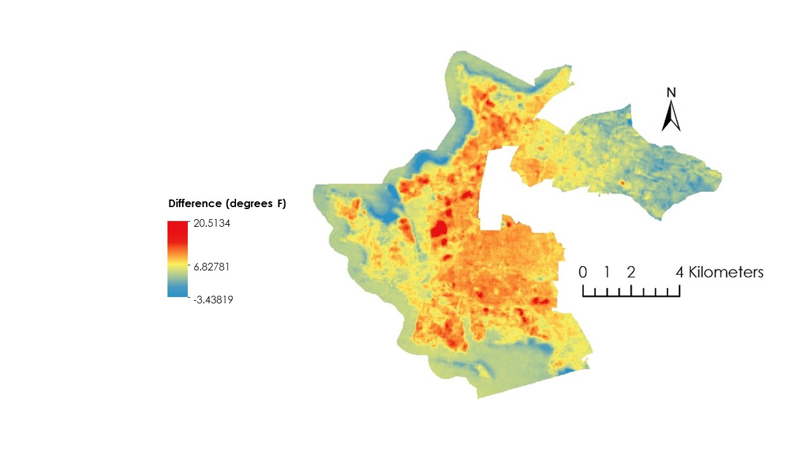

*Figure 3.* 2015 Temperature anomalies between 2015 and 30 year mean.

***3.2.5 IS Layer***

We utilized Zhongchang et al.’s (2017) Modified Normalized Difference Impervious Surface Index (MNDISI) methodology to create impervious surface layers of the study area for the years 1985 and 2015. MNDISI is an index that highlights impervious surface within an image while masking out other types of land cover, including soil, vegetation, and water. When working with Landsat 5 images, we first uploaded atmospherically corrected green, NIR, SWIR1, and SWIR2 bands as well as the LST layer for that year into QGIS and clipped them to the study area shapefile. However, when working with Landsat 8 images, non-atmospherically corrected images were utilized. Similar to LST methodology, each of the layers created in the following steps were also clipped to the shapefile at the end of each step. Next, we created a Modified Normalized Difference Water Index layer using Equation (3).

$\text{MNDWI=}\frac{\text{Green band - SWIR1 band}}{\text{Green band + SWIR1 band}}$ (3)

The MNDWI and LST layers were then stretched to [0,255] for Landsat 5 TM and [0, 65535] for Landsat 8 OLI-TIRS by reassigning the minimum value of each layer a new value of 0, the maximum a new value of 255 or 65535, and linearly interpolating all values in between. TM bands were then adjusted from surface reflectance to 8-bit DN values by multiplying the layers by 400. Since the OLI-TIRS bands used were not atmospherically corrected, their values are already in DN units and did not need to be modified. A MNDISI layer was created using Equation (4).

$\text{MNDISI=}\frac{\text{LST }\text{stretched}\text{ - (MNDWI }\text{stretched}\text{ + NIR }\text{adjusted}\text{ + SWIR1 }\text{adjusted}\text{)/3}}{\text{LST }\text{stretched}\text{ - (MNDWI }\text{stretched}\text{ + NIR }\text{adjusted}\text{ + SWIR1 }\text{adjusted}\text{)/3}}$ (4)

Results revealed that soil and IS have similar MNDISI values, so a Normalized Difference Soil Index (NDSI) layer was created using Equation (5) to help differentiate between the two. Preliminary threshold values for MNDISI and NDSI were found by finding the average of training samples for each category.

$\text{NDSI=}\frac{\text{SWIR2 band - Green band}}{\text{SWIR2 band - Green band}}$ (5)

IS layers were created by assigning a pixel a value of 1 if its MNDISI value was greater than the selected impervious surface threshold and its NDSI value was less than the selected soil index threshold. If a pixel did not meet these criteria, it was assigned a value of 0, meaning it is not classified as an impervious surface. We then performed accuracy assessments by using the random points tool in QGIS, which produced a set of 100 random points on the IS layers. These points were then checked against a true color image to see if they were classified accurately. If the accuracy was less than 80%, this process was repeated by adjusting the threshold values. Impervious surface layers for the years 1985 and 2015 can be found in the Appendix as Figure A4.

***3.2.6 Socioeconomic Analysis***

2015 ACS estimates were processed in Excel in order to get the median property value and percent of people living in poverty at the block group level. These numbers were then saved as a CSV file, joined to the block group shapefile of our study area, and visualized to create choropleth maps. The 2015 RapidEye classification layer was then uploaded to ArcMap and turned into a vector layer of polygons, with each polygon assigned a UTC value as a percentage of the polygon’s area that was classified as tree. This UTC choropleth map was then visually compared to the property value and poverty level choropleth maps as well as visualizations of other data, such as zoning information and crime incidents. The choropleth maps can be found in the Results section and Appendix section E.

***3.2.7 Social Vulnerability Index***

To highlight socioeconomically disadvantaged neighborhoods that are also susceptible to experiencing high LSTs and currently lacking UTC cover, we created a social vulnerability index (SVI) similar to the one created by O’Brien et al. (2017). Inputs into the SVI equation included LST, IS, zoning information, poverty level, property values, and UTC for the year 2015. Zoning data was rasterized by assigning each pixel that falls within a district a value of: 1 if it was a residential community, open space, or park (because GR’s tree planting campaigns focus on residential neighborhoods); 0.5 if it was a residential zone mixed with commercial or industrial activities; and 0 otherwise. Poverty level and property values were rasterized by assigning each pixel the value of the block group polygon in which it was located. These layers, along with the LST layer, were converted to z-score values (Equation 6) in order to keep the maximum SVI value a reasonable single digit number. UTC layer was transformed so that pixels had a value of 1 if it were classified as a tree and 0 otherwise. All layers were converted to 5 meter resolution in ArcMap to match the resolution of the 2015 UTC land classification layer. These layers were then combined with equal weights using the band calculation function in QGIS. The SVI formula is shown in Equation 7. A map of social vulnerability scores for the entire study area can be found in the Appendix as Figure A7.

$\text{Z - Score=}\frac{\text{Pixel Value - Average Pixel Value}}{\text{Standard Deviation of Pixel Values}}$ (6)

$\text{SVI = LST + IS + Zoning Categorization + Poverty Level - Property Values - UTC}$ (7)

# 

# 4. Results & Discussion

**4.1 Discussion of Results**

***4.1.1 Historical Land Cover Time Series***

For the 1985 classification we had an overall accuracy of 98.31% and for 2015 an overall accuracy of 96.69%. When calculating the percentage change for the classes defined between the years 1985 to 2015 (Figure 4) we found that the Urban class had increased by 5.8%. While pervious surfaces (trees, grass and soil) had decreased by 7.29%. From our analysis we can conclude that Richmond has increased in impervious surfaces while decreasing in pervious surfaces from the years 1985 to 2015.

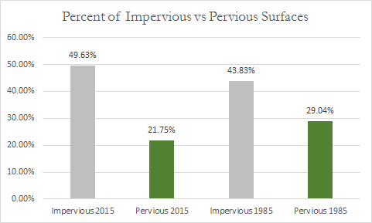

*Figure 4.* Percent of study area classified as pervious versus impervious.

***4.1.2 Current UTC Cover 3-year Analysis***

Visual inspection revealed that although land cover for the year 2015 appeared to be classified correctly, the 2017 classification did not appear to be as accurate as desired. We believe the largest error made was the selection of training sites used to classify the image. Also, both RapidEye images were not atmospherically corrected which would have altered pixel classification. Finally, year to year weather variation that could have altered vegetation health between the years. With these errors for the 2017 land cover classification, we cannot provide conclusive results to determine the impacts of Groundwork Richmond’s greening initiatives.

***4.1.3 LST Assessment***

The average LST has steadily increased between 1985 and 2017, as seen in Figure 5. For example, the absolute difference in average LST between the imagery we utilized from 2015 and 1985 is about 10 oF. Furthermore, when comparing 2015 LST data to the 30 year mean data, we see that the average change in LST is an increase of about 6oF. For context, deviations from the 30 year average range from areas that are hotter by about 22 oF to those that are cooler by approximately 3oF. While the changes in LST in Richmond between 1985 and 2015 at first may seem large, it is worth noting that a study has estimated with 95% confidence that the LST for the entire Earth has increased by 0.9 oC (33.62 oF) between 1951 and 2010 (Rohde et al., 2011). This leads us to believe that our results of a 6 oF increase in average LST between 2015 and the 30-year mean to be reasonably accurate.

When looking at true color satellite imagery at areas that have become much warmer than average, we see that that have become developed and turned into impervious surfaces. Regions that have become cooler than average are those either in the water off the coast of Richmond or areas that are covered with tree canopy, showing that UTC helps to reduce LST. As Earth’s climate changes to due anthropogenic increases to the radiative forcing of the atmosphere, the amount of energy trapped in the Earth system increases. As the energy within the Earth system increases, the amount that is absorbed and re-radiated as heat by impervious surfaces also increases. Since urban develop continues to occur in Richmond in the context of the continuing climate variability of Earth as a whole, LSTs are expected to continue to rise in the future.

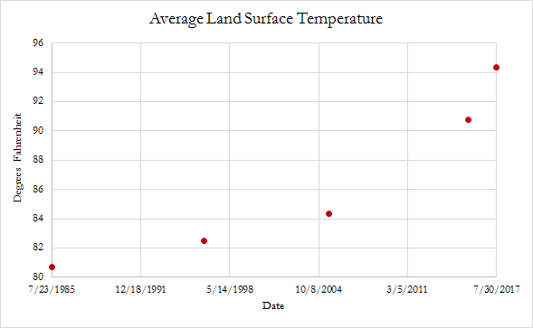

*Figure 5.* Plot of Average LST within study area limits.

***4.1.4 Impervious Surface Layer***

The area classified as impervious surface in 1985 was calculated to be 41.23% with an accuracy of 82%. This number increased to 47.32% in 2015, and was found with an accuracy of 83%. As a result, we see that the increase in IS area between 2015 and 1985 was 6.1%. The increase in the urban classification from the historical land cover classification time series was found to be 5.8%. Because the results of both the supervised and unsupervised classifications match well, we believe them to be accurate. This confirms the finding that urban development continues to occur Richmond, thus contributing to the city’s LST concerns.

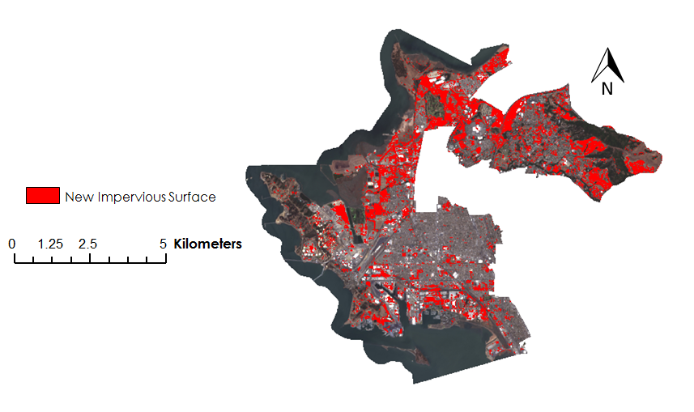

*Figure 6.* Map denoting red areas as new impervious surface built between 1985 and 2015.

***4.1.5 Socioeconomic Analysis***

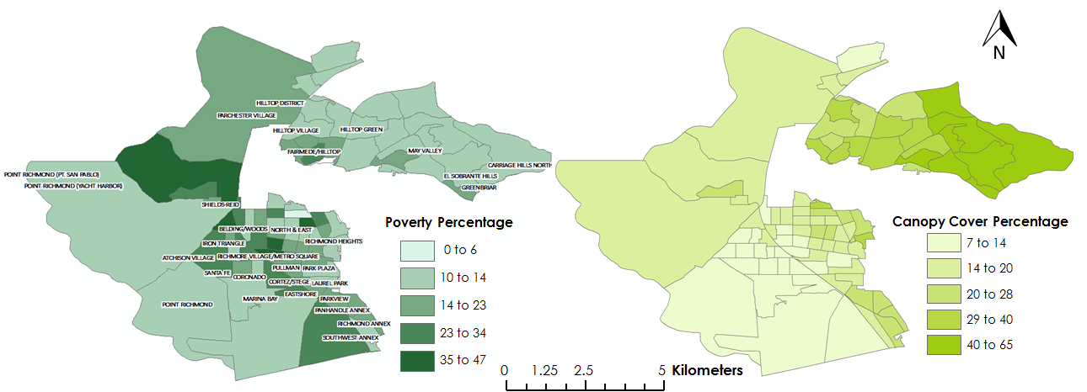

*Figure 7.* Block group comparison of poverty percentage and UTC cover.

A series of choropleth maps were derived to visually investigate the relationship between socioeconomic variables and canopy cover. We used percent poverty to indicate impoverished areas since 40% of Richmond’s population lives under the poverty line (US Census Bureau, 2015). This helped in identifying disadvantaged neighborhoods that can benefit from urban greening campaigns (shown in Figure 7). For example, we observed that impoverished areas such as Metro Village, Iron Triangle and Hilltop District are located in areas with low canopy cover ranging from 7% to 20%. In contrast, more affluent neighborhoods have a considerable amount of tree canopy cover ranging anywhere from 40-60%. We also chose median property values as an indicator of wealth rather than median income, since properties are a physical index of wealth that is situated geographically alongside tree canopy. As we anticipated, we saw an interrelationship with higher property values linked to higher canopy cover, which is seen in the farther east side of Carriage Hilltop, May Valley, and Hilltop Green (Figure 8).

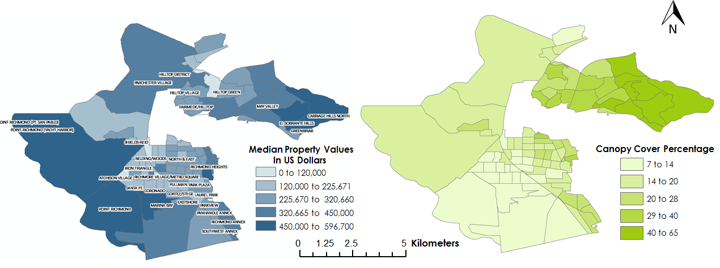

*Figure 8.* Block group comparison of median property values and UTC cover.

Although we were not able to retrieve a complete dataset of all cited crime incidents, we utilized crime that was reported to the Contra Costa County Sheriff department office that primarily gathered incidents from 2015 to present day. This dataset of crime hotspots were overlaid with canopy cover to visually link how trees affect reported crime incidents (Appendix Figure A5). Tree canopy was abundant in Richmond Annex, May Valley and Hilltop Green, which are areas with noticeably less crime incidents. This displays a possible relationship between high canopy and fewer crime incidents. As for additional background context, we incorporated zoning district data (Appendix Figure A6) into our SVI. This zoning data provided by the city of Richmond allows for the proper land use regulations and development standards of zoning districts and permitting procedures that will allow for more urban canopy sites. This initiative aligns with GR’s and the City’s vision for economic and urban green space development.These results point to familiar themes in environmental justice, with wealthier communities receiving significantly more benefits from environmental amenities such as tree canopy. Although the importance of canopy cover may have not been quantitatively correlated as a preliminary assessment, we were able to distinguish the apparent patterns between tree canopy and socioeconomic variables.

***4.1.5 Social Vulnerability Index & Tree Placement Assessment***

SVI (Social Vulnerability Index) scores for the entire study area range from -3.98 to 7.54. A map showing the SVI scores for particular neighborhoods in Richmond that GR focuses on for its tree planting campaigns is shown in Figure 9. Areas with a high score, visualized in purple, are those that are socioeconomically disadvantaged, susceptible to increased land surface temperatures, and currently lacking urban tree canopy. Although there is no threshold value for the SVI to determine where trees are needed the most, we believe that neighborhoods with high scores should be areas of focus for GR’s future tree planting campaigns because they are the ones whose residents could benefit the most from increased green infrastructure.

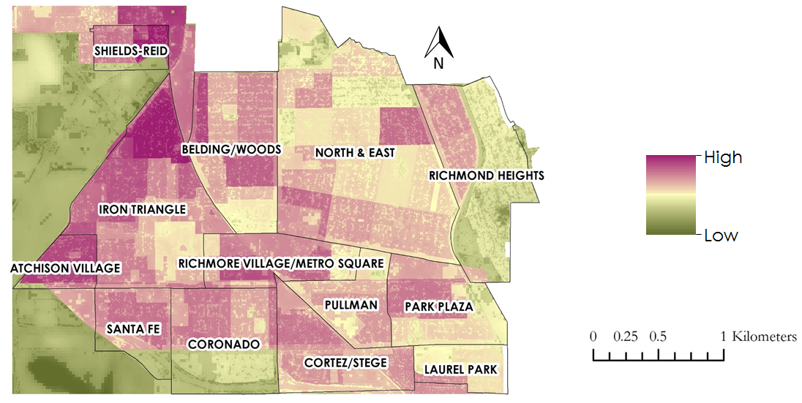

*Figure 9.* Map of SVI scores for neighborhoods of interest to GR.

**4.2 Future Work**

In order to improve our geospatial analysis, we suggest several tactics. First, we recommend improving our land classification findings by using higher spatial resolution imagery that has been atmospherically corrected prior to analysis. To further improve our classifications, we also suggest incorporating spectral profiles of different classes acquired during in situ data collection in the field. Additionally, utilizing Light Detection and Ranging (LiDAR) data would also enable better classification of trees, as LiDAR can detect both height and crown shape of individual trees. In terms of correlating our socioeconomic variables such as poverty, property values, and tree canopy, the data we have collected can be further assessed by running mathematical regression models. These statistical technique will help us better understand the relationship between UTC and the socioeconomic variables of interest. Finally, although LST reveals a warming trend in Richmond, ambient air temperature is what individuals actually feel when walking around. Incorporating ambient air temperatures to our LST analysis would strengthen the argument that residents face higher heat exposure every year.

# 

# 5. Conclusions

Through our results we can conclude that area covered by impervious surfaces have increased by approximately 6 percent between the years of 1985 and 2015 within Richmond, California. It has also been shown that there was an average difference of positive 6 degrees Fahrenheit in LST between 2015 and the 30-year mean. Unfortunately, at this time we cannot determine the impact GR’s tree planting campaigns have made at increasing the city’s UTC cover between the years 2015 and 2017 due to spatial resolution considerations, atmospheric correction limitations, training point selection during classification, and weather anomalies. Still, we were able to produce a social vulnerability index that identified communities that are simultaneously under-treed, socioeconomically disadvantaged, and vulnerable to high heat exposure, thus making them areas that could benefit the most from future tree-planting campaigns. In sum, the geospatial data we have produced can be used to garner support from the local community and secure potential funding sources for upcoming urban canopy campaigns. We hope that the insights gained from this project will remind Groundwork Richmond the full importance of their work so that they may continue their efforts at increasing the city’s green infrastructure to the benefit of all those who live there.

# 6. Acknowledgments

* Sarah Calderon, Executive Director, Groundwork Richmond, CA of Groundwork USA
* Dr. Juan Torres-Pérez, Bay Area Environmental Research Institute, NASA Ames Research Center
* Jenna Williams, Center Lead, DEVELOP National Program at NASA Ames Research Center
* John Dilger, Geoinformatics Fellow, DEVELOP National Program at NASA Ames Research Center

Any opinions, findings, and conclusions or recommendations expressed in this material are those of the author(s) and do not necessarily reflect the views of the National Aeronautics and Space Administration.

This material is based upon work supported by NASA through contract NNL16AA05C and cooperative agreement NNX14AB60A.

# 

# 7. Glossary

**Environmental Justice** – The fair treatment and meaningful involvement of all people regardless of race, color, national origin, or income, with respect to the development, implementation, and enforcement of environmental laws, regulations, and policies

**Impervious Surface (IS)** – Surface Area that does not allow water or liquid to penetrate into ground

**Land Surface Temperature (LST)** – The temperature of land derived from emissivity of different types of land cover

**Normalized difference vegetation Index (NDVI)** –Calculated from visible and near infrared light reflection, this index quantifies the density of plant growth on earth as follows:

NDVI = (NIR-VIS)/ (NIR + VIS)

**Modified Normalized Difference Impervious Surface Index (MNDISI)** – A Gaussian-based index method used to extract impervious surfaces from Landsat imagery

**Normalized Difference Surface Index (NDSI)** – NDSI was calculated by finding the average of training samples for each category as follows: NDSI = SWIR2 band - Green band/SWIR2 band + Green band

**Social Vulnerability Index (SVI)** –The SVI equation quantifies the need for tree placements as follows:

SVI = LST + ISA+ Zoning Data + Poverty Level - Property Values - UTC cover

**Urban Green Infrastructure** – Natural and semi-natural areas with other environmental features (trees, community green spaces, and etc.) designed to provide a wide range of ecosystem services in urban settings

**Urban Heat Island (UHI)** –Index that quantifies urban areas that is significantly warmer than rural regions due to anthropogenic activities

**Urban Tree Canopy (UTC)** – The layer of leaves, branches, and stems of trees that cover the ground when viewed from above particularly in urban settings

# 8. References

Cohen, A., Lopez, A., Malloy, N., and Morello-Frosch, R. (2012). Our environment, our health: A

community-based participatory environmental health survey in Richmond, California. *Health*

*Education and Behavior, 39*(2), 198-209. doi: 10.1177/1090198111412591.

Contra Costa Health Services. (2016). *The Richmond Health Equity Report Card*. Prepared for The Richmond

Health Equity Partnership by Contra Costa Health Services with support from the California

Endowment. Retrieved from https://cchealth.org/health-data/pdf/Richmond-Health-Equity

-Report-Card-Full.pdf.

Data USA. Richmond, CA. Retrieved from https://datausa.io/profile/geo/richmond-ca/#demographics.

Guarnieri, M., & Balmes, J.R. (2014). Outdoor air pollution and asthma. *Lancet, 383*, 1581-1592.

https://doi.org/10.1016/S0140-6736(14)60617-6.

Harlan, S.L., Brazel, A.J., Prashad, L., Stefanov, W.L., and Larsen, L. (2006). Neighborhood microclimates

and vulnerability to heat stress. *Social Science & Medicine, 63*, 2847-2863. doi:

[10.](https://doi.org/10.1016/j.socscimed.2006.07.030)1016/j.socscimed.2006.07.030.

Jimenez-Munoz, J.C., & Sobrino, J.A. (2003). A generalized single-channel method for retrieving land surface

temperature from remote sensing data. *Journal of Geophysical Research, 108*(D22), 4688. doi:

10.1029/2003JD003480.

Kampa, M., & Castanas, E. (2008). Human health effects of air pollution. *Environmental Pollution, 151*, 362-367.

doi: 10.1016/j.envpol.2007.06.012.

McMichael, A.J., Woodruff, R.E., and Hales, S. (2006). Climate Change and human health: present and future

risks. *Lancet, 367*, 859-869. doi:10.1016/S0140-6736(06) 68079-3.

Nowak, D.J. (2002). *The Effects of Urban Trees on Air Quality*. Report prepared for the USDA Forest Service,

Syracuse, NY. Retrieved from https://www.nrs.fs.fed.us/units/urban/local-resources/downloads/

Tree_Air_Qual.pdf.

O’Brien, J., Khan, R., Wilson, C., and Jia, F. (2017). *Assessing the urban heat island and the impact of urbanization in*

*Las Cruces, New Mexico.* Technical Report for the NASA DEVELOP National Program. Retrieved

from [http://www.devpedia.developexchange.com/dp/index.php?title=Las_Cruces](http://www.devpedia.developexchange.com/dp/index.php?title=Las_Cruces_Health_%26_Air_Quality_AZ_Summer_2017)

[_Health_%26_Air_Quality_AZ_Summer_2017](http://www.devpedia.developexchange.com/dp/index.php?title=Las_Cruces_Health_%26_Air_Quality_AZ_Summer_2017).

OEHHA. CalEnviroScreen 3.0 Overall Results and Individual Indicator Maps. (Jan. 2017). esri ArcGIS

online maps. Retrieved from http://oehha.maps.arcgis.com/apps/MapSeries/index.html?appid

=8dad35dcd2274285874e60871c404edc.

Rohde, R., Muller, R.A., Jacobsen, R., Muller, E., Perlmutter, S., et al. (2013). A New Estimate of the Average

Earth Surface Land Temperature Spanning 1753 to 2011. *Geoinfor Geostat, 1*(1), 1000101.

doi:10.4172/2327-4581.1000101.

Sobrino, J.A., Jimenez-Munoz, J.C., and Paolini, L. (2004). Land surface temperature retrieval from

LANDSAT TM 5. *Remote Sensing of Environment, 90*, 434-440.https://doi.org/10.1016/j.rse.

2004.02.003.

Xiao, R., Ouyang, Z., Zheng, H., Li, W., Schienke, E. W., and Wang, X. (2007). Spatial pattern of impervious

surfaces and their impacts on land surface temperature in Beijing, China. *Journal of Environmental*

*Sciences, 19*, 250-256. https://doi.org/10.1016/S1001-0742(07)60041-2.

Zongchang, S., Wang, C., Guo, H., and Shang, R. (2017). A Modified Normalized Difference Impervious

Surface Index (MNDISI) for Automatic Urban Mapping from Landsat Imagery. *Remonte Sensing, 9*(9),

942. doi:10.3390/rs9090942.

# 9. Appendix

Appendix A: Supplementary Figures

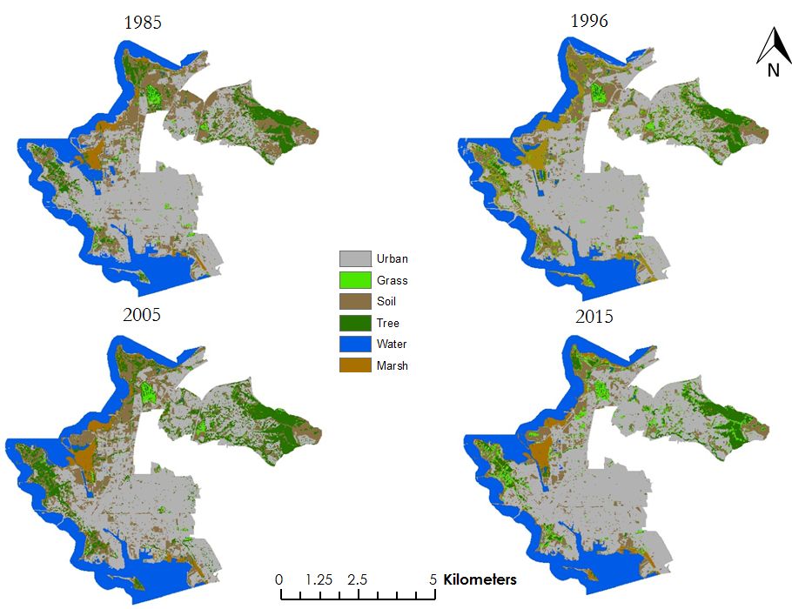

*Figure A1. Historical Land Cover Classifications of Landsat Imagery*

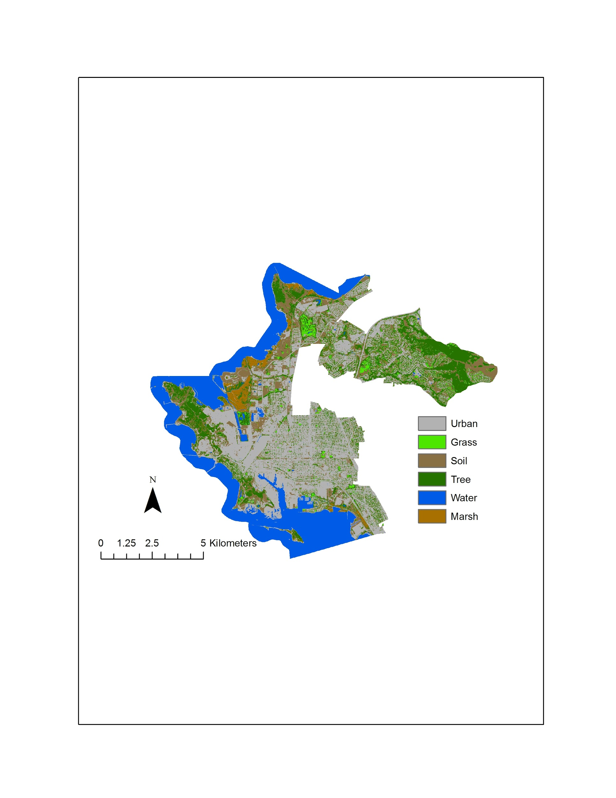

*Figure A2. 2017 Land Cover Classification (RapidEye)*

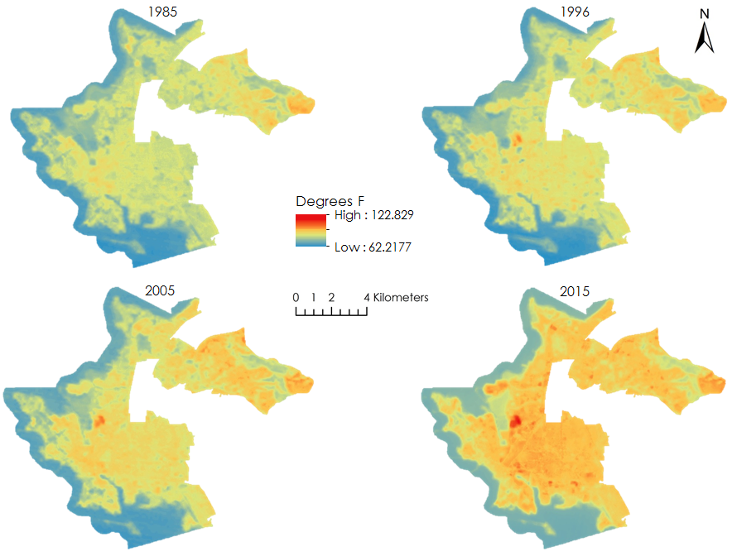

*Figure A3. LST derived from Landsat imagery acquired in 1985, 1996, 2005, and 2015*

*Table A1. Basic Statistics from LST Layers*

|  |  |  |  |  |
| --- | --- | --- | --- | --- |
| **Item** | **Image Date** | **Minimum**  **(degrees F)** | **Maximum**  **(degrees F)** | **Mean**  **(degrees F)** |
| LST 1985 | 24-Jul-85 | 62.22 | 104.57 | 80.69 |
| LST 1996 | 6-Jul-96 | 61.24 | 109.99 | 82.48 |
| LST 2005 | 15-Jul-05 | 63.05 | 110.84 | 84.35 |
| LST 2015 | 27-Jul-15 | 69.38 | 122.83 | 90.75 |
| LST 2017 | 16-Jul-17 | 66.13 | 123.68 | 94.35 |
| Average | N/A | 64.46 | 104.64 | 84.57 |
| LST Differential  (2015 - Average) | N/A | -3.44 | 20.51 | 6.18 |

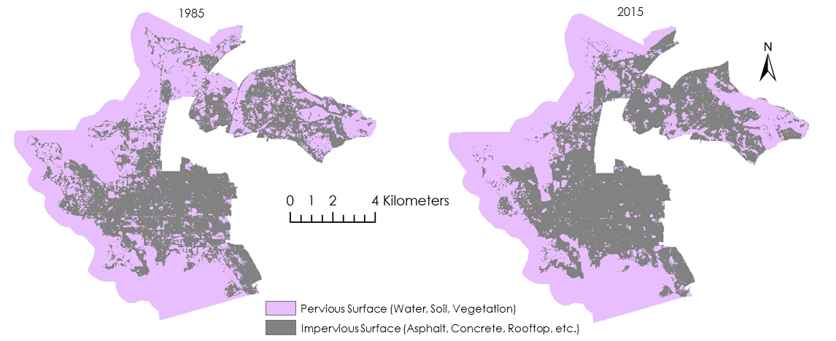

*Figure A4. 1985 and 2015 IS layers derived via unsupervised classification of Landsat imagery*

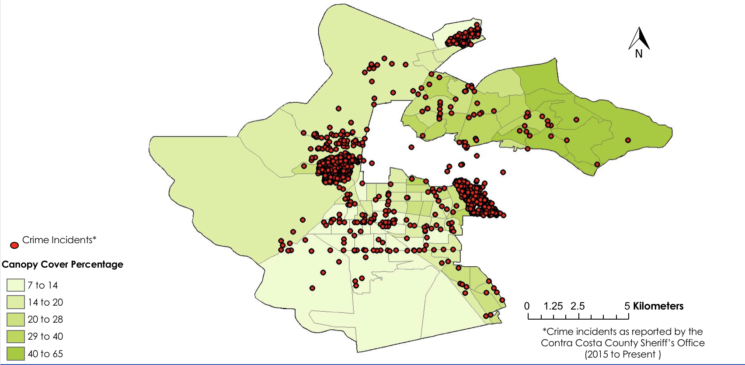

*Figure A5. Crime Incidents Overlaying UTC Choropleth Map*

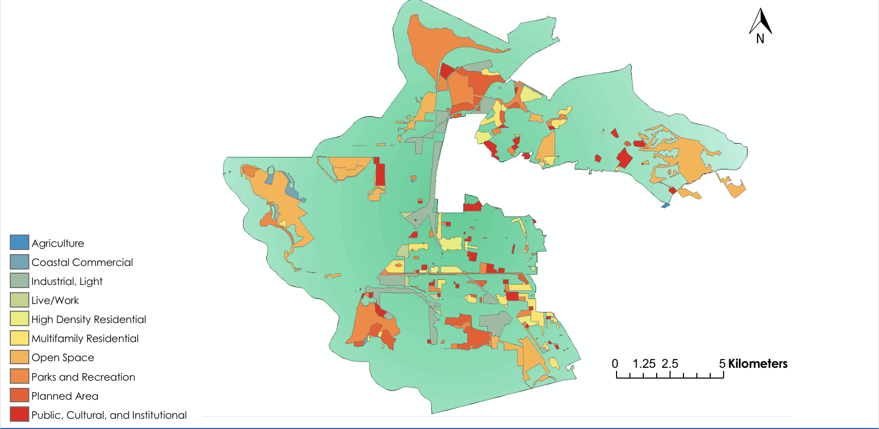

*Figure A6. Zoning Districts in Richmond*

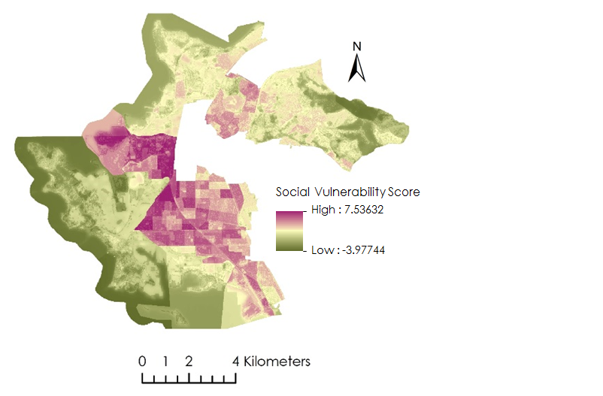

*Figure A7. SVI Map of entire study area*